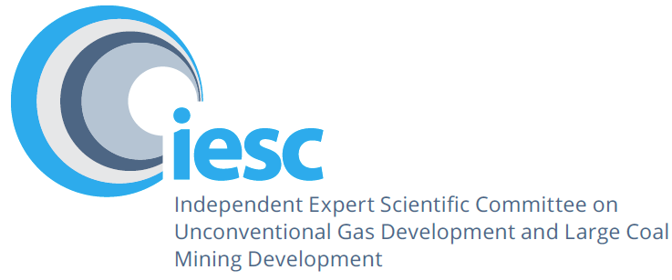

2024–2025

Annual Review of Activities
An overview of the activities of the Independent Expert Scientific Committee on Unconventional Gas Development and Large Coal Mining Development from July 2024 to June 2025
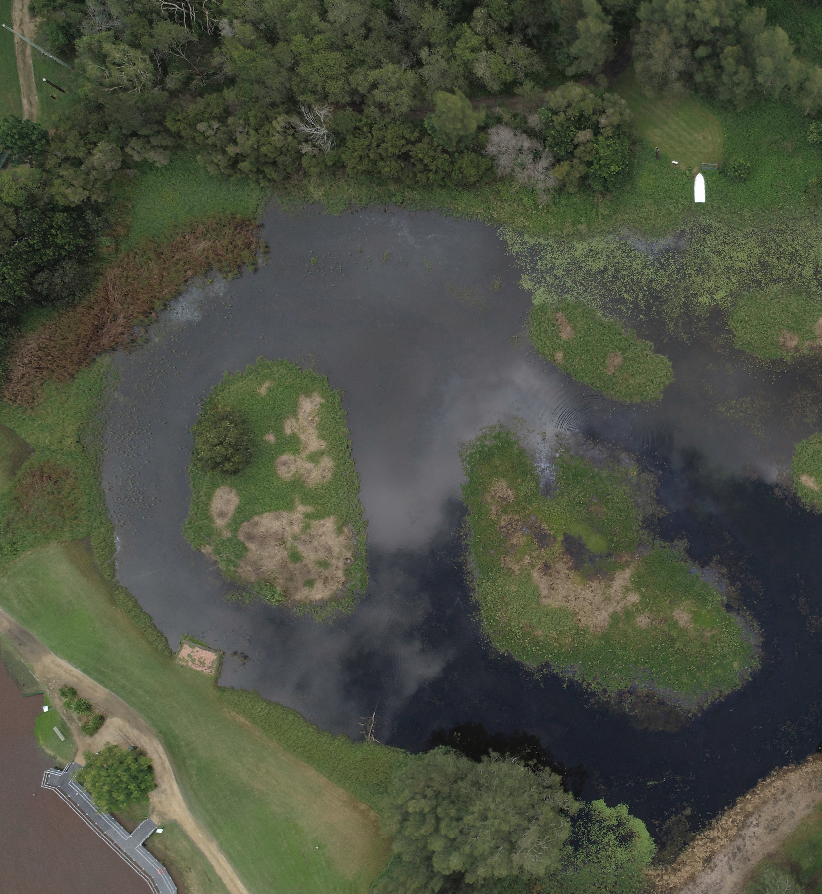

© Commonwealth of Australia 2025

2024-25 Annual Review of Activities is licensed by the Commonwealth of Australia for use under a Creative Commons Attribution 4.0 International licence with the exception of the Coat of Arms of the Commonwealth of Australia, the logo of the agency responsible for publishing the report, content supplied by third parties, and any images depicting people.
For licence conditions see https://creativecommons.Org/licenses/by/4.0/
This report should be attributed as 'Independent Expert Scientific Committee on Unconventional Gas Development and Large Coal Mining Development: 2024-25 Annual Review of Activities, Commonwealth of Australia'.
This publication is funded by the Australian Government Department of Climate Change, Energy, the Environment and Water. The views and opinions expressed in this publication are those of the authors and do not necessarily reflect those of the Australian Government or the Minister for the Environment.
The contents of this report are intended for informational purposes only. All efforts have been made to ensure the information contained in this report is accurate and up-to-date. However, the authors accept no responsibility for any errors, omissions, or inaccuracies.
Contact details
For information about this report or about the work of the IESC, please contact:
IESC Secretariat
Office of Water Science
Department of Climate Change, Energy, the Environment and Water
GPO Box 3090
CANBERRA ACT 2601
Email: IESCSecretariat@dcceew.gov.au
The report can be accessed at http://www.iesc.gov.au/
Images
Front cover: Hunter Estuary, © Copyright Department of Climate Change, Energy, the Environment and Water - photographer Bruce Gray; Hunter Valley Wetlands © Copyright Department of Climate Change, Energy, the Environment and Water
Back cover: Hunter Valley Wetlands © Copyright Department of Climate Change, Energy, the Environment and Water
All other images © Department of Climate Change, Energy, the Environment and Water

Table of Contents
1. Message from the Chair 4
2. Highlights 5
3. Members 6
4. Meetings 9
5. Scientific advice 12
6. Information Guidelines and Explanatory Notes 14
7. Research 16
8. Engagement 17

Message from the Chair
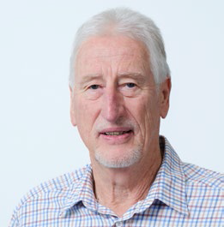
I am pleased to present the Independent Expert Scientific Committee on Unconventional Gas Development and Large Coal Mining Development (IESC) 2024-2025 Annual Review of Activities.
Since its establishment, the IESC (including the interim IESC) has now provided 170 pieces of advice. In 2024-25, we provided 6 pieces of scientific advice to government. Our advice was formulated and other activities were undertaken over 10 committee meetings in 2024-25. This included 9 virtual meetings and one in-person meeting, held in Victoria.
One of the pieces of advice we provided in 2024-25 was to the Australian Government Minister for the Environment and Water on the potential impacts and/or risks to water resources and water-dependent matters of national environmental significance arising from potential unconventional gas exploration and appraisal activities in the Beetaloo Basin, Northern Territory. The IESC discussed and formulated this advice over 5 committee meetings (July, August, October, November and December 2024) and several out of session workshops.
In conjunction with our meetings at different locations in Australia, the IESC continues to engage with a diverse range of stakeholders. In 2024-25, the IESC met with the Victorian Mine Land Rehabilitation Authority and, as Chair, I met with representatives from the Northern Territory Government. These meetings provided us with the opportunity to outline our role and function. The broad range of discussions were highly valuable and very informative to the committee.
Our meeting in Victoria in January incorporated a site visit to view coal mine rehabilitation sites, Hazelwood Rehabilitation Project and Yallourn Power Station. The committee appreciated the efforts of staff at both sites, who made us feel welcomed and took time out of their busy day to explain their work. The tours at the sites and the suite of presentations were extremely valuable to us.
We are excited to have commenced work on our eighth Explanatory Note, which will explore the topic of incorporating climate change into assessments of the environmental impacts of proposed projects. Noting that there have been a number of advancements in methodologies and/or tools since several of our Explanatory Notes were first published, we are also commencing work on updates to a number of existing Explanatory Notes.
On behalf of the whole committee, I thank the Office of Water Science (OWS), within the Australian Government Department of Climate Change, Energy, the Environment and Water, for their continued dedication and hard work. The OWS, through the provision of secretariat support and scientific expertise, continues to support the IESC through all the activities we undertake.
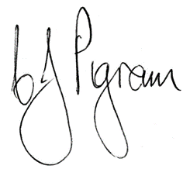
Dr Chris Pigram AM, FTSE
IESC Chair

Highlights
9 | virtual committee meetings |  | 1 | in-person committee meeting |  | 6 | pieces of scientific advice virtual provided and published | 
1. Cadia Continued Operations Project – Expansion
2. Beetaloo Basin – Unconventional Gas Exploration and Appraisal
3. Saraji Mine Grevillea Pit Continuation Project (EPBC 2023/09757) – Expansion
4. Mahalo North Coal Seam Gas Project (EPBC 2023/09689) – New Development
5. Rolleston Coal Mine Continuation Project (EPBC 2023/09547) – Expansion
6. Bloomfield Colliery Continuation Project Modification 5 (EPBC 2024/09978) – Expansion
5 | guest presentations at committee meetings
1 | IESC CHAIR MEETING  (September 2024)  • Representatives from the Northern Territory Government |  |  | 
1 | ROUNDTABLE (January 2025) |  |  | 
 | • Victorian Mine Land Rehabilitation Authority
 |  |  |  |  |  | 1 | video resource published | 
(May 2025)
• eDNA sampling overview video
2 | SITE VISITS (January 2025)  • Hazelwood Rehabilitation Project  • Mining rehabilitation at the Yallourn Power Station |  |  | 
 |  |  |  |  |  | Web statistics  15,035 – total website views  5,776 – total website users  4,300 – document downloads |  | 

Members
The Environment Protection and Biodiversity Conservation Act 1999 (Cth) (EPBC Act) requires the majority of IESC members to possess scientific qualifications in one or more of the following areas: geology, hydrogeology, hydrology and ecology.
The IESC consisted of 8 members throughout 2024-25.

Dr Chris Pigram AM FTSE – Chair, Geology
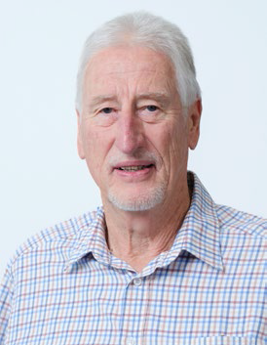
Dr Pigram is a geologist with over 50 years' experience and is a leader in research and management of minerals, marine and petroleum geoscience programs, and geospatial and earth monitoring. Dr Pigram was formerly the CEO of Geoscience Australia, where he held the role for 7 years. Consequently, he has extensive experience in managing the interface between science and government and in stakeholder engagement.

Professor Wendy Timms, Geology and hydrogeology

Professor Timms has 30 years experience in geology, hydrogeology and engineering. She is a Chartered Engineer and Professor of Environmental Engineering at Deakin University. Her projects have included drilling and geophysics, hydraulics and geochemical analysis, water quality monitoring and modelling of water-soil-rock interactions. Wendy's consulting, research and training experience spans mining, energy, agriculture, water supply and carbon sequestration sectors. She has published over 80 peer-reviewed papers, numerous technical reports and is a former Vice President of International Association of Hydrogeologists.

Dr Jenny Stauber, Ecotoxicology

Dr Stauber has over 45 years of research experience in the fields of ecotoxicology, water quality, contaminant environmental risk assessment and human toxicology. She serves as an expert ecotoxicologist on a wide range of advisory panels for national and international agencies. Dr Stauber is an Adjunct Professor at La Trobe University. She is a Fellow of the Australian Academy of Technology and Engineering and a Fellow of the Australian Academy of Science.

Professor Jenny Davis, Ecology

Professor Davis has expertise in freshwater biodiversity and wetland conservation, with more than 200 published papers and reports. She was awarded the Limnology Medal for excellence in freshwater research in 2006. Professor Davis co-chairs the Wetlands Working Group of the International Association for Ecology (INTECOL). She is a member of the Research Institute for Environment and Livelihoods at Charles Darwin University.

Professor Rory Nathan, Hydrology

Professor Nathan has over 40 years' experience in engineering and environmental hydrology and is Professorial Fellow of Hydrology and Water Resources at the University of Melbourne. He has made a substantial contribution to industry best practice in a range of engineering and environmental fields, particularly in the characterisation of hydrologic risk, the assessment of hydrologic impacts, and hydrologic model development and application.

Dr Andrew Boulton, Ecology

Dr Boulton's research spans river and groundwater ecology, especially in semi-arid areas, with 4 books and over 130 peer-reviewed articles. He has been on international and national panels to assess riparian zone policies, environmental flows, groundwater-dependent ecosystems and biodiversity of intermittent rivers. Dr Boulton is Adjunct Professor in Ecosystem Management at the University of New England and has held academic positions at other national and international universities.

Associate Professor Phil Hayes, Hydrogeology

Associate Professor Hayes is a geoscientist, hydrogeologist and groundwater modeller with over 25 years' experience in Australia, the United Kingdom and South America. He has worked across sectors from water resource management and groundwater protection to impact prediction and mitigation for mining, oil and gas, contaminated land, infrastructure, and nuclear waste. He is Associate Professor of Water Resources at the University of Queensland, leading research at the interface between reservoir engineering and hydrogeology, and in groundwater modelling uncertainty analysis.

Dr Juliette Woods, Hydrogeology

Dr Woods has 29 years of national and international experience in hydrogeology across academia, industry and government. Her career spans environmental management, mining assessments, water allocation planning, climate change, salinity, and the mathematics of modelling. She is a principal science advisor to the South Australian Department for Environment and Water and an Adjunct Associate Professor at Flinders University. She is co-leading the development of new Australian Groundwater Modelling Guidelines for the National Water Grid Fund.

Meetings
The IESC predominantly meets virtually, holding 9 virtual meetings in 2024-25. Additionally, the IESC met once in person, in Melbourne. The meeting in Melbourne, in January, incorporated a site visit to the La Trobe Valley.
The infographic on this page gives a timeline and brief overview of IESC meetings in 2024-25. More detailed information about the items discussed is available in linked meeting minutes or on the Minutes page on the IESC website.

IESC meeting dates and subject matter, 2024-25
June 2025 – (Meeting 116)
ADVICE
Bloomfield Colliery Continuation Project
OTHER ITEMS
- Presentation: Cumulative Impacts to Water-Related Environmental Values for the Northern Bowen Basin.
May 2025 – (Meeting 115)
ADVICE
Rolleston Coal Mine Continuation Project
OTHER ITEMS
- Presentation: Hydraulic and Salinity Evolution of Groundwater- Fed Pit Lakes After Mine Closure.
April 2025 – (Meeting 114)
OTHER ITEMS
- Discussed a draft schedule for delivery of the lESC's information materials over the next 12 months, and an updated research priorities and actions table.
- Discussed a draft scope for the delivery of a climate change Explanatory Note.
March 2025 – (Meeting 113)
ADVICE
Mahalo North CSG Project
OTHER ITEMS
- Presentation: Incorporating Climate Change into Environmental Risk Assessment.
- Presentation: National Noble Gas Facility for Groundwater.
January 2025 – (Meeting 112)
OTHER ITEMS
- Presentation on the Hazelwood Mine Rehabilitation Project.
- Mine Land Rehabilitation Authority Roundtable.
- Site visit to the Hazelwood Rehabilitation Project and mining rehabilitation at the Yallourn Power Station.
December 2024 – (Meeting 111)
ADVICE
Saraji Mine Grevillea Pit Continuation Project
Beetaloo Basin - Unconventional Gas Exploration and Appraisal
November 2024 – (Meeting 110)
OTHER ITEMS
- Discussed draft advice on the potential impacts of unconventional gas exploration and appraisal activities in the Beetaloo Basin, Northern Territory.
October 2024 – (Meeting 109)
ADVICE
Cadia Continued Operations Project - Expansion
OTHER ITEMS
- Discussed draft advice on the potential impacts of unconventional gas exploration and appraisal activities in the Beetaloo Basin, Northern Territory.
August 2024 – (Meeting 108)
OTHER ITEMS
- Presentation: Coal Seam Gas Joint Industry Framework - Update.
- Discussed draft advice on the potential impacts of unconventional gas exploration and appraisal activities in the Beetaloo Basin, Northern Territory.
July 2024 – (Meeting 107)
OTHER ITEMS
- OWS presented a Beetaloo Basin background information session to the committee.
- Presentation: Science of Hydraulic Fracture Stimulation.

Guest presentations
The IESC regularly invites guests from a range of organisations and disciplines to present at IESC meetings on a range of topics of interest to the IESC. These presentations help increase the IESC's understanding about how proposed unconventional gas and large coal mining developments might affect water resources.

Guest presentations in 2024-25
- Science of Hydraulic Fracture Stimulation - Sameer Ganpule, Origin Energy Ltd
- Coal Seam Gas Joint Industry Framework - Update - Natasha Amerasinghe and Derek Yates, Department of Climate Change, Energy, the Environment and Water
- National Noble Gas Facility for Groundwater - Dr Dirk Mallants, CSIRO, and Dr Rohan Glover, The University of Adelaide
- The Hydraulic and Salinity Evolution of Groundwater-Fed Pit Lakes After Mine Closure - Birte Moser, National Centre for Groundwater Research and Training
- Cumulative Impacts to Water-Related Environmental Values for the Northern Bowen Basin - Professor Claire Cote, The University of Queensland

Member presentations
IESC members regularly present at committee meetings to update colleagues on the latest developments in their particular scientific disciplines.

Member presentations in 2024-25
- Incorporating Climate Change into Environmental Risk Assessment
- Dr Jenny Stauber and Professor Rory Nathan presented on how understanding the combined effects of global climate change and chemical exposures is essential for improving ecological risk assessments of vulnerable ecosystems.

Scientific advice
Through its scientific advice, the IESC helps increase transparency and strengthens the scientific basis of regulatory decisions by identifying potential impacts of unconventional gas and large coal mining developments.
When formulating its scientific advice, the IESC considers all potential impacts on water resources. This includes the effects on groundwater, surface water, water quality and quantity, ecosystems and ecological processes.

Process for IESC scientific advice

1. Regulator requests advice
The IESC can only give advice when the regulator requests advice. The lESC's functions allow for advice to be requested under different parts of the EPBC Act.

2. IESC provides advice
The IESC considers the request, develops its scientific advice and provides this advice to the regulator for consideration in their decision-making process.

3. Regulator considers advice
The regulator has committed to take the IESC's advice into account and to be transparent about how it does this. The regulator considers the IESC's scientific advice in the decision-making process and may also use it to help develop and set appropriate conditions to ensure that any impacts on water resources are managed.

Details of the development proposals are publicly available.
This includes public notices, referrals and environmental impact statements. The regulator provides this information on its website.

4. IESC publishes advice
The IESC publishes each piece of scientific advice on its website within 10 business days of providing the advice to the regulator.

In 2024-25, the IESC provided 6 pieces of scientific advice. Since the establishment of the interim IESC in 2012, the IESC has provided 170 pieces of advice to government regulators.

Development proposals on which the IESC has provided scientific advice since 2012
1 proposal in NT, 1 OTHER DEVELOPMENT PROPOSAL
2 proposals in WA, 2 COAL MINES
1 proposal in SA, 1 UNCONVENTIONAL GAS PROPOSAL
77 proposals in NSW, 67 COAL MINE PROPOSALS, 6 UNCONVENTIONAL GAS PROPOSALS, 4 OTHER DEVELOPMENT PROPOSALS
89 proposals in QLD, 70 COAL MINE PROPOSALS, 17 UNCONVENTIONAL GAS PROPOSALS, 2 OTHER DEVELOPMENT PROPOSALS

Development proposals on which the IESC provided scientific advice, 2024-25
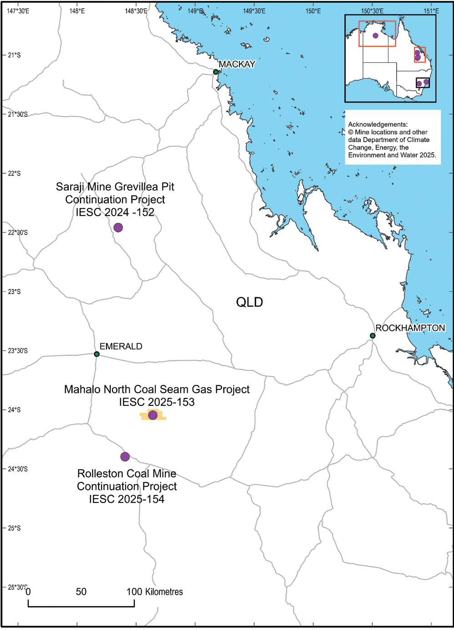 | 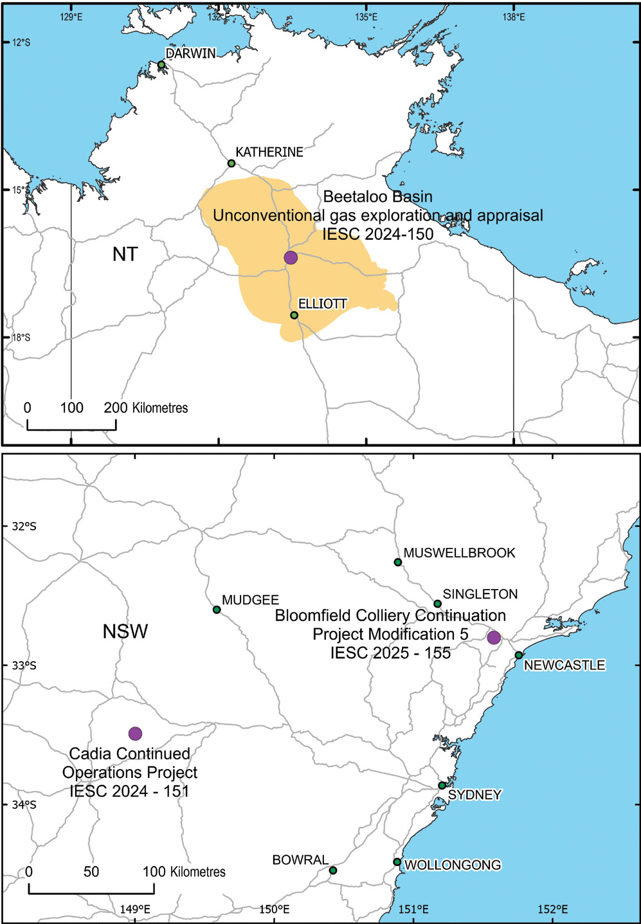
IESC REFERENCE: 2024–152  Saraji Mine Grevillea Pit Continuation Project (click to read advice)  REFERRING GOV: Australian Government  PROJECT LOCATION: QLD  DATE OF IESC ADVICE: 16 December 2024  IESC REFERENCE: 2025–153  Mahalo North Coal Seam Gas Project (click to read advice)  REFERRING GOV: Australian Government  PROJECT LOCATION: QLD  DATE OF IESC ADVICE: 11 March 2025  IESC REFERENCE: 2025–154  Rolleston Coal Mine Continuation Project (click to read advice)  REFERRING GOV: Australian Government  PROJECT LOCATION: QLD  DATE OF IESC ADVICE: 19 May 2025 | IESC REFERENCE: 2024–150  Beetaloo Basin - Unconventional Gas Exploration and Appraisal (click to read advice)  REFERRING GOV: Australian Government  LOCATION: NT  DATE OF IESC ADVICE: 16 December 2024  IESC REFERENCE: 2025–155  Bloomfield Colliery Continuation Project Modification 5 (click to read advice)  REFERRING GOV: Australian Government  PROJECT LOCATION: NSW  DATE OF IESC ADVICE: 23 June 2025  IESC REFERENCE: 2024–151  Cadia Continued Operations Project – Expansion (click to read advice)  REFERRING GOV: NSW Government  PROJECT LOCATION: NSW  DATE OF IESC ADVICE: 10 October 2024

Information Guidelines and Explanatory Notes
The IESC has published several resources to assist industry and regulators with environmental assessments. These documents provide guidance on the suggested information and data to be included in an environmental impact assessment.

Information Guidelines
The Information Guidelines for proponents preparing coal seam gas and large coal mining development proposals outline the information considered necessary to enable the IESC to provide robust scientific advice to government regulators on the potential water-related impacts of coal seam gas and large coal mining development proposals.
The Information Guidelines were most recently updated in early 2024 to ensure that current advances in theory and leading practice are considered and incorporated. The 2024 updates were finalised before amendments to the EPBC Act expanded the IESC's remit to all types of unconventional gas development.

Information Guidelines Explanatory Notes
The Explanatory Note series supplements the Information Guidelines. Explanatory Notes contain a greater level of detail about specific topics. They include case studies and practical examples of how to collect and present relevant information. Each Explanatory Note is accompanied by a summary guide which provides a short, simplified outline of the main points.
Updates to Explanatory Notes are being undertaken as new methodologies and tools are becoming available.
7 Explanatory Notes have been published:
- Information Guidelines Explanatory Note: Uncertainty analysis for groundwater modelling provides a range of approaches available to proponents and regulators in understanding and interpreting uncertainty analysis for groundwater modelling to assist in decision-making.
- Information Guidelines Explanatory Note: Assessing groundwater-dependent ecosystems reviews tools and methods for groundwater-dependent ecosystem assessment to help proponents choose the most effective approach.
- Information Guidelines Explanatory Note: Deriving site-specific guideline values for physico-chemical parameters and toxicants introduces the use of a water and sediment quality management framework to assist with the design of appropriate monitoring programs for measuring physico-chemical parameters and toxicants from which site-specific guideline values can be developed.
- Information Guidelines Explanatory Note: Characterisation and modelling of geological fault zones provides a range of approaches available to proponents to determine the role that faults may play in impeding or propagating pressure and groundwater flow impacts from proposed development projects.
- Information Guidelines Explanatory Note: Subsidence associated with underground coal mining provides tailored guidance and up-to-date robust scientific methodologies and tools for consultants and assessors dealing with project proposals for assessing the risk and magnitudes of subsidence (surface deformation) and its environmental impact due to large coal mining developments.
- Information Guidelines Explanatory Note: Subsidence associated with coal seam gas production provides tailored guidance and up-to-date robust scientific methodologies and tools for assessing the risk and magnitudes of subsidence (one source of surface movement) and its environmental impact due to coal seam gas development. It has been targeted at prospective consultants and assessors dealing with coal seam gas project proposals.
- Information Guidelines Explanatory Note: Using impact pathway diagrams based on ecohydrological conceptualisation in environmental impact assessment promotes the use of impact pathway diagrams based on ecohydrological conceptualisation in environmental impact assessment to map sources, pathways and receptors of impacts arising from, for example, large coal mines and coal seam gas developments.

Explanatory Notes in preparation

Information Guidelines Explanatory Note: Climate change
The IESC is currently preparing a new Explanatory Note to develop pragmatic, fit-for-purpose approaches for proponents to incorporate climate change considerations into assessments of the potential environmental impacts of proposed projects on surface water and groundwater resources.
Coal mining and unconventional gas projects are often multi-decadal projects that can result in long-term changes to the landscape, water resources and their biota, including after project closure. Climate change should be considered in the environmental assessment process to help ensure that projects are designed and constructed to be resilient to future climate conditions, and to properly assess potential environmental impacts of the project under climate change. There is currently no consistent guidance on how to incorporate consideration of the impacts of climate change into surface water and groundwater risk assessment specific to environmental impact studies.
The IESC looks forward to inviting feedback from interested stakeholders during the drafting process.

Future updates to the Information Guidelines Explanatory Note: Assessing groundwater-dependent ecosystems
The Information Guidelines Explanatory Note: Assessing groundwater-dependent ecosystems reviews tools and methods for groundwater-dependent ecosystem assessment to help proponents choose the most effective approach.
The IESC notes there have been advancements in this space, including an expansion of the IESC's remit to cover unconventional gas, since the Explanatory Note was published in 2019. To help shape a future update to the Explanatory Note, the IESC sought stakeholder input in June 2025.
Updates to the Explanatory Note will progress in 2025-26.

Research
In May 2024, the multistage metagenomic research project supported by the IESC was completed by researchers at Macquarie University. This research project evaluated the effectiveness of different groundwater sampling methods and the feasibility for proponents to use environmental DNA (eDNA) to assess groundwater invertebrates (stygofauna) and microbes in aquifers that may be impacted by coal mining and coal seam gas developments.
To support the completed research project, the IESC commissioned a short video to demonstrate the key aspects of the sampling methods. To view the video, click on the image below.


Engagement
In 2024-25, the IESC continued to promote its work by engaging with a range of stakeholders through various activities.

Roundtables
The IESC holds roundtable discussions with stakeholders to discuss various topics of mutual interest. In 2024-25, the IESC hosted a roundtable with:
- the Victorian Mine Land Rehabilitation Authority - January 2025.

Site visits
In January 2025, the IESC visited coal mine rehabilitation sites at the Hazelwood Rehabilitation Project and the Yallourn Power Station. The site visits focused on environmental management activities related to the protection of water resources and mine rehabilitation. The tours and presentations outlining the processes were highly informative, and the IESC learned about current management of the sites and the options for rehabilitation.
The IESC members were accompanied on the site visits by representatives from the Victorian Mine Land Rehabilitation Authority and the OWS.
The closure of mine sites like these in the La Trobe Valley are incredibly challenging and complex. During the recent IESC site visit we saw the scale of the open pits and discussed water risks and possibilities.
— Professor Wendy Timms, IESC member

Chair meetings
The IESC Chair regularly meets with relevant parties to promote the IESC's role.
In 2024-25, the IESC Chair met with:
- representatives from the Northern Territory Government - September 2024.
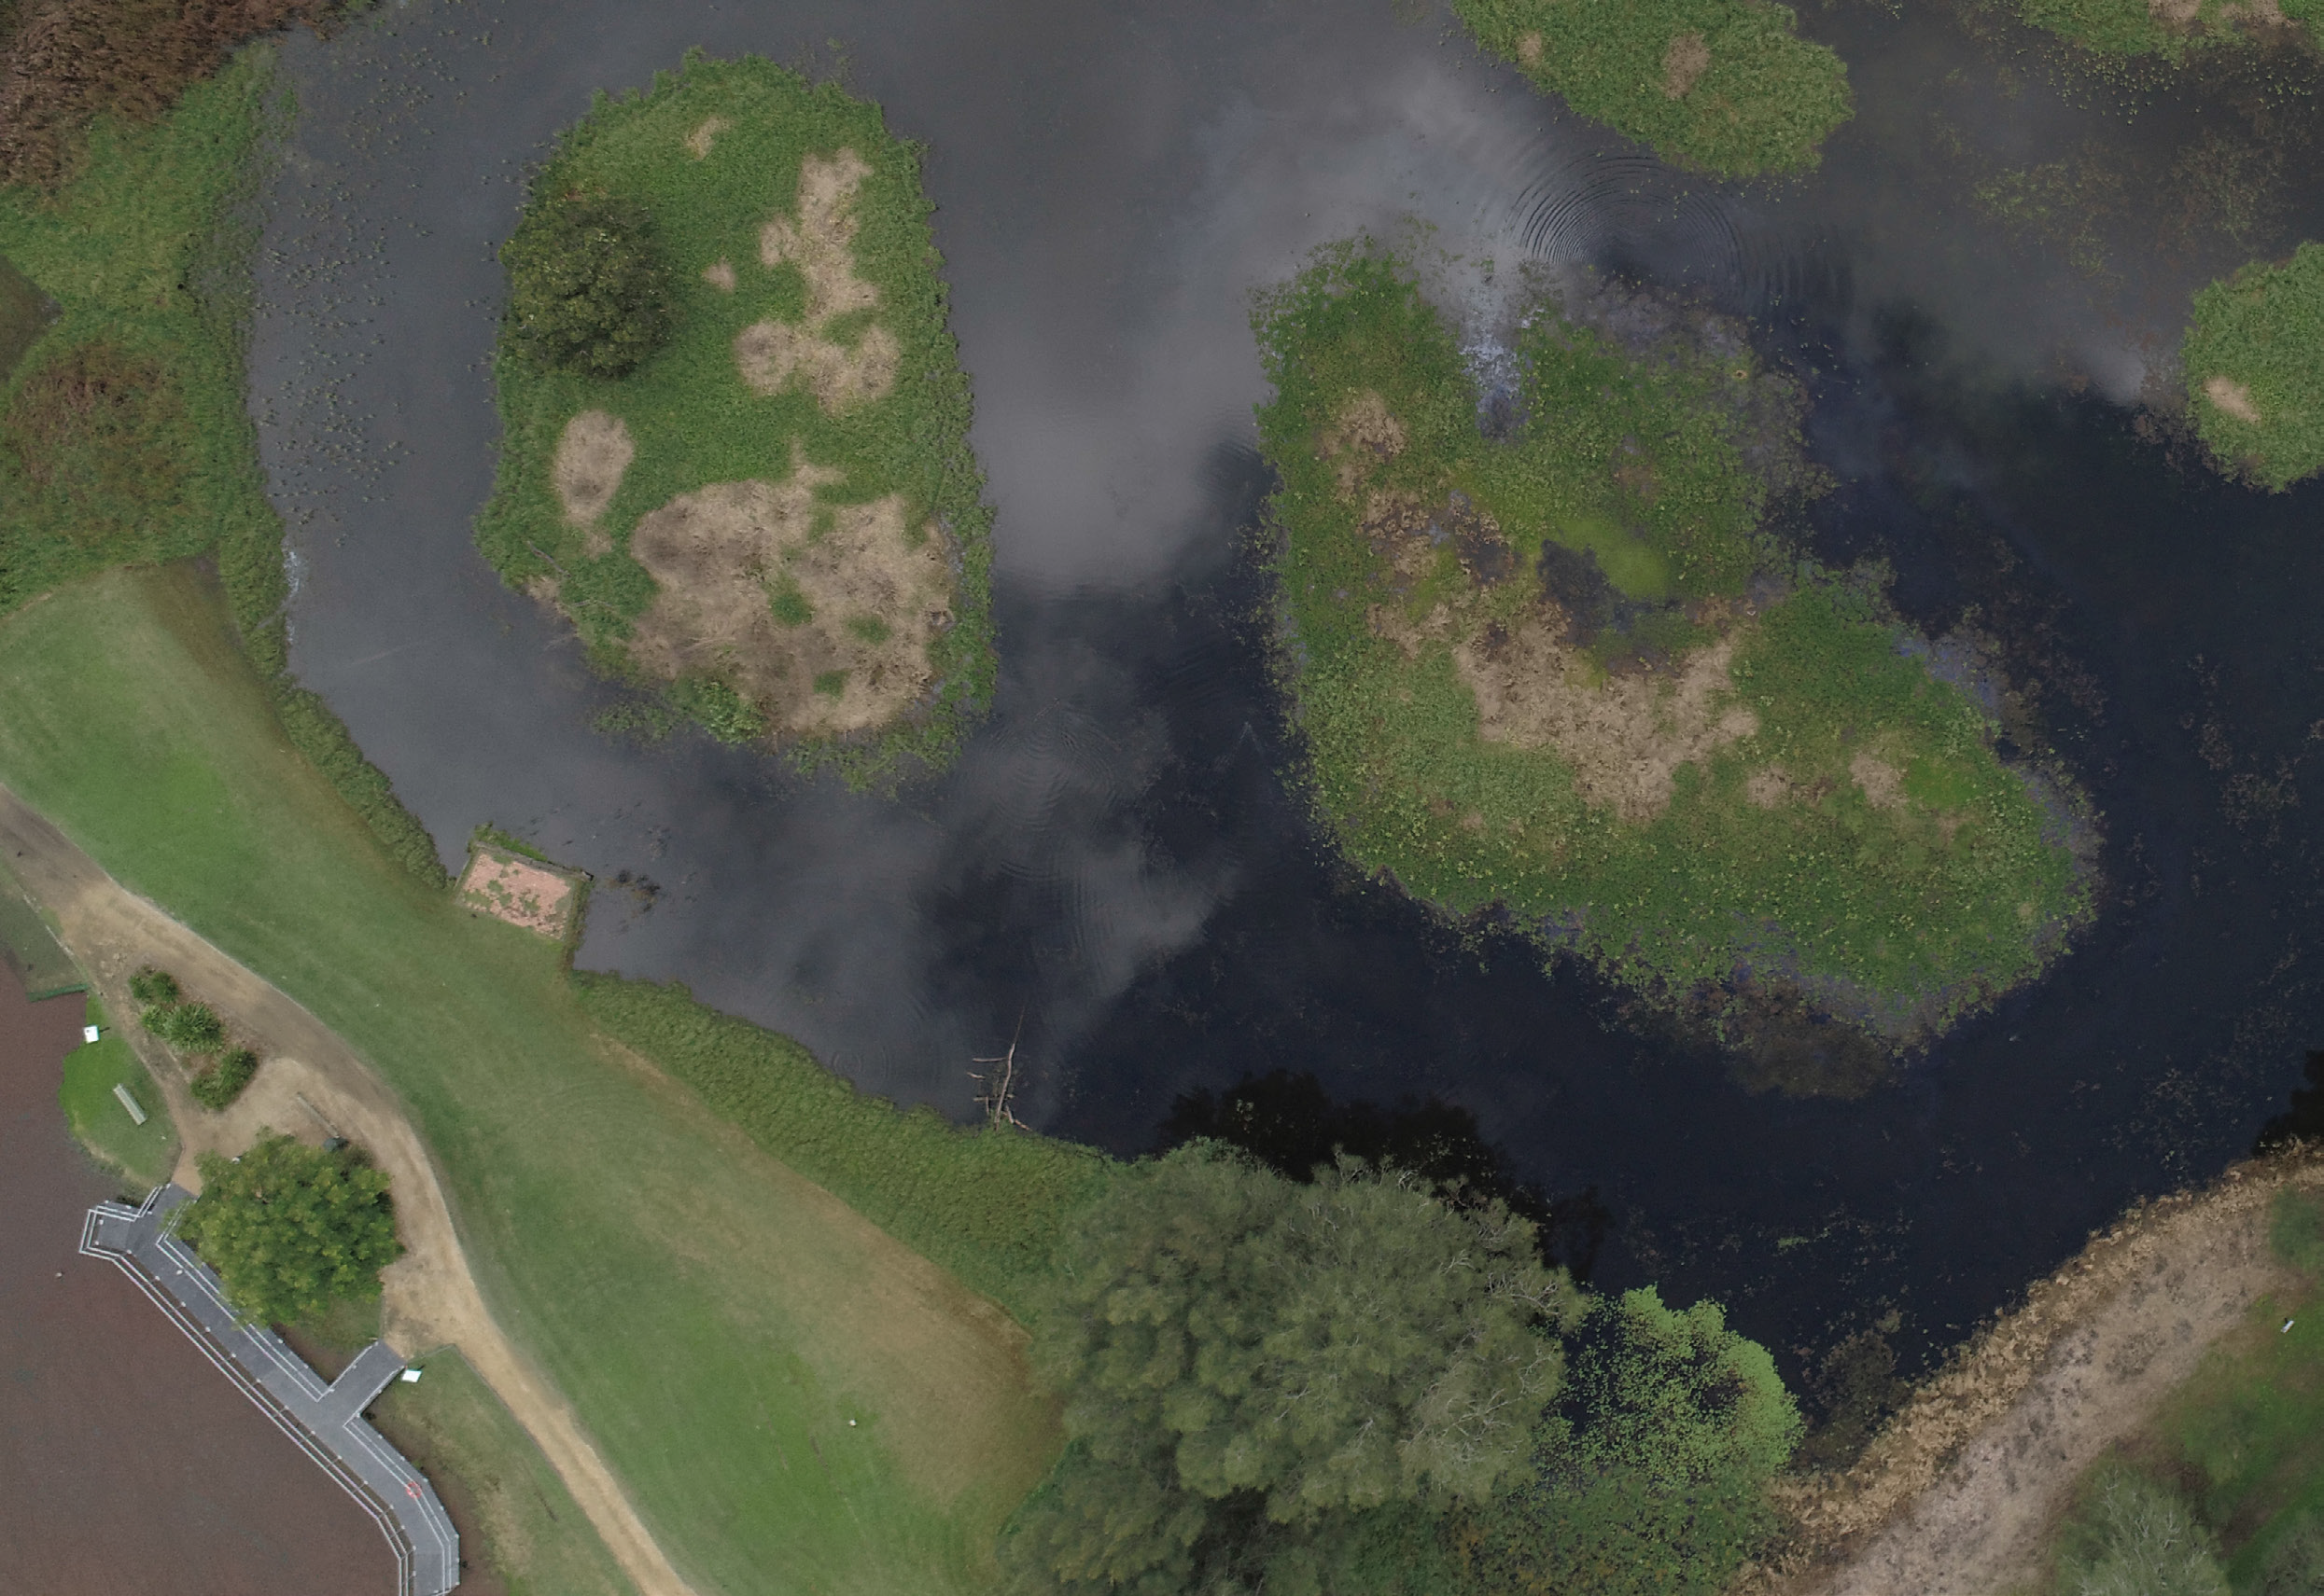

iesc.gov.au

This initiative is funded by the Australian Government

