Information Guidelines Explanatory Note

Using impact pathway diagrams based on ecohydrological conceptualisation in environmental impact assessment

© Commonwealth of Australia, 2024.



Information Guidelines Explanatory Note: Using impact pathway diagrams based on ecohydrological conceptualisation in environmental impact assessment is licensed by the Commonwealth of Australia for use under a Creative Commons Attribution 4.0 International licence with the exception of the Coat of Arms of the Commonwealth of Australia, the logo of the agency responsible for publishing the report, content supplied by third parties, and any images depicting people. For licence conditions see <https://creativecommons.org/licenses/by/4.0/>

This report should be attributed as ‘Commonwealth of Australia 2024. Information Guidelines Explanatory Note: Using impact pathway diagrams based on ecohydrological conceptualisation in environmental impact assessment. Report prepared for the Independent Expert Scientific Committee on Unconventional Gas Development and Large Coal Mining Development through the Department of Climate Change, Energy, the Environment and Water, Commonwealth of Australia, Canberra’.

On 15 December 2023, the *Nature Repair (Consequential Amendments) Act 2023* amended the EPBC Act to expand the IESC’s remit to all unconventional gas developments. This publication was developed prior to these amendments of the EPBC Act commencing.

This publication is funded by the Australian Government Department of Climate Change, Energy, the Environment and Water. The views and opinions expressed in this publication are those of the authors and do not necessarily reflect those of the Australian Government or the Minister for the Environment and Water.

Acknowledgements

This document was finalised by the Independent Expert Scientific Committee on Unconventional Gas and Large Coal Mining Development (IESC) based on consideration of work commissioned by the Office of Water Science (OWS) on behalf of the IESC. We are particularly grateful to Belinda Cale for drawing up the final versions of all the diagrams, often improving their layout and revising drafts quickly, expertly and patiently. Constructive comments on earlier drafts of this report were provided by Dr Luk Peeters (CSIRO), Steve Flook (Office of Groundwater Impact Assessment), David Holmes (Umwelt), Jerilly Armstrong (Queensland Department of Environment and Science), Dr Mark Keppel (Government of South Australia, Department for Environment and Water), staff of OWS (especially James Rae and Frances Knight) and two anonymous reviewers. The Department acknowledges the Traditional Owners of country throughout Australia and their continuing connection to land, sea and community. We pay our respects to them and their cultures and to their elders, both past and present.

Contact details

For information about this document or about the work of the IESC, please contact:

IESC Secretariat

Office of Water Science  
Department of Climate Change, Energy, the Environment and Water  
GPO Box 787  
CANBERRA ACT 2601

The report can be accessed at http://www.iesc.environment.gov.au/

Images

Front cover: McIntyre River | Location: Condamine catchment area | © Department of Climate Change, Energy, the Environment and Water (taken by staff)

All other images © Department of Climate Change, Energy, the Environment and Water unless specified otherwise.

Information Guidelines Explanatory Note

Using impact pathway diagrams based on ecohydrological conceptualisation in environmental impact assessment

Reflections on the lake at the Hunter Wetlands Centre (Shortlands Wetland)


# Overview

## The role of the IESC

The Independent Expert Scientific Committee on Unconventional Gas Development and Large Coal Mining Development (IESC) is a statutory body under the *Environment Protection and Biodiversity Conservation Act 1999* (Cth) (EPBC Act).

The IESC’s key legislative functions are to:

* provide scientific advice to the Commonwealth Environment Minister and relevant state ministers on unconventional gas and large coal mining development proposals that are likely to have a significant impact on water resources
* provide scientific advice to the Commonwealth Environment Minister on bioregional assessments for areas of unconventional gas and large coal mining development
* provide scientific advice to the Commonwealth Environment Minister on research priorities and projects
* collect, analyse, interpret and publish scientific information about the impacts of unconventional gas and large coal mining activities on water resources
* publish information relating to the development of standards for protecting water resources from the impacts of unconventional gas and large coal mining development
* provide scientific advice on other matters in response to a request from the Commonwealth or relevant state ministers.

On 15 December 2023, the Nature Repair (Consequential Amendments) Act 2023 amended the EPBC Act to expand the IESC’s remit to all unconventional gas developments. This publication was developed prior to these amendments of the EPBC Act commencing.

Further information on the IESC’s role is on the [IESC website](http://www.iesc.gov.au).

## The purpose of the Explanatory Notes

One of the IESC’s key legislative functions is to provide scientific advice to the Commonwealth Environment Minister and relevant state ministers in relation to unconventional gas and large coal mining development proposals that are likely to have a significant impact on water resources. The IESC outlines its specific information requirements in the IESC *Information guidelines for proponents preparing coal seam gas and large coal mining development proposals* (IESC 2024). This information is requested to enable the IESC to formulate robust scientific advice for regulators on the potential water-related impacts from coal seam gas (CSG) and large coal mining (LCM) developments.

For some topics, Explanatory Notes have been written to supplement the IESC Information Guidelines, giving more detailed guidance to help the CSG and LCM industries prepare environmental impact assessments. These topics are chosen based on the IESC’s experience of providing advice on over 150 development proposals.

Explanatory Notes provide guidance rather than mandatory requirements. They are typically high-level documents that review up-to-date and robust methods and tools for specific components of environmental impact assessments.

This Explanatory Note describes the benefits of using impact pathway diagrams to integrate and communicate the diverse information in the documentation of environmental impact assessment, and suggests ways to generate these diagrams to portray potential risks and likely impact pathways to water resources from a proposed development.

The IESC recognises that approaches, methods, tools and software will continue to develop. The Information Guidelines and Explanatory Notes will be reviewed and updated as necessary to reflect these advances.

## Legislative context

The EPBC Act states that water resources in relation to unconventional gas and large coal mining developments are a matter of national environmental significance.

A water resource is defined by the *Water Act 2007* (Cth) as:

(a) surface water or groundwater; or

(b) a watercourse, lake, wetland or aquifer (whether or not it currently has water in it);

and includes all aspects of the water resource (including water, organisms and other components and ecosystems that contribute to the physical state and environmental value of the resource).

Australian and state regulators who are signatories to the National Partnership Agreement seek the IESC’s advice under the EPBC Act at appropriate stages of the approvals process for a unconventional gas or large coal mining development that is likely to have a significant impact on water resources. The regulator determines what is considered to be a significant impact based on the Significant Impact Guidelines 1.3 (DCCEEW 2022).

Contents

Overview v

The role of the IESC v

The purpose of the Explanatory Notes v

Legislative context vi

Executive summary 1

1. Introduction 4

2. Impact pathway diagrams: benefits and some examples 7

2.1 Introduction 7

2.2 Benefits of IPDs in environmental impact assessment 7

2.3 The ‘building blocks’ of IPDs 11

2.4 Three examples of IPDs from the resource extraction literature 15

2.4.1 A simple box-and-arrow IPD 15

2.4.2 Complex box-and-arrow IPDs with detailed impact pathways 16

2.4.3 Best practice – IPDs, maps and detailed narratives 22

3. How to generate IPDs for environmental impact assessment 27

3.1 Introduction 27

3.2 The importance of starting collaboration early 28

3.3 Generating ECMs and IPDs in environmental impact assessment 29

3.3.1 Background context 31

3.3.2 The initial meeting of expert consultants 34

3.3.3 Subsequent meetings 48

4. How to use IPDs in environmental impact assessment 55

4.1 Introduction 55

4.2 Portraying impact pathways 55

4.3 Identifying knowledge gaps and guiding design of monitoring programs 56

4.4 Proposing and justifying strategies to avoid or mitigate environmental impacts 58

5. Summary and conclusions 59

5.1 Summary 59

5.2 Conclusions 60

Abbreviations 61

Glossary 62

References 65

# Executive summary

Environmental impact assessment aims to predict potential impacts of a proposed project on valued assets such as groundwaters, surface waters and their associated biota and ecological processes. It is done early in project planning to find ways to reduce adverse impacts and present the predictions and options to regulators and other decision-makers. Typically, the assessment requires a multidisciplinary team of consultant experts with skills in, for example, earth sciences, hydrogeology, hydrology, ecotoxicology and ecology. These experts work together to predict what, how, when and where impacts from the project might affect environmental assets, especially highly valued ones such as water resources. The result is one or more reports that usually include multiple appendices, extensive datasets and detailed numerical and analytical models.

However, very few of these reports bring the information together into an initial ecohydrological conceptual model (ECM) and use it to generate diagrams of the pathways by which impacts of the proposed project are predicted to adversely affect environmental assets. An ECM is a type of conceptual model that integrates information on hydrological (surface water and groundwater) components with ecological ones (e.g., animal and plant species, communities and ecosystems) to understand and communicate their interactions.

As their name suggests, impact pathway diagrams (IPDs) are diagrams that illustrate how impacts of a proposed project are predicted to adversely affect environmental assets (receptors), the potential pathways of the impacts from sources to receptors, and how these pathways might interact with each other. When superimposed on maps of the project area, IPDs also indicate where such impacts might occur. As most of the impact pathways affecting water resources are ecohydrological, drawing up an initial ECM of the project area is an excellent starting place for generating IPDs.

The process of generating these diagrams greatly helps the team of experts share their understanding and knowledge to predict a project’s potential environmental impacts. The collaborative process should begin early with the team listing potential impacts, sources and environmental receptors before drawing up possible impact pathways from sources to receptors. Using maps of the project area, the experts can then discuss where and how these pathways might operate and what site-specific baseline data are needed to support the predictions. As these baseline data are collected, the diagrams can be progressively refined for inclusion in the final report, supported with a narrative that justifies the impacts and pathways that are considered to be most relevant.

The **process** has many benefits, including:

* increased coherence in the assessment approach and documentation, especially among different discipline areas (e.g., matching flow-regime hydrological data to requirements of flow-dependent biota that may be affected by a potential impact pathway)
* collection of relevant field data (saving time and money) because key impact pathways and likely ‘hotspots’ of vulnerable receptors are identified early so that parameters and monitoring programs can be targeted and redundant information is not collected
* enhanced quality of the impact assessment by clearer illustration (the diagrams and their narratives) of what, where and how key impacts might occur and what mitigation options are feasible.

The **product** is one or more IPDs based on an initial ECM to portray the proponent’s conceptualisation of potential impacts and their sources, stressors, pathways and receptors within and near the project area. These diagrams have many benefits in environmental impact assessment because they:

* provide effective visual summaries of potential impact pathways, many of which are hydrological, from sources to relevant receptors (water resources)
* can be presented at multiple levels (as ‘sub-models’) and superimposed on maps of the project area to reflect heterogeneity across the development area and/or focus on particular sources, receptors or pathways
* highlight where information is needed to support assumptions about inferred pathways and their importance, and where there are multiple hypotheses about impacts that require further investigation
* indicate pathways where mitigation is feasible to reduce risks to vulnerable receptors, and guide project-specific monitoring (e.g., relevant parameters and sampling locations) to assess the effectiveness of proposed mitigation strategies
* are powerful tools for integrating information from different sections of the assessment documentation to best convey evidence for a proposed development’s potential impacts
* when done early in the assessment process, can help define the quantities of interest and key predictions in subsequent surface and groundwater modelling
* can provide environmental context for associated groundwater and surface-water numerical models.

Generating IPDs based on an informed understanding of the ecohydrological attributes of the proposed development results in a smoother and more thorough assessment process for little extra work. No extra information is required beyond what already should be provided. For proponents and their consultants, the approach is likely to reduce work and save time (money) because the more systematic integration illustrated through the diagrams helps focus effort on the most important pathways. For regulators, the approach generates clearer assessments of potential impact pathways and their likely interactions. It also illustrates more accurately where water resources in the project area may be adversely affected and what mitigation options are available. Thus, there are substantial benefits in this conceptual modelling approach for all users. Furthermore, as it is based on a site-specific ECM, it acknowledges the fundamental role played by ecohydrological linkages between sources of impacts in the project area and the water resources that may be impacted by the development.

This Explanatory Note begins with a brief review of IPDs, describing their ‘building blocks’ and presenting some examples from the mining and gas-extraction literature. An approach for generating an initial ECM and derivative IPDs is then described, illustrated using a hypothetical worked example of an open-cut coal mine in the Bowen Basin. The worked example is followed by discussion of how to use IPDs to portray the impact pathways of a given development, show how these pathways might convey impacts to vulnerable receptors, identify relevant knowledge gaps, guide the design of monitoring programs, and identify and justify potential strategies to avoid or mitigate environmental impacts.

This Explanatory Note is intended as a primer to guide conceptualisation of the ecohydrology of the area subject to development, and the preparation of IPDs and maps for showing potential pathways by which a proposed project might have impacts on water resources. It does not cover more complex forms of conceptual modelling (e.g., causal network analysis, Bayesian approaches), formal ecological risk assessment or quantitative techniques for assessing evidence in environmental impact assessment. However, the IPDs described in this Explanatory Note can be used as a basis for these more complex forms.

It is also important to recognise that this Explanatory Note is not intended as a comprehensive review of the rich literature on conceptual or causal models; nor does it explore the inevitable limitations and biases of different approaches to using IPDs in environmental impact assessment. Instead, the content is intentionally pitched to meet the needs of collaborating consultants seeking a way to use IPDs to understand and portray potential hydrological and ecological impacts from a proposed development and to draw together the different components of work for the final report.

1. Introduction

This Explanatory Note promotes the use of impact pathway diagrams (IPDs) based on ecohydrological conceptualisation in environmental impact assessment to map sources, pathways and receptors of impacts arising from, for example, large coal mining (LCM) and coal seam gas (CSG) development. The Explanatory Note focuses on potential water-related impacts because of the IESC’s legislated role (see Overview) but the benefits and approaches of such conceptual modelling apply equally to assessment of environmental impacts of other activities. A key point is that the approach involves little extra work but is likely to save substantial time (money) for proponents and their consultants because it helps focus effort in data collection on the most important pathways and how impacts might be monitored and mitigated. There are also benefits to regulators because the approach generates clearer portrayals of potential impact pathways and their likely interactions that are easier and quicker to assess.

Conceptual models are simplified representations of a system of interacting components and their linkages. They are widely used in many disciplines as a powerful tool for understanding and describing relationships among components in complex systems. For example, ecohydrological conceptual models (ECMs) are a type of conceptual model often used to understand and describe relationships between hydrological (surface water and groundwater) components and ecological ones (e.g., specific taxa, communities and ecosystems). Conceptual models are particularly useful for integrating diverse datasets and other information from different disciplines to generate predictions about how a complex system might respond to changes in components, their linkages or both. In environmental science, conceptual models are sometimes also called ‘causal models’ (e.g., Bartolo et al. 2017) and their output diagrams termed ‘causal networks’ (e.g., Peeters et al. 2022).

The process of constructing a conceptual model is valuable because it requires the team of experts who are developing the model to explicitly define components and their linkages, specify assumptions and identify knowledge gaps. Because conceptual models are a trade-off between practical usefulness and real-life complexity, the process also involves careful consideration of which components and linkages are relevant for the model’s purpose so that the product is not over-simplistic but also not so complex that it is difficult to use (i.e., ‘requisite simplicity’ *sensu* Stirzaker et al. 2010). Further helpful information on uses and types of conceptual models can be found on the Australian and New Zealand Guidelines for Fresh and Marine Water Quality website (Australian Government undated).

**Impact pathway diagrams** are a type of conceptual model. As their name suggests, they are diagrams that illustrate how impacts of a proposed project are predicted to adversely affect environmental assets (receptors), the potential pathways of the impacts from sources to receptors, and how these pathways might interact with each other. When superimposed on maps of the project area, IPDs also indicate where such impacts might occur. Such diagrams are powerful tools to complement the report’s text because they integrate the various sections of the report to illustrate what, how and where impacts might occur in the project area, shown in a format that is readily grasped by the reader.

Where the receptors are water resources (Box 1), most of the impacts of human activities such as agriculture, mining or urbanisation are likely to be conveyed by ecohydrological pathways (e.g., streamflow, groundwater flux, riparian zone–alluvium exchanges). Therefore, an ecohydrological conceptual model should be the basis for the IPDs used to portray likely pathways of the environmental impacts of these activities. In an environmental impact assessment, IPDs are a powerful tool for integrating hydrogeological, hydrological, chemical and ecological baseline data and other information to predict how one or more activities might alter the quantities and quality of surface waters and groundwaters and therefore impact on water-dependent biota and ecological processes in a given area and downstream. Such conceptual models are particularly useful as ‘evidence scaffolds’ (Norton and Schofield 2017) for organising and synthesising multiple pieces of evidence from different studies to effectively illustrate and support the assessment’s conclusions.

Box 1. Definition of ‘water resource’

In everyday use, the term ‘water resource’ usually refers to surface water or groundwater that is or can be exploited for human uses. However, the legislative definition in the *Water Act 2007* (Commonwealth of Australia 2007) followed by the IESC is much broader:

*(a) surface water or ground water; or*

*(b) a watercourse, lake, wetland or aquifer (whether or not it currently has water in it);*

*and includes all aspects of the water resource (including water, organisms and other components and ecosystems that contribute to the physical state and environmental value of the water resource).*

As these ‘aspects of the water resource’ encompass the water quality, biodiversity, ecological condition and biogeochemical processes of all water-dependent ecosystems, the term ‘water resource’ is a useful shorthand in this Explanatory Note to refer to all hydrological and ecological components of surface waters, groundwaters and groundwater-dependent ecosystems (GDEs) in a given area.

Many of these components are hydrologically linked to each other (e.g., during flooding, via groundwater flow paths or when ephemeral streams flow). Therefore, intact hydrological linkages are essential to the biodiversity, condition and integrity of connected water resources and contribute to their physical state and environmental value. Disruption of one or more of these hydrological linkages is a common impact arising from human activities such as agriculture, urbanisation and mining.

Section 2 of this Explanatory Note starts by describing ecohydrological IPDs and explaining how their use can enhance the quality, efficiency, clarity and communication of environmental impact assessments. It also defines the ‘building blocks’ of IPDs, and presents three examples from the mining and gas extraction literature. A key theme is the importance of basing IPDs on an evidence-based ecohydrological conceptualisation when evaluating potential impacts of a development on water resources in and near the project area, because most of the impacts are likely to be conveyed by ecohydrological pathways.

Section 3 describes an approach to generating IPDs based on an ecohydrological conceptualisation. Although the approach is flexible and informal, there is a logical sequence of steps that facilitates the efficient generation of IPDs and associated maps and narratives. This approach is illustrated with a worked example of a hypothetical open-cut coal mine in the Bowen Basin, Queensland.

Section 4 outlines how to use IPDs in environmental impact assessment to portray the impact pathways of a given development, show how these might convey impacts to vulnerable receptors, identify relevant knowledge gaps, guide the design of monitoring programs, and identify and justify potential strategies to avoid or mitigate environmental impacts.

The Explanatory Note ends with a summary of the main points and some conclusions (Section 5).

Although the target audience is consultants preparing environmental impact assessment reports, this Explanatory Note may also be useful for regulators and other readers seeking to understand the interacting impact pathways associated with a given development and evaluate how a proposed project might have impacts on water resources. It is important to reiterate that **this Explanatory Note is intended only as a primer to help practitioners prepare IPDs** and their associated narratives. It does not describe more complex forms of conceptual modelling (e.g., causal network analysis, Bayesian approaches), formal ecological risk assessment or quantitative techniques for assessing evidence in environmental impact assessment.

This Explanatory Note expands on the description of IPDs in the Information Guidelines (IESC 2024) and complements the discussions of ecological conceptual models in other Explanatory Notes (e.g., Doody et al. (2019) for assessing GDEs; Peeters and Middlemis (2023) for uncertainty analysis in groundwater modelling).

1. Impact pathway diagrams: benefits and some examples

## 2.1 Introduction

In this Explanatory Note, we discuss how IPDs based on an ecohydrological conceptualisation can be powerful tools in environmental impact assessment to portray pathways by which some anthropogenic (human-induced) driver such as mining might affect environmental receptors – in this case, water resources as defined in Box 1.

**An initial ECM and derivative IPDs should be drawn up as early as possible during the environmental impact assessment process** and soon after the locations, extents and durations of activities (e.g., vegetation clearance, coal extraction) have been proposed. Locations of receptors such as wetlands, streams, aquifers and potential groundwater-dependent vegetation in and near the project area can be readily obtained from maps and internet resources (e.g., the GDE Atlas (BOM undated)), although it is unlikely any field data on their condition will yet exist. As the conceptual modelling is preliminary, the lack of field data is not a problem. Initial discussions during the model development will help flag where and what data should be collected for receptors in the baseline surveys.

A good way to start (described in Section 3) is for the multidisciplinary consultant experts to meet and, using maps of the project area, agree upon the likely sources of impacts from the development and which receptors (e.g., water resources) might be affected. They then collaboratively draw up an ECM linking hydrological and ecological entities and processes within the proposed development area and use this conceptualisation to generate one or more IPDs of the potential impact pathways from the activities to the receptors. These diagrams also provide the basis for preliminary discussions of which risks and pathways are likely to be important and what further data are needed to evaluate each pathway and assess mitigation options. As more field data and other information become available, the ECM and derivative IPDs can be refined for inclusion in the final assessment report.

When assessing environmental impacts, **the decision to omit particular pathways from an IPD must be justified and supported with convincing evidence**. For example, the ECM might indicate a surface-flow pathway of seasonal inundation of a floodplain wetland near a proposed development area, but convincing evidence might be presented by the proponent to show that the development will not alter the flooding regime or water quality. Therefore, the IPD would omit this ecohydrological pathway and the accompanying narrative would explain why. Conversely a proposed development may be likely to create a new pathway that needs to be included in the IPD because it potentially impacts on one or more water resources. For example, predicted subsidence during long-wall mining below a perched swamp may crack its base and create a novel vertical flow path that severely alters the swamp’s water regime and may impact its biota and ecological processes.

This section begins by reviewing the many benefits of using IPDs based on an ecohydrological conceptualisation in environmental impact assessments (Section 2.2). It then describes the ‘building blocks’ (components) of impact pathways (Section 2.3), and presents three examples from the mining and gas-extraction literature (Section 2.4).

## 2.2 Benefits of IPDs in environmental impact assessment

Reports describing environmental impact assessments of proposed developments such as mining routinely include conceptual models of, for example, hydrogeological conditions in the project area. However, it is very rare for these reports to present IPDs that portray predicted impact pathways, despite their fundamental value in understanding and communicating potential environmental impacts of the development. When the receptors are water resources, such IPDs and their narratives should be based on an ecohydrological conceptualisation of the linkages between hydrological and ecological entities and processes within the proposed development area, because most of the impact pathways will follow ecohydrological routes.

A report by the US EPA (2014) assessing the potential impacts of mining on salmon ecosystems of Bristol Bay, Alaska (Box 2) is a powerful demonstration of the benefits of this approach for effectively portraying complex impact pathways (Figure 1) and summarising their mechanisms and processes. Further details of this case study are presented in Section 2.4, and the tools and methods are outlined on the US EPA website (https://www.epa.gov/caddis) on the Causal Analysis/Diagnosis Decision Information System (CADDIS).

Box 2. An example of the effective use of IPDs in the assessment of potential mining impacts on salmonid ecosystems of Bristol Bay, Alaska

The catchment of Bristol Bay is rich in ecological resources, including one of the world’s most productive salmonid fisheries. It is also rich in mineral resources (especially copper) and there is considerable potential for large-scale mine development in the region. Because these deposits contain relatively small amounts of metals relative to the amount of ore, mining will be economic only if conducted over large areas and it will produce large amounts of waste material. Based on preliminary plans developed for Northern Dynasty Minerals, the US EPA (2014) evaluated potential impacts on salmonid ecosystems of three mining scenarios based on the amount of ore processed: Pebble 0.25 (approximately 0.23 billion tonnes over 20 years), Pebble 2.0 (approximately 1.8 billion tonnes over 25 years) and Pebble 6.5 (approximately 5.9 billion tonnes over 78 years). Each mine scenario included a 138-km transport corridor comprising a gravel road and four pipelines.

One of the many strengths of this assessment is its extensive use of multiple IPDs to portray potential impacts of mining on Bristol Bay’s salmonid ecosystems, demonstrating the benefits of this approach for environmental impact assessment. For example, one IPD (Figure 1) illustrates how four sources (defined in Section 2.3) associated with the transport corridor may impact on salmon and other fish. Of particular value is the way this IPD indicates the directions of change in the various components (arrows within the symbols) so that a reader can follow the logic along a pathway of how the sequence of processes may lead to declines in salmon abundance, productivity or diversity. Furthermore, relevant interactions among the pathways are shown (e.g., for suspended and bed sediments), along with sufficient details of various processes (e.g., change in downstream water flows) to show the predicted effects of different elements of the altered flow regime (high flows versus intermittency).

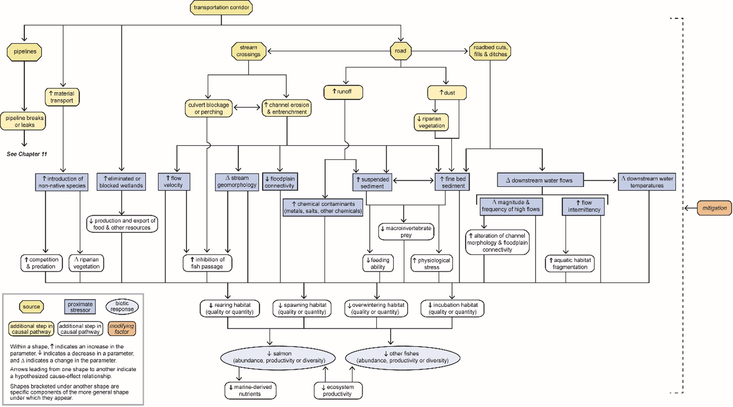

Figure 1. IPD of the potential impacts of the 138-km transport corridor on salmon and other fish in the Bristol Bay catchment (reproduced from Figure 10-3, US EPA 2014)

There are **at least seven benefits for proponents and their consultants in preparing and presenting IPDs in assessments of environmental impacts of a development on water resources** within and near the proposed project area.

1. They provide effective visual summaries of known and hypothesised impact pathways from sources to relevant receptors (water resources).
2. They can be presented at multiple levels (as ‘sub-models’) to reflect heterogeneity across the development area and/or focus on particular sources, receptors or pathways (e.g., Box 2), complemented with concise narratives that highlight sites of particular importance (e.g., remnant native vegetation, high-quality groundwater) and cross-refer to relevant sections of the environmental assessment documents.
3. The diagrams and their narratives can highlight where information is needed to support assumptions about inferred pathways and their likely importance, and where there are multiple hypotheses about impacts that require further investigation; and they can be used to target project-specific monitoring to address these information gaps.
4. When combined with maps of the project area, they indicate pathways where mitigation is feasible to reduce risks to vulnerable receptors, and guide project-specific monitoring (e.g., relevant parameters and sampling locations) to assess the effectiveness of proposed mitigation strategies.
5. They are powerful tools for integrating information from different sections of the assessment documentation to best convey evidence for a proposed development’s potential impacts.
6. When done early in the assessment process, they can help define the quantities of interest and key predictions for subsequent surface and groundwater modelling.
7. They can provide useful environmental context for associated groundwater and surface-water numerical models.

IPDs and supporting maps also greatly help regulators and other readers of the assessment documentation. The main advantages are in being able to quickly see which impact pathways are likely to be most relevant, which pathways require no further consideration (and why), which receptors are at greatest risk, and how this risk can be reduced by proposed mitigation. As the models are complemented with concise narratives that cross-refer to relevant sections of the assessment documentation, readers can efficiently access the information and data supporting the proponent’s claims. This is especially useful because such documentation is often substantial, with multiple appendices.

**Benefits for proponents and their consultants also arise from the process** of developing IPDs in environmental impact assessment. Because IPDs and their initial ecohydrological conceptualisation draw on multiple different sources of information in the assessment documentation (Point 6 above), the process of compiling them requires collaboration across different disciplines. Typically, this will involve the various consultant experts who are preparing the documentation to meet up early in the process and explicitly define the relevant components (e.g., sources, stressors and receptors; see Section 2.3) and their ecohydrological and impact pathways in and near the development area.[1] This early discussion is beneficial because it helps ensure that the expert consultants share a collective understanding of the project’s likely environmental risks and impact pathways, that they know what each consultant plans to do and what data will be collected, and that they can work together more efficiently to produce the final report.

Such collaboration may need to occur several times while the environmental impact assessment is being done. The first meeting can occur soon after the locations, extents and durations of activities (e.g., vegetation clearance, coal extraction) have been proposed. Based on the initial ecohydrological conceptualisation, one or more preliminary IPDs can be drafted that show all the possible impact pathways from the activities to the receptors. Solid lines can be used to indicate which pathways are likely to be important, while dashed lines indicate unlikely or less important pathways. There can also be discussion about which receptors are especially vulnerable, and these can be indicated on the maps of the project area.

This preliminary conceptual modelling and mapping exercise is also an excellent way to identify what further information (including baseline field data) will be needed to assess the condition of the receptors, evaluate each pathway and assess mitigation options. By the end of the discussions, each consultant in the different disciplines knows what information to collect and how their input will complement that of the other consultants to ‘value-add’ to the evidence informing the environmental impact assessment. Such a process greatly helps to minimise collection of redundant information that cannot be used to support or justify claims made in the assessment documentation, saving time and money.

Subsequent meetings of the consultants aim to refine the IPDs and accompanying narratives, confirming the predicted importance of the impacts and pathways. If there have been any changes to the proposed activities or their locations, extents or durations, these can be incorporated into the revised IPDs. There is also the opportunity to evaluate how well the knowledge gaps have been addressed and to discuss optimal monitoring and mitigation strategies. As the assessment draws to a close, final versions can be drafted of the initial ECM, the derivative IPDs and relevant maps and narratives for inclusion in the documentation.

The stages described in this Explanatory Note parallel many of the steps in the standard environmental impact assessment process. For example, the initial meeting of consultant experts is equivalent to the scoping phase; the baseline surveys and other studies to fill key knowledge gaps identified during the meetings of the consultants are equivalent to the assessment studies; and the preparation and presentation of the ECMs, IPDs and accompanying narratives are equivalent to preparing the final report.

## 2.3 The ‘building blocks’ of IPDs

The pathways in IPDs are typically represented as linking consecutive categories of components (Figure 2), starting with drivers and ending in receptors, which in this context are water resources as defined in Box 1. Unfortunately, the hydrological and ecological literature often uses different names for some of these components (Table 1). We have adopted terms used in US EPA (1998, 2014, 2017), Bartolo et al. (2017) and the Australian Government’s Geological and Bioregional Assessment Program (Peeters et al. 2021, Peeters et al. 2022) because these seem to be the most common terms currently used in Australian environmental impact assessment.

Driver – Source – Process – Stressor – Process – Receptor

Figure 2. The consecutive categories of components along an impact pathway from a driver to a receptor in a typical IPD

Note: Processes may occur before and after stressors along the pathway. See Table 1 for definitions and synonyms of the five components.

Table 1. Terms, definitions, synonyms and examples for the categories of components along a pathway from a driver to a receptor (Figure 2) for a typical IPD or ECM

| **Term** | **Definition** | **Synonym(s)** | **Examples** |
| --- | --- | --- | --- |
| Driver | ‘Major external driving forces (human or natural) that have large-scale influences on natural systems’ (Peeters et al. 2021) | Driving force | Natural: climate, geology, latitude |
| Source | An entity or action that generates or increases stressors in the environment (but at smaller scales than drivers) | Activity | Entity: pipelines, roads, mine-affected water storages  Action: vegetation clearance, ore extraction, dam spill |
| Stressor | ‘… any physical, chemical or biological entity that can induce an adverse response’ (US EPA 1998) | Threat, agent, impact variable | Physical: altered flow regimes, temperature, pH, turbidity  Chemical: metals, process chemicals, pesticides  Biological: invasive species, bacterial and viral pathogens |
| Process | ‘… any environmental process that provides a pathway to release, disperse or transform a stressor from a source’ (Stauber et al. 2022) | Exposure pathway, pathway | Physical: surface runoff, groundwater flux, in-channel flow, erosion  Chemical: dissolution, precipitation/flocculation  Biological: movements such as migration and foraging, predation |
| Receptor | ‘… the ecological entity exposed to the stressor. This term may refer to tissues, organisms, populations, communities, and ecosystems’ (US EPA 1998) | Endpoint, ecological component, biological system | Tissue: liver, skin  Organisms and populations: EPBC Act listed species, stygofauna, aquatic invertebrates, native fish, waterbirds, humans  Communities: EPBC Act listed communities, riparian vegetation  Ecosystems: rivers, floodplains, wetlands, groundwater-dependent ecosystems |

EPBC Act = Environment Protection and Biodiversity Conservation Act 1999.

**Drivers**, defined as major external forces that have large-scale influences (Table 1), can be natural, such as climate, geology and latitude of a given area; or anthropogenic (human-induced), such as climate change, urbanisation and resource development. In most environmental assessment documentation, IPDs focus on the impacts of a single anthropogenic driver such as CSG extraction or LCM development. However, they should consider the modifying effects of other relevant natural and anthropogenic drivers to capture important interactions and potential cumulative impacts.

In IPDs, a **source** is any entity or action that generates or increases stressors in the environment (Table 1). The source may be associated with a natural driver such as climate when, for example, cyclonic rainfall increases concentrations of suspended sediments (a stressor) in runoff from a near-pristine floodplain (the source). In environmental impact assessment, we are mainly interested in sources associated with anthropogenic drivers associated with the proposed development. These sources are either anthropogenic entities (e.g., mine pits, wastewater dams, roads) or activities (e.g., vegetation clearance, civil construction, exploratory drilling).

**Stressors** are physical, chemical or biological entities that can induce an adverse response. Table 1 lists examples of these three types of stressors. Although stressors are usually listed as entities, it is useful to also specify the change in the entity that causes stress. For example, the stressor salinity may not induce an adverse response for a particular species of freshwater fish until it starts to exceed some threshold level. Unfortunately, precise thresholds of most stressors are unknown for most species, communities and ecosystems, and therefore potential impacts must often be inferred qualitatively. Furthermore, there are usually multiple stressors (natural and anthropogenic) acting together, which makes it even harder to infer potential impacts. Field and mesocosm experiments are often needed to explore these cause–effect relationships (Stauber et al. 2022). Without this information, inferring collective impacts of multiple stressors is a major source of uncertainty in IPDs in environmental impact assessment, and this must be acknowledged in the narrative accompanying the conceptual models. The CADDIS website (US EPA 2017) has a useful list of potential environmental stressors, along with conceptual models for each of them.

The term **process** describes the way(s) in which a stressor is conveyed from one or more sources to one or more receptors (Table 1). Therefore, processes can precede and follow stressors in the pathway (Figure 2). Some authors (e.g., Entrekin et al. 2011, Bartolo et al. 2017) use ‘pathway’ as a synonym (Table 1) but this risks confusion with use of the term to describe the complete set of linkages from driver to receptor. We prefer to follow Stauber et al. (2022), Peeters et al. (2021) and Peeters et al. (2022) in using ‘process’, because it encourages more specific depiction and explanation of the physical, chemical and/or biological processes involved in the pathway from driver to receptor. When receptors are water resources, these processes are usually ecological and/or hydrological ones that are components of one or more ecohydrological pathways. This is why we strongly advocate that the consultant team initially develop an ECM from which to derive IPDs for the proposed development.

Often, multiple processes are involved along a pathway. For example, a contaminant (stressor) seeping from a tailings dam (source) to enter a nearby river may impact on downstream native fish (receptor) via several concurrent and/or consecutive processes: physical leaching and then entrainment by river flow, chemical dissolution and mobilisation in the river water and sediments, and finally biological uptake by fish either directly across the gills or via prey (Figure 3). Note also that this example involves surface and subsurface ecohydrological pathways.

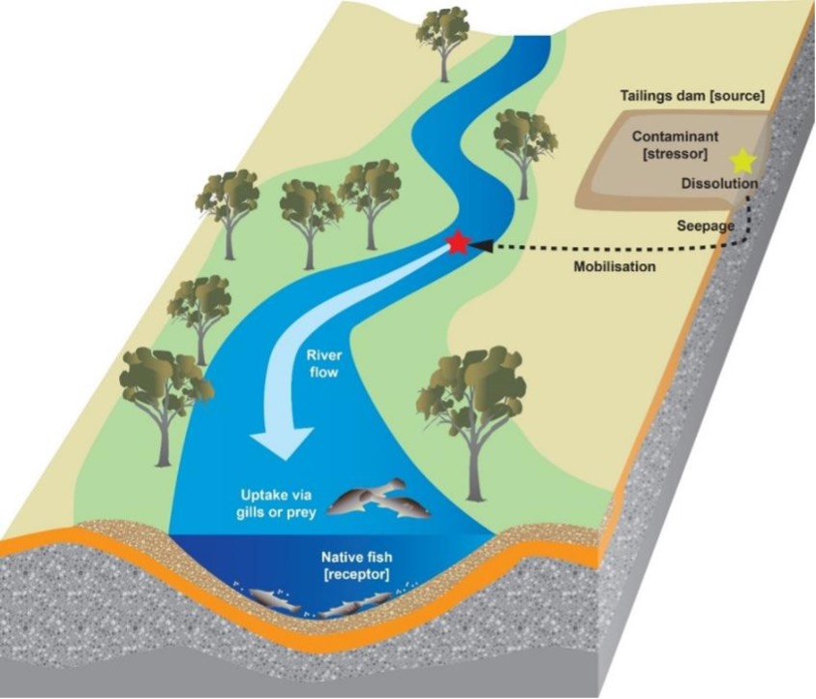

Figure 3. Hypothetical example of physical, chemical and biological processes by which a contaminant (stressor) in a tailings dam (source) might adversely affect downstream native fish (receptor)

Impact pathways end in **receptors** (Figure 2). In the context of this Explanatory Note and the IESC’s focus, receptors are water resources as defined in Box 1, and include all water-dependent species, communities and ecosystems as well as the physical, chemical and biological components of surface waters and groundwaters.

As receptors lie at the end of pathways, they are sometimes also termed ‘endpoints’ (e.g., in Peeters et al. 2022). Particular endpoints may be considered to equate to an explicit expression of an environmental value that must be protected. These receptors are called ‘assessment endpoints’ and their description must include an entity and a specific attribute (Suter 2000). An example of such an assessment endpoint would be ‘maintenance of native fish diversity’. Such attributes (or credible surrogates) that can be measured are termed ‘measurement endpoints’ (Suter 1990) and are crucial for assessing the condition of valued receptors and their responses to impacts. For the earlier example, the measurement endpoint could be native fish species richness as an indicator of diversity.

For simplicity, this Explanatory Note uses the term ‘receptor’ but recommends that narratives accompanying IPDs also specify one or more measurement endpoints for each receptor in the context of the proposed development. The supporting impact assessment documentation should present appropriate baseline data for each of these measurement endpoints, describe the changes expected in response to predicted impacts of the proposed development, and explain how these responses will be captured by the project’s monitoring program (more details are in IESC 2024).

## 2.4 Three examples of IPDs from the resource extraction literature

Before we describe how to generate IPDs (Section 3), it is useful to see some different examples in the literature. The amount of detail in the output diagrams and, where provided, accompanying narratives is usually commensurate with the expected severity and likelihood of the predicted impacts on valued receptors. Typically, projects with larger development footprints and longer durations of resource extraction will require more detailed IPDs.

They may also include formal ecological risk assessment, defined as a process that evaluates the likelihood of adverse ecological effects occurring as a result of exposure to one or more stressors (US EPA 1998). This Explanatory Note does not discuss formal ecological risk assessment (but see, e.g., Burgman 2005, Bayliss et al. 2012, Quanz et al. 2020). It also does not discuss pictorial conceptual models (but see, e.g., the Queensland Government’s Wetland*Info* website (https://wetlandinfo.des.qld.gov.au/wetlands/resources/pictorial-conceptual-models.html) for some very helpful guidance, example models and further references). This latter resource is especially useful for developing ECMs and summarising the main ecohydrological processes in a variety of surface and groundwater environments.

### 2.4.1 A simple box-and-arrow IPD

As our focus in this Explanatory Note is on potential impacts on water resources, we have selected aquatic examples. The first example is a simple box-and-arrow IPD from the review by Entrekin et al. (2011) of the threats posed by natural gas development for surface waters. The IPD shows how three activities associated with hydraulic fracturing may affect a very broadly defined receptor: stream ecosystem structure and function (Figure 4).

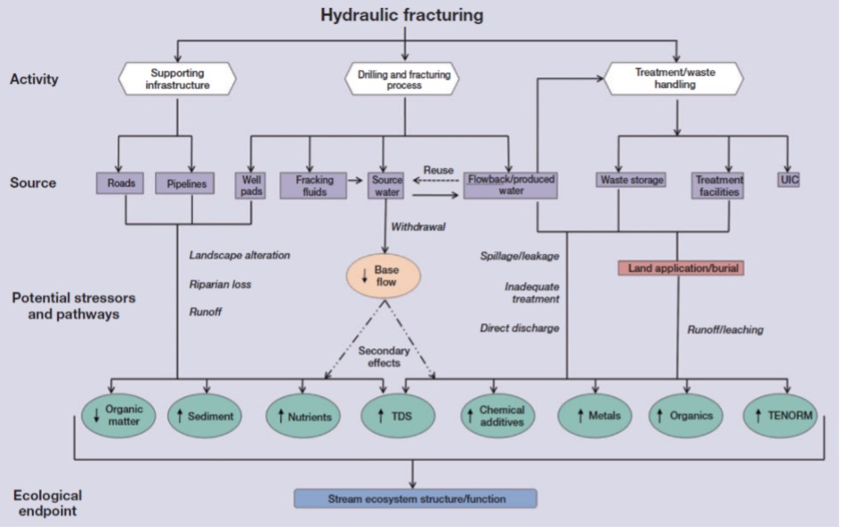

Figure 4. Simplified IPD of potential threats from natural gas development through horizontal drilling coupled with hydraulic fracturing in unconventional natural gas reservoirs (reproduced from Figure 3 in Entrekin et al. 2011)

UIC = underground injection control, TDS = total dissolved solids, TENORM = technologically enhanced naturally occurring radioactive materials. Dashed lines indicate secondary effects from gas development.

Two of the strengths of this output are that it indicates the direction of change of each of the stressors (green ovals in Figure 4) and that the overall diagram is clear, simple and easy to follow. This clarity is partly achieved by amalgamating pathways in a way that, although appropriate for use in a literature review, may be over-simplistic for an environmental impact assessment because individual pathways cannot be discriminated or unambiguously associated with specific sources.

### 2.4.2 Complex box-and-arrow IPDs with detailed impact pathways

The second example, from a large-scale report assessing potential impacts of several mining scenarios on salmonid ecosystems in Bristol Bay, Alaska (introduced in Box 2), also uses box-and-arrow diagrams. It is revisited here because it nicely illustrates how a very complex conceptual model of a large-scale project at various stages of mining can be decomposed into several more-detailed, finer-scale IPDs or sub-models focused on specific pathways, sources and stressors relevant to the salmonid receptor.

For example, the IPDs of predicted impacts of the mine construction stage on salmonids via alterations to physical habitat (Figure 5a) and water chemistry (Figure 5b) would be challenging to present clearly in a single diagram. In these two examples, pathways and their interactions are clearly portrayed. An excellent balance has been struck between clarity and the detail of the different processes along each pathway (also see Box 2), which helps to indicate potential mitigation options (e.g., controlling erosion at stream crossings, preventing leakage from storages of tailings and chemicals). Many of the IPDs in US EPA (2014) also show other relevant drivers (e.g., climate change) and modifying factors. Figure 5c illustrates how these may influence the potential impacts of unplanned events on the physical habitat and water chemistry of salmonid ecosystems, and is accompanied by a comprehensive narrative in the report.

(a)

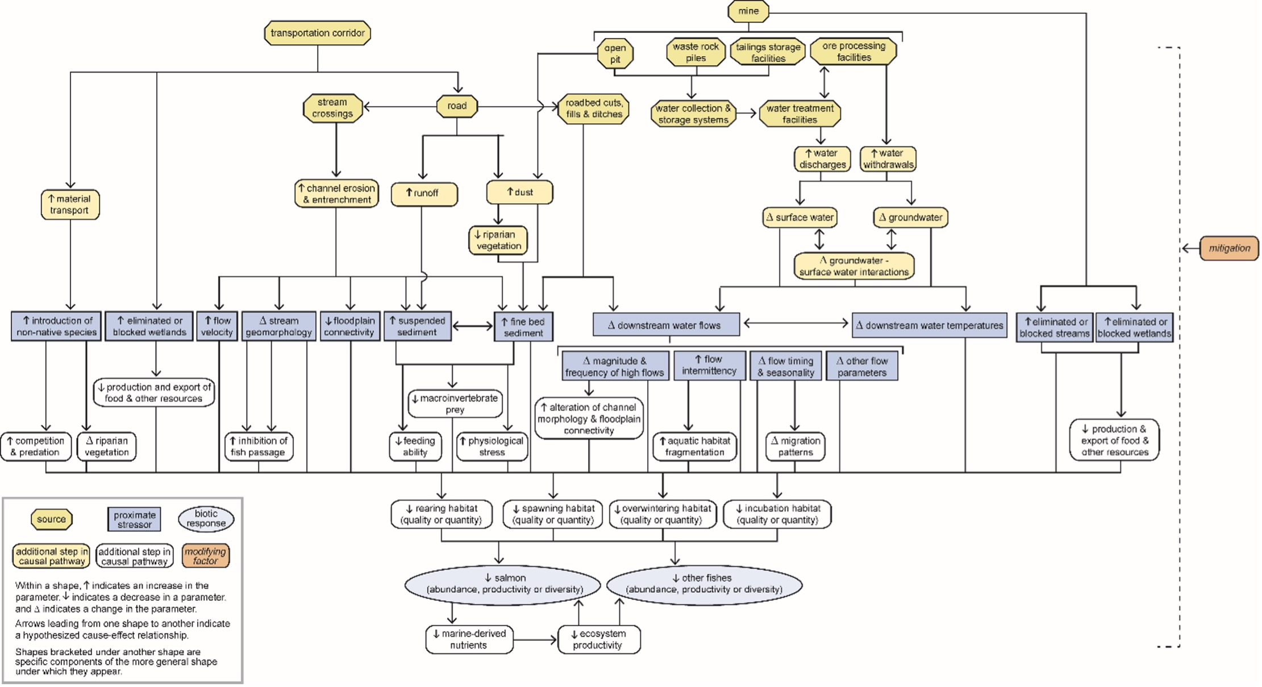

(b)

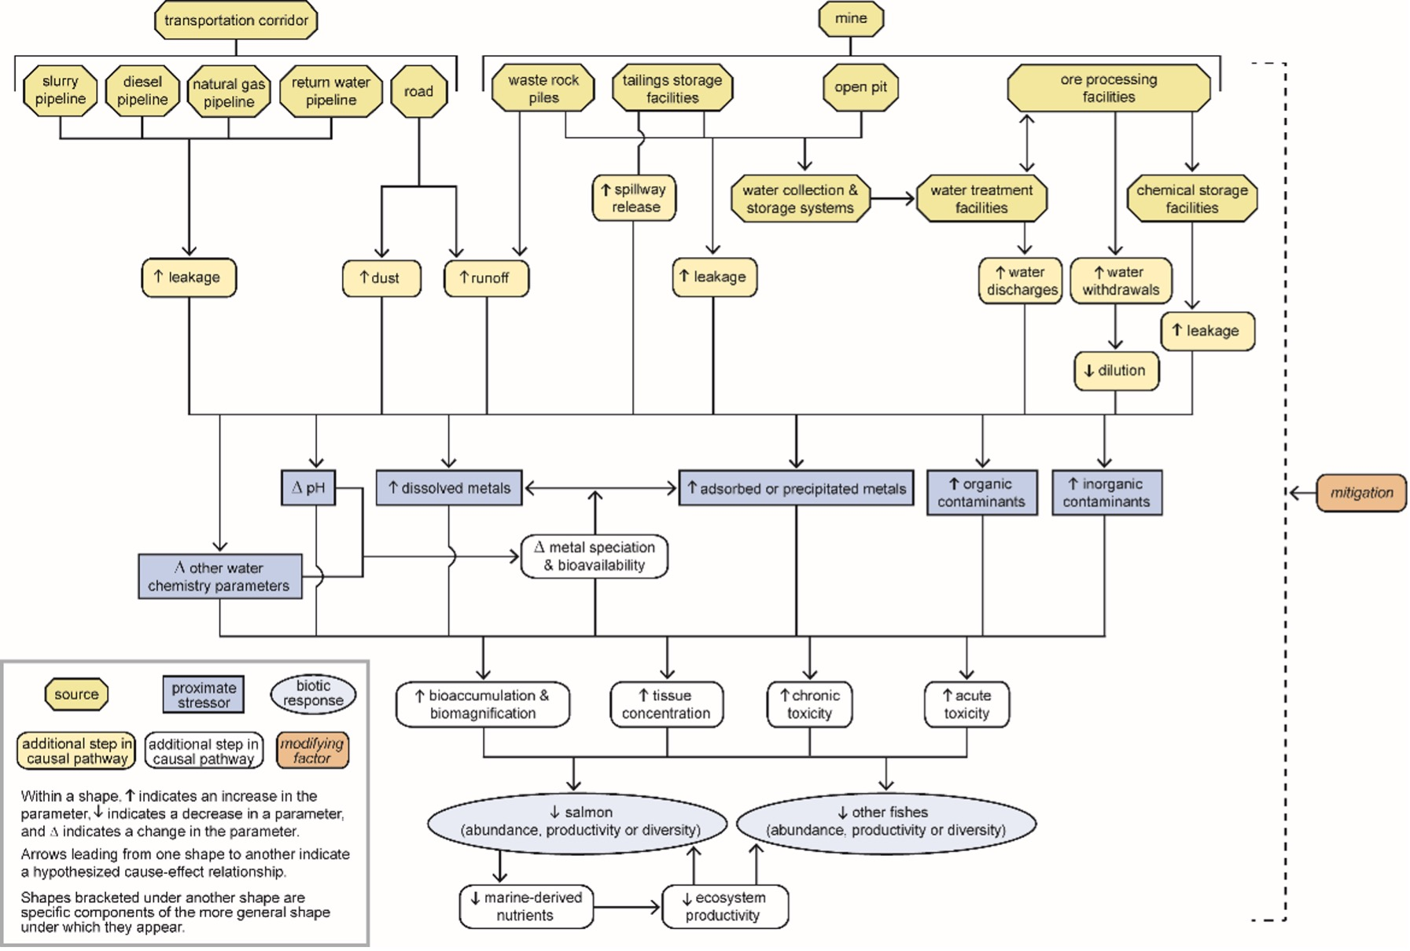

(c)

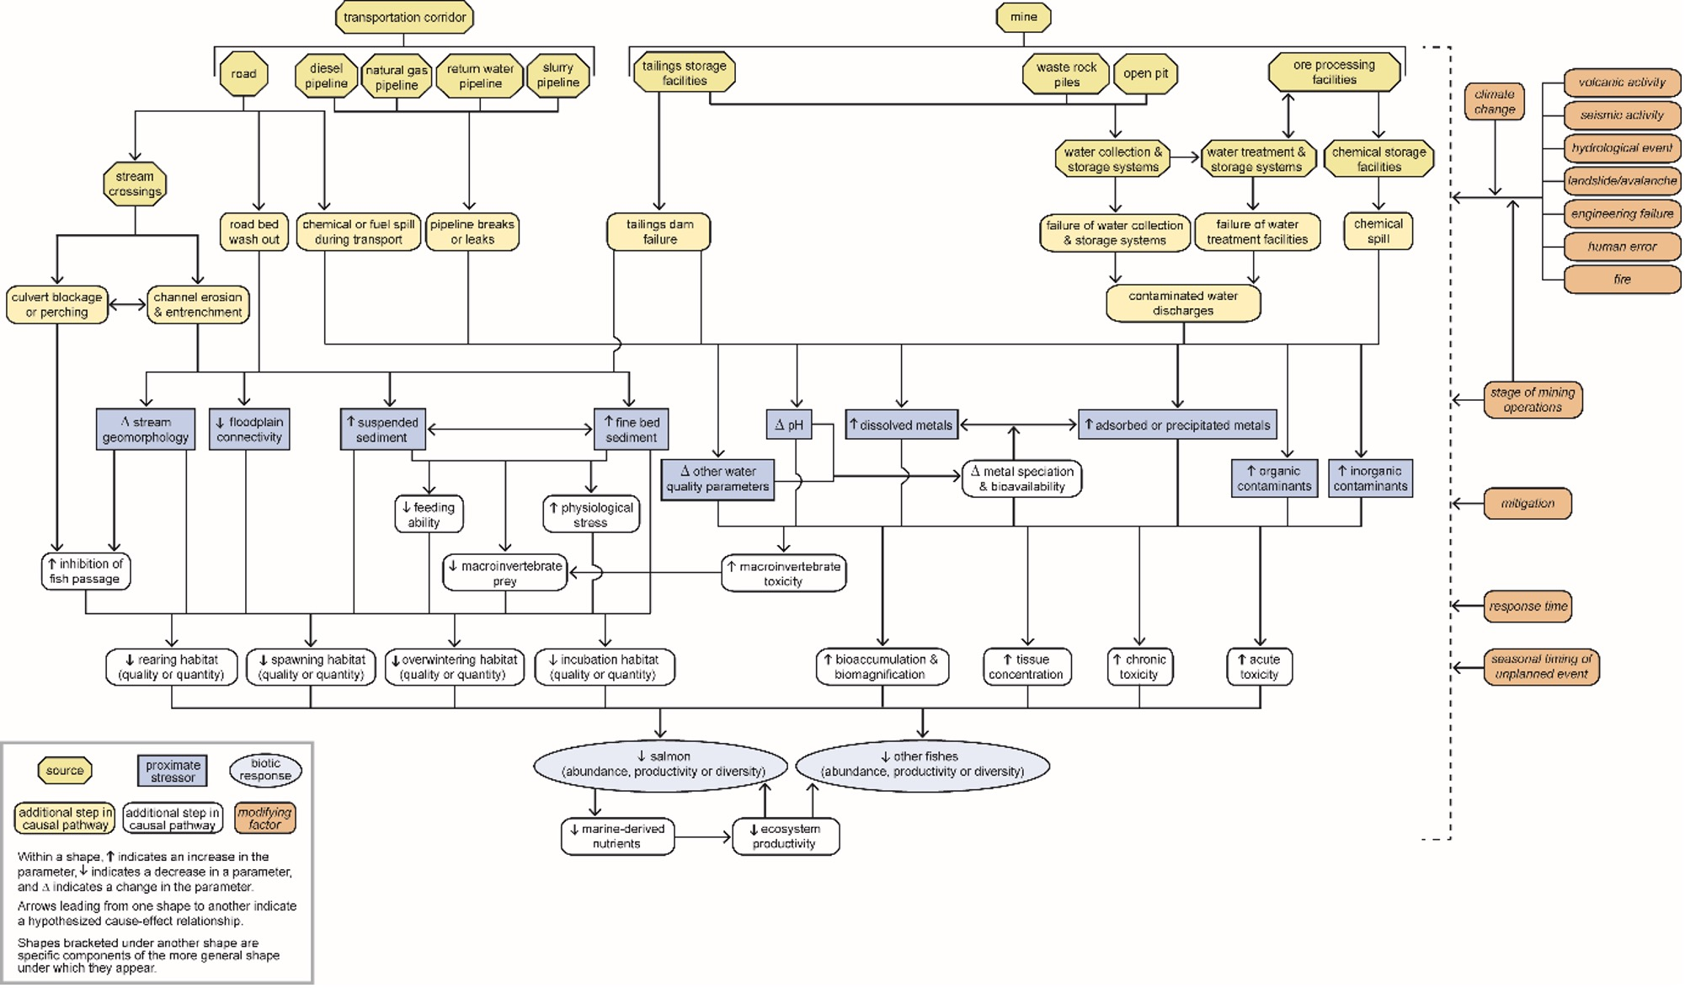

Figure 5. IPDs of predicted impacts of mine construction on Bristol Bay salmonids via alterations to physical habitat (a) and water chemistry (b), and of unplanned events on physical habitat and water chemistry of salmonid ecosystems (c)

Reproduced from Figures 6-12, 6-13 and 6-14 in US EPA 2014, respectively.

All three of the IPDs in Figure 5 specify potential measurement endpoints (abundance, productivity, diversity) for the two receptors. They also use different colours and shapes of symbols to effectively illustrate the different types of components along the pathways. The IPDs do not portray the relative importance of the pathways. However, where there are adequate baseline data, US EPA (2014) presents detailed narratives and ecological risk assessments for the potential impacts of the 18 stressors deemed relevant to salmonid ecosystems in Bristol Bay.

US EPA (2014) also superimposes hypothetical development footprints of the three mining scenarios (Box 2) onto a map of the surface water resources of the Bristol Bay catchment (e.g., Pebble 6.5, Figure 6a) and makes location-specific predictions of, for example, altered streamflows (Figure 6b). Integrating IPDs with maps of the projected development footprint to make site-specific predictions of changes in relevant stressors is a crucial step in developing IPDs for environmental impact assessment (Section 3.3). These outputs illustrate potential ‘hotspots’ where impacts may be substantial (e.g., >20% decreases or increases in streamflows; see Figure 6b) and provide valuable guidance on where to target mitigation and monitoring programs. As the consequences of impacts will vary across the project area depending on, for example, the spatial distribution of sources and vulnerable receptors, a generic IPD cannot accurately present the relative importance of impact pathways that apply at all locations in the development’s footprint. Therefore, complementing IPDs with maps like those in Figure 6 is very useful and is strongly recommended in environmental impact assessment.

In their methodology paper on causal networks, Peeters et al. (2022) describe another approach for matching stressors and impact pathways from box-and-arrow IPDs with spatial information (grid cells) at a regional level. This approach may be too complex for most environmental impact assessments and has other constraints reviewed in Peeters et al. (2022). However, it is mentioned here as an option that might be considered if proponents have access to suitable expertise and spatial data.

(a)

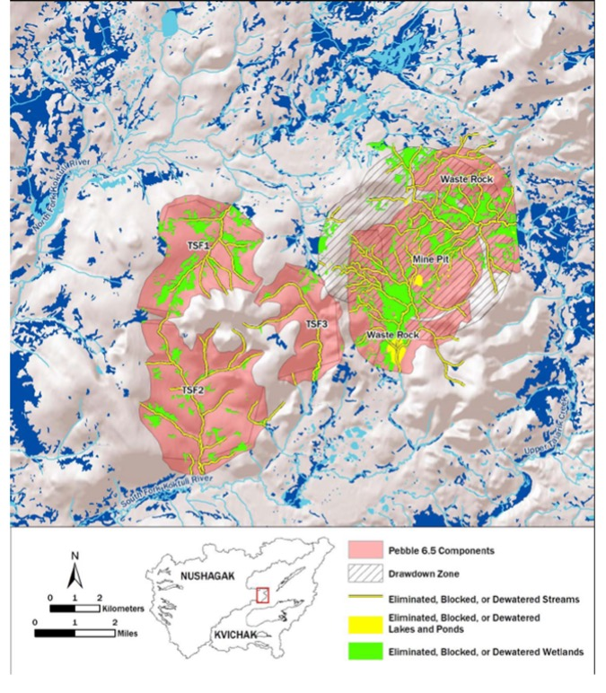

(b)

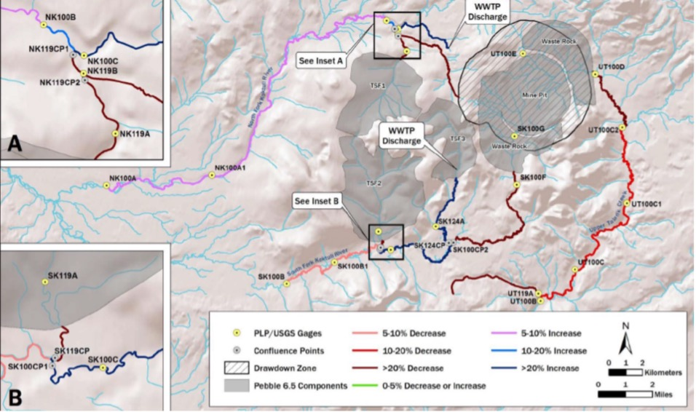

Figure 6. Streams and wetlands lost (eliminated, blocked or dewatered) in the Pebble 6.5 scenario (a), and predicted streamflow changes (%) associated with the footprint of the Pebble 6.5 scenario (b)

Reproduced from Figures 7-12 and 7-16 in US EPA 2014, respectively.

(a) Streams and wetlands lost are indicated by yellow and green areas. Light and dark blue areas indicate surface water resources.

(b) For each stream segment, streamflow modification classes are shown to indicate degree and direction of change. These classes were assigned at a gauge (circled dots) and extend upstream to the next gauge, confluence point, or mine footprint. Channels and tributaries not classified are also shown.

### 2.4.3 Best practice – IPDs, maps and detailed narratives

The third and final example also integrates IPDs with geographical information about the project area to show the physical locations of sources, pathways and receptors for particular stressors. This was the best readily accessible Australian example that we could find dealing with potential impacts of mining on water resources (and other receptors) that mapped IPDs onto the project area and presented detailed narratives. It is presented here as an aspirational goal for proponents and their consultants preparing an environmental impact statement (EIS) where there is a high risk of a development impacting on valued water resources and there are adequate project-specific data and expertise available.

Ranger Uranium Mine in the Northern Territory is Australia’s longest continually operating uranium mine (now undergoing restoration), and its potential and actual environmental impacts have been intensively studied since the early 1980s. Data and other information from these studies have been used to develop and refine multiple conceptual models of its potential impact pathways during operations to communicate the project’s environmental risks to the various stakeholders.

Bartolo et al. (2017) summarise this conceptual modelling work, presenting an example of what they term a causal model for the most important pathway: the transport of inorganic toxicants via the surface-water pathway to surface-water receptors (Figure 7). This example is based on a conceptual model (Figure 7a) indicating six different surface-water flow paths superimposed on a diagram of the project area showing the locations of relevant sources (e.g., tailings storage facilities, land application areas) and receptors (e.g., Magela and Gulungul creeks and their tributaries). Representative surface-water flow paths are colour-coded to represent their sources, providing a useful indicator of their likely water quality and potential threat to downstream receptors. This conceptual model was used to generate an IPD (Figure 7b) of potential surface water to surface water transport of inorganic toxicants (the major stressor) from the mine. The locations of sources and receptors are shown, along with inset diagrams of the environmental compartments that are likely to be affected, the receptors and the measurement endpoints.

(a)

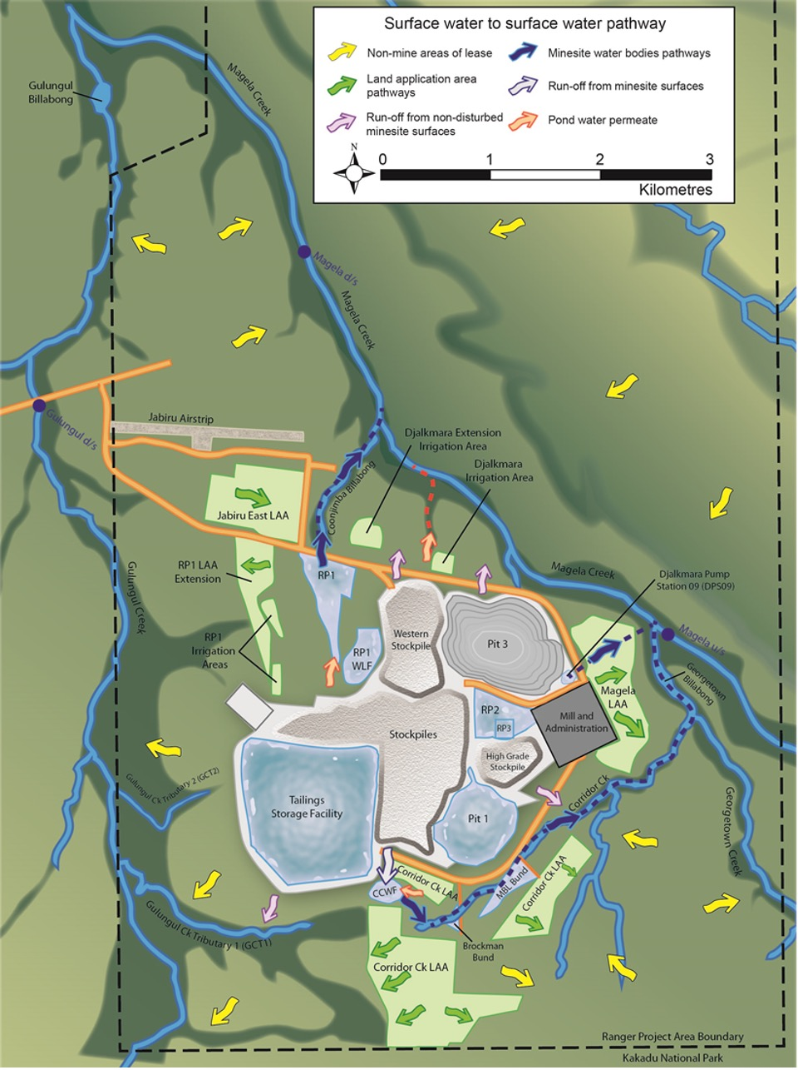

(b)

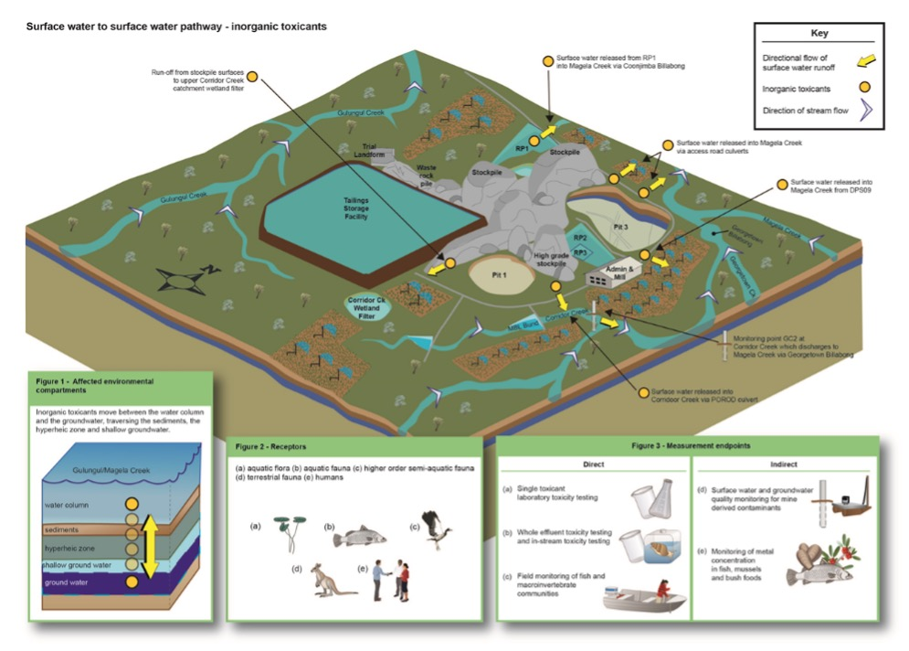

Figure 7. Conceptual model (a) and IPD (b) of the surface-water to surface-water pathways at Ranger Uranium Mine that may transport inorganic toxicants (stressors) to downstream receptors

Reproduced from Figures 3 and 4 in Bartolo et al. 2017, respectively.

The IPD is accompanied by a detailed narrative whose focus ‘was to provide a scientifically valid statement of the current knowledge of each of the nodes in the causal model and, based on this, provide an assessment of the level of importance of that pathway in the operational phase’ (Bartolo et al. 2017, p. 691). This narrative describes the key stressors and their sources, the relevant environmental compartments (e.g., water column, shallow connected groundwater), the receptors and the measurement endpoints. Based on data and expert input (Bartolo et al. 2017), the narrative also presents the relative importance of each impact pathway based on the size and/or potential maximum generating capacity of the relevant stressor source (low, medium or high) and on the potential maximum capacity (as load and rate) of the relevant pathway to transport stressors from the mine site to the surrounding environment (low, medium or high). The IPDs and their narratives for 30 causal models for Ranger Uranium Mine are available in the freely accessible ‘Supplemental information’ for Bartolo et al. (2017) (https://www.tandfonline.com/doi/suppl/10.1080/10807039.2016.1263931?scroll=top&role=tab).

This third example is considered ‘best practice’ because of the assessment of relative importance of each impact pathway, the mapping of IPDs onto the project area, the specification of measurement endpoints, and the accompanying detailed narratives. Although few proponents and their consultants will have access to sufficient expertise and site-level data to generate so many comprehensive models for an assessment, **it should be feasible to develop a simple ECM and one or more derivative IPDs, preferably mapped onto the project area, and an accompanying narrative sufficient to describe the key sources, stressors and receptors along relevant impact pathways**. The next section suggests a way to generate these outputs, illustrated with a worked example of a hypothetical open-cut mine.

1. How to generate IPDs for environmental impact assessment

## 3.1 Introduction

To capitalise on the many benefits of using IPDs in environmental impact assessment (Section 2), we need to know how to generate the initial ECM, the IPDs and their narratives as efficiently as possible. As we have said earlier, both the products and the process are valuable. The products (diagrams and narratives) illustrate and explain the relevant impact pathways, predicted responses and proposed mitigation options and monitoring strategies. The process draws together the multidisciplinary consultants who are compiling the various sections of the assessment documentation and improves collective understanding of the likely environmental impacts. It is an iterative process because the pathways in the initial ECM and IPDs are likely to be largely based on desktop analyses and expert opinion, whereas subsequent diagrams can be refined with baseline data and other information from the project area.

In the assessment documentation, the ECM, the IPDs and their narratives integrate geological, hydrogeological, geomorphological, hydrological, physicochemical, chemical, ecotoxicological and ecological baseline data and information from and near the proposed project area to infer potential impacts on receptors – in this case, water resources (defined in Box 1). One early information requirement is the predicted surface footprint of the project, as well as the likely maximum extent of groundwater drawdown and depressurisation. Another is the predicted changes in surface flows and water regimes, and how far these might extend downstream. Potential changes in physical and chemical water quality of surface waters and groundwaters are also important, especially during different stages of the development and after operations finish. This information, along with relevant geological and geomorphological information on faults, rock types and topography, delimits the **potential impact area** (PIA), defined by Peeters et al. (2021) as the maximum areal extent of potential impacts of the development.

Knowing the PIA is essential for ecologists tasked with assessing the likely impacts of the proposed development on aquatic and riparian plants, animals and ecological processes – key components of the area’s water resources. It also guides the selection of reference sites where impacts from the development are predicted to not occur; water quality and biota at these sites can be monitored for comparison with those of potentially impacted sites (more details are in the IESC Information Guidelines (IESC 2024)). Inevitably, there will be uncertainty in defining the boundary of the PIA (e.g., predicted groundwater drawdown contours, downstream effects of altered flow regimes), so adding a ‘buffer zone’ around the PIA helps minimise the risks of underestimating the area that is truly impacted. If environmental impacts are likely to be severe and their maximum spatial extent is poorly known, a wider buffer zone is probably warranted. Nonetheless, assessing the magnitude of the PIA is not a simple task, especially for cumulative impacts, and the boundaries of the PIA may change as new information and site-specific field data are gathered.

After emphasising the importance of early discussion and multiple meetings of the team of expert consultants (Section 3.2), this section describes an approach to generating an ECM and one or more derivative IPDs in environmental impact assessment, along with supporting maps and narratives (Section 3.3). The approach is illustrated with a simple hypothetical scenario involving open-cut mining and diversion of an ephemeral stream.

## 3.2 The importance of starting collaboration early

Environmental impact assessment for activities such as LCM or CSG development that may have significant impacts (as per the Significant Impact Guidelines 1.3 (DCCEEW 2022)) on water resources requires a multidisciplinary team of consultant experts with individual expertise in, for example, earth sciences, hydrogeology, hydrology, ecotoxicology and ecology. These experts may not know each other, and they typically work for different consulting groups. As it is intended that their various contributions will complement each other to result in a coherent report on likely environmental impacts of a proposed development, it is crucial that each expert knows what other information is available or to be collected. For example, a stream hydrologist will be keen to know what hydrogeological information is available on surface water–groundwater interactions along river channels in the PIA, while an aquatic ecologist will want to know details of the channels’ flow regimes from the hydrologist.

Therefore, it is **strongly recommended that the various experts employed to do the assessment meet as soon as possible to share existing information and agree on what field data are needed**, including how information from one discipline area might be used by others. We believe that the most efficient way to identify these information needs is for all the experts to gather around a whiteboard with maps of the project area to collectively list the major hydrogeological, hydrological, chemical and ecological components and processes (the basis for the preliminary ECM), the potential impacts and their likely sources and associated stressors, and the environmental receptors (water resources), and then draw up links on the board to represent possible impact pathways from sources to receptors (the preliminary IPD). Using the maps, the experts can then discuss where and how these ecohydrological and impact pathways might operate, and what baseline data from different discipline areas are needed from particular locations in the PIA to support the predictions about each pathway and the likely environmental responses.

This initial meeting has several advantages. The first is that the different experts are able to collaborate to generate a preliminary ECM and IPD and agree on which activities and locations are likely to be important sources of impacts and where vulnerable receptors lie in the PIA. These preliminary diagrams are powerful tools for collectively identifying what the major potential impacts might be and where their effects might occur, and provide an important focus for targeting subsequent collection of further information and field data.

The second advantage is greater efficiency in collecting information, saving time, effort and money. At the outset, plans can be made to conduct concurrent fieldwork and baseline data collection and to share directories of information. Where possible, data should be collected from areas and at spatial and temporal scales where the information can be used by different experts. For example, aquatic ecologists doing seasonal surveys of wetlands and streams might be able to also collect water quality samples for analysis by the ecotoxicologist.

The third advantage is reduced data redundancy, because the initial meeting will have highlighted which data are relevant and how (e.g., for testing predicted impact pathways and predicting environmental responses). All too often, assessment documentation includes substantial amounts of data whose worth is difficult to see and that are seldom discussed in detail because of their marginal relevance. Large amounts of redundant information risk distracting the reader from the main messages of the assessment documentation.

The fourth advantage is the higher quality of the final assessment documentation, especially its clarity and coherence in integrating the sections prepared by the different expert consultants. Subsequent meetings (after the initial one) should culminate in the production of a revised IPD that is well supported with relevant field data and analyses. This final IPD can be presented early in the report (and in the executive summary) to provide an effective visual summary of the key potential impacts and their pathways. The narrative accompanying the IPD contributes to the report’s coherence by cross-referencing its different sections where relevant supporting information is presented.

There is a rich literature on the frailties and biases associated with eliciting expert input for assessing risks and potential impacts, and on how to avoid these pitfalls. Although this Explanatory Note does not review that literature, it is important to be aware of potential biases during meetings of the expert consultants and when collating the input for deriving the IPDs and associated narratives.

## 3.3 Generating ECMs and IPDs in environmental impact assessment

Conceptual models are commonly generated by multidisciplinary teams to summarise and communicate their shared understanding when starting to collaborate on a project where each discipline expert contributes knowledge and insight to address a particular topic. Information and data are then collected to test the hypotheses that underpin the conceptual models. **The same approach is ideal for environmental impact assessment of a proposed development, with the experts first generating a preliminary ECM to characterise the major ecological and hydrological components and processes within the project area, and then using it to derive one or more initial IPDs whose hypothesised pathways can then be tested with subsequent baseline and other data**. This hypothesis-testing results in final IPDs which can be presented as box-and-arrow diagrams and/or mapped onto plan and oblique views of the project area and surroundings for incorporation into the final environmental impact assessment documentation.

Some readers may find it helpful to see this approach presented as a workflow of consecutive steps (Figure 8). Steps 1 to 4 involve mapping impact sources, stressors, ecohydrological pathways and receptors onto the PIA, while documenting information gaps and discussing how best to address them. Doing these initial four steps also generates the initial ECM upon which the IPDs will be based and helps the multidisciplinary team of consultant experts become familiar with the project area and where relevant baseline data will be needed to improve understanding of the current state of the receptors in the PIA. Once these steps have been completed, the team is ready to discuss and tabulate potential impact pathways between sources and receptors (Step 5) and construct a preliminary IPD and, if needed, sub-models (Step 6). The seventh step involves mapping these impact pathways onto the PIA to identify the locations of particularly vulnerable receptors and areas where baseline data are needed to establish initial pre-development conditions. The last step, done after baseline and other information has been collected, is to revise the IPDs, maps and narratives into final versions for the environmental impact assessment report.

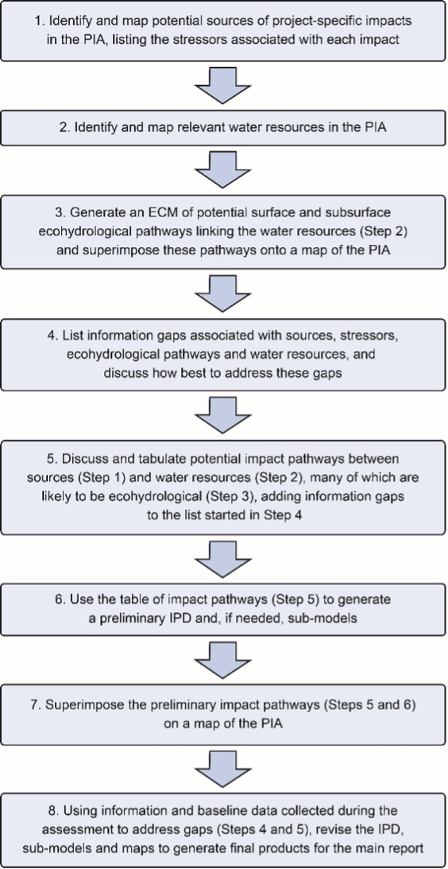

Figure 8. An eight-step workflow to generate an initial ECM and preliminary and final IPDs, sub-models, maps and associated narratives for environmental impact assessment

Note: Although presented as a linear workflow, these steps can be iterative loops (e.g., data collected during Step 8 can inform further meetings at Step 5).

The first seven steps would be done during the initial meeting of the multidisciplinary team of consultant experts, and would generate multiple opportunities for data sharing, field collaboration and cross-analyses of data. These steps will reveal which areas in the PIA need more detailed sampling and the likely locations for monitoring sites (including appropriate reference sites where impacts are not predicted). The experts can also discuss sampling methods that will ensure that relevant data will be collected at appropriate spatial and temporal scales to optimise their use for multiple purposes. The eighth step would be done in subsequent meetings where the preliminary IPD, sub-models, maps and narratives are revised for inclusion in the final report.

Although the workflow is presented as a linear process in Figure 8, there are several places where iterative loops can refine the products in response to further data and information. For example, data collected during baseline surveys (Step 8) can feed into further meetings to discuss any additional impact pathways that may become apparent (Step 5). The workflow process is very flexible and should be modified to suit the specific needs of the expert consultants and the information needed for assessing potential impacts of the proposed development.

In this section, we illustrate this approach with a fictional scenario describing the initial and subsequent meetings of the expert consultants who have been employed to assess the likely environmental impacts of a proposed hypothetical mine in the Bowen Basin, Queensland, an area where coal mining occurs. The hypothetical example is intentionally small and only focuses on a subset of possible impacts. After presenting the background context (Section 3.3.1) at the level of detail likely to be given in the initial brief to the consultants, we describe how an initial meeting to develop a simple ECM and then derive a preliminary IPD might proceed (Section 3.3.2), followed by several subsequent meetings to generate one or more final IPDs and superimpose them on maps and oblique views of the project area and nearby (Section 3.3.3). Our main focus is to highlight the key points that should be addressed in the meetings and the outputs that might emerge. We also demonstrate that no new information is needed beyond that already provided in a competent environmental impact assessment.

### 3.3.1 Background context

XYZ Pty Ltd’s Hypothetical Mine (the ‘project’) is a proposed open-cut coal mine to be developed approximately 35 km south-east of Moranbah in the Bowen Basin and within the Isaac River catchment of the Fitzroy River basin. It will target the Leichhardt and Vermont seams within the Rangal Coal Measures. The predicted average extraction rate is 2 million tonnes per annum of run-of-mine coal over nine years, which will result in a total direct disturbance area of 520 ha (pit, out-of-pit waste-rock emplacement and mine infrastructure). Coal will be extracted from an open pit approximately 1.5 km by 2 km with a maximum depth of 170 m. Local groundwater elevations vary across the site, with a depth to water of 10 m to 30 m. Relatively low rates of groundwater discharge into the pit are expected, with control via in-pit pumps.

Approximately 1.5 km of the ephemeral North Creek will be diverted around the pit (Figure 9). A highly ephemeral tributary of North Creek will also be diverted several hundred metres into the northern sediment dam. The pit will be backfilled during mining to leave no voids, and the final landform will be rehabilitated to support its current land use (grazing).

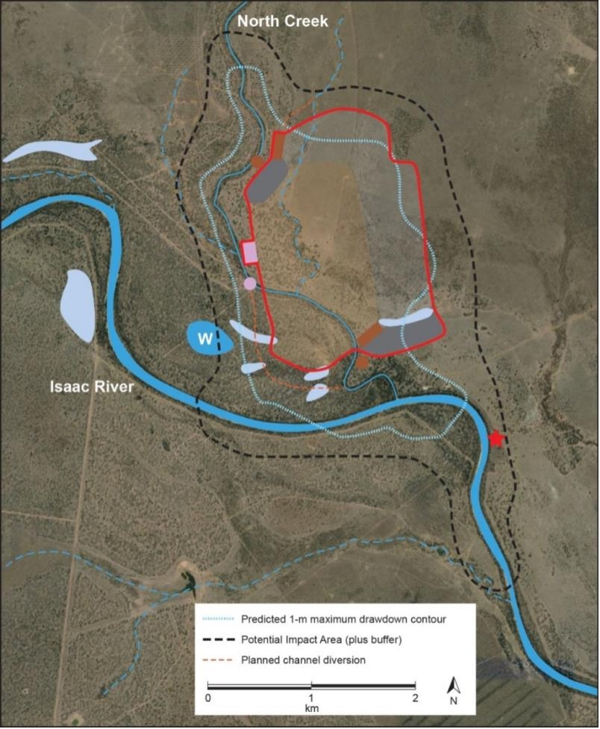

Figure 9. Hypothetical Mine, showing final areas of the proposed pit (pale brown), out-of-pit waste rock (pale grey) and mine infrastructure (dark grey)

Red line encloses total disturbance footprint. A single dam for mine-affected water (mauve rectangle) also has a release point (mauve circle) into North Creek. The red star indicates the Deverill gauging station (130410A). Surface water resources in the PIA include the Isaac River (thick blue line), North Creek (thin blue line) and ephemeral tributaries (dashed blue lines) and wetlands (pale blue polygons) including W, a wetland of high ecological significance. Satellite image from Google Maps, <https://www.google.com/maps/place/Deverill,+Valkyrie+QLD+4742/@-22.162121,148.3590068,10129m/data=!3m1!1e3!4m5!3m4!1s0x6bdaaa01c1c673bf:0xa31255f9726a91e0!8m2!3d-22.166651!4d148.3759>

Much of the area has been cleared for grazing but there are several remnant areas of native vegetation. Riparian vegetation along the Isaac River and North Creek, especially near their confluence downstream of the proposed mine, is mapped as Forest Red Gum (*Eucalyptus tereticornis*) with occasional Poplar Box (*E. populnea*) and likely to be habitat and a movement corridor for wildlife such as Koala (Phascolarctos cinereus) and Greater Glider (*Petauroides volans*).

The GDE Atlas (BOM undated) classifies riparian vegetation along the Isaac River and North Creek as a ‘high potential GDE’ (Figure 10a). An unpublished field study of Forest Red Gum and Poplar Box near the Isaac River–North Creek confluence indicated them to be groundwater dependent. However, this assessment has not been done for other terrestrial GDEs in the PIA.

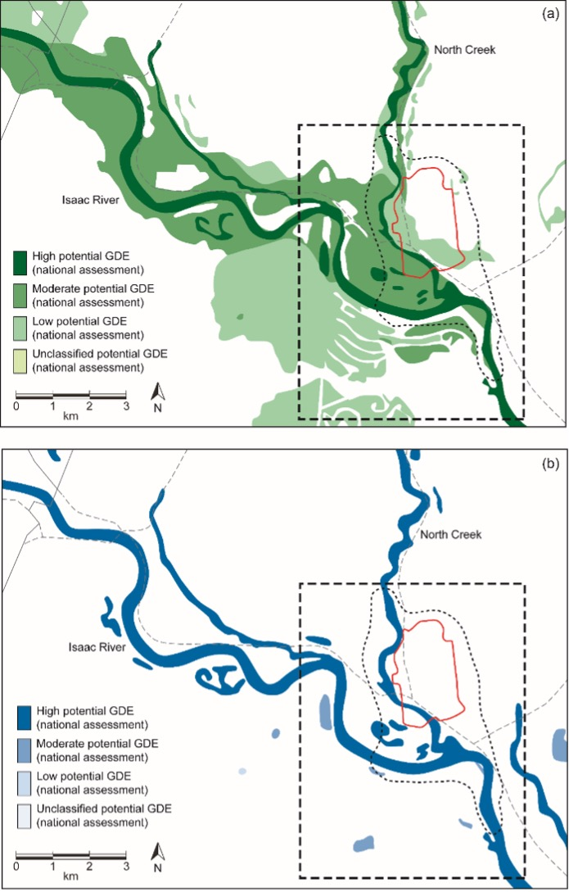

Figure 10. Potential terrestrial GDEs (a) and aquatic GDEs (b) near and within the PIA (dashed polygon) of Hypothetical Mine

Red outline represents the mine’s disturbance footprint; dashed box represents the outline of Figure 9. Maps derived from the Bureau of Meteorology’s GDE Atlas (BOM undated), <http://www.bom.gov.au/water/groundwater/gde/map.shtml>

The PIA lies in a subtropical climatic zone characterised by high summer temperatures, warm dry winters and distinct wet and dry seasons. Surface flows are seasonal, mainly during the wet season (December to March). The Isaac River flows approximately 27% of the time at the Deverill gauging station (130410A) less than 1 km downstream of the Isaac River–North Creek confluence (Figure 9).

Pools persist in channels along the larger waterways such as the Isaac River and lower North Creek, and are probably important aquatic refugia. Museum records and other databases list 12 fish species from the Isaac River and lower reaches of North Creek collected during and soon after periods of flow, along with Krefft’s River Turtle (*Emydura macquarii krefftii*) and Eastern Snake-Necked Turtle (*Chelodina longicollis*). Aquatic macroinvertebrate community composition at several sites along both rivers indicated moderately impaired ecological condition, apparently correlated with high suspended sediment loads and turbidity and limited in-stream habitat diversity.

The standing waters in the PIA are ephemeral. In general, surface waters are fresh (<1,500 µS/cm) but become more saline through evapoconcentration during drying. Wetland W (Figure 9), spanning the PIA’s western border, is designated a wetland of High Ecological Significance (HES) by the Queensland Government. The GDE Atlas (BOM undated) classifies this wetland and nearby ones as ‘high potential GDEs’ (Figure 10b); further data are needed to field-verify this dependence on groundwater. When filled, the wetlands support water plants and aquatic macroinvertebrate communities typical of slightly to moderately disturbed standing waters in the region. A survey of the wetlands in 2020 collected several Eastern Snake-Necked Turtles, and tadpoles and adults of five frog species.

Alluvial sediments have been mapped along the Isaac River and lower North Creek in the PIA and contain fresh-brackish groundwater (<5,000 µS/cm) 10 m to 20 m below the surface. In addition to being accessible to groundwater-dependent vegetation, this alluvial groundwater is likely to support stygofauna. Predicted contours (>2 m) of maximum project-specific drawdown in the alluvial sediments typically extend less than 1 km from the pit except along the intercepted channel of North Creek and the confluence with the Isaac River (Figure 9).

Near the proposed mine (within 20 km) are several operational or planned coal mines (including Poitrel, Daunia, Moorvale South, Olive Downs, Winchester South and Eagle Downs mines), as well as CSG extraction from the Bowen Gas Project. Modelling of the cumulative predicted drawdown of these developments with that expected from the project (correcting for assumed peaks in drawdown from each mine) indicates no substantial cumulative drawdown (i.e., >2 m) in alluvia in the PIA. Although there is substantial cumulative contribution to drawdown in the deeper groundwater layers of the underlying coal measures, the water quality of this groundwater is too poor for domestic use and unlikely to support stygofauna.

### 3.3.2 The initial meeting of expert consultants

Several weeks after the proponent had engaged a multidisciplinary team of expert consultants, they met to discuss the sources, stressors, pathways and receptors for potential impacts arising from the proposed mine. In addition to a facilitator, a note-taker and the proponent’s representative, the participants comprised two hydrogeologists, a surface water hydrologist, an ecotoxicologist, an aquatic ecologist, a botanist and a vertebrate ecologist. The hydrologist and two of the ecologists had worked in the area before, collecting survey data for other projects.

The meeting started with a presentation by the proponent’s representative describing the proposed project, particularly the planned vegetation clearance, channel diversions, open-cut mining and waste-rock placement. Several maps were provided that showed the intended locations, extent and timing of these activities. These were supplemented with site photos taken across the project area within the previous six months. By the end of this presentation, the map of the project area had been annotated to show the main potential ‘sources’ of impacts associated with the proposed development (Figure 11), which were also listed on the whiteboard along with relevant stressors (Table 2).

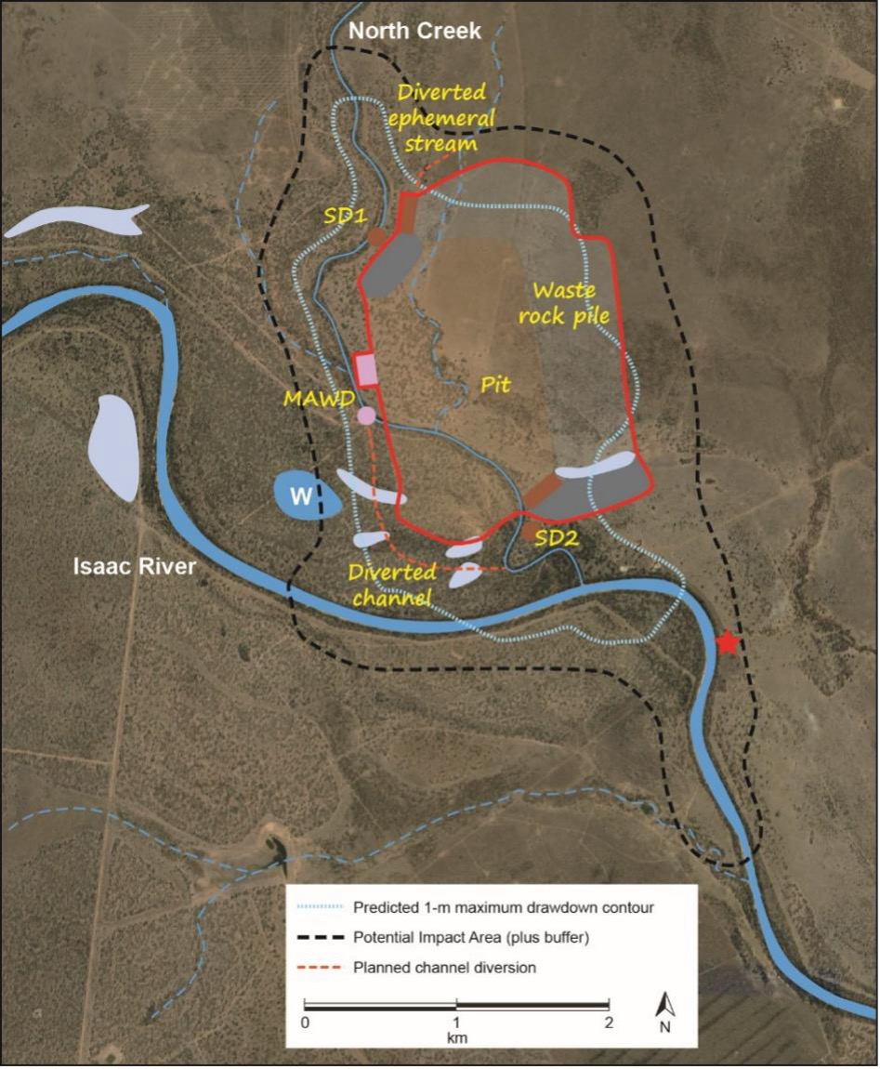

Figure 11. Annotated map of Hypothetical Mine (Figure 9) showing potential sources of impacts from the proposed development that were identified during the initial meeting of consultant experts

Abbreviations match those in Figure 9 except that SD1 and SD2 are used to refer to the two sediment dams and MAWD refers to the dam for mine-affected water.

Table 2. Part of the list of impact sources and associated stressors (examples) from the proposed development that were identified during the initial meeting of consultant experts

| **Impact (locations and activities)** | **Examples of associated stressors** |
| --- | --- |
| Locations |  |
| Waste rock pile | Reduced groundwater water quality from contaminated seepage |
| Pit | Lowered water table caused by dewatering the pit |
| Diverted channel | Reduced surface runoff into ephemeral wetlands |
| Mine-affected water dam | Reduced stream water quality from uncontrolled releases |
| Sediment dams | Reduced stream water quality from uncontrolled releases |
| Activities |  |
| Clearance of native vegetation | Loss of habitat for terrestrial plants and wildlife |
| Drawdown from pit dewatering | Reduced groundwater availability for GDEs |
| Disrupted alluvial connectivity in North Creek due to the diverted channel | Reduced groundwater recharge of alluvial sediments of the North Creek–Isaac River confluence |
| Altered overland flow due to the diverted channel of North Creek | Altered duration of water persistence in several ephemeral wetlands |

Note: Some of the sources are locations, whereas others are activities. Although only single examples of stressors are listed for each impact, there may be multiple stressors associated with an impact, and the same stressor can apply to several different impacts.

Quite a bit of discussion focused on how the PIA had been delineated (Figure 9), especially given the uncertainty at this early stage of the maximum extent of drawdown. It was agreed that as the proposed mine was relatively small and would operate for less than a decade, the buffer around the predicted drawdown contour need not be extensive except along North Creek and downstream along the Isaac River but it should encompass the groundwater-dependent vegetation known to occur near the North Creek–Isaac River confluence (Figure 9). Although Wetland W and its likely catchment did not fully lie in the PIA, the aquatic ecologist suggested that it would be appropriate to sample the wetland and fringing vegetation if the preliminary IPD indicated any risks of impacts from the project. It was also agreed that there would be a further meeting with the regulator to ensure that there were no other areas that might require assessment, such as potentially sensitive sites downstream from the PIA.

The ecologists then described the terrestrial and aquatic biota known or predicted to occur in the area, especially those listed by the EPBC Act. The likely locations of these receptors (where known) were marked on the maps of the PIA. Similarly the locations of all surface and subsurface water resources, including potential GDEs (Figure 10) and the domestic bore at Deverill, were mapped (Figure 12a), which also necessitated drafting an oblique cut-away diagram (Figure 12b). These maps and diagrams were complemented with a list of receptors, together with notes of their current condition (Table 3). An asterisk was added next to those receptors (North Creek, Wetland W, Forest Red Gum/Poplar Box GDEs at confluence, saturated alluvium at and just downstream of confluence, and Deverill bore) that were especially valued and/or likely to be very sensitive to environmental changes such as altered groundwater supply or reduced water quality. It was quickly apparent which mapped receptors had distributions that coincided with, for example, planned vegetation clearance, channel diversion and predicted drawdown.

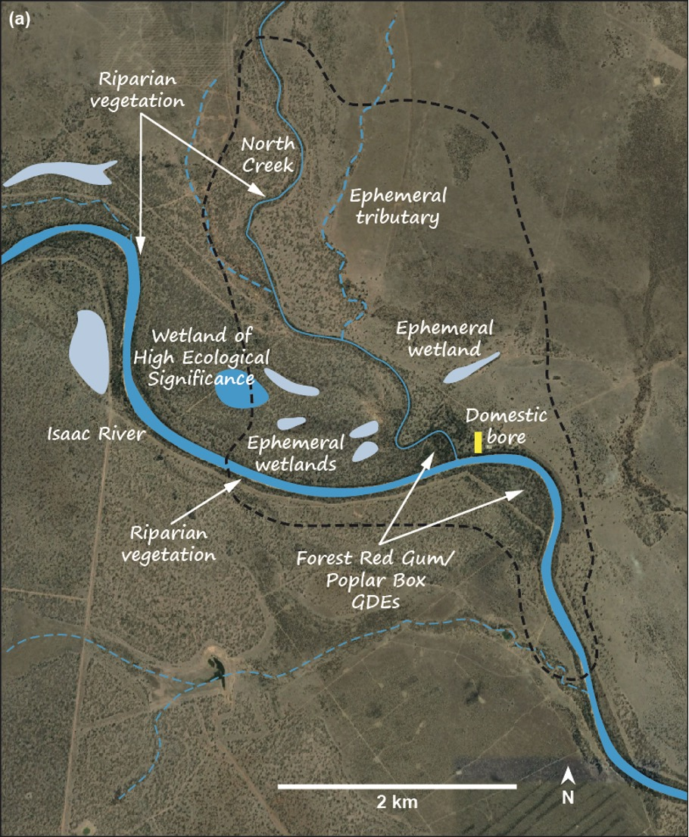

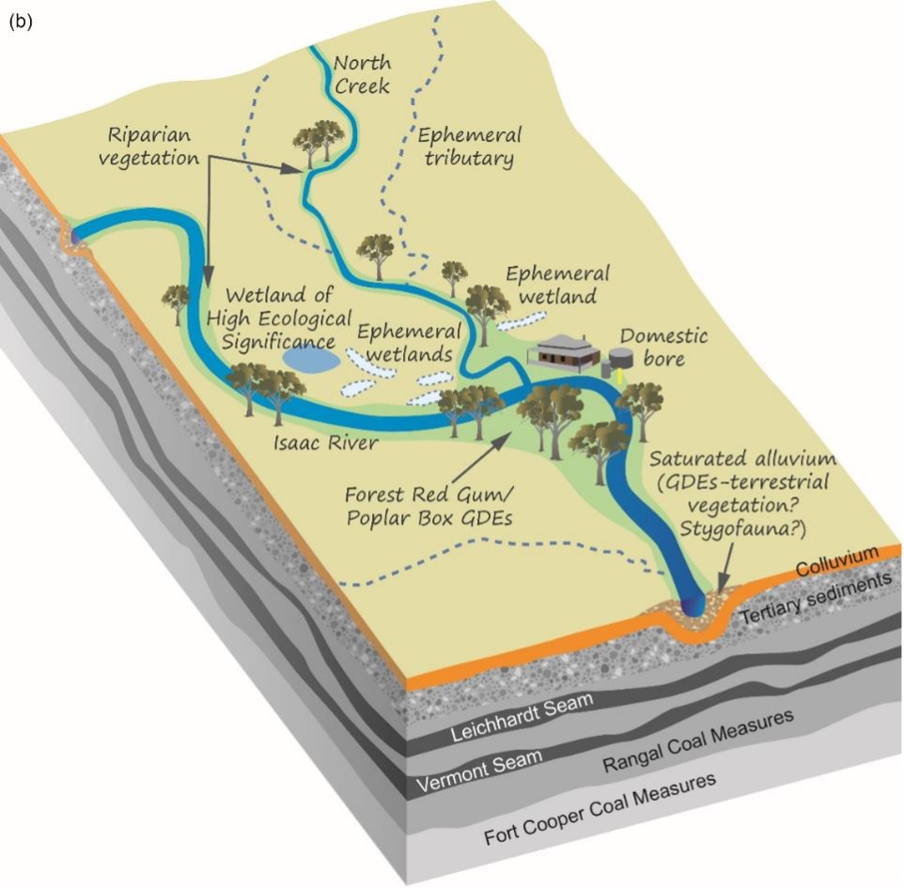

Figure 12. Plan (a) and oblique (b) diagrams of the potential surface and subsurface water resources (receptors) in the PIA (dashed polygon in (a)) of Hypothetical Mine that were proposed during the initial meeting of the expert consultants

Note: For simplicity, these maps do not include potential locations of other receptors such as EPBC Act-listed vertebrates. Representation of geological layers is simplified for this example and does not reflect the actual geology of this area.

Table 3. Partial excerpt of the list of receptors potentially vulnerable to impacts from the proposed development that were identified during the initial meeting of consultant experts

| **Receptor** | **Condition (where known)** |
| --- | --- |
| North Creek (downstream of proposed diverted channel)* |  |
| Isaac River |  |
| Wetland W* | Very good (classified as wetland of high ecological significance) |
| Ephemeral tributary |  |
| Forest Red Gum/Poplar Box GDEs at confluence* | Most trees in good condition (unpublished study on groundwater use by these two species) |
| Saturated alluvium at and just downstream of confluence* |  |
| Riparian vegetation along North Creek |  |
| Deverill bore* | Currently in use. Twenty years of groundwater depths, some water quality data (EC). Apparently 25 m deep in alluvium (to check) |

EC = electrical conductance. Receptors deemed especially vulnerable are marked with an asterisk. In some cases, information about the condition and other details of the receptor was also available.

The diagrams of the potential surface and subsurface water resources (receptors) in the PIA provided the ideal starting place for drawing up an initial ECM to facilitate discussion before commencement of the proposed development about how these water resources might be ecohydrologically linked. This preliminary ECM was drawn up as a simple box-and-arrow diagram (Figure 13) to show the potential linkages between the various water resources. Although simple diagrams like this are ideal for initial portrayal and discussion of general ecohydrological connections, they lack the spatial context of the project area (e.g., locations of impact sources and potentially vulnerable receptors). Therefore, once the links in the box-and-arrow ECM had been agreed upon, the hypothesised flow paths of these links (e.g., streamflows, groundwater fluxes, seepage, surface runoff) were superimposed on the plan and oblique views of the PIA and nearby areas (Figure 14). This now allowed the team to see where the flow paths of the inferred ecohydrological links might lie near sources of potential impacts associated with the proposed mine and lead to potentially vulnerable receptors. For example, hypothetical flow paths could be mapped from groundwater to the terrestrial GDEs and the ephemeral wetlands implied to be ‘high potential GDEs’ by the GDE Atlas (BOM undated) (Figure 10).

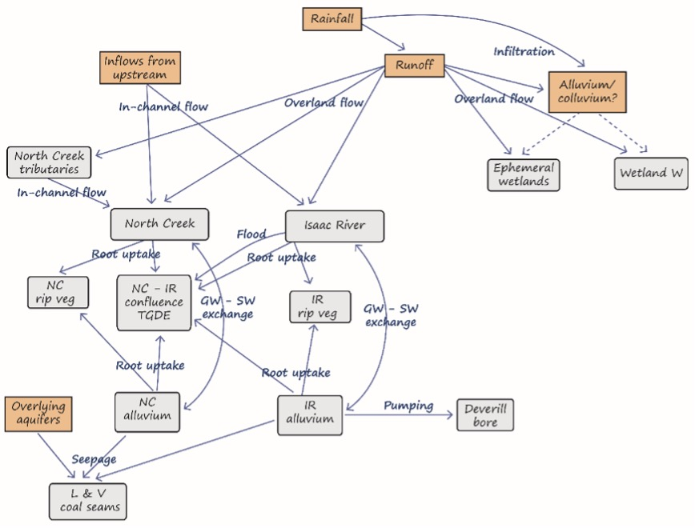

Figure 13. Preliminary box-and-arrow ECM drawn up by the consultant team to show the inferred ecohydrological pathways near and within the PIA

Receptors (water resources) are shaded in grey, other hydrological components are shaded in apricot, and processes are superimposed on the arrows. Dashed lines represent highly speculative pathways. GW = groundwater, SW = surface water, IR = Isaac River, NC = North Creek, TGDE = terrestrial GDE, L & V = Leichhardt and Vermont, rip veg = riparian vegetation.

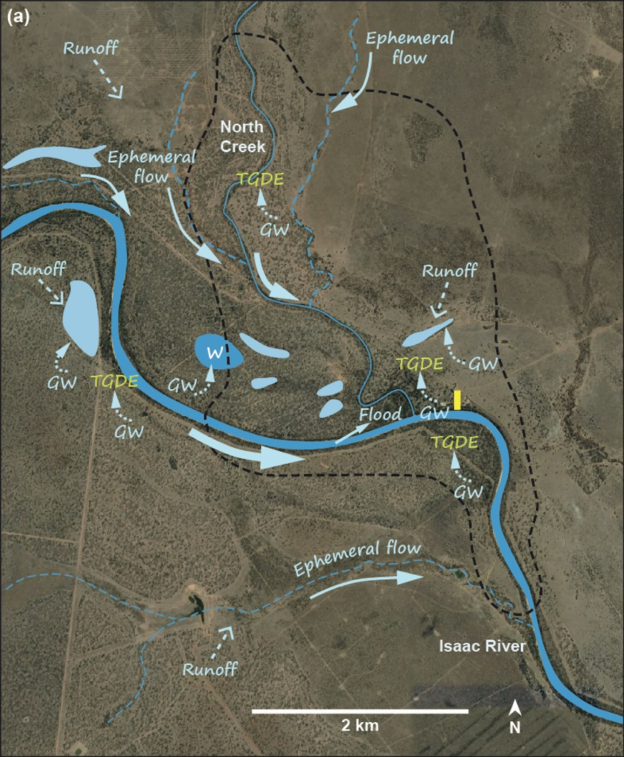

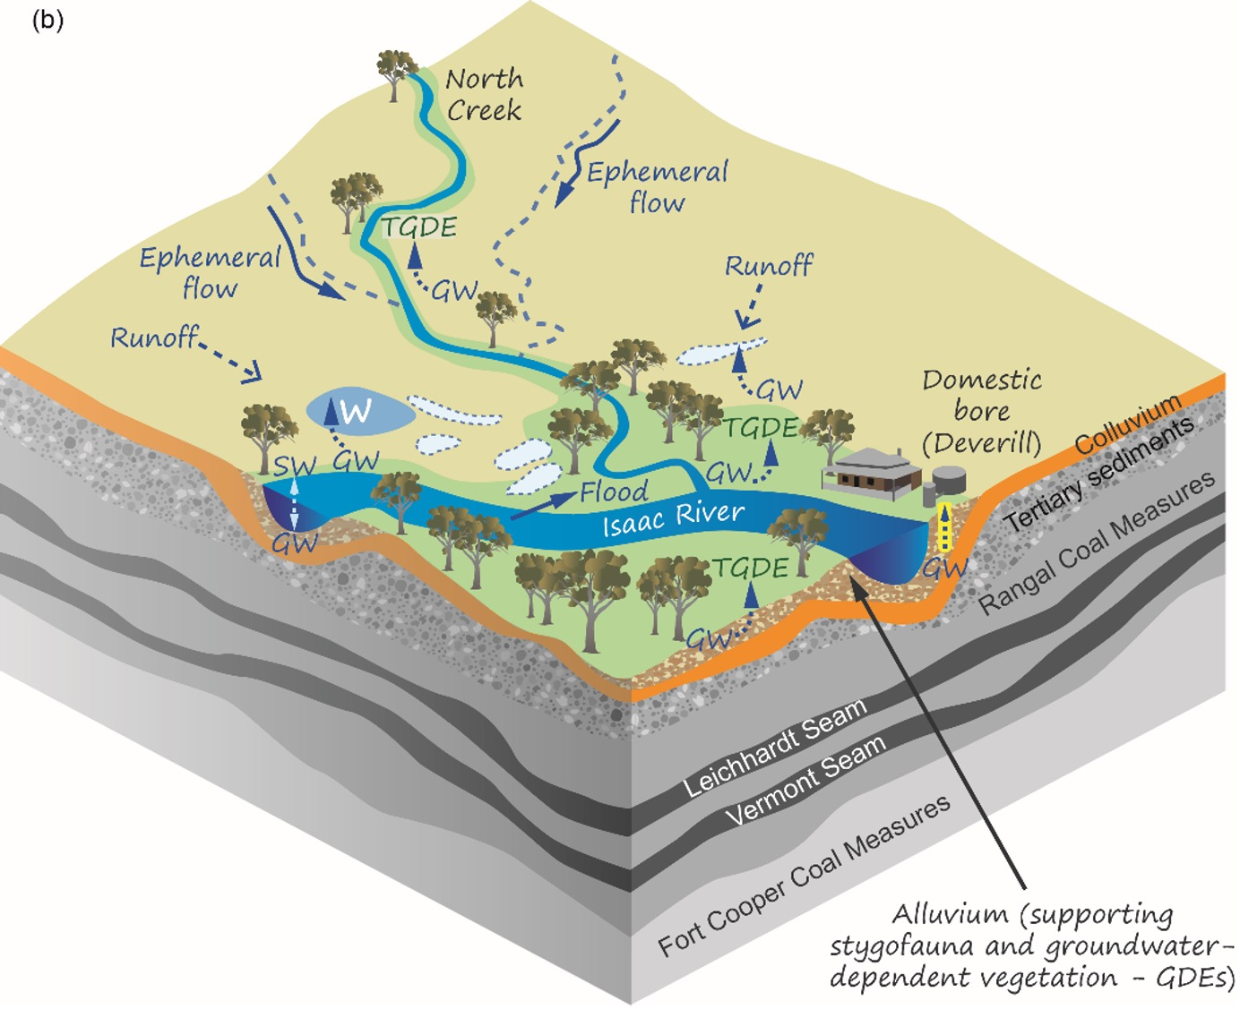

Figure 14. Preliminary plan (a) and oblique (b) diagrams of the ecohydrological pathways inferred near and within the PIA (dashed polygon in (a)) of Hypothetical Mine, and presented as a box-and-arrow ECM in Figure 13

In-channel flow and overbank floods are shown as solid arrows; groundwater movements are shown as dashed arrows. TGDE = terrestrial GDE, GW = groundwater, SW = surface water. Some pathways (e.g., evaporation, evapotranspiration, seepage to coal seams) are not shown. Representation of geological layers is simplified for this example and does not reflect the actual geology of this area.

By this stage, all the participants were familiar with the potential ‘sources’ (sites and activities) of impacts and stressors associated with the proposed project, the locations and likely sensitivity of the ecological receptors in the PIA, and the potential ecohydrological linkages in the project area. Where confidence was low in the distribution or other relevant information about sources, receptors or ecohydrological pathways, a third list was made to document the information gaps. For example, there was particular uncertainty about the groundwater resources, especially in the alluvial and colluvial sediments of North Creek, and their linkages, which was the cue for the two hydrogeologists to share their insights.

The hydrogeologists were sceptical that North Creek and the wetlands south-west of the proposed pit were truly GDEs as implied by Figure 10, and stated that field data were needed on groundwater levels and fluxes in the sediments underlying these surface waters to elucidate the likely groundwater dependence and ecohydrological connectivity. The ecologists agreed and there was discussion about planning some concurrent sampling of bores in the area to collect hydrogeological, water quality and stygofaunal data. There was general agreement that the alluvial sediments along the Isaac River and at its confluence with North Creek were more likely to be permanently saturated, and the botanist reminded the other experts of an unpublished field study demonstrating groundwater use by two riparian tree species at this location. Given the importance of the native vegetation in this area, it was agreed that field data were needed on groundwater fluxes, use by vegetation and groundwater water quality – another opportunity for concurrent collaborative sampling. The vertebrate ecologist added that it would be relevant to survey arboreal and other vertebrates in the area because they might be using this native vegetation for habitat and food.

Discussion then turned to groundwater modelling of the likely changes in groundwater levels and fluxes associated with the open-cut mining and, post mining, the refilling of the pit with waste rock. Groundwater models exist for the nearby mines, and the hydrogeologists discussed the insights from these models, particularly whether the proposed project might contribute to cumulative drawdown in the area. Given the likely presence of GDEs in the PIA, the hydrogeologists planned to model the progress and maximum extent of project-specific and cumulative drawdown during and after mining. Particular attention would be paid to potential changes in fluxes and depths to groundwater in the alluvium and colluvium (used by surface-expression GDEs) as well as the source aquifer for the Deverill bore.

There was also consultation with the hydrologist about the likely contribution of groundwater to baseflow in the Isaac River and whether predicted drawdown would have a detectable effect on the flow regime of the river. As the river only flows approximately 27% of the time at the Deverill gauging station (Figure 9), the hydrologist suggested that the most likely effects of drawdown would be on the duration and timing of the low- and zero-flow components of the flow regime. The aquatic ecologist explained how these components of the flow regime were relevant to aquatic biota such as fish and turtles, especially in refugial pools of the Isaac River. It was agreed that this was an area for further collaboration among the expert consultants to fill knowledge gaps about the likely hydrological and ecological responses to any changes in flow regime as a result of drawdown. Surveys of biota, water quality and hydrology of refugial pools in the Isaac River and the lower section of North Creek were planned to assess the baseline condition of these water resources and clarify their ecohydrological linkages.

The hydrologist and hydrogeologists discussed likely recharge routes of shallow groundwater in the PIA and the effects, if any, of the channel diversions of North Creek. Knowledge gaps included whether runoff into the ephemeral wetlands recharged shallow groundwater and might be a water source for fringing vegetation. This led to discussion of how the catchments of some of the wetlands were likely to be altered by the proposed channel diversion, how this might alter the surface water regime of the wetlands, and what the repercussions might be for aquatic and semi-aquatic biota. The list of information gaps grew.

There was vigorous discussion about the potential effects of the channel diversion on streamflow in North Creek and downstream, because few details were available on the design of the diversion, its bed form and materials, and even its final route – a key pathway identified in the preliminary ECM (Figures 13 and 14). The ecologists expressed concern that the diversion would substantially disrupt riparian vegetation and alluvial connectivity along the channel. Although the riparian vegetation connectivity might be partly mitigated by prompt establishment of suitable vegetation along the new channel, it was less clear how subsurface flows down North Creek could be maintained unless the channel’s bed was constructed in such a way as to allow this. The panel agreed that much more geomorphological, hydrological and ecological information was needed about the channel diversion to adequately assess its potential impacts and ways to mitigate them. This was useful feedback for the proponent’s representative, who promised to prioritise obtaining details of the planned channel form for the next meeting of the consultant team.

The ecotoxicologist was interested in whether controlled releases from the sediment and mine-affected water dams might affect the water quality and/or sediments in North Creek and perhaps the Isaac River. Although the controlled releases were to be done when there was considered to be sufficient flow in the receiving stream, it was not clear whether there might still be residual impacts, including from unintentional releases (e.g., overtopping of the dams) and/or seepage. Other possible sources of poor water quality that were discussed included seepage from rainfall infiltrating the waste-rock pile and, in the longer term, the refilled mine pit.

During all these discussions, the note-taker had been listing potential impact pathways and their constituent stressors. Where possible, measurement endpoints (Section 2.3) were suggested by the ecologists for particular receptors when discussing likely ecological responses to stressors in the listed impact pathways. These measurement endpoints included taxa richness, abundance or density, condition and persistence, and were relevant parameters to consider when designing survey and monitoring programs to collect baseline data and assess the effectiveness of mitigation measures (Sections 4.3 and 4.4). There were also side discussions about opportunities for combining expertise in the field; for example, the hydrologist and ecologists arranged to do several of the baseline surveys concurrently.

The facilitator asked the panel members whether they had any other particular points to discuss before the team collaborated to use the ECMs and preceding discussion to draw up an IPD with pathways linking the likely sources (Figure 11) with receptors (e.g., water resources, Figure 12). One consultant observed that there had been little discussion of the potential impact of existing activities such as the nearby mines and agricultural land use. It was agreed that these were relevant and should be acknowledged in the IPD. The team also acknowledged that it would be necessary to locate reference and monitoring sites so that the sampling program would be able to discriminate ongoing impacts of existing activities from those of the proposed development.

Two preliminary IPDs were drawn up concurrently – one as a simple box-and-arrow diagram (Figure 15) and the other superimposing the hypothesised pathways onto the map and oblique-view diagram of the project area (Figure 16, Table 4). This approach of drafting the two figures concurrently was the one that was preferred by the panel members, but some of the consultants had worked on panels where the preliminary IPD was not also superimposed on a map of the project area.

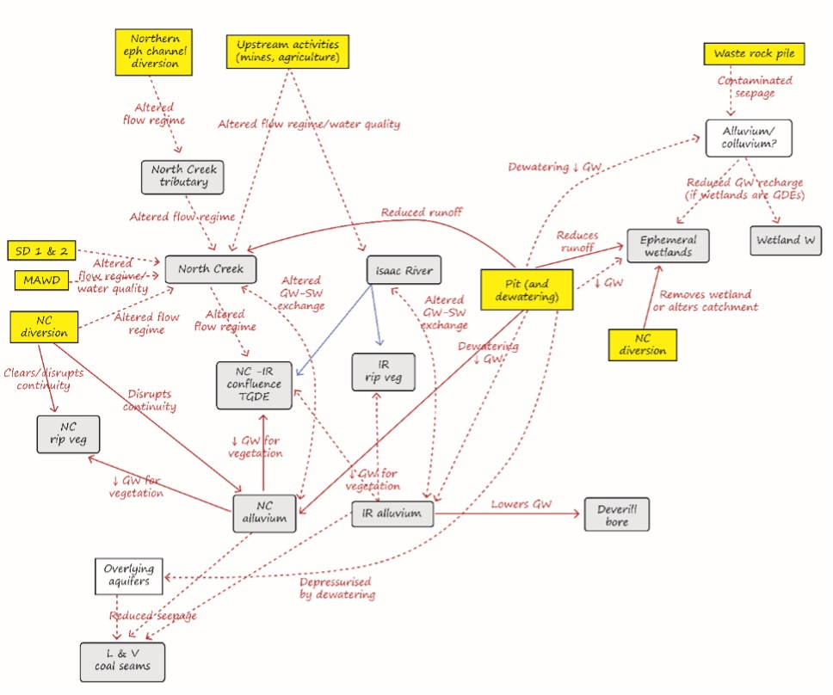

Figure 15. Initial IPD drawn up by the multidisciplinary team

Red arrows show impacts; blue arrows represent unimpacted hydrological pathways. Impact sources are in yellow, receptors (water resources) in grey, and processes superimposed on the arrows. Dashed lines indicate uncertain pathways. GW = groundwater, SW = surface water, IR = Isaac River, NC = North Creek, SD = sediment dam, MAWD = mine-affected water dam, TGDE = terrestrial GDE, L & V = Leichhardt and Vermont, eph = ephemeral, rip veg = riparian vegetation. Note that the North Creek diversion box is duplicated to reduce the need for arrows to cross over intervening boxes.

Table 4. Twelve potential impact pathways (Figure 16) suggested during the initial meeting of the expert consultants

| **Pathway number in Figure 16** | **Description of hypothesised pathway** |
| --- | --- |
| 1 | Changes in flow regime due to ephemeral channel diversion |
| 2 | Potentially contaminated seepage, either from dams or through the waste-rock pile |
| 3 | Controlled and uncontrolled releases from sediment and MAW dams that may alter water quality and flow regime in North Creek |
| 4 | **Drawdown that dewaters alluvial sediments and groundwater-dependent riparian vegetation along North Creek** |
| 5 | **Reduced runoff to North Creek caused by the pit** |
| 6 | **Drawdown that dewaters alluvial sediments and groundwater-dependent remnant vegetation near the North Creek–Isaac River confluence** |
| 7 | Altered flow regime and water quality along North Creek downstream of release points from the three dams and the new diversion channel |
| 8 | **Drawdown that dewaters the Deverill bore** |
| 9 | Altered flow regime and water quality along Isaac River downstream of North Creek |
| 10 | Altered surface water–groundwater exchange in North Creek and Isaac River caused by drawdown that dewaters alluvial sediments |
| 11 | **Disruption by the diverted channel of alluvial and riparian connectivity along North Creek** |
| 12 | **Altered/reduced runoff to ephemeral wetlands caused by the new diversion channel (and parts of some wetlands will be removed during construction of the channel)** |

MAW = mine-affected water. Pathways in bold type (4, 5, 6, 8, 11, 12) are those about which the team of experts felt confident; more information is required to confirm the likelihood and/or consequence of the others.

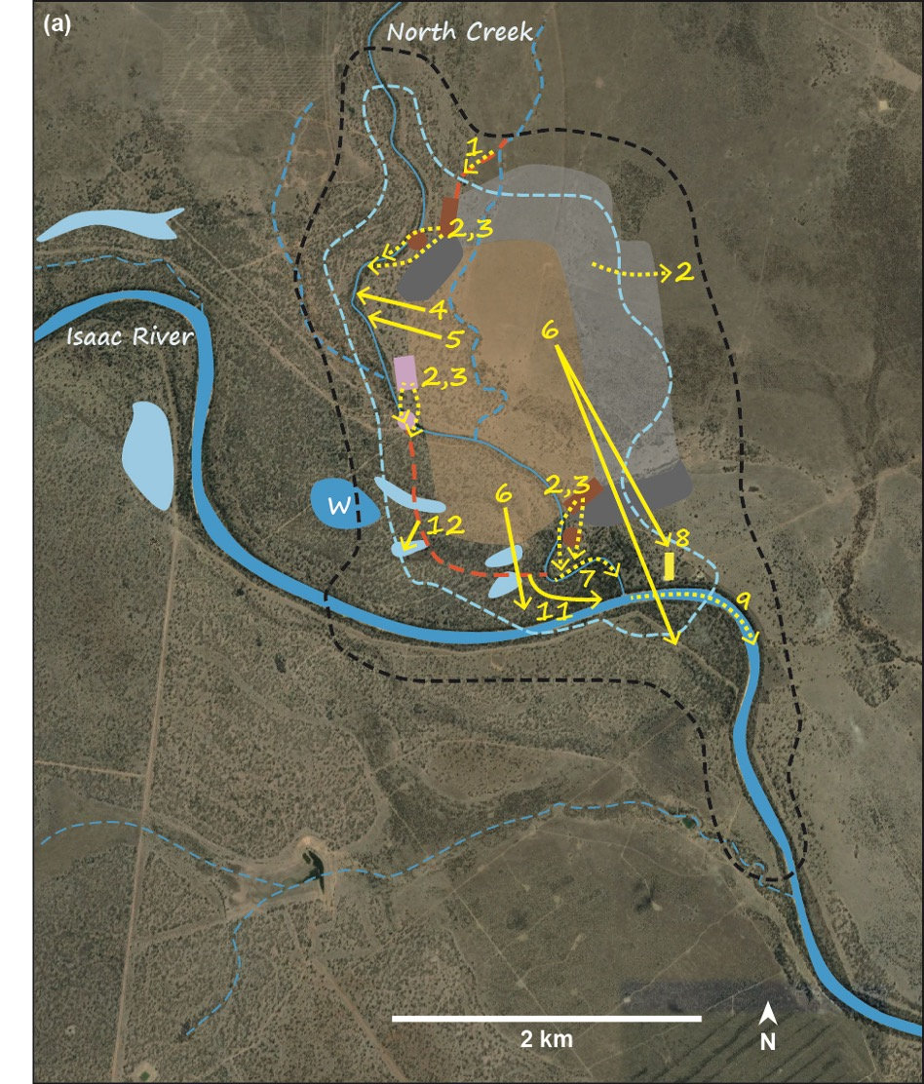

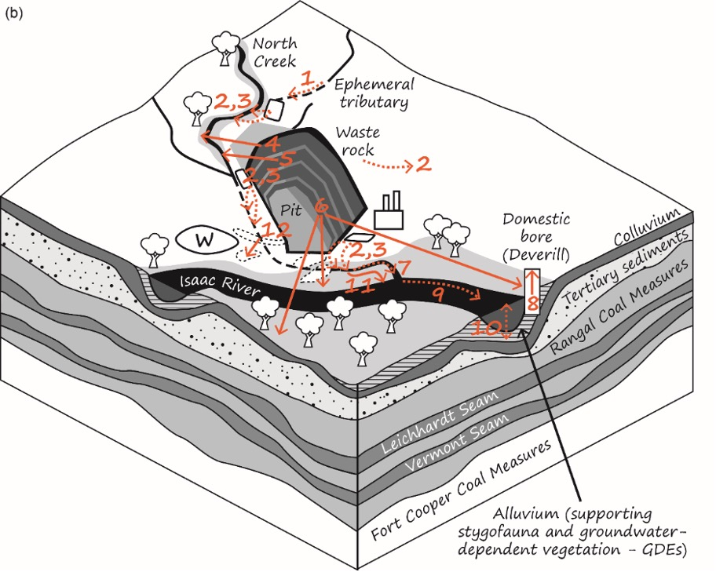

Figure 16. Twelve potential impact pathways suggested during the initial meeting of the expert consultants and superimposed on plan (a) and oblique (b) diagrams of the PIA (dashed polygon in (a)) of Hypothetical Mine

Dashed lines indicate uncertain pathways; numbered boxes represent the 12 pathways described in Table 4. Representation of geological layers is simplified for this example and does not reflect the actual geology of this area.

### 3.3.3 Subsequent meetings

There were three subsequent meetings during the two years following the initial meeting. The first meeting was about six months into the assessment, mainly to see whether preliminary sampling had indicated any additional impact pathways to consider or whether any of the original 12 needed to be modified or removed. It was agreed that potential changes in water quality covered in Pathways 3, 7 and 9 should be separated from potential changes in flow regime because the effects on aquatic receptors such as macroinvertebrates and fish might be different and occur by different mechanisms. No new pathways were added. Early results from the first set of baseline surveys were discussed, mainly to ensure that the field data were all relevant and had been collected at appropriate scales and resolution. This was especially important where different consultants planned to use the same data for their specialist reports. It also helped in finalising the best measurement endpoints for assessing the effectiveness of mitigation strategies (Sections 4.3 and 4.4).

Two further meetings were conducted 12 and 18 months after the initial meeting. By this time, substantial baseline data and other information had been collected, and the panel was able to refine the IPD because it had greater confidence in some of the inferred pathways. For example, there was now enough information to confirm that Pathway 7 (Table 4) was more likely than originally considered. Surveys had found several large refugial pools in the lower reaches of North Creek whose permanence and water quality were likely to be substantially altered by the planned channel diversion upstream. Groundwater modelling had also been completed so that predictions of the extent of drawdown could be refined (e.g., up to 4 m in Deverill bore). By now, the IPD was in a near-final format, and the team was confident about the key potential impacts of the project and their likely mechanisms and effects on receptors. There were also productive discussions about how to mitigate or remediate the impacts that would be unavoidable, and the team shared data and other evidence to support the feasibility of these proposed management measures.

The final meeting occurred soon after the main report had been prepared. This main report drew information from the various consultants’ reports, using the final version of the IPD (Figure 17) as a key graphic to collate the conclusions and inferences from various discipline areas. The main outputs of the final meeting were sets of comments on the main report to correct inconsistencies, confirm correct interpretation of the conclusions of the specialist reports, and support the proposed management strategies to minimise the project’s potential impacts. In the main report, the IPD appeared in the executive summary and later in the text, and greatly assisted with its coherent and succinct presentation of the key potential impacts of the project, their pathways, and how they might affect water resources and other receptors. The IPD was accompanied by a narrative that succinctly described each pathway and cross-referenced relevant sections of the report for supporting evidence. For some of the more complex impact pathways, sub-models of particular sources (e.g., North Creek diversion, Figure 18) were also drawn up, allowing more detailed listing of stressors and receptors.

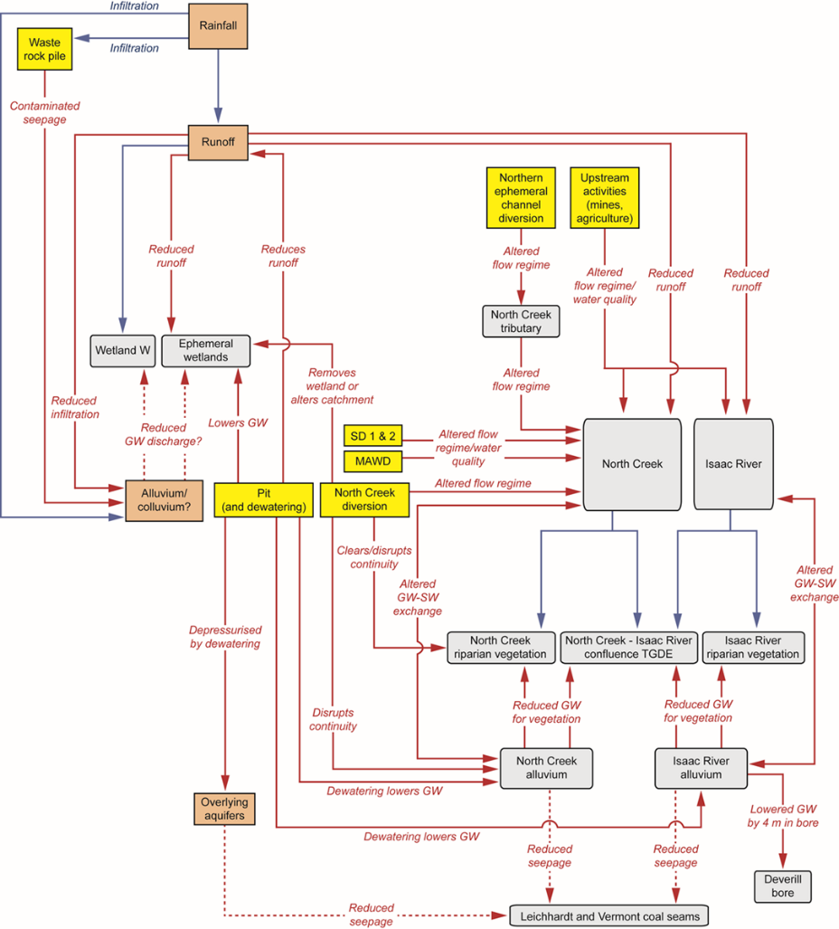

Figure 17. Final IPD, refined after several meetings of the team of expert consultants

Red arrows show impacts; blue arrows represent unimpacted hydrological pathways. Impact sources are shaded in yellow, receptors (water resources) are shaded in grey, and processes are superimposed on or near the arrows. Dashed lines indicate pathways that remain uncertain. MAWD = mine-affected water dam, SD = sediment dam, TGDE = terrestrial GDE.

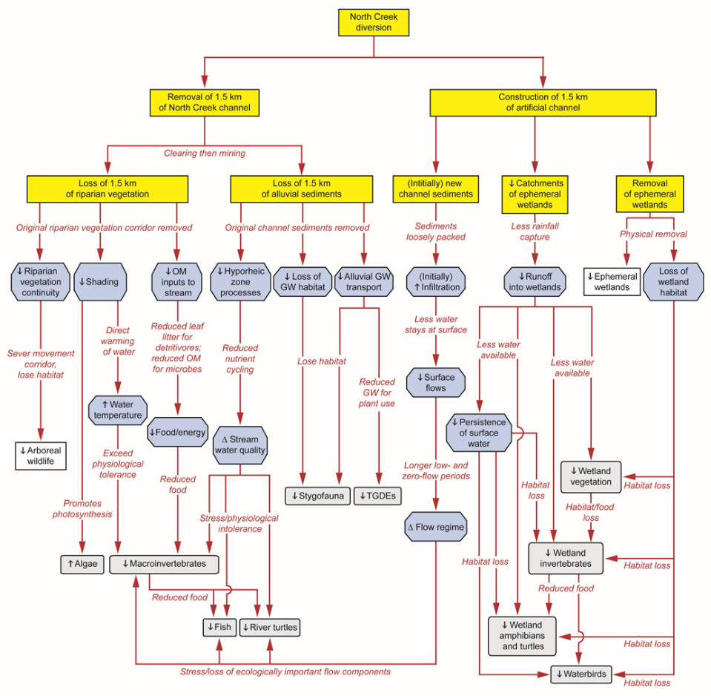

Figure 18. Detailed sub-model IPD of the potential impact pathways due to the diversion of North Creek

Anthropogenic sources are shaded in yellow, stressors in blue, and receptors (water resources) in grey. Processes are superimposed on or near the arrows. GW = groundwater, OM = organic matter, TGDE = terrestrial GDE. Directions of change are á = increase, â = decrease, r = change.

There were also final versions of the map and oblique-view diagram of the impact pathways (Figure 19) and the accompanying table (Table 5). Data collected during baseline surveys for the environmental impact assessment provided greater confidence in three pathways (Pathways 3, 7 and 10 in Table 5). Consequently the lines representing these three pathways, which were dashed in the preliminary figure (Figure 16), were drawn as solid (Figure 19) in the final report.

Table 5. Twelve potential impact pathways (Figure 19) of the proposed Hypothetical Mine on water resources in the PIA

| **Pathway number in Figure 19** | **Description of hypothesised pathway** |
| --- | --- |
| 1 | Changes in flow regime due to ephemeral channel diversion |
| 2 | Potentially contaminated seepage, either from dams or through the waste-rock pile |
| 3 | **Controlled and uncontrolled releases from sediment and MAW dams that may alter water quality and flow regime in North Creek** |
| 4 | **Drawdown that dewaters alluvial sediments and groundwater-dependent riparian vegetation along North Creek** |
| 5 | **Reduced runoff to North Creek caused by the pit** |
| 6 | **Drawdown that dewaters alluvial sediments and groundwater-dependent remnant vegetation near the North Creek–Isaac River confluence** |
| 7 | **Altered flow regime and water quality along North Creek downstream of release points from the three dams and the new diversion channel** |
| 8 | **Drawdown that dewaters the Deverill bore** |
| 9 | **Altered flow regime and water quality along Isaac River downstream of North Creek** |
| 10 | **Altered surface water–groundwater exchange in North Creek and Isaac River caused by drawdown that dewaters alluvial sediments** |
| 11 | **Disruption by the diverted channel of alluvial and riparian connectivity along North Creek** |
| 12 | **Altered/reduced runoff to ephemeral wetlands caused by the new diversion channel (and parts of some wetlands will be removed during construction of the channel)** |

MAW = mine-affected water. Pathways in bold type (3 to 12) are those that the team of experts felt confident about; more information is required to confirm the likelihood and/or consequence of the others.

(a)

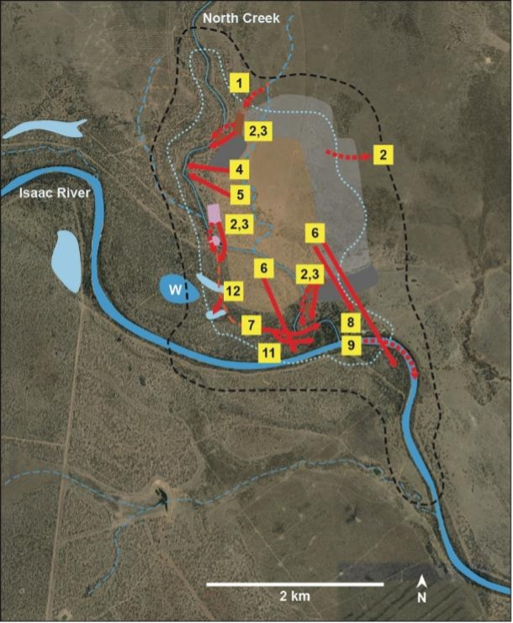

(b)

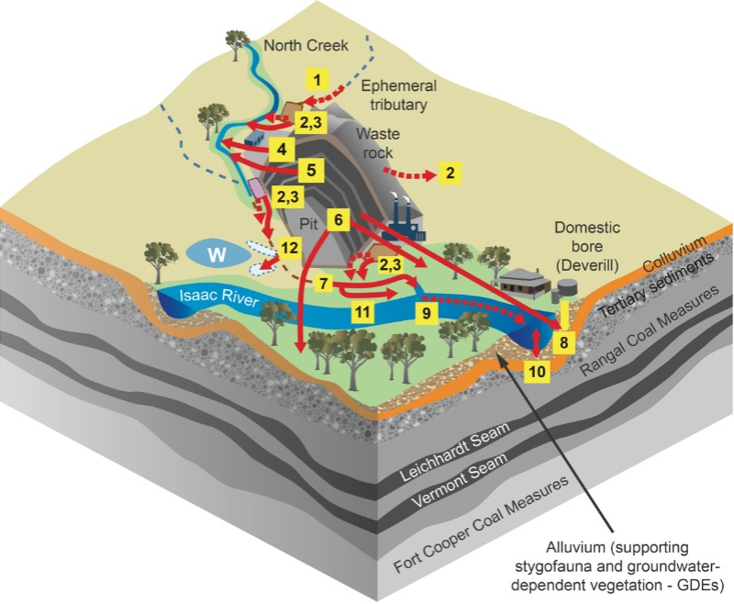

Figure 19. Twelve potential impact pathways of the proposed Hypothetical Mine on water resources superimposed on plan (a) and oblique (b) diagrams of the PIA (dashed polygon in (a))

Dashed lines indicate uncertain pathways; numbered boxes represent the 12 pathways described in Table 5. Representation of geological layers is simplified for this example and does not reflect the actual geology of this area.

1. How to use IPDs in environmental impact assessment

## 4.1 Introduction

Having generated the initial ECM, derivative IPDs and accompanying maps and narratives (Section 3), we now want to use the outputs for other parts of the environmental impact assessment process and in the final report. These uses include identifying information gaps underlying assumptions about pathways and their importance, guiding project-specific monitoring to address these gaps and provide ongoing environmental data, and justifying mitigation strategies to reduce risks of a proposed development’s activities to vulnerable receptors – all benefits of IPDs identified in Section 2.2.

It is important to acknowledge the limited resources available to most developers to address and ‘close out’ all the information gaps that might be identified – the ‘best practice’ example is presented in Section 2.4.3 as an aspirational target rather than expected to be the norm. Instead, the emphasis in this Explanatory Note is on the benefits of the conceptual modelling and IPDs for consultants’ ability to understand and communicate impact pathways. Nonetheless, where this activity reveals major gaps in knowledge about how a potential project might impact on water resources in the PIA, there is merit in either addressing these gaps or demonstrating that the impacts, even if they are likely, either are not material or can be readily mitigated. It is also important to acknowledge all assumptions and limitations of the derivation and interpretation of the IPDs for a given proposed development.

This section of the Explanatory Note begins by describing ways to use IPDs and other outputs in an environmental impact assessment report to portray the impact pathways of a given development and show where and how these pathways might convey impacts to vulnerable receptors in the PIA (Section 4.2). It then explains how to use the outputs to identify relevant knowledge gaps and design an efficient monitoring program to address these gaps (Section 4.3). This section also reviews the selection of measurement endpoints and sampling locations that can be justified using the IPD superimposed on a map of the PIA, supplemented with tables and narratives. Section 4.4 follows this logical thread to demonstrate the use of the diagrams and other outputs to propose and justify feasible mitigation strategies.

## 4.2 Portraying impact pathways

The two most useful graphics generated from the approach described in Section 3 are the final IPD (e.g., Figure 17 and any sub-models such as Figure 18) and the map of the PIA with the impact pathways superimposed on it (e.g., Figure 19).

The first shows the main pathways of concern, the key stressors and the most vulnerable receptors. It should be presented early in the final assessment report to integrate the different sections of the documentation and illustrate *which* impact pathways associated with the proposed development are considered with high confidence to be likely to occur and *which* receptors are potentially at greatest risk of impacts.

The second shows *where* these impact pathways are likely to occur and *where* the most potentially vulnerable receptors occur in the PIA. It also indicates ‘hotspots’ where multiple and, often, interacting impact pathways are likely to occur and have collective effects on a receptor. For example, drawdown from pit dewatering may act via a groundwater pathway to interact with a surface-water pathway conveying contaminated water to collectively impact a terrestrial GDE that depends on water from both ecohydrological pathways. Both these graphics should also be accompanied by suitable explanatory narratives and cross-reference relevant sections of the final report for supporting evidence, including baseline data, to justify the assertions of potential impacts, their pathways and predicted responses.

There is merit in presenting some of the other supporting graphics too. These graphics include maps of potential sources of development-related stressors (e.g., Figure 11), locations of water resources (e.g., Figure 12), and possibly the initial ECM superimposed on plan and oblique views of the PIA (e.g., Figure 13). One or both of the first two of these are presented in most reports but usually in different sections or even different appendices, which makes it difficult for the reader to readily integrate them when inferring likely impact pathways. Providing them together and discussing them in the context of the initial ECM highlights the reasoning underlying the derivation of the box-and-arrow diagrams and maps of the IPDs and helps the reader quickly grasp the proponent’s impression of the different impact pathways, what might be affected and where these effects might occur.

As mentioned in Section 3, it may be necessary to generate several ‘sub-models’ that are nested within the high-level IPD. These sub-models would be used to support more focused discussion in the environmental impact assessment report on specific pathways, specific phases of resource extraction (e.g., exploration, operations and rehabilitation) and/or specific areas of the PIA (e.g., ‘hotspots’ of complex or vulnerable receptors, and areas where multiple impact pathways interact). The sub-model diagrams can also show more detail such as finer levels of receptors (e.g., particular components of the biota of wetlands, rivers and groundwaters) and can include brief descriptions of the various processes along the impact pathways (e.g., Figure 18). Furthermore, these finer-scale sub-models, especially when superimposed on maps of the PIA, are likely to be useful when identifying and justifying potential monitoring sites (Section 4.3) and where to target specific avoidance or mitigation strategies (Section 4.4).

## 4.3 Identifying knowledge gaps and guiding design of monitoring programs

Predicting the potential environmental impacts of any proposed resource extraction inevitably involves numerous assumptions and inferences, especially during preliminary discussions of the expert consultant team (Section 3.2). Some of these assumptions can be made confidently because they are well supported with strong evidence and widely accepted. However, most assumptions about potential impact pathways and likely ecological responses in a specific area have far less supporting evidence and, in some cases, are just ‘best guesses’ because local data are usually so sparse.

Consequently, there is substantial uncertainty in predicting some of the environmental impacts of a given development, particularly when inferring likely impact pathways that have multiple linkages that all involve assumptions made with varying degrees of confidence. Confidence in an inferred impact pathway is only as strong as confidence in the weakest link (i.e., the link that has the most poorly supported critical assumptions and has the least confidence) (Peeters et al. 2021). Therefore, if this impact pathway appears to be relatively important in a given situation but has limited confidence associated with it, then collecting site-specific data and other local information to increase confidence in the weakest link is a priority. This is one way in which the process of using IPDs in an environmental impact assessment highlights relevant knowledge gaps.

Another way involves predicting the likely ecological responses of a valued receptor to one or more stressors. Ecological and ecotoxicological data are seldom available for local species. Therefore, assumptions about their likely responses to particular stressors are tentatively drawn from literature on similar taxa, often from different parts of the world and different environments. These assumptions can be perilous, especially as multiple stressors typically act together and their combined effects may not simply be additive. IPDs can highlight specific receptors that are potentially vulnerable to impacts from, for example, uncontrolled releases of mine-affected water via an impact pathway that might be rated as important yet with very low confidence associated with the reliability of the assessment. To address this uncertainty, relevant field and laboratory data (e.g., ecotoxicity tests using various concentrations of mine-affected water) are needed.

A third way involves highlighting key gaps in spatial knowledge. Mapped IPDs rely heavily on assumptions about likely impacts and potential ecological responses in particular parts of the PIA. For example, a desktop study using the GDE Atlas (BOM undated) may indicate terrestrial GDEs in an area where drawdown is predicted due to the proposed development. The assumption that GDEs exist in this area is an important one because of the challenges in mitigating impacts of drawdown on groundwater-dependent vegetation. Therefore, the proponent would want to test this assumption using field assessments of the extent of groundwater dependence of these potential terrestrial GDEs (see Doody et al. 2019 for methods); it may be that the vegetation in that area never depends on groundwater. Assumptions of the spatial extent and magnitude of drawdown in the PIA are also critical, and an IPD with impact pathway routes superimposed on a map of the PIA helps highlight ‘hotspots’ in the predicted drawdown area for more detailed assessments of uncertainty and sensitivity of the groundwater models used in the assessment.

Of course, many of the knowledge gaps underpinning key assumptions highlighted by the IPDs can only be addressed with further data or environmental monitoring of selected parameters in judiciously chosen locations. Although pre-operations environmental data collected for the environmental impact assessment report may have increased the evidence base and confidence in key assumptions underlying the impact assessment, many sources, stressors, processes and receptors (in our case, water resources) will vary over time and space. If the project or its effects are likely to extend longer than a decade, these changes will also interact with those associated with climate change and other drivers. The report must predict these variations, including at reference sites assumed to be unaffected by the proposed development, and present a monitoring program that will provide credible data to test these predictions and discriminate natural variation from changes caused by the development. These predictions should also encompass the post-closure period, because environmental conditions may continue to change (e.g., recovery of groundwater levels) and there may even be persistent legacy impacts (e.g., contaminants from tailings dams).

Mapped IPDs are ideal for justifying locations of proposed sampling points for relevant parameters (stressors, processes or measurement endpoints) for potentially important impact pathways. For example, Figure 19 could be used to justify the locations of sampling points along North Creek where water quality parameters could be monitored to assess potential impacts from controlled and uncontrolled releases from the MAW and sediment dams. The same reasoning applies to justifying the best locations for groundwater monitoring bores to track drawdown and altered water quality of groundwater below ground-truthed GDEs in the alluvial sediments of North Creek and the Isaac River.

The number of sampling locations and the intensity of monitoring are often informed by the consultant team’s assessment of the likely importance of each impact pathway. For pathways rated as very important, the mapped IPD could be used to justify additional sampling sites, a broader suite of parameters and more frequent sampling than for other pathways that are rated as less important. Similarly, the mapped IPDs can be used to identify and justify the locations of reference sites outside the PIA but, ideally, in areas where similar environmental conditions occur.

In most cases, the parameters that are monitored will be those for which baseline data were collected as well as measurement endpoints for receptors (Section 3.3). Explicitly linking measurement endpoints with the parameters that are sampled ensures that results can be tied back to the predictions of specific impact pathways in the IPD, especially where strategies have been adopted to mitigate impacts on valued receptors. Again, these responses must be interpreted against a backdrop of temporal variation, especially that associated with climate change. Monitoring of stressors or impact pathway processes is also often necessary to (1) confirm inferred impact pathways and (2) provide early warning of potential impacts on receptors. Thus, there needs to be a distinction between monitoring for impact effects (often based on measurement endpoints of receptors) and monitoring to inform precautionary management or intervention measures, which are typically based on monitoring of stressors or pathways.

Where the IPDs identify receptors that are likely to be especially vulnerable to impacts from activities associated with the proposed development, monitoring should focus on these receptors and the relevant stressors. Even if there is high confidence that the impact pathways leading to a vulnerable receptor are unlikely, the severity of the consequences usually warrants designing the monitoring program to be able to detect early warning signs of impending impacts on such vulnerable receptors. These monitoring programs would be spelled out in the management plans, justified using the IPDs and their associated narratives.

## 4.4 Proposing and justifying strategies to avoid or mitigate environmental impacts

A fundamental part of environmental impact assessment is the proposal and justification of strategies to avoid or, if this is not feasible, mitigate likely impacts of the development on valued receptors. Many environmental impact assessment reports present rather generic descriptions of mitigation strategies. They also seldom specify where and when the strategies will be applied or how their effectiveness will be assessed. These are serious failings because there may be environmental impacts of the development that either could readily be avoided by minor changes in the layout of the development or could be mitigated cheaply and effectively by judiciously placed controls.

IPDs superimposed on maps of the PIA illustrate the locations of potential impact pathways from sources to water resources, including via ecohydrological routes illustrated in the initial ECM. Therefore, they are ideal for guiding the most effective way for a proponent to avoid or mitigate potential impacts of the development on water resources in the PIA. In the worked example presented in Section 3, Figure 19 indicates that, for example, by changing the route of the planned diversion channel, it may be possible to avoid removing one or more of the ephemeral wetlands to the west of the mine pit. It may even be feasible to change the depth and/or extent of the pit to avoid or reduce drawdown below the terrestrial GDEs at the North Creek–Isaac River confluence yet still allow the mine to be economically viable.

In some cases, impacts are unavoidable but there are standard mitigation strategies available. These include, for example, releasing water from sediment and mine-affected water dams when flows in the receiving creek are high enough to dilute the released waters to an acceptable water quality. The timing and durations of controlled releases would be guided by data collected from appropriately located monitoring sites (Section 4.3), and the effectiveness of the release strategy in maintaining an acceptable water quality in the receiving creek would be monitored downstream, again guided by the mapped IPD. However, the impact on the receiving stream may be sufficiently severe to warrant additional mitigation strategies (e.g., erosion controls, water treatment). In our worked example, the sediments of the newly constructed artificial diversion may have insufficient assimilative capacity to cope with releases from the upstream mine-affected water dam (Figure 19), and the proponent may need to consider this in the environmental impact assessment report. The effectiveness of mitigation strategies in certain areas may also change in response to altered environmental conditions associated with climate change and other long-term drivers. For example, increases in mean water temperature in headwater streams due to climate change may reduce aquatic ecosystem resilience and lessen the effectiveness of mitigation strategies such as riparian restoration or in-stream habitat enhancement.

The mapped IPD will also indicate where mitigation strategies are not needed, and can help justify their omission. If there is high confidence that an impact pathway is of relatively low importance and impacts on water resources are highly unlikely, the mapped IPD could be used to justify not going to the expense or effort of installing mitigation works. For example, seepage from the waste-rock pile to the east of the mine pit is probably not an important impact pathway (although confidence in this assessment is low; see Figure 19) and so the proponent could argue that there is little need for extensive engineering works to prevent rainfall infiltration and contaminated seepage from the waste-rock pile.

1. Summary and conclusions

## 5.1 Summary

Impact pathway diagrams based on an initial ECM are powerful tools in environmental impact assessment yet are currently underused. They greatly enhance the integration and communication of the predictions in an environmental impact assessment, especially when superimposed on maps of the proposed development and surrounding PIA. They require no additional information beyond that expected in a competently prepared environmental impact assessment report, and their use helps ensure that redundant information is not included in the report. They also promote targeted and efficient collection of baseline data that can be readily justified with reference to the diagrams, maps and associated narratives.

When based on an initial ECM and accompanied by suitable narratives and maps, IPDs:

* provide effective visual summaries of potential impact pathways from sources to relevant receptors (water resources)
* can be presented at multiple levels (as ‘sub-models’) to reflect heterogeneity across the development area and/or focus on particular sources, receptors or pathways
* highlight where information is needed to support assumptions about inferred pathways and their importance, and where there are multiple hypotheses about impacts that require further investigation
* indicate pathways where mitigation is feasible to reduce risks to vulnerable receptors and guide project-specific monitoring (e.g., relevant parameters and sampling locations) to assess the effectiveness of proposed mitigation strategies
* are powerful tools for integrating information from different sections of the assessment documentation to best convey evidence for a proposed development’s potential impacts
* when done early in the assessment process, can help define the quantities of interest and key predictions for subsequent surface and groundwater modelling
* can provide environmental context for associated groundwater and surface-water numerical models.

During preparation of documentation for environmental impact assessment, the process of developing an initial ECM and derivative IPDs is also valuable because it encourages collaboration among consultants from different disciplines to share their knowledge and understanding, and then successively refine their predictions and evidence base as baseline data and information accumulate. Thus, **both the products and the process of this conceptual modelling greatly improve the quality of the EIS and the overall environmental assessment**.

It is crucial for the team of expert consultants conducting the assessment to meet as early as possible to discuss the likely impact pathways and generate an initial ECM and one or more preliminary IPDs. The IPDs, mapped onto plan and oblique views of the PIA, should be presented in the final report to portray the potential impact pathways of a given development and show where and how they might convey impacts to vulnerable receptors in the PIA. These outputs can also help the proponent identify relevant knowledge gaps, design an efficient monitoring program to address these gaps and collect environmental data during operations, and propose and justify feasible avoidance and mitigation strategies.

## 5.2 Conclusions

We have outlined the many compelling reasons for proponents and their consultants preparing environmental impact assessment reports to use IPDs based on an initial ECM, and described how to generate these diagrams with an approach that uses data and information that are already routinely collected in environmental impact assessment. The IPDs can be comparatively simple box-and-arrow models and superimposed on plan- and oblique-view graphics of the PIA without a need for specialist software packages. Although there are more sophisticated approaches that can be used in environmental impact assessment, such as Bayesian modelling (e.g., McDonald et al. 2016) and the spatial causal network approach described by Peeters et al. (2021), these are unlikely to be needed for most environmental impact assessments. However, if formal risk assessment is required or the proposal is especially large and complex, there may be merit in considering these options.

This balance between project complexity, potential impact and the most suitable approaches for conceptual modelling underpins the notion of ‘requisite simplicity’ (Stirzaker et al. 2010). Requisite simplicity seeks to discard needless detail while retaining conceptual clarity and scientific rigour, and goes to the heart of generating IPDs that are fit for purpose for environmental impact assessment of a given development. Presenting IPDs early in the report will help readers quickly grasp the potential impact pathways that may be important and see which receptors might be at risk if the development is approved.

In conclusion, we strongly advocate both the products and the process of deriving IPDs because they greatly enhance the overall effectiveness of environmental impact assessment, with substantial benefits to proponents, regulators and other users. The most powerful approach is for the team of consultant experts to meet early in the process and generate an initial ECM and one or more preliminary IPDs, map the IPDs onto the PIA, and list information gaps that, when addressed, will lead to a revised version for the final environmental impact assessment report.

# Abbreviations

| **Abbreviation** | **Full term** |
| --- | --- |
| BOM | Bureau of Meteorology |
| CADDIS | Causal Analysis/Diagnosis Decision Information System |
| CSG | Coal seam gas |
| ECM | Ecohydrological conceptual model |
| EIS | Environmental impact statement |
| EPBC Act | *Environment Protection and Biodiversity Conservation Act 1999* (Cth) |
| GDE | Groundwater-dependent ecosystem |
| IESC | Independent Expert Scientific Committee on Coal Seam Gas and Large Coal Mining Development |
| IPD | Impact pathway diagram |
| LCM | Large coal mine |
| MAW | Mine-affected water |
| PIA | Potential impact area |
| TGDE | Terrestrial groundwater-dependent ecosystem |
| US EPA | United States Environment Protection Agency |

# Glossary

Terms are defined in the context of their use in this Explanatory Note. For some terms, references are cited because they either define the term or provide relevant discussion.

| **Term** | **Definition** |
| --- | --- |
| Anthropogenic | Caused by human activities (human induced). |
| Assessment endpoint | An explicit expression of the environmental value to be protected. An assessment endpoint must include an entity and a specific attribute of that entity (Suter 2000). |
| Baseline data | Data collected before a development begins (usually for at least two years (IESC 2024)) to establish conditions against which changes can be compared when the development commences. |
| Box-and-arrow diagram | As the name suggests, a diagram comprising boxes and arrows where the boxes represent states and the arrows represent transitions or links among the states. |
| Causal model | Synonym for conceptual model (cf. Peeters et al. 2022). |
| Causal network | Output from causal modelling (cf. Peeters et al. 2022). |
| Collective impacts | Combined effects of multiple stressors at a given time (i.e., does not include historical single or combined impacts – see Cumulative impacts). |
| Conceptual model | Simplified representation of a system of interacting components and their linkages, widely used in many disciplines as a powerful tool for understanding and describing relationships among components in complex systems. |
| Cumulative impacts | Impacts typically resulting from the collective and interacting effects of multiple stressors and arising from multiple sources over time whose impacts have accumulated. For example, collective impacts of stressors such as surface water extraction, native vegetation clearance and groundwater drawdown from several adjacent mines may combine with the impacts of other stressors that have occurred previously and may still be arising from nearby activities such as agriculture and urbanisation to cumulatively impact on water resources (as defined in Box 1). |
| Development footprint | The area that will be directly affected by a development by, for example, vegetation clearance and inundation by dams or diverted channels. Also see Potential impact area. |
| Dewatering | Removing water, usually groundwater. Mine pits typically have to be dewatered to access desired mineral resources, causing drawdown of connected aquifers around the pit. |
| Drawdown | Lowering of groundwater level, usually by removing groundwater. |
| Driver | ‘Major external driving forces (human or natural) that have large-scale influences on natural systems’ (Peeters et al. 2021). |
| Ecohydrological conceptual model (ECM) | A type of conceptual model that represents and integrates data and other information on hydrological (surface water and groundwater) components with ecological ones (e.g., specific taxa, communities and ecosystems) to understand and communicate their interactions. |
| Ecological risk assessment | A process that evaluates the likelihood that adverse ecological effects are occurring as a result of exposure to one or more stressors (US EPA 1998). |
| Endpoint | Synonym for receptor. Endpoints lie at the end of impact pathways. |
| Evapoconcentration | Process by which the concentration of a solution increases through evaporation. |
| Evapotranspiration | Process by which water is transferred from land, water and plant surfaces to the atmosphere by evaporation from the soil and other surfaces and by transpiration from plants. |
| Groundwater-dependent ecosystem (GDE) | Ecosystems that require access to groundwater on a permanent or intermittent basis to meet all or some of its water requirements so as to maintain its communities of plants and animals, ecological processes and ecosystem services. Examples include groundwater-dependent terrestrial vegetation, surface waters (swamps, lakes and rivers), and ecosystems in aquifers and caves. |
| Impact pathway | Connection or route along which an impact associated with a proposed development is inferred to travel from one or more sources to one or more receptors as portrayed in an impact pathway diagram. |
| Impact pathway diagrams (IPDs) | Conceptual models, often box-and-arrow types, used specifically to understand and communicate potential impact pathways between sources and receptors in an environmental impact assessment. |
| Measurement endpoint | ‘A measurable environmental characteristic related to the valued characteristic chosen as the assessment endpoint’ (Suter 1990). These are used to measure the response of a receptor (assessment endpoint) to one or more stressors. |
| Narrative | Text and/or tables accompanying IPDs to explain the current knowledge of the components and linkages in the conceptual models, provide and evaluate confidence in relevant supporting evidence, and inform estimates of the likely importance of impact pathways. |
| Potential impact area (PIA) | The maximum areal extent of potential impacts of a development (Peeters et al. 2021). |
| Process | ‘… any environmental process that provides a pathway to release, disperse or transform a stressor from a source’ (Stauber et al. 2022). |
| Receptor | ‘… the ecological entity exposed to the stressor. This term may refer to tissues, organisms, populations, communities, and ecosystems’ (US EPA 1998). Synonymous with endpoint. |
| Requisite simplicity | In conceptual modelling, the trade-off between practical usefulness and real-life complexity so that the product is not over-simplistic but also not so complex that it is difficult to use (see Stirzaker et al. 2010). |
| Source | An entity or action that generates or increases stressors in the environment. |
| Stressor | ‘… any physical, chemical or biological entity that can induce an adverse response’ (US EPA 1998). |
| Stygofauna | Fauna, mainly invertebrates, occurring in groundwater ecosystems such as aquifers and cave streams. |
| Sub-models | Finer-scale and more detailed IPDs that focus on specific sources, pathways, events, receptors or particularly valued areas in the potential impact area. They are often ‘nested’ within the high-level IPD (e.g., US EPA 2014). |
| Water resources | As defined in the *Water Act 2007* (Commonwealth of Australia 2007) and used in this Explanatory Note: ‘(a) surface water or ground water; or (b) a watercourse, lake, wetland or aquifer (whether or not it currently has water in it); and includes all aspects of the water resource (including water, organisms and other components and ecosystems that contribute to the physical state and environmental value of the water resource).’ |

# References

Australian Government undated. *Conceptual models*. Australian & New Zealand Guidelines for Fresh & Marine Water Quality website, Australian Government Initiative, Commonwealth of Australia. Available [online]: <https://www.waterquality.gov.au/anz-guidelines/resources/key-concepts/conceptual-models> accessed 30 December 2022.

Bartolo RE, Harford AJ, Bollhoefer A, van Dam RA, Parker S, Breed K, Erskine W, Humphrey CL and Jones DR 2017. Causal models for a risk-based assessment of stressor pathways for an operational uranium mine. *Human and Ecological Risk Assessment* 23: 685–704.

Bayliss P, van Dam RA and Bartolo RE 2012. Quantitative ecological risk assessment of the Magela Creek floodplain in Kakadu National Park, Australia: Comparing point source risks from the Ranger uranium mine to diffuse landscape-scale risks. *Human and Ecological Risk Assessment* 18: 115–151.

Bureau of Meteorology (BOM) undated. *Groundwater dependent ecosystems atlas*. Australian Government, Bureau of Meteorology. Available [online]: [http://www.bom.gov.au/water/groundwater/gde](http://www.bom.gov.au/water/groundwater/gde/) accessed 12 January 2023.

Burgman MA 2005. *Risks and decisions for conservation and environmental management*. Cambridge University Press, Cambridge, UK.

Commonwealth of Australia 2007. *Water Act 2007*. <https://www.legislation.gov.au/Details/C2017C00151/html/text>

DCCEEW (Department of Climate Change, Energy, the Environment and Water) 2022. *Significant Impact Guidelines 1.3: Coal seam gas and large coal mining developments – impacts on water resources*. Department of Climate Change, Energy, the Environment and Water, Australian Government, Canberra. Available [online]: <https://www.dcceew.gov.au/environment/epbc/publications/significant-impact-guidelines-13-coal-seam-gas-and-large-coal-mining-developments-impacts> accessed 15 January 2023.

Doody TM, Hancock PJ and Pritchard JL 2019. *Information Guidelines Explanatory Note: Assessing groundwater-dependent ecosystems*. Report prepared for the Independent Expert Scientific Committee on Coal Seam Gas and Large Coal Mining Development. Department of the Environment and Energy, Commonwealth of Australia, Canberra. Available [online]: <https://www.iesc.gov.au/publications/information-guidelines-explanatory-note-assessing-groundwater-dependent-ecosystems> accessed 13 January 2023.

Entrekin S, Evans-White M, Johnson B and Hagenbuch E 2011. Rapid expansion of natural gas development poses a threat to surface waters. *Frontiers in Ecology and Environment*, 9: 503–511.

IESC 2024. *Information Guidelines for proponents preparing coal seam gas and large coal mining development proposals*. Independent Expert Scientific Committee on Coal Seam Gas and Large Coal Mining Development. Available [online]: <https://www.iesc.gov.au/publications/information-guidelines-independent-expert-scientific-committee-advice-coal-seam-gas> accessed 20 February 2024.

McDonald KS, Tighe M and Ryder DS 2016. An ecological risk assessment for managing and predicting trophic shifts in estuarine ecosystems using a Bayesian network. *Environmental Modelling & Software*, 85: 202–216.

Norton SB and Schofield KA 2017. Conceptual model diagrams as evidence scaffolds for environmental assessment and management. *Freshwater Science*, 36: 231–239.

Peeters LJM and Middlemis H 2023. *Information Guidelines Explanatory Note; Uncertainty analysis for groundwater modelling*. Report prepared for the Independent Expert Scientific Committee on Coal Seam Gas and Large Coal Mining Development. Department of the Environment and Energy, Commonwealth of Australia, Canberra. Available [online]: <https://www.iesc.gov.au/publications/information-guidelines-explanatory-note-uncertainty-analysis> accessed 20 February 2024.

Peeters LJM, Holland KL, Huddlestone-Holmes CR and Boulton AJ 2022. A spatial causal network approach for multi-stressor risk analysis and mapping for environmental impact assessments. *Science of the Total Environment*, 802: 149845.

Peeters LJM, Holland KL, Huddlestone-Holmes CR, Brandon C, Lawrence E and Tetreault-Campbell S 2021. *Introduction to causal networks*. Geological and Bioregional Assessment Program. Department of Agriculture, Water and the Environment, Bureau of Meteorology, CSIRO and Geoscience Australia. Available [online]: <https://www.bioregionalassessments.gov.au/gba/introduction-causal-networks> accessed 30 December 2022.

Quanz M, Willis R, Burr D, Recoskie R and Walker TR 2020. Aquatic ecological risk assessment frameworks in Canada: a case study using a single framework in South Baymouth, Ontario, Canada. *Environmental Monitoring and Assessment*, 192: 530.

Stirzaker R, Biggs H, Roux D and Cilliers P 2010. Requisite simplicities to help negotiate complex problems. *Ambio*, 39: 600–607.

Stauber JL, Adams MS, Batley GE, Golding LA, Hargreaves I, Peeters L, Reichelt-Brushett AJ and Simpson SL 2022. A generic environmental risk assessment framework for deep-sea tailings placement. *Science of the Total Environment*, 845: 157311.

Suter GW 1990. Endpoints for regional ecological risk assessments. *Environmental Management*, 14: 9–23.

Suter GW 2000. Generic assessment endpoints are needed for ecological risk assessment. *Risk Analyses*, 20: 173–178.

US EPA (United States Environmental Protection Agency) 1998. *Guidelines for ecological risk assessment*. DC Federal Register, Washington, DC.

US EPA (United States Environmental Protection Agency) 2014. *An assessment of potential mining impacts on salmon ecosystems of Bristol Bay, Alaska*. Seattle, WA. EPA-901-R-14-001. Available [online]: <https://www.epa.gov/sites/default/files/2015-05/documents/bristol_bay_assessment_final_2014_vol1.pdf> accessed 20 February 2024.

US EPA (United States Environmental Protection Agency) 2017. *Causal Analysis/Diagnosis Decision Information System (CADDIS)*. Office of Research and Development, Washington, DC. [www.epa.gov/caddis](http://www.epa.gov/caddis)

Webb JA, Schofield K, Peat M, Norton SB, Nichols SJ and Melcher A 2017. Weaving the common threads in environmental causal assessment methods: towards an ideal method for rapid evidence synthesis. *Freshwater Science*, 36: 250–256.

**Official crest of the Australian Government. This initiative is funded by the Australian Government. 
www.iesc.environment.gov.au
**

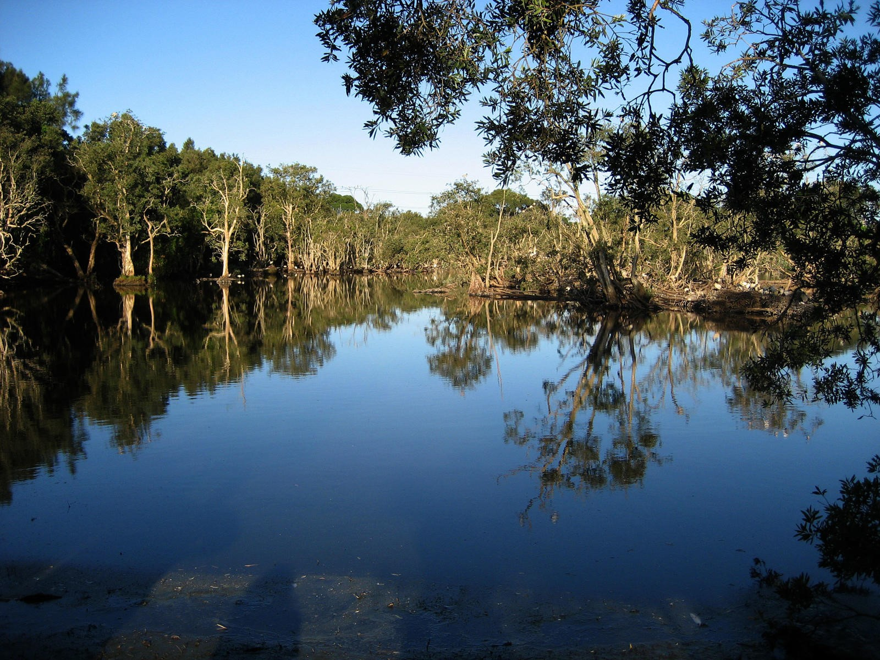

1. In this Explanatory Note, we are assuming that a proponent has employed multiple consultants from different disciplines such as hydrogeology, hydrology, ecotoxicology and ecology to contribute relevant sections to the assessment documentation.