Uncertainty analysis for groundwater modelling

# Background

Groundwater modelling is a core aspect of assessing the potential environmental impacts of coal seam gas and large coal mines on water resources.

The subsurface environment is complex, heterogeneous and difficult to directly observe, characterise or measure. Groundwater systems are influenced by geology, topography, vegetation, climate, hydrology and human activities. Uncertainty affects our ability to accurately measure or describe the existing or predicted states of these systems.

Groundwater modelling plays a key role in decision support by quantifying the level of risk associated with developments and management options, and providing evidence that the uncertainties affecting impact predictions are not underestimated and management risks are not understated.

Simply put, risk – involving both the likelihood and the consequence of a particular hazard or impact – cannot be assessed without an understanding of uncertainty. An uncertainty analysis provides a range of model predictions, relevant to risk-based decision-making, that are consistent with knowledge of the system and with observations.

Uncertainty analysis is essential to understand, quantify, predict, manage, mitigate, reduce and communicate uncertainty so as to enable wise decision-making and inform management, policy and technical matters.

# Context

There are many unknowns and challenges in groundwater modelling of potential environmental impacts from coal resource developments. Our understanding and knowledge of the subsurface environment is not perfect; nor is our ability to capture its complexity in groundwater models. This means that there will always be a degree of uncertainty in groundwater model predictions.

The IESC Information Guidelines suggest:

* modelling results be presented to show the range of possible outcomes based on uncertainty analysis, consistent with system understanding and observations
* assessments of potential impacts outline the quality of the background data, and the risks and uncertainty inherent in the modelling, particularly with respect to predicted potential scenarios
* assessments acknowledge uncertainties, identify the sources of errors (e.g. conceptual model and parameter uncertainty) and quantify the level of uncertainty.

To assist with meeting the requirements of the IESC Information Guidelines and with further advancements in knowledge, the IESC Explanatory Note on uncertainty analysis for groundwater modelling provides additional guidance to stakeholders commissioning or reviewing an uncertainty analysis, and outlines some minimum standards:

* clear definition of quantity of interest and the model outcomes sought in specific terms
* justification of the methods, assumptions and assertions
* objective evidence that the uncertainties affecting decision-critical predictions of impacts on aquifer resources and dependent systems are not underestimated
* transparent documentation of methods and results such that they are open to scrutiny, and consideration of the effects of potential bias.

The Explanatory Note on uncertainty analysis for groundwater modelling complements the detailed technical methodologies that are championed by the Groundwater Modelling Decision Support Initiative (gmdsi.org).

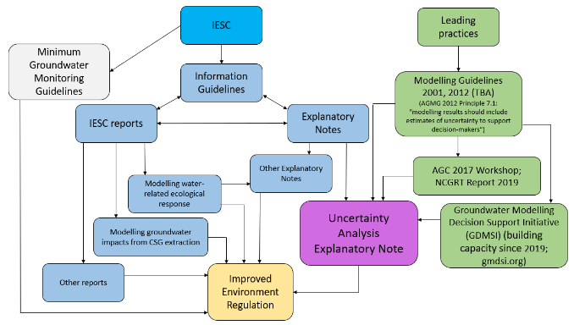

Flow chart showing the linkages between resources as described in this section

# Impact assessment and management

Uncertainty analysis of a groundwater model starts with clearly defining the quantity of interest: the model outcomes that are relevant for risk-based decision-making. This is preferably done by identifying potential causal pathways for impacts. A causal pathway is a logical chain of events (either planned or unplanned) that links the planned resource development and potential impacts on water resources. Once causal pathways are identified, they inform the modelling approach, the sources of uncertainty to consider and the model outcomes required. Ecohydrological conceptual models and causal pathways will be addressed in a future complementary Explanatory Note which is in preparation (2023).

Adaptive management involves implementing management actions, monitoring and evaluating outcomes, and systematically adapting management actions according to what is learnt. Adaptive management is often invoked to address environmental issues in the face of uncertainty, but reviews of adaptive management principles and groundwater management plans have revealed significant shortcomings, such as:

* lack of specific objectives
* unclear monitoring approaches
* absence of substantive mitigation measures that are explicitly described in unambiguous terms
* underdeveloped predictive models for assessing alternative management actions and investigating uncertainties.

Proposing vague adaptive management actions should not be able to be used as a pretext to defer or avoid detailed up-front analysis of environmental impacts and management options. Three key factors are critical to the design of effective adaptive management strategies:

* the permanence (or conversely, the ‘reversibility’) of groundwater impacts
* the severity of groundwater impacts from project operations.
* the level of uncertainty in groundwater system responses to project operations.

Adaptive management is unsuitable to protect against permanent or irreversible impacts on groundwater systems. Where impacts are considered severe, the permanence/reversibility and uncertainty factors warrant detailed investigation before project approval to identify effective mitigation and monitoring strategies.

# Designing uncertainty analysis

Groundwater models are developed from a conceptual understanding based on available data and knowledge that is implemented in a computational model in a process that involves trade-offs between reliability, usability and feasibility. Uncertainty analysis design requires clear definition of the quantity of interest (the model output or key prediction that is relevant to decision-makers), and balancing of trade-offs.

Within the context of risk-based decision-making, the purpose of uncertainty analysis is to provide:

* objective evidence that the uncertainties affecting decision-critical predictions of impacts on aquifer resources and dependent systems are not underestimated
* information about the uncertainty in conceptualisations and model simulations in a way that allows decision-makers to understand the effects of uncertainty on project objectives and the effects of potential bias.

If this is achieved, and the trade-offs, methods, assumptions and assertions are justified, then the groundwater modelling and uncertainty analysis may be considered fit for purpose.

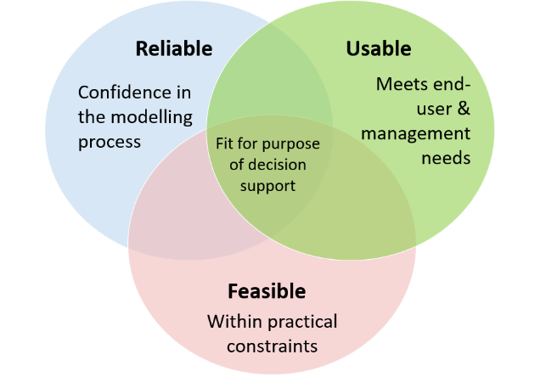

Fitness for purpose is a trade-off between usability, reliability and feasibility

Sensitivity analysis is complementary to uncertainty analysis, not an alternative. Sensitivity analysis is recommended since it provides insight into the sources of uncertainty that contribute most to the predictive uncertainty and the extent to which available observations are able to constrain predictive uncertainty.

# Reporting uncertainty analysis

The main goal of the modelling report is to document, discuss and justify the methods, assumptions, assertions and trade-offs in an open and transparent way (amenable to review).

The key to successful communication is to present information about uncertainty in a way that is most likely to aid decision-making – that is:

* adequately tailored to decision-makers’ needs
* focused on the messages that are most likely to be relevant to their decisions
* presented in plain and clear language.

An independent reader of the environmental assessment documents should be able to verify all significant assumptions, methodologies, techniques, assertions and conclusions made by the proponent. Independent readers should also be able to evaluate whether the analysis effort applied is commensurate with the risk and the predictions of impacts on groundwater and dependent systems.

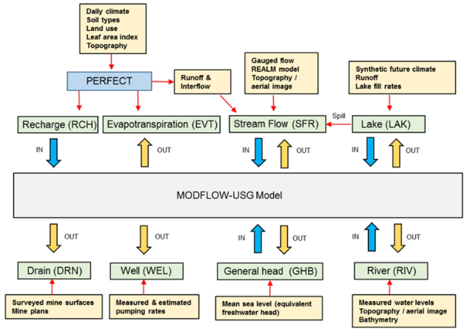

Example of interactions between groundwater and surface water models

Assessment reports should be as self-contained as possible, to minimise the need for readers to consult several documents. For example, there are linkages between the groundwater and surface water assessments, such as to estimate recharge and/or runoff and to evaluate the site water and salt balance (usually presented in the surface water report). The site water/salt balance outputs can feed back into post-mining groundwater modelling scenarios, such as for a final void lake, which may also require information from geochemical assessments and from rehabilitation plans. Groundwater models also need information on groundwater-dependent ecosystems from ecological assessments. Thus, groundwater assessment reports need to be self-contained so as to ensure readers do not have to consult several technical reports to understand the methodologies and assumptions applied to the groundwater modelling scenarios and the predictions of impacts on groundwater and dependent ecosystems.