Office of Water Science

Scoping study - Coal mine voids, Queensland

A report commissioned for the Independent Expert Scientific Committee on Coal Seam Gas and Large Coal Mining Development.
754-MELEN275156
9 November 2021



This page has been left intentionally blank

Scoping study - Coal mine voids, Queensland

Prepared for
Office of Water Science

Prepared by
Coffey Services Australia Pty Ltd
Level 1, 436 Johnston Street
Abbotsford
Vic 3067 Australia
t: +61 3 9290 7000 f: +61 3 9290 7499
ABN 55 139 460 521

9 November 2021
754-MELEN275156
754-MELEN275156_R1
Quality information
Revision history
Revision | Description | Date | Originator | Reviewer | Approver
V1a draft | Draft report of Milestone 3a and 3b | 27/11/2020 | D Green and R Whitchurch | R Cresswell | R Cresswell
V1c draft | Draft report of Milestone 3a, 3b and 3c | 21/12/2020 | D Green and R Whitchurch | R Cresswell | R Cresswell
V1e draft | Draft report of Milestone 3a, 3b and 3c | 25/01/2021 | D Green and R Whitchurch | R Cresswell | R Cresswell
V1g final draft | Draft report of Milestone 3a, 3b and 3c | 24/02/2021 | D Green | R Cresswell | R Cresswell
V1g final draft | Draft report of Milestone 3a, 3b and 3c | 9/11/2021 | D Green | R Cresswell | R Cresswell

Distribution
Report Status | No. of copies | Format | Distributed to | Date
V1b draft | 1 | PDF | K Strike and P Baker | 30/11/2020
V1d draft | 1 | PDF and Word | K Strike and P Baker | 23/12/2020
V1f draft | 1 | PDF and Word | K Strike and P Baker | 27/01/2021
V1h final draft | 1 | PDF | K Strike, P Baker and N Smillie | 25/02/2021
V1 final | 1 | PDF and Word | K Strike and P Baker | 9/11/2021

Table of contents
Glossary, acronyms, initialisms and abbreviations vi
Executive summary ix
1. Introduction 1
1.1. Background 1
1.2. Scope of works 1
2. Scoping study approach 2
2.1. Introduction 2
2.2. Database development 2
2.3. Case study analysis 5
2.4. Risk assessment approach development 6
3. Residual void flow regimes 7
3.1. Concepts 7
3.1.1. Water flow 7
3.1.2. Water quality 7
3.1.3. Assessment approaches 8
3.2. Open residual void 9
3.2.1. Terminal sink void 9
3.2.2. Source void 11
3.2.3. Flow-through void 11
3.2.4. Risk of flooding 13
3.2.5. Effects of climate change 13
3.2.6. Potential impacts 14
3.3. Partially-filled final void 14
3.4. Complete void filling 15
4. Database of open cut coal mines in Queensland 16
4.1. Introduction 16
4.2. Current open pit status 16
4.3. Location and area 17
4.3.1. Geological basin 19
4.3.2. Drainage basin and catchment 19
4.4. Floodplain mapping 20
4.5. Proximity to surface waters 21
4.6. Rehabilitation 24
4.6.1. Rehabilitation management planning 24
4.6.2. Rehabilitation examples 24
4.7. Preliminary characterisation of vulnerability 25
5. Case studies 27
5.1. Olive Downs coking coal project 27
5.1.1. Project status 27
5.1.2. Physical setting 27
5.1.3. Proposed design of residual voids 28
5.1.4. Conceptualisation of flow regime 30
5.1.5. Potential impacts 31
5.1.6. Rehabilitation planning 32
5.1.7. Risk mitigation and management 37
5.2. Middlemount coal mine 38
5.2.1. Project status 38
5.2.2. Physical setting 38
5.2.3. Proposed design of residual voids 39
5.2.4. Conceptualisation of flow regime 41
5.2.5. Potential impacts 42
5.2.6. Rehabilitation planning 43
5.2.7. Risk mitigation and management 47
5.3. Jellinbah coal mine 48
5.3.1. Project status 48
5.3.2. Physical setting 48
5.3.3. Proposed design of residual voids 50
5.3.4. Conceptualisation of flow regime 54
5.3.5. Potential impacts 54
5.3.6. Rehabilitation planning 57
5.3.7. Risk mitigation and management 59
5.4. Ensham coal mine 60
5.4.1. Project status 60
5.4.2. Physical setting 61
5.4.3. Proposed design of residual voids 62
5.4.4. Conceptualisation of flow regime 65
5.4.5. Potential impacts 67
5.4.6. Rehabilitation planning 67
5.4.7. Risk mitigation and management 72
5.5. Case study summary 74
6. Development of a risk assessment approach 80
7. References 87

Tables
Table 2-1 Database attributes and information sources
Table 4-1 Type and current status of open cut coal mines in Queensland
Table 4-2 Distribution of current open coal pits in Queensland according to geological basin or province
Table 4-3 Distribution of current open coal pits in Queensland according to drain basin and drain sub-basins
Table 4-4 Current open coal pits in Queensland located in mapped floodplain zones
Table 5-1 Proposed geometrics of final void design (Pembroke Resources, 2018)
Table 5-2 Long-term water level and quality model simulation results of final voids (Pembroke Resources, 2018 & 2019)
Table 5-3 Preliminary rehabilitation requirements for residual voids (Pembroke Resources, 2019)
Table 5-4 Geometrics of final void design (MCPL, 2018a)
Table 5-5 Long-term water level and quality model simulation results of final voids (MCPL, 2018a)
Table 5-6 Rehabilitation management of final void RMU
Table 5-7 Rehabilitation objectives, success criteria and corrective actions for final voids (MCPL, 2018b)
Table 5-8 Geometrics of final void design (AARC, 2018)
Table 5-9 Long-term water level and quality model simulation results of final voids (AARC, 2018 and Engeny, 2019) ⁽¹⁾
Table 5-10 Jellinbah mine rehabilitation goals, objectives, indicators and completion criteria for final voids
Table 5-11 Predicted final equilibrium water levels of final voids (Ensham, 2019b)
Table 5-12 Ensham rehabilitation objectives for void domains based on rehabilitation goals
Table 5-13 Ensham mine rehabilitation indicators and completion criteria
Table 5-14 Summary of key findings from the case study analysis ⁽¹⁾
Table 6-1 Possible approach to risk assessment based on the QERMF

Figures
Figure 3-1 Simplified conceptual hydraulics of residual mine voids (after Commander, et al., 1994)
Figure 3-2 Conceptualised equilibrium condition of residual void – Terminal sink flow regime (adapted from Mackie, 2009)
Figure 3-3 Conceptualised equilibrium condition of residual void – Source flow regime (adapted from Mackie, 2009)
Figure 3-4 Conceptualised equilibrium condition of residual void – Groundwater throughflow regime (adapted from Mackie, 2009)
Figure 3-5 Conceptualised equilibrium condition of residual void – Surface water flow
Figure 3-6 Conceptualised equilibrium condition of partially filled residual void (adapted from Mackie, 2009)
Figure 3-7 Conceptualised equilibrium condition of completely filled void (adapted from Mackie, 2009)
Figure 4-1 Distribution of current open coal pits in Queensland
Figure 4-2 Distance of current open coal pits from minor streams
Figure 4-3 Distance of current open coal pits from major streams
Figure 5-1 Olive Downs Coking Coal Project - Final voids (Pembroke Resources, 2018)
Figure 5-2 Layout of Middlemount coal mine – Western Extension Project (MCPL, 2018a)
Figure 5-3 Location of residual voids at the Jellinbah coal mine (AARC, 2018)
Figure 5-4 Final landform of the Jellinbah coal mine - MacKenzie North and Plains (AARC, 2018)
Figure 5-5 Final landform of the Jellinbah coal mine – Central North, Central, Jellinbah Central South and Jellinbah South (AARC, 2018)
Figure 5-6 Location of open-cut pits and mining leases – Ensham coal mine (Ensham, 2019b)
Figure 6-1 Snapshot of QERMF risk assessment approach (Queensland Fire and Emergency Services, 2018)
Figure 6-2 QERMF risk matrix (Queensland Fire and Emergency Services, 2018)

Glossary, acronyms, initialisms and abbreviations
AEP | Annual exceedance probability; the probability that at least one event in excess of a particular magnitude will occur in any given year.
AHD | Australian Height Datum
AMD | Acid and metalliferous drainage
ANC | Acid neutralising capacity
ARI | Average recurrence interval
ATM | Approach to Market
CMIP | Coupled Model Inter-comparison Project
CNE project | Central North Extension project (Jellinbah coal mine)
DAWE | Department of Agriculture, Water and the Environment
DEHP | Queensland Department of Environment and Heritage Protection
DEM | Digital Elevation Model
DES | Department of Environment and Science
DNRME | Department of Natural Resources, Mines and Energy
DTM | Digital Terrain Model
EA | Environmental Authority; an Environmental Authority granted in relation to an environmentally relevant activity under the Environmental Protection Act 1994.
EC | Electrical conductivity
EIS | Environmental Impact Statement
EPBC Act | Environment Protection and Biodiversity Conservation Act
Esri | Environmental Systems Research Institute; an international supplier of GIS software, web GIS and geodatabase management applications.
Esri Shapefile | Geospatial vector data format for geographic information system software.
Final (residual) void | An open pit resulting from the removal of ore and/or waste rock which will remain following the cessation of all mining activities and completion of rehabilitation processes. The terms ‘final void’ and ‘residual void’ are used interchangeably throughout this report.
Forblands | Barren-looking stony deserts with a few scattered saltbushes, but when the rains come, many types of herbs germinate and blossom overnight.
GA | Geoscience Australia
GAB | Great Artesian Basin
GDE | Groundwater dependent ecosystem
GIS | Geographic Information System
GoldSim | Dynamic, probabilistic simulation software developed by GoldSim Technology Group.
ha | Hectare
JEJV | Jellinbah East Joint Venture
IAR | Impact Assessment Report
ID | Identification number
IESC | Independent Expert Scientific Committee on Coal Seam Gas and Large Coal Mining Development
FoS | Factor of Safety
ILF | In-line Flocculation
IPCC | Intergovernmental Panel on Climate Change
km | kilometre
KPI | Key performance indicator
KMZ | Keyhole Mark-up language Zipped; a file extension for a placemark file used by Google Earth.
LFA | Landscape Function Analysis; a monitoring procedure developed by CSIRO that uses rapidly acquired field-assessed indicators to assess the biogeochemical functioning of landscapes at the hillslope scale.
Levee | An embankment that only provides for the containment and diversion of stormwater or flood flows from a contributing catchment, or containment and diversion of flowable materials resulting from releases from other works, during the progress of those stormwater or flood flows or those releases; and does not store any significant volume of water or flowable substances at any other times.
MCPL | Middlemount Coal Pty Ltd
mg/L | milligrams per litre
μS/cm | micro siemens per centimetre
ML | Mining Lease
ML/year | Megalitres per year
Mm³ | Million cubic metres
MNES | Matters of National Environmental Significance
MSES | Matters of State Environmental Significance
Mtpa | Mega tonnes per annum
n | Count
NAF | Non-acid forming
NASA | National Aeronautics and Space Administration
Open pit/open cut | Any constructed, open excavation in the ground.
OWS | Office of Water Science
PAF | Potentially acid forming
PCI | Pulverized coal injection
Pit lake | ‘Pit lakes’ can form in open coal mine open pits that extend below the watertable. On completion of mining, dewatering ceases and groundwater levels begin to recover, creating a ‘pit lake’ within the void which may be supplemented by varying quantities of surface water inputs.
PMF event | Probable Maximum Flood event
PMLU | Post mining land use
Progressive rehabilitation | Rehabilitation (defined below) undertaken progressively, or in a staged approach as mining operations are ongoing.
QERMF | Queensland Emergency Risk Management Framework
QFAO | Queensland Floodplain Assessment Overlay
RE | Regional ecosystem
Rehabilitation | The process of reshaping and revegetating land to restore it to a stable landform and in accordance with the acceptance criteria set out in an EA and, where relevant, including remediation of contaminated land.
RMU | Rehabilitation management unit
Residual (final) void | An open pit resulting from the removal of ore and/or waste rock which will remain following the cessation of all mining activities and completion of rehabilitation processes. The terms ‘residual void’ and ‘final void’ are used interchangeably throughout this report.
Risk | The probability of a hazard event causing harmful consequences.
RMU | Rehabilitation management units
RPEQ | Registered Professional Engineer of Queensland
RVP | Residual Void Project
SILO | SILO (Scientific Information for Land Owners) is a Queensland Government database containing continuous daily climate data for Australia from 1889 to present.
SRTM | Shuttle Radar Topography Mission
TBLA | Triple Bottom Line Assessment
TDS | Total Dissolved Solids
ToR | Terms of Reference
Vulnerability | The geographical or physical conditions that increases the susceptibility of the environment to a hazard or to the impact of a hazard event.

Executive summary
As part of the Independent Expert Scientific Committee on Coal Seam Gas and Large Coal Mining Development (IESC) research priorities, the Committee is aiming to increase the understanding of residual (final) coal mine voids in Queensland through a scoping study to identify the location and potential impacts of these features within the landscape. The Office of Water Science (OWS) is assisting the IESC to undertake this scoping study, the outcomes of which are documented in this report.
The scoping study consisted of the following approach.
- Development of a database (and accompanying spatial files) of current open-cut coal pits in Queensland and characterisation of the vulnerability to potential impacts these features may present in the landscape in their final form and at a cumulative scale. The contents of the database (as defined in the scope of works) consists of:
  - identification and definition of current and proposed open-cut coal pits in Queensland that have Environmental Approval (EA) records, including rehabilitation planning conditions;
  - digitisation of current open-cut pit coal areas for those sites with sufficient information to enable digitisation; and
  - definition of landform, geological, hydrological, hydrogeological and ecological attributes of each current open pit coal area.
- Case study analysis of residual coal mine voids for four selected mine sites (Olive Downs, Middlemount, Jellinbah and Ensham). The characterisation of each case study (as defined in the scope of works) consisted of:
  - dimensions and design features;
  - predicted equilibrated flow regime (including inflows: groundwater inflow and seepage from overburden, direct precipitation, catchment run-off and surface water diversions and outflows: evaporative losses, groundwater and surface water outflows);
  - potential water quantity and quality impacts;
  - rehabilitation planning and successes; and
  - risk mitigation and management measures.
- Development of a high-level approach for consideration by the IESC (as defined in the scope of works) for use in assessing open-cut coal mine development proposals and amendments, with reference to characterising the risks of residual coal mine voids on water resources and the receiving environment.
The database of current (February 2021) open-cut coal mines in Queensland is documented in an Excel file, as an accompaniment to this report. Esri Shape files and KMZ files of the digitised coal mine pits, including key attributes that can be uploaded by the user to Queensland Globe, are also provided as part of the scoping study outputs. A total of 71 EA records are associated with open-cut coal mining in Queensland, consisting of 12 that are currently in pre-construction and 45 in operation. A total of 50 EA records have conditions concerning residual voids and environmental harm, 20 do not and 1 is currently in application. A total of 39 EA records are required to have a rehabilitation management plan, 31 do not and 1 is currently in application.
Sufficient information was available to enable the digitisation of 128 current open-cut coal pits associated with 57 EA records. The planimetric areas of the open-cut coal pits digitised totals
100,892 hectares (ha), varying between approximately 8 ha and 24,405 ha, and averaging approximately 827 ha. It should be noted that the reported areas do not necessarily reflect future residual coal mine voids that may remain in the landscape following mining cessation. The size of any residual voids left at the conclusion of open-cut mining will be dictated by the depth of the open-cut, final slope design criteria, the extent of waste emplacement within the voids, mining sequencing and rehabilitation commitments. The area of a residual void defined by the void’s equilibrium water level and/or spill elevation will be less than the planimetric area of the void remaining in the landscape.
The existing open-cut coal pits are largely situated in the Permo-Triassic Bowen Basin, in the northeast part of the State, within the North East Coast drainage division. A large proportion of the pits (94 in total) are located in the Fitzroy River (drainage) Basin, with the Isaac River Catchment holding 39 pits and the MacKenzie River Catchment holding 23 pits.
The high evaporation rates in most of Queensland, relative to rainfall, are such that with design features that minimise surface run-off into the void (e.g. land contouring and drainage diversions away from the void), large residual voids are likely to equilibrate to terminal sink groundwater flow regimes with water qualities that exhibit increasing salt (and possibly acidity and metal) concentrations over time.
A range of variables may affect the groundwater flow regime of a residual void (i.e. over time and hence its associated risks to the receiving environment. Such variables will require consideration on a site-by-site basis, and should consider that:
- the residual void groundwater flow regime (even at equilibrium or quasi-equilibrium conditions) will respond dynamically to changes in precipitation and evaporation rates that may occur at seasonal time scales. Longer-term climate changes may also affect the evolution of the residual void’s groundwater flow regime and conditions that prevail at equilibrium; and
- while the lateral hydraulic gradient in a terminal sink groundwater flow regime is expected to prevent potentially saline or contaminated groundwater migrating into surrounding aquifers, several factors (i.e. potential for density driven flow reversing hydraulic gradients, geological fault structures) have the potential to alter groundwater flow processes at equilibrium and their potential risk in the long-term.
An important part in understanding potential impacts and decisions regarding rehabilitation planning and management of residual voids will be the time scale (e.g. decades, centuries or millennia) over which equilibrium or quasi-equilibrium conditions will take to be reached, and the evolution and rate of change of the flow regime during this time. These aspects will also require consideration on a site-by-site basis, noting that rehabilitation requirements will change as these features evolve towards equilibrium conditions.
Temporary flooding of residual voids (in particular, those with terminal sink groundwater flow regimes) has the potential to spill poor quality water onto surrounding land or into receiving groundwater and river systems. Residual voids situated within floodplain areas are considered particularly vulnerable to flooding events. Approximately 44% of the current open pits digitised as part of the scoping study (56 in total) are indicated to be situated in potential flood hazard areas.
Minor streams are generally located less than 2 km from current open-cut coal pits, with 57 pits indicated to be intersected by minor streams. Major streams are distributed across a range of distances from current open-cut coal pits, from intersection to distances over 16 km. Any minor or major stream that intersects an operational open-cut coal pit is expected to be diverted either temporarily or permanently.
From a cumulative perspective, most of the current open-cut coal pits indicated to be in potential flood hazard areas occur in the Fitzroy Basin (44 pits), with the Isaac River Catchment accounting for 18 pits and the MacKenzie River Catchment accounting for 16 pits. These catchments also have the highest number of minor and major streams in close proximity to current open-cut coal pits. Ultimately, understanding the risk these features pose in the landscape from flooding events will require a consideration of the final void design, including the overland flow and flood protection design features that will remain or be engineered at mine closure.
Of the case studies explored, Olive Downs, Middlemount and Jellinbah coal mines will each have multiple residual voids remaining in the landscape post-mining that were assessed by the operators to ultimately equilibrate to terminal sink groundwater flow regimes with ‘pit lake’ levels equilibrating below overflow levels and reaching hypersaline conditions (i.e. > 35,000 mg/L total dissolved solids, TDS) over variable timescales (i.e. 100-550 years). For these mine sites, residual voids situated in floodplain areas will incorporate design features to provide protection from flood waters up to and including a Probable Maximum Flood (PMF) event (Olive Downs and Middlemount) or up to and including a 0.1% annual exceedance probability (AEP) event (Jellinbah). The risk assessments reported for each of these case studies concluded that the residual void designs pose a low risk of environmental harm.
The Ensham coal mine undertook a staged Residual Void Project (RVP) in accordance with the EA to evaluate three options for rehabilitation of the open-cut areas. The final (preferred) option, determined by way of a Triple Bottom Line Assessment (TBLA), was Option 2 – ‘Beneficial use’, which involves partial backfilling of the open-cuts to produce rehabilitated landforms. The rehabilitated landforms that overlap the floodplain area will operate as groundwater sinks; however, the partial backfilling will reduce the area and volume of groundwater presenting (‘daylighting’) in the landscape. The two pits to the north of the floodplain area are designed such that the pit floor level is above stabilised groundwater levels and no groundwater will ‘daylight’. Each rehabilitated void will be isolated from the floodplain by the rehabilitated landforms providing flood immunity up to and including a 0.1% AEP event. Similar to the other case studies, Ensham concluded that the rehabilitated landforms will pose a low risk of environmental harm.
For each of the case studies, the characterisation of the residual void’s groundwater flow regime and the assignment of risk relies on coupled analytical or numerical modelling that carries a range of assumptions/simplifications and a level of uncertainty (as identified by the IESC in their advice documents for the case studies). The actual groundwater flow regime of the residual void may ultimately differ from the model predictions and pose a different level of risk to that assigned by the operator. Model updates and future validation with appropriate site-specific data will assist in overcoming some of the inherent uncertainties of modelling and the accompanying assessment of environmental risk.
Post-relinquishment there remains a risk that the rehabilitated area or engineered structures may require management in perpetuity, or in some cases the structure may fail (e.g. due to seismic activity) and require remedial action to address or prevent potential environmental harm. Recent amendments to the Environmental Protection Act 1994 (Qld) (EP Act) have been made to minimise risks associated with project relinquishment requirements (i.e. following completion of the project). Specifically, these include a residual risk framework that seeks to ensure that risks remaining on a resource site following completion of resource activities are identified, costed and managed.
All of the case studies have developed their rehabilitation planning around Queensland Government policies, to achieve safe, non-polluting, stable landforms that are able to sustain a post-mining land use (PMLU), where one exists. The rehabilitation themes are consistent across the four case studies and includes final landform and re-shaping, safety, remediation of hazards and reducing impacts on the surrounding environment. Olive Downs (not yet operational) and Ensham have committed to rehabilitating the final voids to a PMLU. Middlemount and Jellinbah coal mines do not have a PMLU for residual voids. Both mine operators intend to leave a void water body that is safe with exclusions to some wildlife (excluding birds), cattle and humans. With no final land use for these areas, there are no objectives or completion criteria developed for sustaining a PMLU.
On the basis of the outcomes of the case study analysis, an option to assist the IESC in understanding project specific and cumulative risks of residual coal mine voids on water resources and the receiving environment in Queensland is to build on the contents of the database developed in the scoping study using site-specific State and/or Commonwealth environmental approvals documentation. The tabulated information required for each coal mine site would include:
- local scale physical setting (i.e. climate, geology, hydrogeology, ecology);
- the Number and dimensions of proposed residual void(s);
- the approach used by proponents to assess the residual void(s) flow regime, flood risk and potential impacts;
- residual void(s) rehabilitation planning approach;
- projected flow regime of the residual void(s);
- The assessed risk potential of the residual void(s); and
- potential impacts of residual void(s), as identified by the IESC.
Information from this expanded database could be used to generate a comparative risk profile of approved residual coal mine voids to enable the relative risk of an individual coal mine site and the cumulative risk of multiple coal mine sites to be understood by the IESC when assessing new coal mine development proposals and amendments to existing EAs. The Queensland Emergency Risk Management Framework (QERMF) documented in the Risk Assessment Process Handbook (Queensland Fire and Emergency Services, 2018) describes a risk assessment methodology for disaster management planning in Queensland that could be applied to generate a comparative risk profile for residual coal mine voids in the State.
The QERMF risk assessment approach would need to be tailored to accommodate the objectives of the residual void risk assessment and the nature of the data and information that would be used in defining or assigning the various attributes in each step. The outputs of the risk assessment (being an overall level of risk for each potential hazard and corresponding exposed element) could be overlaid and inspected spatially. Weighted criteria could be used for each risk level in a weighted overlay process that gives a spatially explicit quantitative assessment for each residual void to guide review and assessment effort and help define appropriate management tools. By applying Geographic Information System (GIS) multi-component analysis to the comparative risk profile, the cumulative risk of multiple projects within a defined area (e.g. catchment) could also be represented spatially.

Introduction

Background
The Independent Expert Scientific Committee on Coal Seam Gas and Large Coal Mining Development (IESC) provides advice to the Australian Government Environment Minister on priorities for research to improve the understanding of the impacts of coal seam gas and large coal mining developments on water resources. As part of the Committee’s research priorities, the IESC is aiming to increase the understanding of residual (final) coal mine voids in Queensland through a scoping study to identify the location and potential impacts of these features within the landscape. The Office of Water Science (OWS) is assisting the IESC to undertake this scoping study, the outcomes of which are documented in this report.

Scope of works
The scope of works is broadly aligned with the original Approach to Market (ATM) and was further informed by project meetings on the 5th June 2020 and 25th August 2020. Two reviews and commentary provided of the draft report by the OWS (received 18 December 2020 and 18 January 2021) provided further refinement of the scope of works. The following is the agreed scope of works of the scoping study.
- Identify and define current and proposed open-cut coal pits in Queensland that have Environmental Approval (EA) records, including rehabilitation planning conditions.
- Map current open-cut coal pit areas for those sites with sufficient information to enable digitisation.
- Define landform, geological, hydrological, hydrogeological and ecological attributes of each current open-cut coal pit area.
- Characterise the vulnerability to potential impacts of existing and future residual coal mine voids in Queensland (including from a cumulative perspective), according to their potential flow regime, position in the landscape and proximity to receptors.
- For selected coal mine sites, characterise proposed or existing residual coal mine voids according to the following attributes.
  - Dimensions and design features.
  - Predicted equilibrated flow regime.
  - Potential water quantity and quality impacts.
  - Rehabilitation planning and successes.
  - Risk mitigation and management measures.
- Develop a high-level approach for consideration by the IESC for use in assessing open-cut coal mine development proposals and amendments, with reference to characterising the risks of residual coal mine voids to water resources and the receiving environment.

Scoping study approach

Introduction
To address the agreed scope of works (Section 1.2), the scoping study consisted of the following approach.
- Development of a database of current open-cut coal pits in Queensland and characterisation of the vulnerability to potential impacts such features may present in the landscape in their final form (as residual voids) and at a cumulative scale (Section 2.2).
- Case study analysis of residual coal mine voids for four selected mine sites (Section 2.3).
- Development of a risk assessment approach to assess the risks of residual coal mine voids to water resources and the receiving environment (Section 2.4).
As an introduction to the key technical concepts of the scoping study, water flow processes and regimes for different types of residual coal mine voids are described in Section 3.

Database development
The approach to developing the database of current open-cut coal pits in Queensland consisted of:
- collating Mining Lease (ML) numbers from Environmental Authority (EA) records of coal mines, supplied by the Department of Environment and Science (DES);
- digitising current open coal pit areas using high-resolution imagery;
- interrogating and extracting relevant and publicly available datasets/GIS layers for each current coal pit area that was digitised including: Digital elevation model (DEM)/ Digital Terrain Model (DTM), landform, geology, hydrology, hydrogeology and ecology/bioregion;
- Geographic Information System (GIS) analysis to define relevant attributes of the open cut coal mine areas. A 10 km radius has been selected to capture those attributes that occur in proximity to the open cut coal mine areas;
- interrogating publicly available EA records and documenting rehabilitation planning details for each open pit coal mine area with an EA record, as it relates to residual voids; and
- developing a project database and accompanying spatial datasets.
The attributes of the database and their source of information and extraction method is listed in Table 2-1.
Table 2-1 Database attributes and information sources
Parameter | Attribute | Source | Extraction method
Open-cut coal mine pit location, permit and operational details | Mine name | DES register | Supplied
 | ML number | Relevant EA report | Interrogation
 | EA number | DES register | Supplied
 | Operational status | DES register | Supplied
 | Mine type | DES register | Supplied
 | EA conditions relating to voids | DES register | Supplied
 | Does the EA have a condition about residual voids/environmental harm? | DES register | Supplied
Open coal mine pit elevation, area and slope | Open coal pit identification number (ID) | Coffey | Unique ID assigned
 | Open coal pit shapes (polygons) | Queensland Globe and Esri high-resolution satellite imagery of varying capture dates | Digitisation
 | Digitisation status of open coal pit | Coffey | GIS analysis
 | Number of digitised open coal pit(s) for each mine | Coffey | GIS analysis
 | Elevation (and accuracy) including minimum, maximum and mean of elevation and slope of the open coal pit | Geoscience Australia (GA) DEM 1-Sec (~ 30 m). Derived from Shuttle Radar Topography Mission (SRTM) data acquired by National Aeronautics and Space Administration (NASA) in February 2000. | GIS analysis
 | Total open coal pit area (ha) including planimetric area and surface area | Coffey | GIS calculation
Landform, geology, hydrology and hydrogeology in proximity to the open coal mine pit area | Dominant land systems mapping | Queensland Globe | Download and GIS analysis
 | Dominant surface and solid geology classification | Queensland Globe | Download and GIS analysis
 | Structural geological framework | Queensland Globe | Download and GIS analysis
 | Intersectional proximity to different major and minor streams (including their name, perennial and nearest distance) | BoM Hydrological Geospatial Fabric | Download and GIS analysis
 | Is the open coal pit in a floodplain hazard area (if so, floodplain sub-basin name) | Department of Natural Resources, Mines and Energy (DNRME) Queensland Floodplain Assessment Overlay (QFAO) ⁽¹⁾ | Download and GIS analysis
 | ID, name and distance of surface water gauging systems within 10 km | BoM Hydrological Geospatial Fabric | Download and GIS analysis
 | Registered ID and distance of registered groundwater bores within 10 km | Queensland Globe | Download and GIS analysis
Ecology/Biodiversity in proximity to the open coal mine pit area | Does the open coal pit overlap or within 10 km of any areas designated as Matters of State Environmental Significance (MSES)? | Queensland Globe | Download and GIS analysis
 | Biogeographic region | Queensland Globe | Download and GIS analysis
 | Biogeographic sub-region | Queensland Globe | Download and GIS analysis
 | Dominant regional ecosystem mapping | Queensland Globe | Download and GIS analysis
 | Biodiversity status – remnant, including code and condition within 10 km | Queensland Globe | Download and GIS analysis
 | Dominant surface expression Groundwater Dependent Ecosystems (GDEs) within 10 km (ID and confidence interval) | Queensland Globe | Download and GIS analysis
 | Dominant terrestrial GDEs within 10 km (ID and confidence interval) | Queensland Globe | Download and GIS analysis
 | Dominant subterranean GDEs within 10 km (ID and confidence interval) | Queensland Globe | Download and GIS analysis
 | Dominant wetland areas within 10 km (including available information, i.e. system type, ID) | Queensland Globe | Download and GIS analysis
 | Dominant springs and GAB spring net sites within 10 km (including available information, i.e. number, name, complex) | Queensland Globe | Download and GIS analysis
Rehabilitation planning associated with existing or proposed residual coal mine voids | Rehabilitation management plan required in EA? | Relevant EA report | Interrogation
 | Rehabilitation monitoring program required to be implemented? | Relevant EA report | Interrogation
 | Rehabilitation monitoring frequency | Relevant EA report | Interrogation
 | Post-mining land use | Relevant EA report | Interrogation
 | Groundcover Key Performance Indicator (KPI) | Relevant EA report | Interrogation
 | Slope KPI | Relevant EA report | Interrogation
 | Water quality KPI | Relevant EA report | Interrogation
 | Species richness KPI | Relevant EA report | Interrogation
 | Canopy cover KPI | Relevant EA report | Interrogation
 | Any specific rehabilitation requirements? | Relevant EA report | Interrogation
Notes:
(1) The QFAO represents a floodplain area within drainage sub-basins in Queensland that has been developed for use by local governments as a potential flood hazard area. It represents an estimate of areas potentially at threat of inundation by flooding. The data has been developed through a process of drainage sub-basin analysis utilising data sources including 10 m contours, historical flood records, vegetation and soils mapping and satellite imagery.
(2) Database fields attributed with “N/A” indicate an absence of data or information.
(3) Database fields attributed with “-“ indicate that the nominated feature did not occur within the set distance criteria.
Key elements of the open pit coal mine database for Queensland are described in Section 4, including:
- Current status (Section 4.2).
- Location and area (Section 4.3).
- Floodplain mapping (Section 4.4).
- Proximity to surface waters (Section 4.5).
- Rehabilitation (Section 4.6).
On the basis of the outputs of the database, a preliminary characterisation of the vulnerability to potential impacts residual voids may present in the landscape in their final form, and at a cumulative scale, is presented in Section 4.7.

Case study analysis
Four coal mine sites were selected as case studies to examine a range of characteristics of residual voids and to assist in developing a risk assessment approach (Section 2.4) for consideration by the IESC.
The four case studies, selected to represent a range of hydrological settings, operational histories and data availability, are:
- Olive Downs coking coal project.
- Middlemount coal mine.
- Jellinbah coal mine.
- Ensham coal mine.
Case studies were chosen in consultation with DES and with consideration of IESC advice that specifically identified final voids as a potential risk. Critically, this selection of case studies highlight Queensland climatic conditions and coal basin hydrogeology (and resulting mine design considerations) that favour the development of terminal sink groundwater flow regimes for final voids (see Section 4.7). Only one case study (Ensham) includes proposed final voids that will not be terminal ‘pit lakes’, though terminal sinks will be also included in its final rehabilitation design (Section 5.4.3).
A critical vulnerability in Queensland is related to coal mines located on floodplains and all chosen case studies will leave final voids on a major floodplain.
Selection also considered the current status and relevance to Queensland approvals’ timing to help provide some guidance on current and pending mines with potentially critical final voids. The Ensham case study, therefore, was included as important and relevant despite not having received IESC advice at the time of reporting. Further, the Ensham mine is the only case study that includes a conditioned Residual Void Project (RVP), which may guide future approval conditions for new mines and modifications of existing ones.
It is acknowledged that an incomplete cross-section of possible void types and void issues have been addressed and future iterations of this study might consider additional case studies to consider other materially significant issues. Coal mines in NSW and WA, for example, would highlight potential responses under differing climatic and hydrological regimes.
For the four selected case studies, publicly available information (e.g. environmental impact statement (EIS), impact assessment report (IAR), EA, IESC advice) and information made available by DES (i.e. rehabilitation management plans) was collated and interrogated for the purposes of characterising proposed or existing residual voids according to the following attributes.
- Dimensions and design features.
- Predicted equilibrated flow regime.
- Potential water quantity and quality impacts.
- Rehabilitation planning and successes.
- Risk mitigation and management measures.
The outputs of the case study analysis are summarised in Section 5.

Risk assessment approach development
On the basis of the outcomes of the case study analysis (Section 2.3), an option to assist the IESC in understanding project specific and cumulative risks of residual coal mine voids on water resources and the receiving environment has been scoped and documented in Section 6.

Residual void flow regimes

Concepts
The following section provides an overview of the different types of equilibrated flow regimes possible within an open residual void, including their potential impacts to the receiving environment. Should further detail be required, the reader is referred to the following references: Johnson & Wright (2003); Doupé & Lymbery (2005); McCullough et al. (2013); McCullough & Schultze (2015) and Vandenberg & McCullough (2017).

Water flow
Open-cut coal mining can result in residual voids that extend below the pre-mining watertable. Groundwater abstraction (dewatering) from sumps or in-pit/perimeter dewatering bores is then required during open-cut coal mining below the watertable to facilitate dry-floor mining practices. On completion of mining, dewatering ceases and groundwater levels begin to recover, potentially resulting in a ‘pit lake’ within the void, which may be supplemented by varying quantities of surface water inputs and moderated by varying evaporative or discharge processes. Hydrological and geochemical processes within the ‘pit lake’ evolve with time and may take decades or centuries to reach near equilibrium conditions.
The equilibrated ‘pit lake’ water balance and final ‘pit lake’ depth is defined by the net effect of all its hydrologic components (McCullough et al., 2013) as follows:
- Inflows: groundwater inflow and seepage from overburden, direct precipitation, catchment run-off and surface water diversions; and
- Outflows: evaporative losses, groundwater and surface water outflows.
The dynamics of these water flows are governed by the final void design and site-specific processes that may change as the void fills. At equilibrium, a range of flow regimes are possible within an open residual void (Section 3.2.1, 3.2.2 and 3.2.3). The time scale to reach equilibrated water level conditions in the ‘pit lake’ is dependent on a range of factors including the area and depth of the void and the rate of groundwater infiltration, evaporation and precipitation. Importantly, even at equilibrium, the ‘pit lake’, and its flow regime, will respond dynamically to changes in precipitation and evaporation rates that may occur seasonally or at much shorter time scales (e.g. impacts from cyclonic events).
Residual voids situated in floodplain areas are also susceptible to flooding (Section 3.2.4) which may, albeit temporarily, alter the flow regime and contribute to water quality impacts within the broader catchment area. On a longer timescale, climate changes may also have the potential to affect the flow regime of residual voids (Section 3.2.5).
Remediation of the open-cut coal pits, by partial (Section 3.3) or complete (Section 3.4) backfilling, will alter the flow regime, and ultimately the risk such features pose in the landscape.

Water quality
Understanding the evolution of water quality in ‘pit lakes’ is complex, as the hydrological and chemical inputs are qualitatively different from those of natural lakes. The water quality in a ‘pit lake’, and its evolution over time, are dependent on a host of factors including (but not limited to) (Johnson & Wright, 2003):
- final void design;
- flow regime;
- quality of groundwater and surface water inputs;
- dynamics of temperature, evaporation and precipitation;
- composition, exposure and fragmentation of wall rock and overburden;
- biological activity; and/or
- human intervention.
Water quality issues often associated with ‘pit lakes’ in coal mine voids include salinisation and acid and metalliferous drainage (AMD) (Doupé & Lymbery, 2005). In the case of salinisation, the flow regime of the void will largely determine whether the ‘pit lake’ water quality reaches equilibrium or continues to evolve over time. A void flow regime with evaporation as the primary water loss process (Section 3.2.1) will typically lead to increases in solute concentrations compared to a flow-through system (Section 3.2.3) where inflowing water can continue to replenish and dilute solute concentration effects that are occurring or have occurred in previous dryer seasons (Niccoli, 2009 as cited in McCullough & Schultze, 2015). AMD has the potential to be generated in open-cut coal mine voids if the wall rock or surrounding overburden contains potentially acid forming (PAF) materials that are exposed to the atmosphere.
The circulation pattern within ‘pit lakes’ is also an important environmental factor due to the central role of oxygen in chemical reactions affecting water quality. In comparison to natural lakes, ‘pit lakes’ are more prone to becoming meromictic (i.e. lower layers non-mixing) owing to their comparatively smaller surface areas, steeper sides, greater depths, and higher salinities (Gammons & Duaine, 2006, as cited in Vandenberg & McCullough, 2017). Vertical mixing in lakes is primarily driven by wind currents across the lake surface, and the smaller fetch of ‘pit lakes’ provides less opportunity to translate wind energy into water currents that are necessary for lake turnover.
The nature of vertical mixing will control the level of oxygen transported to the lower portion of the ‘pit lake’, which in turn affects biological and chemical reactions. Total dissolved solids concentrations and electrolytic conductivity tend to increase with depth with values near the bottom often several times those at the surface. The hypolimnion (lower stratum) of a stratified lake has the tendency to contain low dissolved oxygen concentrations, if oxygen demand (chemical and/or biological) is high enough. The existence of a sub-oxic or anoxic (no oxygen) layer in a pit lake can have significant effects on the lake’s chemical and biological characteristics and thus on its potential for remediation.
Ultimately, the flow regime of an open residual void (Section 3.2) will govern the nature and level of risk impacted ‘pit lake’ waters present to surrounding and connected receptors. In general, early in lake evolution, physical (temperature, rainfall, evaporation) and chemical (rock type, solutes, oxidation and pH state) drivers will be dominant. As the ‘pit lake’ reaches equilibrium, biological factors may become more critical in determining the final pit water quality (McCullough & Schultze, 2015).

Assessment approaches
The prediction of final water quality and quantity/levels in residual voids is required to assist in decisions concerning mine site rehabilitation. While existing modelling techniques, such as stochastic water-balance modelling, are capable of providing predictions of water levels in the final ‘pit lake’ (Johnson & Wright, 2003), challenges can be experienced in the prediction of long-term quality of ‘pit lake’ water. The prediction of water-quality evolution in residual voids requires an understanding of the hydrogeological, limnological and biological/ biochemical processes that control solute fate and transport quality. Typically, predictions are made by coupled modelling using a mass balance model and chemical equilibrium model. As most ‘pit lakes’ are still relatively young (relative to the timeframes to reach equilibrium), there is often insufficient data available to support the testing and validation of model predictions (Johnson & Wright, 2003). Effective rehabilitation management of ‘pit lakes’ will need to consider this predictive uncertainty and the changing rehabilitation requirements as these features evolve towards equilibrium conditions.

Open residual void
Broadly, the following end-member flow regimes of residual voids are possible once quasi-equilibrium has been reached (McCullough & Schultze, 2015) (Figure 3-1):
- Terminal – as an evaporative sink (Section 3.2.1).
- Source – perched above local groundwater levels (Section 3.2.2).
- Flow-through – dominantly to groundwater or surface waters (Section 3.2.3).
The conceptual end member hydraulic regimes will have distinct and direct influence on the water quality aspects of final voids dependent on the host rock, geochemistry of the coal seams and climate. Temporal changes in weather patterns and climate mean that pure end members rarely exist, and regimes may alternate between sink and source and will be contingent on the geology of each site requiring a site-by-site appraisal.
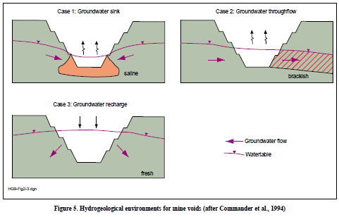
Figure 3-1 Simplified conceptual hydraulics of residual mine voids (after Commander, et al., 1994)

Terminal sink void
Terminal sink flow regimes (Figure 3-2) typically occur in arid climates where evaporation potential is higher than average rainfall runoff (Niccoli, 2009, as cited in McCullough & Schultze, 2015). During groundwater level rebound at mining cessation, the ‘pit lake’ water level rises to a level where inflows (i.e. direct rainfall, catchment and pit wall runoff, and groundwater inflow) are in equilibrium with evaporation losses. In a terminal sink flow regime, the ‘pit lake’ water level rises to levels lower than adjacent groundwater levels, and due to the generated lateral hydraulic gradient towards the pit, the ‘pit lake’ water does not seep into the surrounding groundwater system.
The evolution to a terminal sink flow regime, which may take decades or centuries to achieve, can be described as follows (McCullough et al., 2013).
- Once mining and dewatering ceases, water will begin to accumulate in the residual void from precipitation, seepage through backfill and groundwater inflows (assuming voids are deeper than pre-mining groundwater levels).
- As the residual void typically has sloping sides, its ‘pit lake’ will initially have a relatively small surface area, and accordingly, groundwater inflows will exceed evaporative losses.
- As the residual void fills, its ‘pit lake’ surface area will expand, resulting in greater evaporation, slowing the rise of the ‘pit lake’ water level. Groundwater inflows will also decrease non-linearly as the ‘pit lake’ water level rises towards pre-mining levels and lateral hydraulic gradients decline. Percolation through backfill material may continue.
- Eventually the ‘pit lake’ surface area will increase to a point where an equilibrium is achieved: evaporative losses balance all inflows. Typically, this will occur below the pre-mining groundwater level due to volumetric considerations (i.e. movement from a porous material to an open body of water), so groundwater will continue to flow towards the void, resulting in a permanent local groundwater sink. The water level in the ‘pit lake’, while equilibrated, will respond dynamically to changes in seasonal precipitation and evaporation rates.
The water quality of terminal sink ‘pit lakes’ is expected to exhibit increased acidity and metals and salt concentrations over time as solutes introduced through groundwater inflow and pit wall runoff are concentrated by evaporation.
A long-term risk of increasing ‘pit lake’ salinity is the potential for density-driven flow to reverse hydraulic gradients, promoting seepage into the surrounding groundwater system. Fault structures (and associated fracture systems) that intersect or occur in proximity to residual voids may also have the potential to affect long-term equilibrium conditions and associated risks. These risks will require evaluation on a site-by-site basis.
Local aquifers will be permanently depressurised surrounding the terminal sink feature. The extent and magnitude of the groundwater level drawdown will depend upon local hydrological conditions and the degree to which the equilibrated ‘pit lake’ water level approaches pre-mining groundwater levels. In the case of terminal sink features that intersect with productive alluvial aquifers, the long-term impacts of groundwater drawdown caused by terminal sink voids may be considerable. Conversely, where such features are distant from productive alluvial aquifers, and local rock is considered relatively impermeable, groundwater level impacts may be localised and minimal.
The generally arid or semi-arid climate of much of inland Australia is such that most large open residual voids in Queensland ultimately become terminal sinks due to high evaporation rates. Design features including land contouring and the construction of swales and drainage ditches to divert runoff water, minimise surface water infiltration into the void, further contributing to the formation of equilibrated terminal sink flow regimes.
Figure 3-2 Conceptualised equilibrium condition of residual void – Terminal sink flow regime (adapted from Mackie, 2009)
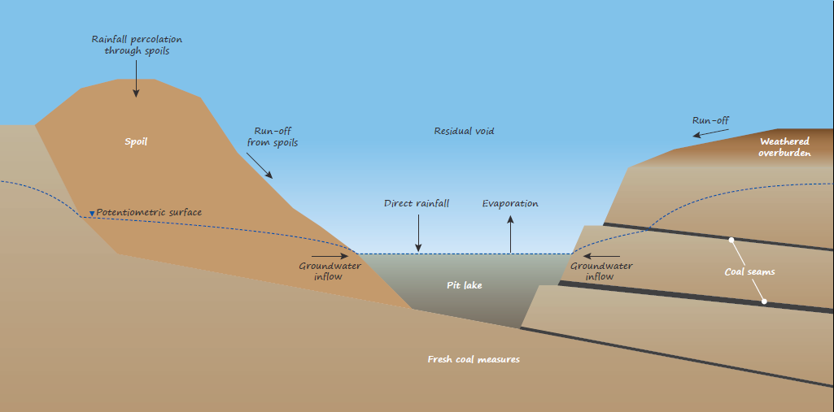

Source void
In net positive water balance areas (e.g. where rainfall significantly exceeds evaporative loss, or in cases where surface water run-off is diverted into the residual void once mining has ceased), the final void may operate as a source flow regime (Figure 3-3), perched above the surrounding watertable. The residual void becomes a recharge zone for the local aquifer and may overflow during periods of excessive rainfall, if the void spill height is exceeded.
In the case of a source flow regime, groundwater levels surrounding the residual void will be elevated above pre-mining levels. While the salinity of the ‘pit lake’ water is likely to be low (relative to the surrounding groundwater), the risk of seepage of AMD to the surrounding groundwater system will need to be evaluated on a site-by-site basis.
Figure 3-3 Conceptualised equilibrium condition of residual void – Source flow regime (adapted from Mackie, 2009)
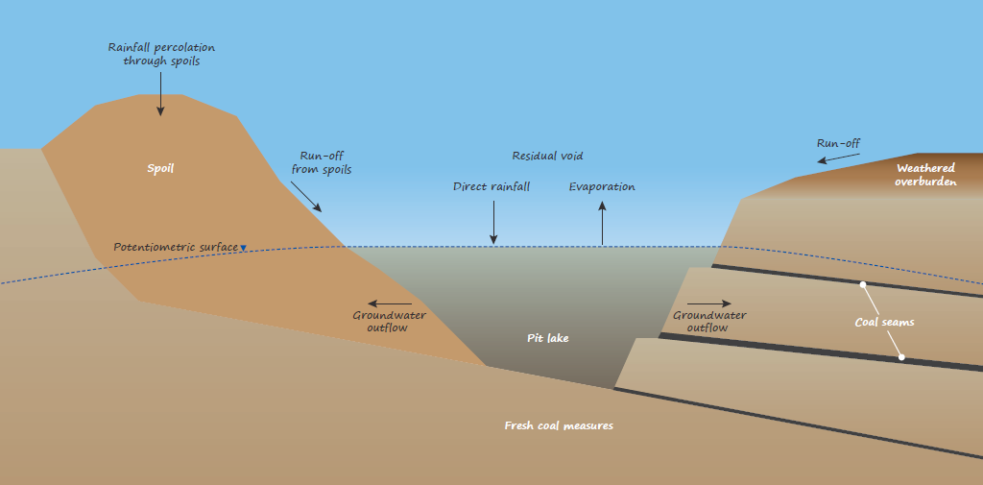

Flow-through void
Where hydraulic gradients result in greater lateral flux compared to vertical flux of water, that is, where a distinct hydraulic asymmetry occurs across a void, then a flow-through regime may be initiated. This can occur where asymmetric groundwater tables develop, or where directional surface waters cross the void area. Generally, a combination of these two end member types occurs and the proportion of each process may change with season. These regimes develop following progression through a terminal sink or source regime and tend to characterise mature voids in open landscapes, such as floodplains.

Groundwater flow-through
A terminal sink flow regime (Section 3.2.1) may ultimately evolve into a groundwater throughflow regime (Figure 3-4) in settings with comparatively lower evaporative potential relative to groundwater inflow. The final ‘pit lake’ water level will reach the surrounding pre-mining groundwater level and a groundwater throughflow system will occur at equilibrium. This type of groundwater flow regime is primarily associated with residual voids in high-permeability ore bodies surrounded by lower permeability rocks (Johnson & Wright, 2003).
The ‘pit lake’ water, subject to evaporation, will slowly increase in salinity (and potentially other constituents), with the potential to migrate via groundwater seepage, as a saline plume downgradient of the void. The salinisation of the plume, and resultant impact on the surrounding aquifer, is largely dependent on the rate of groundwater throughflow through the void.
The potential risks associated with density-driven groundwater flow and/or the occurrence of fault structures, as described for a terminal sink flow regime (Section 3.2.1) may also apply to a groundwater throughflow regime.
Figure 3-4 Conceptualised equilibrium condition of residual void – Groundwater throughflow regime (adapted from Mackie, 2009)
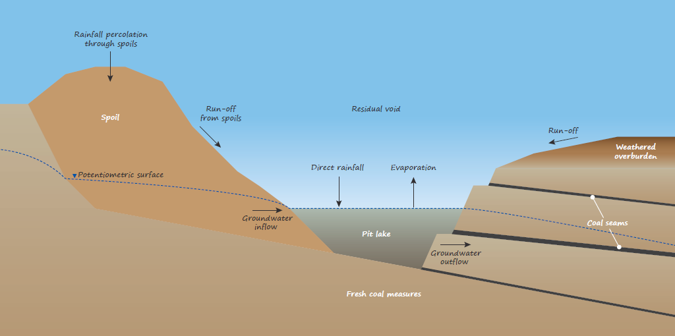

Surface water flow-through
A surface water flow-through regime (or riverine flow-through) (Figure 3-5) is one that is generally engineered for the purposes of maintaining or improving ‘pit lake’ water quality, by permanently diverting a river or other surface water into the residual void, with discharge into a natural waterway downstream. The rationale for engineering such systems may include (McCullough & Schultze, 2015):
- a surface drainage system that was originally diverted around the open pit and it is desirable that the system is diverted back into its natural channel at mine closure for cultural or other purposes;
- that a ‘pit lake’ is proposed as a water reservoir, or for retaining and buffering high flows as flood protection for downstream;
- the requirement for higher quality river water to maintain a minimum ‘pit lake’ water level or minimum water quality; or
- that the ‘pit lake’ is proposed as a treatment facility to improve water quality of the river.
A surface water flow through regime has the potential to contribute a range of important processes to improve and maintain the water quality of ‘pit lakes’ over long-term scales (e.g. dilution, neutralisation). The risks and benefits to upgradient and receiving river(s), and whether such risks can be appropriately managed, will also require careful consideration in assessing the feasibility of this flow regime.

Figure 3-5 Conceptualised equilibrium condition of residual void – Surface water flow
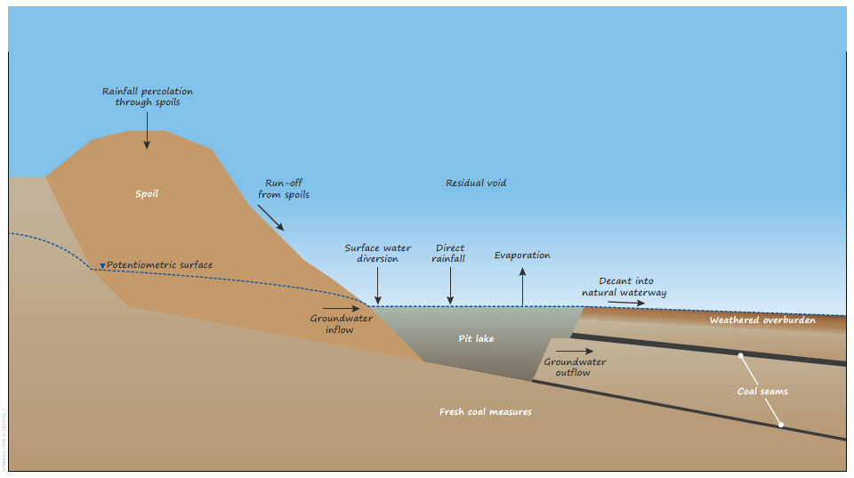

Risk of flooding
As the quality of water within residual voids may be poor (Section 3.1.2), and likely to worsen over time (particularly in the case of terminal sink and groundwater throughflow regimes), the spilling of this water onto surrounding land, or receiving groundwater and river systems, has the potential for detrimental impacts. These temporary flooding events may occur as a result of:
- high rainfall events that increase the ‘pit lake’ water level above the void’s spill height; or
- open voids being located in floodplain areas, with flooding events have the potential to overtop levees and intercept the residual void.

Effects of climate change
Long-term climatic changes will affect the evolution and hydrologic processes of an equilibrated residual void flow regime. Recent results from climate model simulations under the sixth phase of the international Coupled Model Inter-comparison Project CMIP (CMIP6) (to be assessed in the Intergovernmental Panel on Climate Change (IPCC) Sixth Assessment Report in 2021) indicate a signiﬁcant drying of southwest Australia in the cool season and less certain or less signiﬁcant rainfall projections elsewhere, including the Northern Australian monsoon region (Grose et al., 2020).
Drier conditions may reduce ‘pit lake’ water levels to the extent that groundwater throughflow regimes evolve into terminal sink flow regimes, whilst a wetter climate may result in rising ‘pit lake’ water levels and previously terminal sink flow regimes become surface or groundwater flow-through regimes (Kumar et al., 2009). Wetter climates also heighten the risk of the residual void over-topping or flooding.
Importantly, climate changes have the potential to affect all components of a residual void’s hydrologic system. Each flow component will require evaluation to predict the effect of long-term climate changes and potential implications to the residual void’s flow regime (Mines Lakes Consulting, 2017). Hydrology designs that can accommodate the deep uncertainty associated with changes to future climate is crucial to the successful closure of a mine site (Zhan et al., 2020).

Potential impacts
Following mine cessation, all residual voids have the potential to affect the flow regimes and qualities of surrounding groundwater and surface water resources at variable scales. Understanding the risks such features present in the landscape will require an evaluation on a site-by-site basis. Importantly, any residual void subject to flooding has the potential to flush poor quality ‘pit lake’ water to nearby waterways and underlying groundwater systems.
The potential magnitude and scale of these affects and the potential impacts to connected receptors (e.g. GDEs, surface water ecosystems, groundwater and surface water users) will be site specific and require an understanding of the proximity and sensitivity of potential receptors.
An important aspect in understanding potential impacts and decisions regarding rehabilitation planning and management will be the timescale (e.g. decades, centuries or millennia) over which equilibrium or quasi-equilibrium conditions will take to be reached and the evolution and rate of change of the flow regime and its water quality during this time.
The potential cumulative impacts of multiple residual voids in relatively small areas also requires consideration. That is, individual or single residual voids may not pose a significant long-term risk; however, collectively multiple residual voids in the landscape may present a significant source of diffuse contamination and/or water source depletion.

Partially-filled final void
A partially-filled final void is partly filled with spoils to a designated elevation and reshaped. The design is such that a shallow water table within spoils prevails at equilibrium rather than a ‘pit lake’, generally mitigating the potential water quality issues that may arise in terminal sink and flow through residual void regimes.
Rainfall to the partially-filled void, rainfall runoff from rehabilitated spoils, rainwater percolation through spoils and groundwater seepage are balanced by evaporative losses from the shallow water table within the void.
Figure 3-6 Conceptualised equilibrium condition of partially filled residual void (adapted from Mackie, 2009)
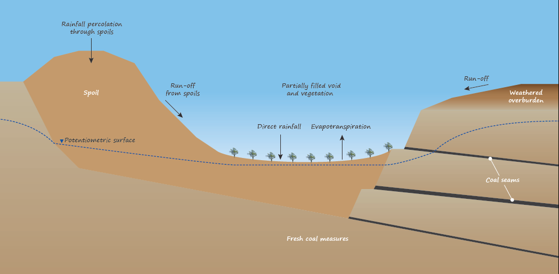

Complete void filling
In cases of complete void filling, no ‘pit lake’ or shallow watertable prevails at equilibrium. The recovered watertable rises within the waste rock dump until spillage occurs at the most vulnerable location which may be an exit point to a surface drainage, or diffuse spillage at a predictable but low rate through shallow more permeable strata connected to the pit shell. Complete void backfilling is commonly undertaken to mitigate issues associated with poor ‘pit lake’ water quality potentially developing from weathering of PAF material in the pit void and pit walls. It should be noted that the backfilling material will generally have a more porous structure, and hence high hydraulic conductivity, which will drive faster watertable response (both rising and falling) in the vicinity of the spoil.
Figure 3-7 Conceptualised equilibrium condition of completely filled void (adapted from Mackie, 2009)
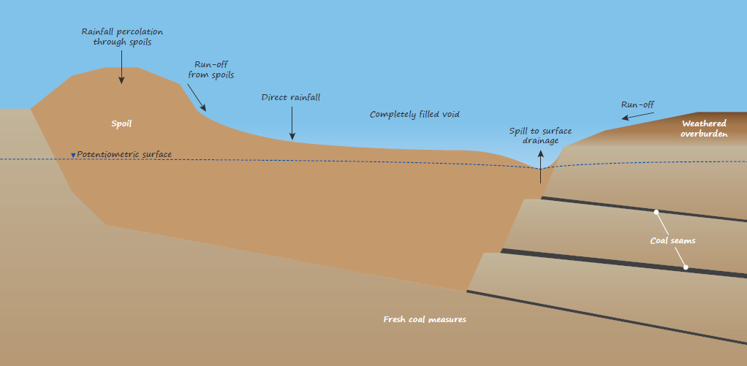

Database of open cut coal mines in Queensland

Introduction
The approach to preparing the scoping study database of current open-cut coal mines in Queensland is described in Section 2.2, including the data and information sources accessed. This section summarises the contents of the database, including review of rehabilitation activities (Section 4.6), and provides a preliminary characterisation of the vulnerability to potential impacts that residual voids pose in the landscape (Section 4.7).
In analysing the contents of the database, the following key assumptions and limitations apply.
- The data and information supplied for operational, elevation and landform and rehabilitation parameters are subject to change over time during the mine’s operational and closure phases.
- The information provided relates primarily to current open-cut coal pits and does not include future residual coal mine voids that may remain in the landscape following mining cessation. Residual coal mine voids are typically left at the conclusion of open-cut mining with the size of these voids dictated by the depth of the open-cut, final slope design criteria, the extent of waste emplacement within the voids, mining sequencing and rehabilitation commitments.
- The area of a residual void defined by the void’s equilibrium water level and/or spill elevation will be less than the planimetric area of the void remaining in the landscape.
- It was not possible to assign digitised open-cut coal pits to particular EA records in cases where the same ML number was listed under multiple EAs (i.e. EPML00318213, EPML00862313 and EPML00865013).
- The open-cut coal pit digitisation exercise includes all currently visible excavated areas associated with the mine site (e.g. excavated areas for waste rock emplacements), not just those areas associated with the extraction of the coal reserve.
- The (vertical) elevation accuracy for SRTM DEM (~30 m horizontal resolution) varies across Australia, with significant differences for open, flat terrain relative to more mountainous regions. A generalized estimate of (vertical) elevation accuracy for SRTM DEM (~30 m resolution) across Australia is approximately ± 9.8 m. This accuracy constraint specifically applies to the minimum, maximum and mean elevations and calculated slopes of the pits as reported in the database.
- The SRTM DEM was acquired in February 2000 (Table 2-1) and may not reflect the current elevation of the mine site and its surrounds.

Current open pit status
The database of current (February 2021) open-cut coal mine pits in Queensland is documented in an Excel file, as an accompaniment to this report. Esri Shape files and KMZ files of the digitised open-cut coal mine pits, including key attributes that can be uploaded by the client to Queensland Globe are also provided as part of the scoping study outputs. The current status of the mine sites associated with the open-cut mines is listed in Table 4-1.
The following is a summary of the current status of open pit coal mines in Queensland (as provided in the database).
- Across Queensland, a total of 88 coal mine sites are currently recorded with DES, of which 83 have EA records.
- Twelve coal mine EA records are associated with underground coal mining and are excluded from this database. The remaining 71 EA records (Table 4-1) are mostly associated with open-cut coal mining (63 EA records), plus seven associated with both open-cut and underground coal mining and one now associated with a trial plant for oil shale energy.
- Of the 71 EA records, 12 are currently in pre-construction and 45 are in operation.
- Of the 71 EA records, 50 have conditions concerning residual voids and environmental harm, noting that one is currently in application. This is reference to a standard condition which states that other than the environmental harm constituted by the void itself, the void must not cause environmental harm to land, surface water or groundwater. The remaining 20 EA records do not have conditions concerning residual voids and environmental harm.
- Of the 71 EA records, 39 are required to have a rehabilitation management plan, noting that one is currently in application. The remaining 31 EA records have no specific condition requiring rehabilitation management plans. The conditioning of a rehabilitation management plan can be dependent on how the Department deemed the rehabilitation risk at the time of assessment. If rehabilitation was assessed as a lower priority, the approval holder may not be required to prepare one as part of the current operations.
- Of the 71 EA records, 57 had sufficient information to enable digitisation of current open-cut coal pits (see Section 2.2). Open-cut coal pits associated with the remaining 14 EA records were not able to be digitised as the site is either not yet operational (i.e. pre-approval, pre-construction or pre-mining – 11 mines) or was not visible on the imagery (three mines).
Table 4-1 Type and current status of open-cut cut coal mines in Queensland
Parameter | Description | Number of EA records
Type of open-cut coal mine | Open-cut coal mining | 63
 | Open-cut and underground coal mining | 7
 | Former open-cut coal mine that is now a trial plant for oil shale energy | 1
Current status | Exploration | 1
 | In application | 2
 | Pre-construction | 12
 | In construction | 1
 | Operational | 45
 | Closure | 3
 | Care and maintenance | 5
 | Care, maintenance and rehabilitation | 1
 | Not defined | 1

Location and area
In total, 128 current open-cut coal pits were digitised across Queensland as part of this scoping study. The distribution of current open-cut coal mine pits in Queensland is presented in Figure 4-1. This figure and the discussion in Sections 4.3, 4.4, 4.5 and 4.7, do not include open-cut coal mining sites (associated with 14 EA records) that are not yet operational or not visible on imagery (Section 4.2).

Figure 4-1 Distribution of current open-cut coal pits in Queensland. For further information, Esri Shape files and KMZ files of the digitised coal mine pits can be uploaded by the user to Queensland Globe Interactive maps
The planimetric areas of the 128 open-cut coal pits digitised varies between approximately 8 ha and 24,405 ha, averaging approximately 827 ha. The total planimetric area occupied by the 128 open-cut coal pits is estimated to be approximately 100,892 ha.

Geological basin
A large proportion of the open-cut coal pits (95%) are situated in the Permo-Triassic Bowen Basin which contains much of the known Permian coal resources in Queensland. The distribution of the open-cut coal pits according to geological basin or province is presented in Table 4-2.
Table 4-2 Distribution of current open-cut coal pits in Queensland according to geological basin or province
Geological basin/province | Number of current open-cut coal pits | Planimetric area (ha)
 |  | Minimum | Maximum | Average | Total
Bowen Basin | 107 | 16 | 24,405 | 914 | 92,273
Clarence-Moreton Basin | 6 | 25 | 719 | 305 | 1,830
Callide Basin | 5 | 213 | 1,519 | 644 | 3,222
Surat Basin | 5 | 97 | 677 | 284 | 1,418
Tarong Basin | 2 | 266 | 800 | 533 | 1,066
Anakie Province | 1 | 963
Coastal Sub-province | 1 | 113
Fork Lagoons Sub-province | 1 | 8

Drainage basin and catchment
The distribution of the current open-cut coal pits relative to drainage division, drainage basin and catchment is indicated in Figure 4-1 and tabulated in Table 4-3.
Within Queensland, current open-cut coal pits are largely located in the north-east part of the State, within the North East Coast drainage division according to the following drainage basins.
- The Fitzroy Basin contains a large proportion of the current open-cut coal pits (94 in total) with a total area of 90,787 ha. Within the Basin, the Isaac River Catchment contains the highest number of pits; 39 in total, with an area of 50,408 ha. Other catchments in the Fitzroy Basin with current open-cut coal pits include Mackenzie River (23 pits; 25,399 ha in area), Dawson River (14 pits; 7,622 ha in area), Nogoa River (13 pits; 5268 ha in area) and Comet River (5 pits; 2,100 ha in area).
- The Burdekin Basin currently holds 20 open-cut coal pits (5,667 ha in area), within the Bowen River (16 pits; 4,443 ha in area) and Suttor River (4 pits; 1,224 ha in area) catchments.
- The Brisbane Basin currently contains 4 open-cut coal pits, all located within the Bremer River Catchment, totalling 416 ha in area.
- The Burnett Basin currently holds 2 open-cut coal pits, all located within the Barker & Barambah Creeks Catchment, totalling 1,066 ha in area.
- The Calliope Basin, on the east coast, currently holds 1 open-cut coal pit (113 ha in area), within the Calliope River Catchment.
Seven current open coal pits (totalling 2,154 ha in area) are situated in southeast Queensland, within the Balonne River Catchment of the Balonne-Condamine Basin in the Murray-Darling Basin drainage division.
Table 4-3 Distribution of current open-cut coal pits in Queensland according to drain basin and drain sub-basins
Drainage division | Drainage basin | Catchment | Number of current open-cut coal pits | Planimetric area (ha)
 |  |  |  | Minimum | Maximum | Average | Total
Murray-Darling Basin | Balonne-Condamine | Balonne River | 1 | 677 |  |  | 677
 |  | Condamine River | 6 | 97 | 719 | 359 | 2,154
 |  | Sum Balonne-Condamine | 7 | - | - | - | 2,832
North East Coast | Brisbane | Bremer River | 4 | 25 | 200 | 104 | 416
 |  | Sum Brisbane | 4 | - | - | - | 416
 | Burdekin | Bowen River | 16 | 23 | 1,702 | 278 | 4,443
 |  | Suttor River | 4 | 201 | 423 | 306 | 1,224
 |  | Sum Burdekin | 20 | - | - | - | 5,667
 | Burnett | Barker & Barambah Creeks | 2 | 266 | 800 | 533 | 1,066
 |  | Sum Burnett | 2 | - | - | - | 1,066
 | Calliope | Calliope River | 1 | 113 |  |  | 113
 |  | Sum Calliope | 1 | - |  |  | 113
 | Fitzroy | Comet River | 5 | 17 | 784 | 420 | 2,100
 |  | Dawson River | 14 | 30 | 2,835 | 544 | 7,622
 |  | Isaac River | 39 | 16 | 24,405 | 1,528 | 50,408
 |  | Mackenzie River | 23 | 106 | 11,324 | 1,104 | 25,399
 |  | Nogoa River | 13 | 8 | 1,552 | 405 | 5,268
 |  | Sum Fitzroy | 94 | - | - | - | 90,798

Floodplain mapping
Of the 128 open coal pits digitised, 56 (44%) are located in a potential flood hazard area as designated by the QFAO (Section 2.2) mapped floodplain zone. The number of current open-cut coal pits located in potential flood hazard areas of river catchments is listed in Table 4-4.
In summary, within Queensland, current open-cut coal pits situated in potential flood hazard areas are generally located within the North East Coast drainage division according to the following drainage basins.
- Most of the current open-cut coal pits situated in potential flood hazard areas are situated in the Fitzroy Basin (44 pits), across five catchments: Isaac River (18 pits), MacKenzie River (16 pits), Dawson River (4 pits), Nogoa River (4 pits) and Comet River (2 pits).
- The Burdekin Basin holds 8 current open-cut coal pits in potential flood hazard areas: 4 pits in each of the Bowen River and Suttor River catchments.
- The Burnet Basin holds one current open-cut coal pit in a potential flood hazard area of the Barker & Barambah Creeks Catchment.
Within the Murray-Darlin Basin drainage division, the Balonne-Condamine Basin holds three current open-cut coal pits in potential flood hazard areas of the Condamine River Catchment.
Table 4-4 Current open-cut coal pits in Queensland located in mapped floodplain zones
Drainage division | Drainage basin | Catchment | Number of current open-cut coal pits within a potential flood hazard area ⁽¹⁾
Murray-Darling Basin | Balonne-Condamine | Balonne River | Nil
 |  | Condamine River | 3
 |  | Sum Balonne-Condamine | 3
North East Coast | Brisbane | Bremer River | Nil
 |  | Sum Brisbane | Nil
 | Burdekin | Bowen River | 4
 |  | Suttor River | 4
 |  | Sum Burdekin | 8
 | Burnett | Barker & Barambah Creeks | 1
 |  | Sum Burnett | 1
 | Calliope | Calliope River | Nil
 |  | Sum Calliope | Nil
 | Fitzroy | Comet River | 2
 |  | Dawson River | 4
 |  | Isaac River | 18
 |  | Mackenzie River | 16
 |  | Nogoa River | 4
 |  | Sum Fitzroy | 44
Note:
(1) The potential flood hazard area is designated by the QFAO.

Proximity to surface waters
In consideration of surface waters as potential receptors in the event that a residual void overtops its spill height and spills onto surrounding land, the distance of current open-cut coal pits to minor and major streams (as defined by the BoM Hydrological Geospatial Fabric; Section 2.2) is graphically presented in Figure 4-2 and Figure 4-3, respectively. The actual risk to nearby surface waters from residual coal mine voids will be dependent on the potential for the residual void to overtop and the associated engineered flood protection measures in place should such an event occur. It should be noted that levees and other flood management structures are required as part of a mine’s EA and provide some level of protection by segregating the pits from surface waters.
The proximity of current open-cut coal pits to minor streams is characterised as follows (Figure 4-2).
- Minor streams are generally located less than 2 km from current open-cut coal pits .
- Each catchment (with the exception of Calliope River) holds at least one current open-cut coal pit indicated to intersect a minor stream. In total, 57 current open-cut coal pits in Queensland are indicated to be intersected by minor streams; 42 of which are located in the Fitzroy Basin, with 19 located in the Isaac River and 10 in the MacKenzie River catchments. Minor streams that intersect operational open-cut cuts are expected to be diverted either temporarily or permanently.
- The Condamine River (Balonne-Condamine Basin) Bremer River (Brisbane Basin) Calliope River (Calliope Basin), Dawson River, Isaac River, MacKenzie River and Nogoa River (Fitzroy Basin) catchments, each contain one or multiple current open-cut coal pits less than 100 m from a minor stream.
The proximity of current open-cut coal pits to major streams is characterised as follows (Figure 4-3).
- Current open-cut coal pits are distributed across a range of distances from major streams, from intersection to distances over 16 km.
- Catchments that hold current open-cut coal pits indicated to intersect a major stream include Isaac River (five pits), MacKenzie River (two pits) and Dawson River (one pit) in the Fitzroy Basin and Suttor River (one pit) in the Burdekin Basin. Major streams that intersect operational open-cuts are expected to be diverted either temporarily or permanently.
- The Isaac River and MacKenzie River catchments, of the Fitzroy Basin, both have seven current open-cut coal pits that are located less than 500 m from a major river. The Condamine River (Balonne Condamine Basin) and Suttor River (Burdekin Basin) both have two current open-cut coal pits located less than 500 m from a major river, while the Comet River and Nogoa River catchments (Fitzroy Basin) both have one.
- Current open-cut coal pits within the Balonne River (Balonne-Condamine Basin), Barker & Barambah Creeks (Burnett Basin), Calliope River (Calliope Basin) catchments are all located at over 5 km from major streams.

Figure 4-2 Distance of current open-cut coal pits from minor streams
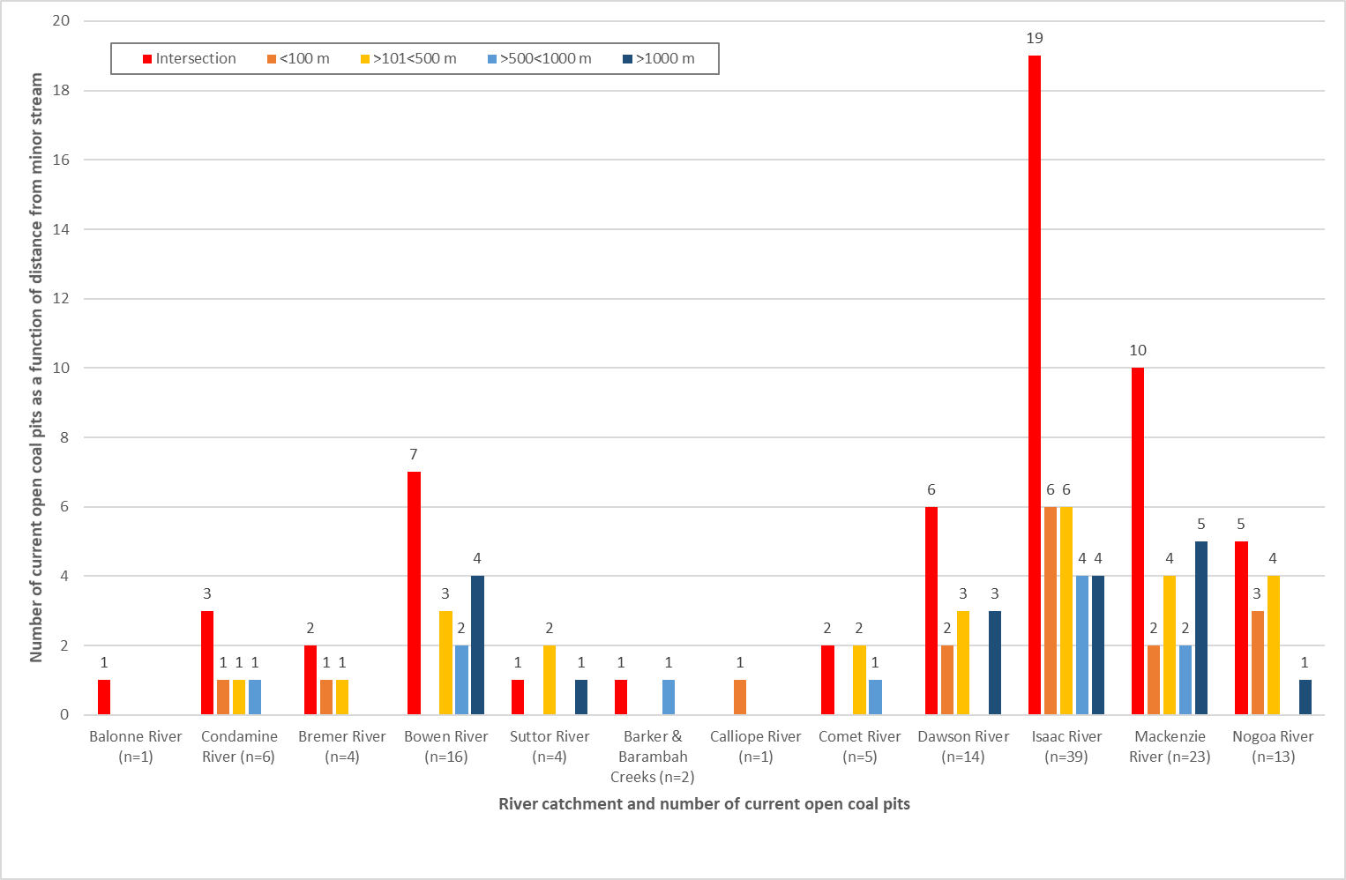
Figure 4-3 Distance of current open-cut coal pits from major streams
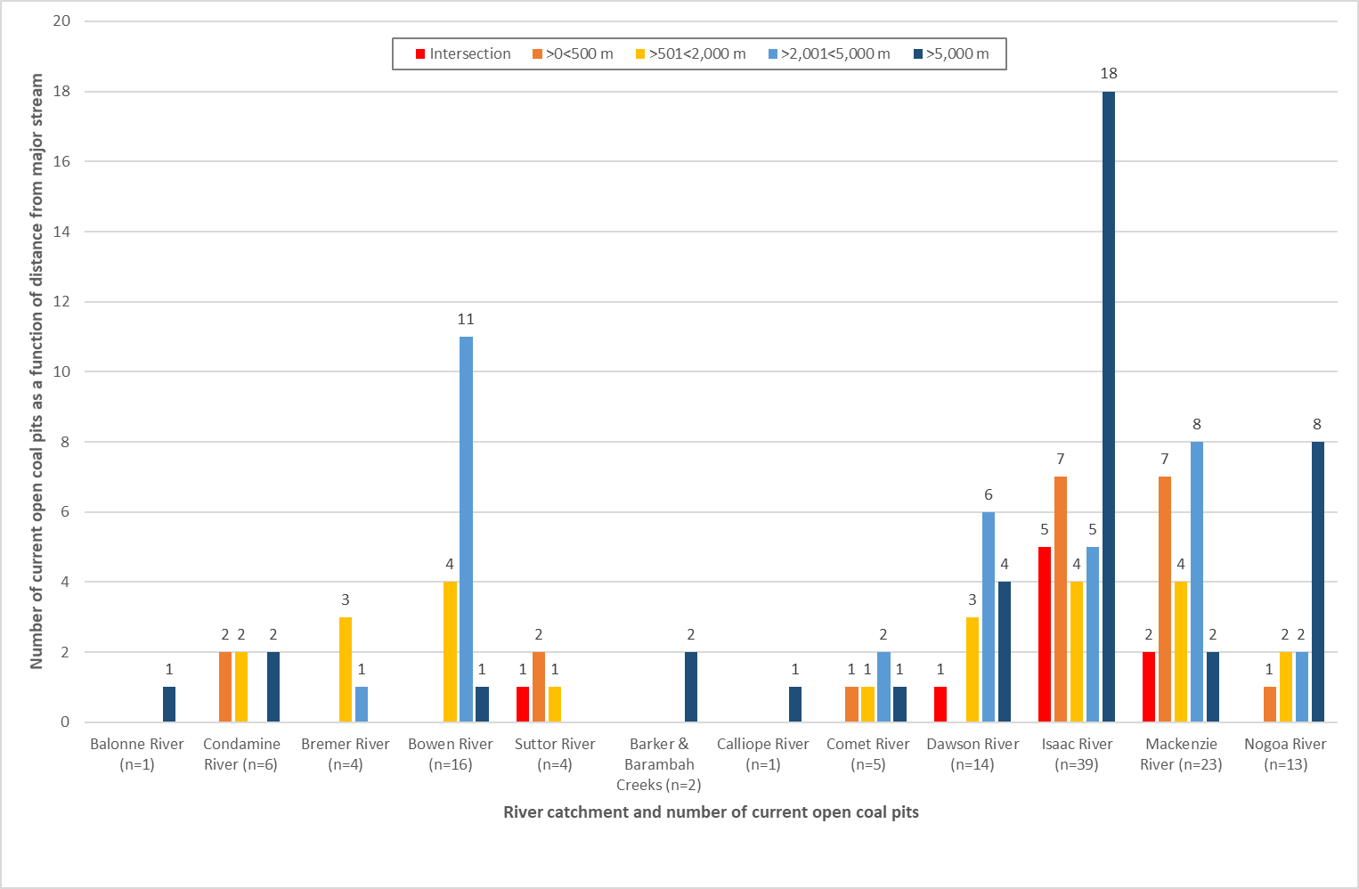

Rehabilitation

Rehabilitation management planning
The 71 EA records associated with coal mines with open-cuts were reviewed to assess which mines are conditioned to prepare a rehabilitation management plan or implement a rehabilitation monitoring program (where there is an existing prescribed rehabilitation strategy defined in the EA). Of the 71 EA records reviewed, 39 mines are conditioned to prepare a rehabilitation management plan, and 36 are conditioned to prepare a rehabilitation monitoring program, noting that one EA record is currently in application. The remaining EA records have no specific condition requiring rehabilitation management plans or monitoring programs to be developed, which were likely assessed as not having a residual risk that would require these plans to be put in place (C. Loveday, pers. comm. 22nd December 2020). In most cases this decision reflected a mine’s geomorphic location and proximity to critical receptors.
A review of EA records is the most reliable source of publicly available information to understand which mines are required to prepare these plans. However, the EA may not provide detail on how the mine intends to approach mine rehabilitation or monitoring. Additionally, where plans are available, these may not include detail on final void rehabilitation, as post-mining land use for these areas may not have been allocated and therefore no rehabilitation or monitoring planned.
The case study analysis of four selected coal mine sites (Section 5), for which rehabilitation management plans have been provided by DES (where available), assisted in understanding how these mines are approaching rehabilitation planning.

Rehabilitation examples
There are minimal data on successful rehabilitation of open-cut coal mine voids in Queensland to date. This is due to most open-cut mines still being operational and rehabilitation works have not yet been carried out, or mine voids were abandoned prior to the amendment of Queensland laws requiring rehabilitation.
Many operational mines across Queensland do conduct progressive rehabilitation and several of these have successfully rehabilitated and relinquished areas. These include:
- Newlands Mine (Glencore): 73 ha certified in 2017;
- Rolleston (Glencore): 220.6 ha certified in 2018 and 166 ha in 2019;
- Collinsville (Glencore): 99.5 ha certified in 2020;
- Wilkie Creek (Peabody): 86.67 ha certified in 2019;
- New Acland (New Hope Group): 349 ha certified in 2018;
- Gregory Crinum (BMA): 1,176 ha certified in 2018; and
- Norwich Park (BMA): 294 ha certified in 2019.
Whilst this shows successful rehabilitation at these mines, these areas do not include rehabilitated voids, with many of these examples returning disturbed mining areas to grazing pasture.
Whilst there is a lack of data from void rehabilitation examples to identify rehabilitation themes, other available literature such as published peer reviewed journal articles, conference proceedings and Australian Coal Industry Research Program (ACARP) reports are available (ELA, 2019).
With particular reference to ACARP, several relevant examples include:
- ACARP (2001) – Project number C7007, Water quality and discharge prediction for final void and spoil catchments;
- ACARP (2007) – Project number C11503, Centre for sustainable mine lakes; and
- ACARP (2014) – Project number C21038, Enhancing ecological values of coal pit lakes with simple nutrient additions and bankside vegetation.
These sources are likely to provide the best current information available to identify a suitable approach to void rehabilitation to inform future guidelines.
The approach to void rehabilitation and potential post-mining land use is complex and dependent on several variables (ELA, 2019) including:
- final void type and reshaping of land, its stability and accessibility; and
- whether voids remain as mined with steep highwalls, have some reshaping of walls to improve access or are completely backfilled.
Other ecological aspects also need to be considered, such as connectivity and ability for the void to be recolonised by native fauna/aquatic species, the water quality of the final void and its suitability to support fauna or grazing animals, the slope stability and design to allow safe access for fauna/grazing animals. A detailed assessment of these aspects on a case-by-case basis is required to determine the most appropriate approach to successful final void rehabilitation.

Dawson Mine
Dawson Mine operated by Anglo-American Australia near Moura is one example of void high wall rehabilitation. Whilst this area has not been certified, available information indicates rehabilitation is progressing well (Anglo-American, 2019). A case study on rehabilitation at the mine indicated that Anglo-American pioneered the use of blasting techniques to reshape the highwall into final landform position in 2013. This involved the following activities.
- Pre- and post-blast surveys to understand how much reshaping material was required.
- Four blasts were required to complete the project.
- The area was reshaped and seeded with a grazing mix of native and introduced species.
- The area was treated with five tonnes of Gypsum in 2017 and re-seeded.
- Rehabilitation monitoring is currently being undertaken every three years.
The area is expected to be ready for grazing between 2023 and 2024.

Preliminary characterisation of vulnerability
In total, 128 current open-cut coal pits (occupying an area of approximately 100,892 ha) were digitised across Queensland as part of the scoping study. Most of the open-cut coal pits (95%) are situated in the Permo-Triassic Bowen Basin, in the north-east part of the State, within the North East Coast drainage division. A large proportion of the pits (94 in total) are located in the Fitzroy (drainage) Basin, with the Isaac River and MacKenzie River catchments holding 39 and 23 pits respectively (Section 4.3).
The high evaporation rates in Queensland, specifically relative to rainfall, are such that with design features that minimise surface run-off into the void (e.g. land contouring and drainage diversions), most large residual voids are likely to equilibrate to terminal sink flow regimes with water qualities that exhibit increasing salt (and possibly acidity and metal) concentrations over time (Section 3.2.1).
Importantly, a range of variables may affect the flow regime of a residual void over time and its associated risks to the receiving environment. Such variables will require consideration on a site-by-site basis. Critically:
- the residual void flow regime (even at equilibrium or quasi-equilibrium conditions) will respond dynamically to changes in precipitation and evaporation rates that may occur at seasonal time scales. Longer-term climate changes may also affect the evolution of the residual void’s flow regime and conditions that prevail at equilibrium; and
- while the lateral hydraulic gradient in a terminal sink flow regime, for example, is expected to prevent potentially saline or contaminated water migrating into surrounding aquifers, several factors (e.g. potential for density-driven flow reversing hydraulic gradients; geological fault structures enhancing or restricting flow) have the potential to alter flow processes at equilibrium and the potential risk in the longer-term (Section 3.2.1).
An important part in understanding potential impacts and decisions regarding rehabilitation planning and management of residual voids will be the time scale (e.g. decades, centuries or millennia) over which equilibrium or quasi-equilibrium conditions are expected to be reached and the evolution and rate of change of the flow regime during this time. These aspects will also require consideration on a site-by-site basis.
Temporary flooding of residual voids (in particular, those with terminal sink flow regimes) has the potential to spill poor quality water onto surrounding land or receiving groundwater and river systems. Residual voids situated within floodplain areas without appropriate flood protection are considered vulnerable to flooding events. Approximately 44% of the current open-cut coal pits digitised as part of the scoping study (56 in total) are indicated to be situated in potential flood hazard areas (Section 4.4).
In consideration of surface waters as potential receptors in the event that a residual void overtops its spill height and poor quality water spills onto surrounding land (in particular, those with terminal sink flow regimes), the distance of minor and major streams from each current open-cut coal pit digitised was calculated in the scoping study. Minor streams are generally located less than 2 km from current open-cut coal pits, with 57 pits indicated to be intersected by minor streams. With reference to major streams, current open-cut coal pits are distributed across a range of distances from these features, from intersection to distances over 16 km (Section 4.5). Any minor or major stream that intersects an operational open-cut coal pit is expected to be diverted either temporarily or permanently. The actual risk to nearby surface waters from residual open-cut coal mine voids will be dependent on the potential for the residual void to overtop and the associated engineered flood protection measures in place should such an event occur.
From a cumulative perspective, open-cut coal mine voids that remain in the landscape (as residual voids with terminal sink flow regimes) within the Isaac River and MacKenzie River catchments (Figure 4-1) are considered particularly vulnerable to flooding events. Most of the current open-cut coal pits indicated to be in potential flood hazard areas occur in the Fitzroy Basin (44 pits), with the Isaac River and MacKenzie River catchments accounting for 18 and 16 pits respectively (Section 4.4). These catchments also have the highest number of minor and major streams in close proximity to current open-cut coal pits (Section 4.5). Ultimately, understanding the risk these features pose in the landscape from flooding events will require a consideration of the final void design, including the overland flow and flood protection design features that will remain or be engineered at mine closure.

Case studies
IESC note: The following case studies are presented to demonstrate different approaches to residual void design and may not accurately reflect the current approved plans for these projects. Although the information presented here was current at the time of writing (February 2021), some aspects are known to be superseded.

Olive Downs coking coal project

Project status
The Olive Downs Coking Coal Project (herein in Section 5.1 referred to as the Project) is a proposed metallurgical open-cut coal mine and associated infrastructure within the Bowen Basin, located approximately 40 km south-east of Moranbah, Queensland (Figure 4-1). The Proponent for the Project is Pembroke Olive Downs Pty Ltd (Pembroke). The following is a summary of the approval process for the Project.
- The Project was declared a ‘coordinated project’ by the Queensland Government in February 2017 and the Commonwealth declared the Project a ‘controlled action’ under Section 75 of the Environment Protection and Biodiversity Conservation Act (EPBC Act) (Referral number EPBC 2017/7867) in March 2017. The Terms of Reference (ToR) for an EIS was issued in June 2017.
- A draft EIS (Pembroke Resources, 2018) was issued in October 2018 by the Proponent, followed by additional information to the EIS (Pembroke Resources, 2019) in March 2019.
- The Project was approved by Queensland’s Coordinator General in May 2019 and the Proponent received the Environmental Authority (EPML00380113) in October 2019.
- The Project received Federal approvals from the Department of Agriculture, Water and the Environment (DAWE) under the EPBC Act in May 2020.
- The Queensland Government approved Mining Leases for the Project in September 2020, and construction will commence shortly.
The following sections describe relevant information made available by Pembroke in the draft EIS (Pembroke Resources, 2018) and additional information to the EIS (Pembroke Resources, 2019).

Physical setting
The subtropical climate of the region is characterised all year round by monthly-average potential evaporation that exceeds measured monthly-average rainfall.
The Project is located within the headwaters of the Isaac River Catchment of the greater Fitzroy River Basin (Figure 4-1). The Isaac River is the main watercourse which bisects the Project area and flows in a north-west to south-east direction, passing the township of Moranbah.
The Project’s coal resource is located within the northern part of the Permo-Triassic Bowen Basin. Permian sediments occur at outcrop on the eastern and western edges of the basin and are unconformably overlain by Triassic-aged terrestrial sediments within the basin. The Permian and Triassic sediments are covered by a thin veneer of unconsolidated to semi-consolidated Cainozoic sediments. Alluvial sediments are localised along the rivers and their tributaries.
The hydrogeological regime comprises the following hydrogeological units (youngest to oldest).
- Cainozoic sediments:
  - Quaternary alluvium - unconfined aquifer localised along Isaac River and its tributaries.
  - Regolith - unconfined and largely unsaturated unit bordering the alluvium.
- Triassic Rewan Group – aquitard.
- Permian coal measures with:
  - hydrogeologically ‘tight’ interburden units; and
  - coal sequences that exhibit secondary porosity through cracks and fissures.
Groundwater within the Quaternary alluvium is fresh to moderately saline (averaging 1,458 mg/L total dissolved solids(TDS)), while groundwater within the regolith material is generally highly saline; however, some locations are brackish to moderately saline (averaging 9,757 mg/L TDS). Groundwater within the Permian coal measures can range between fresh and highly saline but is generally moderately saline within the coal seams (averaging 7,402 mg/L TDS), and brackish to moderately saline within the interburden units (averaging 4,746 mg/L TDS).
Land within the Project area has been predominantly cleared for grazing and cropping, with small tracts of remnant vegetation remaining, mostly associated with riparian corridors of the Isaac River. Remnant vegetation is made up of the following vegetation types.
- Eucalypt dry woodlands on inland depositional plains.
- Eucalypt open forests to woodlands on floodplains.
- Eucalypt woodlands to open forests.
- Acacia dominated open forests, woodlands and shrubland.
- Wetlands.
- Other coastal communities and heaths.
- Tussock grasslands, forblands.

Proposed design of residual voids
Pembroke indicates that at the cessation of mining, three final, partially-backfilled voids will remain within pits ODS3 and ODS7/ODS8 in the Olive Downs South Domain and WIL5 in the Willunga Domain (Figure 5-1). The proposed geometrics of the final void designs are presented in Table 5-1.
Table 5-1 Proposed geometrics of final void design (Pembroke Resources, 2018)
Final void | Depth (m) | Volume Mm³ | Overflow level of void (m AHD) | Overflow level to receiving environment (m AHD)
ODS3 | 275 | 360 | 172 | 194
ODS7/ODS8 ⁽¹⁾ | 289 | 670 | 163 | 178
WIL5 | 227 | 720 | 157 | 161
Note:
(1) ODS7 and ODS8 will connect to form one final void. ODS3 and ODS7/ODS8 will be separated by waste rock material, enabling flow-through from ODS3 towards ODS7/ODS8.

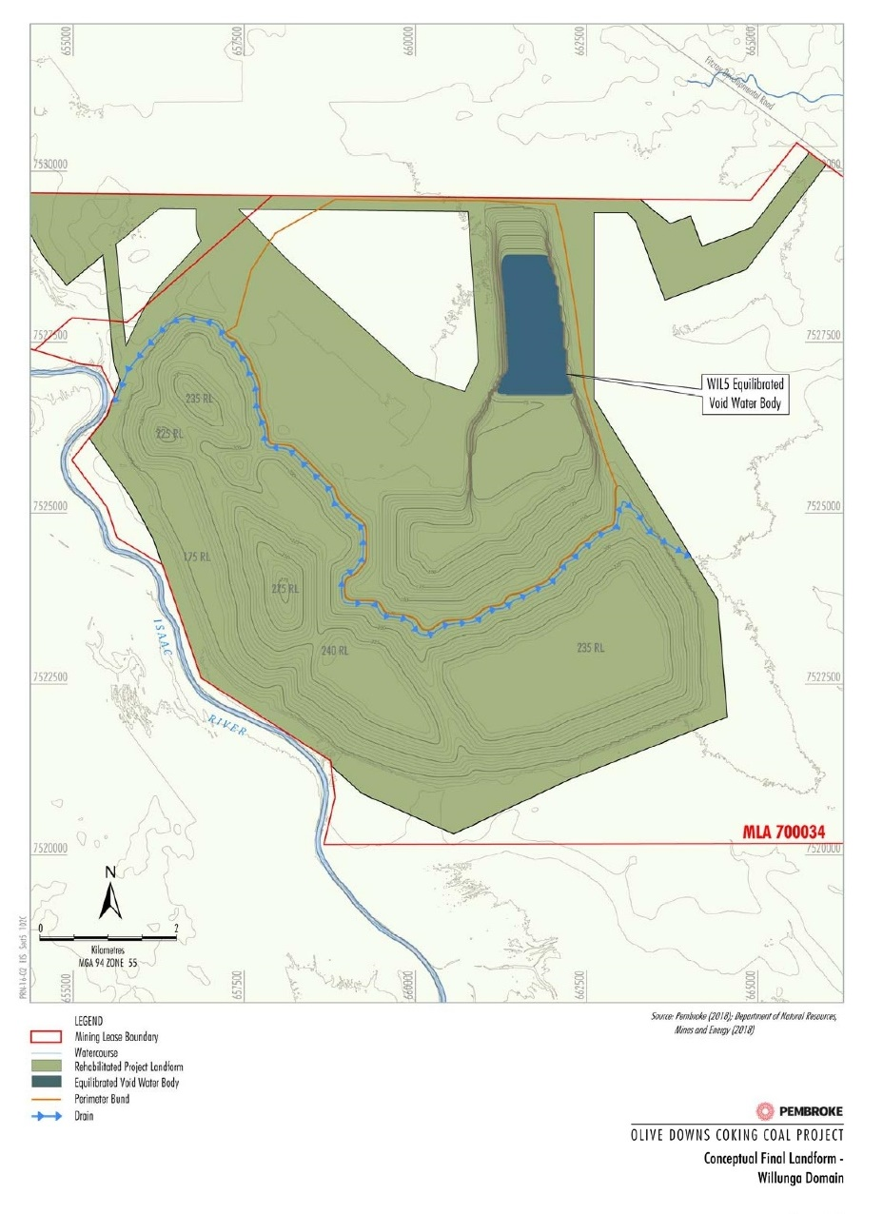
Figure 5-1 Olive Downs Coking Coal Project - Final voids (Pembroke Resources, 2018)
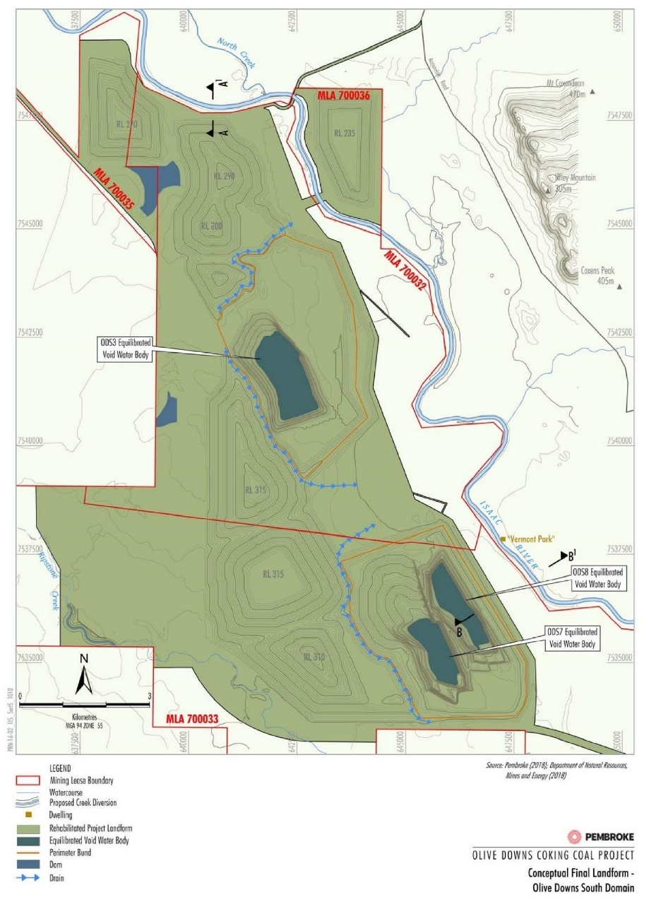

In reference to flood and overland flow protection the following design features of the voids are also reported.
- ODS3 and ODS7/ODS8 would be located within the extent of the existing Isaac River floodplain (i.e. within the 1:1000 annual exceedance probability (AEP) extent). The construction of permanent highwall emplacements to the east and southeast of the proposed Olive Downs South domain open-cut coal pits adjacent to the Isaac River floodplain would isolate the mining operation from the floodplain and provide immunity to flood levels up to a Probable Maximum Flood (PMF) event. In effect, the highwall emplacements would redefine the floodplain extent, such that the open-cut mining operation, and the final voids, would not be located within a floodplain.
- WIL5 would be protected from overland flows by a perimeter bund such that rising flood waters from the Isaac River would not reach the void.
Catchment areas of the final voids would be minimised through the construction of upslope drains/bunds to direct runoff around the voids to the surrounding landscape.

Conceptualisation of flow regime
Existing data and information, supplemented by monitoring and site investigations formed the basis of the baseline surface water and groundwater assessment, and accompanying impact assessment, prepared for the EIS (Pembroke Resources, 2018 & 2019).
A GoldSim model (coupled with predicted groundwater inflows from the site’s groundwater model) was employed in the EIS to conceptualise and assess the post-mining equilibrated final void flow regimes. Climate data used in the model was generated from historical rainfall and evaporation sequences (128 years in total, repeating 5 times). Given the uncertainty regarding void evaporation factors, a sensitivity analysis adopting reduced and increased evaporation factors was undertaken to assess this parameter on equilibrium ‘pit lake’ water levels and qualities within the final voids.
Flood modelling conducted as part of the wider EIS also informed the void flood risk assessment and design features to mitigate the flood risk to these features.
The components of the void’s water balance are predicted to be:
- Inflows:
  - Incident rainfall;
  - Runoff within the final void catchment area; and
  - Groundwater inflows (including waste rock emplacement infiltration), declining over time.
- Outflows:
  - Evaporation.
The predicted equilibrated ‘pit lake’ water level and quality of the three final voids are reported in Table 5-2.
Table 5-2 Long-term water level and quality model simulation results of final voids (Pembroke Resources, 2018 & 2019)
Final void | ‘Pit lake’ water level | ‘Pit lake’ water quality ⁽¹⁾
Pit ODS3 | The water level reaches equilibrium between 80 m AHD and 90 m AHD (~ 65 m below pre-mining groundwater levels), 200 years following mining cessation. The maximum modelled water level is ~ 82 m below the overflow level, and ~ 100 m below the level at which overflows would reach the receiving environment. | Remains brackish (< 5,000 mg/L TDS) for 150 years post-mining.
Pit ODS7/ODS8 | The water level reaches equilibrium between 20 m AHD and 30 m AHD (~ 140 m below pre-mining groundwater levels), 150 years following mining cessation. The maximum modelled water level is ~ 130 m below the overflow level, and ~ 145 m below the level at which overflows would reach the receiving environment. | Remains brackish (< 5,000 mg/L TDS) for 300 years post-mining.
Pit WIL5 | The water level reaches equilibrium between 55 m AHD and 70 m AHD (over 77 m below pre-mining groundwater levels), 100 years following mining cessation. The maximum modelled water level is ~ 85 m below the overflow level, and ~ 90 m below the level at which overflows would reach the receiving environment. | Remains brackish (< 5,000 mg/L TDS) for 550 years post-mining.
Note:
(1) The final void water bodies are not predicted to become hypersaline (>35,000 mg/L TDS) for at least the duration of the modelling exercise of 600 years.
As the ‘pit lake’ water level is predicted to equilibrate well below pre-mining groundwater levels (Table 5-2), the three final voids are expected to behave as terminal sinks into perpetuity (Section 3.2.1). The modelling indicates that equilibrated pit lake water levels will remain below their respective full supply levels (Table 5-2). Flood modelling indicated that flood waters would not enter any of the final voids in events up to and including the PMF event.
Evaporation from the ‘pit lake’ surface is expected to concentrate salts in the void over time. Pembroke’s commitment to remove basement coal from the floor of the three voids at the end of mining is anticipated to prevent the ‘pit lake’ water reaching hypersaline conditions for at least 600 years post-mining (the extent of the modelling period) (Pembroke Resources, 2019).
The sensitivity analysis of reduced and increased evaporation factors indicated that (Pembroke Resources, 2018):
- reduced evaporation factors may contribute to longer timeframes (up to 100 years) for the ‘pit lake’ water level to equilibrate, higher ‘pit lake’ water level equilibrium conditions (between 20 and 40 m), and lower salinity levels (by between 35% and 50%), at 600 years post-mining (the extent of the modelling period). The predicted higher ‘pit lake’ water level equilibrium conditions remain below each void’s overflow level; and
- increased evaporation factors are not predicted to change the timeframes for the ‘pit lake’ water level to equilibrate; however, lower ‘pit lake’ water level equilibrium conditions are predicted (between 5 and 20 m), as are higher salinity levels (by between 10% and 70%), at 600 years post-mining (the extent of the modelling period).

Potential impacts
The EIS (Pembroke Resources, 2018 & 2019) made the following conclusions regarding potential water quantity and quality impacts as a consequence of the final voids remaining in the landscape following mining cessation.
- The predicted loss of groundwater due to evaporative processes from the final voids (at equilibrium) is ~ 146 ML/year (Quaternary Alluvium) and ~ 183 ML/year (sub-artesian aquifers).
- The predicted long-term seepage loss from the Isaac River to the alluvium is ~ 1.9 ML/day.
- Although the final voids would result in continual take of groundwater from the adjacent Quaternary Alluvium, it is unlikely that this potential impact would result in a significant impact to any GDEs surrounding the Project. The vegetation in these locations is subject to continuous (natural) wetting and drying cycles and any potential GDEs are most likely facultative ecosystems that rely more heavily on the replenishment of moisture in the soil following rainfall rather than access to the groundwater system.
- While evaporation from the ‘pit lake’ surface would concentrate salts over time, the permanent terminal sink flow regime would prevent potentially saline or contaminated water migrating into surrounding aquifers. Accordingly, no adverse groundwater quality related impacts to surrounding aquifers or connected GDEs is anticipated.
Potential impacts of the residual void on ecological values are to be addressed within the rehabilitation and mine closure plan. This will assess the final void design and consideration of long-term environmental harm.
The IESC provided advice on the Project (IESC, 2018a) in response to a request made by the, then, Australian Government Department of the Environment and Energy (DoEE) and the Queensland Office of the Coordinator-General. The following key potential impacts associated with the Project’s residual voids were identified by the IESC (2018a).
- The waste rock emplacements will reduce the extent of the floodplain. This will increase flow velocities in the river channel and permanently reduce potential floodplain habitat.
- The waste rock emplacements will alter the surface hydrology, which is likely to adversely impact remnant floodplain vegetation, particularly the establishment and growth of seedlings.

Rehabilitation planning
A description of rehabilitation planning across Olive Downs is described within the EIS, specifically Section 5 rehabilitation strategy (Pembroke Resources, 2018), Section 4 – Rehabilitation additional information to the EIS (Pembroke Resources, 2019), and Appendix D – additional information on the rehabilitation strategy (Pembroke Resources, 2019). These documents are summarised in the sections below, particularly where they apply to rehabilitation of residual voids.

Preliminary rehabilitation planning
Rehabilitation goals at Olive Downs are consistent with Queensland Government policy and guidelines, which are to be approved through a progressive rehabilitation and mine closure plan (noting that this plan was not available for review for this case study). These goals require post-mining landforms to be:
- safe;
- non-polluting;
- stable; and
- able to sustain a post-mining land use.
The Project has been divided into domains with similar geomorphological characteristics. These domains will require different rehabilitation techniques and specific rehabilitation objectives, performance criteria and completion criteria to achieve the goals listed above. These domains include the:
- waste rock emplacements;
- final voids;
- infrastructure area;.
- water management infrastructure;
- In-line Flocculation (ILF) cells; and
- Ripstone Creek diversion.
General rehabilitation (short and medium to long term) objectives for the project are described in Table 5-1 (Section 5) of the rehabilitation strategy (Pembroke Resources, 2018). Objectives that are most relevant to the residual voids include:
- short term:
  - progressively place waste rock within the footprint of the open-cut voids and reshape completed areas to their final landform shape so that they can be progressively rehabilitated.
- medium to long term:
  - remediate safety hazards at the mine infrastructure areas and any potentially contaminated sites to remove safety risks to people and animals;
  - produce final voids that do not impact the receiving surface waters surrounding the Project; and
  - isolate the final voids from the Isaac River floodplain through the development of a permanent highwall waste rock emplacement and minimise the final void catchment areas with up-catchment diversions.
To achieve the objectives listed above, preliminary rehabilitation goals, performance indicators and completion criteria specific to final void domains have been developed within the rehabilitation strategy and are described in Table 5-3.

Final void post mining land use
Each mine domain has been allocated a proposed post-mining land use (Pembroke Resources, 2019). These include agriculture (low intensity cattle grazing), native vegetation (woodland) and fauna habitat.
Final void post mining land use is intended to be fauna habitat and will comprise of three landforms; void water body, void low wall and void high wall. Pembroke Resources (2019) investigated the likelihood that the final void would provide suitable native fauna habitat for each landform component as follows.
- Void water body: The revised EIS committed to removing basement coal from the final void floor at the end of mining to reduce salinity and delay the potential onset of hypersaline conditions (Section 5.1.4). Investigations by Pembroke found that some plants recorded on site can grow in brackish water providing habitat structure and is potable to most (if not all) terrestrial wildlife. This includes bird and bat species recorded on site, which are known to use brackish and saline habitats, particularly as a dry season refuge.
- Void low wall: This is planned to be rehabilitated with mostly native grasses to provide habitat for native ground-dwelling mammals.
- Void highwall: This is planned to be rehabilitated with native vegetation on the upper slope (< 20 degrees). Cliff habitat may be used by nesting native birds and cave-dwelling bats that roost in rock fissures and crevices. Bats may also use the air space above the void waterbody to forage for flying insects.

Table 5-3 Preliminary rehabilitation requirements for residual voids (Pembroke Resources, 2019)
Rehabilitation goal | Objectives | Performance indicators | Selection of performance indicator | Completion criteria
Long-term safety | Final void final landforms are geotechnically stable and safe. | Geotechnical assessment of the final void final landforms (slope angle and length) prepared by a suitably qualified person.  The geotechnical assessment would be reported and interpreted in the Final Rehabilitation Report. | Geotechnical assessments of final landforms are recommended by the Planning for Integrated Min Closure: Toolkit (International Council on Mining and Metals, 2008). | The geotechnical assessment concludes that:  - final void highwalls slopes are 20º or lower where located within alluvium and tertiary clays (known as the Cenozoic overburden) to achieve a factor of safety of 1.5;  - final void highwall slopes are 45º or lower where located within a fault fractured zone, and 55º where they are located away from fault zones. An overall angle of 55º is achieved by 50 m high batters at 65º incorporating 10 m wide intermediate benches;  - low wall slopes are stable;  - the toe of out-of-pit waste rock emplacements standoff the crest of the final voids by at least 50 m;  - the perimeter bunding is formed and security is fencing installed; and  - the final void final landforms are stable and safe.
 | Potentially contaminated areas are remediated and are safe | Contaminated land assessment prepared in accordance with the Queensland auditor handbook for contaminated land (DES, 2018b) by a suitably qualified person. The contaminated land assessment would be reported and interpreted in the Final Rehabilitation Report. | Consistent with the requirements of Chapter 7, Part 8 of the EP Act. | The contaminated land assessment concludes that the Project site is suitable for the proposed post-mining land use.
 | Other potential safety risks (e.g. falls from height) are identified and appropriately addressed so the site is safe. | Safety assessment (including risk assessment) prepared by a suitably qualified person.  The safety assessment would be reported and interpreted in the Final Rehabilitation Report. | Post-mining safety assessment is recommended by Rehabilitation Requirements for Mining Resource Activities Guideline (DEHP, 2014). | The safety assessment concludes that the risks associated with other potential safety risks are low.
Non-polluting | Final voids are isolated from the Isaac River. | Flood assessment prepared by a suitably qualified person.  The flood assessment would be reported and interpreted in the Final Rehabilitation Report. | Hydrological studies are recommended by Rehabilitation Requirements for Mining Resource Activities Guideline (DEHP, 2014). | The flood assessment concludes that the final voids are isolated from all flood events, up to and including a PMF event.
 | Final voids are a low risk of causing environmental harm. | Groundwater assessment prepared by a suitably qualified person.  The groundwater assessment would be reported and interpreted in the Final Rehabilitation Report. |  | The groundwater assessment concludes that the final voids are acting as groundwater sinks, preventing the migration of potentially saline water into adjacent aquifers and watercourses.
 |  | Final void balance prepared by a suitably qualified person.  The final void balance would be reported and interpreted in the Final Rehabilitation Report. |  | The final void balance concludes that the final void water bodies would equilibrate well below the point at which they would spill to the surrounding environment.
 |  | Surface and groundwater quality (e.g. pH, heavy metal content, etc) monitoring data.  Surface and groundwater quality monitoring data would be reported and interpreted in the Final Rehabilitation Report. | Water quality monitoring is recommended by Rehabilitation Requirements for Mining Resource Activities Guideline (DEHP, 2014). | Receiving water quality monitoring results comply with Environmental Authority surface and groundwater quality criteria, for a period of at least two years post-mining.
 |  | Environmental risk assessment prepared by a suitably qualified team.  The environmental risk assessment would be reported and interpreted in the Final Rehabilitation Report. | Consistent with the requirements of Chapter 5, Part 10 of the EP Act. | The environmental risk assessment concludes that there is a low risk of environmental harm.
Stable | Final void final landforms are geotechnically stable and safe. | Geotechnical assessment of the final void final landforms (slope angle and length) prepared by a suitably qualified person.  The geotechnical assessment would be reported and interpreted in the Final Rehabilitation Report. | Geotechnical assessments of final landforms are recommended by the Planning for Integrated Mine Closure: Toolkit (International Council on Mining and Metals, 2008). | The geotechnical assessment concludes that:  - the final void highwalls slopes are 20º or lower where located within alluvium and tertiary clays (known as the Cenozoic overburden) to achieve a factor of safety of 1.5;  - the final void highwall slopes are 45º or lower where located within a fault fractured zone, and 55º where they are located away from fault zones. An overall angle of 55º is achieved by 50 m high batters at 65º incorporating 10 m wide intermediate benches;  - the toe of out-of-pit waste rock emplacements standoff the crest of the final voids by at least 50 m;  - the perimeter bunding is formed and security fencing is installed; and  - the final void final landforms are stable and safe
Sustainable Land Use | Establish self-sustaining (fauna habitat) land use. | Landscape Function Analysis (LFA) (e.g. erosion, soil physical parameters, organic matter and nutrient content and cycling, vegetation dynamics, habitat complexity and habitat quality) monitoring.  LFA monitoring data would be reported and interpreted in the Final Rehabilitation Report. | CSIRO | LFA monitoring demonstrates that:  - sustainable fauna usage (e.g. Strip-faced Dunnart, Hoary Wattled Bat and Australian Grey Teal) of the final voids is achieved;  - weed diversity and abundance is comparable to relevant rehabilitation monitoring reference sites; and  - pests do not occur in substantial numbers.

Future management plans
Detailed rehabilitation management plans are to be developed for the Project and were not available for review for this case study. The rehabilitation strategy outlines the following relevant documents to be developed.
- Topsoil management plan.
- Erosion and sediment control plan.
- Weed and pest management plan.
- Rehabilitation and mine closure plan.
The rehabilitation and mine closure plan will outline the rehabilitation monitoring program, rehabilitation milestones, developed rehabilitation methods and completion criteria. Mine closure planning will continue to develop over the life of the Project and become more detailed as the Project approaches the end of the mine life, at around 2100.

Risk mitigation and management
According to the EIS (Pembroke Resources, 2018 & 2019), the final three voids are anticipated to equilibrate as terminal sink flow regimes, with ‘pit lake’ levels that will remain below overflow levels. The EIS concluded the final voids pose a low risk of environmental harm, with commitments to implementing the following key risk mitigation and management measures.
- Progressive backfilling of the open-cut pits behind the advancing operations would be undertaken to minimise the potential for environmental harm consistent with the rehabilitation hierarchy outlined in the Rehabilitation Requirements for Mining Resources Activities Guideline (DEHP, 2014). The mine schedule has been optimised to maximise opportunities to backfill advancing open-cut pits during mining operations such that ten open-cuts will be completely backfilled at the completion of mining, with three partially backfilled voids remaining in the landscape.
- Final voids ODS3 and ODS7/ODS8 would be isolated from all floodwaters up to and including a PMF event by permanent waste rock emplacements, while final void WIL5 would be protected from overland flows and rising flood waters from the Isaac River, by a perimeter bund (Section 5.1.3).
- The waste rock material (constituting the highwall emplacements) is expected to be principally non-acid forming (NAF), with excess acid neutralising capacity (ANC), and a negligible risk of developing acid conditions. The material is also predicted to generate relatively low-salinity surface run-off and seepage with low soluble metals concentrations. Where highly sodic and/or dispersive waste rock is identified, the material would be selectively handled so that it does not report to final landform surfaces of the permanent highwall emplacements.
- To improve water quality (reducing salinity) within the final void water bodies for flora and fauna post-mining, the basement coal layer from the floor of the ODS3, ODS7/8 and WIL5 open cut pits will be removed at the end of mining (Section 5.1.3).

Middlemount coal mine

Project status
The Middlemount open-cut coal mine, operated by Middlemount Coal Pty Ltd (MCPL); an incorporated joint venture between Peabody Energy Australia Pty Ltd and Yancoal Australia Ltd), is an existing mine located approximately 90 km northeast of Emerald and 3 km to the southwest of the Middlemount township, Queensland (Figure 4-1). The mine produces medium-volatile pulverized coal injection (PCI) coal and semi-hard coking coal for the export market. Full-scale operations at the open-cut mine commenced in November 2011 and the current mine life is estimated to be in excess of 20 years. Mining operations consist primarily of excavator and truck strip mining augmented by cast and doze. The following is the most recent approval process for the Western Extension Project (herein in Section 5.2 referred to as the Project); a continuation of open-cut coal mining operations within the extended portion of ML 70379 and extension of the East Dump within MLA 700027.
- MCPL sought approval for the Project; a continuation of open-cut coal mining operations, through a major amendment of EA EPML00716913. In March 2018, DES issued a request for additional information from MCPL to enable the Department to make a decision on the application and an Environmental Assessment Report (EAR) (MCPL, 2018a) was prepared. DES issued the EA for the Project, taking effect on 26 February 2020.
- MCPL also sought approval of the Action under the Commonwealth EPBC Act (EPBC 2017/8130). The Commonwealth Environment Minister declared the Action to be a ‘controlled action’ for the purposes of the EPBC Act. MCPL prepared preliminary documentation (MCPL, 2019) to enable the Commonwealth Environment Minister and interested parties to understand the environmental consequences of the Action on Matters of National Environmental Significance (MNES). The Action received Federal approvals from the DAWE under the EPBC Act (with conditions) in October 2019.
The following section describe relevant information made available by MCPL to support the State (MCPL, 2018a) and Commonwealth (MCPL, 2019) approval processes for the Project.

Physical setting
The area of mine has a semi-arid to sub-tropical climate, typical for Central Queensland, with mean evaporation and evapotranspiration rates exceeding rainfall for all months of the year.
The mine site is located within the Roper Creek Catchment, within the Mackenzie River sub-basin of the greater Fitzroy Basin (Figure 4-1). Local drainage includes:
- the ephemeral Roper Creek including its approved diversions;
- Thirteen Mile Gully diversion (including associated upstream drainage features) which diverts the upstream sub-catchments of Thirteen Mile Gully (north and west of the ML 70379 boundary) to Roper Creek; and
- an unnamed tributary of Roper Creek located immediately east of the Project, which joins Roper Creek about 4.2 km downstream of Dysart Middlemount Road.
The regional scale geology comprises a Quaternary and Tertiary sequence overlying older Permian coal measures of the Bowen Basin. These geological units are separated into three key hydrostratigraphic units based on their hydraulic properties and lithology, and from youngest to oldest include:
- Quaternary units: alluvial aquifer consisting of localised stream channel deposits and associated flood plain deposits.
- Tertiary-aged units: Duaringa Formation, a low-yielding aquifer or aquitard, consisting of thick clay-rich laterite, sourced from highly weathered Permian sandstones and siltstones, and occasional basalt.
- Permian-aged units:
  - interburden/overburden consisting of sandstone, siltstone, and mudstone that typically have low permeability and generally form aquitards; and
  - coal seams (principally the Middlemount and Pisces Seams) constituting low to moderate yielding aquifers confined by interburden/overburden units.
Three primary seams of the Rangal Coal Measures are targeted for coal mining, specifically the Middlemount, Pisces and Tralee Seams. Groundwater at the Project site is indicated to be brackish to saline, averaging 13,071 mg/L TDS in the Tertiary aquifers and 9,758 mg/L TDS in the Permian aquifers.
Water quality monitoring of fresh water and/or mine affected water that discharges to, or is stored in the current open-cut pits, may be collected as part of MCPL’s compliance monitoring or environmental management commitments; however, this data is not publicly accessible.
The Project is situated within the Brigalow Belt North bioregion. The land within the Project area has been predominantly cleared for cattle grazing, most of which (66%) is pasture grasslands and regrowth vegetation (non-remnant).
Surveys conducted within the Project area identified six vegetation communities. Remaining vegetation areas area mostly associated with riparian areas. These communities consist of:
- Acacia harpophylla and/or Casuarina cristata open forest on alluvial plains.
- Eucalyptus populnea woodland on alluvial plains.
- Eucalyptus populnea woodland on alluvial plains / Eucalyptus tereticornis and/or Eucalyptus spp. woodland on alluvial plains.
- Eucalyptus camaldulensis and/or E. tereticornis woodland.
- Acacia harpophylla shrubby woodland with Terminalia oblongata on Cainozoic clay plains.
- Eucalyptus populnea ± E. melanophloia ± Corymbia clarksoniana woodland on Cainozoic sand plains and/or remnant surfaces.

Proposed design of residual voids
The Project will require two final voids (totalling 595 ha in area) located at either end of the mine path (MCPL, 2018a) (Figure 5-2). The geometrics of the final void designs are presented in Table 5-5.
Table 5-4 Geometrics of final void design (MCPL, 2018a)
Final void ⁽¹⁾ | Depth (m) | Area (ha) | Full supply volume (ML) | Contributing catchment area (ha)
North void | 120 | 373 | 15,770 | 390.5
South void | 240 | 222 | 12,100 | 345.5
Note:
(1) The two voids are separated by spoil backfill that rises up to 180 m AHD.
The maximum slope range of the final voids is indicated to be 53-75%.

Figure 5-2 Layout of Middlemount coal mine – Western Extension Project (MCPL, 2018a)
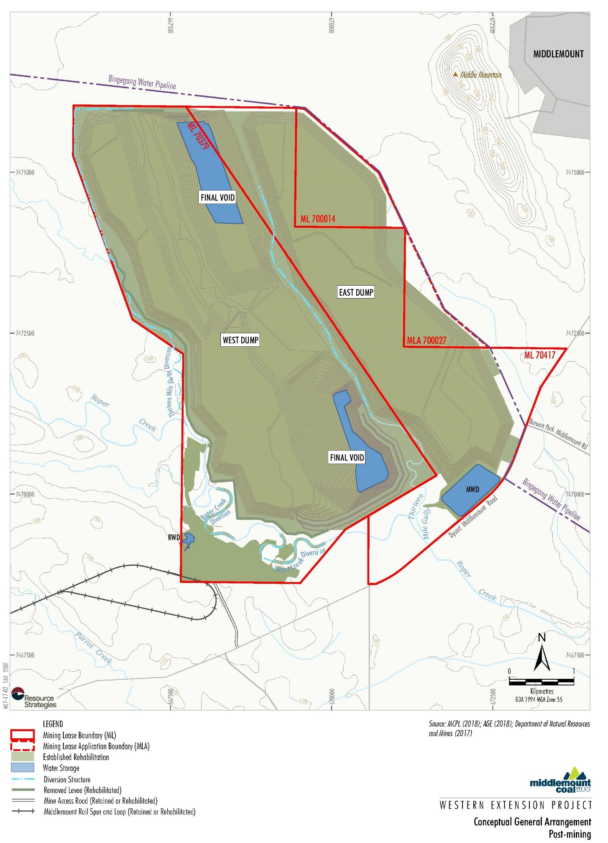
In reference to flood and overland flow protection, the following design features of the residual voids are also reported (MCPL, 2018a).
- Final catchment areas draining to the voids will be minimised using upslope diversion drains.
- The southern void will be located on the pre-mine Roper Creek floodplain. The flood bund up to 100 m wide at the crest will be incorporated into the rehabilitated final landform of this void to prevent floodwater from entering and to form a self-sustaining structure that does not require long-term maintenance. The bund will have a crest height above the PMF level from Roper Creek. The flood protection levees on the western side of the mine will also be removed such that the rehabilitated out-of-pit overburden areas will prevent floodwater from entering the pit. There is at least 150 m of out-of-pit overburden area and 1 km of in-pit overburden between the floodplain and the final void, which is considered by the MCPL to be more than adequate to prevent floodwater from entering the final void.

Conceptualisation of flow regime
Baseline and ongoing surface water and groundwater monitoring informed the impact assessments prepared for the EAR (MCPL, 2018a).
A GoldSim model was used to assess the likely long-term water level behaviour of the final voids. The model relied on predicted groundwater inflows developed as part of the groundwater assessment. Climate data used in the model was generated from historical rainfall and evaporation sequences (128 years in total, repeating 5 times).
Once mining operations cease, groundwater inflows to the final voids would no longer be collected and pumped out, and as a result, the final voids would gradually begin to fill with groundwater.
The components of the equilibrated water balance of the two final voids are predicted to be:
- Inflows:
  - incident rainfall;
  - runoff within the final void catchment area; and
  - groundwater inflows (including soil dump infiltration), declining over time.
- Outflows:
  - evaporation.
The predicted quasi-equilibrated ‘pit lake’ water level and quality of the two final voids are reported in Table 5-5.
Table 5-5 Long-term water level and quality model simulation results of final voids (MCPL, 2018a)
Final void | ‘Pit lake’ water level | ‘Pit lake’ water quality
North void | The ‘pit lake’ water level reaches equilibrium between 60 m AHD and 65 m AHD relatively quickly and varies between these levels and empty throughout the simulation. The average stored volume is predicted to be 460 ML. The maximum modelled water level is ~ 95 m below full supply level. | Salt accumulates in the void at an average rate of around 63 tonnes/year, becoming hyper-saline within approximately 100 years.
South void | The ‘pit lake’ water level reaches equilibrium between -70 m AHD and -30 m AHD relatively quickly and generally varies between these levels throughout the simulation. The average stored volume is predicted to be 1,500 ML. The maximum modelled water level is ~ 175 m below full supply level. | Salt accumulates in the void at an average rate of around 155 tonnes/year, becoming hyper-saline within approximately 100 years.
Modelling of the final voids indicated that the ‘pit lake’ water levels are expected to be well below the full supply levels for each void and that the features will remain as long-term groundwater sinks in perpetuity (i.e. terminal sink flow regime, Section 3.2.1), with no potential for migration of contained water into the surrounding Rangal Coal Measures or Fort Cooper Coal Measures (Table 5-5). The final voids are not predicted to spill under any of the simulated climatic sequences.
The predicted minor groundwater inflows relative to other inputs (i.e. rainfall) means that the water level response in the equilibrated final voids are likely to be largely driven by climatic processes. The modelling also predicted that there would be no interaction between the long-term ‘pit lake’ water levels within the northern and southern void.
With reference to potential flood risk, the northern final void is located well beyond the current floodplain of Roper Creek. The southern final void is located partially on the pre-mine floodplain of Roper Creek; however, as described Section 5.2.3, at the completion of mining the operational flood protection levee in the south would be incorporated into the final landform to provide flood immunity up to the PMF level from Roper Creek.
As there is no mechanism to lose salt within the closed void systems, evaporation will cause the voids to continually accumulate salt over time, with modelling indicating potentially hypersaline conditions in approximately 100 years post-mine closure (Table 5-5).

Potential impacts
The EAR (MCPL, 2018a) made the following conclusions regarding potential water quantity and quality impacts as a consequence of the final voids remaining in the landscape following mining cessation.
- The increasing salinity (and AMD generated from coal rejects placed with overburden within the open-cuts) would not pose a risk to neighbouring aquifers and surface water features as the final voids would remain a permanent sink.
- No existing landholder water supply bores are located within the predicted groundwater drawdown or depressurisation extents attributable to dewatering of the coal measures during operation of the Project. Post-mining, the extent and magnitude of groundwater drawdown or depressurisations impacts are expected to reduce.
- Roper Creek is conceptualised as an ephemeral ‘losing’ stream with limited to nil potential for a baseflow contribution from the Tertiary aquifer. It is not clear whether the EAR assessed the potential for seepage losses from Roper Creek (or other surface water features) as a consequence of the Project (both during operation and post-mining).
- Operation of the Project is not predicted to impact any aquatic or terrestrial GDEs on the basis that such GDEs were assessed as being unlikely to occur within and surrounding the mine site.
Potential impacts and liabilities of final voids is to be considered within the Plan of Operations. Final assessment of rehabilitated landforms and vegetation will be undertaken at the practical completion of the works specified in the Plan of Operations. This assessment will provide a summary of results for each of success criteria (Table 5-7) and will provide a basis for making arrangements for return of lease.
The IESC provided advice on the Project (IESC, 2018b) in response to a request made by DoEE. The following key potential impacts associated with the Project’s residual voids were identified by the IESC (2018b).
- Groundwater interaction/leakage from the final voids due to probable fracturing associated with the Jellinbah Fault that lies close to the eastern boundary of both voids.
- Changes to water quantity and quality within the floodplain from the two final voids as a result of potential overtopping and leakage into or from groundwater. There is also a risk of density driven groundwater flow arising from salinity build-up in the final voids.

Rehabilitation planning
A description of rehabilitation planning for the Project is described within the EAR (MCPL, 2018a), the Stage 2 Rehabilitation Management Plan (MCPL, 2012) and the Middlemount Coal Rehabilitation Management Plan Addendum (MCPL, 2018b). The addendum has been developed to include the western extension area. These documents are summarised in the sections below, particularly where they apply to rehabilitation of final voids.

Rehabilitation management and planning
Rehabilitation goals at Middlemount Coal are consistent with Queensland guidelines, Rehabilitation Requirements for Mining Resource Activities (DES, 2014). These goals require post-mining landforms to be:
- safe to humans and wildlife;
- non-polluting;
- stable; and
- able to sustain an agreed post-mining land use.
Final voids are one of eight domains that are to be rehabilitated. For each of these domains, rehabilitation management units (RMU) have been identified which reflect the differing rehabilitation works required (described below). The rehabilitation works differ based on soil preparation, successional plant communities and timing of activities.
Progressive rehabilitation will occur within the rehabilitation domains in order to achieve the proposed post-mine land uses. Whilst rehabilitation works have been planned for the final voids, there is currently no intended final land use for these areas, and they are to remain as voids (MCPL, 2018b). MCPL has assessed final voids as a single RMU, broken down into three sections; M, N & O. Rehabilitation management intended for two final voids within the western extension area are described in Table 5-6.
Table 5-6 Rehabilitation management of final void RMU
Parameter | M | N | O
Slope (%) | <18.5 | <18.5 | <18.5
Weed removal | Selective spot spraying using knapsack type spray packs | Selective spot spraying using knapsack type spray packs | Broad scale removal of weeds using earthmoving equipment and machine mounted spraying
Soil cultivation/ripping | NA | Ripping of soil to a 200 mm depth – to undisturbed land or areas or areas covered by a capping material | Deep ripping of soil to a 400 mm depth – applied to general site areas except for heavily compacted areas
Growing medium structure | 50% ameliorated topsoil and 50% rock mulch | 60% ameliorated topsoil and 40% rock mulch. | 70% ameliorated topsoil and 30% rock mulch
Growing medium mulch | A minimum of 50 mm depth of organic mulch to be installed over structured soils/ and tube-stock plantings
Initial planting schedule | Crop | Pasture / Crop | Native Grass
Final planting schedule broad vegetation group | 24 Native | 18 Native | 17 Native
Primary planting method | Direct seeding
Supplementary planting method | Tube-stock
The rehabilitation objectives and success criteria relevant to each domain have been developed and are described in the Rehabilitation Management Plan addendum (MCPL, 2018b) and the current EA (EPML00716913). The objectives and success criteria are used to measure the achievement of rehabilitation goals and are described in Table 5-7 for the final void domain.
There are no rehabilitation objectives, indicators or completion criteria to measure the goal of sustaining agreed post mining land use, as there is currently no post mining land use commitment for final voids.

Final void post mining land use
There is currently no post mining land use commitment for final voids at the Middlemount Coal mine. The western extension will have two final voids that MCPL has indicated will be rehabilitated to a safe, stable, non-polluting landform.

Future management plans
A void hazard management plan will be developed by MCPL to consider geotechnical risks identified within the rehabilitation management plan addendum. A progressive rehabilitation and closure plan will also be developed that will include enforceable milestones that relate to progressive rehabilitation and identify suitable post mining land use.

Table 5-7 Rehabilitation objectives, success criteria and corrective actions for final voids (MCPL, 2018b)
Rehabilitation goal | Objectives | Indicators | Success criteria | Corrective actions
Safe to humans and wildlife | Structurally safe with very low probability of subsidence or rock fails with serious consequences | Safety assessment of landform stability. | Certification by an appropriately qualified person, that final voids are stable, including:  - certification that slopes are as per Table F3: Residual Void Design (of the EA) and are geotechnically stable for the foreseeable future;  - certification that drainage structures are sufficiently designed and implemented for operation into the foreseeable future, and direct surface water flow away from residual voids;  - certification that erosion and sediment controls are sufficiently designed and implemented for operation into the foreseeable future;  - A safety assessment to be conducted and included in Post Closure Management Plan; and  - geotechnical stability of the high wall, low wall and end walls has been achieved and geotechnical investigations demonstrating this have been undertaken and reported. | Re-work site to a stable state and monitor erosion and sediment mitigation measures.  Assessment by a geotechnical professional and cut back landforms if necessary.
 | Hazardous materials adequately managed | Contaminated land assessment.  Risk to humans and animals. | Evidence which has been certified by an appropriately qualified person will include that:  - hydrocarbon, heavy metal or other contamination levels are within allowable departmental limits;  - no acid rock drainage is occurring or has the potential to occur; and  - fencing and/or safety bunding and prominent signage is installed around the perimeter of the final voids to restrict access. | Undertake additional contaminated land assessment by an appropriately qualified person to determine source and extent of potential issue. Ensure fencing, separation infrastructure and signage is in place.  Remediation as required.
Non-polluting | Polluted water contained on site or treated | Residual void water quality | Evidence which is certified by an appropriately qualified person includes that that:  - the low, high and end walls drain internally to the final void; and  - final void waters comply with specifications detailed in the Residual Void Water Quality Management Plan. | Undertake additional contaminated land assessment by an appropriately qualified person to Ensure any residual to determine source and extent of potential issue.  Remediation as required.
 | Ensure any residual water bodies have a low risk of environmental harm
 | No contamination of surface water and groundwater resources | Upstream and downstream surface and ground water quality (e.g. sediment load, pH, heavy metal content, etc) meet EA conditions | Evidence which is certified by an appropriately qualified person includes that:  - groundwater and monitoring bores have parameters consistent with those specified in Table C8 of the EA, for the period of the Post Closure Management Plan;  - based on up to date groundwater modelling, that any residual void water will not overflow nor potentially contaminate any other surface water bodies; and  - voids do not discharge to any receiving waters, including surface water and groundwater.
Stable | Very low probability of subsidence or rock fails with serious consequences | Safety assessment of landform stability including slope angle, length and profile. | Certification from an appropriately qualified person that the final voids are stable into the foreseeable future and have been constructed in accordance with RPEQ designs and the criteria defined in Table F3: Residual Void Design of the EA. | Re-work site to a stable state and monitor erosion and sediment mitigation measures. Residual void design to be reassessed. Assessment by geotechnical professional and cut back landforms if necessary.
 | Very low probability of slope slippage with serious consequences
 | Landform design achieves appropriate erosion rates. | Erosion rates and gully formation

Risk mitigation and management
According to the EAR and preliminary documentation (MCPL, 2018a & 2019), the north and south voids are anticipated to equilibrate as terminal sink flow regimes, with ‘pit lake’ levels that will remain below overflow levels. The assessment concluded the final voids pose a low risk of environmental harm, with commitments to implementing the following key risk mitigation and management measures.
- Minimisation of out-of-pit waste emplacements via backfilling of the open cut pit void.
- Final catchment areas draining to the voids will be minimised using upslope diversion drains (Section 5.2.3).
- For the southern void (partially located on the Roper Creek floodplain), a flood bund will be incorporated into the rehabilitated final landform of this void to prevent floodwater from entering and to form a self-sustaining structure that does not require long term maintenance. The bund will have a crest height above the PMF level from Roper Creek. The flood protection levees on the western side of the mine will also be removed such that the rehabilitated out-of-pit overburden areas will prevent floodwater from entering the pit (Section 5.2.3).

Jellinbah coal mine

Project status
The Jellinbah coal mine, situated in the Bowen Basin at Jellinbah in Central Queensland, approximately 30 km northeast of Blackwater and 180 km west of Rockhampton (Figure 4-1), commenced operation in 1989. It is an open-cut operation with overburden drilling and blasting, followed by conventional removal with truck and shovel and dozer push. The reserves are low volatile bituminous coal with high specific energy and low ash and the mine has a current production capacity of approximately 5 Mtpa. Jellinbah East Joint Venture (JEJV) own the mine, with shared ownership between Jellinbah Group (70%), Marubeni Coal (15%) and Sojitz Coal (15%).
The most recent approval process for the Central North Extension (CNE) project entails the addition of three mining leases to the existing mine for the purpose of extending approved mining activities further to the east and expanding the area available for spoil dumping and topsoil placement. The process is as follows.
- JEJV sought approval for the CNE project through a major amendment of EA EPML00516813 in August 2015. An ‘Information Request’ from DES was received in September 2015, and a ‘Response to Information Request’ was submitted in September 2016 (AARC, 2015). Following a public notice period, the EA Amendment Application was approved on 10 January 2017, and ML 700011, ML 700012, and ML 700013 were granted in July 2017. Site-specific conditions were included for management and mitigation of impacts on environmental values.
- JEJV also sought approval of the Action under the Commonwealth EPBC Act (EPBC 2018/8139). The Commonwealth Environment Minister declared the Action to be a ‘controlled action’ for the purposes of the EPBC Act. JEJV prepared preliminary documentation (AARC, 2019) to enable the Commonwealth Environment Minister and interested parties to understand the environmental consequences of the Action on MNES. In April 2020, the Action received Federal approvals from the DAWE under the EPBC Act (with conditions).
The following sections describe relevant information made available by JEJV to support the State (AARC, 2015) and Commonwealth (AARC, 2018 & 2019) approval processes for the CNE project.

Physical setting
The Jellinbah mine area has a sub-tropical climate, dominated by a wet humid summer and dry winter, with mean evaporation and evapotranspiration rates exceeding rainfall for all months of the year.
The mine site is located within the Blackwater Creek and the Mackenzie River catchments of the Fitzroy (drainage) Basin (Figure 4-1). Blackwater Creek runs parallel to the western boundaries of the existing Jellinbah Central mining lease area, while the Mackenzie River traverses the mine area between the Mackenzie North mining lease area and the existing mining operations at Jellinbah Plains and Jellinbah Central.
Watercourses within the region are ephemeral with the exception of the Mackenzie River, which carries controlled releases from Fairbairn Dam, along the Nogoa River, upstream of the mine site. A number of minor ephemeral streams are present in the mine area and some have been disturbed by the operations.
The mining operation (within the Bowen Basin) targets the Rangal Coal Measures where the unit sub-crops at shallow depths beneath the Tertiary cover. The regional scale stratigraphy and hydrostratigraphy of the mine area is summarised as follows (from youngest to oldest) (AARC, 2019).
- Quaternary alluvium consisting of consolidated soil, silt clay, sand and gravel is limited in lateral extent and is generally associated with the larger surface drainages. Groundwater in the unit has an electrical conductivity (EC) range of between 456 and 5,410 μS/cm (averaging 1,620 μS/cm).
- Tertiary deposits comprising mudstone, sandstone, siltstone, and conglomerate of the Duaringa Formation and sediments derived from weathering and remobilisation of older units occur throughout the mine area. Where the unit outcrops or sub-crops it is likely to be generally dry. Groundwater EC within the unit ranges between 900 and 16,100 μS/cm.
- Triassic sediments of the Rewan Group comprising lithic sandstone and green to reddish brown mudstone occur in the eastern sections of the mine area. Groundwater in the sediments is generally of poor quality, with an EC range of between 6,500 and 30,000 μS/cm (averaging 19,118 μS/cm).
- Late Permian Blackwater Group coal-bearing sediments, including the Rangal Coal Measures (the target coal seam for mining at the site) occur at shallow depths in the mine area. The unit comprises interbedded siltstone, sandstone, shale (interburden), and coal. The Permian interburden is hydrogeologically ‘tight’ (i.e. very low yielding), with significant groundwater flow generally occurring within the coal seams. Groundwater in the unit is generally of poor quality, with an EC range of between 1,328 and 38,400 μS/cm, averaging 9,951 μS/cm.
Structurally, the mine site occurs within the Jellinbah Thrust Belt, which lies between the Jellinbah Fault to the west and the Yarrabee Fault to the east. The faults act to compartmentalise the various groundwater units in the area of the mine site.
The two groundwater bearing units at the mine site are the spatially limited Quaternary alluvium and the low yielding Permian coal measures. Current pit developments associated with the mine site have encountered negligible groundwater ingress, with the rate of evaporation greater than the rate of groundwater inflow.
Water quality monitoring of fresh water and/or mine affected water that discharges to, or is stored in, the current open pits may be collected as part of JEJV’s compliance monitoring or environmental management commitments; however, this data is not publicly accessible.
The mine site is situated within the Brigalow Belt North bioregion of the Isaac–Comet Downs sub-bioregion. Land within the mine site had been predominantly cleared for grazing prior to mining. Remnant vegetation typically remains along watercourses and roads, or in isolated patches of limited connectivity.
Surveys conducted within the project area identified ten vegetation communities. These communities consist of:
- Brigalow Woodland 1 – Regional Ecosystem (RE) 11.3.1, Acacia harpophylla and/or Casurina cristata open forest on alluvial plains.
- Poplar Box Woodland – RE 11.3.2, Eucalytpus populnea open woodland on alluvial plains.
- Red Gum Riparian Woodland – RE 11.3.25, Eucalyptus camaldulensis woodland fringing drainage lines.
- Coolabah Grassy Woodland – RE11.3.3, Eucalyptus coolabah open woodland on alluvial plains.
- Coolabah Palustrine Wetlands – RE 11.3.3c, Eucalyptus coolabah open woodland to woodland with a sedge or grass understory in back swamps and old channels.
- Dawson Gum Woodland – RE 11.4.8, Eucalyptus cambageana woodland to open forest with Acacia harpophylla on Cainozoic clay plains.
- Brigalow Palustrine Wetlands – RE 11.4.8a, Gilgai and small depressions on clay plains usually associated with Acacia harpophylla.
- Brigalow Woodland 2 – RE 11.4.9, Acacia harpohylla shrubby woodland with Terminalia oblongata on Cainozoic clay plains.
- Brigalow and Dawson Gum Open Forest – RE 11.4.9b, Acacia harpophylla and Eucalyptus cambageana open forest to woodland on Cainozoic clay plains.
- Narrow-leaved Ironbark Woodland – RE 11.5.2, Eucalyptus crebra on lower slopes of Cainozoic sand plains.

Proposed design of residual voids
The Jellinbah mine operation will result in eight final voids (totalling 744 ha in area). Table 5-8 defines the residual void design parameters adopted in the final landform design. The location of the final voids is presented in

Figure 5-3, and their layout is shown in more detail in Figure 5-4 (MacKenzie North and Plains) and Figure 5-5 (Central North, Central, Central South and Jellinbah South).
Table 5-8 Geometrics of final void design (AARC, 2018)
Void name | Void ID  (as per EA) | Void wall competent rock max slope (°) | Void wall incompetent rock max slope (°) | Void maximum surface area (ha)
MacKenzie North Void | MacKenzie North | 70 | 45 | 149
Plains Void (North and South) | MacKenzie South |  |  | 30 | 147
 | Plains North |  |  | 52
 | Plains South |  |  | 65
Central Void North and Central Void | Central North Extension (CNE) |  |  | 95 | 330
 | Central North |  |  | 140
 | Central |  |  | 45
 | Central East |  |  | 50
Max Pit Void | Max Pit |  |  | 18 | 18
Central Void South | Central South |  |  | 70 | 70
Jellinbah South Void | South |  |  | 30 | 30
At the northern-most extent, the Plains Void North will be located approximately 250 m south of the Mackenzie River and the final void will be located within the Mackenzie River floodplain. The MacKenzie North Void will be located on the northern floodplain of the Mackenzie River (AARC, 2018).
AARC (2018) indicates that the final voids at mine closure will be designed to have flood immunity to extreme weather events and for the purposes of minimising clean water capture and long-term storage of floodwater. A 1:1000 AEP design flood immunity was adopted as a minimum design reference, with the following three flood protection landforms proposed to prevent flood ingress to the final voids (AARC, 2018).
- Plain North levee: the existing levee crest levels will be maintained to continue to provide 1:1000 AEP flood immunity from Mackenzie River (Figure 5-4). The long-term geotechnical stability of the levees, and potential reshaping requirements, will require investigation.
- Mackenzie North levee: proposed landform to provide pit protection from the Mackenzie River anabranch (Figure 5-4).
- Levees between Plains North and Plains South: to prevent ingress from the re-established Three Mile Lagoon flow path.
In reference to overland flow protection, AARC (2018) also report that final landform drains were incorporated to divert external catchments where possible to reduce the volume of runoff reporting to the residual voids.

Figure 5-3 Location of residual voids at the Jellinbah coal mine (AARC, 2018)
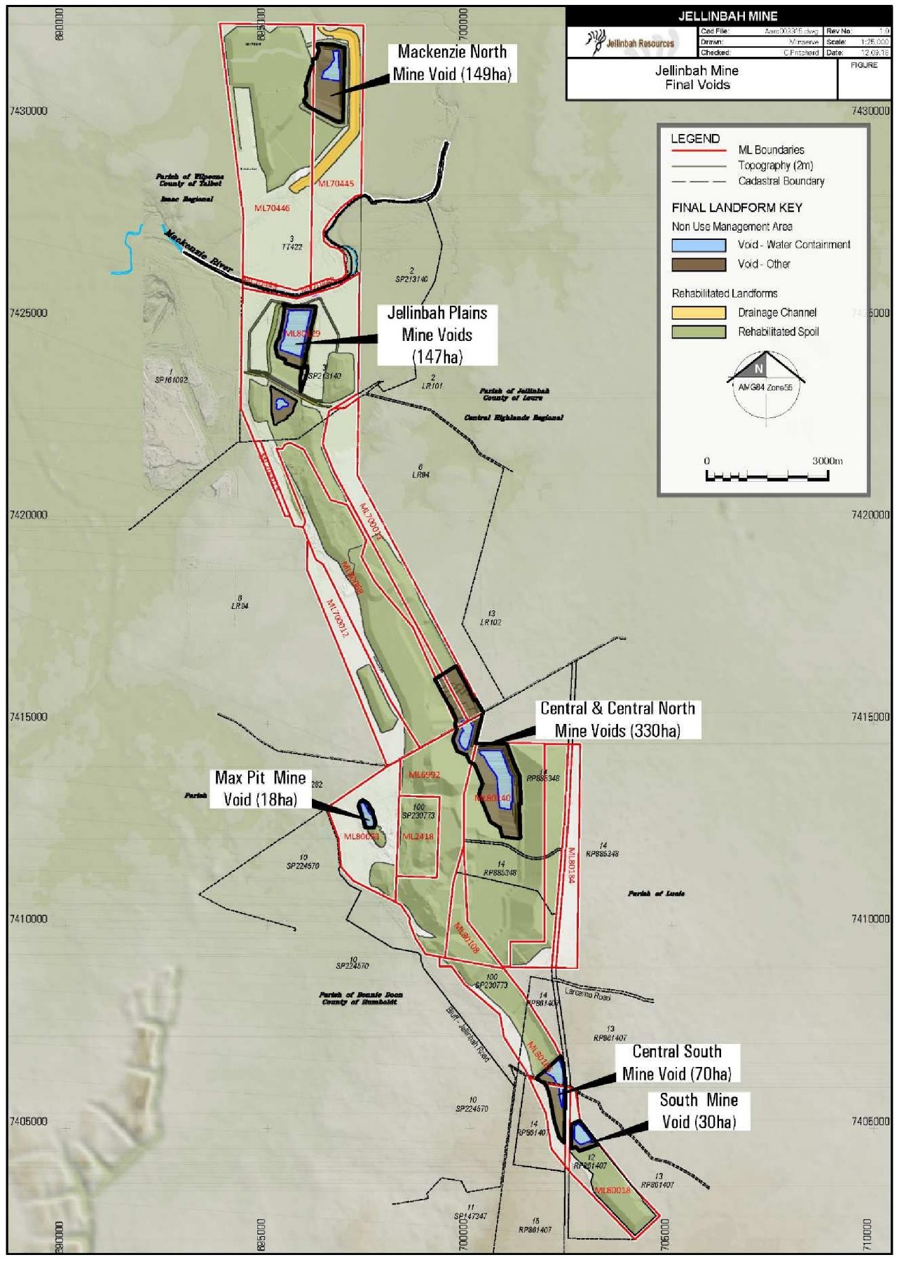

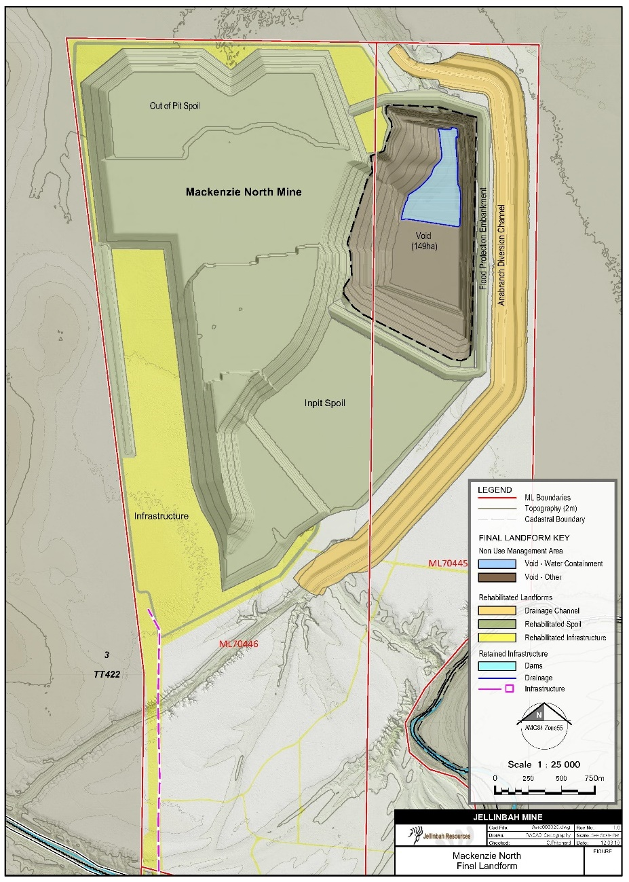
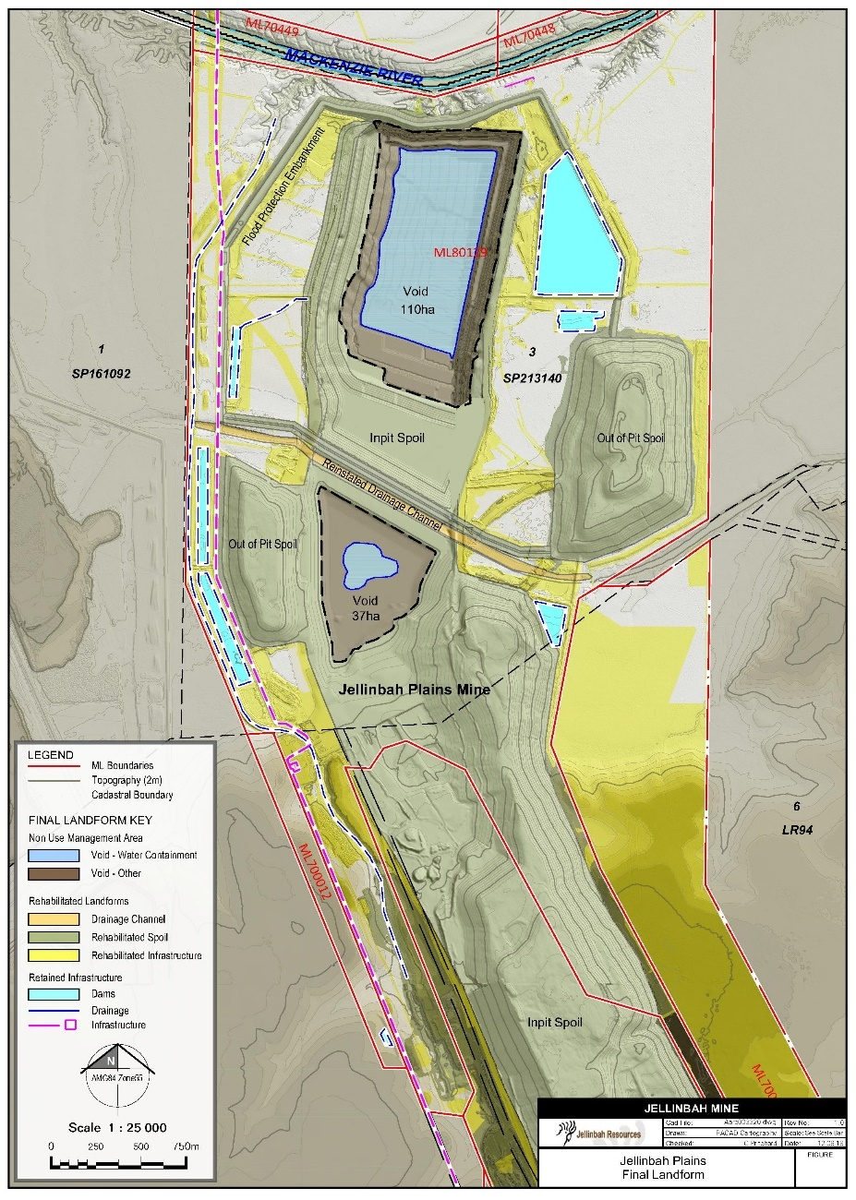
Figure 5-4 Final landform of the Jellinbah coal mine - MacKenzie North and Plains (AARC, 2018)

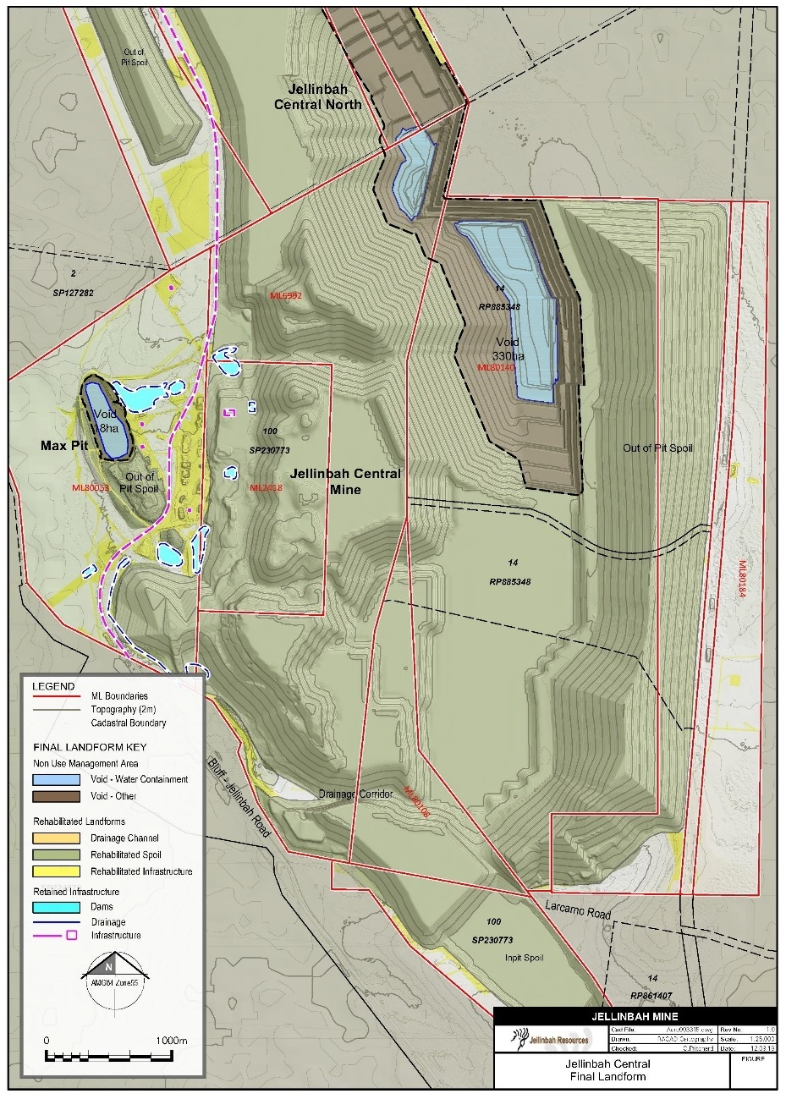
Figure 5-5 Final landform of the Jellinbah coal mine – Central North, Central, Jellinbah Central South and Jellinbah South (AARC, 2018)
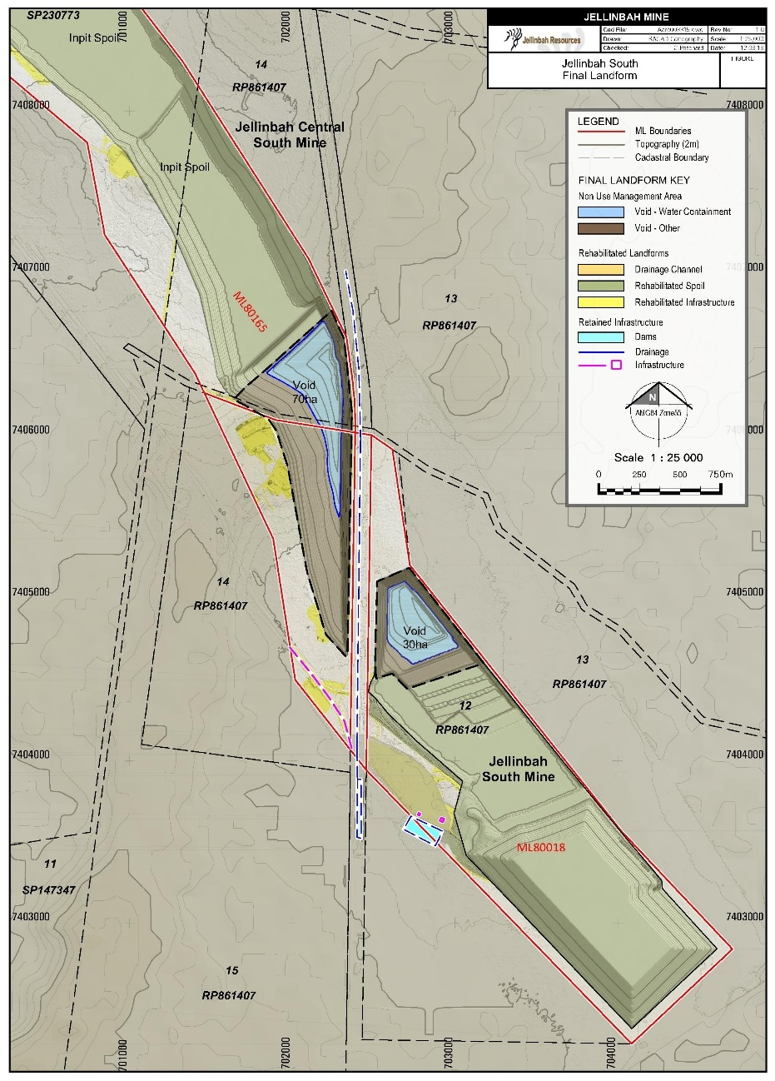

Conceptualisation of flow regime
Potential groundwater inflow to the residual voids was estimated for each residual void using numerical groundwater modelling (MacKenzie North), 2-dimesnional finite element modelling (Plains North), analytical modelling (Central and Central North) or assumptions (Central South, Jellinbah South, Max Pit, Plains) (AARC, 2018).
The potential groundwater inflow estimates informed the long-term ‘pit water’ level and salt balance of the residual voids which was simulated using the GoldSim software, utilising daily time steps. The GoldSim model was simulated by looping the 129 years of available Scientific Information for Land Owners (SILO) climate data, until the volume of each void was observed to reach an equilibrium state (AARC, 2018). The final voids ‘pit lake’ water level and salinity conditions were also assessed under a future climate change scenario.
Table 5-9 summarises the final void water and salt balance simulation results. Modelling of the final voids indicated that the equilibrated ‘pit lake’ water levels are expected to be below the full supply levels for each void and that the features will remain as long-term groundwater sinks in perpetuity (i.e. terminal sink flow regime, Section 3.2.1), with no potential for migration of contained water into the surrounding aquifers. All modelled final void equilibrium volumes remain under 25% total void capacity (Table 5-9). The salinity of the final voids is predicted to slowly increase over time as a consequence of evaporative processes, and with no significant clean water flushing from rainfall runoff (Table 5-9).
AARC (2018) and Engeny (2019) also report the following for the flow regimes of the residual voids.
- While the model predicts average concentrations for fully mixed lake conditions, stratification of the water column is expected to result in lower solute concentrations in the surface layer of the lakes and higher solute concentrations in the deeper layer of the lakes.
- With the exception of Plains (North) Void which is anticipated to have significant alluvial groundwater contribution, all residual voids are expected to become hypersaline 100 years following mining cessation.
- Plains South Void will regularly evaporate to empty due to the absence of groundwater inflows, small catchment and large base area, becoming hypersaline within a few years.
- Potential seepage connections were identified through backfilled spoil (having a higher hydraulic conductivity than in-situ material) from Plains South to Plains North and from Central North to Central voids. Seepage from Plains North Void to South Void is expected to be negligible. Seepage from Central North to Central may be significant depending on the adopted final landform designs. Worst case scenario results were presented with regard to seepage and void volumes are expected to remain well below void capacity.
- For the MacKenzie North and Plains voids, final ‘pit lake’ water levels are modelled to remain below the base of alluvium and therefore seepage from the final void to the shallow groundwater system is considered unlikely.
- Max Pit tailings dam is an inactive void currently used for tailing storage and water recycling. JEJV are considering various closure options for this feature including reprocessing of the tailings and backfilling at closure. For the purposes of applying conservative assumptions in the water and salt balance modelling, the existing elevation and catchment were assumed to apply at closure.
- The climate change sensitivity analysis conducted as part of the Engeny (2019) assessment indicated no potential for overflow to the receiving environment from the Central North Void (including the proposed CNE) and interconnected Central Void.

Potential impacts
An assessment of potential water quantity and quality impacts associated with the Jellinbah mining operation (pre CNE project) is documented in reports that are not publicly available (e.g. AGE 2006). Documentation provided to support the Commonwealth approval process for the CNE project is publicly available (AARC, 2018 & 2019) and the following conclusions regarding potential water quantity and quality impacts as a consequence of this project extension are summarised below as they relate to final voids.
- Creeks to the west and east of the CEN project area (Blackwater Creek and Twelve Mile Creek, respectively) are ephemeral, and available groundwater level data indicates that the regional watertable is generally at or below the base of Tertiary unit. The assessment concluded that there is a low risk that the project extension will impact on baseflow contribution to surface water resources, with a correspondingly low risk of impact on GDEs.
- Quaternary alluvium exists to the north of the CEN project area, associated with the Mackenzie River main channel and flood plains. GDEs in association with the Mackenzie River to the north of the proposed CEN project are not considered to be at risk from any potential groundwater related impacts from this project extension, as the modelled drawdown contour is well south of the GDEs.
- The CNE project could impact the receiving environment if water within the final Central North Void was able to exit to unconsolidated sediments (i.e. the base of Tertiary) and flow via the groundwater system towards sensitive environmental receptors such as Twelve Mile Creek. An assessment of the potential for water within this final void to exit via the base of Tertiary sediments was undertaken by JBT (2019) which concluded that as the base of the Tertiary sediments is interpreted to be at an elevation of approximately 120 m AHD, and the equilibrated ‘pit lake’ level is expected to be 45.3 m AHD (Table 5-9), there is no potential for outflow from the residual void via the base of these sediments. The risk of the CNE project impacting the water quality of the receiving environment was therefore assessed as very low.
The IESC provided advice on the CEN project (IESC, 2019) in response to a request made by DoEE. The following key potential impacts associated with the CEN project’s residual voids were identified by the IESC (2019).
- Risks associated with increasingly saline water contained in the final void in the floodplain (noting there are six other voids approved for existing Jellinbah operations), and the potential for extreme events and changing climatic conditions to cause changes to the predicted void behaviour, including ‘pit lake’ water levels in the voids to rising above the base of the alluvium providing a connection between the void and the surrounding environment.
- Cumulative impacts on groundwater, surface water as well as terrestrial and aquatic ecosystems from open-cut mining, releases of mine-affected water, and final voids (that are predicted to become hypersaline) in the region.

Table 5-9 Long-term water level and quality model simulation results of final voids (AARC, 2018 and Engeny, 2019) ⁽¹⁾
Final void | Bottom of pit  (m AHD) | Void spill  elevation (m AHD) | Time to  equilibrium  (years) | Void equilibrium  water level (m AHD) | Max level after  equilibrium  reached (m AHD) | Void equilibrium  lake area (ha) | Equilibrium  volume (ML, % of total) | Void EC after 100 years (µS/cm) | Void EC after 400 years (µS/cm)
Mackenzie North Void | 5.7 | 119.5 | 100 | 33.4 | 38.8 | 17.6 | 2,370 (2.9%) | 42,662 | 187,852
Plains (North) Void | -34.6 | 118 | 125 | 57.9 | 61.4 | 56.3 | 21,414 (25%) | 5,185 | 18,537
Plains (South) Void | 113.9 | 120 | 0 | 114.3 | 117.5 | 23.0 | 83 (4.0%) | >10⁶ | >10⁶
Central Void (North) | -7.1 | 140 | 30 | 45.3 | 45.3 | 21.3 | (4.1%) | 19,900 | 28,730
Central Void | -60.2 | 140 | 90 | 2.82 | 10.15 | 69.6 | (22.4%) | 26,410 | 106,920
Max Pit Void | 122.7 | 136.4 | 20 | 127.6 | 131.6 | 2.7 | 77 (8.8%) | 33,445 | 284,628
Central South Void | 74.4 | 153.9 | 30 | 113.8 | 118.2 | 19.7 | 2,876 (13%) | 46,645 | 207,017
Jellinbah South Void | 54.8 | 159.9 | 100 | 97.3 | 101.3 | 10.9 | 2,437 (13%) | 55,466 | 206,442
Note:
(1) The results reported for the Central Void (North) and Central Void are sourced from Engeny (2019) and the remaining results are sourced from AARC (2019).

Rehabilitation planning
A description of rehabilitation planning for the CNE Project is described within Appendix C2 of the preliminary documentation (AARC, 2018). Rehabilitation planning, particularly where it applied to voids, has been summarised from this document in the sections below.

Rehabilitation management and planning
Rehabilitation planning at Jellinbah incorporates four mining areas; Jellinbah Central and Jellinbah Plains, Jellinbah South and Mackenzie North. At the time of writing of the rehabilitation plan, Jellinbah Central and Plains were active mining areas, Jellinbah South was inactive, and Mackenzie North was in construction.
Rehabilitation goals at Jellinbah Coal Mine are consistent with Queensland guidelines ‘Rehabilitation Requirements for Mining Resource Activities’ (DES, 2014). These goals require post-mining landforms to be:
- able to maintain a safe landform for humans and fauna;
- stable;
- non-polluting; and
- sustainably supporting the identified post-mining land use.
To assist in achieving the goals listed above, the following rehabilitation objectives have been defined for the CNE project.
- Ensure mine sites are rehabilitated to sound environmental and safety standards, and to a level at least consistent with the condition of surrounding land.
- Provide appropriate community returns for using mineral resources and achieve better environmental protection and management in the mining sector.
- Improve community consultation and information, improve performance in occupational health and safety and achieve social equity objectives.
Rehabilitation areas have been divided into domains based on disturbance type and geophysical characteristics. Final voids are one of 11 rehabilitation domains. To measure progress towards the goals listed above for each domain, rehabilitation indicators and acceptance criteria have been developed for the CNE project. The indicators and acceptance criteria for final voids is shown in Table 5-10.
Table 5-10 Jellinbah mine rehabilitation goals, objectives, indicators and completion criteria for final voids
Goal | Rehabilitation objective | Rehabilitation indicator | Acceptance criteria
Safe site | Final pits and voids are safe for humans and animals now and in the foreseeable future | - Final landform survey  - Safety assessment of final landform by an appropriately qualified person.  - Safety barriers and signage assessed against requirements of the Mining and Quarrying Safety and Health Act 1999. | - Certification in rehabilitation report that ground is structurally sound and safe to people and animals.  - Evidence in rehabilitation report that all safety precautions have been implemented in accordance with the relevant legislation.  - Exclusion Fencing in place  - Landform design is consistent with EA Table G5
Non-polluting | Hazardous and contaminated material are adequately managed | - Monitoring targeting downstream surface water, groundwater and stream sediments.  - REMP | - Evidence in the rehabilitation report that receiving environment monitoring program indicates no evidence of contamination.  - Contaminated water must be contained within the final void areas.
 | Polluted runoff and seepage are contained within void | - Monitoring targeting downstream surface water, groundwater and stream sediments.  - REMP | - Evidence in the rehabilitation report that receiving environment monitoring program indicates no evidence of contamination.  - Contaminated water must be contained within the final void areas.
Stable Landform | Establish safe and stable waterbody with a low risk of environmental harm | - Monitoring of water level and quality in the residual void and surrounding aquifer. | - Evidence in rehabilitation report that adequate water levels and quality are maintained in the residual void and surrounding aquifer.
 | Landform design is stable | - Final survey  - Engineer’s assessment of factor of safety | - Engineer certification in rehabilitation report that the final void achieves suitable factor of safety for stability.  - Landform design is consistent with EA Table G5
Sustains agreed land use | Establish final void as containment for contaminated water | N/a | N/a
Progressive rehabilitation will occur within the rehabilitation domains in order to achieve the proposed post-mine land uses. Whilst rehabilitation works have been planned for the final voids, there is currently no intended final land use for these areas and they are to remain as voids for water storage.
Assessments by suitability qualified personnel will determine that the acceptance criteria for final voids has been met, then certification of the rehabilitation areas will be sought. There are no rehabilitation objectives, indicators or completion criteria to measure the goal of sustaining agreed post mining land use, as there is currently no post mining land use commitment for final voids.

Final void post mining land use
There is currently no post-mining land use commitment for final voids at the Jellinbah coal mine. Final voids are expected to cover a total surface area of 744 ha and will be used for water containment. As the voids do not support a beneficial post mining land use, they have been designated as non-use management areas.

Final void assessment
Whilst there is no post-mining land use for the final voids, works will still be undertaken to ensure the final void is safe, non-polluting and stable. As per condition G10 of the Project EA (EPML00516813):
Residual voids must not cause any serious environmental harm to land, surface waters or any recognised groundwater aquifer, other than the environmental harm constituted by the existence of the residual void itself and subject to any other condition within this environmental authority.
The residual void study assessed the potential for environmental harm to land or waters associated with the current closure plan and void design, which concluded that:
- no voids described in the final landform are expected to overtop or seep to groundwater;
- the voids will remain as a contaminated water sink. Saline water will be contained within the void footprint; and
- the residual voids are not predicted to be a risk of environmental harm to surface or groundwaters.

Associated management plans
Jellinbah Coal mine has developed several management plans that will assist with overall rehabilitation planning (Appendix C of Preliminary Documentation (AARC, 2018)), these include:
- Topsoil management plan.
- Weed and pest management plan.
- Erosion and sediment control management plan.
- Central North extension water management plan.

Risk mitigation and management
According to the documentation provided to support the Commonwealth approval process for the CNE project (AARC, 2018), each residual void is modelled to equilibrate to terminal sink flow regimes, with ‘pit lake’ levels that are anticipated to remain below overflow levels (Section 5.3.4). The assessment concluded the final voids pose a low risk of environmental harm, with commitments to implementing the following key risk mitigation and management measures.
- The final voids at mine closure will be designed to have flood immunity (1:1000 AEP design) to extreme weather events and for the purposes of minimising clean water capture and long-term storage of floodwater. Three flood protection landforms were proposed to prevent flood ingress to the final voids (Section 5.3.3).
- Final landform drains will be incorporated to divert external catchments where possible to reduce the volume of runoff reporting to the residual voids (Section 5.3.3).
- In relation to the CEN project, AARC (2019) report that runoff generated from catchments associated with the CNE mining void will be redirected to the receiving waterways through progressive backfilling and rehabilitation of overburden during the life of the mine. The available documentation does not indicate the extent of backfilling activities for the other final voids not subject to the most recent approval process.

Ensham coal mine

Project status
The Ensham mine is an open cut and underground coal mine located 35 km east of Emerald along the Nogoa River in Central Queensland (Figure 4-1). The mine is a large-scale operation currently producing 5.2 Mtpa from dragline/truck/shovel operations in the northern pits and underground bord and pillar operations under the Nogoa floodplain.
The mine is operated by Ensham Resources Pty Ltd (Ensham), a wholly owned subsidiary of Idemitsu Australia Resources Pty Ltd (Idemitsu), on behalf of the Ensham Mine joint venture (JV) partners: Bligh Coal Limited (47.5%), Idemitsu (37.5%), and Bowen Investment (Australia) Pty Ltd (15%).
The mine operates over seven mining leases in accordance with EA EPML00732813. Of particular relevance to residual voids is EA Conditions G15 to G24.
Condition G16 (Residual Void Project)
A Residual Void Project (RVP) must be completed and submitted to the administering authority for review and comment by 31 March 2019, and must be comprised of the following at a minimum:
(a) Terms of Reference;
(b) Residual Void Study;
(c) Progress Reports; and
(d) rehabilitation success criteria for voids
Condition G20
The Residual Void Project required by Condition G16 must include, but not be limited to, the following:
a) options available for minimising final void area and volume
b) design objectives for rehabilitation of final voids
c) void hydrology, addressing the long-term water balance in the voids, connections to groundwater resources and water quality parameters in the long term
d) pit wall stability, considering the effects of long-term erosion and weathering of the pit wall and the effects of significant hydrological events;
e) options available for minimising risk of flood interaction for all flood events up to and including the Probable Maximum Flood level;
f) void capability to support native flora and fauna, and
g) void rehabilitation success criteria and final void areas and volumes to meet the outcomes in Condition G24
The approved ToR divided the RVP into five separate stages.
- Stage 1 – Project Definition and Options Identification.
- Stage 2 – Preferred Options Technical Studies.
- Stage 3 – Preferred Options Detail Design.
- Stage 4 – Most Preferred Option Identification.
- Stage 5 – Regulatory Documentation.
Stages 1 to 4 of the RVP evaluated three options (Ensham, 2019b):
- Option 1 – ‘Landform levee’; the conversion of the current engineered levees into permanent landforms, augmenting the existing earthworks by backfilling between the levees and the pits they protect;
- Option 2 – ‘Beneficial use’; partial backfilling of residual voids to create a rehabilitated landform consistent with the regional topography protected by permanent landforms. Initially Option 2 included a water reservoir as a PMLU (and was referenced as ‘Flood mitigation and beneficial use’), however following consultation with DES and DNRME, this feature is no longer a part of the rehabilitation design. The rehabilitated landform of Option 2 will allow Ensham to meet rehabilitation obligations whilst preserving the optionality at a later date of a water storage facility (subject to a future application); and
- Option 3 – ‘Backfill to PMF’; backfill open pits located within the pre-mining floodplain up to the height and width of the original flood plain within the lateral extent of the pre-mining PMF.
The ‘Final Option’ determined in the Stage 4 Triple Bottom Line Assessment (TBLA) was Option 2 – ‘Beneficial use', which was the only option that passed all 14 stage gate questions for the selected environment, social and economic criteria. Option 1 – ‘Landform levee’ and Option 3 – ‘Backfill to PMF’ did not pass the economic and social criteria having significantly increased capital costs with limited additional benefits to environment, social or economic outcomes relative to Option 2 – ‘Beneficial use’ (Ensham, 2019b).
Ensham (2019b) documents the outcomes of Stage 5 of the RVP which provide details of how the selected ‘Final Option’ (Option 2 – ‘Beneficial use’) will be implemented, managed and maintained for submission to the administering authority.
Ensham (2019b) also responds to Condition G24:
Prior to 31 March 2019 the environmental authority holder must submit an Environmental Authority amendment application to populate Appendix 4: Rehabilitation Success Criteria with rehabilitation success criteria for voids and residual void areas and volumes.
The EA Amendment Application (EPML00732813) was approved on 19 March 2020. In 2021, the project will be assessed for Federal approvals under the EPBC Act.
The following sections describe relevant information prepared by Ensham to support the State EA Amendment Application (Ensham, 2019a&b and Umwelt, 2018a,b,c).

Physical setting
The Ensham mine site, located in Central Queensland, has a sub-tropical climate characterised by a hot, moist summer and warm, dry winter.
The project area (defined by the extent of the mining leases) is situated within both the Nogoa River sub-basin and the Comet River sub-basin of the Fitzroy Basin, within a landscape of alluvial floodplains and rolling hills, with Tertiary-aged plateaus situated in the north. The Nogoa River and its anabranch flow through the project area in a south-easterly direction. The Nogoa River is naturally ephemeral but generally has constant low flows due to controlled water supply releases from Fairbairn Dam, located approximately 60 km upstream of the project area. The Nogoa River floodplain in the vicinity of the mine has several overland flow channels, some of which are fed from breakout flows of the river further upstream during periods of high flow. Several ephemeral creeks are present in the area. Approximately 10 km downstream of the mine the Nogoa and Comet Rivers meet to form the Mackenzie River.
The project area, located in the Bowen Basin, has the following stratigraphy (youngest to oldest) (Ensham, 2019b):
- Quaternary alluvium – silt, clay, sand and gravel.
- Tertiary (Emerald Formation) - mudstone, sandstone, conglomerate, siltstone sediments, weekly consolidated in parts.
- Triassic (Rewan Group) - Mudstone with lithic sandstone interbeds.
- Permian (Rangal Coal Measures) - Feldspathic and lithic sandstone, carbonaceous mudstone, siltstone, tuff and coal seams. The coal seams include the Aries, Castor, Pollux and Orion seams with the main economic seams at Ensham being the Aries 2 and Castor seams. Underlying the Rangal Coal Measures is the Burngrove Formation, Fair Hill Formation and Macmillan Formation.
The principal groundwater-bearing strata within the project area is associated with the Permian coal seams (Rangal Coal Measures) and the Quaternary alluvium, with the siltstones and sandstones that make up the majority of the overburden largely found to have low permeability.
Shallow silts and clays are anticipated to be partially isolating the Nogoa River, limiting leakage from the river into the basal sands and gravels. It is possible that leakage may occur in isolated areas where these clays are absent or where the basal sands are exposed within the river. The hydraulic separation of the alluvium from the Nogoa River means that whilst the water in the river is fresh, the underlying alluvium can be naturally brackish to highly saline.
The alluvium is considered as a largely unconfined system recharged by rainfall, irrigation campaigns and upward leakage from the underlying Rewan Group or Rangal Coal Measures. The alluvium may also receive localised baseflow recharge from the Nogoa River, where clay and silt layers are absent.
Groundwater within the Quaternary alluvium is subject to seasonal effects of dilution from rainfall and flow events in the river and evaporation and concentrative effects during the dry season, and consequently can exhibit a wider range of salinity than groundwater sourced from the Permian units. The average EC values recorded in 2017 for groundwater sampled from the Quaternary alluvium was approximately 14,000 μS/cm, and from the Permian units approximately 7,000 μS/cm.
Water quality monitoring of fresh water and/or mine affected water that discharges to, or is stored in, the current open pits may be collected as part of Ensham’s compliance monitoring or environmental management commitments; however, this data is not publicly accessible.
The project area is situated within the Brigalow Belt North bioregion within the Nogoa floodplain, between two important agricultural areas: Golden Mile and Central Highlands, both of which are known for high quality soils for grazing and cropping. Land within the project area has been predominantly cleared for agricultural purposes. Remnant vegetation typically remains along the Nogoa River and associated tributaries or in steeper, less agriculturally productive lands.
Significant vegetation communities identified within the project area include:
- Acacia harpophylla and/or Casuarina cristata open forest on alluvial plain (RE 11.3.1).
- Eucalyptus tereticornis or E. camaldulensis woodland fringing drainage lines (RE 11.3.25).
- Eucalyptus coolabah woodland on alluvial plains (RE 11.3.3).
- Eucalyptus cambageana woodland to open forest with Acacia harpophylla or A. argyrodendron on Cainozoic clay plains (RE 11.4.8).
- Acacia harpophylla and/or Casuarina cristata and Eucalyptus thozetiana or E. microcarpa woodland on lower scarp slopes on Cainozoic lateritic duricrust (RE 11.7.1).
- Acacia spp. woodland on Cainozoic lateritic duricrust. Scarp retreat zone (RE 11.7.2).

Proposed design of residual voids
The EA (EPML00732813) covers seven mining leases (ML7459, ML7460, ML70049, ML70326, ML70365, ML70366 and ML70367), with the underground bord and pillar operation located on ML7459 and ML70365.
Ensham comprises the following open-cuts (Figure 5-6) (Ensham, 2019b).
- A Pit South, A Pit Central and A Pit North.
- B Pit.
- C Pit.
- D Pit.
- E Pit.
- F Pit South and F Pit North.
- Y Pit South, Y Pit Central and Y Pit North.
Parts of A Pit and B Pit lie south of the Nogoa River within the floodplain and are protected by 1 in 1000-year Average Recurrence Interval (ARI) (0.1% AEP) levees. C Pit to Y Pit lie to the north of the Nogoa River. Parts of C Pit and D Pit are located within the floodplain and are protected by 0.1% AEP regulated structure levees.
The selected ‘Final Option’ (Option 2 – ‘Beneficial use’) (Section 5.4.1) involves partial backfilling of the open-cuts to produce a rehabilitated landform consistent with the regional topography protected by permanent landforms. These landforms have been designed and independently peer reviewed by Registered Professional Engineer of Queensland (RPEQ) certified engineers and would be along the existing levee alignment to provide flood immunity and exclude the rehabilitated areas from flood interactions up to and including a 0.1% AEP event (Ensham, 2019b).
The existing levees will be incorporated into the landform design, with overburden emplacement areas behind the levee being reshaped in a manner that achieves a stable landform. According to Ensham (2019b) all slopes have been designed to exceed a Factor of Safety (FoS) of 1.5 which aims to deliver long-term safe and stable slopes with Post Mining Land Uses (PMLUs).
- Sustainable grazing/water body.
- Self-sustaining vegetated cover.
- Native bushland corridor.
- Mining infrastructure retained.
- Boggy Creek diversion.
The existing 0.1% AEP levees adjoining A, B, C and D pits will be upgraded to 0.1% AEP landforms that exceed a FoS of 1.5 to ensure that these areas safe and stable into perpetuity. While groundwater is predicted to ‘daylight’ in a number of the rehabilitated landforms, F and Y rehabilitated areas are designed such that groundwater would never ‘daylight’ (Ensham, 2019b).

Figure 5-6 Location of open-cut pits and mining leases – Ensham coal mine (Ensham, 2019b)
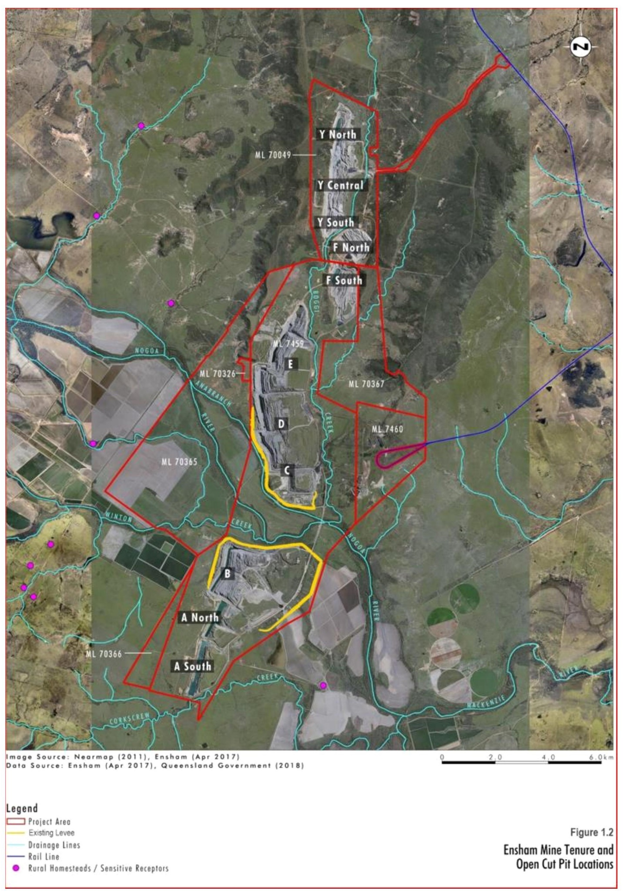

Conceptualisation of flow regime
The Ensham (2019b) report documents the outcomes of groundwater modelling for the selected ‘Final Option’ (Option 2 – ‘Beneficial use’) conducted in the RVP. The stabilised groundwater levels for the rehabilitated landform areas are presented in Table 5-11, along with the approximate timeframe for groundwater to ‘daylight’ and for groundwater levels to reach equilibrium conditions.
While rehabilitated landforms A (South), A (North), B, CD, E will operate as groundwater sinks, F and Y pits have been designed such that the floor level is above stabilised groundwater levels (by 5 m). Accordingly, no groundwater is expected to ‘daylight’ in the rehabilitated F and Y areas. Only surface water runoff will report to the lowest point in these rehabilitated landforms, and in turn, drain through the backfill material to the watertable.
Water quality modelling predicts that where groundwater ‘daylights’ in the residual landforms, salinity concentrations (as EC) will increase (to between 26,000 to 40,000 µS/cm over the 240-year model period) due to water loss caused from evaporation. Modelling also indicates a potential for metals/metalloids to bioaccumulate within the rehabilitated landform waters. As there is no groundwater outflow to the receiving environment predicted from these pits, any increase in salinity or other contaminant concentrations will be confined to the rehabilitated landforms.
The rehabilitated voids will be isolated from the floodplain by the rehabilitated landforms (Section 5.4.3). It is predicted that for flood water to overtop the landforms there would need to be a flood event in the magnitude of 1.5 times greater than the 0.1% AEP; an extreme and very rare event (occurring approximately once every 5,000 years on average). Should such an event occur, the mixing of the relatively small volume of potentially poor-quality water (maximum volume of 20,860 ML) in the rehabilitated areas with the comparatively large volume of flood water is considered inconsequential (Ensham, 2019b). Any water remaining in the rehabilitated voids once the flood had passed would be of the similar in quality to the flood water and migrate to watertable over time. There would be no requirement to pump out this water as the water remaining in the rehabilitated areas from flood flows will be lower in salinity relative to the more saline groundwater (Ensham, 2019b).

Table 5-11 Predicted final equilibrium water levels of final voids (Ensham, 2019b)
Area | Equilibrated groundwater level  (m AHD) | Storage  volume  (ML) | Area affected (ha) | Total rehabilitated area (ha) | % of rehabilitated area | Predicted time (years) for  groundwater  to ‘daylight’  (post-mining) | Approximate year groundwater is predicted to  reach  equilibrium
A (South) | 121 | 18 | 1 | 1,895 | 1.3 | 50 | 2140
A (North) | 129 | 889 | 12.5 |  |  | 50 | 2140
B | 109 | 476 | 11.8 |  |  | 50 | 2200
CD | 121 | 19,416 | 126.2 | 2,333 | 5.5 | 55 | 2220
E | 134.1 | 61 | 2.4 |  |  | 55 | 2185
F | Groundwater will not daylight in this area |  |  | 1,767 | 0 | N/a | N/a
Y | Groundwater will not daylight in this area |  |  |  |  | N/a | N/a
Note:
N/a: not applicable.

Potential impacts
Ensham (2019b) made the following conclusions regarding potential water quantity and quality impacts as a consequence of the selected ‘Final Option’ (Option 2 – ‘Beneficial use’) remediated landform.
- Surface water quality objectives for any downstream users for irrigation, farming, stock use, aquaculture or human consumption purposes is highly unlikely to be impacted.
- There is unlikely to be any material change to run-off volumes as a result of the remediated landform design, and consequently no changes to local run-off volumes to the river are expected.
- On a regional scale, negligible impacts to groundwater levels and groundwater quality are expected. Negligible groundwater level drawdown in the Quaternary alluvium is predicted, and consequently negligible effects on river-aquifer interaction processes are anticipated.
- No adverse impacts to the deeper groundwater aquifers (and their dependent ecosystems) are expected. Landholder stock and domestic bores are predicted to be affected by less than a 5 m level drawdown throughout the 240-year model period.
An assessment of potential impacts on land related environmental values was assessed within the RVP (Ensham, 2019b). The assessment found that there is one insignificant negative impact from the accumulation of known contaminants to bioaccumulate within void water.

Rehabilitation planning
A description of rehabilitation planning for the mine site is described within the Rehabilitation Management Plan (Ensham, 2019a) and is summarised in the sections below, particularly where they apply to rehabilitation of final voids.

Rehabilitation management and planning
Rehabilitation goals at Ensham Coal Mine are consistent with Queensland guidelines, Rehabilitation Requirements for Mining Resource Activities (DES, 2014). These goals require post-mining landforms to be:
- safe to humans and wildlife;
- non-polluting;
- stable; and
- able to sustain an agreed post-mining land use.
The mine site has been divided into five domains for rehabilitation, of which the voids will consist of three; sustainable grazing/water body, native bushland corridor and self-sustaining vegetated cover. Rehabilitation objectives have been developed for each domain. The objectives for void domains are shown in Table 5-12.

Table 5-12 Ensham rehabilitation objectives for void domains based on rehabilitation goals
Domain | Objectives based on rehabilitation goals
 | Safe to humans and wildlife | Non-polluting | Stable landform | Sustains an agreed post-mining land use
Sustainable grazing / water body | Safety hazards in rehabilitated areas are similar to surrounding regional landscapes | Surface runoff leaving the domain is non-polluting to receiving environment | Landforms are both geotechnically and erosionally stable with a Factor of Safety > 1.5 | Rehabilitated land is suitable for cattle grazing on landforms A to Y  Aquatic habitat
Native bushland corridor |  |  |  | Native bushland vegetation corridor allowing connectivity between Corkscrew Creek and Nogoa River
Self-sustaining vegetated cover |  |  |  | All Pits – self-sustaining vegetation
The landform design criteria have been established for the highwall and endwall of voids to achieve the rehabilitation goals and objectives described above. The landform design will support the achievement of the rehabilitation success criteria.
To achieve long term stability, highwalls must have regard to the following aspects.
- Tertiary material – maximum slope 1V:3H (18° or 33%).
- Weathered Permian – maximum slope 1V:3H (18° or 33%) – for the purposes of landform design weathered Permian to be regarded as Tertiary material due to lack of information on the interface between these two materials, which aligns with current rehabilitation practices on site.
- Fresh Permian – maximum slope of 1V:1H (45° or 100%).
- Minimum 5 m wide bench to be provided between weathered and fresh Permian layers.
- Buttressing of highwalls from pushed or blasted material from the highwall side to be sloped inward at a maximum slope of 25%.
- A 100m wide native bushland corridor to be provided down to the 33% / 100% interface. Tree species to be native species evidenced to thrive within the project area.
Rehabilitation indicators and completion criteria have been developed for each domain. Indicators were developed to provide robust and defensible measurements of progress towards the rehabilitation objectives. The completion criteria provide the benchmarks against which the indicators are to be assessed, to determine that objectives have been met. Rehabilitation indicators and completion criteria for relevant void domains are shown in Table 5-13.

Table 5-13 Ensham mine rehabilitation indicators and completion criteria
Domain | Goals | Objective | Indicator | Completion Criteria
All Domains | Safe | Safety hazards in rehabilitation are similar to surrounding unmined landscapes | Hazard assessment by a suitably qualified and experienced person | 0 (zero) significant difference as defined in AS/NZS ISO 31000:2009 Risk Management
Sustainable Grazing | Non-polluting | Surface runoff leaving domain is non-polluting to receiving waters | pH | 7.1 – 8.2 as developed in accordance with section .3 the Queensland Water Quality Guideline 2009 (see Rehabilitation Management Plan for dataset)
 |  |  | EC (salinity) | < 520 μs/cm as developed in accordance with section 4.3 the Queensland Water Quality Guideline 2009 (see Rehabilitation Management Plan for dataset)
 |  |  | Total suspended solids (TSS) (sediment loss) | < 1,097 mg/L as developed in accordance with section 4.3 the Queensland Water Quality Guideline 2009 (see Rehabilitation Management Plan for dataset)
 |  |  | Sulphate | < 36 mg/L as developed in accordance with section 4.3 the Queensland Water Quality Guideline 2009 (see Rehabilitation Management Plan for dataset)
 |  |  | Groundcover | >50% established and persistent groundcover that is not significantly different from non-mining affected land that is or will be used for a similar purpose
 | Stable | Landforms are both geotechnically and erosionally stable | Factor of safety | ≥ 1.5 as defined in Guideline Geotechnical considerations in open pit mines (State of Western Australia 1999).
 |  |  | Slope gradient | Maximum 15% with slope
 | Land use | Rehabilitation is suitable for sustainable grazing | Land suitability assessment by a suitably qualified person | Equal to or greater than a Class 4 as defined in Appendix A; Land use limitation subclass threshold limits
Water area | Non-polluting | Groundwater bioaccumulation | Salinity | <13,000 EC
 |  |  | Sulphate | <3,500 mg/L
 |  |  | Arsenic | <0.04 mg/L
 |  |  | Molybdenum | <0.06 mg/L
 |  |  | Selenium | <0.09 mg/L
 |  | Deep drainage (seepage) from domain is non-polluting to recognised groundwater resources | Groundwater investigation trigger levels | Condition C41 of the EA
 | Water use | Aquatic habitat | Bird species | ≥8
Native bushland corridor | Non-polluting | Surface runoff leaving domain is non-polluting to receiving waters | pH | 7.1 – 8.2 as developed in accordance with section .3 the Queensland Water Quality Guideline 2009 (see Rehabilitation Management Plan for dataset)
 |  |  | EC (salinity) | < 520μs/cm as developed in accordance with section 4.3 the Queensland Water Quality Guideline 2009 (see Rehabilitation Management Plan for dataset)
 |  |  | Total suspended solids (TSS) (sediment loss) | < 1,097 mg/L as developed in accordance with section 4.3 the Queensland Water Quality Guideline 2009 (see Rehabilitation Management Plan for dataset)
 |  |  | Sulphate | < 36 mg/L as developed in accordance with section 4.3 the Queensland Water Quality Guideline 2009 (see Rehabilitation Management Plan for dataset)
 | Stable | Landforms are both geotechnically and erosionally stable | Factor of safety | ≥ 1.5 as defined in Guideline Geotechnical considerations in open pit mines (State of Western Australia 1999).
 |  |  | Slope gradient | Maximum 33% with rock mulch or other suitable controls
 |  |  | Groundcover | >50%
 | Land use | Rehabilitation has some characteristics of native bushland. | Native species  richness:  - Trees  - Shrubs  - Tree canopy cover | ≥2  ≥3  ≥16%  As per BioCondition benchmarks for regional ecosystem condition assessment, DSITI 2018.
Self-sustaining vegetation | Non-polluting | Water leaving domain is non-polluting to receiving waters | pH | 7.1 – 8.2 as developed in accordance with section .3 the Queensland Water Quality Guideline 2009 (see Rehabilitation Management Plan for dataset)
 |  |  | EC (salinity) | < 520 μs/cm as developed in accordance with section 4.3 the Queensland Water Quality Guideline 2009 (see Rehabilitation Management Plan for dataset)
 |  |  | Total suspended solids (TSS) (sediment loss) | < 1,097 mg/L as developed in accordance with section 4.3 the Queensland Water Quality Guideline 2009 (see Rehabilitation Management Plan for dataset)
 |  |  | Sulphate | < 36 mg/L as developed in accordance with section 4.3 the Queensland Water Quality Guideline 2009 (see Rehabilitation Management Plan for dataset)
 | Stable | Landforms are both geotechnically and erosionally stable | Factor of safety | ≥ 1.5 as defined in Guideline Geotechnical considerations in open pit mines (State of Western Australia 1999).
 |  |  | Slope gradient | Maximum for high walls:  - 33% for Tertiary  - 50% for weathered Permian  - 100% for fresh Permian  - Maximum for inward facing spoil:  25% with rock mulch or other suitable controls
 | Land use | Self-sustaining vegetation | Groundcover | >50%

Final void post mining land use
Post mining land use for final voids has been identified as sustainable grazing/water body, native bushland corridor and self-sustaining vegetated cover (defined within rehabilitation domains). All voids are to be partially backfilled to accommodate reduced spoil slopes and to achieve the post mining land uses.
Water bodies are expected to form part of the final void landscape; however, this is not expected to occur until 50 to 55 years post mining. The water body domain is presented as a sub-set of the sustainable grazing domain. Waterbodies will be fenced either prior to relinquishment or once groundwater daylights (whichever is sooner), to prevent cattle from accessing groundwater with fences to be maintained by the landowner. It is anticipated that aquatic bird life will reside in these areas, with current modelled salinity showing the areas will not become hypersaline.
The native bushland corridor rehabilitation has been designed to integrate with the existing vegetation around areas disturbed for mining. Areas with a final landform between 33% and 100% will be rehabilitated to bushland. With much of the surrounding area extensively cleared for agricultural use, remaining remnant vegetation exists on riparian corridors associated with Nogoa River and its tributaries. The native bushland corridor has been designed to be 100 m wide along the highwall of voids ABCD, which will provide improved connectivity with existing corridors. Native bushland corridor is expected to occupy 150 ha (or 2.5%) of the total rehabilitated area.
Sustainable grazing is planned for the outward facing low wall spoil slope. This is planned for areas with a slope ranging between 10% to 15% and is approved in the current Ensham Mine EA. Cattle will be allowed to graze in areas up to 25% slope.
Slope angles of 100% or more will support self-sustaining vegetation cover.

Future management plans
A Post Closure Management Plan (PCMP) to be prepared at least 18 months prior to final coal processing on site and be implemented for a nominal period of at least 30 years (or shorter if the site has proven to be stable and to the satisfaction of administering authority). The PCMP will require ongoing monitoring of surface water, groundwater, seepage, erosion, integrity and effectiveness of final cover systems and the health and resilience of native vegetation cover.

Risk mitigation and management
According to documentation prepared by Ensham to support the State EA Amendment Application (Ensham), the rehabilitated landforms A (South), A (North), B, CD, E for the selected ‘Final Option’ (Option 2 – ‘Beneficial use’) will operate as groundwater sinks (Section 5.4.4). The assessment concluded these landforms pose a low risk of environmental harm, with commitments to implementing the following key risk mitigation and management measures.
- Partial backfilling of the open-cuts to produce a rehabilitated landform consistent with the regional topography protected by permanent landforms (Section 5.4.3). The partial backfilling will reduce the volume and area of poor quality ‘pit lake’ water remaining at equilibrium post-mining.
The RVP indicated that that in order to prevent groundwater from daylighting in the A to E pits, considerable fill material would be required (with filling activities increasing groundwater levels, and in turn, the requirement for further fill material). Ensham (2019b) concluded that due to the volume of fill material required, together with the small areas where groundwater would ‘daylight’, significant period before groundwater is predicted to ‘daylight’ and low risk of environmental harm constituted by the existence of the small volume of ‘pit lake’ water remaining in the rehabilitated landform, additional backfilling to eliminate groundwater ‘daylighting’ was not warranted.
- Existing levees will be incorporated into the landform design to provide flood immunity and exclude the rehabilitated areas from flood interactions up to and including a 0.1% AEP event (Section 5.4.3).
- Rehabilitated F and Y pits will also be subject to partial backfilling; however, their design is such that the floor levels will be above stabilised groundwater levels. No groundwater is therefore expected to ‘daylight’ in the rehabilitated F and Y areas, eliminating the risk of poor quality ‘pit lake’ water remaining in the landform post-mining. Only surface water runoff will report to the lowest point in these rehabilitated landforms, and in turn, drain through the backfill material to the watertable (Section 5.4.4).

Case study summary
A summary of the key findings reported for the four case studies is presented in Table 5-14. In general, residual voids in Queensland with design features that minimise surface run-off are likely to equilibrate to terminal sink flow regimes with ‘pit lake’ water qualities that exhibit increasing salt (and possibly acidity and metal) concentrations over time (Section 3.2.1). Of the case studies explored, the Olive Downs (Section 5.1), Middlemount (Section 5.2) and Jellinbah (Section 5.3) coal mines will each have multiple residual voids remaining in the landscape post-mining that were assessed by the operators to ultimately equilibrate to terminal sink flow regimes, with ‘pit lake’ levels equilibrating below overflow levels and reaching hypersaline conditions over variable timescales (100-550 years). For these mine sites, residual voids situated in floodplain areas will incorporate design features to provide protection from flood waters up to and including a PMF event (Olive Downs and Middlemount) or up to and including a 0.1% AEP event (Jellinbah). The risk assessments reported for each of these cases studies concluded that the residual voids pose a low risk of environmental harm.
In accordance with the EA, the Ensham coal mine (Section 5.4) undertook a staged RVP to evaluate three options for rehabilitation of the open-cut areas. The final (preferred) option, determined by way of a TBLA, was Option 2 – ‘Beneficial use’; which involves partial backfilling of the open-cuts to produce a rehabilitated landform consistent with the regional topography protected by permanent landforms. The rehabilitated landforms that overlap the floodplain area will operate as groundwater sinks; however, partial backfilling will reduce the area and volume of groundwater presenting (‘daylighting’) in the landscape. The two pits to the north of the floodplain area are designed such that the floor level is above stabilised groundwater levels and no groundwater will ‘daylight’. Each rehabilitated void will be isolated from the floodplain by rehabilitated landforms providing flood immunity up to and including a 0.1% AEP event. Similar to the other case studies, Ensham concluded that the rehabilitated landforms will pose a low risk of environmental harm.
For each of the cases studies, the characterisation of the residual void’s flow regime and the assignment of risk relies on coupled analytical or numerical modelling that carries a range of assumptions/simplifications and a level of uncertainty. The actual flow regime of the residual void may ultimately differ from the model predictions and pose a different level of risk to that assigned by the operator. A range of predictive modelling limitations, and their implications for assessing potential impacts, were identified by the IESC in their advice documents for the case studies. These included:
- the potential for density-driven flow in increasingly saline ‘pit lakes’ to reverse hydraulic gradients, promoting seepage into the surrounding groundwater system (Middlemount and Jellinbah);
- fault structures (and associated fracture systems) that intersect or occur in proximity to residual voids may have the potential to affect long-term equilibrium conditions and associated risks (Middlemount);
- the effects of extreme events (e.g. successive high-rainfall years) and future climatic regimes on ‘pit lake’ water levels and implications for overtopping and temporary changes to flow regimes (Middlemount and Jellinbah); and
- the effects of future climatic regimes on rainfall extremes and the potential for flooding events to overtop levees and intercept the residual void (Jellinbah).
Model updates and future validation with appropriate site-specific data will assist in overcoming some of the inherent uncertainties of modelling and climate change effects, and the accompanying assessment of environmental risk.
Post-relinquishment there remains a risk that the rehabilitated area or engineered structures may require management in perpetuity, or in some cases the structure may fail (e.g. due to seismic activity) and require remedial action to address or prevent potential environmental harm. Recent amendments to the Environmental Protection Act 1994 (Qld) (EP Act) have been made to minimise risks associated with project relinquishment requirements (i.e. following completion of the project). Specifically, these include a residual risk framework that seeks to ensure that risks remaining on a resource site following completion of resource activities are identified, costed and managed.
All mine case studies have developed their rehabilitation planning in line with Queensland Government policies, to achieve safe, non-polluting, stable landforms that are able to sustain a PMLU, where one exists.
Each mine has taken a slightly different approach to the development of rehabilitation objectives; however, the themes are consistent and feed into the rehabilitation goals. These themes include final landform and re-shaping, safety, remediation of hazards and reducing impacts on the surrounding environment.
Of the four mines, only two have committed to rehabilitating the final voids to a PMLU, being Olive Downs (Section 5.1.6) and Ensham (Section 5.4.6). Olive Downs is not yet operational, and rehabilitation management plans or void studies were not available for review (and potentially not yet developed). As such, their commitments to PMLU of final voids is basic, with areas rehabilitated to groundcover for small mammal habitat and cliff habitat for highwalls. There is little detail available on how these areas are to be rehabilitated.
Ensham mine is well into operation with many spoil areas already rehabilitated. The mine has developed a comprehensive plan for void rehabilitation, which was informed by a RVP. Ensham mine has identified several domains intended for different land use (aquatic, bushland and grazing) and has considered surrounding areas to maximise the effectiveness of rehabilitated areas (i.e. improving bushland corridors).
Middlemount (Section 5.2.6) and Jellinbah (Section 5.3.6) mines do not have a PMLU. Both mines intend to leave a void water body that is safe, with exclusions to some wildlife (excluding birds), cattle and humans. With no final land use for these areas, there are no objectives or completion criteria developed for sustaining a PMLU.
Table 5-14 Summary of key findings from the case study analysis ⁽¹⁾
Theme | Parameter | Mine site case study
 |  | Olive Downs | Middlemount | Jellinbah | Ensham
Latest project status | State approval received | Yes | Yes | Yes | Yes
 | Federal approval received | Yes | Yes | Yes | TBA
Physical setting | Climate | Sub-tropical | Semi-arid to sub-tropical | Sub-tropical | Sub-tropical
 | Geological basin | Bowen Basin | Bowen Basin | Bowen Basin | Bowen Basin
 | Drainage basin (and catchment) | Fitzroy Basin  (Isaac River) | Fitzroy Basin  (MacKenzie River) | Fitzroy Basin  (MacKenzie River) | Fitzroy Basin (Nogoa River and Comet River)
 | Groundwater salinity of coal measures | Brackish to moderately saline | Moderately saline | Brackish | Brackish
 | Major fault structures in proximity to residual void | No | Jellinbah Fault | No | No
 | Remnant vegetation | Dominated by eucalypt woodlands on riparian corridors and flood plains | Dominated by eucalypt woodlands on riparian corridors and flood plains | Dominated by eucalypt woodlands on riparian corridors and flood plains | Dominated by eucalypt woodlands on riparian corridors and flood plains
Proposed residual voids | Total number | 3 | 2 | 8 | 12
 | Total surface area | Not reported | 595 ha | 744 ha | Not reported
 | Number of proposed residual voids in floodplain | 2 | 1 | 2 | 6
Assessment approach | Coupled water balance and salinity modelling | Yes (relying on the looping of historical climate data) | Yes (relying on the looping of historical climate data) | Yes (relying on the looping of historical climate data) | Yes ⁽³⁾
 | Water balance and salinity sensitivity analysis (parameter) | Yes (evaporation factors) | No | Yes (climate change) | Unsure ⁽³⁾
 | Consideration of climate change impacts in water balance modelling | Partial ⁽⁴⁾ | Partial ⁽⁴⁾ | Yes | Unsure ⁽³⁾
 | Consideration of climate change impacts in flood modelling | No, but modelled PMF event | No, but modelled PMF event | No, but modelled to 0.1% AEP event | No, but modelled to extreme (50% greater than 0.1% AEP: ≈PMF) event
 | Receiving environment impact assessment | Yes | Yes | Yes | Yes
 | TBLA of multiple rehabilitation options | No | Unsure ⁽²⁾ | No | Yes
Rehabilitation | Partial backfill | 3 | 2 | Unsure | 12
 | Complete backfill | 10 | Nil | Nil | Nil
 | Minimisation of catchment area of residual voids | Yes | Yes | Yes | Yes
 | Engineered flood protection | Yes; up to and including a PMF event | Yes; up to and including a PMF event | Yes; up to and including a 0.1% AEP event | Yes; up to and including a 0.1% AEP event
 | Rehabilitation goals | Consistent with Queensland guidelines | Consistent with Queensland guidelines | Consistent with Queensland guidelines | Consistent with Queensland guidelines
 | PMLU | Fauna habitat | None | None | Sustainable grazing/water body  Native bushland corridor  Self-sustaining vegetation
Projected flow regime at equilibrium | Type | Terminal sinks | Terminal sinks | Terminal sinks | Terminal sinks (7 voids) designed to reduce the volume and area of poor quality ‘pit lake’ water remaining at equilibrium post-mining. Five voids will be designed to eliminate groundwater inflow altogether.
 | Volume of ‘pit lake’ water | Not reported | ~ 2 GL | ~ 29 GL | ~ 21 GL
 | Time to reach equilibrated ‘pit lake’ water levels | ~ 100-200 years post mining | < 10 years | ~ 0-125 years | ~ 110-190 years post-mining
 | Overtopping potential | ‘Pit lake’ water level is projected to remain below overflow levels | ‘Pit lake’ water level is projected to remain below overflow levels | ‘Pit lake’ water level is projected to remain below overflow levels | ‘Pit lake’ water level is projected to remain below overflow levels
 | Timeframe for hypersaline conditions to be reached | 150 to 550 years post-mining | 100 years post-mining | Within 100 years post-mining | Within 240 years post-mining
Risk potential assigned by proponent | Assigned risk to receiving environment | Low | Low | Low | Low
Potential impacts identified by IESC | Potential impacts to receiving environment | Waste rock emplacements will:  - Reduce potential floodplain habitat.  - Impact remnant floodplain vegetation. | - Groundwater leakage from final voids due to probable fracturing associated with the Jellinbah Fault.  - Changes to water quantity and quality within the floodplain from the residual voids as a result of potential overtopping and leakage into or from groundwater.  - Density driven groundwater flow altering the flow regime of the residual voids. | - Extreme events and changing climatic conditions to cause changes to the predicted void behaviour containing increasingly saline water.  - Cumulative impacts on groundwater, surface water and terrestrial and aquatic ecosystems from the hypersaline residual voids. | TBA
Notes:
N/a: Not available.
TBA: to be assessed.
(1) The contents of the table are derived from publicly available documents made available by the mine site operator. The case study outcomes documented in Section 5 and listed in Table 5-14 were not subject to review as part of this scoping study.
(2) A Residual Void Study was completed by Middlemount in 2014. As the report is not publicly accessible it is not known whether a TBLA of different options was undertaken.
(3) Further detail concerning the water balance and salinity modelling, sensitivity analysis and flood modelling of the Ensham RVP are contained in technical reports accompanying the main document which were not available for this scoping study.
(4) Partial assessment of potential climate change impacts based on sensitivity modelling.

Development of a risk assessment approach
IESC note: The following approach has been developed by Coffey Services Australia Pty Ltd and Eco Logical Services Australia Pty Ltd as an example only. The IESC Information Guidelines outline what types of information are required to enable the IESC to provide robust scientific advice to government regulators on the potential water-related impacts of CSG and large coal mining projects.
On the basis of the outcomes of the case study analysis (Section 5), an option to assist the IESC in understanding project specific and cumulative risks of residual coal mine voids on water resources and the receiving environment in Queensland is to build on the contents of the database developed in the scoping study.
As a first consideration, the basic hydraulic mine geometry can aid in determination of the propensity of a void to be a terminal sink, source or flow-through feature in the landscape and this is used either as a guide to developing final void strategies (e.g. Ensham) or as a default to constrain environmental risk (e.g. Olive Downs). Thus, under equilibrium external (surface water and atmospheric) water balance conditions, specific geometries and climatic environments favour particular groundwater flow conditions (Section 3).
The case study analysis (Section 5) has demonstrated that site-specific assessments prepared by mine site operators as part of State and/or Commonwealth environmental approval processes (whether publicly available or available through State or Commonwealth agencies) contains key information that characterises proposed residual coal mine voids (including their proposed rehabilitation design and projected flow regime).
Quantification of the components in Table 5-14 can therefore provide an initial assessment of the risk posed for a specific mine void and allow consideration against rehabilitation and final cumulative risks. Collating and recording the parameters listed in Table 5-14 for all approved open coal mines in Queensland would assist in informing the assignment of risk potential of proposed residual voids across the State.
The parameters listed in Table 5-14 are not exhaustive and others may be identified as part of this exercise that are considered important in assigning the risk potential of these features. Digitising the projected outline of residual voids (if different to the already digitised open-cut area) would also assist in the spatial representation of the risk.
The output of this exercise would be a comprehensive database (and accompanying spatial files) of key details for approved residual coal mine voids in Queensland. Current data gaps and uncertainties could also be identified in the database.
Information from this database could be used to generate a comparative risk profile of approved residual coal mine voids to enable the relative risk of an individual coal mine site and the cumulative risk of multiple coal mine sites to be understood by the IESC when assessing new coal mine development proposals and amendments to existing EAs.
The Queensland Emergency Risk Management Framework (QERMF) documented in the Risk Assessment Process Handbook (Queensland Fire and Emergency Services, 2018) describes a risk assessment methodology for disaster management planning in Queensland that could be applied to generate a comparative risk profile for residual coal mine voids in the State.
The risk assessment approach underpinning the QERMF includes two key processes: identifying the risk and then assigning the level of risk. Specifically, Process 1 allows for an initial identification of risk in relation to the probability of a hazard occurring versus its impact upon the environment, while Process 2 allows for greater analysis of the identified risk and the assignment of a level of risk. The outcomes of these two processes are used to populate multiple risk management documents including the Risk Assessment Table and Decision Log as outlined in
Figure 6-1. The Risk Register, used in the consideration and planning of management and treatment options, will require the involvement of DES and local government and may be undertaken as a subsequent stage to the risk assessment.

Figure 6-1 Snapshot of QERMF risk assessment approach (Queensland Fire and Emergency Services, 2018)
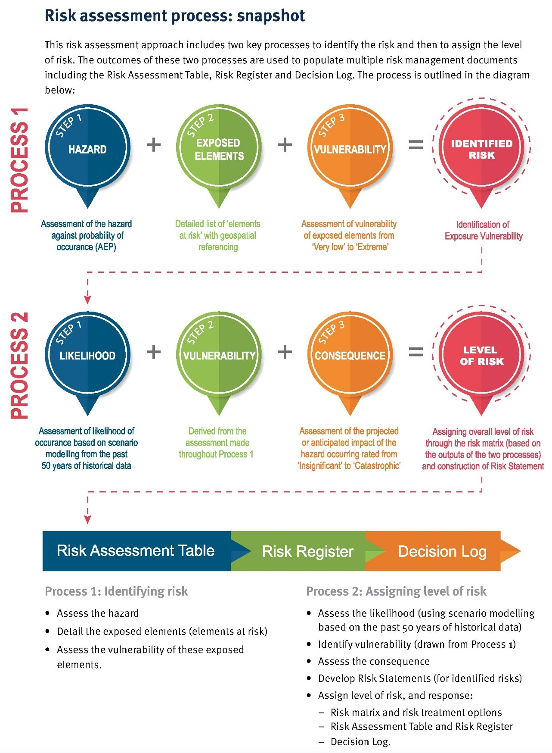
The QERMF risk assessment approach would need to be tailored to accommodate the objectives of the residual void risk assessment and the nature of the data and information that would be used in defining or assigning the various attributes in each step. An important distinction is that the risk assessment would rely on defining the hazard probability (Process 1, Step 1) and likelihood (Process 2, Step 1) attributes based on model projections (if available) rather historical data as applied in the QERMF.
In the context of this study, potential hazards of residual coal voids that could be considered in the risk matrix include:
- overtopping of the residual void;
- flood inundation of residual voids located in floodplains;
- groundwater seepage from residual void (i.e. in the event that a residual void evolves into a source or groundwater/surface water flow regime or fault structures intersect a terminal sink flow regime);
- clearing of remnant vegetation for open-cut areas, which will ultimately occupy residual voids; and
- change to ecological values upon rehabilitation of the residual void to a PMLU.
A possible approach to each step in Process 1 and Process 2 is defined for each potential hazard in Table 6-1 as is the input data required to define the attribute. Following definition of each of these steps, an overall level of risk (corresponding to each potential hazard and corresponding exposed element) can be calculated and assigned according to a risk matrix (Figure 6-2) which inputs the likelihood (X), vulnerability (Y) and consequence (Z) levels (ranked 1-5 respectively) to output an overall severity rating (1-13). The severity rating is then broken down across five levels of risk which range from Very Low to Extreme. The outputs of the risk assessment can be recorded in a Risk Assessment Table (inclusive of a risk statement if required) and incorporated into the study’s database. Any supporting documentation associated with the risk assessment, including the rationale behind judgements and decisions can be recorded in a Decision Log. Templates for both the Risk Assessment Table and Decision Log are provided in the Risk Assessment Process Handbook (Queensland Fire and Emergency Services, 2018).
The outputs of the risk assessment (being an overall level of risk for each potential hazard and corresponding exposed element) can be overlaid spatially. Weighted criteria could be used for each risk level in a weighted overlay process that gives a spatially explicit quantitative assessment for each residual void to guide review and assessment effort and help define appropriate management tools. By applying GIS multi-component analysis to the comparative risk profile, the cumulative risk of multiple projects within a defined area (e.g. catchment) could also be represented spatially. As with all risk assessment, the outputs will identify the relative risk (reflecting only the data that is available for inclusion) and should not be considered as definitive.

Table 6-1 Possible approach to risk assessment based on the QERMF
QERMF Process number | Process 1 |  |  | Process 2
Steps in QERMF | Step 1 - Potential hazard ⁽¹⁾ | Step 2 - Exposed elements (water resource and receiving environment) | Step 3 - Vulnerability | Step 1 – Likelihood ⁽²⁾ | Step 2 - Vulnerability | Step 3 - Consequence | Level of risk
Possible approach for risk assessment | Refer to key potential hazards defined in this table. | Identify the range of exposed elements (i.e. surface water systems, groundwater systems, vegetation and ecosystems) for each residual void. | Develop a vulnerability ranking (very low, low, moderate, high or extreme) of each exposed element that is dependent on its proximity to the residual void and its beneficial use or ecological value.  GIS analysis can be used to assign a vulnerability ranking for each exposed element. | Develop a likelihood ranking (rare, unlikely, possible, likely, almost certain) for each potential hazard.  Using information and data collated in the updated database assign a likelihood ranking.  Consideration of the limitations of any model projections and the potential impact of climate change on the hazard potential can be incorporated into the likelihood ranking. | Derived from Step 1 ⁽³⁾ | Develop a consequence ranking (insignificant, minor, moderate, major, catastrophic) for each potential hazard and corresponding exposed element.  Using information and data collated in the updated database assign a consequence ranking. | Calculate according to QERMF matrix (Figure 6-2).
Key inputs to define elements/ranking | Overtopping of residual void | Data and information contained in scoping study database. | Data and information contained in the scoping study and updated database. | Projected flow regime of residual void recorded in the updated database. | N/a ⁽³⁾ | Projected equilibrated ‘pit lake’ volume in residual void recorded in the updated database.  Projected salinity (and other quality) conditions of the ‘pit lake’ water at equilibrium or quasi-equilibrium and rate of change to hypersaline conditions (if applicable) as recorded in the updated database. | QERMF risk matrix (Figure 6-2).
 | Flood inundation of residual voids located in floodplains |  |  | Location of residual void in flood hazard area and proposed engineered floodplain protection recorded in the updated database.
 | Groundwater seepage from residual void |  |  | Data and information recorded in the updated database including:  Projected flow regime of residual void.  ‘Pit lake’ water salinity and groundwater salinity with reference to the potential for density-driven flow to reverse hydraulic gradients.  Major fault structures that intersect or occur in proximity to residual voids.
 | Clearing of remnant vegetation for open-cut areas |  |  | Queensland vegetation mapping recorded in the scoping study database. |  | Ecological value of the vegetation being cleared as recorded in the scoping study database.
 | Change to ecological values upon rehabilitation of the residual void to a PMLU |  |  | Rehabilitation commitments reported within EAs, EIS and Rehabilitation Management Plans recorded in the scoping study database and to be expanded upon in the updated database. |  | Comparison of pre-mining land use and post-mining land use commitments.
Notes:
(1) The QERMF assignment of Hazard considers the overall probability for a hazard to occur using the AEP. This information will not be available for the risk assessment. Instead this attribute can be defined as for the Likelihood attribute.
(2) The QERMF assignment of Likelihood relies on historical occurrences of the hazard. This information will not be available for the risk assessment. Instead this attribute can be defined using other approaches including model projections, vegetation mapping and rehabilitation commitments.
(3) The QERMF assignment of Vulnerability involves the review and finalisation of the exposure vulnerability assessment made as a result of Process 1 as a precursor to the assessment of the level of consequence of an event. According to the QERMF, re-assessment of vulnerability should only occur if existing controls are in place to mitigate identified vulnerabilities of exposed elements and/or a risk mitigation strategy becomes apparent during consultation with an owner or operator of an asset or network during the planning cycle. Neither of these conditions are likely to be relevant in the context of this risk assessment.

Figure 6-2 QERMF risk matrix (Queensland Fire and Emergency Services, 2018)
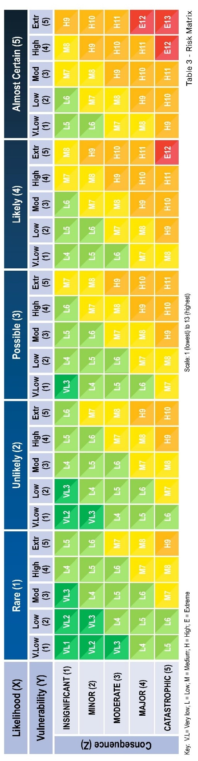

References
Anglo-American (2019). Mine rehabilitation – Case Study: Dawson Mine. Available at: https://www.qrc.org.au/wp-content/uploads/2020/11/190320-Anglo-Dawson-Leading-Rehabiltiation-Case-Studies.pdf, reviewed on 27 November 2020.
AustralAsian Resource Consultants Pty Ltd (AARC). (2015). Central North Extension – Jellinbah Coal Mine Environmental Authority Amendment – Supporting Information. Prepared for Jellinbah Group Pty Ltd on behalf of the Jellinbah East Joint Venture. September 2015.
AustralAsian Resource Consultants Pty Ltd (AARC). (2018). Jellinbah Coal Mine Rehabilitation and Void Investigation Report. Prepared for Jellinbah Group Pty Ltd. November 2018.
AustralAsian Resource Consultants Pty Ltd (AARC). (2019). Central North Extension Preliminary Documentation Ver 2. Prepared for Jellinbah Group Pty Ltd on behalf of the Jellinbah East Joint Venture. November 2019.
Australian Coal Association Research Program (ACARP). (2001). Water Quality and Discharge Prediction for Final Void and Spoil Catchments. Project number C7007.
Australian Coal Association Research Program (ACARP). (2007). Centre for Sustainable Mine Lakes. Project number: C11053.
Australian Coal Association Research Program (ACARP). (2014). Enhancing Ecological Values of Coal Pit Lakes with Simple Nutrient Additions and Bankside Vegetation. Project number C21038.
Australasian Groundwater and Environmental (AGE). (2006). Mackenzie South Project: Groundwater Impact Assessment. Report prepared for AustralAsian Resource Consultants Pty Ltd, February 2006.
Commander, D.P, Mills, C.H., and Waterhouse, J.D. (1994). Salinisation of mined-out pits in Western Australia: Conference proceedings of the XXV Congress of the International Association of Hydrogeologists, Adelaide, South Australia, November 1994.
Department of Environment and Science (DES). (2014). Rehabilitation requirements for mining resource activities. Queensland Government.
Doupé, R.G., Lymbery, A.J. (2005). Environmental Risks Associated with Beneficial End Uses of Mine Lakes in Southwestern Australia. Mine Water Environ 24, 134–138 (2005). https://doi.org/10.1007/s10230-005-0084-0.
Eco Logical Australia (ELA). (2019). Assessment of Biodiversity for Final Mine Voids. Prepared for BHP.
Engeny. (2019). Jellinbah Resources - Central North Pit Final Void Hydrology Study, Central North Extension Assessment. October 2019.
Ensham Resources Pty Ltd (Ensham). (2019a). Rehabilitation Management Plan. Final report. March 2019.
Ensham Resources Pty Ltd (Ensham). (2019b). Residual Void Report. Final report prepared for the Residual Void Project Stage 5.
Gammons, C.H., and Duaine., T.E. (2006). Long term changes in the limnology and geochemistry of the Berkeley Pit Lake, Butte, Montana. Mine Water and the Environment 25:76–85.
Gammons, C.H., Harris, L.N., Castro, J.M., Cott, P.A. and Hanna, B.W. (2009). Creating lakes from open pit mines: Processes and considerations, with emphasis on northern environments. Canadian Technical Report of Fisheries and Aquatic Sciences NWT Pit Lake Report 2836, Ottawa, Canada. 106p.
Grose, M. R., Narsey, S., Delage, F. P., Dowdy, A. J., Bador, M., Boschat, G., et al. (2020). Insights from CMIP6 for Australia's future climate. Earth's Future, 8, e2019EF001469. https://doi.org/10.1029/2019EF001469.
Hobday, A. J. and Lough, J. M. (2011). Projected climate change in Australian marine and freshwater environments. Marine and Freshwater Research 62: 1,000-1,014.
Independent Expert Scientific Committee on Coal Seam Gas and Large Coal Mining Development (IESC). 2018a. Advice to decision maker on coal mining project IESC 2018-096: Olive Downs Project (EPBC 2017/7867 – Olive Downs Project Mine Site and Access Road, 2017/7868 – Olive Downs Project Water Pipeline, 2017/7869 – Olive Downs Project Electricity Transmission Line, 2017/7870 – Olive Downs Project Rail Spur) – New Development. Prepared for the Australian Government Department of the Environment and Energy and the Queensland Office of the Coordinator-General. 9 October 2018.
Independent Expert Scientific Committee on Coal Seam Gas and Large Coal Mining Development (IESC). 2018b. Advice to decision maker on coal mining project IESC 2018-097: Middlemount Coal Mine Western Extension (EPBC 2017/8130) – Expansion. Prepared for the Australian Government Department of the Environment and Energy. 14 November 2018.
Independent Expert Scientific Committee on Coal Seam Gas and Large Coal Mining Development (IESC). 2019. Advice to decision maker on coal mining project IESC 2019-103: Jellinbah Coal Mine – Central North Extension (EPBC 2018/8139) – Expansion. Prepared for the Australian Government Department of the Environment and Energy. 29 May 2019.
JBT Consulting Pty Ltd. (2019). Conceptual and Numerical Groundwater Modelling Jellinbah Central North Extension (CNW) Area. October 2019.
Johnson, S.L. and Wright, A.H. (2003). Mine Void Water Resource Issues in Western Australia. Water and Rivers Commission Resources Science Division. Hydrogeological Record Series, Report No. HG.9. 2003.
Kumar, R. N., McCullough, C. D. and Lund, M. A. (2009). Water resources in Australian mine pit lakes. Mining Technology 118: 205-211.
Mackie. C.D. (2009). Hydrogeological Characterisation of Coal Measures and Overview of Impacts of Coal Mining on Groundwater Systems in the Upper Hunter Valley of NSW. Doctoral Dissertation, University of Technology, Sydney, NSW, Australia.
McCullough, C. D., Marchand, G. and Unseld, J. (2013). Mine closure of pit lakes as terminal sinks: best available practice when options are limited? Mine Water and the Environment 32: 302-313.
McCullough, C.D. and Schultze, M. (2015). Riverine Flow-through of Mine Pit Lakes: Improving Both Mine Pit Lake and River Water Quality Values? In Proceedings of the Joint International Conference on Acid Rock Drainage ICARD/International Mine Water Association (IMWA) Congress, Santiago, Chile, 28 April–1 May 2015.
Middlemount Coal Pty Ltd (MCPL). (2012). Middlemount Coal Project Stage 2: Rehabilitation Management Plan.
Middlemount Coal Pty Ltd (MCPL). (2018a). Western Extension Project Environmental Assessment Report. Prepared by Resource Strategies Pty Ltd.
Middlemount Coal Pty Ltd (MCPL). (2018b). Rehabilitation Management Plan Addendum. Prepared by GT Environmental.
Middlemount Coal Pty Ltd (MCPL). (2019). Western Extension Project (EPBC 2017/8130) EPBC Act Preliminary Assessment Documentation.
Mines Lakes Consulting. (2017). Industry Practice Review - Pit lake closure with strategic riverine connectivity. Report submitted to Glencore Pty Ltd. Report Number: 1702-001-R-Rev0.
Niccoli, W. L. (2009). Hydrologic characteristics and classifications of pit lakes. In, Mine Pit Lakes: Characteristics, Predictive Modeling, and Sustainability Castendyk, D. & Eary, T. (eds.) Society for Mining, Metallurgy, and Exploration (SME), Colorado, USA, 33-43pp.
Pembroke Resources. (2018). Olive Downs Coking Coal Project – Draft Environmental Impact Statement.
Pembroke Resources. (2019). Olive Downs Coking Coal Project – Additional Information to the Environmental Impact Statement.
Queensland Fire and Emergency Services. (2018). Queensland Emergency Risk Management Framework (QERMF). Risk Assessment Process Handbook. Prepared by Community Resilience and Risk Mitigation Unit, Emergency Management and Community Capability, Queensland Fire and Emergency Services.
Umwelt Australia Pty Ltd (Umwelt). (2018a). Stage 2 Environmental Assessment Report, Ensham Residual Void Project Option 1: Landform Levee. Final. July 2018.
Umwelt Australia Pty Ltd (Umwelt). (2018b). Stage 2 Environmental Assessment Report, Ensham Residual Void Project Option 2: Flood Mitigation and Beneficial Use. Final. July 2018.
Umwelt Australia Pty Ltd (Umwelt). (2018c). Stage 2 Environmental Assessment Report, Ensham Residual Void Project Option 3: Backfill to Probable Maximum Flood Level. Final. July 2018.
Vandenberg, J.A. and McCullough, C.D. (2017). Key Issues in Mine Closure Planning for Pit Lakes. In: Nanthi Bolan N, Ok Y, Kirkham M (eds) Spoil to soil: mine site rehabilitation and revegetation. CRC Press, Boca Raton, pp 175–188.
Zhan, W., Nathan, R., Buckley, S., & Hocking, A. (2020). Climate Change Adaptation in BHP’s Queensland Mine Water Planning and Hydrologic Designs. Proceedings of the 14th IMWA Congress “Mine Water Solutions, 231–236. Christchurch, N.Z.": International Mine Water Association.
This page has been left intentionally blank

A salinity mass balance model considers the amount of water plus salt entering a system and the amount of water plus salt leaving. When inputs and outputs are in balance, the system is said to be in equilibrium. A chemical equilibrium model is designed to simulate chemical reactions and transport processes in natural or polluted water, based on equilibrium chemistry of aqueous solutions interacting with minerals, gases, solid solutions, exchangers, and sorption surfaces.
It is not known how many of the 71 EA records associated with open-cut coal mining would have environmental approval documentation available to interrogate and collate the relevant parameters listed in Table 5-14.
In particular, the residual void case studies assessed in this scoping study all projected terminal sinks flow regimes. If other types of flow regimes are identified across Queensland, other parameters may be identified that are considered important to the risk assessment.

