REPORT TO: Office of Water Science
Department of Agriculture, Water and the Environment
John Gorton Building
King Edward Terrace,
PARKES ACT 2600

ATTN: Ms Mio Kuhnen
Acting Assistant Director,
Office of Water Science

Peer Review of:
Report prepared by Gordon Geotechniques Pty Ltd -
“Subsidence Report for the Ensham Life of Mine Extension Project”, March 2020

REPORT NO: 2105/01.1

PREPARED BY: BRUCE K HEBBLEWHITE

DATE: 4 June 2021

__________________________________________________________________________

B K HEBBLEWHITE BE(Min.) PhD 5 Plant St
Consultant Mining Engineer Balgowlah NSW 2093
AUSTRALIA

B K Hebblewhite Consulting Mobile: +61 (0) 417 267 876
ABN 85 036 121 217 Email: hebble@bigpond.com
1. SCOPE OF WORK

1.1 Background to Ensham Subsidence Study

The following introduction is provided in a report prepared by Gordon Geotechniques Pty Ltd (GGPL), as listed below, which outlines the overall scope of the study undertaken by GGPL:

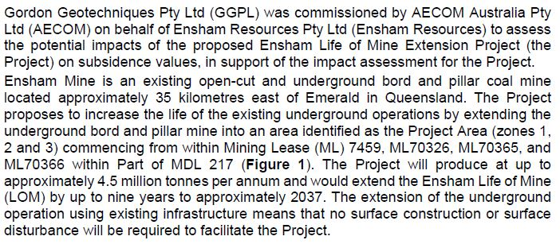

Figure 1 is taken from the GGPL report and shows the overall site location plan, including the nominated Zones 1, 2 and 3.

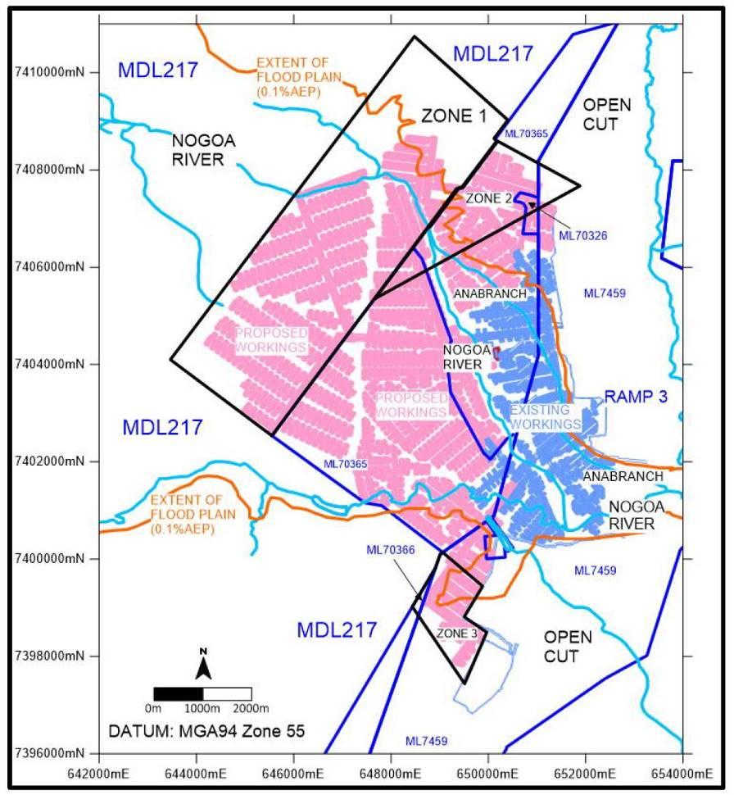
Figure 1. Overall site location plan
(source: GGPL Report, Figure 1)
The Gordon Geotechniques Pty Ltd Report provided for the purposes of this peer review, hereafter referred to as the “GGPL Report”, was an unnumbered report, dated March 2020, titled:

“Subsidence Report for the Ensham Life of Mine Extension Project”, prepared for AECOM Australia Pty Ltd, on behalf of Ensham Resources Pty Ltd.

1.2 Scope of Work Requested

The following scope of work was defined by the Office of Water Science (OWS):

“The Office of Water Science (OWS) has identified a need for an independent review of subsidence documentation relating to the Ensham Life of Mine Extension Project, a coal mine in Queensland on the Nogoa River. The independent review will form part of the advice provided to the Independent Expert Scientific Committee on Coal Seam Gas and Large Coal Mining Development’s for the formal assessment of the underground mine.
The scope of this contract will be to provide an independent review of the provided subsidence documentation. Critical information OWS would like to be considered in the review to include:
- The overburden cover is adequate for the depth of mining and the width to pillar ratio, in particular under the Nogoa River.
- Are there further considerations required during flood scenarios for the proponent to consider in the underground workings design – i.e. in 2008 the Nogoa River peaked at 15.4 m at Emerald?
- Lack of geological formation and faults considered in the subsidence assessment.
- If applicable to provide any consideration of groundwaters impacts with respect to the relationship of the mine geotechnical parameters on groundwater.
The documents would be provided on the 17 May 2021 and advice would be required to be provided by 11 June 2021 (this allows for the independent review to be included in the advice provided to the IESC)”.

1.3 Documentation Provided

The following documents were provided by OWS, including the report referenced above, for the purposes of conducting this peer review:

- Gordon Geotechniques Pty Ltd Report: “Subsidence Report for the Ensham Life of Mine Extension Project”, prepared for AECOM Australia Pty Ltd, on behalf of Ensham Resources Pty Ltd, March 2020.
- Email from Ensham Project Manager, Mr Garry Gough, to Eri Bartkow (and others), dated 11 May 2021 – in response to a query raised in IESC RFI 4, with the following Gordon Report (10 May 2021) attached.
- Gordon Geotechniques Pty Ltd letter report to Mr Garry Gough: “Discussion on Sinkhole Subsidence”, dated 10 May 2021.

Further to the initial consideration of the above documentation, it was noted that the supplementary 10 May 2021 GGPL Report made reference to an earlier GGPL report for Ensham from 2015, and an independent peer review that was conducted of that earlier report. These two additional documents were requested to be made available for background reference purposes. The two documents were:

- Gordon Geotechniques Pty Ltd Report to Ensham Coal: “Geotechnical Review of the Ensham Mine Plan in Areas 1 and 2”, dated March 2015.
- Mine Advice Pty Ltd Report: “Peer Review of Gordon Geotechniques (GGPL) Report to Ensham Coal: Geotechnical Review of the Ensham Mine Plan in Areas 1 and 2 (dated March 2015)”, dated January 2016.

1.4 This Report

I offer the following peer review commentary on the above primary GGPL report, incorporating consideration of the additional supporting documents, as outlined above, based on my relevant professional qualifications, experience and background (see Summary CV in Appendix A).

My background relevant to this project includes a close association with a number of different coal mining projects across Australia and internationally – from various perspectives, including mine design, geotechnical assessment (including pillar stability and mine subsidence), peer review and audit on behalf of coal companies; and independent consulting/review studies on behalf of government and various agencies (e.g. NSW Dept of Planning, Dept of Primary Industry and Dams Safety Committee); an earlier such study being as Chair of the Independent Expert Panel of Review into “Impacts of Underground Coal Mining on Natural Features in the Southern Coalfield” (jointly for the NSW Dept of Planning & Dept of Primary Industry, 2006-2008).

I confirm that the documentation provided, as listed above, is considered sufficient and appropriate for the purposes of carrying out this review which has been conducted in accordance with all relevant professional standards and practices.

Prior to providing specific review comments on the GGPL Report, some additional background information is provided in section 2 of this report, drawing from the GGPL Report.

In relation to my report review commentary contained in section 3, specific comments are provided on points in the order they appear in the report text, and not in any order of priority or importance. Some issues may be quite minor and are more in the form of an observational comment rather than a request or recommendation for any significant alteration in the studies. Typographical errors detected are also not reported as a matter of course.

For the purposes of transparency, I declare that I have had no previous employment association with either Gordon Geotechniques Pty Ltd or Ensham Coal.

I have had previous associations with GGPL in the following manner:

- Previously employed by the same employer as the GGPL principal, Mr Nick Gordon (by ACIRL Ltd) - see my CV.
- Joint contractual consulting work with GGPL on other mine assignments, including mine geotechnical reviews and accident investigations.

I declare that I have no current involvement or association with GGPL on either this or any other project.

2. BACKGROUND

The following background information regarding the Ensham mine design project has been extracted directly from the Introduction section of the GGPL Report. This, and all other project-related factual information is assumed to be correct for the purposes of this review and has not been independently verified. (In the following extended extract, the figures and references are all contained within the GGPL Report and are not all reproduced here).

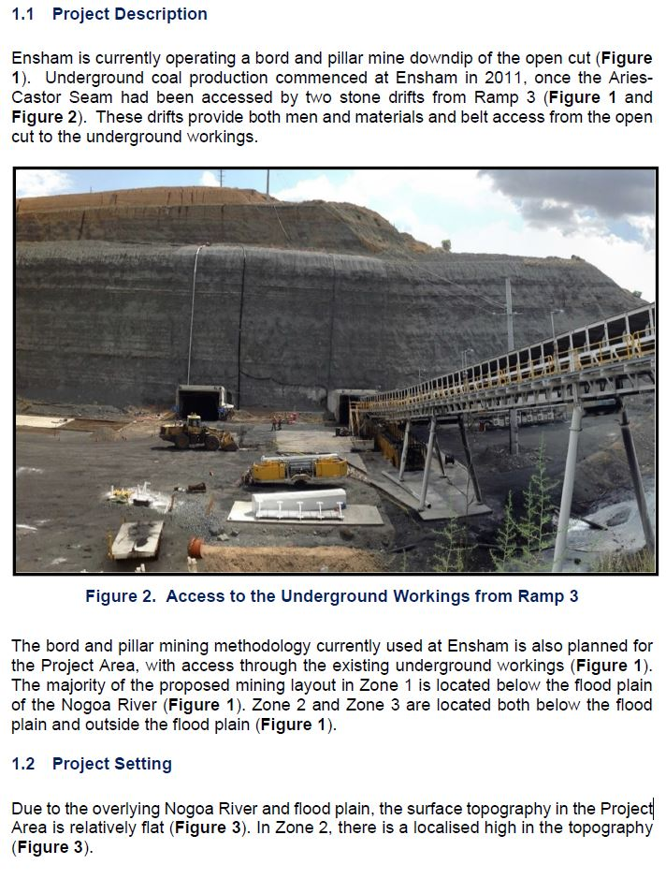
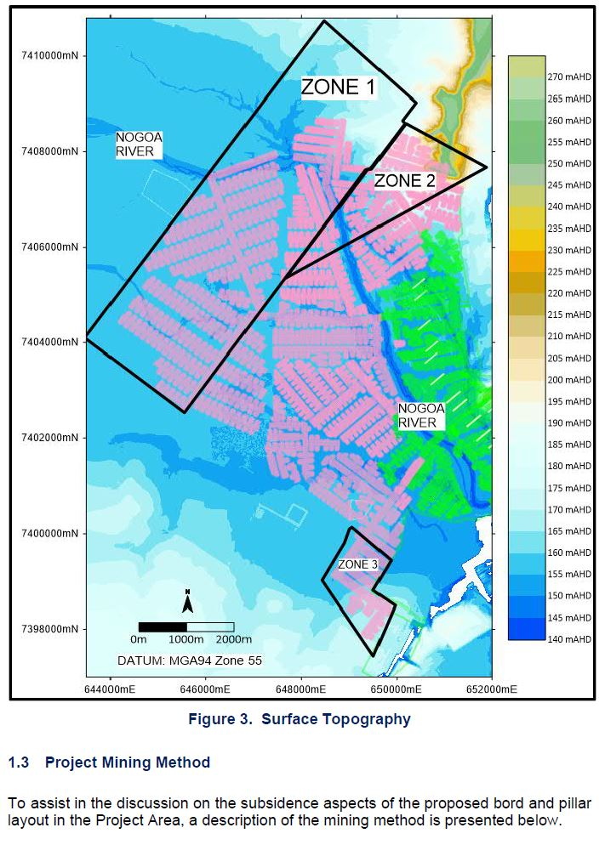

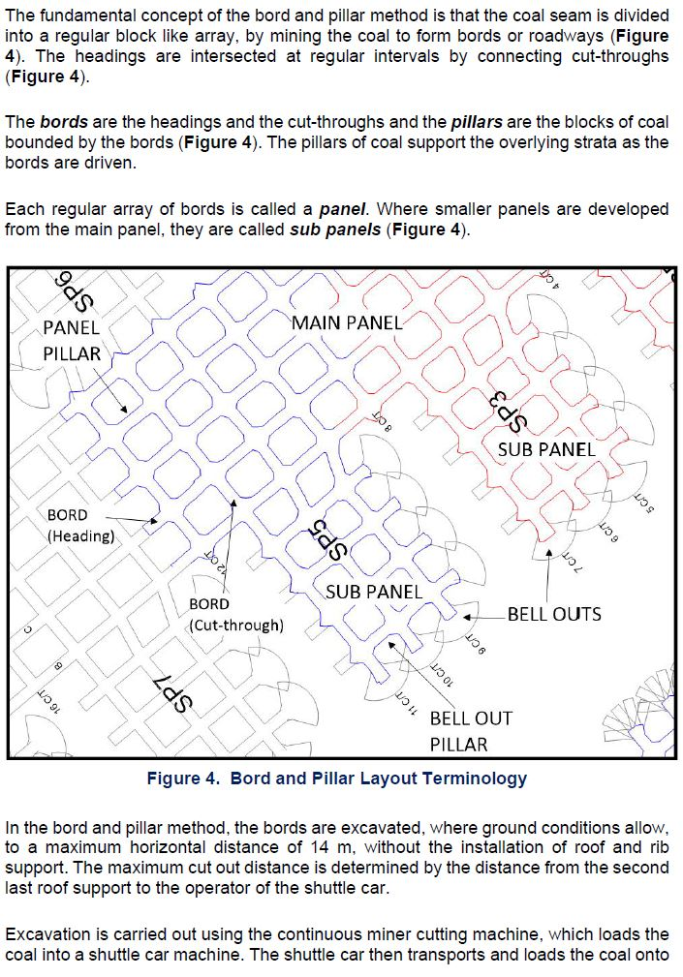

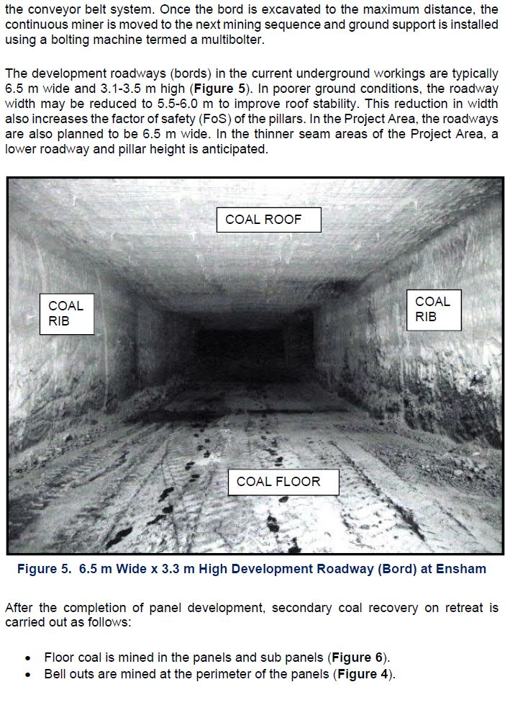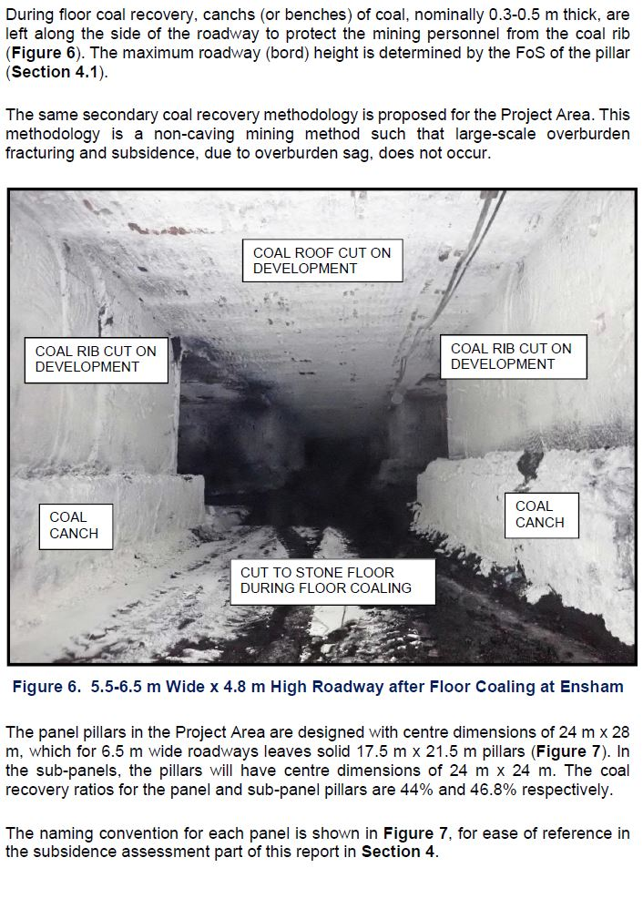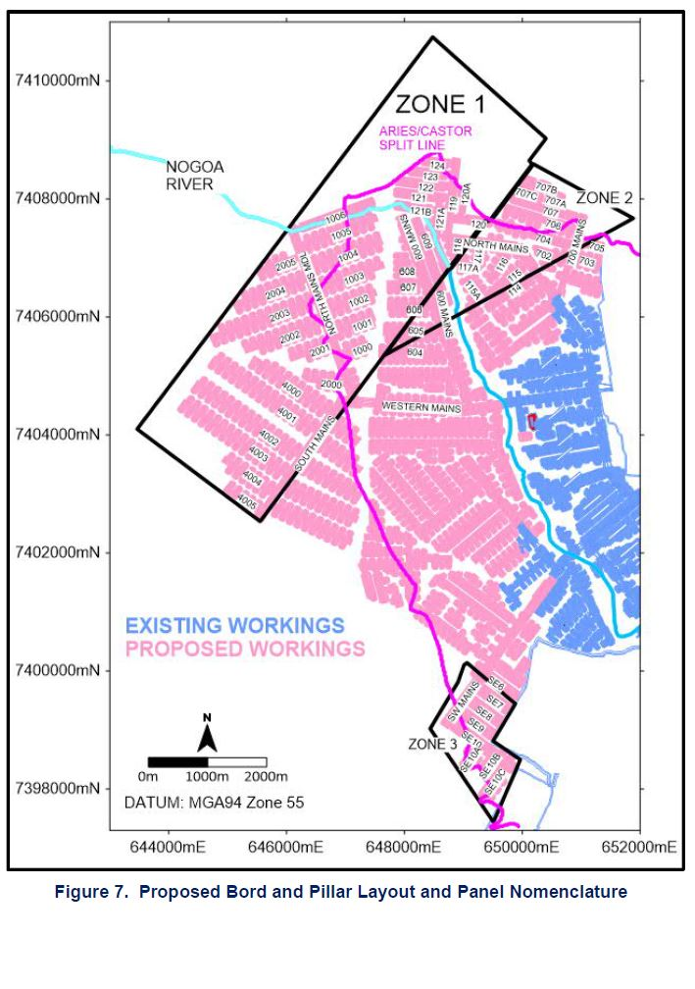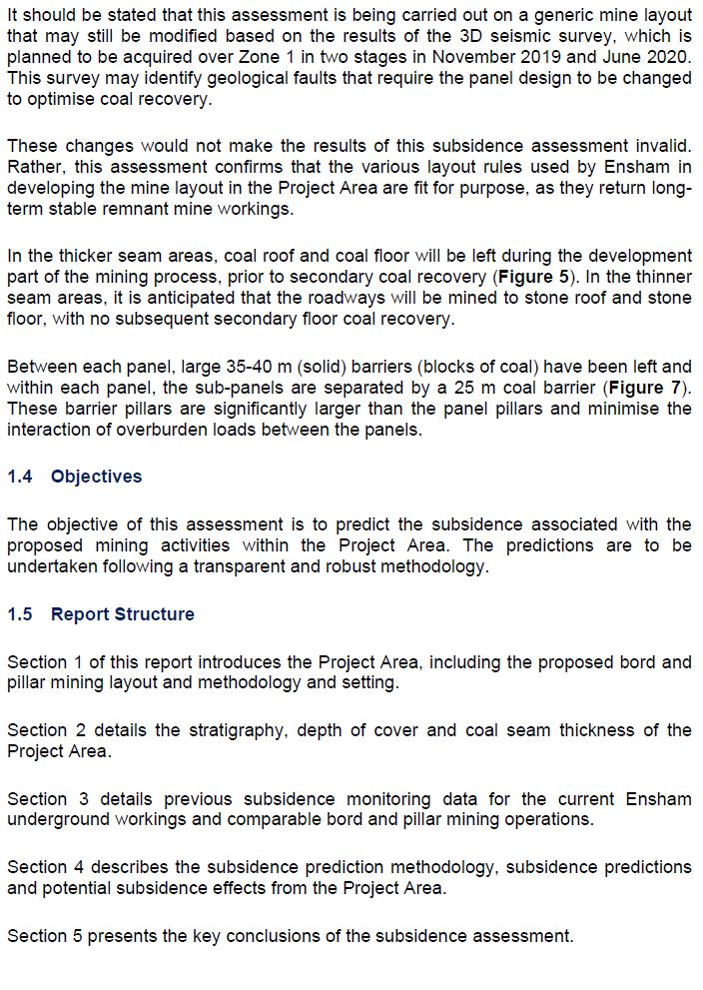

3. REVIEW COMMENTARY

The following independent review comments are provided by me on the GGPL Report.

  - Section 1 – Introduction

- Pages 1, 2 – It is noted that the current design study is focussed on Zones 1, 2 and 3 with the majority of Zone 1 and parts of both Zones 2 and 3 located beneath the Nogoa River flood plain. (These zones and the flood plain are indicated on the mine plan shown as Figure 1 above).

- Page 2 and following – The proposed mining method for the project is that already in use at Ensham, being a bord and pillar partial extraction system, as described in the extract from Section 1 of the GGPL Report, reproduced in section 2 above. It is noted that a cut-and-flit, or place-change mining system is in use, with cut-out distances of up to 14m, prior to installation of roof support. This generic bord and pillar system is a well proven, high productivity method in use in Australia and the USA and is suited to mines with average to good ground conditions.

- Roadways (bords) are mined at widths up to 6.5m unless conditions dictate narrower widths. Primary mining heights are 3.1m to 3.5m.

- Secondary partial extraction is achieved by mining of floor coal on the retreat, after primary panel completion; plus, bell-outs mined around the perimeter of each panel. Roadway heights are increased through the floor coal recovery. Maximum mining height is determined by the design value of Factor of Safety (FoS) for each pillar panel.

- It is noted that: “The same secondary coal recovery methodology is proposed for the Project Area. This methodology is a non-caving mining method such that large-scale overburden fracturing and subsidence, due to overburden sag, does not occur”.

- Panel pillars have solid dimensions of 17.5m x 21.5m, with sub-panel pillars being 17.5m square solid dimensions, achieving up to 46% extraction ratio or coal recovery within each panel.

- Page 8 – GGPL notes: “It should be stated that this assessment is being carried out on a generic mine layout that may still be modified based on the results of the 3D seismic survey, which is planned to be acquired over Zone 1 in two stages in November 2019 and June 2020. This survey may identify geological faults that require the panel design to be changed to optimise coal recovery”.

The results of these subsequent surveys or any consequent changes to the mine layout have not been provided to support this review. It would be important to confirm that the generic layouts have not changed significantly. It would also be important to understand the nature, location and magnitude of any geological structures detected, and the modifications to the mine layout that may have been made to accommodate such structures, or any other identified hazards that may be associated with such structures.

In regard to this exploration activity referenced above, the following additional advice was provided by Ensham, via OWS, during the preparation of this peer review:

“All zones (ie zones 1,2 and 3) have been assessed for major faulting based on exploration, 2D and /or 3D seismic work. The mine plan / design submitted as part of the EIS work allowed for major faulting to be considered and panel layouts /designs adjusted accordingly. Further exploration work and evaluation / interpretation of the acquired 3D seismic data is continuing in the MLA and the mine plan will be updated (if required) as more information becomes available”.

- Page 8 – It is noted that solid barrier pillars of 35m to 40m width have been left between each of the panels, and 25m solid barriers between each sub-panel.

  - Section 2 – Engineering Geology

- Page 9 – The exploration drill hole spacing over the Project Zones is shown in Figure 8 of the GGPL Report and is considered to provide adequate coverage of the area to enable a good understanding of the geology and its variability across the zones.

- Page 11 – It is noted that the minable coal seam varies between the Castor Seam and a combination of both Castor and Aries Seams in some locations. Where the two seams have coalesced, the working thickness ranges from 4.0m to 5.5m. Where the seams split, the working section in the Castor Seam ranges between 2m and 3m.

- Page 12 – The following is the GGPL summary of depth of cover over the Project Zones:

“Where the Aries and Castor Seams are coalesced in Zone 1, the depth of cover ranges from 130 m to 180 m (Figure 11). Where the Castor Seam only is mined in Zone 1, the depth is between 170 m and 210 m (Figure 11).

In the northern part of Zone 1, the depth to the working section is as shallow as 110m, however no mining is planned in this area due to the inconsistent thickness of the plies in both the Aries and Castor Seams (Figure 11).

In Zone 2, the depth of cover is typically 130-140 m (Figure 11). A topographic surface feature locally increases the depth of cover to 200 m in the eastern part of Zone 2 (Figure 11).

In Zone 3, the depth of cover ranges from 80 m in the east, up to 160 m in the western part of Zone 3 (Figure 11)”.

The GGPL Figure 11 showing depth of cover contours is reproduced below (as Figure 2), together with GGPL Figure 12 (as Figure 3) showing depth of weathering:

Figure 2. Depth of cover
(source: GGPL Report, Figure 11)

Figure 3. Depth of weathering
(source: GGPL Report, Figure 12)

- The above depth of cover data indicates quite a range of depths across the three different zones, as summarised in the extract above, from a low of 80m above Zone 3 to a high of 210m above Zone 1. The depth of weathering is reported to average between 10m and 20m below the surface, apart from a localised region above Zone 2 where it rises to 50m.

- What would have been more useful would have been an additional set of contours derived from the above two plotted data sets, providing contours of “rock head”, or thickness of unweathered overburden above the mining horizon. It is this thickness that is of most relevance to the overall regional geotechnical stability.

- It is interesting that there is no reference in this, or any other section of the GGPL Report to the presence, or inference, of any structural geological features across the mine workings or Project Zones. The exception to this statement is the reference, discussed in section 3.1 (g) above, where a seismic survey is discussed, but the results have not been provided, to date.

In regard to geological structure, it would seem highly unlikely that the entire mine is free from any such structures. It is therefore considered important to consider the location, magnitude and nature of any structures that do exist – in reference to their possible impact on both pillar stability and overburden integrity (with respect to both subsidence and hydrogeological impacts).

3.3 Section 3 - Previous Subsidence Monitoring Data

- Page 15 - Section 3.1 discusses previous subsidence data from Ensham Mine. The results of two LIDAR surveys are presented, undertaken in March 2016 and February 2017. The mining that took place in the intervening period was in Panels 204 and 105. It is not clear if any secondary extraction of floor coal had taken place in these panels during this time interval, or only primary development.

- The LIDAR survey accuracy is quoted as being + 50mm, which is accepted as reasonable for such technology. However, if there is a need for ensuring compliance with the predicted maximum subsidence of <40mm, a more accurate subsidence survey technique may be required.

- The LIDAR survey results are plotted as actual topographic surface horizons or ground levels. Any subsidence is therefore the difference between the two LIDAR result plots shown on each of the two diagrams, for subsidence above the two mining panels. This is not easy to deduce directly, however, it is clear that there is very little difference between the two sets of survey results, indicating low levels of surface subsidence. It is claimed that this provides validation of the subsidence predictions of < 40mm.

- Figure 4 is a copy of GGPL Figure 14, showing the LIDAR results above 204 Panel.

- Presentation of the LIDAR results in this manner is useful, but it would be more helpful if the actual subsidence relative to the baseline March 2016 survey was plotted, in addition to these raw topographic results. Such a plot should include the +50mm error band to illustrate that the results largely fall within the 50mm error band. There are some clearly anomalous spikes in the data which can be disregarded. However, there are some localised areas where the subsidence does appear to exceed the 40mm prediction – such as between 200m and 220m on the section line over 204 Panel. An approximate visual estimate of the difference in the LIDAR results indicates potential subsidence levels of between 100mm and 200mm in this location, unless there were known problems with the LIDAR survey at this location which account for these differences – again reinforcing the possible need and benefit of using a more accurate subsidence survey technique.

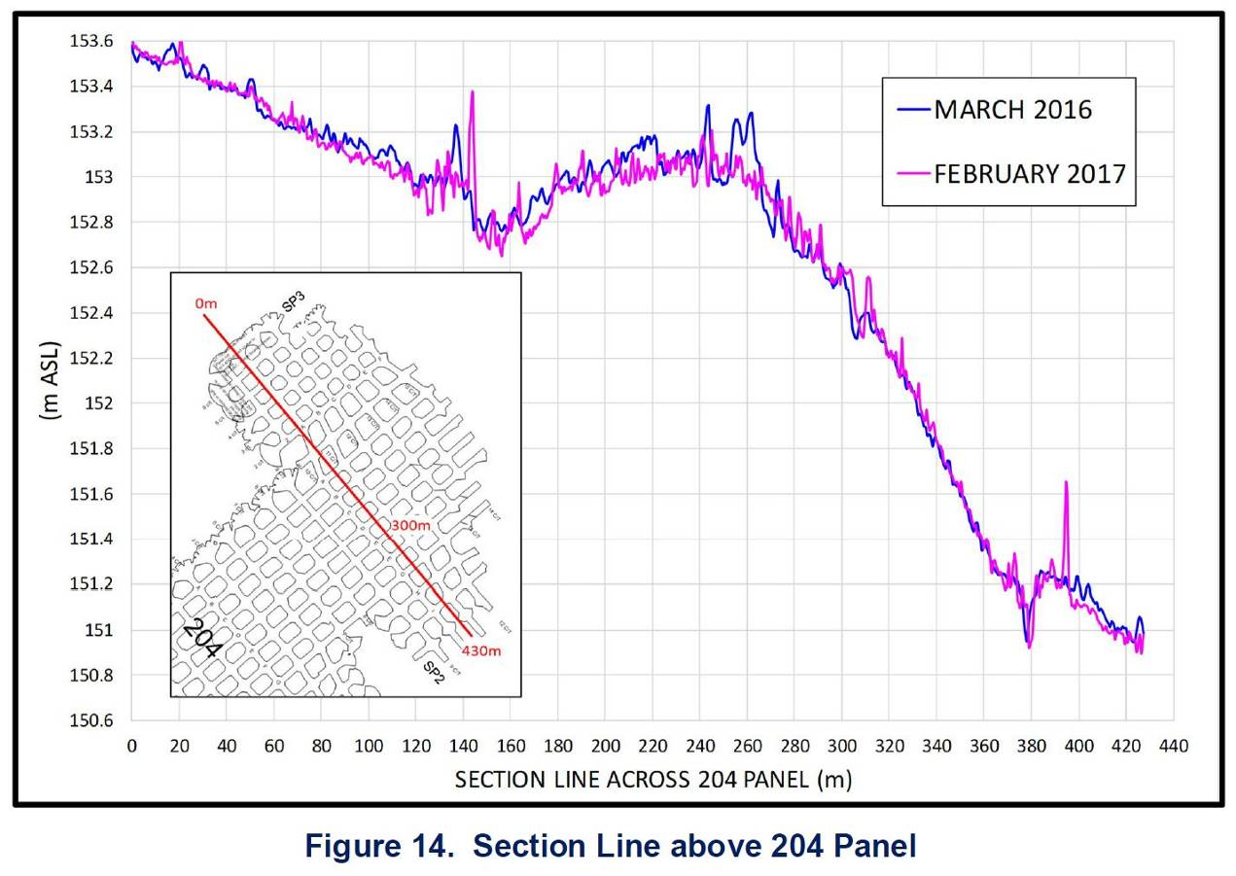

Figure 4. LIDAR subsidence survey results above 204 Panel
(source: GGPL Report, Figure 14)

- Sections 3.2 and 3.3 discuss subsidence above two other partial extraction bord and pillar mining operations in NSW – Clarence Colliery and Tasman Mine. This is a useful comparison, although it cannot be used to provide any quantitative metrics, due to different geology and geometric parameters.

- The Clarence data lists four distinct stages of subsidence development. The fourth stage is an interesting one where it is noted that after mining, water accumulation and panel flooding result in the surface subsidence increasing by up to 100%, albeit still within the applicable limit of 100mm. The GGPL Report does not offer any comment on the significance or relevance of this for the Ensham Mine workings. It would be useful to consider whether there is any expectation of similar flooding and consequent subsidence increases at Ensham.

- The Tasman data refers to some anomalous subsidence exceedances that occurred due to a claystone unit in the immediate floor beneath the coal pillars resulting in some pillar punching into the floor. This led to subsidence increasing from levels of approximately 100mm to more than 500mm. GGPL acknowledges that the issue of soft floor is therefore one that must be considered for the Ensham mining layout and is discussed later in their report.

3.4 Subsidence Prediction Methodology and Results

- Page 21 – The design criteria of ensuring stable pillar workings to prevent any caving or roof or pillar collapses is restated here, as the primary basis for controlling surface subsidence. Pillar design for long-term stability is therefore a critical issue in this mine design.

- GGPL has used the recognised empirical UNSW Pillar Design Procedure (UNSW PDP) for assessing pillar stability, and in particular, calculating pillar strength. This is an empirical method based on a database of Australian case studies of both failed and unfailed pillar systems. It adopts a risk-based probabilistic approach enabling Factors of Safety (FoS) to be assigned with associated estimates of probability of failure (or inversely, probability of stability). FoS is calculated as the ratio of average pillar strength divided by average pillar stress, colloquially referred to as “pillar load”.

The methodology considers the pillar system within its useful functional life but does not attempt to assign “time to failure”. It also assumes that the components of the pillar system – immediate roof, coal, floor, and contacts are relatively competent, or good.

The methodology is widely used in Australia and is accepted as the most appropriate and reliable of the empirical methods available, when applied within appropriate limits and recognising the relevant assumptions and levels of accuracy.

- Pages 21, 22 – It is noted that pillar load has been determined using the widely accepted empirical technique known as the tributary area theory that assigns the full weight of the overburden equally onto each pillar, within a system of similarly sized pillars. It is also noted that the majority of panels in the Ensham project have panel width to depth (W:H) ratios of >1, and so there is no level of load protection from the adjacent barrier pillars, hence the pillars are conservatively designed with the full cover load, as determined by the tributary area theory. This is an appropriate approach.

- The question of panel widths and the W:H ratio is an important one when considering regional stability. There is an insufficient level of detail in the diagrams showing the proposed mine plan to determine panel widths. It would have been helpful, and potentially important information, to have included a summary of panel widths, and the value of W:H for each panel. This should be assessed in conjunction with barrier pillar design, for regional stability and overall subsidence considerations.

- Page 22 – It is reported that the stability of pillars in each panel has been assessed using the maximum depth existing over each panel – this is considered an appropriate approach.

- Page 23 – Reference is made to the tabulated panel dimensions and data contained in Appendices 1 and 2 of the GGPL Report. Discussion then refers to seam thicknesses in some areas up to 5.5m, but reports that from previous experience in such thick sections, it has been typical to leave 0.8m of coal in the roof, which would make the mining (and hence pillar) heights a maximum of 4.8m. However, reference to the Appendices only lists maximum coal thickness for each panel, and these figures are as high as 5.8m in a number of instances. It is therefore not possible to precisely determine the maximum possible mining heights to be used for design purposes, unless the 0.8m of roof coal is assumed as a default for all thick seam sections. However, it must be assumed that for some panels, the mining height could theoretically be as high as 5.0m, using the 0.8m coal roof figure. Further guidance is then provided on determination of the maximum mining height in each panel/sub-panel – see point (g) below.

- Page 23 – Further to the above question of actual design mining height for each panel, GGPL proposes use of a design chart which plots maximum allowable mining height to achieve an FoS value of 1.6, relative to depth. This diagram (Figure 19 in the GGPL Report) is reproduced below, as Figure 5 in this review. Two curves are plotted on this diagram, being for the main panel rectangular pillars (24m x 28m centres – 17.5m x 21.5m solid), and the sub-panel square pillars (24m x 24m centre – 17.5m x 17.5m solid).

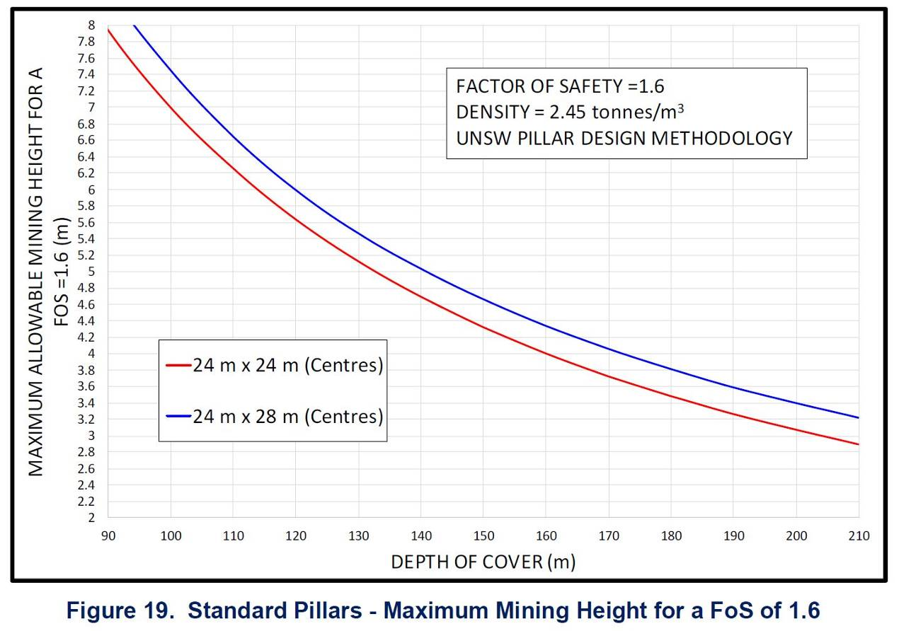

Figure 5. Proposed maximum panel mining heights, relative to depth
(source: GGPL Report, Figure 19)

The use of this diagram raises a number of questions which are discussed, in turn, below.

- The first issue with this diagram is a one of accuracy of the curves provided. Using the generalised UNSW PDP formulae for pillar strength, it appears that the above curves are very slightly over-stating the maximum allowable height, using the FoS value of 1.6. For example, considering the 17.5m x 17.5m solid square pillars (the red line), for a depth of 180m, by my calculations, the maximum mining/pillar height should be 3.4m, not 3.5m as shown here. Similarly, for 150m depth, the maximum pillar height should be 4.2m, not 4.3m as indicated. A similar very minor level of discrepancy applies to the blue curve for the rectangular pillars. It is recommended that this design diagram should therefore be altered to reflect the adjusted values.

- The second issue relates to the choice of a value of 1.6 for the FoS. One of the quite unique features of the UNSW PDP is that it provides a quantitative probability of failure figure, assigned to each value of FoS. This enables a risk-based design decision to be made for the pillar system for the duration of its working life. The recommended approach for using the UNSW system is to select an appropriate level of probability of failure as the starting point, rather than simply an FoS value – considering both the function of the pillar system over its lifetime, and also the consequences of pillar system failure. GGPL has made no reference to, or discussed different levels of failure probability, which is considered to be a shortcoming of the reported design approach.

Figure 6 shows the UNSW chart of Factor of Safety plotted against Probability of Failure (this relationship is only applicable to the use of the UNSW pillar strength formulae). Note: The only curve on the chart below to be used should be the generalised “UNSW Rectangular Power” curve, marked with triangles.

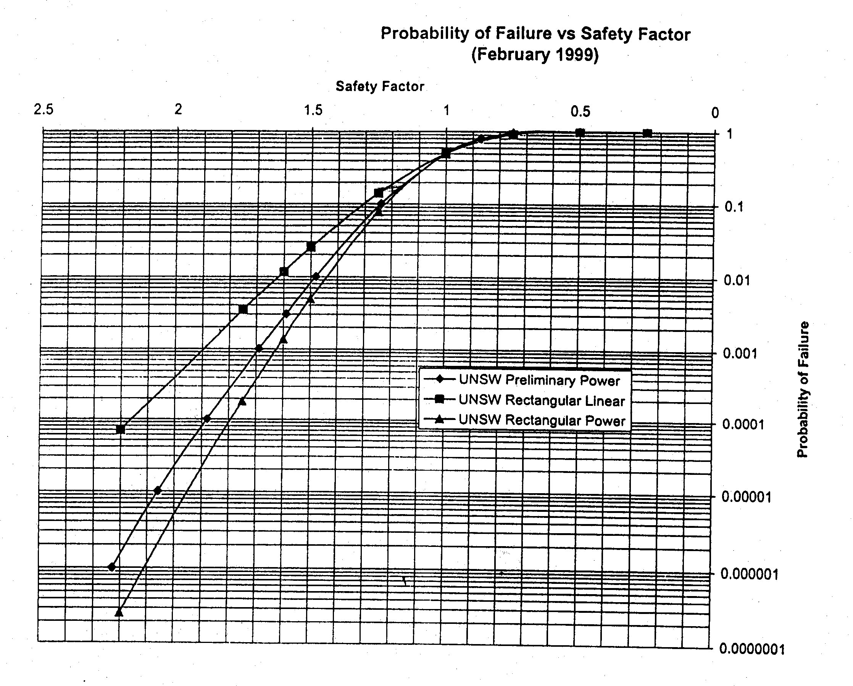

Figure 6. UNSW pillar design Factor of Safety versus Probability of Failure
(source: UNSW Pillar Design Procedure)

By interrogation of this chart, the GGPL selected value of 1.6 for the design FoS represents a probability of failure of approximately 0.0012, or 1.2 in 1,000. This is a design decision, taking into account the points mentioned above. It is a typical value used commonly for normal production panels of bord and pillar workings, required to function for a normal mine lifetime period, and on this basis, I consider it to be an appropriate value to choose as the starting point for the normal Ensham panels.

However, where the potential consequence of a pillar system failure is more serious, and where the pillar system integrity must be maintained well beyond the life of the panel or even the life of the mine, such as beneath one of the major rivers running across the lease, it would be more appropriate to adopt a lower level of failure probability, and hence a higher design FoS. I consider that this use of a higher FoS to reflect a lower probability of failure should be applied to any panel that runs either directly beneath one of the rivers, or even beneath a corridor adjacent to the rivers on either side, as defined by a conservative angle of draw from the vertical alignment, such as 35⁰.

As noted earlier, it is not clear from the level of mine plan detail available in the diagrams of this report, which or how many of the proposed panels pass under one of the rivers or under such an angle of draw corridor. However, by examination of Figure 7 of the GGPL Report (see extract contained in Section 2 of this report, above), it is clear that at least panels 1006, 121A, 121B, and potentially others, lie beneath the Nogoa River alignment and/or an adjacent angle of draw corridor.

Reference to the earlier 2015 GGPL Report for panel design at Ensham stated the following, on this issue:

“The Anabranch crosses above the panels in Area 1 at depths of 100-136 m and the Nogoa flows above Area 2, where the depth of cover is 40-64 m (Figure 1). As part of the environmental approval for underground mining at Ensham, minimum factors of safety of 2.11 for the pillars are required below these watercourses (Figure 22).

Due to the catastrophic consequences of connecting the underground workings to the Nogoa in Area 2, it is recommended that the pillars are designed to not only satisfy the 2.11 factor of safety but also to plot to the right of the green line in Figure 12”.

It is strongly recommended that this same approach be taken for the current project design and applied to any panels that lie beneath the rivers or the adjacent angle of draw corridors – rather than applying a blanket FoS of 1.6, which has been stated by GGPL on page 23 as being the current basis for design:

“This 1.6 FoS value also applies below the Nogoa River where it flows across the Project Area (Figure 1)”.

The minimum FoS value of 2.11 referred to in the 2015 report is considered to be an appropriate long-term design value under such circumstances. This is equivalent to a probability of failure of 1x10⁻⁶, or 1 in 1,000,000 when using the UNSW PDP.

- A further issue for consideration, with respect to appropriate design parameters, is the question of panels which lie beneath the flood plain – reflecting one of the concerns raised by the OWS. It is clear from Figure 1 that this affects the majority of the proposed new workings.

In relation to the impact of up to 16m of floodwater over the area during time of flood, this would only have a very modest impact on underground loading of pillar workings. The density of the overburden used by GGPL to calculate pillar loads was 2,450kg/m³, or a Specific Gravity of 2.45, as compared to 1.0 for water. Therefore, a 16m surcharge of water depth would be equivalent to an additional 6.5m of overburden rock. It is a simple adjustment to the pillar calculations and design curves to add this value – 6m of rock – to the maximum panel depths, to take account of this loading surcharge.

As to the consequence of a pillar system failure under the floodplain, apart from under the river corridor, I am comfortable with the current use of a design FoS value of 1.6, given that the likelihood of such a failure occurring during the very small windows of time whilst the river was in flood would be extremely low, and the design, as it stands would be adequate for the purpose. The consequence of such a failure, in the very unlikely event if it were to occur, would not be expected to be a break-through to the surface, but a level of subsidence exceedance. Should any subsidence exceedance occur, this could be dealt with by any necessary land re-shaping, undertaken out of flood periods.

- The fourth and final point of issue in relation to use of this chart for specifying the maximum allowable mining height, dependant on depth, for each panel, is simply the practical issue of implementation and management to ensure compliance. This is a matter for mine management, rather than for the geotechnical designer, but it may be one that it is difficult to achieve consistence compliance with design. Every panel is going to be mined to a different maximum mining height, which in many instances in the thicker sections of coal, is going to be well less that the available seam thickness.

Unless there are very well prescribed maximum mining heights for each and every panel, and there is close supervision of underground crews to ensure that such heights are complied with, it is quite conceivable that different mining crews may either inadvertently, or deliberately, take out more coal, especially during floor recovery on the retreat, than has been specified in the design, without anyone being aware of such non-compliance. This could have serious consequences at a later date, well after the panels have been completed, if a region of instability develops due to excessive mining heights.

- Pages 24-26 – The design of the bell-out pillars on the perimeter of each sub-panel is now considered and the same FoS value of 1.6 is used, but assumptions of a wider effective mined area, and a reduced overall load is made. These assumptions are accepted as being reasonable, although the design curve for maximum allowable mining height shown in Figure 22 of the GGPL Report should be checked for accuracy, in the same manner as minor differences were reported above, for Figure 19, using the UNSW PDP. If any bell-outs are located beneath the river or adjacent angle of draw corridor, a lower probability of failure and higher value of FoS should be applied, as discussed earlier.

As discussed under point 4 above in section (g), there are also some similar operational management concerns regarding the mining of the bell-outs, to ensure that the overall geotechnical design is not compromised. As above, firstly, it is essential to ensure that bell-outs are not mined higher than the design limit. Secondly, there must be a clear limit on the depth of mining of each plunge into the bell-outs. This is not specified in the GGPL Report, but it is assumed that this is governed by the maximum unsupported plunge depth of 14m nominated previously.

- Page 26 – GGPL appropriately notes that the rib canches left when bottom coal is mined on the retreat is not factored into the pillar design calculations, as such canches would not offer any significant additional support or strength capacity to the pillars.

- Pages 26, 27 – There is only a brief reference to the design of the barrier pillars – being 25m wide pillars between the sub-panels and 35m to 40m wide between the main panels. Again, it is difficult to validate the application and distribution of these dimensions across the proposed mine plan area, relying just on the available diagrams. However, from the available plan images there does appear to be some variability in barrier pillar sizes across the Project area.

For all barrier pillars, it is critical to ensure that the barrier width is not compromised by the adjacent secondary extraction through bell-outs or other mining activity. The widths quoted must therefore be the remaining solid width, beyond such mining activity.

GGPL reports the following values of FoS for the different barrier widths, for a 180m depth, a barrier length of at least 50m and assuming a conservative (maximum) barrier height of 5m:

- 25m barrier – 2.04 FoS
- 35m barrier – 2.75 FoS
- 40m barrier – 3.15 FoS

As for previous FoS values, there appears to be a very minor error or inconsistency in the FoS calculations. By my calculations, the values should be:

- 25m barrier – 2.02 FoS
- 35m barrier – 2.69 FoS
- 40m barrier – 3.09 FoS

These figures are for a barrier with 6.5m roadways adjacent to them on either side. However, if the bell-outs are factored into the calculation, as is appropriate for this design, using the assumed equivalent 10m wide roadway on either side of the barrier, the FoS values decrease further, to:

- 25m barrier – 1.82 FoS
- 35m barrier – 2.48 FoS
- 40m barrier – 2.87 FoS

I believe that the above figures for the wider two barrier widths are adequate for providing long-term stability. However, I am concerned that the 25m wide barrier may be inadequate in width. It is a matter for further design and consideration of adjacent sub-panel and panel widths, but I would consider it more appropriate for the barriers to be designed to a greater width with a lower probability of failure, for example, adopting the 1 x 10⁻⁶ probability of failure, or a UNSW FoS value of 2.11. If this is applied to the barriers between sub-panels, the barrier width would increase from 25m to 30m.

A further point regarding barriers was raised in the Mine Advice peer review of the 2015 GGPL design report for Ensham. This related to barrier widths required to manage hydrostatic head due to water present in the adjacent open-cut voids. At the time the proposed barriers under consideration were 20m wide. The Mine Advice stated:

“It is recommended that the issue of barrier pillar stability under lateral hydrostatic water pressure be re-examined and the mine layout modified accordingly…….It is recommended that a more detailed analysis be undertaken on the impact of different barrier widths and also driving heads on inflow rates, this being required to consider pumping requirements underground, maximum water head levels in the open cut presumably being controlled by very high rainfall periods rather than planned water storage as part of mining”.

It is unknown whether this additional analysis was undertaken, and if it has influenced the recommended 25m barriers in the current (2020) GGPL design. It is also not known whether the question of proximity to flooded open cut voids is even an issue for the current project, although examination of the mine plans suggests it could be so for Zone 3, in which case it may be an important consideration.

- Page 27 – I agree with the statements by GGPL that the width:height (w/h) ratio of pillars is an important consideration, albeit that it is already factored into the strength calculations for pillars. It is correct to recognise that pillars with a smaller w/h ratio are more prone to a sudden or brittle failure mode than larger pillars. This is impacted by factors including weakness planes such as cleating dominating the failure mode.

- Page 28 – GGPL discusses various pieces of work by each of Reed, Hill and Galvin regarding the question of pillar w/h ratio and the potential pillar failure modes. A conclusion is reached that the majority of pillar failures in the industry have occurred in the past with w/h ratios < 4. This is accepted as a valid conclusion. It is then noted that for the proposed Ensham design, GGPL states:

“For the development pillars in the current underground workings at Ensham, the width to height ratios are typically 5 or greater. Using the limiting FoS of 1.6 for mining below the Nogoa River and flood plain, it is not until the width to height ratio is <3.5 that the design criteria in Figure 25 become relevant”.

Two points are made in response to this:

- It is correct that on the data available (subject to some degree of interpretation, discussed earlier, regarding pillar heights), the proposed Ensham w/h ratios are typically greater than 5. Although there are at least two examples with w/h ratios of 3.5 – panels 118 and 120 which, for an FoS value of 1.6, result in a mining height of 5.0m in a 5.8m seam thickness. There may also be others.

- The w/h design criteria referred to above and illustrated in GGPL Figure 25 is that developed by Hill (2005). I have serious misgivings about this design criteria for the following reasons.

The Hill data presented in GGPL Figure 25 is a plot of failed pillar cases, taken from the UNSW failed pillar database; plus published South African failed pillar cases; plus, a set of highwall mining failed pillars. This plot has been used to derive a design formula using w/h and FoS.

My concerns with the Hill analysis and hence its application in pillar design, are as follows, recognising that this or a similar analysis has been published some time ago and it is known that such analysis has attracted some previous criticism by other reviewers.

My comments are as follows:

- I will restrict my interpretation to consideration of the Australian underground failed cases only, as I am not sufficiently familiar with the other data.

- As a general rule for analysis of any data, when describing any mathematical relationship between two parameters, it is normal that there is an independent variable, and a dependent variable. This relationship is usually expressed as a function. A dictionary definition of a function is given as:

Function, in mathematics: an expression, rule, or law that defines a relationship between one variable (the independent variable) and another variable (the dependent variable).

- Such a functional relationship can be described as:

  - y = f(x), where x is the independent variable, and y is the dependent variable.

- In the case of the data under consideration here, the parameter w/h is clearly the independent variable in relation to pillar behaviour, while FoS is a dependent variable. It would therefore make much more sense to plot FoS as a function of w/h, rather than the reverse, as has been done by Hill. This would correctly place FoS on the y-axis as the dependent variable, with w/h on the x-axis. Any derived equation for the upper bound to the plotted data would then be in the form of FoS=f(w/h), rather than vice-versa, as has been done.

- Further analysis of the function can then be made, recognising that FoS is in fact a simple ratio of pillar strength/average pillar stress (or “load”).

  - FoS = Pillar Strength
Average Pillar Stress

- But we already know that pillar strength is itself a dependent variable as an exponential function of width to height ratio, so

  - Pillar Strength = f (w/h)

- So, by substituting these terms into the FoS=f(w/h) equation results in:

  - (f(w/h)) = f(w/h)
(Average pillar stress)

- What this then implies is that the plot, as presented, is more a representation of the various constants included in the strength calculation that make up the functional expression of strength; but in addition, that there is a further independent variable, pillar stress, that is not represented in the plot or resultant equation, that explains the significant scatter of the data in the FoS axis direction.

Having made these comments, I am therefore not at all comfortable with relying on this analysis, as presented, and the derived equations provided. I am much more comfortable in simply using the value of Factor of Safety and its link to probability of failure, as a suitable design approach. The graph presented does provide a simple representation of the dataset and the range of w/h values represented by failed cases, and that again is useful information to potentially set a minimum value of w/h to be considered, but beyond that, the FoS values should be the guiding design parameter.

- Page 29 – It is reported by GGPL that there is a failed pillar case (w/h ratio of 8.16) in the UNSW database that has been the subject of considerable technical debate with the validity of the case under some question. As a result, GGPL concludes that the UNSW strength formulae based on including this failed case may be under-estimating pillar strength and over-estimating probability of failure. It is correct that there had been some debate over this failed case in the past, raised by one industry consultant. However, after extensive investigation by the UNSW researchers, the failed case in question was deemed to be a valid result and so there is no ongoing question regarding the formulae under-estimating pillar strength on this basis, within the limits of the database.

- Page 32 – GGPL makes further use of the Hill diagram of failed pillar cases and has plotted the proposed Ensham pillar systems on the same chart. Whilst it is accepted that they plot on this diagram to the right of the so-called failure envelope, the proximity to this envelope and to some of the failed pillars in the database is significant. From a design perspective, the earlier comments regarding FoS and its determination should take precedence over use of this graph – for the reasons discussed above.

- Page 32 and following – GGPL notes that pillars in previous secondary extraction panels at Ensham have now stood stable for close to seven years. Inspection of a 2019 mined panel (106) showed no significant sign of spalling. It is also noted that there are no bands of swelling clays present within or adjacent to the seam which can help propagate rib spall in standing pillars over time. This is encouraging evidence but does not guarantee ongoing stability.

- Page 35 – Section 4.2.1 – An analysis of floor strata is conducted to ensure there is no potential for a bearing capacity floor failure beneath pillars. The analysis reveals no floor strata of less than 10 MPa UCS, and no weak layers of more than 0.5m in thickness. Subject to pillar design to an FoS of 1.6 or greater, the proposed design does not indicate any propensity for soft floor failure beneath the proposed pillar workings. GGPL further reports that there are no floor strata units present that have any slaking or water sensitivity properties that might result in loss of strength in the presence of flooded workings or wet strata.

- Page 44 – On the basis of strata properties discussed in the previous pages, GGPL conducts an analysis of potential subsidence based on an elastic compression analysis of overburden, pillar coal and floor strata. This yields a maximum predicted surface subsidence of <40mm over the proposed mining areas. This form of analysis is an indirect, but reasonable first-pass approach to predicting what would be expected to be a limited level of subsidence over stable bord and pillar workings.

- Page 48 – It is further noted and accepted that there is no surface or sub-surface fracturing expected over the proposed mine workings. It is also agreed (as outlined in the supplementary GGPL report of 10 May 2021) that there is negligible potential for subsidence pot-holing over the proposed underground workings, due to the depths and the competence of the overburden strata.

- Page 48 – The following statement is made here:

“there are no localised features or variations in the geology, geotechnical conditions or surface topography that are considered likely to result in any significant deviations from the subsidence predictions presented in this report”.

The significance of any potential structural geology has already been commented upon and is the subject of further information under investigation. It will be important to ensure that if there are any structural features present in the project area, they are sufficiently isolated so as to not only avoid compromising pillar stability, but also avoid any potential surface water flow-path due to increased permeability along structure planes.

4. CONCLUSIONS

- The overall proposed mining layout for Ensham is considered to be an appropriate and well-developed geotechnical design, subject to a number of minor clarifications and adjustments, as noted above.

- Aspects of the design where some further refinement or adjustment is recommended, are as follows:

  - Recalculation and minor adjustment of the pillar FoS design curves, as noted.
  - Addition of a small depth loading supplement (6m) to all design figures to provide for the potential maximum weight of floodwater above the majority of the project area which lies under the flood plain.
  - Adoption of a lower probability of failure/higher FoS criteria for the pillar panels that lie beneath the Nogoa River and an adjacent angle of draw corridor on either side.
  - Consideration of wider barrier pillars between sub-panels, designed to a higher FoS value.
  - Provision of clarity and guidance to the mine operator to enable a simple but reliable and effective means of managing mining heights (and bell-out geometries) in each panel to avoid any exceedances;
  - Further clarity with respect to known geological structures across the Project area and how these have been taken account of within the design;
  - Updating panel plans, as necessary, in the light of any further structural geological information that arises from recent exploration studies.

- In regard to the specific concerns raised by OWS, I believe that these have all been addressed by the above conclusions and detailed points raised within this review.

Emeritus Professor Bruce Hebblewhite
4 June 2021

APPENDIX A

Attached is a summary Curriculum Vitae for the author of this report, Bruce Hebblewhite. Bruce has worked within the Australian mining industry from 1977 to the present time, through several different employment positions. Throughout this period, he has been actively involved in all facets of mining industry operations. In addition, he has visited and undertaken consulting and contract research commissions internationally in such countries as the UK, South Africa, China, Indonesia, New Zealand and Canada. For the majority of his 17-year employment period with ACIRL Ltd he had management responsibility for ACIRL’s Mining Division which included specialist groups working within both the underground and surface coal mining sectors, and the coal preparation industry– actively involved in both consulting and research in each of these areas.

In his most recent permanent employment position with The University of New South Wales, Bruce was involved in academic management, undergraduate and postgraduate teaching and research, and contract industry consulting and provision of industry training and ongoing professional development programs – for all sectors of the mining industry – coal and metalliferous, both national and international.

Both past substantive employment positions required regular visits, inspections and site investigations throughout the Australian mining industry, together with almost daily contact with mining industry management, operations and production personnel.

On his retirement from UNSW at the end of December 2020, Bruce was appointed as a Professor Emeritus to UNSW Sydney (an ongoing honorary appointment).

Throughout his consulting career which continues to the present time, Bruce has maintained contacts with the mining industry and mining profession and an ongoing connection with the School of Minerals & Energy Resources at UNSW Sydney and is involved in a number of ongoing industry research projects.

SUMMARY CURRICULUM VITAE

Bruce Kenneth Hebblewhite

Consultant Mining Engineer & Principal, B K Hebblewhite Consulting

Date Of Birth 1951

Nationality Australian

Qualifications
1973: Bachelor of Engineering (Mining) (Hons 1) School of Mining Engineering, Uni. of New South Wales

1977: Doctor of Philosophy, Department of Mining Engineering, University of Newcastle upon Tyne, UK
1991: Diploma AICD, University of New England

PROFESSIONAL MEMBERSHIPS; APPOINTMENTS; AWARDS &
SPECIAL RESPONSIBILITIES

Fellow - Australasian Institute of Mining and Metallurgy
Member - Australian Geomechanics Society
Member – Society of Mining and Exploration Engineering (SME), USA
Member - International Society of Rock Mechanics (President – Mining Interest Group (2004 – 2011))
Emeritus Member - Society of Mining Professors (SOMP) (President (2008/09); Council Member (2006 -2018; 2020 - present); Secretary-General (2011-2018))
Executive Director – Mining Education Australia (July 2006 – December 2009)
Chair, Governing Board – Mining Education Australia (2015)
Member, Branch Committee – AusIMM Sydney Branch (2017-2019)
________________

Expert Witness assisting Coroner: Coronial Inquest (2002-2003): 1999 Northparkes Mine Accident.
Chair: 2007-2008 Independent Expert Panel of Review into Impact of Mining in the Southern Coalfield of NSW (Dept of Planning & Dept of Primary Industries).
Expert Witness assisting NSW Mines Safety Investigation Unit – Austar Mine double fatality, April 2014.
Member (2012 – 2019): Scientific Advisory Board, Advanced Mining Technology Centre, Uni. of Chile.
Trustee (2013 – 2020): AusIMM Education Endowment Fund.
Member (2020 – present): Independent Advisory Panel for Underground Mining, NSW Dept of Planning, Industry & Environment (DPIE).
2012 Syd S Peng Ground Control in Mining Award (SME (USA)) – “in recognition of his long and distinguished career conducting research, providing instruction and applying practical solutions in the field of ground control”.
2017 Ludwig Wilke Award (Society of Mining Professors) – “for his pioneering work as a researcher, his accomplishments as a global educator, and his leadership and vision as Secretary-General of the Society of Mining Professors (SOMP)”.
2017 Rock Mechanics Award (SME (USA)) – “for his significant contribution as an educator, researcher and consultant in rock mechanics and ground control”.
2020 AusIMM Institute Medal – “for contributions to the mining industry and profession through education, research and training”.
2021 – Professor Emeritus, University of New South Wales
Professional Experience

1995 - present B K Hebblewhite Consulting
Consultant Mining Engineer & Principal

2014 – 2020 University of New South Wales, School of Minerals & Energy Resources Engineering (formerly School of Mining Engineering)
Professor of Mining Engineering (p/t)

2003-2014 University of New South Wales, School of Mining Engineering
Head of School and Research Director,
(Professor, Kenneth Finlay Chair of Rock Mechanics (to 2006);
Professor of Mining Engineering (from 2006))

2006 – 2009 Mining Education Australia
(a national joint venture between UNSW, Curtin University of Technology, The University of Queensland & The University of Adelaide)
Executive Director (a concurrent appointment with UNSW above).

1995-2002 University of New South Wales, School of Mining Engineering
Professor, Kenneth Finlay Chair of Rock Mechanics and Research Director, UNSW Mining Research Centre (UMRC)

1983-1995 ACIRL Ltd, Divisional Manager, Mining - Overall management of ACIRL’s mining activities. Responsible for technical and administrative management of ACIRL’s Mining Division covering both research and consulting activities in all aspects of mining and coal preparation.

1981-1983 ACIRL Ltd, Manager, Mining - Responsibility for ACIRL mining research and commissioned contract programs.

1979-1981 ACIRL Ltd, Senior Mining Engineer - Assistant to Manager, Mining Research for administrative and technical responsibilities. Particularly, development of geotechnical activities in relation to mine design by underground, laboratory and numerical methods.

1977-1979 ACIRL Ltd, Mining Engineer Project Engineer for research into mining methods for Greta Seam, Ellalong Colliery, NSW. Also, Project Engineer for roof control and numerical modelling stability investigations.

  - Cleveland Potash Ltd, Mining Engineer and Department of Mining Engineering, University of Newcastle-upon-Tyne, UK - Research Associate. Employed by Cleveland Potash Limited to conduct rock mechanics investigations into mine design for deep (1100m) potash mining, Boulby Mine, N Yorkshire (subject of Ph.D. thesis).

Specialist Skills & Interests
- Mining geomechanics
- Mine design and planning
- Mining methods and practice
- Mine safety and training
- Mine system audits and risk assessments
- Mining education and training

