Information Guidelines Explanatory Note

Uncertainty analysis for groundwater modelling

© Commonwealth of Australia, 2023.



Information Guidelines Explanatory Note: Uncertainty analysis for groundwater modelling is licensed by the Commonwealth of Australia for use under a Creative Commons Attribution 4.0 International license with the exception of the Coat of Arms of the Commonwealth of Australia, the logo of the agency responsible for publishing the report, content supplied by third parties, and any images depicting people. For license conditions see <https://creativecommons.org/licenses/by/4.0/>

This report should be attributed as ‘Peeters LJM and Middlemis H 2023. Information Guidelines Explanatory Note: Uncertainty analysis for groundwater modelling, A report prepared for the Independent Expert Scientific Committee on Coal Seam Gas and Large Coal Mining Development through the Department of Climate Change, Energy, the Environment and Water, Commonwealth of Australia, 2023’.

This publication is funded by the Australian Government Department of Climate Change, Energy, the Environment and Water. The views and opinions expressed in this publication are those of the authors and do not necessarily reflect those of the Australian Government or the Minister for the Environment and Water.

Contact details

For information about this report or about the work of the IESC, please contact:

IESC Secretariat

Office of Water Science

Department of Climate Change, Energy, the Environment and Water

GPO Box 787

CANBERRA ACT 2601

The report can be accessed at <http://www.iesc.environment.gov.au/>

Images

Front cover: McIntyre River | Location: Condamine catchment area | © Department of Climate Change, Energy, the Environment and Water

© Department of Climate Change, Energy, the Environment and Water (taken by staff)

All other images © Department of Climate Change, Energy, the Environment and Water unless specified otherwise.

Information Guidelines Explanatory Note

Uncertainty analysis for groundwater modelling

Reflections on the lake at the Hunter Wetlands Centre (Shortlands Wetland)


Overview

## The role of the IESC

The Independent Expert Scientific Committee on Coal Seam Gas and Large Coal Mining Development (IESC) is a statutory body under the *Environment Protection and Biodiversity Conservation Act 1999* (Cth) (EPBC Act). The IESC’s key legislative functions are to:

* provide scientific advice to the Commonwealth Environment Minister and relevant state ministers on coal seam gas (CSG) and large coal mining (LCM) development proposals that are likely to have a significant impact on water resources
* provide scientific advice to the Commonwealth Environment Minister on bioregional assessments (CoA 2018) of areas of CSG and LCM development
* provide scientific advice to the Commonwealth Environment Minister on research priorities and projects
* collect, analyse, interpret and publish scientific information about the impacts of CSG and LCM activities on water resources
* publish information relating to the development of standards for protecting water resources from the impacts of CSG and LCM development
* provide scientific advice on other matters in response to a request from the Commonwealth or relevant state ministers.

Further information on the IESC’s role is on the IESC website (CoA 2022).

## The purpose of the Explanatory Notes

One of the IESC’s key legislative functions is to provide scientific advice to the Commonwealth Environment Minister and relevant state ministers in relation to CSG and LCM development proposals that are likely to have a significant impact on water resources.

The IESC outlines its specific information requirements in the IESC *Information Guidelines for proponents preparing coal seam gas and large coal mining development proposals* (IESC 2018) (the Information Guidelines). This information is requested to enable the IESC to formulate robust scientific advice for regulators on the potential water-related impacts of CSG and LCM developments.

For some topics, Explanatory Notes have been written to supplement the IESC Information Guidelines, giving more detailed guidance to help the CSG and LCM industries prepare environmental impact assessments. These topics are chosen based on the IESC’s experience of providing advice on over 100 development proposals.

Explanatory Notes are intended to assist proponents in preparing environmental impact assessments. They provide tailored guidance and describe up-to-date, robust scientific methodologies and tools for specific components of environmental impact assessments of CSG and LCM developments. Case studies and practical examples of how to present certain information are also discussed. Explanatory Notes provide guidance rather than mandatory requirements. Proponents are encouraged to refer to issues of relevance to their particular project.

The tools and methods identified in this document are provided to help explain to proponents the range of available approaches to determine, at the highest level, the role faults may play in impeding or propagating pressure and groundwater flow impacts of proposed project developments. Proponents are encouraged to refer to specialised literature and engage with their relevant state regulators.

The IESC recognises that approaches, methods, tools and software will continue to develop. The Information Guidelines and Explanatory Notes will be reviewed and updated as necessary to reflect these advances.

## Legislative context

The EPBC Act states that water resources in relation to CSG and LCM developments are a matter of national environmental significance.

A water resource is defined by the *Water Act 2007* (Cth) as:

(a) surface water or ground water; or

(b) a water course, lake, wetland or aquifer (whether or not it currently has water in it);

and includes all aspects of the water resource (including water, organisms and other components and ecosystems that contribute to the physical state and environmental value of the resource).

Australian and state regulators who are signatories to the National Partnership Agreement seek the IESC’s advice under the EPBC Act at appropriate stages of the approvals process for a CSG or LCM development that is likely to have a significant impact on water resources. The regulator determines what is considered to be a significant impact based on the Significant Impact Guidelines 1.3 (CoA 2013).

# Executive summary

This Explanatory Note (EN) on uncertainty analysis for groundwater aims to provide high-level guidance for non-specialists such as project proponents, decision-makers and regulators who commission, use and/or review groundwater modelling studies. It is an Explanatory Note to the IESC Information Guidelines, which are essential prior reading. While it is written within the context of coal mining and coal seam gas development, the concepts discussed to make numerical groundwater modelling and uncertainty analysis relevant to decision-makers make the EN also suitable for other resources projects. This IESC Explanatory Note on uncertainty analysis:

* augments the best practice Australian Groundwater Modelling Guidelines (AGMG; Barnett et al. 2012), which are currently being updated
* complements the detailed uncertainty methodologies that are championed by the Groundwater Modelling Decision Support Initiative (GMDSI.org) and are aimed more at technical specialists.

The EN is inspired by the guiding principles on numerical modelling presented by Saltelli et al. (2020) (section 1.2), which make the case that modellers must not be permitted to project more certainty than their models deserve, while decision-makers must not be allowed to offload accountability to models of their choosing. This Explanatory Note recognises that each project is unique in its hydrogeology, the hazards associated with development and the constraints on the modelling. The strategic guidance provided in this document is therefore designed not to be prescriptive. It rather aims at describing guiding principles and information needed in modelling reports such that readers, reviewers and decision-makers can assess whether a groundwater model and uncertainty analysis are fit for purpose. Determining whether a groundwater model is fit for purpose should not be based on the AGMG ‘confidence classification’ scheme. This EN defines a groundwater model as fit for purpose when the model results are:

* **Usable**

Relevant to the decision-making process, providing information about the uncertainty in conceptualisations and modelling simulations in a way that allows decision-makers to understand the effects of uncertainty on project objectives and the effects of potential bias.

* **Reliable**

Demonstrate that the range of model outcomes is consistent with the system knowledge and honours historical observations, and provide objective evidence that uncertainties affecting decision-critical predictions of impacts on aquifer resources and dependent systems are not underestimated.

* **Feasible**

Trade-offs due to budget, time and technical constraints are reasonable and justifiable within the risk context of the project.

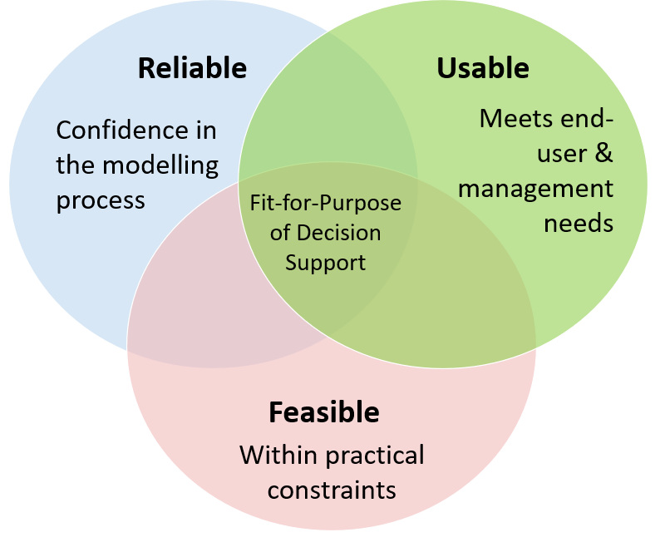

Fit for purpose is a trade-off between usability, reliability and feasibility (after Hamilton et al. 2022)

This Explanatory Note does not advocate for a particular approach to groundwater modelling and uncertainty analysis. It rather illustrates how different approaches can be justified, depending on the project and risk context, and points to advantages and drawbacks of different approaches. The three main categories of uncertainty analysis approaches (scenario analysis, linear analysis and ensemble methods) introduced in the previous EN on uncertainty analysis (Middlemis and Peeters, 2018) are still relevant. Sensitivity analysis can complement an uncertainty analysis by providing insight into the model behaviour, but is not an alternative to uncertainty analysis. Recent years have seen more development of practical approaches of uncertainty analysis for groundwater modelling, for instance through the GMDSI. It is expected that coming years will see more development of new approaches. The EN therefore focuses on particular aspects of the uncertainty analysis that require careful design, execution and review, regardless of the approach chosen. These can be summarised as:

* What is the quantity of interest to the decision-maker?
* What are the main sources of uncertainty to the quantity of interest?
* How do system knowledge and historical observations constrain or condition the quantity of interest (the key prediction(s) for informing decisions)?

The quantity of interest is a key prediction, a model outcome from a specified model scenario, with a predefined spatial and temporal setting, that is relevant to assessing the likelihood and consequence of a causal pathway element representing a hazard. If the same groundwater model is used for multiple quantities of interest, it is essential that these three questions are discussed for each quantity of interest individually. The EN subscribes to the notion that ‘model’ should not be thought of as simply a noun or a deliverable, but more as a verb for a risk-based process of investigating the complex interplay of hydrological stressors, sources for and causal pathways for impacts on receptors and the uncertainties involved, in order to provide information to support decision-making and environmental management. This requires a model to be designed with optimum complexity, which can be judged not by whether more complexity can be added (e.g., geological structure, hydrological processes) but by whether none of the key system features included in the design can be taken away.

This edition of the Explanatory Note is still underpinned by the same principles that underpinned the (now superseded) 2018 Explanatory Note (Middlemis and Peeters, 2018): the need to account for and report on predictive uncertainty in an open and transparent way. Where the emphasis in the 2018 EN was on encouraging uptake of uncertainty analysis as an essential part of groundwater modelling practice, this EN aims to make groundwater model outcomes more relevant to decision-makers, provide a way to establish confidence in the results, and inspire creativity and innovation in quantifying and reducing uncertainty in groundwater model results. To this end, workflow figures, classifications and checklists that can be perceived as prescriptive have been removed. Instead, the guidance is presented as open-ended questions to be addressed in groundwater model reports. The EN does set out some minimum standards for modelling and reporting:

* clear definition of the quantity of interest and the model outcomes sought in specific terms
* justification of the assumptions, approximations and assertions and limitations, and of the method selections and workflows used to quantify the uncertainties of the quantity of interest
* provision of objective evidence that the uncertainties affecting decision-critical predictions of impacts on water resources are not underestimated, and management risks are not understated
* transparent documentation of the methods and results in a manner that is open to scrutiny, and consideration of the effects of potential bias.

Reflections on the lake at the Hunter Wetlands Centre (Shortlands Wetland)


Contents

Overview v

The role of the IESC v

The purpose of the Explanatory Notes v

Legislative context vi

Executive summary vii

1. Introduction 1

1.1 Context 1

1.2 Decision support 3

1.3 Information guidelines 6

1.3.1 Conceptual models and causal pathways 7

1.3.2 Numerical groundwater modelling 7

1.4 Purpose of this Explanatory Note 9

2. Impact assessment and management 11

2.1 Causal pathways and ecohydrological conceptual models 11

2.2 Adaptive management 12

3. Designing uncertainty analysis 15

3.1 Fit for purpose 15

3.2 Usability: quantity of interest 17

3.3 Reliability: range–observations–knowledge trade-off 19

3.3.1 Range of QoI 19

3.3.2 Observations 21

3.3.3 Knowledge 25

3.3.4 Trade-off examples 26

3.4 Feasibility: uncertainty analysis techniques 28

4. Reporting uncertainty analysis 36

4.1 General 36

4.2 Bias 38

4.3 Justifications 39

4.4 Qualitative uncertainty analysis 40

4.5 Probabilistic language 41

5. Conclusion 43

6. References, glossary and abbreviations 44

6.1 References 44

6.2 Glossary 49

6.3 Abbreviations and acronyms 57

1. Introduction

## 1.1 Context

This Explanatory Note was prepared for the Independent Expert Scientific Committee on Coal Seam Gas and Large Coal Mining Development (IESC). The IESC is a statutory body under the *Environment Protection and Biodiversity Conservation Act 1999* (Cth) which provides robust scientific advice to government regulators on the potential water-related impacts of such development proposals, but it does not make regulatory decisions. The IESC Information Guidelines (2018) detail the statutory context and the information that the environmental assessment for a project proposal should include.

The IESC Information Guidelines are essential prior reading for all Explanatory Notes.

Explanatory Notes supplement the IESC Information Guidelines with guidance on specialist topics, such as:

* uncertainty analysis for groundwater modelling (this report)
* assessing groundwater-dependent ecosystems (Doody et al. 2019; crucial input to groundwater model design in terms of causal pathways for impacts)
* deriving site-specific guideline values for physico-chemical parameters and toxicants (Huynh and Hobbs 2019)
* ecohydrological conceptual models (draft in prep. 2023)
* characterisation and modelling of geological fault zones (Murray and Power 2021).

The linkages between the Information Guidelines, Explanatory Notes and other IESC reports, and the complementary best practice resources are shown in Figure 1.

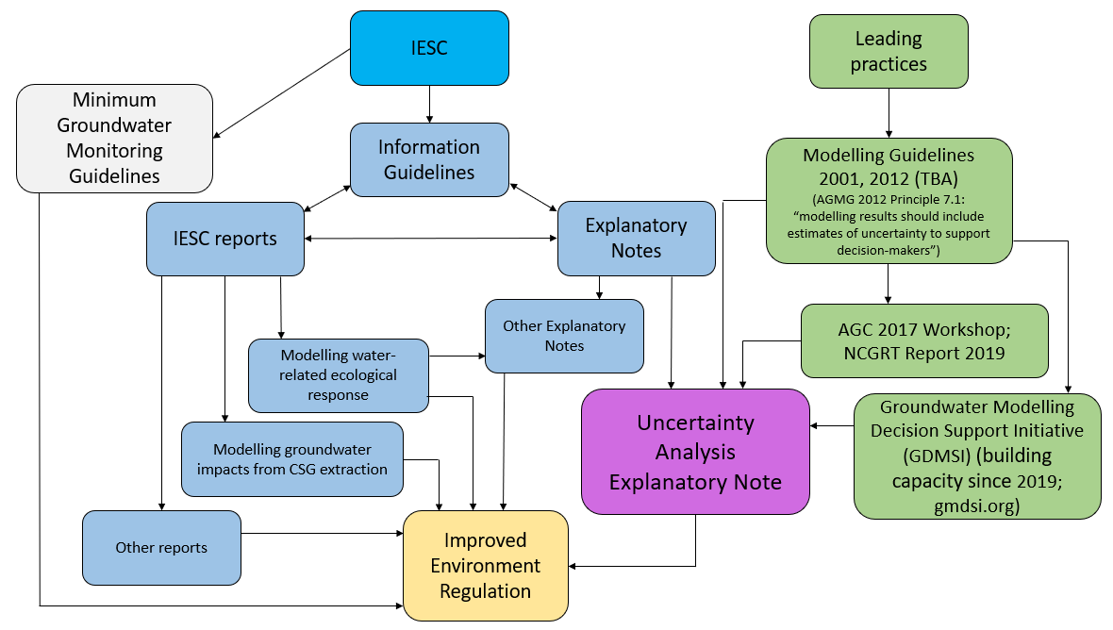

Figure 1. Flow chart showing the linkages between resources as described in this section

As shown in Figure 1, this Explanatory Note on uncertainty analysis for groundwater modelling augments the best practice Australian Groundwater Modelling Guidelines (AGMG; Barnett et al. 2012). Box 1 provides background on the role of such modelling guidelines.

Box 1: Modelling guidelines

Hill et al. (2004) summarise some fundamental principles that are shared by all groundwater modelling guidelines, based on ideas set out in the Murray–Darling Basin Commission modelling guidelines report (Middlemis et al. 2001) that was the foundation for the AGMG (Barnett et al. 2012). These principles remain valid for this Explanatory Note:

* The aim of most guidelines is to reduce and reveal model uncertainty for the users of modelling studies, including resource management decision-makers and the community. This is achieved by promoting transparency in modelling methodologies and encouraging innovation, consistency and best practice. Guidance is provided to non-specialist modellers and auditors or reviewers of models by outlining the steps involved in scoping, managing and evaluating the results of groundwater modelling studies. Guidelines serve modelling specialists by providing a baseline set of ideas and procedures from which they can innovate.
* Guidelines are intended for use in raising the minimum standard of modelling practice and allowing appropriate flexibility, without limiting necessary creativity or rigidly specifying standard methods. Guidelines also should not limit the ability of modellers to use simple or advanced techniques appropriate for the study purpose. Techniques recommended in the guidelines may be omitted, altered or enhanced, subject to the modeller providing a satisfactory explanation for the change and negotiation with the client and/or regulator as required. Not all aspects of guidelines would necessarily be applicable to every study. It also is acknowledged that there is a need for subjective judgement during the model development process.
* Guidelines should be seen as a best practice reference point for framing modelling projects, assessing model performance, and providing clients with the ability to manage contracts and understand the strengths and limitations of models across a wide range of studies (scopes, objectives, budgets) at various scales in various hydrogeological settings. The intention is not to provide a prescriptive step-by-step guidance, as the site-specific nature of each modelling study renders this impossible, but to provide overall guidance and to help make the reader aware of the complexities of models, and how they may be managed.

These guiding principles allow for flexibility, but this Explanatory Note insists on minimum standards:

* clear definition of the quantity of interest and the model outcomes sought in specific terms
* justification of the methods, assumptions and assertions
* provision of objective evidence that the uncertainties affecting decision-critical predictions of impacts on aquifer resources and dependent systems are not underestimated
* transparent documentation of the methods and results in a manner that is open to scrutiny
* consideration of the effects of potential bias.

The Explanatory Note complements the detailed methodologies that are championed by the Groundwater Modelling Decision Support Initiative ([GMDSI.org](http://gmdsi.org/)), which are aimed more at technical specialists. GMDSI resources provide more detailed information on the practical application of uncertainty analysis methods, and the necessary focus on hypothesis testing (e.g. Doherty 2022), which is beyond the scope of this report.

That said, technical specialists are expected to conduct uncertainty analyses in a manner consistent with the principles outlined in this Explanatory Note, even though it does not set out a step-by-step guide. For example, a quantitative uncertainty analysis is required for high-risk/consequence projects (most coal mines and coal seam gas (CSG) projects would likely warrant a quantitative assessment), and clear report documentation should be amenable to review and include assumptions, assertions, approximations, limitations and justifications for method selections and workflows (see also section 1.4, Table 1, and sections 3 and 4). This EN is aimed at non-specialists such as proponents and regulators who commission and/or review modelling studies; it omits deep technical detail on how to conduct uncertainty analysis. The main focus in application for this EN is coal mining and CSG development, but the material is also relevant in the context of other resource development projects.

## 1.2 Decision support

Risk management, decision support and uncertainty analysis are interrelated issues. Saltelli et al. (2020) use the context of the COVID-19 pandemic and epidemiological modelling to propose a five-step manifesto of principles for responsible mathematical modelling, adopted by UNESCO:

* **Mind the assumptions** – uncertainty quantification and sensitivity analysis are complementary approaches to estimating the robustness and usefulness of model predictions.
* **Mind the hubris** – models are simplified representations of real systems or processes and should be developed with an optimum trade-off between complexity and error.
* **Mind the framing** – framing refers to the different lenses, worldviews and underlying assumptions that guide how individuals or groups perceive a particular issue; transparent framing can support effective communication of results and enhance trust with stakeholders.
* **Mind the consequences** – well-executed mathematical modelling helps society make wise decisions; but when not done well, models can lead to wrong or simply unjustified choices.
* **Mind the unknowns** – failure to acknowledge and communicate uncertainties can artificially limit policy options and open the door to unintended consequences.

A key point is worth highlighting:

Modellers must not be permitted to project more certainty than their models deserve; and politicians must not be allowed to offload accountability to models of their choosing.

The mathematical modelling of interest for this Explanatory Note is the numerical groundwater modelling applied to assessing potential impacts of large coal mine or CSG developments. Freeze et al. (1990) characterise the role of models in decision support as quantifying the level of risk associated with management options. This succinct principle remains valid today. It follows that if a model is applied to support environmental decision-making that seeks to avoid unwanted outcomes (so-called ‘bad things’), its simulations of the consequences of management options must quantify the related uncertainties (Doherty 2022; Doherty and Moore 2019, 2021). Quantifying uncertainties conveys the confidence in the model results; indeed, the subtitle for this Explanatory Note could be more positively framed as improving confidence in modelling, rather than as uncertainty analysis.

Uncertainty is also integral to risk management, as outlined in the fundamental principles of the risk management standard AS/NZS ISO 31000:2009:

* Risk is defined as the effect of uncertainty on project objectives.
* Risk is characterised as a function of the likelihood and consequence of an outcome.

It follows that risk cannot be assessed or managed without an understanding of uncertainty, and an uncertainty analysis should be conducted within a risk management context to support decision-making:

* where the model predictions of the consequences (impacts) of developments or management options should be quantified with related uncertainties (likelihoods)
* to inform decisions that seek to avoid the risk of unwanted impacts
* to inform assessments of risk treatment options, mitigation measures and management and thus support decision-making.

It is worth noting that similar principles are required to conform with the IESC Information Guidelines:

* Quantify uncertainties of predictions so that risks can be associated with intended management actions.
* Reduce predictive uncertainties through assimilation of pertinent data.
* Ensure that parameter and structural variability is represented in the range of outputs through uncertainty analysis so that the uncertainties of decision-critical model predictions are not underestimated, and management risks are not understated.

In this way, simulation modelling and uncertainty analysis is used to investigate current and future system states and thus support decisions on groundwater resource assessment, management and policy.

Simulation models are developed as simplified representations of ‘real world’ systems that are usually history-matched to measured data, albeit affected to some degree by various sources of uncertainty. These models are continuously refined with new data, conceptualisations and processes, to investigate the effects of management options on future eventualities. A quantitative uncertainty analysis uses these models to set out a range of model prediction scenarios, each with associated likelihoods and each plausible in that it is consistent with all available information and data. While models cannot predict the future with total confidence, decision-makers and stakeholders use model results to inform decisions on the acceptable level of risk in a specific context (i.e. potential impacts and their likelihoods), such as for specified courses of action or to avoid unwanted outcomes.

Uncertainty analysis also helps identify the main sources of uncertainty and by how much the uncertainty in outcomes can be reduced by incorporating further data into the model. A robust uncertainty analysis will ensure that management options are commensurate with the level of overall risk and the likelihood of any particular impact.

Simply put, as risk is the likelihood and consequence of a particular hazard or impact, it cannot be assessed or managed without an understanding of uncertainty. However, even the most comprehensive modelling and uncertainty analysis cannot completely rule out the potential for unwanted outcomes.

The AGMG (Barnett et al. 2012) provides guidance and advice on simulation modelling, which is acknowledged as a complex undertaking because the subsurface environment is complex, heterogeneous and difficult to directly observe, characterise or measure. Groundwater systems are influenced by geology, topography, vegetation, climate, hydrology and human activities. Uncertainty affects our ability to accurately measure or characterise the existing or predicted states of these systems. Box 2 expands on the different sources of uncertainty in the context of groundwater modelling.

Box 2: Sources of uncertainty

The subsurface environment is complex, heterogeneous and difficult to directly observe, characterise or measure. Groundwater systems are influenced by geology, topography, vegetation, climate, hydrology and human activities. Thus, uncertainty affects our ability to accurately measure or describe the existing or predicted states of these systems.

Walker et al. (2003) provide an overview of uncertainty definitions for model-based decision support which, two decades later, is still relevant. They recognise two types of uncertainty: epistemic and variability uncertainty. Variability or aleatory uncertainty is due to inherent variability. An example is a fair coin: we know that the probability of heads is 50%, but we do not know if the next toss will result in heads or tails. Epistemic uncertainty is uncertainty due to imperfect knowledge. The difference between the two types of uncertainty is important from a theoretical standpoint, as epistemic uncertainty can be reduced by improving our knowledge of the system, while variability uncertainty cannot be reduced. In practice, however, most sources of uncertainty in groundwater models will have both an epistemic and a variability component. Uncertainty in recharge, for example, is both aleatory, as it depends on the natural variability of rainfall, and epistemic, as we often do not fully capture the recharge processes in a groundwater model.

The four main sources of uncertainty that affect groundwater model simulations are:

* structural/conceptual – geological structure and hydrogeological conceptualisation assumptions applied to derive a simplified view of a complex hydrogeological reality (any system aspect that cannot be changed in an automated way in a model)
* parameterisation – hydrogeological property values and assumptions applied to represent complex reality in space and time (any system aspect that can be changed in an automated way in a model via parameterisation)
* measurement error – combination of uncertainties associated with the measurement of complex system states (heads, discharges), parameters and variability (3D spatial and temporal) with those induced by upscaling or downscaling (site-specific data, climate data)
* scenario uncertainties – guessing future stresses, dynamics and boundary condition changes (e.g. mining, climate variability, land and water use change).

While many of us have an intuitive understanding of these terms, clearly defining each source of uncertainty is much more challenging. Take recharge for instance. Recharge can be categorised as:

* conceptual model uncertainty, if it is not clear which recharge process is most important
* structural uncertainty, if recharge depends on which hydrostratigraphic unit is outcropping
* input uncertainty, as recharge is one of the driving forces of a model
* parameter uncertainty, if it is varied in calibration and uncertainty analysis
* measurement uncertainty, if the value of recharge is based on different recharge estimation techniques
* scenario uncertainty, if future projections of climate are considered.

Quantitative uncertainty analysis only accounts for parameter uncertainty, as quantitative uncertainty analysis always involves systematically changing aspects of the model. It is possible to ‘parameterise’ other sources of uncertainty to include them in the quantitative uncertainty analysis. For instance, the presence or absence of a fault is a typical conceptual or structural source of uncertainty. This feature can be represented in a groundwater model with a hydraulic conductivity that ranges from simulating the fault as completely impermeable to flow to simulating the fault as a conduit of flow. The parameter ‘fault hydraulic conductivity’ means that the effect of structural uncertainty can be included in the quantitative uncertainty analysis. Likewise, scenario uncertainty can be parameterised, for instance by considering a parameter representing the range of future recharge, informed by climate change projections. A practical difference between structural/conceptual uncertainty and scenario uncertainty is that the expertise needed to characterise structural/conceptual uncertainty resides with the geology, hydrogeology and hydrology experts, while characterising scenario uncertainty will often require engagement with a much more varied group of experts and stakeholders, such as economists, climatologists and agronomists.

Measurement uncertainty mainly features in qualitative uncertainty exploring the extent to which observations can be used to constrain the model parameters. This is discussed in more detail in section 3.3.2 Observations.

Despite creative parameterisation schemes as outlined in this box, there will always remain sources of uncertainty that are hard-coded into the model. This Explanatory Note emphasises the need to identify and discuss these as well and their potential impact on the quantity of interest (see section 4.4 on qualitative uncertainty analysis).

## 1.3 Information guidelines

The Information Guidelines are essential prior reading for this Explanatory Note. However, to help set the context for this EN, while trying to minimise repetition, the points in this section summarise some key Information Guidelines requirements that are foundational to this EN.

The development proposal should present sufficient evidence for independent verification of:

* the processes of cause and effect between the project and water resources
* the materiality and likelihood of the potential impacts on and risks to water resources.

Early in the investigation process, preliminary risk-based assessments should consider all available data to:

* identify and characterise water resources and water-dependent ecosystems in the region
* develop the initial hydrogeological and ecohydrological conceptual models (ECMs) (Ecohydrological Conceptual Models Explanatory Note in prep., DCCEEW 2023)
* identify potential stressors and causal pathways for impacts on water-dependent ecosystems (see DCCEEW 2023, Doody et al. 2019)
* conduct a preliminary risk assessment, with consideration of treatments and/or mitigations, and develop preliminary analytical/numerical models if warranted for the risk context
* engage with relevant regulators and stakeholders on the initial findings and next steps.

It is noteworthy that these steps are consistent with the [NSW Gateway process requirements](https://www.planning.nsw.gov.au/Policy-and-Legislation/Mining-and-Resources/Gateway-Assessment-and-Site-Verification) (see the NSW Department of Planning and Environment website).

### 1.3.1 Conceptual models and causal pathways

Conceptual models are very useful at any stage of environmental risk assessment, but especially at the problem definition stage, to understand and communicate the complex interplay of stressors, sources, causal pathways for impacts and possible multiple cause-effect pathways (see Doody et al. 2019). An ECM (DCCEEW 2023) integrates the hydrological components (surface and groundwater) with the ecological components. An ECM and its derived impact pathway diagram illustrate the likely causal pathways for impacts on key aspects of water resources (e.g. flow/level regime, water quality, biota, ecological function), and the likely relative materiality of these pathways during operations and post-project.

During the comprehensive environmental impact assessment process, evidence-based estimates are required of the range of potentially significant impacts on water resources and water-dependent ecosystems. Significant impact is defined in the Glossary, based on the Significant Impact Guidelines on matters of national environmental significance (CoA 2013). The assessment should involve an iterative process using best practice source–pathway–receptor methods (Morrison-Saunders 2018). Most large developments will likely require numerical modelling and quantitative uncertainty analysis unless a low-risk context and simpler methods can be justified. For example, the Cooper subregion bioregional assessment (CoA 2017) considered causal pathways and the coal development horizon, concluding that detailed modelling for impact assessment was not warranted and that conceptual modelling was adequate at that time. This example demonstrates how establishing a low-risk context, via consideration of causal pathways and undertaking a risk assessment at an early stage, can be used to justify a qualitative approach to impact and uncertainty assessments, especially under an adaptive management framework (e.g. subject to future changes to the Cooper Basin coal development pathway). Progressive results should be used to refine the models (conceptual, ecohydrological, numerical/analytical) to decrease uncertainties and to inform plans for mitigation, management and monitoring.

For each causal pathway for significant impact (Peeters et al. 2022), the intensity, duration, timing, magnitude and geographic extent of the potential impacts on the water resource should be clearly described, along with the consequence or significance of the impact on receptors. Any modelling should be conducted at spatial and temporal scales suitable to represent the physical, chemical and ecological processes associated with the water resources. The assessment should estimate the range of impacts at all phases (construction, operation and post-closure) and the potential cumulative impact of all past, present and reasonably foreseeable actions and significant water-affecting stressors in the area. These stressors can include other similar mine or coal seam gas developments in the area but also come from other sectors, such as agriculture, or from climate change. Note that this does not necessarily mean that all of these stressors need to be integrated in the groundwater model. Section 3.2 discusses the development of scenarios, which should align with the causal pathway assessment.

### 1.3.2 Numerical groundwater modelling

The level of resources (data, time, budget, methods) applied to the assessment should be commensurate with the level of risk, by considering the likelihood and potential consequences of significant impacts/hazards, and the value, the condition and the vulnerability and/or sensitivity of the ecosystems affected. Again, most large coal and CSG projects will likely require numerical modelling and quantitative uncertainty analysis unless a low-risk context and simpler methods can be justified. As the assessment progresses, effort should focus on the ecosystems and other receptors at greatest risk.

The combination of conceptual, hydrogeological and ecohydrological models, coupled with risk analysis, may be sufficient to adequately estimate low-impact outcomes with low levels of uncertainty such that analytical and/or numerical models may not be required or that modelling may only be needed to test a limited number of causal pathways.

However, when analytical and/or numerical models are required, they should be designed for the purpose of supporting decision-making (Doherty 2022; Doherty and Moore 2019, 2021), to:

* quantify the uncertainties of predictions of management interest (the ‘quantities of interest’) so that risks can be estimated for proposed management actions
* justify the model simplifications and abstractions involved in assessing these uncertainties
* reduce predictive uncertainties through assimilation of data
* ensure that parameter and structural variability is represented in the range of uncertainty analysis outputs so that the uncertainties of decision-critical model predictions are not underestimated and management risks are not understated.

In that sense, **‘model’ should not be thought of as simply a noun or a deliverable, but more as a verb** for a risk-based process of investigating the complex interplay of stressors, sources and causal pathways for impacts on receptors and the uncertainties involved, in order to provide information to support decision-making and environmental management. This requires a model to be designed with optimum complexity (Doherty and Moore 2019), which can be judged not by whether more complexity can be added (e.g., geological structure, hydrological processes) but by whether none of the key system features included in the design can be taken away (Voss 2011a, Voss 2011b, Ferré 2016). The results from any modelling should show a robust estimate of the range and likelihood of possible outcomes to support risk management and regulatory decision-making. Note that a model itself cannot be described as ‘having low uncertainty’, but the results of model simulations (modelling in the verb sense) can objectively quantify the uncertainty.

Sufficient information should be provided in the environmental assessment documentation to allow an independent reviewer (IESC or others) to evaluate the justifications for the assertions made – for example, on the basis for the conceptual or ecohydrological models, discussing the underlying assumptions for the numerical models and why an ecosystem is or is not groundwater dependent. IESC reviews of environmental impact statements have often found report documentation is unsatisfactory on the justification or testing of the assumptions, approximations and assertions that are made in developing the conceptual model and then designing and implementing that in a numerical model and uncertainty analysis. An independent reader of the environmental assessment documents should be able to verify the justifications for all significant assumptions, approximations, assertions, methodologies, techniques and conclusions made by the proponent.

To that end, **assessment reports should be as self-contained as possible**, minimising the need for the reader to consult several volumes of technical reports to understand the methodologies and assumptions applied and the predictions of impacts on groundwater and surface water systems and dependent ecosystems (but allowing for the flow of information between disciplines conducting the assessments). For example, there are usually linkages between the groundwater and surface water assessments, such as to estimate recharge/runoff and to evaluate the site water balance (usually presented in the surface water report). These site water balance assessments typically use outputs from the groundwater model as key inputs, and produce outputs that can form inputs to post-mining groundwater model scenarios of a final void lake (Figure 2). All of these assessments should involve uncertainty assessment methods. See also section 4.1.

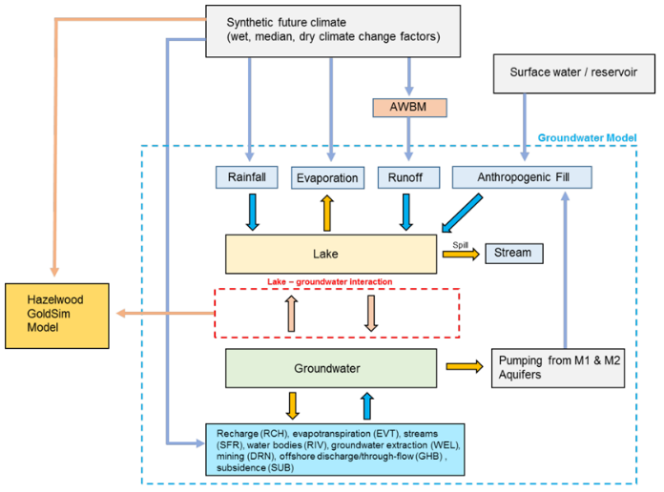

Figure 2. Example of interactions between groundwater and surface water models (after Gresswell et al. 2019)

## 1.4 Purpose of this Explanatory Note

This Explanatory Note complements the Information Guidelines summarised in section 1.3, with a focus on the role of uncertainty analysis in risk-based decision-making. ENs provide guidance, rather than mandatory requirements, to assist the preparation and review of environmental impact assessments. The IESC recognises that approaches, methods, tools and software will continue to develop, and reviews and updates the guidance accordingly. This EN on uncertainty analysis for groundwater modelling updates and supersedes the first version (Middlemis and Peeters 2018) and is again designed to complement best practice initiatives (Figure 1).

The aim of this Explanatory Note is to provide a high-level introduction and strategic overview of uncertainty analysis relating to groundwater modelling for environmental impact assessment, management and decision-making. Rather than retaining the prescriptive ‘fatal flaws’ checklist and groundwater model confidence classification, this edition introduces simple and intuitive concepts and diagrams to facilitate discussions on whether a groundwater model and uncertainty analysis is fit for purpose.

As summarised in Table 1, this document is not a formal guideline or an instruction manual, and it does not provide a step-by-step guide to conducting uncertainty analysis (see Box 1: Modelling guidelines). This would not be feasible, given the many approaches and methodologies that are available and continue to be developed, for instance through the GMDSI initiative ([GMDSI.org](http://gmdsi.org/)). As will be discussed in section 3, the appropriate approach will depend on the characteristics of the proposed development and its risk profile and should be designed in consultation with relevant regulators.

Table 1. Aims and exclusions of this Explanatory Note on uncertainty analysis for groundwater modelling

| Explanatory Note is intended/designed to ... | Explanatory Note exclusions |
| --- | --- |
| Complement the IESC Information Guidelines by providing a high-level strategic overview of uncertainty analysis for groundwater modelling. | Not a textbook, instruction manual or a formal guidelines document. |
| Complement the Australian Groundwater Modelling Guideline, which requires uncertainty analysis (ch. 7), and the GMDSI initiative [gmdsi.org](http://gmdsi.org/) | Not a step-by-step guide to uncertainty analysis (that is not workable, given the diversity of methods, projects and risks). |
| Integrate uncertainty analysis within a risk management framework, to a level of detail that is commensurate with the potential risks and/or consequences. See also point opposite. | Does not identify a single preferred method of uncertainty analysis, but requires:   * qualitative UA as a minimum, and * quantitative UA for high risks/consequences. |
| Outlines guiding principles and reporting requirements for a workflow process of uncertainty analysis for groundwater modelling to support environmental impact assessment, management and decision making, by providing objective evidence that uncertainties are not underestimated and management risks are not understated, to assist proponents and regulators commission and review studies. | Does not preclude use of any techniques, provided satisfactory justifications are provided of   * the assumptions, approximations and assertions, * the method selections, workflows and limitations,   and that the effects of bias are explored in clear reports amenable to review (see sections 4.2 and 4.3). |

1. Impact assessment and management

## 2.1 Causal pathways and ecohydrological conceptual models

A groundwater impact and uncertainty assessment that is integrated within a risk management framework begins with an identification of potential causal pathways for impacts under an initial conceptualisation and investigates possible risk mitigations. A causal pathway is the logical chain of events, either planned or unplanned, that link the planned resource development activities and potential impacts on water resources.

Best practice source–pathway–receptor impact assessment methods (Morrison-Saunders 2018), such as the risk-based mining project methods of Howe et al. (2010) that were curated by the National Water Commission are consistent with the risk-based causal impact pathway aspects of the best practice groundwater modelling guidelines (Barnett et al. 2012), the IESC Information Guidelines and this Explanatory Note. A common principle is that if an exposure pathway between mine-water affecting activities (a ‘source’) and a receptor is unlikely to exist, the impact assessment ‘chain’ breaks, rendering that particular risk redundant (Howe et al. 2010). Peeters et al. (2022) developed a methodology to combine and evaluate the various causal pathways in an environmental impact assessment into a logically consistent causal network. Examples of such causal networks for assessing potential impacts on water and the environment of unconventional gas resource development can be found on the [GBA Explorer](https://gba-explorer.bioregionalassessments.gov.au/) website.

Identifying causal pathways is an important part of uncertainty analysis. Which causal pathways require investigation will determine the modelling approach, the sources of uncertainty to consider and, most importantly, the model outcomes required. Causal pathways should be identified by conservatively considering potential connectivities between groundwater units and/or surface water features and related water-dependent ecosystems. An Explanatory Note on ecohydrological conceptual models, including causal pathways, is in preparation (DCCEEW 2023).

All projects require at a very minimum a preliminary uncertainty analysis, discussing the potential causal impact pathways and the perceived effect of uncertainties on the impact assessment outcomes. Such a preliminary uncertainty analysis should use conceptual models and qualitative or semi-quantitative estimates of the likelihood of risks to and impacts on environmental receptors and related values, along with the level of confidence of scientific advice on these risks and impacts. Minimising and acknowledging bias in such investigations of causal pathways is a key element of the ecological values analysis at the problem definition stage, along with data analysis, conceptualisation, and the initial risk analysis and treatment options assessment.

Where resource development projects are classified as posing high environmental risk, a quantitative uncertainty assessment is also warranted, using groundwater models that are designed to:

* investigate the causal pathways for potential impacts on water resources and water-dependent ecosystems
* quantify the likelihood of the impact and assess the consequence (magnitude, extent, severity)
* enable the investigation of effective risk treatment and avoidance strategies or mitigation measures as an integral part of a risk management framework.

Section 3 focuses on this quantitative uncertainty analysis. As the modelling and assessment workflow proceeds through its iterations, the objectives should be reviewed according to risk, and complexity may be added or refined as necessary. As will be discussed in that section, increased complexity does not necessary result in lower uncertainty or higher confidence in the model predictions. In the preliminary stages, there may be no need for numerical modelling. If risks are not high at any stage, nothing more may be required, and the investigation may be cut short. However, many resource projects are likely to pose high environmental risks. This means that the proponent should conduct a quantitative uncertainty assessment to a level of detail commensurate with the potential risks and consequences of the project. During the risk and uncertainty assessment process, socially and economically acceptable and effective risk treatments or mitigations may be identified that can be part of adaptive management strategies (see section 2.2).

Bioregional assessments (and geological and bioregional assessments (GBAs)) provide useful regional-scale case studies, with an emphasis on causal pathways, for environmental impact assessments of large coal mine and coal seam gas proposals. They also illustrate how impact assessments can address principles from the Information Guidelines requiring consideration of:

* causal pathways linking depressurisation and dewatering of coal seams at depth with impacts on anthropogenic and ecological values of water-dependent receptors
* conceptual models and quantitative, semi-quantitative or qualitative analyses for estimating the likelihood of risks to and impacts on receptors and related values, along with the level of confidence of scientific advice on these risks and impacts
* potential direct, indirect and cumulative impacts on water resources
* monitoring, evaluation and review programs, and related risk assessment and treatment studies, to minimise or mitigate impacts on water resources.

However, the bioregional assessments approach should not be considered a template for an environmental impact assessment, as the objectives, scope and scale are quite different. Bioregional assessments provide advice on development stressors, causal pathways, receptors and ecosystems but they are not development specific. Bioregional assessments do, however, inform environmental impact assessment studies by providing regional context information and, importantly, independent cumulative impacts assessment.

## 2.2 Adaptive management

Adaptive management (AM) is an approach to natural resource management that involves implementing management action, and then monitoring and evaluating outcomes and systematically adapting management actions according to what is learned (Morrison-Saunders 2018). More specifically, best practice AM uses information gained through targeted monitoring, investigations and modelling to revise and improve management practices (including risk/hazard treatments) in a structured and iterative way through reassessment of the efficacy of management policies and system understanding (Thomann et al. 2020, 2022). ‘Active’ AM can be differentiated from ‘passive’ AM by the degree to which uncertainty or hazard reduction is emphasised and pursued by project managers, and the degree to which any reductions in uncertainty inform management practices and/or decision-making (e.g. conditional/staged project approvals).

In practice, adaptive management is often invoked to address environmental issues in the face of uncertainty, but usually without adequate justification. A review of adaptive management principles and groundwater management case studies (Thomann et al. 2020, 2022) revealed significant shortcomings. Typical shortcomings included a lack of specific objectives, unclear monitoring approaches, an absence of substantive mitigation measures that are explicitly described in unambiguous terms, and/or underdeveloped predictive models for assessing alternative management actions and investigating uncertainties. Effective AM requires specific and actionable directions to change project activities and management protocols in response to exceeding groundwater threshold or trigger levels. Mitigation measures proposed at the project assessment stage are usually presented as a list of broadly described criteria for unstructured/ad hoc revision of management protocols or action purported to mitigate adverse events, but without explicit prescription of the conditions leading to management actions or for feasible execution of the treatments. This could be considered nominally reasonable in terms of compliance with regulatory requirements that typically allow for groundwater monitoring and management plans (GMMPs) or trigger-action-response plans (TARPs) to be prepared after project approval.

However, the lengthy time lags affecting groundwater processes can mean that it may be difficult to effectively reverse the impacts of an action once initiated (Walker 2017). By the time monitoring shows that a valued ecosystem will be affected, it may be too late to prevent impacts occurring. For example, groundwater drawdown could continue to increase due to the hydrogeological time lag effects, despite groundwater extraction ceasing. This can mean that adverse effects from groundwater activities may become physically, technologically, ecologically and/or economically infeasible to treat or reverse unless they are properly investigated at the project assessment stage and detailed groundwater management plans are prepared. Proposing vague adaptive management actions should not be able to be used as a pretext to defer or avoid detailed up-front analysis of environmental impacts and management options prior to development approval decisions.

Thomann et al. (2020, 2022) identify three key factors that are critical to the design of effective AM strategies:

1. the permanence (or, conversely, the ‘reversibility’) of groundwater impacts
2. the severity of groundwater impacts from project operations
3. the level of uncertainty in groundwater system responses to project operations.

AM is considered unsuitable to protect against permanent or irreversible impacts on groundwater systems, except where threshold groundwater conditions are known and impacts can be managed within that in a reversible and responsive manner (e.g. the ‘minimum harm’ elements of the NSW Aquifer Interference Policy, and similar settings elsewhere). Where impacts are considered severe, the permanence/reversibility and uncertainty factors warrant detailed investigation before project approval to identify effective mitigation and monitoring strategies. Staged approval conditions that consider uncertainty issues may be worth considering, such as thresholds for uncertainty reduction, notwithstanding the issues of impact permanence, reversibility and time lags.

Tolerance of an unwanted outcome (‘failure’) is related to the cost of failure. If the cost is relatively low, then a moderate likelihood of failure may be tolerated, provided there are economically and socially acceptable risk-reduction options that can be implemented in a timely fashion. On the other hand, if the cost of failure is high (e.g. unwanted impacts on high-value ecosystems), the likelihood of failure must be low for a management option or adaptive management plan to be deemed socially and economically acceptable, and effective. Early consultation and ‘without prejudice’ discussions between proponents and their consultants and relevant regulators as to the likely occurrence of such risks and the application of such measures is recommended to reduce the risks to an efficient assessment process.

This drives the need for a conservative approach to impact assessment. Such an approach includes careful analysis of uncertainties and investigation of options for risk treatments and mitigation. It is also important to communicate the residual risk, i.e. the risk remaining after taking into account risk treatments and mitigation, and be able to adaptively manage it.

However, even the most comprehensive modelling and uncertainty analysis study cannot completely rule out the potential for unwanted outcomes. Decisions on developments are often accompanied by a set of conditions. These can be aimed at reducing uncertainty by addressing knowledge gaps, for instance through additional field investigations. They can also stipulate requirements to monitor the responses to the development of groundwater, surface water and ecology. Uncertainty analysis and sensitivity analysis, however, can greatly assist in setting such conditions and can justify reducing the need for some conditions that may otherwise be invoked to cover for limitations in the assessment. Uncertainty analysis and sensitivity analysis can also help in identifying the most important knowledge gaps to be addressed and in designing monitoring strategies. Modelling methods can also be applied in a formal data-worth analysis (i.e. expanding on the above) to identify where as-yet-ungathered data may most effectively reduce the uncertainties of decision-critical predictions, which can help objectively prioritise monitoring strategies.

1. Designing uncertainty analysis

## 3.1 Fit for purpose

The goal of an uncertainty analysis in general is to provide a range of model predictions that are consistent with knowledge of the system and with observations relevant to the prediction. Within the context of risk-based decision-making, the purpose of uncertainty analysis becomes more specific as it needs to provide:

* objective evidence that the uncertainties affecting decision-critical predictions of impacts on aquifer resources and dependent systems are not underestimated
* information about the uncertainty in conceptualisations and model simulation outputs in a way that allows decision-makers to understand the effects of uncertainty on project objectives (echoing the AS/NZS ISO 31000:2009 risk definition) and the effects of potential bias.

A groundwater modelling investigation and associated uncertainty analysis is fit for purpose if it achieves the above. It emphasises the need to clearly define the quantity of interest and the model output or key prediction that is relevant to decision-makers, and to develop the groundwater model and execute the uncertainty analysis accordingly.

Hamilton et al. (2022) discuss whether a model is fit for purpose in terms of a trade-off between usability, reliability and feasibility (Figure 3). Usability relates to the intended use of the model results – how the model will be used to inform decision-making. Reliability is about the confidence in the model results and the trust in the modelling process, both of which will be informed by the uncertainty quantification, assessing the likelihood and consequences of potential impacts. Feasibility pertains to the pragmatic aspects of delivering the modelling project within the time and budget constraints.

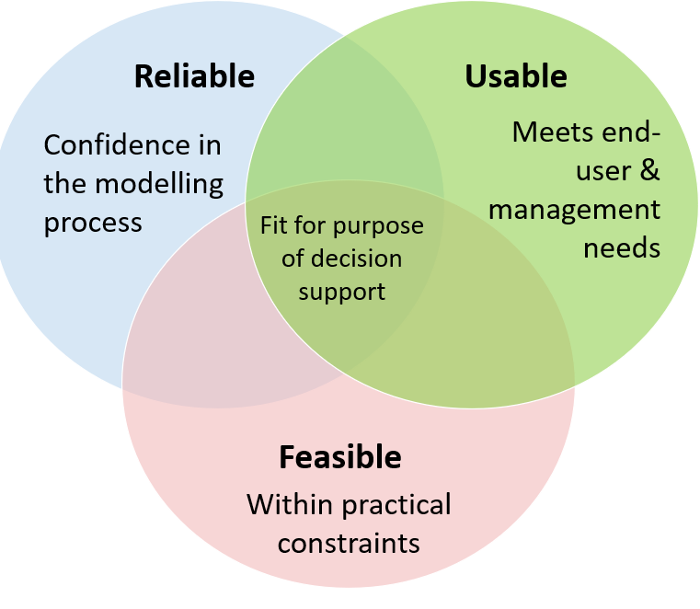

Figure 3. Fitness for purpose is a trade-off between usability, reliability and feasibility (after Hamilton et al. 2022)

Uncertainty analysis primarily addresses the reliability dimension by providing a likelihood of an event or a prediction interval based on the range of predictions, where this range of predictions is constrained or conditioned by the available knowledge of the system and observations. An open and transparent representation of the range of model outputs helps in building trust and confidence in the model approach and results, especially if it complements an honest reporting of the state of knowledge on the aquifer system and how this is captured in the groundwater model. The extent to which uncertainty can be quantified, however, cannot be separated from the other dimensions of fitness for purpose. Usability refers to the context in which risk-based decision-making occurs, and feasibility refers to the trade-offs required for the study resources available (data, time, budget).

A fit-for-purpose assessment of a groundwater model and uncertainty analysis will be highly context specific and difficult to capture in formalised checklists or classifications (see Box 3: AGMG confidence classification).

Box 3: AGMG confidence classification

The 2012 Australian Groundwater Modelling Guidelines (AGMG; Barnett et al. 2012) introduced the concept of a confidence classification. It is a rubric: a checklist in which the confidence of the model as a whole is determined based on a number of criteria related to the design of the model and the observation data available. It is interesting to note that the AGMG also stated that ‘the confidence level classification of the model predictions can be expressed quantitatively in a formal model uncertainty analysis’. In the decade since publication of the AGMG, the confidence level concept has become redundant, replaced by the development and uptake of efficient and effective uncertainty analysis methods.

The AGMG approach to assessing confidence in a model is inconsistent with the foundational principles of this Explanatory Note. The confidence level classification can be very misleading and can lead to unrealistic expectations that nothing less than a ‘high confidence’ model is ‘acceptable’, when that is not warranted or justified. It is unlikely that the rubric adequately captures whether the assumptions and model choices that underpin a groundwater model and associated uncertainty analysis are appropriate to represent or understand the quantity of interest relevant for decision-making on any project.

The AGMG is currently being revised (2023) and the confidence level scheme will likely be replaced by uncertainty analysis methodologies (consistent with this Explanatory Note). The first version of this EN (now superseded; Middlemis and Peeters 2018) recommended to no longer use the model confidence level rubric to commission, design or review groundwater models. The current version of the Information Guidelines reinforces this recommendation by stating that the confidence classification should not be used as a determining factor in deciding whether a groundwater model is fit for purpose.

Rather than relying on such a rubric, each model report should clearly identify and discuss the model choices and assumptions and to what extent these may affect the simulated quantity of interest and, more importantly, the findings of the modelling investigation. Reporting of uncertainty analysis, with an emphasis on justifying model assumptions, is discussed in section 4.

In developing a groundwater model, from creating a conceptual model based on available data and knowledge to implementing this in a numerical model and performing an uncertainty analysis, trade-offs will be made between the different aspects of the fit-for-purpose framework (Figure 3). These assumptions and model choices will introduce uncertainty in the results that is hard to quantify, but the potential implications are essential to understand in the interpretation of the model predictions. The next sections explore further what these trade-offs can look like in groundwater modelling and uncertainty analysis. Section 4 expands on the need to transparently and openly capture these trade-offs, assumptions and model choices in the model reports.

## 3.2 Usability: quantity of interest

The usability of a groundwater model is mainly focused on how the model outcomes will inform risk-based decision-making. Hazard identification identifies how the proposed development can cause an environmental impact, which requires an understanding of causal pathways. A risk assessment evaluates the likelihood and consequence of each hazard and possibly which actions can be taken to mitigate the hazard. The outcomes of a groundwater model are only usable for risk assessment if it is clear which groundwater-related hazards they relate to and how the outcomes will quantify likelihood and consequence. The outcomes of a groundwater model often only address a component on the hazard causal pathway. Consider the hazard of the persistence of a groundwater-dependent ecosystem (GDE) being adversely affected by an open pit mine. The causal pathway for this hazard can look like this:

*Open pit mine à mine dewatering à drawdown at GDE à persistence of GDE*

A groundwater model could be designed to assess the likelihood and magnitude of mine dewatering or to assess the likelihood and magnitude of drawdown at the GDE. A groundwater model would, however, not be able to provide information on the effect of drawdown at the GDE on the health and persistence of that GDE. This requires an ecohydrological understanding of the functioning of the GDE and how it is dependent on groundwater (see Doody et al. 2019).

This simple causal pathway highlights a couple of challenges common to many groundwater modelling exercises for impact assessment. A groundwater model can be used to estimate mine dewatering rates and a groundwater model can be used to estimate drawdown caused by that dewatering. For the former, the relevant model outcome is a prediction of inflows to the mine void and/or active dewatering wells as mining progresses, while for the latter it is a difference between groundwater levels at the location of a GDE at a future time, with and without mine development. We refer to these model outcomes or key predictions as the quantity of interest (QoI). A QoI is a model outcome from a specified model scenario, with a predefined spatial and temporal setting, that is relevant to assessing the likelihood and consequence of a causal pathway element representing a hazard.

The concept of QoI is crucial in assessing whether a groundwater model and uncertainty analysis is usable; it needs to be demonstrated that the groundwater model is able to provide reliable predictions of the QoI, within the feasibility constraints of time, budget and computational resources. All assumptions and model choices need to be evaluated within the QoI in terms of whether the choice will affect the QoI and, if so, whether the potential error introduced will be acceptable.

Identifying a QoI is an activity that should involve all parties: proponent, regulator, stakeholders and modelling team. The QoI will represent the environmental, social and economic values of importance. What is considered an acceptable level of risk is a value-laden decision that needs broad support.

In the example of the causal pathway earlier in this section, there are two quantities of interest: mine dewatering rate and drawdown. The model choices and assumptions that are appropriate for simulating mine dewatering are not necessarily appropriate for simulating drawdown at a distance from the mine pit. In an ideal case, a groundwater model is designed and developed for each QoI, starting from the same knowledge base. If the same groundwater model is used for multiple QoIs, it is essential that all assumptions and model choices are discussed for each QoI. Building a groundwater model for a single QoI often allows a greatly simplified conceptualisation, as only the processes and structures relevant to the QoI need to be represented. In a model with multiple QoIs, it is much harder to justify simplifications that are appropriate for each QoI. Such models can end up as a compromise, with suboptimal results for all QoIs.

Consider in the same example the conceptualisation and parameterisation of recharge. One way to explore whether an assumption on the conceptualisation and parameterisation is appropriate is to consider how the QoI changes if the assumption is wrong. In this case, if recharge is overestimated, it will lead to an overestimate of mine dewatering rates. If we further assume (the overestimated) recharge is the same both in a future with and a future without mine development, then a simple comparison of the effect of recharge on drawdown may have identical results and lead to a conclusion that drawdown is not influenced by recharge. However, if the overestimated recharge were used while estimating aquifer hydraulic conductivity by matching historical head observations, it would result in an overestimated hydraulic conductivity (to compensate for recharge that is too high). An overestimated aquifer hydraulic conductivity may lead to drawdown propagating more rapidly (faster impact) and a lower, underestimated maximum drawdown.

Having two models with potentially different assumptions and parameter sets for the same region can be counterintuitive. After all, there is only one hydrogeological reality that the models are trying to represent. This apparent contradiction can be resolved by considering each model and the associated parameter sets not as the ‘best model for this region’ but as ‘the model that allows to predict the range of the QoI, consistent with the observations and knowledge of the system’.

The GDE example also highlights another issue in specifying a QoI, in that ‘drawdown at GDE’ is quite vague. Research into the ecology of the GDE will be essential to figure out what is actually relevant for the persistence of the GDE. Is there an absolute groundwater level below which the vegetation can no longer access groundwater? Is the GDE most sensitive to the total change in groundwater level, or to the rate of change in groundwater level? Is there a seasonal component, in which the vegetation is more sensitive to changes in groundwater level in the dry period than in the wet period? The answers to these questions will lead to subtle changes as to which outcome of the groundwater model is relevant for decision-making. This would usually be facilitated by a multidisciplinary investigation team and could also benefit from early engagement with the regulator.

The definition of the QoI includes specifying the model scenario. The investigation focus is often on implementing the proposed water extraction for the development. Other time-varying boundary conditions, such as recharge rates or stream stages, are often implicitly assumed to remain similar to their historical observed behaviour. A QoI that is defined as a difference between two futures often has less uncertainty, as uncertainties associated with boundary conditions that do not vary between the two futures largely cancel out (Barnett et al. 2012).

Including multiple scenarios for time-varying boundary conditions is worthy of consideration – for instance, based on climate change scenarios. This is important as some impacts may not be additive or linear. For instance, predictions of mine inflow and drawdown in a future in which a stream is variably gaining-losing but connected can be very different to predictions of mine inflow and drawdown in a climate-change future in which that stream is losing at maximum rate (i.e. acting as a perched recharge source well above a depressed watertable). Note that such changes in future boundary conditions can be represented in a groundwater model as individual model runs (with an uncertainty analysis for each) or can be parameterised (e.g. recharge rates; dynamic stream-aquifer interactions) and included in the predictive uncertainty analysis. In that case, the parameters that represent future conditions should not be constrained by historical data (as that would limit the range to the historical range).

The next section discusses the trade-offs in establishing reliability of a groundwater model, depending on the QoI.

## 3.3 Reliability: range–observations–knowledge trade-off

The traditional approach of the calibrated model implicitly assumes that there is a single model that best fits the data and knowledge and that all predictions made with such a best-fit model have the same confidence. The definition of uncertainty analysis (see Box 2) on the other hand recognises that there will not be a single model or parameter combination to fit the data. More importantly, the prediction uncertainty will differ depending on the kind of prediction.

The goal of uncertainty defined in section 3.1 focuses on range, observations and knowledge as main factors that contribute to the reliability of a model. The range of predictions serves as a quantification of prediction uncertainty while being consistent with system knowledge, and honouring observations provides confidence that the model is an appropriate and accurate simulator of the groundwater system, at least of the historical behaviour of the system.

### 3.3.1 Range of QoI

Estimating the range of the QoI is often the prime objective of uncertainty analysis. Based on the spread or range of the model predictions, likelihoods can be calculated. The ranges of model predictions are often presented through summary statistics, such as the mean and the standard deviation, or the median and the range spanned between the 10th and 90th percentiles. The mean and standard deviation are useful when the predictions are normally distributed, while median and percentiles are more useful when the predictions have a skewed distribution. As risk is a function of likelihood and consequence, it is often not enough to represent the range of predictions by summary statistics; they should be represented as likelihoods, for instance through exceedance probabilities. An exceedance probability is the probability that a value in an ensemble is exceeded (or not exceeded), such as ‘the probability of more than 20 cm drawdown at this bore is 2.4%’. Another, less quantitative, way of presenting the possible range of predictions is through a single simulation of an extreme parameter combination, often referred to as a ‘worst case scenario’. While the term ‘worst case scenario’ is fundamentally flawed (it is impossible to demonstrate that this is indeed the worst possible outcome) and the use of the term should be avoided, the concept has some merit. A carefully selected extreme parameter combination that can be demonstrated to overestimate impact provides an upper bound to impact estimation and can be used to exclude areas of investigation with great confidence. This is explored further in Box 4: Precautionary principle and conservatism.

Box 4: Precautionary principle and conservatism

The precautionary principle is a key component of many environmental policies. While there are many definitions of this principle, they often can be traced back to the formulation in Principle 15 of the 1992 Rio Declaration on Environment and Development:

*In order to protect the environment, the precautionary approach shall be widely applied by States according to their capabilities. Where there are threats of serious or irreversible damage, lack of full scientific certainty shall not be used as a reason for postponing cost-effective measures to prevent environmental degradation.*

The principle provides a rule for environmental decision-making that complements risk-based decision-making. The interpretation and implementation of this principle can, however, be challenging, as discussed in Steel (2014) and Stefánsson (2019). Application of the precautionary principle can lead to a reversal of the burden of proof (Peterson 2006), where a proponent needs to demonstrate with sufficient certainty that a development will not harm the environment. This is the context in which conservatism in modelling features, in that conservative model choices and assumptions bias a model by overestimating impacts. This provides confidence in the model results that the ‘bad thing’ is not going (or is very unlikely) to happen.

Underschultz et al. (2018) showed that conservatism in geological representation and in groundwater modelling led to overestimated impacts of coal seam gas development. Reported (measured) amounts for water and salt production in Queensland were about 25% of those predicted by academia and government, and about 70% of those predicted by industry.

Making conservative assumptions is especially relevant for model aspects that are not usually varied in uncertainty analysis (for instance, conceptual model choices) and in estimating prior distributions for parameters that cannot be constrained by the available observations. Which model choice will lead to an overestimate depends on the kind of prediction and is not always trivial, especially in complex models.

Consider a project with two quantities of interest: drawdown in an unconfined aquifer; and streamflow depletion in a river connected to that unconfined aquifer, due to pumping from a bore. Drawdown close to the pumping site increases with decreasing diffusivity (ratio of transmissivity over storativity). Underestimating transmissivity and storativity can lead to an overestimate of localised drawdown and is therefore a conservative estimate of localised drawdown. Streamflow depletion, however, increases with increasing transmissivity and its onset increases with increasing storativity. The conservative choice would be to use higher diffusivity to overestimate streamflow depletion. It is not possible to make choices that lead to overestimates for both QoIs, so conservatism is not a valid approach to guide model development. In this case, both transmissivity and storativity should be included in the uncertainty analysis and constrained or conditioned by available observations. Section 3.2 discusses similar counterintuitive effects with regard to simulation of recharge.

Another example is to consider a situation with a single QoI, drawdown prediction in an unconfined aquifer, with transmissivity and storativity included in uncertainty analysis, constrained or conditioned by historical observations of groundwater level. The groundwater level observations are, however, influenced by historical pumping rates that have not been metered. The available computational budget does not allow inclusion of historical pumping rates in the uncertainty analysis. Should the pumping rates in the model be overestimated or underestimated? History matching with fixed pumping rates will lead to biased hydraulic properties. If pumping rates are overestimated, the parameter inference will compensate for that by increasing hydraulic properties. Vice versa, underestimated pumping rates will lead to underestimated hydraulic properties. In this case, underestimating pumping rates during history matching is justified as it will ensure that estimated hydraulic properties in the vicinity of pumping wells are underestimated and will lead to overestimated drawdown.

These examples illustrate that making conservative choices is not trivial and that, especially in high-profile projects, one should strive to include and parameterise as many known sources of uncertainty as possible.

In the selection of the QoI, it is also important to consider how the range of this QoI is likely to be used by decision-makers. Is the focus on the most likely value, with uncertainty analysis providing an estimate of the spread around that value? Or is the focus on the largest realistic impact? Or is it on the probability of exceeding a predefined threshold?

### 3.3.2 Observations

Observations of the natural system are used to conceptualise the model and in defining the initial ranges or prior distributions for each parameter, as well as to constrain the parameters. In groundwater modelling, this process of constraining parameters by honouring observations is traditionally referred to as calibration: the formal minimisation of the mismatch between observed and simulated state variables, such as groundwater level measurements, river fluxes or salinity. In other fields, this process is referred to as history matching, data assimilation, inverse modelling or parameter inference.

The mismatch between observed and simulated values is generally captured in a single value, the objective function value. The objective function can be expanded to include regularisation terms, i.e. terms that penalise parameter values that deviate from their prior value. Such regularisation terms can be used to include ‘soft’ constraints formally in the parameter inference (see section 3.3.3 Knowledge).

Despite its name, a number of often subjective choices need to be made to create the dataset of observations used in the objective function, including:

1. **Which observations to include**

Some observations are not representative of the system under study, and it can be justifiable to not include these. An example would be groundwater levels observed in a monitoring well very close to an unmetered pumping well. Groundwater levels in this location will be affected by the pumping regime of the well, which means that history matching based on this point may bias hydraulic property estimates if the pumping rate is not included as a parameter.

1. **How to weight different types of observations**

The importance of each observation or group of observations can be changed through adjusting their weighting. One way of weighting observations is based on the measurement uncertainty. This often proves difficult in practice, as measurement uncertainty is seldom quantified. More subjective, ad hoc weighting schemes are therefore usually applied; these need to be documented and justified.

1. **How to pre-process observations**

Pre-processing of observations can be an effective way of better exposing the information content in observations. Examples are baseflow separation of river flow measurements, cumulative observed drawdown, and temporal and spatial differencing of groundwater levels.

1. **The acceptable level of mismatch between observed and simulated values**

In groundwater modelling, the mismatch is generally summarised in a performance metric such as the normalised root mean squared error, although other metrics exist (Bennett et al. 2013).

It is not common practice in groundwater modelling to explicitly state what is an acceptable level of mismatch between observations and simulations, apart from the often misinterpreted ‘target’ of 5%–10% for the normalised root mean squared error in groundwater modelling guidelines (Middlemis et al. 2001, Barnett et al. 2012). An acceptable mismatch is project- and model-specific and depends on the measurement uncertainty, the scale and resolution of the groundwater model, and the purpose of the model.

This list highlights the need to discuss and justify the various choices and assumptions in compiling and presenting the dataset used to constrain or condition the model.

Another important aspect of compiling the history-matching dataset is to demonstrate that the observations can constrain the parameters that are relevant to the QoI. Figure 4 shows an example of a global sensitivity analysis of a groundwater model (Scheidt and Caers 2018). The analysis shows the relative importance of parameters both to the QoI and to the simulated equivalents of observations. The main goal of history matching is using historical observations to constrain or condition parameters that are important to the QoI so that the uncertainty in the QoI reduces. Sensitivity analysis allows identifying whether the QoI and the simulated equivalents to observations are affected by the same parameters and whether therefore the observations will be able to constrain the prediction. In the example in Figure 4, the parameters to which the QoI is sensitive are different to those to which the observations are sensitive. Honouring observations will not greatly reduce the uncertainty in predictions.

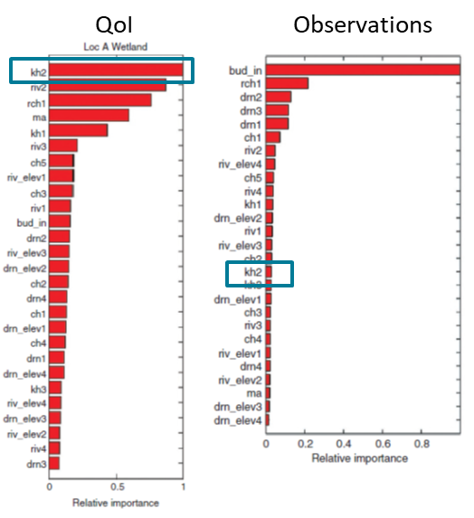

Figure 4. Sensitivity analysis (from Scheidt and Caers 2018)

The left-hand plot shows the relative importance of different parameters to the quantity of interest, drawdown under a wetland. The right-hand plot shows the relative importance of different parameters to match available observations.

There can, however, be an indirect effect on the QoI of constraining or conditioning parameters by observations. In the example in Figure 4, reproducing historical observations predominantly depends on the fluxes into and out of the model. Should these parameters be excluded from the parameter inference and fixed on a prior value, the inference will result in biased estimates of the hydraulic properties that do matter to the QoI.

Figure 5 shows the most typical situation in groundwater models where there is overlap between the parameter set to which the QoI is sensitive, and the parameter set to which the simulated equivalents to observations are sensitive. The figure shows that only part of the uncertainty in the QoI will be reduced by honouring observations. The part of the uncertainty due to parameters to which only the QoI is sensitive will not be reduced through honouring observations. As pointed out in the previous paragraph, parameters to which only the observations are sensitive are still relevant in parameter inference as they ensure that the parameters to which the QoI is sensitive will not be biased.

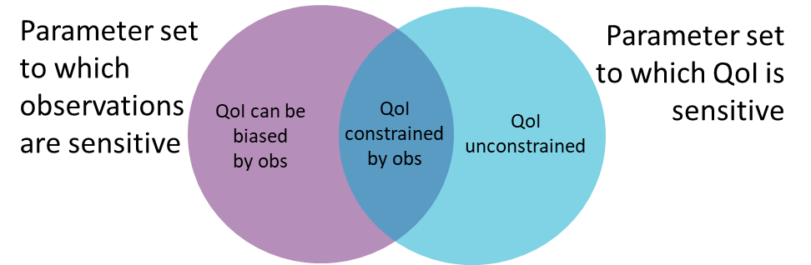

Figure 5. Only parameters to which both the observations and the QoI are sensitive will reduce uncertainty in the QoI

The contribution to the range of QoI from parameters to which the observations are not sensitive will be unconstrained through history matching. Parameters to which only observations are sensitive need to be included in history matching to avoid bias in parameters to which both the QoI and observations are sensitive. Parameters to which neither the observations nor QoI are sensitive can be omitted from history matching or uncertainty analysis.

For some groundwater models, there will be no overlap between the two parameter sets. In that case, honouring observations will not reduce uncertainty in the QoI and will not increase confidence in the model. Parameters to which neither the observations nor the QoI are sensitive can be excluded from the uncertainty analysis. Retaining these as part of the parameter sets in the uncertainty analysis may be warranted if there is a need to explicitly demonstrate that these parameters will not affect the QoI.

It is not always possible to identify which parameters will be relevant for matching observations and which parameters are relevant to the QoI before the modelling. It is often only possible to do this through examining the model results through a sensitivity analysis. The previous paragraphs highlights the need to present the results of a sensitivity analysis so as to show to which parameters the QoI is sensitive and to which parameters the observations are sensitive. It is not sufficient to only show the sensitivity of parameters to observations. Box 5 expands on different sensitivity analysis methods.

It is important to note that in groundwater modelling the term ‘sensitivity analysis’ is often used to describe manually adjusting one parameter while keeping others at the calibrated value and reporting either how the match to historical observations changes or how predictions change. In this report we refer to this approach as ‘scenario analysis with subjective probability’. While such an approach will provide some insight into the groundwater model, it will always be constrained by the limited and subjective choice of parameter sets evaluated. While it can provide some useful insights, such one-at-a-time sensitivity analysis should not be considered an alternative to a formal uncertainty quantification.

Box 5: Sensitivity analysis

Sensitivity analysis complements uncertainty analysis, but it is not an alternative to uncertainty analysis.

In groundwater modelling sensitivity analysis often refers to changing one parameter at a time and examining the changes in model outputs. This is a very narrow interpretation of sensitivity analysis. In its most general sense, sensitivity analysis is the study of how the ‘outputs’ of a ‘system’ are related to, and influenced by, its ‘inputs’ (Razavi et al. 2021). In the context of groundwater modelling, the ‘system’ is the groundwater model, ‘inputs’ are the aspects of the model that are parameterised and ‘outputs’ are the simulated equivalents to observations and the QoI. Where the main goal of uncertainty analysis is about quantifying uncertainty in outputs, sensitivity analysis focuses on identifying the main sources of uncertainty. The outcome of uncertainty analysis is directly relevant to decision-makers (e.g. is the likelihood of an unwanted event sufficiently low for the risk to be acceptable?). The outcomes of sensitivity analysis are directly relevant to modellers as they provide additional insight into the model. This makes sensitivity analysis relevant to decision-makers as well, as it not only provides additional confidence in the model results but also allows development of efficient strategies to reduce uncertainty in future.

Razavi et al. (2021) provide an excellent review of the current state of the art in sensitivity analysis, including an overview of the main approaches and software implementations. They distinguish between local sensitivity analysis and global sensitivity analysis. Local sensitivity analysis is based on changing one or more parameters from an initial ‘base’ value and evaluating the resulting changes in outcome. This is the most commonly reported sensitivity analysis in groundwater modelling practice. Analysis of sensitivity based on a Jacobian matrix (see Box 6 on uncertainty analysis techniques), often complementing automated history matching and linear error propagation, should also be considered a local sensitivity analysis, as the Jacobian matrix is populated by perturbing a ‘base’ parameter combination. Local sensitivity analysis only explores a very small part of parameter space, especially for highly parameterised models, and the results can therefore be misleading, particularly when the model response to changes in parameters is not linear (Saltelli and Annoni 2010).

Global sensitivity analysis addresses this issue by evaluating the sensitivity of outputs based on multiple parameter combinations. Global sensitivity analysis methods differ in the selection and number of parameter combinations. Readers are referred to Razavi et al. (2021) for a comprehensive review. Methods that are especially relevant for groundwater modelling and uncertainty are given-data sensitivity analyses that provide sensitivity metrics based on existing ensembles of model evaluations (e.g. Plischke et al. 2013, Pianosi and Wagener 2018). As these approaches can be used on an existing ensemble of model evaluations, like those generated in ensemble uncertainty analysis techniques, they come at a very small additional computational cost. Global sensitivity analysis can therefore be an integral part of history matching or uncertainty analysis, not requiring additional model evaluations if an ensemble of realisations is available. A comparison between the prior and posterior parameter ensemble provides an indication of which parameters are sensitive to the observations and which are not. Plotting parameter values in an ensemble against the corresponding QoI values provides insight into which parameters are relevant to the QoI.

Data-worth analysis extends sensitivity analysis by quantifying the reduction in predictive uncertainty should new observations, with a known measurement uncertainty, become available (Dausman et al. 2010, Gosses and Wöhling 2021). The closely related concept of ‘value of information’ takes this further by evaluating whether the change in uncertainty due to new information would change the decision and whether the cost of acquiring new information outweighs the cost of the unwanted outcome eventuating, based on the current probability (Bratvold et al. 2009).

Data-worth analysis extending a linear error propagation (see Box 6) does not require additional model runs, provided the Jacobian matrix includes the sensitivity to the hypothetical observation. The main drawbacks are that it requires the same assumptions for linear error propagation to be valid and, more importantly, that the new observation would not change the calibration to the extent that the parameter sensitivities change. Data-worth analysis with ensemble methods is computationally very demanding as it involves randomly drawing a hypothetical observation and evaluating a Bayesian inference with the hypothetical observation added to the observation dataset. The advantage of this approach is that it is more robust against new observations changing the estimated parameter values.

New observations can, however, challenge the current conceptualisation or parameterisation – the so-called conceptual surprises (Bredehoeft 2005). Most data-worth analysis approaches are not capable of accounting for such conceptual surprises. A more robust approach would be to use the results of a sensitivity analysis to identify the main sources of uncertainty and focus field investigations on addressing any knowledge or data gaps that relate to these sources of uncertainty.

The results of history matching or calibration are often reported through scatterplots in which the observed values are plotted against their corresponding simulated values or through time series plots in which observed and simulated values are plotted. The posterior range of parameters, i.e. after history matching, is also often provided, mostly with the initial or prior parameter range as reference. Critical examination of such plots can help identify critical conceptual, structural or parameterisation issues. Figure 6 shows some stylised examples of such issues. Figure 6a shows a situation in which a model fails to reproduce observed variability. This is especially problematic if all the points are from the same monitoring well or the same region in the model. This can point to issues with boundary conditions (e.g. a specified head) or a diffusivity (ratio of storage and transmissivity) that is too high. Figure 6b shows the opposite, where the model simulates variability that in reality is not present. This can again be a boundary condition issue (e.g. overestimated historical pumping) or the diffusivity values may be too low. Figure 6c compares prior and posterior parameter values, where most of the posterior values are at or close to the parameter bounds for that parameter. This can be merely due to too narrowly specified parameter bounds. If the parameter bounds are realistic or conservatively chosen to be wide, then this situation can indicate that a parameter is compensating for a conceptual or structural issue.

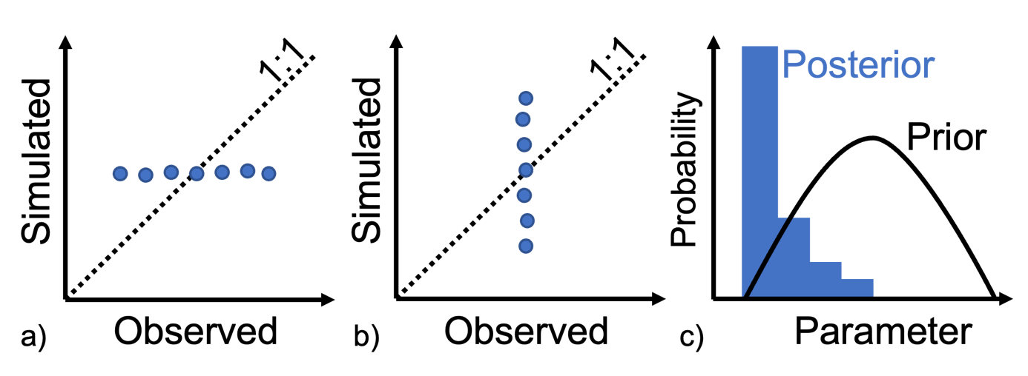

Figure 6. Stylised and exaggerated features in diagnostic plots that can indicate structural, conceptualisation or parameterisation issues

a) Model fails to reproduce observed variability. b) Model simulates variability where it is not observed. c) Parameter values are at bounds.

### 3.3.3 Knowledge

The third objective of uncertainty analysis is to demonstrate that the range of outcomes is consistent with system knowledge. This recognises that observations used in history matching only capture part of the knowledge about the system. A model that matches observations is not guaranteed to be able to adequately simulate the QoI; vice versa, a model that does not match all observations is not necessarily unsuited to simulate the QoI. The reasons for this can be varied – for instance, when observations are dominated by processes or local detail that is not relevant to the QoI.

As the mismatch between observed and simulated values is not sufficient to evaluate whether a model is appropriate to simulate the QoI, it is necessary to evaluate whether the model is consistent with the understanding of the groundwater system. A crucial aspect of this is how the conceptual model of the aquifer system is translated into a numerical model. This includes the representation of geometry and structures in the subsurface, fluxes into and out of the model, and the spatial variability of parameters (Enemark et al. 2019). This requires a model to be designed with optimum complexity (Doherty and Moore 2019), which can be judged not by whether more complexity can be added (e.g., geological structure, hydrological processes) but by whether none of the key system features included in the design can be taken away (Voss 2011a, Voss 2011b, Ferré 2016). To assess whether the model adequately captures these aspects, the quantitative evaluation of mismatch with observed values is often complemented by a more qualitative evaluation of whether the model can reproduce temporal trends in groundwater levels, variations in space and time of recharge processes, or the flow patterns around faults and discontinuities.

### 3.3.4 Trade-off examples

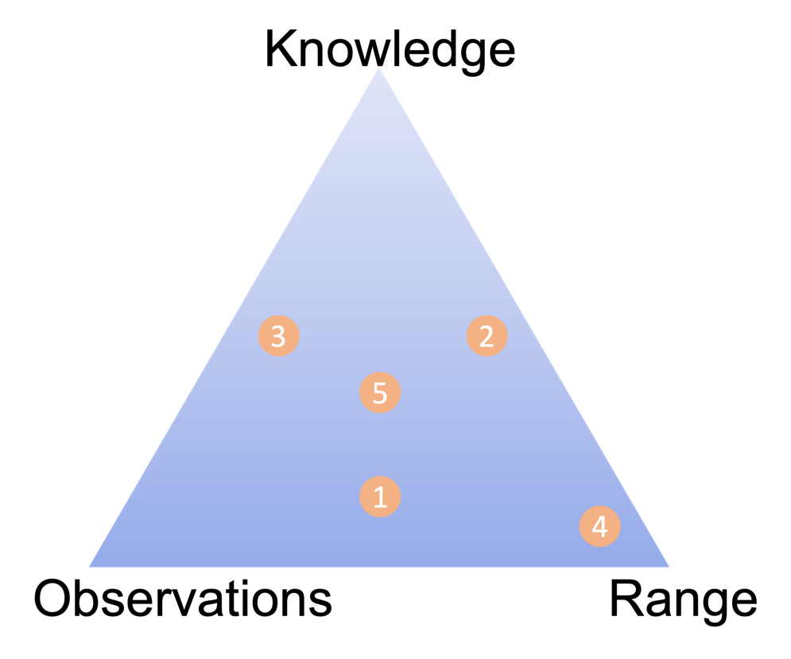

Figure 7. Trade-off between estimating the range of a prediction, being consistent with the available knowledge and honouring relevant observations (numbered circles refer to the examples in the text)

Figure 7 shows the three objectives of uncertainty analysis as the endmembers of a ternary diagram to highlight that a groundwater model with an uncertainty analysis always represents a trade-off between the three objectives. Examples 1 to 5 in this section illustrate that an appropriate trade-off depends entirely on the context of the project and that different trade-offs can be justified for uncertainty analysis. While the examples are hypothetical, each includes a reference to a publicly available case study that is illustrative of the example.

1. **Observations + Range of QoI > Knowledge**

Consider a model to predict dewatering rates for an open pit mine. The geology is very complex with steeply dipping layers and faults with unknown hydraulic behaviour. There is an existing monitoring network to measure groundwater levels in the vicinity of the existing mine, and several pumping tests have been carried out. With such a database of historical observations, the structure and parameter values of the model can be inferred through history matching and justified. The range of model predictions can subsequently be estimated through linear uncertainty analysis or ensemble methods. This trade-off is emphasising the honouring of observations and estimating the range of predictions over the consistency with system knowledge. Note that this does not mean the model is inconsistent with system knowledge. Rather, it conveys that the representation of reality is simplified, for instance by having a limited number of model layers with a constant thickness rather than a model grid that closely follows the complex geology.

**Hypothetical example inspired by**: Simultaneous interpretation of six pumping tests in the Pilbara (Manewell and Doherty 2021).

1. **Knowledge + Range of QoI > Observations**

Consider a model to predict drawdown in a fractured and weathered unconfined aquifer due to coal seam gas depressurisation. The existing monitoring is scarce and mostly strongly influenced by local processes, such as surface water–groundwater interaction, that will not be able to greatly constrain or condition hydraulic properties relevant to predicting mine water inflow, such as the transmissivity and storativity of the coal measures and the aquitard. Reservoir modelling by the proponent does provide an estimate of the expected volumes of co-produced water. In this setting, it can be justified to focus on accurately representing the geometry of the underground and of the planned development, and defining prior distributions for hydrogeological properties based on site characterisation and literature and on using ensemble methods to provide an estimate of the range of drawdown consistent with this existing system knowledge, including the co-produced water volumes expected by the proponent.

**Hypothetical example inspired by**: Bioregional assessments for the Gloucester subregion (Peeters et al. 2018).

1. **Observations + Knowledge > Range of QoI**

Consider a model to investigate whether a fault near a proposed mine can be considered a barrier to groundwater flow. As part of the investigation, a long-duration pumping test has been carried out, with drawdown measured in observation wells on both sides of the fault.

In this case, it can be justifiable to focus on accurately representing the fault geometry and pumping test set up in the model and to use a highly parameterised model to capture the response to pumping in detail. The range of model predictions is then only used to estimate the likelihood of the fault being permeable, and the related implications.

**Hypothetical example inspired by**: Understanding, detecting and conceptualising hydrogeological barriers (Marshall 2021).

1. **Range of QoI > Knowledge + Observations**

Consider a screening model to prioritise areas for further research in estimating cumulative drawdown caused by multiple developments. In this case, it is advisable to be overly conservative to ensure only areas with a very low likelihood of being impacted are excluded from further research. Conservative model assumptions, i.e. assumptions that can be shown to overestimate impacts, provide confidence that the range of model prediction includes extremes of drawdown. Such assumptions are often not consistent with existing knowledge and will not be able to honour observations. An example is not representing recharge in the model. This is not consistent with available knowledge as the aquifer is known to receive recharge. Not accounting for recharge, however, will lead to an overestimate of drawdown.

**Hypothetical example inspired by**: GBA Beetaloo drawdown estimates in Cambrian Limestone Aquifer (GBA 2021).

1. **Range of QoI = Knowledge = Observations**

Consider a high-profile mine development close to a wetland system that is listed as a matter of national environmental significance. In this setting, it is of utmost importance that the model results can withstand a high level of public scrutiny and that the uncertainty analysis can be shown to have estimated a wide range of model predictions, consistent with the current system understanding and honouring all relevant information.

**Hypothetical example inspired by**: Majority of coal mining and coal seam gas development referred to the IESC for advice. These developments are typically heavily scrutinised and the opportunity for trade-offs between the range of QoI, knowledge and observations is limited. An example of finding a balance between these three components can be found in Mather et al. (2022), in the context of constraining the response of continental-scale groundwater flow for climate change.

These examples illustrate that different trade-offs are possible. The list of examples is not exhaustive; there are more examples and combinations possible. Justifying these trade-offs typically requires being able to demonstrate which model aspects are important for the QoI or that model choices are conservative and will overestimate the impact on the QoI. This is discussed in more detail in boxes 4 and 5 on conservative assumptions and sensitivity analysis respectively.

As pointed out earlier, groundwater modelling should be considered more as a verb (the action of undertaking an iterative process of investigation), rather than simply as a noun (a deliverable). The emphasis on the different components in a trade-off is therefore not static and can change throughout the life of the project. In the initial stage of a project, the emphasis can be on screening models to prioritise areas for further investigation, then during characterisation the focus can be on matching field data and refining system knowledge, while later, when more data is available, the focus can be on predicting the range and honouring observations.

The examples also highlight that the trade-offs cannot be easily codified (see Box 2 on confidence classification); they require an open and transparent discussion early in the modelling process. The trade-offs made at this stage will affect many of the other components of groundwater modelling and uncertainty analysis, as well as the time, budget and computational resources, which are discussed in the next section.

## 3.4 Feasibility: uncertainty analysis techniques

Uncertainty analysis techniques commonly used in groundwater modelling can be organised in three main groups: scenario analysis, linear error propagation, and ensemble methods (Figure 8).

Comparison of the 3 types of analysis described in this section:
Scenario analysis
Linear error propagation
Ensemble methods

Figure 8. Types of uncertainty analysis commonly used in groundwater modelling

Scenario analysis describes approaches in which the range of model predictions is explored by evaluating a limited number of parameter combinations. An example is changing the recharge of a groundwater model by 10% and inspecting the changes in the results. The advantages of this method are that it is easy to implement and explain and that it only requires a single model run per scenario or parameter combination. The drawbacks are that this approach does not provide a quantitative estimate of likelihood and that uncertainty analysis is not comprehensive as the practical upper limit on the number of scenarios that can be evaluated and analysed is small, generally less than 10.

Linear error propagation techniques create a linear approximation of the effect of the parameters on the predictions. When the uncertainty in the parameters and observations can be characterised as normal, or normal after log transform, error propagation equations can be used to propagate the uncertainty of the parameters to the predictions. The linear approximation of the model is captured in the Jacobian matrix, which includes the change in each model outcome due to a small change in each parameter. The advantage of this approach is that it is a well-established technique that is computationally efficient. At a minimum, it requires one model run per parameter, plus one. However, as the Jacobian matrix is an essential part of gradient-based optimisation, and if the model has been calibrated or history-matched through gradient-based optimisation, the Jacobian matrix for the calibrated parameter values is available from the optimisation. Compared to evaluating the groundwater model, error propagation with Jacobian methods is computationally very efficient. The drawbacks of linear error propagation are that the results can be biased if the parameters, observation uncertainties or predictions are not normally distributed or the model cannot be accurately represented with a linear approximation, and that the uncertainty analysis is not comprehensive as only the parameter space in the immediate vicinity of the base parameter set is explored.

Ensemble methods rely on evaluating a large number of parameter combinations and estimating the likelihood of predictions based on the resulting ensemble of model outcomes. The advantage is that this approach does not require a linear approximation of the model or normally distributed parameters, observation uncertainties or predictions. The drawbacks are that estimating robust summary statistics, especially extreme percentiles of skewed distributions, requires large ensemble sizes (i.e. more model runs) and that finding ensembles that are consistent with observations is often extremely computationally inefficient, where only a fraction of evaluated parameter combinations are accepted in the final ensemble. Ensemble methods usually require hundreds to thousands of model evaluations.

Technological advances in uncertainty analysis techniques have mainly focused on overcoming the various drawbacks of each technique. An overview of some of the more common techniques used in groundwater modelling is provided in Box 6.

Box 6: Uncertainty analysis approaches

Uncertainty analysis is important for all scientific and engineering challenges. This has led to an explosion of jargon, mixing terms from different disciplines. This box provides a high-level overview of uncertainty analysis and the context for commonly used terms in uncertainty analysis (see also Glossary).

The first goal of uncertainty analysis is to quantify a range of model predictions that reflect the effect of uncertainty in model parameters on the model outcomes. A model **parameter** is any aspect of the model that is considered uncertain and that is allowed to vary during the analysis. Parameters can represent uncertainty in model input, properties, boundary conditions and even structure or conceptualisation if carefully designed.

To quantify the uncertainty in model outcomes, the model must be evaluated in such a way that uncertainty in parameters is propagated to the model outcomes. In most modelling disciplines, this is called the **forward model**. The uncertainty in parameters is captured in the **prior probability distribution**, or **prior** for short. This term comes from Bayesian statistics and it expresses one’s belief about the variability of parameters. When parameters are correlated, which is often the case for spatially varying parameters, the **joint prior probability distribution** needs to be specified. Priors of parameters that can be assumed to be normally or log-normally distributed can be fully described by the **mean** and **variance** (the square of **standard deviation**), and correlations between parameters is captured in the **covariance matrix**. In geostatistics, a **covariance function** is used to describe how a parameter varies in space.

**Scenario analysis** assesses uncertainty by evaluating the forward model for a number of scenarios, where a scenario is a model run in which one or more parameters are changed compared to a reference parameter combination or baseline model. The scenarios provide information on what model outputs are possible, but generally only have a subjective/qualitative assessment of likelihood, and scenarios need to be carefully designed and justified. Maier et al. (2016) show how scenario analysis, such as to evaluate extreme parameter combinations, can be highly relevant to decision-makers. The parameter combinations chosen in a scenario should be part of the prior, but scenarios usually only change a subset of the parameters that are considered uncertain.

Scenario analysis is often referred to as ‘sensitivity analysis’, a term reserved in this document for the formal process of identifying which parameters affect the QoI. Scenario analysis can be considered an exploratory sensitivity analysis, provided both the change in QoI and the change in mismatch with observations due to a change in parameter value are reported.

**Linear error propagation** is a more comprehensive and quantitative uncertainty analysis technique in which the effect of the parameters on the outcomes is approximated by a linear function such as the **Jacobian matrix**, which is the matrix of all first-order partial derivatives of model outputs to parameters. The partial derivatives are numerically approximated by the slope of changes in output by perturbing each parameter of the model by a small amount. If the variability in parameters can be fully described by standard deviation and covariance matrix and the model output is a linear function of the parameters, the uncertainty in model outcomes is obtained by combining the Jacobian matrix and the covariance matrix. The main advantage of this method is that it is computationally efficient as it only requires (at a minimum) one model run per parameter plus one. The main drawback is that the estimates of uncertainty are biased (i.e. overestimated or underestimated) if the parameters are not normally distributed or the model outputs are not a linear function of the parameters.

**Ensemble methods** for uncertainty analysis overcome some of the issues of scenario analysis and linear error propagation by drawing a number of random parameter combinations of the prior parameter distributions and evaluating the model for each parameter combination. The uncertainty in model outcomes can then be empirically estimated from the resulting ensemble of model outcomes. This is referred to as **Monte Carlo** sampling, to emphasise the random component. The advantage of this approach is that it does not require assumptions on normality of parameters or linearity of the model. The drawback is the computational cost of evaluating the model for each randomly generated parameter combination. Box 7, on uncertainty bounds and convergence, discusses the effect of ensemble size on the accuracy of the uncertainty analysis.

The second and third goals of uncertainty analysis are for the range of predictions to be consistent with system knowledge and to honour historical observations. The latter part, how to constrain or condition model predictions with observations, has been a focus of research for many decades. It is referred to as **calibration**, **history matching**, **data assimilation** and **inverse modelling**. A generic term is **parameter inference**, as the goal is to infer parameters from observations. The term **Bayesian inference** is used when Bayes’ law is formally used to estimate a **posterior probability distribution**, or **posterior**. Bayes law describes how the probability of a model can be estimated from prior belief in the model (the prior of parameters) and the evidence (the dataset of historical observations). For a model ***M*** and dataset ***D***, Bayes law can be written can be written as:

$P\left(M | D\right)=\frac{P\left(D | M\right)P\left(M\right)}{P\left(D\right)}$

in which P(M|D), the probability of a model, can be estimated from P(M), the prior of the model; P(D), the probability of the dataset; and P(D|M), the likelihood of the dataset given the model. This last term is usually computed based on the mismatch between observed and simulated values, accounting for observation uncertainty.

Many techniques for parameter inference are designed as optimisation algorithms with the goal of minimising the difference between observed and simulated values. Quantifying uncertainty bounds of inferred parameters is often only a secondary objective. In some disciplines, like geophysics, the parameters are the QoI (e.g. electric conductivity of the subsurface inferred from an airborne electromagnetic survey). In groundwater modelling, however, the parameters are seldom the QoI and the uncertainty in parameters captured in the posterior still needs to be propagated to the QoI.

A common choice in scenario analysis is that the base case or reference scenario is the parameter combination that best fits the data. This parameter combination is often obtained through manual calibration, i.e. sequentially adjusting parameter values based on the modeller’s experience until a predefined calibration target is achieved or the available computational budget is exhausted.

Many iterative least squares curve fitting methods, like the Levenberg-Marquardt algorithm implemented in PEST, use the Jacobian matrix to find the local minimum of the objective function. Linear error propagation can therefore be readily implemented as the Jacobian matrix is available (Moore and Doherty 2005). While this is computationally efficient, the number of model runs still scales with the number of parameters, which means that these methods are still not feasible for highly parameterised models. The iterative ensemble smoother (IES) method (Chen and Oliver 2013; White 2018) approximates the Jacobian by estimating it from an ensemble. This allows assimilation of data very efficiently, within around 1,000 model evaluations, regardless of the number of parameters. Evensen (2018) points out, however, that the IES does not precisely sample the posterior probability distribution. This means that using the IES does not guarantee that prediction intervals from IES ensembles are accurate or that extremes are properly characterised.

Other ensemble methods aim to estimate the posterior probability distribution by randomly sampling from the prior using a likelihood function, where parameter combinations that result in a small mismatch between observed and simulated values are more likely to be accepted in the posterior distribution. Many proposed parameter combinations from random sampling of the prior can have a low likelihood and will therefore not be accepted in the posterior. **Markov chain Monte Carlo (McMC) sampling** is a more efficient sampling strategy in which a new parameter combination is chosen in such a way that it is more likely that the new parameter combination has a greater likelihood than the previous one. McMC methods mainly differ in how they select the next parameter combination in a sequence. A good overview of these methods, including **DiffeRential Evolution Adaptive Metropolis (DREAM)** sampling, can be found in Vrugt and Massoud (2018).

The likelihood function that underpins McMC sampling often assumes that the model error is normally distributed, which cannot always be justified (Schoups and Vrugt 2010). **Generalised Likelihood Uncertainty Estimation (GLUE)** and **Approximate Bayesian Computation (ABC)** (Vrugt and Beven 2018) instead use an approach in which samples are accepted in the posterior if a summary metric of the mismatch between simulated and observed values is less than a predefined threshold. The commonly used approach in groundwater modelling practice of evaluating a random ensemble of parameter values from the posterior and only accepting those for which the root mean squared error is below a predefined threshold can be considered as ABC.

Common to all parameter inference methods is that they require many model evaluations, often proportional to the number of parameters. One way of overcoming this problem is making the inference methods more efficient – i.e. requiring fewer model evaluations. Another way is by reducing the runtime of models. **Model emulators** or surrogate models are black-box models that reproduce the dynamics of a model – i.e. how model outputs vary as a function of the parameter values – but run much more quickly. An overview of such approaches is presented in Asher et al. (2015). Recently, machine learning algorithms are increasingly considered as model emulators (Razavi 2021).

Another feature common to all parameter inference methods is that they assume that (1) the model is an adequate, unbiased simulator of reality and (2) the prior parameter combination contains the posterior, i.e. that the parameter combination with the lowest error is within the prior. The first assumption can often not be strictly justified, as each model will have a structural error component. This can be due to factors such as the resolution of the model, inaccuracies in historical boundary conditions such as pumping rates, or lack of spatial variability. Structural error can lead to biased parameters, as parameter inference attempts to compensate for these structural errors (White et al. 2014). The effect of structural errors can be mitigated by increasing complexity of models or increasing parameterisation, but not completely eliminated. The second assumption is seldom tested and if it is not true it will also lead to a biased posterior, as the area of highest likelihood is not included. The effect of both structural error and incorrect priors often manifests itself in posterior parameter distributions that are close to the bounds of the prior distribution. Scheidt and Caers (2018) recommend, before starting a parameter inference, evaluating a small initial ensemble of the prior and test whether the resulting ensemble of simulated values encompasses the observed values. Such a small initial ensemble also serves as a ‘stress test’ of the model to test whether it is stable and converging over the entire parameter range of the prior.

Two assumptions regularly used in uncertainty analysis are that parameters are (1) normally or lognormally distributed and (2) the model can be (partly) linearised, i.e. that the objective function and QoI are locally a linear function of the parameters. Even when these assumptions are (mildly) violated, most uncertainty analysis approaches will succeed in finding the most likely parameter set and corresponding QoI. The range of model outcomes, however, can be quite affected if the assumptions of normal or lognormal parameter distributions or locally linear model behaviour do not hold. Checking the validity of these assumptions when estimating the range of a QoI is of high importance.

In practice, each project has limitations in time, budget and computational resources. The selection of uncertainty analysis technique will be a trade-off between the aspects of reliability discussed previously and the project limitations, which mainly focus on the time needed to develop the model and carry out the uncertainty analysis. These computational demands are affected by three main aspects:

1. **Complexity of the model**

More complex models have finer discretisation to represent spatial variations in structure, geometry and hydraulic properties and/or more complex representations of processes affecting fluxes into and out of the model. The development time and runtime tend to increase with increased complexity, while numerical stability tends to decrease.

1. **Number of parameters**

Each aspect of the model that needs to be included in the uncertainty analysis needs to be represented by parameters. Especially when representing spatial or temporal variability, this can lead to a very large number of parameters. More parameters allow for more detail to be captured and increase the fit to observations. The number of model evaluations needed for uncertainty analysis generally increases with the number of parameters. Calculating a Jacobian matrix for a model with 100 parameters, for instance, would require at least 101 model runs.

1. **Number of model evaluations**

The robustness of likelihood estimates from ensembles increases with the number of model evaluations. While the mean and standard deviation can often be robustly estimated from a small ensemble of around 100 model evaluations, estimating more extreme percentiles, such as the 90th or 95th percentile, often requires many more model evaluations, often more than 1,000, especially if the model distribution is skewed. A summary statistic is considered robust if the value has converged, i.e. that the value of the summary statistic does not change by increasing the ensemble size. This is further explored in Box 7 on prediction bounds and convergence.

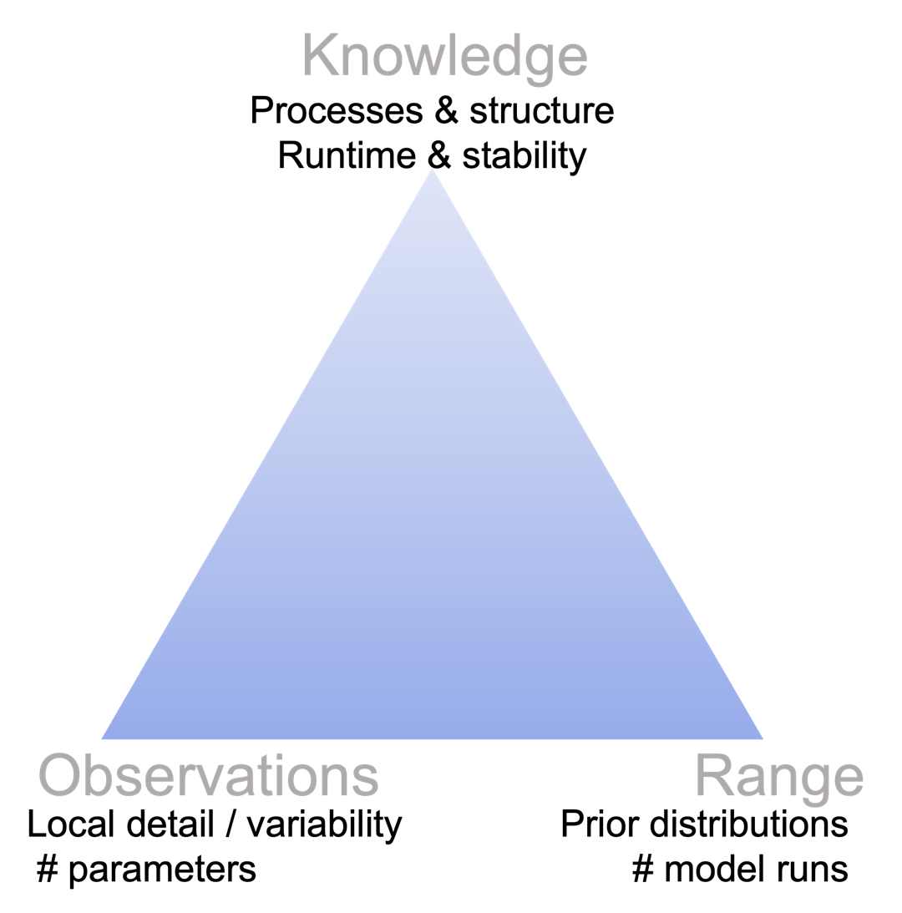

Figure 9. Trade-offs in reliability affect feasibility

Figure 9 illustrates how the aspects that affect the computational resources needed for a project are linked to the trade-offs in reliability. A focus on being consistent with system knowledge requires more complexity in the way structures and processes are represented in the model, which increases development time and runtime and decreases stability. An emphasis on honouring historical observations will require a model with many parameters to represent local detail and flexibility to adjust these parameters as a function of the observations. More parameters will increase the number of model evaluations needed for uncertainty analysis. When the range of model predictions is of importance, more time and resources need to be invested in characterising the prior distributions for each parameter, especially if these cannot be constrained or conditioned by available observations, and more model evaluations are needed if robust estimates of more extreme summary statistics are needed.

The justification of these trade-offs in relation to the project resources and constraints is an integral part of the formal uncertainty analysis, as discussed in section 4.

Box 7: Prediction intervals and convergence

Ensemble methods rely on Monte Carlo or random sampling of a distribution to estimate summary statistics, such as the mean and prediction intervals. The 95th percentile prediction interval is the range spanned between the 2.5th and 97.5th percentiles of a distribution. The accuracy of the estimates of mean and prediction interval increases with the size of the ensemble. Creating large ensemble sizes, with more than 1,000 or 10,000 model realisations, is often computationally very expensive and not feasible within the constraints of a project. A much-used approach to assess whether the size of the ensemble is sufficient is to create a convergence plot. In a convergence plot, the evolution of the summary metric is plotted as more evaluations are added to the ensemble. The summary statistic is said to have converged if its value does not change with adding more values. Such plots can be quite misleading. Figure 10 shows the convergence plot for the 5th, 50th and 95th percentiles of a drawdown prediction (top row) and river depletion prediction (bottom row). The distribution for the drawdown is almost symmetrical (i.e. 5th and 95th percentiles are at a similar distance from the 50th percentile), while the streamflow depletion prediction is strongly skewed (i.e. the 5th and 95th percentiles are at very different distances from the 50th percentile. The left plot uses the full ensemble size of 1,000 evaluations and the right plot only the first 300 evaluations. The percentiles for the drawdown prediction have stabilised after 300 simulations, and the estimates of 5th, 50th and 95th percentiles based on 300 simulations are very close to those based on 1,000 simulations. The convergence plot for 300 simulations for streamflow depletion (bottom right) appears to indicate that the 95th percentile has converged after 150 simulations to a value close to 10 m3/d. The plot of 1,000 evaluations shows, however, that the 95th percentile only starts to stabilise after 500 model evaluations to a value close to 18 m3/d. Using the ensemble of 300 simulations for the drawdown prediction would be justified, but would result in an underestimation of the 95th percentile for streamflow depletion by more than 40%.

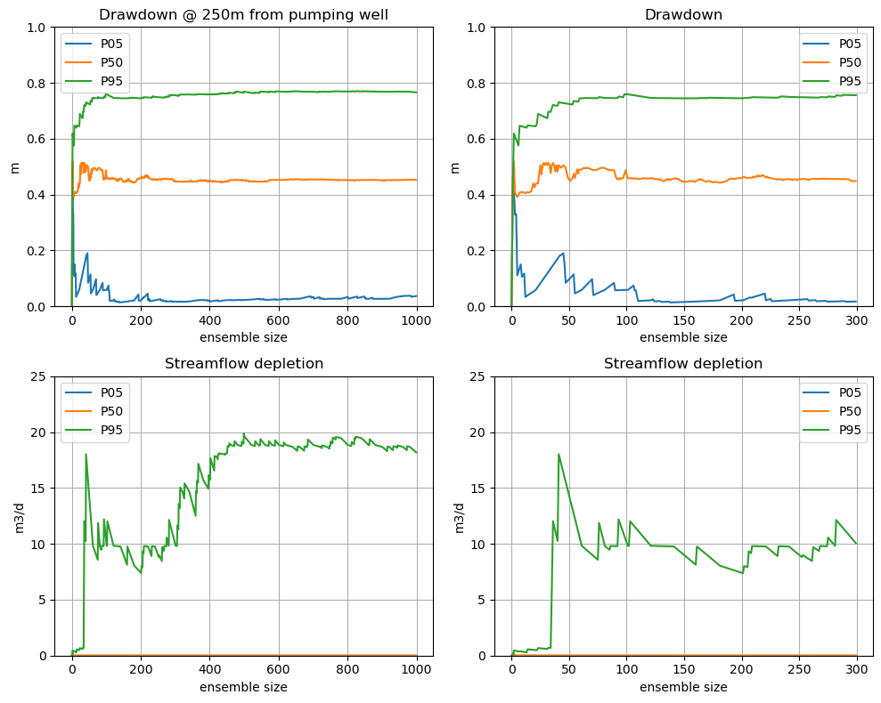

Figure 10. Convergence plot of 5th (P05), 50th (P50) and 95th (P95) percentiles for 1,000 model evaluations (left) and 300 model evaluations (right) for drawdown (top) and streamflow depletion (bottom)

*Simulation based on Monte Carlo sampling of an analytic element model of an unconfined aquifer with a fully penetrating river at 1,250 m from a pumping well with a specified drawdown of N(2,0.05), aquifer thickness of 10 m, log Kh of N(-1,1), log Kh_riverbed of N(-1,1) and log Sy of N(-1,0.5). Drawdown is calculated 12.5m from pumping well.*

The accuracy of prediction intervals from Monte Carlo sampling is explored in more detail by Roy and Gupta (2021) (Figure 11). They show that the uncertainty in estimates of extreme percentiles can be considerable for small ensemble sizes (100), especially for skewed distributions.

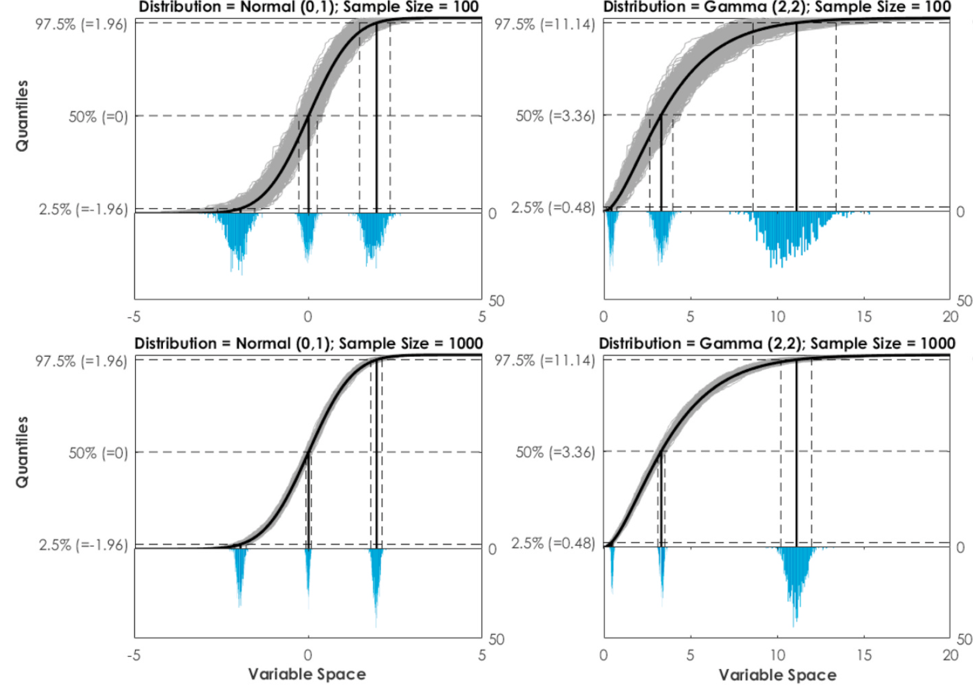

Figure 11. Illustration of sampling a normal (left) and skewed (right) distribution 1,000 times with a sample size of 100 (top) and sample size of 1,000 (bottom)

*The histograms under the 0 line show the distribution of estimated 2.5th, 50th and 97.5th percentiles (after Roy and Gupta 2021).*

Roy and Gupta (2021) developed a method to adjust for this uncertainty by inflating prediction intervals through selecting a more extreme percentile as a function of the ensemble size (Table 2). The adjustment does not depend on the shape of the distribution that is sampled. Note that for small ensemble sizes, less than 100, the adjustment is considerable and that it is unlikely that 95th percentile prediction intervals can be reliably estimated.

Table 2. Prediction interval adjustment to account for limited ensemble size

|  |  |  |  |  |  |  |
| --- | --- | --- | --- | --- | --- | --- |
| Theoretical | N=25 | N=50 | N=100 | N=500 | N=1,000 | N=10,00 |
| 97.5 | 99.9 | 99.6 | 99.3 | 98.6 | 98.3 | 97.8 |
| 95 | 99.3 | 98.6 | 98.0 | 96.6 | 96.2 | 95.4 |
| 5 | 0.7 | 1.3 | 2.0 | 3.4 | 3.8 | 4.6 |
| 2.5 | 0.1 | 0.4 | 0.7 | 1.4 | 1.7 | 2.2 |

The theoretical 90% prediction interval (the range spanned by the 5th and 95th percentiles) for an ensemble with size 100 can be approximated by the prediction interval spanned by the 2nd and 98th percentiles estimated from the ensemble. Values are calculated using equation 3 in Roy and Gupta (2021).

1. Reporting uncertainty analysis

Section 3 highlights the many assumptions, choices and trade-offs needed in a modelling and uncertainty analysis project. The main goal of the model report is to document, discuss and justify the assumptions, choices and trade-offs in an open and transparent way that is amenable to review. The report is crucial in decision-making – less so the actual model dataset, scripts and results, as these are usually only accessible to the modelling team.

The key to successful communication is to present the information about uncertainty in a way that is most likely to aid decision-making. To achieve this, analysis of uncertainty information in model output needs to be:

1. adequately tailored to decision-makers’ needs
2. focused on the messages that are most likely to be relevant to their decisions
3. presented in plain and clear (precise, non-technical) language.

## 4.1 General

As outlined herein, the environmental assessment documentation should provide enough information to allow an independent reviewer (IESC or others) to evaluate the justifications for the assertions made – for example, on the basis for the conceptual or ecohydrological models, the underlying assumptions for the numerical models and why an ecosystem is or is not groundwater dependent. An independent reader of the environmental assessment documents should be able to verify all of the proponent’s significant assumptions, methodologies, techniques, assertions and conclusions, and evaluate whether the analysis effort applied is commensurate with the risk.

To that end, **assessment reports should be as self-contained as possible**, minimising the need for the reader to consult several volumes of technical reports to understand the methodologies and assumptions applied and the predictions of impacts on groundwater and dependent ecosystems (but allowing for the flow of information between disciplines conducting the assessments). For example, there are usually linkages between the groundwater and surface water assessments, such as to estimate recharge and/or runoff (Figure 12). Groundwater model outputs typically form inputs to evaluate the site water and salt balance (see also Figure 2) that is usually presented in the surface water report. The site water and salt balance itself produces outputs that become inputs to post-mining groundwater model scenarios, such as for the final void lake, which may also require information from geochemical assessments (Figure 13). Post-mining scenarios need information on closure from the rehabilitation report, and the groundwater model also needs information on groundwater-dependent ecosystems from the ecological report.

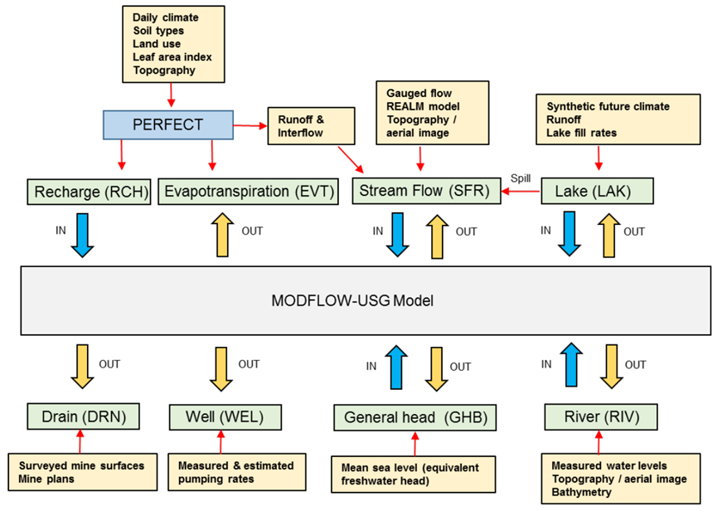

Figure 12. Example of interactions between groundwater and surface water models (after Gresswell et al. 2019)

Terms in capitals refer to models or model components.

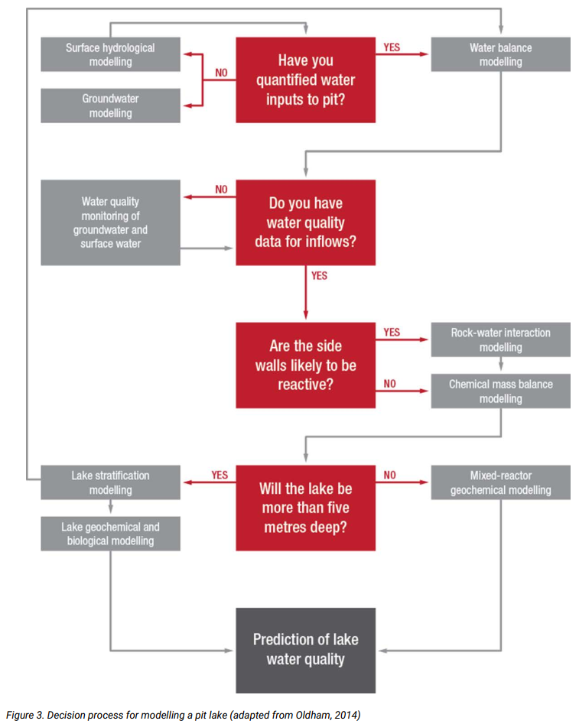

Figure 13. Example workflow for final void lake water balance and quality modelling (after WA DMIRS 2020)

## 4.2 Bias

The effects of bias must be acknowledged and discussed in the report.

Some of the cognitive biases to which everyone is prone, such as availability bias, confirmation bias, and confidence and framing bias (see Glossary). Although a groundwater model is designed to be an objective representation of physical reality, the multitude of choices and assumptions that need to be made during modelling and uncertainty analysis make bias in predictions unavoidable.

Minimising and acknowledging bias in investigations and modelling of causal pathways is a key element of the ecological values analysis at the problem definition stage, along with data analysis, conceptualisation, and the initial risk analysis and treatment options assessment.

Conceptual models for resource development projects should consider and minimise potential biases when analysing how causal pathways can transmit direct, indirect and cumulative impacts of coal seams to water resources or water-dependent ecosystems. More than one model conceptualisation or realisation may need to be tested to understand the effect of conceptual or other sources of uncertainty and bias on model outputs. This may lead to more than one mathematical model, as outlined in the AGMG (Barnett et al. 2012). The multiple models may be of different types – e.g. conceptual, analytical or numerical – depending on the objective to be investigated.

While bias in modelling can never be eliminated, known biases need to be honestly and transparently communicated as part of the uncertainty analysis. From a management perspective, modelling is considered to have failed if there is sufficient bias for a poor decision to be made (e.g. through lack of transparency or inadequate uncertainty analysis), especially if the consequence is significant (Walker 2017).

## 4.3 Justifications

Most technical reports focus on what has been done and how it has been done, with often less focus on why a particular choice is made. This means that, despite often very lengthy and detailed descriptions of the model, the uncertainty analysis technique and the results, reviewers frequently ask for more information. Just as this document does not advocate for or prescribe a particular approach to uncertainty analysis, it does not recommend any particular structure or content in a report on groundwater model uncertainty analysis. A technical report should, however, provide clear, unambiguous and easy to find information to address three key questions:

1. How is this model relevant to a decision-maker? What is the quantity of interest (QoI) (or ‘key prediction’) and how will/can it be used in decision-making?
2. What are the main sources of uncertainty affecting this QoI? How have they been identified and how are they represented in the model and uncertainty analysis?
3. What is the range of predictions? How is this range obtained and how is this range constrained or conditioned with available knowledge and observations?

The first question addresses the usability component of the fit-for-purpose trade-offs (section 3.2; Figure 3). Usability emphasises the importance of demonstrating why a model is needed and which of its outputs (key predictions) are relevant for decision-making, including how uncertainty in the QoI will be used in the decision-making process. This should be front and centre in a model report. Not only does it demonstrate the relevance of the model but also the justification of all assumptions, model choices and trade-offs (i.e. questions 2 and 3 above) will be evaluated in the context of this QoI.

The main three approaches for such justification are (1) theoretical hydrogeological research, (2) project-specific conceptual hypothesis testing and (3) sensitivity analysis:

1. Theoretical hydrogeological research provides insights that transcend the specifics of a project. It can range from using the Glover-Balmer analytic solution for streamflow depletion to demonstrate that recharge does not affect streamflow depletion estimates (Glover and Balmer 1954) to more elaborate work, such as Cook et al. (2016) on simulating the impacts of unconventional gas development on water resources, Peeters and Turnadge (2019) on when hydraulic properties can be constrained or conditioned with groundwater level observations, Marshall et al. (2019) on the effect of undetected barriers on groundwater drawdown and recovery, or Herckenrath et al. (2015) on the potential bias due to ignoring the effect of a gas phase in simulating the effect of coal seam gas extraction.
2. Addressing more project- and site-specific assumptions or model choices can be done through project-specific hypothesis testing, using a combination of field work and modelling. Examples can include testing the hypothesis that a mapped groundwater-dependent ecosystem is relying on a regional unconfined aquifer, assessing the hydraulic behaviour of a fault through a pumping test across a fault, or identifying the source aquifers of a spring complex. This is an opportunity to tie hydrogeological field investigations more closely to the groundwater modelling and uncertainty analysis. Doherty (2022) presents a monograph on hypothesis testing and the scientific method, which can find practical application in demonstrating the low risk (or otherwise) of particular causal pathways for potential impacts.
3. The first two methods of theoretical research and project-specific hypothesis testing are ideal to justify model choices at the initial stages of developing the groundwater model and designing the uncertainty analysis. There will, however, always remain sources of uncertainty that, based on experience, would be considered of minor importance, but cannot be excluded conclusively based on theoretical grounds or field work. One approach can be to parameterise these sources of uncertainty and use a formal sensitivity analysis to quantify the effect of the source of uncertainty on the QoI. Such a check after the modelling has been concluded can provide confidence that the initial choice or assumption was justified.

A final comment on justification is that some trade-offs are pragmatically driven by constraints in budget, time and computational budget. It is recommended to report on these openly and transparently. An example would be a project assessing potential reductions in flow to a spring due to an underground mine over the life of that mine. The main source in simulating this reduction is the mine dewatering rate. This rate will depend not only on the mine design and the local hydrogeological conditions but also on the economic conditions and mine management. Including all these economic and engineering scenarios will often be beyond the budget of the groundwater modelling project. The report should acknowledge this and that all results will be conditional to the scenario adopted, which is often the largest source of uncertainty.

## 4.4 Qualitative uncertainty analysis

Groundwater field investigations, modelling and uncertainty analysis tend to be very technical, detailed and steeped in jargon. This can be quite daunting for readers with limited background in these fields. The jargon is, however, necessary to accurately capture and justify the technical content of a report. A qualitative uncertainty analysis table (Peeters 2017) is one of the ways to summarise that information in a more accessible, concise way without jargon. While qualitative uncertainty analysis is discussed here as part of the reporting, the discussion of assumptions and model choices should be considered an integral part of uncertainty analysis.

Such a table lists the main assumptions and model choices and scores the reasoning as well as the potential impact on the QoI. Each assumption is scored on whether the assumption or model choice is driven by data availability, time and budget available for the project, or technical challenges. The scoring and justification can be facilitated by prompting questions such as:

1. Would a different choice have been made if more/other data were available?
2. Would a different choice have been made if more time were available?
3. Would a different choice have been made if technical limitations were resolved?

The most important score, however, is the perceived effect of the assumption on the model outcomes. Summarising these scores in a table allows reviewers and stakeholders to quickly assess the importance of the various model assumptions, which is particularly valuable in an environmental impact assessment.

Table 3 illustrates the concept of a qualitative uncertainty analysis with an assumption that is often made in groundwater modelling studies: representing aquifer properties as spatially uniform. The table shows both the scoring and its justification. This example highlights that it is possible to score ‘medium’ on the prediction attribute despite scoring ‘high’ on the data and resources attributes.

Table 3. Illustrative example of qualitative uncertainty analysis

| Quantity of interest | 95th percentile of maximum difference in groundwater level at landholder bore in an unconfined aquifer at 3 km from a new open-cut mine, between a scenario for the next 100 years with no mine and a scenario for the next 100 years where the mine is operational for the first 25 years |
| --- | --- |
| Model choice | Parameterise hydraulic conductivity field using pilot points |
| Data: Medium | Pilot points require a prior range of hydraulic conductivity and an estimate of spatial correlation length. Even when data assimilation is used to constrain these values, these initial estimates need to be based on locally relevant data and information. |
| Resources: Low | Recent developments (see [GMDSI](https://gmdsi.org/)) make data assimilation and uncertainty analysis with highly parameterised groundwater models computationally efficient. The choice of pilot point parameterisation is not constrained by available resources. |
| Technical: Medium | The choice of pilot point parameterisation is not constrained by the availability of software, but still requires a suitably trained and skilled modeller for correct and efficient implementation. |
| Prediction: Medium | The QoI will primarily be affected by the accuracy with which the amount of water taken from the unconfined aquifer by the open-cut mine is represented in the model, followed by the bulk hydraulic conductivity between the mine and the bore and then the spatial variability of the hydraulic conductivity field. |

## 4.5 Probabilistic language

The presentation of outcomes of uncertainty analysis remains challenging. Outputs of groundwater models are often multi-dimensional (space, time, different state variables). Uncertainty analysis adds another dimension to this, making reporting and visualising results challenging. It is recommended to use probabilistic language on likelihood throughout a report. Using consistent and precise language to communicate the analysis will help to prevent the subjective biases of the water manager or the project proponent affecting their decision-making. It is critical for all parties not to distort the implications of the findings presented in the assessment. To reduce the scope for distortion, the modeller should present the methods and results in a way that is not open to misinterpretation.

The Intergovernmental Panel on Climate Change (2013) devised a set of narrative descriptors of the likelihood of future climate outcomes that relate directly to probability classes (reflecting uncertainty). Those principles have been combined with risk-based visualisation methods to develop an approach (Table 4) to effective communication. This comprises:

1. narrative descriptors of the likelihood of a given outcome, with careful consideration of which description best fits the impact being assessed
2. quantitative ranges of probabilities from an uncertainty analysis
3. qualitative visual methods (risk assessment style colour-coding).

In Table 4, the first column relates to the likelihood of exceedance and is designed to support the narrative descriptions. The 10th and 90th percentiles each has about a 10% probability of occurring. For the 10th percentile, there is approximately a 10% probability that the outcome will be less than the prediction, while for the 90th percentile there is approximately a 10% probability that the outcome will be greater than the prediction. Approximately 80% of outcomes will lie within the 10–33% and 67%–90% categories. It is important to note that an 80% probability based on a set of 1,000 simulations means that 200 simulations predicted outcomes outside the criteria range selected.

Table 4. Probabilistic language example of a combined numeric, narrative and visual approach to describing likelihood

| Percentile (outcomes ranked from small to large) | Description (in terms of likelihood of exceedance) | Alternative description or framing |
| --- | --- | --- |
| <10% | It is **very likely** that the outcome is **larger** than this value | It is **very unlikely** that the outcome is **smaller** than this value |
| 10–33% | It is **likely** that the outcome is **larger** than this value | It is **unlikely** that the outcome is **smaller** than this value |
| 33–67% | It is **as likely as not** that the outcome is **larger** than this value | It is **as likely as not** that the outcome is **smaller** than this value |
| 67–90% | It is **unlikely** that the outcome is **larger** than this value | It is **likely** that the outcome is **smaller** than this value |
| >90% | It is **very unlikely** that the outcome is **larger** than this value | It is **very likely** that the outcome is **smaller** than this value |

1. Conclusion

An uncertainty assessment should be conducted to a level of detail commensurate with the potential risks and consequences of the project, as part of a risk management framework where socially and economically acceptable and effective risk treatments or impact mitigations may be identified as part of adaptive management strategies.

An uncertainty analysis needs to provide a range of the quantity of interest, consistent with the available observations and what is known about the system. A quantity of interest is a model outcome from a specified model scenario, with a predefined spatial and temporal setting, that is relevant to assessing the likelihood and consequence of a causal pathway element representing a hazard. The range of this quantity of interest informs risk-based decision making.

This Explanatory Note emphasises the importance of clearly and unambiguously defining the quantity of interest and identifying the sources of uncertainty affecting the quantity of interest. Quantifying uncertainty through numerical simulation is important, and the EN gives an overview of the main advantages and drawbacks of currently available approaches. The EN recognises that there is no single approach that is suitable for all projects. Groundwater model results, with their assessment of uncertainty, are fit for purpose if they find a relevant trade-off between reliability, usability and feasibility. More specific for uncertainty analysis, this means finding a balance between characterising the range of predictions, matching historical observations and representing existing knowledge in the model. The AGMG confidence classification should not be used to assess whether a model is fit for purpose.

A groundwater model report needs to be open and transparent, allowing readers and reviewers to assess that the assumptions, assertions and approximations are appropriate, relevant and justified.

Research and development in groundwater modelling and uncertainty analysis has focused in recent years on making the algorithms more efficient, such that it is feasible for practitioners to efficiently explore uncertainty in groundwater model results. We expect this trend to continue and look forward to more innovation in this space. Where the focus of many methods is on reproducing historical observations, we see opportunity for research on assuring that the range of model outcomes is consistent not only with observations but also with the knowledge about the system. Capturing this will undoubtedly require engagement from different stakeholders, close collaboration between disciplines and creativity from modellers in integration and implementation.

1. References, glossary and abbreviations

## 6.1 References

AS/NZS ISO 31000:2009. Risk management – *Principles and guidelines*. Standards Australia, Sydney.

Asher MJ, Croke BFW, Jakeman AJ and Peeters LJM 2015. *A review of surrogate models and their application to groundwater modeling. Water Resources Research*, 51: 5957–5973. Available [online]: <https://doi.org/10.1002/2015wr016967>

Barnett B, Townley LR, Post V, Evans RE, Hunt RJ, Peeters L, Richardson S, Werner AD, Knapton A and Boronkay A 2012 (update in prep. 2023). *Australian groundwater modelling guidelines*. Waterlines report. National Water Commission. Available [online]: <https://www.groundwater.com.au/media/W1siZiIsIjIwMTIvMTAvMTcvMjFfNDFfMzZfOTYwX0F1c3RyYWxpYW5fZ3JvdW5kd2F0ZXJfbW9kZWxsaW5nX2d1aWRlbGluZXMucGRmIl1d/Australian-groundwater-modelling-guidelines.pdf> accessed January 2023.

Bennett ND, Croke BFW, Guariso G, Guillaume JHA, Hamilton SH, Jakeman AJ, Marsili-Libelli S, Newham LTH, Norton JP, Perrin C, Pierce SA, Robson B, Seppelt R, Voinov AA, Fath BD and Andreassian V 2013. Characterising performance of environmental models. *Environmental Modelling and Software*, 40: 1–20. Available [online]: <https://doi.org/10.1016/j.envsoft.2012.09.011>

Bratvold RB, Bickel JE and Lohne HP 2009. Value of information in the oil and gas industry: past, present, and future. *SPE Reservoir Evaluation & Engineering*, 12(04): 630–638. Available [online]: <https://doi.org/10.2118/110378-pa>

Bredehoeft J 2005. The conceptualization model problem – surprise. *Hydrogeology Journal*, 13(1): 37–46. Available [online]: <https://doi.org/10.1007/s10040-004-0430-5>

Chen Y, Oliver DS 2013. Levenberg-Marquardt forms of the iterative ensemble smoother for efficient history matching and uncertainty quantification. *Computational Geosciences*, 17: 689–703. Available [online]: <https://doi.org/10.1007/s10596-013-9351-5>

Commonwealth of Australia (CoA) 2013. *Significant Impact Guidelines 1.3: Coal seam gas and large coal mining developments – Impacts on water resources*. Available [online]: <https://www.dcceew.gov.au/environment/epbc/publications/significant-impact-guidelines-11-matters-national-environmental-significance> accessed January 2023.

Commonwealth of Australia (CoA) 2017. Bioregional Assessments: Cooper subregion. Available [online]: <http://www.bioregionalassessments.gov.au/assessments/cooper-subregion> accessed August 2018.

Commonwealth of Australia (CoA) 2018. Bioregional Assessments. Available [online]: <https://www.bioregionalassessments.gov.au/> accessed March 2023.

Commonwealth of Australia (CoA) 2022. Independent Expert Scientific Committee on Coal Seam Gas and Large Coal Mining Development (IESC). Available [online]: <https://www.iesc.gov.au/> accessed March 2023.

Cook PG, Miller A, Shanafield M and Simmons CT 2016. Predicting water resource impacts of unconventional gas using simple analytical equations. *Groundwater*, 55(3): 387–398. Available [online]: <https://doi.org/10.1111/gwat.12489>

Dausman AM, Doherty J, Langevin CD and Sukop MC 2010. Quantifying data worth toward reducing predictive uncertainty. *Groundwater*, 48(5): 729–740. Available [online]: <https://doi.org/10.1111/j.1745-6584.2010.00679.x>

Department of Climate Change, Energy, the Environment and Water (DCCEEW) 2018. *Information Guidelines Explanatory Note: Using ecohydrological conceptual models in environmental impact assessment*. Report prepared for the Independent Expert Scientific Committee on Coal Seam Gas and Large Coal Mining Development through the Department of Climate Change, Energy, the Environment and Water, Commonwealth of Australia.

Department of Climate Change, Energy, the Environment and Water (DCCEEW) 2023 (in prep.). *Information Guidelines Explanatory Note: Using ecohydrological conceptual models in environmental impact assessment*. Report prepared for the Independent Expert Scientific Committee on Coal Seam Gas and Large Coal Mining Development through the Department of Climate Change, Energy, the Environment and Water, Commonwealth of Australia.

Doherty J 2022. *Scientifically-based, decision-support groundwater modelling: a conceptual framework, draft of Part 1*. Available [online]: <https://gmdsi.org/blog/scientifically-based-decision-support-groundwater-modelling/> accessed January 2023.

Doherty J and Moore C 2019. Decision support modeling: data assimilation, uncertainty quantification and strategic abstraction. *Groundwater*, 58(3): 327–337. Available [online]: <https://doi.org/10.1111/gwat.12969>

Doherty J and Moore C 2021. *Decision support modelling viewed through the lens of model complexity*. A GMDSI Monograph. Available [online]: <https://gmdsi.org/blog/monograph-decision-support-modelling-viewed-through-the-lens-of-model-complexity/> accessed January 2023.

Doody TM, Hancock PJ and Pritchard JL 2019. *Information Guidelines Explanatory Note: Assessing groundwater-dependent ecosystems*. Report prepared for the Independent Expert Scientific Committee on Coal Seam Gas and Large Coal Mining Development through the Department of the Environment and Energy, Commonwealth of Australia. Available [online]: <https://iesc.environment.gov.au/publications/information-guidelines-explanatory-note-assessing-groundwater-dependent-ecosystems> accessed January 2023.

Enemark T, Peeters LJM, Mallants D and Batelaan O 2019. Hydrogeological conceptual model building and testing: a review. *Journal of Hydrology*, 569: 310–329. Available [online]: <https://doi.org/10.1016/j.jhydrol.2018.12.007>

Evensen G 2018. Analysis of iterative ensemble smoothers for solving inverse problems. *Computers and Geosciences*, 22: 885–908. Available [online]: <https://doi.org/10.1007/s10596-018-9731-y>

Ferré T 2016. *Seeing things differently: rethinking the relationship between data, models, and decision-making*. 2016 Darcy Lecture Series in Groundwater Science. Available [online]: <https://www.youtube.com/watch?v=6YnYGwYSmQk> accessed January 2023.

Freeze RA, Massmann J, Smith L, Sperling T and James B 1990. Hydrogeological decision analysis: 1. A framework. *Groundwater*, 28(5): 738–766. Available [online]: <https://doi.org/10.1111/j.1745-6584.1990.tb01989.x>

Geological and Bioregional Assessment Program (GBA) 2021. *Fact sheet 18: Modelling of potential hydraulic impact pathways in the Beetaloo GBA region*. Fact sheet for the Geological and Bioregional Assessment Program. Available [online]: <https://www.bioregionalassessments.gov.au/sites/default/files/fact_sheet_18_modelling_of_potential_hydraulic_impact_pathways_in_the_beetaloo_gba_region_0.pdf> accessed January 2023.

Glover RE and Balmer GG 1954. River depletion resulting from pumping a well near a river. Eos, *Transactions American Geophysical Union*, 35: 468. Available [online]: <https://doi.org/10.1029/tr035i003p00468>

Gresswell R, Foley G and Faithful J 2019. Hydrogeological modelling to inform closure planning for Hazelwood Mine. In Fourie A and Tibbett M (eds) *Mine Closure* 2019. Australian Centre for Geomechanics, Perth. Available [online]: [www.ghd.com/en/about-us/resources/106_Gresswell.pdf](http://www.ghd.com/en/about-us/resources/106_Gresswell.pdf)

Gosses M and Wöhling T 2021. Robust data worth analysis with surrogate models. *Groundwater*, 59(5): 728–744. Available [online]: <https://doi.org/10.1111/gwat.13098>

Hamilton SH, Pollino CA, Stratford DS, Fu B and Jakeman AJ 2022. Fit-for-purpose environmental modeling: targeting the intersection of usability, reliability and feasibility. *Environmental Modelling and Software*, 148: 105278. Available [online]: <https://doi.org/10.1016/j.envsoft.2021.105278>

Herckenrath D, Doherty J and Panday S 2015. Incorporating the effect of gas in modelling the impact of CBM extraction on regional groundwater systems. *Journal of Hydrology*, 523: 587–601. Available [online]: <https://doi.org/10.1016/j.jhydrol.2015.02.012>

Hill MC, Middlemis H, Hulme P, Poeter E, Riegger J, Neumann S, Williams H and Anderson M 2004. Brief overview of selected groundwater modelling guidelines. *Proceedings of FEM-Modflow: International conference on finite element models, Modflow and more. Karlovy Vary, Czech Republic, 13–16 September 2004*. Available [online]: <https://www.researchgate.net/profile/Hugh-Middlemis/publication/342302546_Hill_Middlemis_etal_2004_GWmodel_guidelines_overview/data/5eec2de9458515814a6ab53e/Hill-etal-2004-guidelines-overview.pdf> accessed January 2023.

Howe P, Moran C and Vink S 2010. Framework for assessing cumulative effects of mining operations on groundwater systems. Water in Mining 2010, 2nd International Congress on Water Management in the Mining Industry, Chile, June 2010.

Huynh T and Hobbs D 2019. *Information Guidelines Explanatory Note: Deriving site-specific guideline values for physico-chemical parameters and toxicants*. Report prepared for the Independent Expert Scientific Committee on Coal Seam Gas and Large Coal Mining Development through the Department of the Environment and Energy, Commonwealth of Australia. Available [online]: <https://www.iesc.gov.au/publications/information-guidelines-explanatory-note-deriving-site-specific-guidelines-values> accessed January 2023.

IESC 2018. *Information Guidelines for proponents preparing coal seam gas and large coal mining development proposals*. Available [online]: <https://www.iesc.gov.au/publications/information-guidelines-independent-expert-scientific-committee-advice-coal-seam-gas> accessed January 2023.

Intergovernmental Panel on Climate Change 2013. *Climate Change 2013 The Physical Science Basis Summary for Policymakers, Technical Summary and Frequently Asked Questions*. Available [online]: <https://www.ipcc.ch/site/assets/uploads/2018/03/WG1AR5_SummaryVolume_FINAL.pdf> accessed January 2023

Maier HR, Guillaume JHA, van Delden H, Riddell GA, Haasnoot M and Kwakkel JH 2016. An uncertain future, deep uncertainty, scenarios, robustness and adaptation: how do they fit together? *Environmental Modelling and Software*, 81: 154–164. Available [online]: <https://doi.org/10.1016/j.envsoft.2016.03.014>

Manewell N and Doherty J 2021. *Rapid data assimilation using an appropriately complex model*. A GMDSI worked example report. Available [online]: <https://gmdsi.org/blog/worked-example-simultaneous-interpretation-of-six-pumping-tests/> accessed January 2023.

Marshall SK 2021. *Understanding , detecting and conceptualising hydrogeologic barriers in groundwater modelling studies*. PhD thesis, College of Science and Engineering, Flinders University. Available [online]: <https://theses.flinders.edu.au/view/1643b2a4-73f6-4636-b6e5-fecf8f12192a/1> accessed January 2023.

Marshall SK, Cook PG, Miller AD, Simmons CT and Dogramaci S 2019. The effect of undetected barriers on groundwater drawdown and recovery. *Groundwater*, 57(5): 718–726. Available [online]: <https://doi.org/10.1111/gwat.12856>

Mather B, Müller RD, O’Neill C, Beall A, Vervoort RW and Moresi L 2022. Constraining the response of continental-scale groundwater flow to climate change. *Scientific Reports*, 12: 1–16. Available [online]: <https://doi.org/10.1038/s41598-022-08384-w>

Middlemis H, Merrick N, Ross J and Rozlapa K 2001. *Groundwater flow modelling guideline*. Report prepared for Murray–Darling Basin Commission by Aquaterra Consulting Pty Ltd. Available [online]: [www.mdba.gov.au/sites/default/files/archived/mdbc-GW-reports/2175_GW_flow_modelling_guideline.pdf](http://www.mdba.gov.au/sites/default/files/archived/mdbc-GW-reports/2175_GW_flow_modelling_guideline.pdf) accessed January 2023

Middlemis H and Peeters LJM 2018. *Information Guidelines Explanatory Note: Uncertainty analysis – guidance for groundwater modelling within a risk management framework*. Report prepared for the Independent Expert Scientific Committee on Coal Seam Gas and Large Coal Mining Development through the Department of the Environment and Energy, Commonwealth of Australia. Available [online]: <https://iesc.environment.gov.au/publications/information-guidelines-explanatory-note-uncertainty-analysis> accessed January 2023. Superseded by this Explanatory Note.

Moore C and Doherty J 2005. Role of the calibration process in reducing model predictive error. *Water Resources Research*, 41: 1–14. Available [online]: <https://doi.org/10.1029/2004WR003501>

Morrison-Saunders A 2018. *Advanced introduction to environmental impact assessment*. Edward Elgar Publishing.

Murray TA and Power WL 2021. *Information Guidelines Explanatory Note: Characterisation and modelling of geological fault zones*. Report prepared for the Independent Expert Scientific Committee on Coal Seam Gas and Large Coal Mining Development through the Department of Agriculture, Water and the Environment, Commonwealth of Australia. Available [online]: <https://iesc.environment.gov.au/publications/information-guidelines-explanatory-note-characterisation-modelling-geological-fault-zones> accessed January 2023.

Peeters LJM 2017. Assumption hunting in groundwater modeling: find assumptions before they find you. *Groundwater*, 55(5): 665–669. Available [online]: <https://10.1111/gwat.12565>

Peeters LJM, Holland KL, Huddlestone-Holmes C and Boulton AJ 2022. A spatial causal network approach for multi-stressor risk analysis and mapping for environmental impact assessments. *Science of the Total Environment*, 802: 149845. Available [online]: <https://doi.org/10.1016/j.scitotenv.2021.149845>

Peeters LJM, Pagendam DE, Crosbie RS, Rachakonda PK, Dawes WR, Gao L, Marvanek SP, Zhang YQ and McVicar TR 2018. Determining the initial spatial extent of an environmental impact assessment with a probabilistic screening methodology. *Environmental Modelling and Software*, 109: 353–367. Available [online]: <https://doi.org/10.1016/j.envsoft.2018.08.020>

Peeters LJM and Turnadge C 2019. When to account for boundary conditions in estimating hydraulic properties from head observations? *Groundwater*, 57(3): 351–355. Available [online]: <https://doi.org/10.1111/gwat.12880>

Peterson DC 2006. Precaution: principles and practice in Australian environmental and natural resource management. *Australian Journal of Agricultural and Resource Economics*, 50: 469–489. Available [online]: <https://doi.org/10.1111/j.1467-8489.2006.00372.x>

Pianosi F and Wagener T 2018. Distribution-based sensitivity analysis from a generic input-output sample. *Environmental Modelling and Software*, 108: 197–207. Available [online]: <https://doi.org/10.1016/j.envsoft.2018.07.019>

Plischke E, Borgonovo E and Smith CL 2013. Global sensitivity measures from given data. European Journal of *Operational Research*, 226: 536–550. Available [online]: <https://doi.org/10.1016/j.ejor.2012.11.047>

Razavi S 2021. Deep learning, explained: fundamentals, explainability, and bridgeability to process-based modelling. *Environmental Modelling and Software*, 144: 105159. Available [online]: <https://doi.org/10.1016/j.envsoft.2021.105159>

Razavi S, Jakeman A, Saltelli A, Prieur C, Iooss B, Borgonovo E, Plischke E, Lo Piano S, Iwanaga T, Becker W, Tarantola S, Guillaume JHA, Jakeman J, Gupta H, Melillo N, Rabitti G, Chabridon V, Duan Q, Sun X, Smith S, Sheikholeslami R, Hosseini N, Asadzadeh M, Puy A, Kucherenko S and Maier HR 2021. The future of sensitivity analysis: an essential discipline for systems modeling and policy support. *Environmental Modelling and Software*, 137: 104954. Available [online]: <https://doi.org/10.1016/j.envsoft.2020.104954>

Richardson S, Irvine E, Froend R, Boon P, Barber S and Bonneville B 2011. *Australian groundwater-dependent ecosystem toolbox part 1: Assessment framework*. Waterlines report. National Water Commission, Canberra. Available [online]: <http://webarchive.nla.gov.au/gov/20160615084626/http://archive.nwc.gov.au/library/waterlines/69-70> accessed January 2023.

Roy T and Gupta H 2021. How certain are our uncertainty bounds? Accounting for sample variability in Monte Carlo-based uncertainty estimates. *Environmental Modelling and Software*, 136: 104931. Available [online]: <https://doi.org/10.1016/j.envsoft.2020.104931>

Saltelli A 2022. Reckoning with uncertainty, social sciences lessons for mathematical modelling. In Dhersin J-S, Kaper H, Ndifon W, Roberts F, Rousseau C and Ziegler GM (eds) *Mathematics for action: supporting science-based decision-making*, UNESCO [62236]. Available [online]: <https://unesdoc.unesco.org/ark:/48223/pf0000380883.locale=en> accessed January 2023.

Saltelli A and Annoni P 2010. How to avoid a perfunctory sensitivity analysis. *Environmental Modelling and Software*, 25: 1508–1517. Available [online]: <https://doi.org/10.1016/j.envsoft.2010.04.012>

Saltelli A, Bammer G, Bruno I, Charters E, Di Fiore M, Didier E, Nelson Espeland W, Kay J, Lo Piano S, Mayo D, Pielke R, Portaluri T, Porter TM, Puy A, Rafols I, Ravetz JR, Reinert E, Sarewitz D, Stark PB, Stirling A, van der Sluijs J and Vineis P 2020. Five ways to ensure that models serve society: a manifesto. *Nature*, 582: 482–484. Available [online]: <https://doi.org/10.1038/d41586-020-01812-9>

Scheidt C and Caers J 2018. *Quantifying uncertainty in subsurface systems*. Geophysical Monograph Series. John Wiley & Sons, Hoboken, NJ. Available [online]: <https://doi.org/10.1002/9781119325888.ch8>

Schoups G and Vrugt JA 2010. A formal likelihood function for parameter and predictive inference of hydrologic models with correlated, heteroscedastic, and non-Gaussian errors. *Water Resources Research*, 46: W10531. Available [online]: <https://doi.org/10.1029/2009WR008933>

Steel D 2014. *Philosophy and the precautionary principle: science, evidence, and environmental policy*. Cambridge University Press. Available [online]: <https://doi.org/10.1017/CBO9781139939652>

Stefánsson HO 2019. On the limits of the precautionary principle. *Risk Analysis*, 39: 1204–1222. Available [online]: <https://doi.org/10.1111/risa.13265>

Thomann JA, Werner AD, Irvine DJ and Currell MJ 2020. Adaptive management in groundwater planning and development: a review of theory and applications. *Journal of Hydrology*, 586: 124871. Available [online]: <https://doi.org/10.1016/j.jhydrol.2020.124871>

Thomann JA, Werner AD and Irvine DJ 2022. Developing adaptive management guidance for groundwater planning and development: *Journal of Environmental Management*, 322: 116052. Available [online]: <https://doi.org/10.1016/j.jhydrol.2020.124871>

Underschultz JR, Vink S and Garnett A 2018. Coal seam gas associated water production in Queensland: actual vs predicted. *Journal of Natural Gas Science and Engineering*, 52: 410–422. Available [online]: <https://doi.org/10.1016/j.jngse.2018.02.010>

Voss C 2011a. Editor’s message: Groundwater modeling fantasies – part 2, down to earth. *Hydrogeology Journal*, 19: 1455–1458.

Voss C 2011b. Editor’s message: Groundwater modeling fantasies – part 1, adrift in the details. *Hydrogeology Journal*, 19: 1281–1284.

Vrugt JA and Beven KJ 2018. Embracing equifinality with efficiency: Limits of Acceptability sampling using the DREAM(LOA) algorithm. *Journal of Hydrology*, 559: 954–971. Available [online]: <https://doi.org/10.1016/j.jhydrol.2018.02.026>

Vrugt JA and Massoud EC 2018. Uncertainty quantification of complex system models: Bayesian analysis. In Duan Q, Pappenberger F, Wood A, Cloke HL and Schaake JC (eds) *Handbook of hydrometeorological ensemble forecasting*. Springer, Berlin, Heidelberg, 1–74. Available [online]: <https://doi.org/10.1007/978-3-642-40457-3_27-1>

WA Department of Mines, Industry, Regulation and Safety (DMIRS) 2020. Mine closure plan technical guidance. Available [online]: [www.dmp.wa.gov.au/Environment/Mine-Closure-Plan-6034.aspx](http://www.dmp.wa.gov.au/Environment/Mine-Closure-Plan-6034.aspx) accessed January 2023.

Walker G 2017. Predictive uncertainty in groundwater modelling: how is it best used? Discussion paper no. 1 in Middlemis H et al. 2019 (eds) *NCGRT National Groundwater Modelling Uncertainty Workshop, Sydney, 10 July 2017*. National Centre for Groundwater Research and Training, Australia. Available [online]: <https://groundwater.com.au/news_items/groundwater-modelling-uncertainty> accessed January 2023.

Walker WE, Harremoes P, Rotmans J, van der Sluijs JP, van Asselt MBA, Janssen P and von Krauss PM 2003. Defining uncertainty: a conceptual basis for uncertainty management in model-based decision support. *Integrated Assessment*, 4: 5–17. Available [online]: <https://doi.org/10.1076/iaij.4.1.5.16466>

White JT 2018. A model-independent iterative ensemble smoother for efficient history-matching and uncertainty quantification in very high dimensions. *Environmental Modelling Software*, 109: 191–201. Available [online]: <https://doi.org/10.1016/j.envsoft.2018.06.009>

White JT, Doherty JE and Hughes JD 2014. Quantifying the predictive consequences of model error with linear subspace analysis. *Water Resources Research*, 50: 1152–1173. Available [online]: <https://doi.org/10.1002/2013WR014767>

## 6.2 Glossary

The glossary provides short, succinct definitions of key terms used in the report. Some terms can have different meanings, depending on the context and the discipline, which means that definitions provided here may differ from definitions found elsewhere. This glossary is not intended to provide ‘definitive’ definitions; it is intended to clarify the use of terms within this Explanatory Note for uncertainty analysis.

| Term | Description |
| --- | --- |
| Adaptive management | An approach that uses information gained through targeted monitoring, investigations and modelling to improve management practices in a structured and iterative way through reassessment of the efficacy of management policies and system understanding (Thomann et al. 2020, 2022). Adaptive management involves proactive and retrospective learning from the outcomes of management practices. |
| Aleatory | Aleatory uncertainty is due to inherent variability or randomness. |
| Bias – availability | People tend to judge events that are easily recalled as more risky or more likely to occur than events that are not readily available to memory. An event may have more availability if it occurred recently, if it was a high-profile event, or if it has some other significance for an individual or group. |
| Bias – confidence | People typically have too much confidence in their own judgements. This appears to affect almost all professions, as well as the lay public. The few exceptions are people who receive constant feedback on the accuracy of their predictions, such as weather forecasters. The psychological basis for this unwarranted certainty seems to be insensitivity to the weaknesses in assumptions on which judgements are based. |
| Bias – confirmation | Confirmation bias is the filtering of new information to fit previously formed views. In particular, it is the tendency to accept as reliable new information that supports existing views, but to see as unreliable or erroneous and filter out new information that is contrary to current views. People may ignore or dismiss uncertainty information if it contradicts their current beliefs. |
| Bias – framing | How probabilistic information is framed can influence how that information is understood as well as the confidence that people have in the information. ‘Priming’ the brain with a particular stimulus can affect how it responds to a later stimulus. Using expressions that take advantage of this priming (i.e. the direction and expression are consistent) can reduce cognitive strain, which makes it easier for stakeholders to understand the idea presented without requiring further analysis. For example, the phrase ‘there is a 5% chance the drawdown in the groundwater level will be greater than 0.2 m’ may leave a different impression than the phrase ‘there is a 95% chance the water drawdown level will be less than 0.2 m’, even though the two phrases contain the same information. The latter requires less mental workload because your brain is already ‘primed’ to think about being ‘down’ when it hears ‘less than’. This is particularly effective when paired with explicit advice about whether precautionary action is advised. |
| Causal pathway | The logical chain of events, either planned or unplanned, that link resource development and potential impacts on water resources and water-dependent ecosystems. |
| Consequence | Severity of an impact, often measured as the magnitude or extent. |
| Consequence | Severity of an impact, often measured as the magnitude or extent. |
| Controls or countermeasures | The methods or actions currently planned, or in place, to detect hazards when they occur or to reduce the likelihood and/or consequences of these hazards should they occur. |
| Cumulative impact | The total impact of a resource development on water resources when all past, present and reasonably foreseeable regional stressors that are likely to impact on water resources are considered. |
| Data worth | The ability (or otherwise) of as-yet-ungathered data to reduce the uncertainties of decision-critical predictions using modelling methods (e.g. PEST). See also [Data Worth Analysis (GMDSI.org)](https://gmdsi.org/blog/data-worth-analysis/) |
| Decision-maker | Authority that makes the decision whether to approve a development proposal. Results of a groundwater model as part of an environmental impact assessment can be part of the information considered by a decision-maker. |
| Ecohydrological conceptual model (ECM) | A type of conceptual model that integrates the hydrological components (surface and groundwater) and processes with the ecological components (e.g. specific taxa, communities and ecosystems) to show the likely pathways by which a proposed project might impact on key aspects of water resources (e.g. water quality, flow regime, biota, ecological function). |
| Ensemble | A collection of model realisations of random parameters. |
| Epistemic | Uncertainty due to imperfect knowledge. |
| Failure | Tolerance of an unwanted outcome |
| Fit for purpose | Hamilton et al. (2022) describe modelling as fit for purpose when it is useful, reliable and feasible for its given context (see Figure 3). Groundwater modelling can be considered fit for purpose in the context of impact assessment for coal mines and coal seam gas developments when it provides:   * objective evidence that the uncertainties affecting decision-critical predictions of impacts on aquifer resources and dependent systems are not underestimated * information about uncertainties in the conceptualisations and model simulation outputs in a way that allows decision-makers to understand the effects of uncertainty on project objectives (echoing the AS/NZS ISO 31000:2009 risk definition) and the effects of potential bias. |
| Groundwater-dependent ecosystem (GDE) | Ecosystems that require access to groundwater on a permanent or intermittent basis to meet all or some of their water requirements so as to maintain their communities of plants and animals, ecological processes and ecosystem services. GDEs include terrestrial vegetation, wetlands (swamps, lakes and rivers) and ecosystems in aquifers and caves. The types and characteristics of GDEs are discussed further in the Explanatory Note for GDEs (Doody et al. 2019). |
| Hazard | An event, or chain of events, that might result in an effect (change in the quality or quantity of surface water or groundwater). |
| History matching | The process of changing parameter values in a model such that the simulated values are closer to historical, observed values of the system. The term is often used interchangeably with calibration, inverse modelling or parameter inference. |
| Hydrogeological conceptual model (HCM) | A simplified and idealised representation (usually graphical) of the physical hydrogeologic setting and our hydrogeological understanding of the essential flow processes of the system. This includes the identification and description of the geologic and hydrologic framework, media type, hydraulic properties, sources and sinks, and important aquifer flow and surface–groundwater interaction processes.  See also Ecohydrological conceptual model. |
| Hypothesis | In the environmental risk management context where groundwater modelling is applied, the hypothesis to be tested typically comprises the conjecture of an unwanted outcome or consequence associated with a particular development and/or management strategy. In practice, the hypothesis should be clearly stated in terms of threshold impacts (preferably regulatory based) and/or resource condition indicators, and should be closely linked with the specified modelling objectives. The hypothesis of an unwanted outcome can never be completely rejected. |
| Impact | A change resulting from events at any stage in a chain of events or a causal pathway. An impact might be equivalent to an effect (change in the quality or quantity of surface water or groundwater), or it might be a change resulting from those effects (for example, ecological changes that result from hydrological changes). |
| Jacobian matrix | A matrix of partial derivatives (i.e. sensitivities) of model outputs (generally those that are matched with field measurements) with respect to model parameters. |
| Key prediction | See Quantity of interest. |
| Knowledge | The cumulative, often qualitative, understanding of the functioning of a groundwater system. Epistemic knowledge is based on interpretation of available geological and hydrogeological observations and information. |
| Likelihood | In risk management terminology, likelihood is the chance of something happening, whether defined, measured or determined objectively or subjectively, qualitatively or quantitatively, and described using general terms or mathematically (AS/NZS ISO 31000:2009).  In statistical literature, likelihood refers to how well a sample provides support for particular values of a parameter in a model. In Bayesian inference, the equivalent to the objective function is therefore called the likelihood function.  See also Probability. |
| Material | Pertinent or relevant. |
| Model – analytical | A model that provides an exact mathematical solution of a given problem by making simplifying assumptions (for example, that properties of the aquifer are considered to be constant in space and time). |
| Model – conceptual | A descriptive and/or schematic hydrological, hydrogeological and ecological representation of a site, environment or process showing the stores, flows and uses of water, which illustrates the geological formations, water resources and water-dependent ecosystems. It provides a basis for developing water and salt balances and inferring water-related ecological responses to changes in hydrology, hydrogeology and water quality. |
| Model – numerical | Computer codes that enable simulation of physical systems and processes such as groundwater and/or surface water flow and can be applied to assess the potential impacts of a project or management plan. They are similar to analytical models in that they make simplifying assumptions; however, features of the governing equations and boundary conditions in numerical models (e.g. aquifer geometry, hydrogeological properties, pumping rates or sources of solute) can be specified as varying over space and time. This enables more complex representations of groundwater or surface water systems than could be achieved with an analytical model. |
| Model complexity (Middlemis et al. 2001) | The degree to which a model application resembles, or is designed to resemble, the physical hydrogeological system (adapted from the model fidelity definition given in Ritchey and Rumbaugh 1996, cited in Middlemis et al. 2001). There are three main complexities (in order of increasing complexity): basic, impact assessment and aquifer simulator. Higher complexity models have a capability to provide for more complex simulations of hydrogeological processes and/or address resource management issues more comprehensively. |
| Model simplicity (effective) | The simplicity (or parsimony) principle implies that a conceptual model has been simplified yet retains enough complexity to adequately represent the physical system and its behaviour for the specified purpose of the model. The term ‘effective model simplicity’ was discussed by Voss (2011a, 2011b). Model simplification involves testing and removing all redundant elements of the model to which prediction is insensitive. |
| Objective function | A measure of model-to-measurement misfit, the value of which is lowered as the fit improves between model outputs and field measurements; often calculated as the sum of squared weighted residuals. |
| Observation | A quantitative measurement of a groundwater system, such as groundwater pressure, streamflow or environmental tracer concentration. |
| Parameter | Any aspect of a model that may be varied systematically during history matching, sensitivity analysis or uncertainty analysis. |
| Pathway | See Causal pathway, and Source–pathway–receptor. |
| Pilot point | A type of spatial parameterisation device. A modeller, or a model-driver package such as PEST or PEST++, assigns values to a set of points which are distributed in two- or three-dimensional space. A model pre-processor then undertakes spatial interpolation from these points to cells comprising the model grid or mesh. This allows parameter estimation software to ascribe hydraulic property values to a model on a pilot-point-by-pilot-point basis, while a model can accept these values on a model-cell-by-model-cell basis. The number of pilot points used to parameterise a model is generally far fewer than the number of model cells. |
| Prior probability | The pre-history-matching probability distribution of random variables (model parameters). Prior distributions are informed by expert knowledge, and by data gathered during site investigations. |
| Posterior probability | The post-history-matching probability distribution of random variables (model parameters). Posterior distributions are informed by expert knowledge and by site investigations, and measurements of the historical behaviour of a system. |
| Probability | In statistical literature, probability refers to the chance that a particular outcome occurs based on the values of parameters in a model.  In risk management terminology, probability is often used interchangeably with likelihood (AS/NZS ISO 31000:2009). |
| Probability density function / probability distribution function | The probability distribution of a random variable specifies the chance that the variable takes a value in any subset of the real numbers. For example: ‘there is a probability of p that the variable is between x and y’. |
| Proponent (actor in engagement process) | The person or organisation that owns the project or development (e.g. a mine). The project proponent is asking the water manager to make a decision related to impacts on a water resource. The project proponent commissions studies by outside professionals such as consulting hydrogeologists. |
| Quantity of interest (QoI) | A quantity of interest is a model outcome from a specified model scenario, with a predefined spatial and temporal setting, that is relevant to assessing the likelihood and consequence of a causal pathway element representing a hazard. An alternative term is ‘key prediction’ |
| Range of QoI | The predicted range for a quantity of interest produced by a quantitative uncertainty analysis. |
| Realisation | A random set of parameters. |
| Receptor | A point in the landscape where water-related impacts on assets are assessed. |
| Reviewer (actor in engagement process) | A person conducting an external review of a modelling study. The review may be more or less comprehensive depending on the requirements of the particular case. The reviewer is typically appointed by the water manager to support them to match the modelling capability of the modeller. |
| Risk (calculation) | Combination of consequence and likelihood (AS/NZS ISO 31000:2009). |
| Risk (definition) | Risk is the effect of uncertainty on management objectives. The level of risk is the magnitude of a risk, expressed in terms of the combination of consequences and their likelihood (AS/NZS ISO 31000:2009). The effects of uncertainty can be a positive or a negative deviation from the expected. |
| Risk (residual) | The potential occurrence of an adverse event that remains after controls or countermeasures have been applied to eliminate or treat identified risks. |
| Sensitivity analysis | The study of how uncertainty in the output of a model (numerical or otherwise) can be apportioned to different sources of uncertainty in the model input. |
| Significant impact | Defined by the Significant Impact Guidelines (CoA 2013) as an impact which is important, notable or of consequence, having regard to its context or intensity. Whether an action is likely to have a significant impact depends on the sensitivity, value and quality of the potentially threatened water resource, and on the intensity, duration, timing, magnitude and geographic extent of the impacts. |
| Source–pathway–receptor | A conceptual model for a hazard assessment of the water-affecting activities of a development (e.g. drawdown due to pumping) via exposure pathways by which these effects may impact on receptors (see also Hazard, Causal pathway and Receptor).  Central to the source–pathway–receptor approach is that an exposure or causal pathway must exist between a water-affecting activity (direct effect via groundwater and/or surface water response mechanisms) and a receptor (a user of water resources – indirect effect); otherwise the logical assessment process breaks down, rendering a particular risk redundant (Howe et al. 2010). |
| Stressor | A change in hydrological conditions that places stress on the health and functioning of an aquifer system or dependent ecosystem. Stressors can be natural or anthropogenic in origin, and direct or indirect in their effects. |
| Uncertainty – measurement error | Combination of uncertainties associated with the measurement of complex aquifer system states (heads, discharges), parameters and variability (3D spatial and temporal) with those induced by upscaling or downscaling (site-specific data, climate data). |
| Uncertainty – parameterisation | Uncertainties associated with hydrogeological property values and assumptions applied to represent complex reality in space and time (any system aspect that can be changed in an automated way in a model via parameterisation). |
| Uncertainty – predictive | The quantification of uncertainty in predictions. The bias and spread associated with model predictions that are made via a model that is consistent with the conceptual understanding of the system and associated measurements. |
| Uncertainty – scenario | Uncertainties associated with guessing future stresses, dynamics and boundary condition changes (e.g. mining, climate variability, land and water use change). |
| Uncertainty – structural/conceptual | Uncertainties associated with geological structure and hydrogeological conceptualisation assumptions applied to derive a simplified view of a complex hydrogeological reality (any aspect of a system that cannot be changed in an automated way in a model). See also Barnett et al. (2012, section 3.4). |
| Uncertainty (definition) | Uncertainty is the state, even partial, of deficiency of information related to the understanding or knowledge of an event, its consequence or its likelihood (AS/NZS ISO 31000:2009). |
| Uncertainty (source/type) | Any deficiency in information relating to understanding or knowledge in four main classes/sources of uncertainty:  1. structural/conceptual uncertainty  2. parameter/input uncertainty  3. measurement error  4. scenario uncertainties. |
| Uncertainty analysis (qualitative) | A formal and structured discussion of all model choices and assumptions and their effect on predictions. |
| Uncertainty analysis (quantitative) | Quantitative uncertainty analysis seeks to identify a range of model predictions that are consistent with available knowledge and are constrained by historical observations, and that support decision-making by not underestimating the uncertainty associated with unwanted outcomes. See also Fit for purpose. |
| Water balance | A mathematical expression of water flows and exchanges, described as inputs, outputs and changes in storage. Surface water, groundwater and atmospheric components should be included. |
| Water-dependent ecosystems | Water-dependent ecosystems are defined by the *Water Act 2007* (Cth) as surface water ecosystems or groundwater ecosystems, and their natural components and processes, that depend on periodic or sustained inundation, waterlogging or significant inputs of water for their ecological integrity. This includes ecosystems associated with a wetland, stream, lake or waterbody, salt marsh, estuary, karst system or groundwater system. A reference to a water-dependent ecosystem includes the biodiversity of the ecosystem.  The Information Guidelines state that the IESC recognises that water-dependent ecosystems are captured under the definition of water resource (see Water resource) but sees the value of retaining the term ‘water-dependent ecosystem’ because everyday usage of the term ‘water resource’ typically refers only to surface water or groundwater that is or can be exploited for human uses. Refer to the Information Guidelines for further detail. |
| Water manager (actor in engagement process) | The person or organisation responsible for the management or protection of the water resources, and thus of the modelling study and the outcome (the problem owner). |
| Water resource | Defined by the *Water Act 2007* (Cth) as ‘surface water or groundwater or a watercourse, lake, wetland or aquifer (whether or not it currently has water in it); and includes all aspects of the water resource, including water, organisms and other components and ecosystems that contribute to the physical state and environmental value of the water resource.’ |

## 6.3 Abbreviations and acronyms

| Term | Description |
| --- | --- |
| AGMG | Australian Groundwater Modelling Guidelines (Barnett et al. 2012) |
| CoA | Commonwealth of Australia |
| CSG | Coal seam gas |
| EPBC | Environment Protection and Biodiversity Conservation |
| GDE | Groundwater-dependent ecosystem |
| GMDSI | Groundwater Modelling Decision Support Initiative (GMDSI.org) |
| HCM | Hydrogeological Conceptual Model |
| IES | Iterative ensemble smoother software for efficient history matching and uncertainty quantification (open source, model independent and scalable) |
| IESC | Independent Expert Scientific Committee on Coal Seam Gas and Large Coal Mining Development |
| Kh | Aquifer horizontal hydraulic conductivity [L/T] |
| Kv or Kz | Aquifer vertical hydraulic conductivity [L/T] |
| PEST and PEST++ | Parameter ESTimation software (open source) for application to any model; often used in uncertainty analysis methods. See [pesthomepage.org](http://pesthomepage.org/) |
| S | Aquifer storativity [-] |
| Ss | Aquifer specific storage [L-1] |
| Sy | Unconfined aquifer specific yield [-] |
| T | Transmissivity [L2/T] |

**Official crest of the Australian Government. This initiative is funded by the Australian Government. 
www.iesc.environment.gov.au
**

