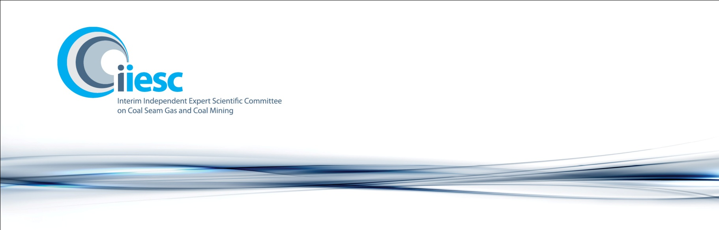

Communiqué
Seventh Meeting: 18-19 July 2012, Canberra

Attendees: Professor Craig Simmons (Chair), Emeritus Professor Peter G Flood, Professor John Langford, Associate Professor David Laurence and Ms Jane Coram. Apologies: Professor Chris Moran and Professor David Laurence.

The Interim Independent Expert Scientific Committee on Coal Seam Gas and Coal Mining (the interim committee) met in Canberra, on 18-19 July 2012. The main focus of the interim committee was to consider six coal mining projects referred to it by the Australian Government. The interim committee was also briefed on the progress of the bioregional assessments and knowledge projects.

The interim committee provided advice on the following six projects: Hancock Prospecting Pty Ltd – Alpha Coal Project – Mine and Rail Development; Centennial Coal Clarence Expansion; Anglo Coal (Foxleigh) Pty Ltd/Foxleigh Coal Mine Extension; Middlemount Coal/Middlemount Coal Mine; Santos Future Gas Supply Area Project and the Arrow Bowen Gas Project.

The interim committee were provided with an overview of the development of the bioregional assessment methodology. The interim committee agreed that the methodology was the underpinning scientific framework and guidance to conduct bioregional assessments, and noted that the methodology would be referred for peer review.
In developing Information Guidelines to support the provision of robust advice, the interim committee agreed that a risk-based assessment of the impact on water resources at both the site and regional level should be provided for each project to be sent to the interim committee for advice. This assessment should include, but not be limited to:
- details of the measured hydrogeological data, and model parameters, uncertainties, and confidence/reliability
- a site and regional water balance which provides basin and catchment-scale context for the proposed action
- surface water and groundwater quantity and quality fluxes, including impacts of the proposal on the water resource, water balance and solute balance
- regional cumulative impacts (covering surface water, groundwater, geomorphological, hydrological and ecological impacts); and
- mitigation and management measures to address these identified risks appropriately.

Committee Support

The interim committee is supported by the Office of Water Science, a dedicated unit established in the Department of Sustainability, Environment, Water, Population and Communities. The interim committee will continue to work closely with the Office of Water Science to progress its work until a handover to the new statutory committee is complete.

