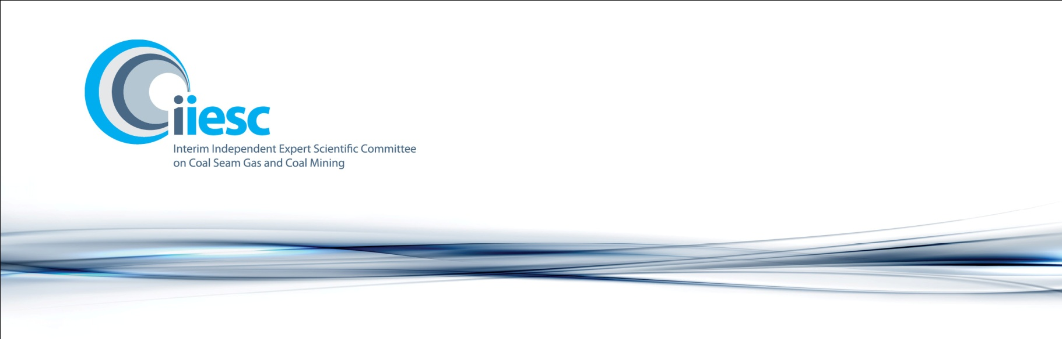

**Communiqué**

**Sixth Meeting: 20-21 June 2012, Canberra**

Attendees: Professor Craig Simmons (Chair), Emeritus Professor Peter G Flood, Professor John Langford, Associate Professor David Laurence and Ms Jane Coram. Apologies: Professor Chris Moran.

The Interim Independent Expert Scientific Committee on Coal Seam Gas and Coal Mining (the committee) met in Canberra, on 20-21 June 2012, to discuss the provision of advice on four coal mining projects referred to it by the Australian Government. The committee also discussed its strategic framework, the development of information guidelines to help industry submit proposals, progress on research projects, bioregional assessments and lessons learnt that could be provided to the statutory committee when it commences.

The committee considered five projects: the AMCI (Alpha) Pty Ltd – South Galilee Coal Project, the Adani Resources Ltd – Carmichael Coal Mine and Rail Project, the Aquila Resources Ltd – Blackwater Washpool Coal, the Alpha Coal Project and the Warkworth Mine Extension (open cut coal mine). The committee provided advice on the AMCI (Alpha) Pty Ltd, the Adani Resources Ltd, the Aquila Resources Ltd and the Warkworth Mine Extension projects. The committee agreed to further discuss and provide advice on the Alpha Coal Project at the next meeting in July.

The draft strategic framework for the committee was further discussed. The committee considered the document and its intended audience, the committee’s aspirations, cumulative impacts, best practice examples, the need for case studies and an increased dialogue with regulators and proponents.

The development of information guidelines to help industry submit coal seam gas and coal mining proposals was also supported by the committee to complement the strategic framework. The information guidelines would provide regulators and proponents with the information needed to provide proposals to the committee for advice and include examples of best practice when preparing proposals.

In developing the information guidelines, the committee agreed that proponents and regulators could include information on water balances, cumulative impacts and an uncertainty analysis in their proposals to assist the committee to provide more timely advice on projects. The committee noted that while proponents were in a position to provide site water information and perform an uncertainty analysis of the proposed operation, the water balance and cumulative impact information would need to be provided by regulators.

A progress report on research projects was presented to the committee. The committee agreed that governance arrangements, such as establishing steering committees to oversee the progress and finalisation of research activities, should be developed.

The Office of Water Science advised that the first meeting of the National Partnership Agreement Reference Group had been held on 7 June 2012 and positive feedback had been received about the development of information guidelines. Representatives from New South Wales, Queensland, South Australia and Victoria attended the meeting. Current activities being conducted by the Natural Resource Management boards includes research on water balances and restrictions of use, cataloguing of existing data and working with communities to catalogue environmental assets in regions.

The Queensland Water Commission provided a presentation on the Surat Underground Water Impact Report. The committee was provided with an overview of the research activity and progress to date. The commission advised the committee that its role was to promote the research activity, provide an annual report to government on the outcomes of the project, develop biannual reports with companies and review the research methodology of the project every three years.

A presentation was provided by the Department of Resources, Energy and Tourism in conjunction with the Chair of the Standing Council on Energy and Resources, Coal Seam Gas Steering Committee and SKM consultants on the development of a harmonised framework for the Australian coal seam gas industry. The committee was advised that the project would be looking at hazards, re-use of water extracted by coal seam gas, inter-leakage of aquifers from poor well construction or abandonment and chemical use. It was noted by the committee that the findings so far indicate that the Australian coal seam gas industry is leading the way with best practice in chemical use in the industry. It was also noted by the committee that stakeholder meetings would be held during the project.

The committee had discussions about lessons learnt that would assist the statutory committee when it commences. The committee noted that having a multi-disciplinary group, two-day committee meetings, workshops with stakeholders and the electronic dissemination of information had worked well.

**Committee support**

The committee is supported by the Office of Water Science, a dedicated unit established in the Department of Sustainability, Environment, Water, Population and Communities. The committee will continue to work closely with the Office of Water Science to progress its work until a handover to the statutory committee is complete.