

Independent Expert Scientific Committee on Coal Seam Gas and Large Coal Mining Development:

Review of activities

July 2014-June 2015

*An overview of the activities of the Independent Expert Scientific Committee on Coal Seam Gas and Large Coal Mining Development from July 2014 to June 2015*

© Copyright Commonwealth of Australia, 2015



*Review of activities - July 2014–June 2015* is licensed by the Commonwealth of Australia for use under a Creative Commons By Attribution 3.0 Australia licence with the exception of the Coat of Arms of the Commonwealth of Australia, the logo of the agency responsible for publishing the report, content supplied by third parties, and any images depicting people. For licence conditions see: <http://creativecommons.org/licenses/by/3.0/au/>.

This report should be attributed as ‘*Independent Expert Scientific Committee on Coal Seam Gas and Large Coal Mining Development: Review of activities – July 2014-June 2015, Commonwealth of Australia, 2015’.*

This publication is funded by the Australian Government Department of the Environment. The views and opinions expressed in this publication are those of the authors and do not necessarily reflect those of the Australian Government or the Minister for the Environment.

**Contact details**

For information about this report or about the work of the IESC, please contact:

IESC Secretariat

Office of Water Science

Department of the Environment

GPO Box 787

CANBERRA ACT 2601

The report can be accessed at www.iesc.environment.gov.au .

This report outlines the activities of the Independent Expert Scientific Committee on Coal Seam Gas and Large Coal Mining Development (the IESC) for the period July 2014 to June 2015.

Contents

**Foreword** 4

**1.** **Introduction** 5

**1.1.** **Key achievements** 5

**1.3.** **Appointment of new Chair and members** 6

[**1.2.** **Legislative functions of the IESC** 6](http://spire.environment.gov.au/spire/170614/804/Communication%20-%20IESC%20Annual%20Review%20of%20Activities/IESC%20Review%20of%20Activities%20-%20July%2014%20to%20June%2015%20Final%20Sept%2015.docx#_Toc433016358)

**2.** **Coal seam gas and large coal mining development proposals** 7

**2.1.** **Scientific advice on development proposals** 7

**2.2.** **Publication of advice** 8

**2.3.** **Application of advice** 8

**3.** **Bioregional Assessments** 9

**3.1.** **Scientific advice on bioregional assessments** 9

**3.2.** **Governance, quality assurance and products** 10

**4.** **Research** 11

**4.1.** **Scientific advice on research priorities** 11

**4.2.** **Case study: Subsidence from coal mining activities** 12

**4.3.** **Case study: Research on water-related ecological responses to coal seam gas extraction and coal mining development** 13

**4.4.** **Case study: Research on peat swamps and potential impacts from longwall coal mines** 13

**5.** **Understanding and disseminating scientific information** 14

**5.1.** **Communication and publication of information** 14

**Appendix A** 15

**Foreword**

**I am pleased to present the Independent Expert Scientific Committee on Coal Seam Gas and Large Coal Mining Development Annual Review of Activities 2014-2015.**



The IESC has provided over 80 pieces of advice to regulators on the water-related impacts of coal seam gas and large coal mining developments since its establishment in 2011.

Through the delivery of another years intensive work program, we have in 2014-15 continued to contribute to a strengthened regulatory decision making framework for both Commonwealth and State Governments. The work of the IESC has been very ably supported by the Office of Water Science in the Department of Environment.

The IESC welcomed three new members in 2014. Dr Andrew Boulton, Dr Tom Hatton and Dr Jenny Stauber all bring a wealth of knowledge and expertise to the IESC. Dr Boulton is Adjunct Professor in Ecosystems Management at the University of New England, his research has focussed on river and groundwater ecology. Dr Hatton has over 25 years of research experience, both nationally and internationally, in a broad range of environmental disciplines. Dr Stauber is an internationally renowned ecotoxicologist with over 30 years of research experience.

I would like to thank and acknowledge former members Emeritus Professor Angela Arthington, Mr Jim McDonald and Professor Dayanthi Nugegoda for their valuable service.

I would particularly like to thank Ms Lisa Corbyn who retired as Chair of the IESC in April 2015. Ms Corbyn played an outstanding role in establishing the IESC as a highly-respected, independent advisory body. We will miss her leadership, dedication and enthusiasm!

The IESC looks forward to continuing to provide excellent and independent scientific advice to its stakeholders in the year ahead.



Dr Andrew Johnson FTSE FAICD

Chair

1. **Introduction**

**The Independent Expert Scientific Committee on Coal Seam Gas and Large Coal Mining Development (the IESC) is a statutory body established under the *Environment Protection and Biodiversity Conservation Act 1999* (EPBC Act). The IESC provides scientific advice to the Australian and state government regulators on the water-related impacts of coal seam gas and large coal mining development proposals. The IESC also provides advice to the Australian Government on bioregional assessments and research priorities and projects.**

The IESC currently consists of seven members with extensive scientific qualifications and expertise in the fields of geology, hydrogeology, hydrology, ecology, ecotoxicology, natural resource management and environment protection. Members are appointed by the Australian Government Minister for the Environment on a part-time basis.

**Further information:** [www.iesc.environment.gov.au/committee/index.html](http://www.iesc.environment.gov.au/committee/index.html)

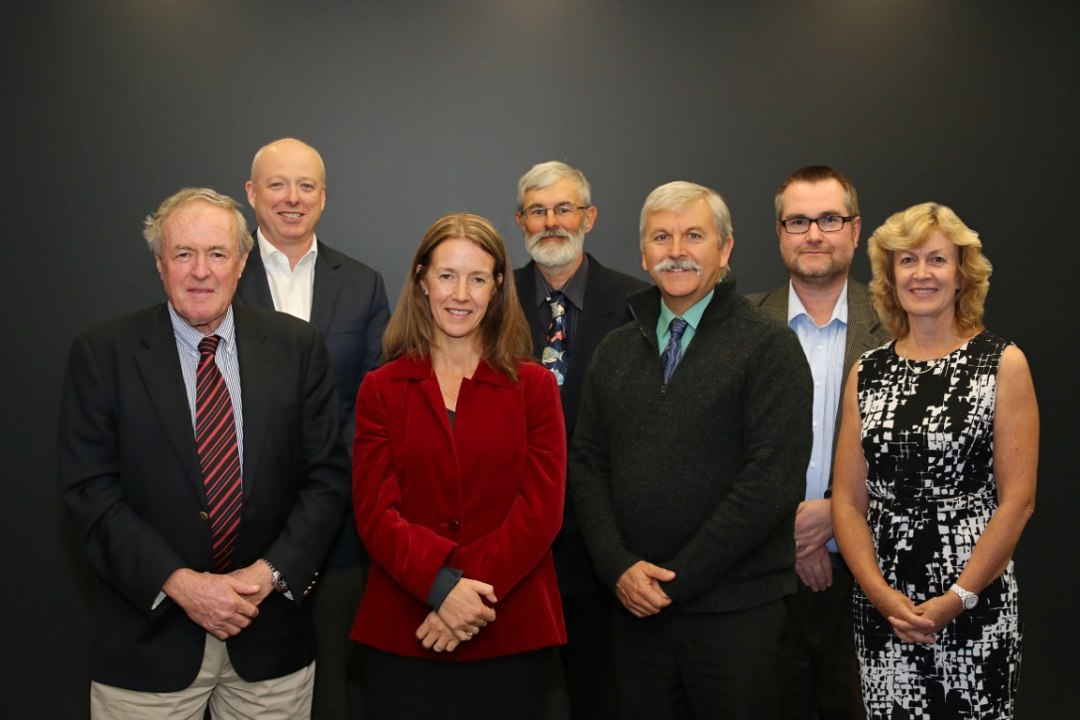

**IESC members (left-right)**

**Emeritus Professor Peter Flood**

**Dr Andrew Johnson (Chair)**

**Ms Jane Coram**

**Dr Andrew Boulton**

**Dr Tom Hatton**

**Professor Craig Simmons**

**Dr Jenny Stauber**

*Photo: Independent Expert Scientific Committee*

* 1. **Key achievements**

The IESC has contributed to strengthening the science underpinning regulatory decisions on coal seam gas and large coal mining development proposals by:

* providing advice on 17 requests from the Australian, New South Wales, South Australian and Queensland government regulators on coal seam gas and large coal mining development proposals; and
* providing advice to the Australian Government on bioregional assessments and other priority research, including endorsing the methodology for the bioregional assessments, providing advice on research projects and priorities, endorsing six reports for publication and publishing three fact sheets on current scientific issues.
  1. **Legislative functions of the IESC**

Under the EPBC Act, the IESC has several legislative functions. These include to:

* Provide scientific advice to the Australian Government Environment Minister and relevant state ministers on the water-related impacts of proposed coal seam gas or large coal mining developments.
* Provide scientific advice to the Australian Government Environment Minister on:
* bioregional assessments being undertaken by the Australian Government; and
* research priorities and projects commissioned by the Australian Government Environment Minister.
* Publish and disseminate scientific information about the impacts of coal seam gas and large coal mining activities on water resources.
  1. **Appointment of new Chair and members**

Inaugural Chair, Ms Lisa Corbyn retired from the IESC on 30 April 2015. During her tenure, Ms Corbyn played a pivotal role in establishing the IESC as a highly-respected, independent advisory body delivering expert scientific advice to government.

The Minister for the Environment, the Hon Greg Hunt MP, appointed existing IESC member Dr Andrew Johnson as Chair of the IESC from 1 May 2015 to 30 June 2017. Dr Johnson is an internationally regarded natural resource scientist and research leader, and a Fellow of the Australian Academy of Technological Sciences and Engineering. Dr Johnson has been a member of the IESC since its inception in 2012.

The Minister for the Environment also appointed three new members on 27 November 2014:

* Dr Andrew Boulton-Adjunct Professor in Ecosystem Management at the University of New England.
* Dr Tom Hatton - Adjunct Professor at the University of Western Australia and Chair of the Western Australian Marine Parks and Reserves Authority.
* Dr Jenny Stauber - ecotoxicologist and Chief Research Scientist in the CSIRO Land and Water Flagship.

The appointment of new members followed the conclusion of the terms of members Emeritus Professor Angela Arthington, Mr Jim McDonald and Professor Dayanthi Nugegoda.

1. **Coal seam gas and large coal mining development proposals**
   1. **Scientific advice on development proposals**

A primary role of the IESC is to provide expert scientific advice on the water-related impacts of coal seam gas and large coal mining development proposals to the Australian and state government regulators to enable better informed regulatory decision-making. The IESC’s advice is intended to help increase transparency and strengthen the scientific basis of regulatory decisions.

To date, the IESC’s advice has highlighted the need to provide adequate baseline information and to consider:

* development and application of conceptual and numerical models at multiple scales;
* potentially significant impacts to water resources and water-related assets, including upstream and downstream, direct and indirect impacts;
* potential impacts to groundwater dependent ecosystems;
* site water and salt balances, and cumulative impacts from activities in the same catchment or region; and
* the effectiveness of ongoing monitoring, mitigation and management measures.

**Summary of development proposals considered by the IESC from July 2014 to June 2015**

* The IESC responded to seventeen requests from the Australian, New South Wales, South Australian and Queensland government regulators.
  + Five requests from the Australian government regulator, five joint requests from Australian and New South Wales government regulators, three joint requests from the Australian and Queensland government regulators, three requests from the New South Wales government regulator and one request from the South Australian government regulator.
  + Fourteen requests related to large coal mining development proposals and three related to coal seam gas proposals.
  + Four requests were for development proposals in Queensland, 11 in New South Wales, one in South Australia and one in Western Australia.
  + Six requests were for new developments and 11 were extensions to existing developments.
  + The expected production of the proposed coal mining developments ranged from 1 million to 20 million tonnes per year, and represents a sum total of 91.5 million tonnes per year.
  + The proposed coal seam gas developments ranged from 10 to 6,100 wells and covered development areas of up to 10,000 km2 and represent a sum total of 10,110 wells and 18,700 km2 of gas field area.

A list of development proposals considered by the IESC during the period July 2014 to June 2015 is provided at Appendix A.

* 1. **Publication of advice**

To achieve well informed communities that have greater confidence in the regulation of coal seam gas and large coal mining developments, the IESC makes all of its advice on development proposals publicly available on its website: [www.iesc.environment.gov.au/advice/proposals.html](http://www.iesc.environment.gov.au/advice/proposals.html).

Amendments to the Environment Protection and Biodiversity Conservation Regulations 2000 that came into effect in July 2014 require the IESC to publish its advice within 10 business days of it being provided to the relevant regulator/s. Consistent with this requirement, the IESC routinely publishes its advice on the 10th business day ensuring that this statutory obligation is met.

* 1. **Application of advice**

The IESC’s advice is required to be taken into account by regulators in all relevant assessment and approval decisions. Explicit adoption of advice depends on the particularities of the advice provided and the proposed project. The IESC has been fundamental in identifying where there is insufficient information to fully determine the water impacts and where additional research, including modelling of potential impacts, needs to be undertaken to ensure better understanding of the impacts of the proposed development.

*Photo: Site visit to the Woronora River catchment*

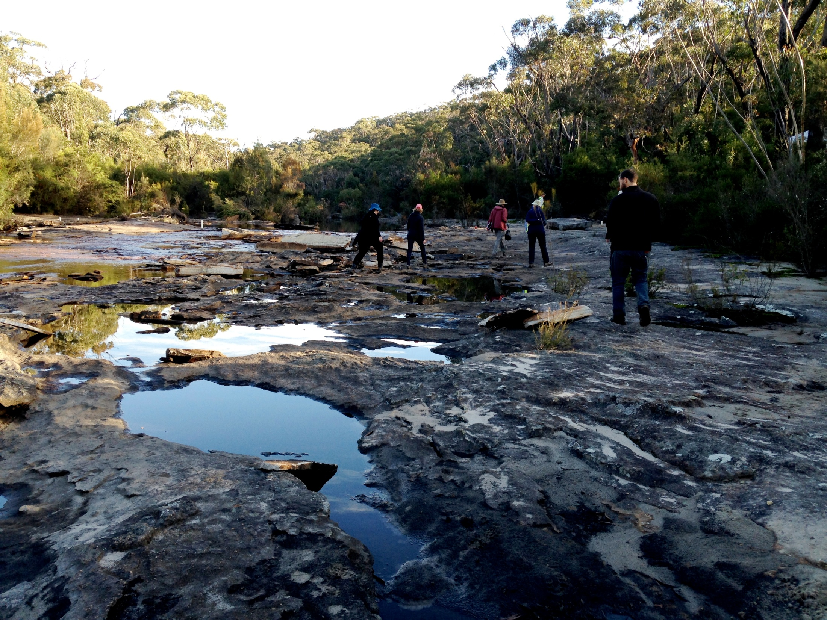

The IESC’s advice strengthens the scientific basis of regulatory decisions in a number of ways, including by advising on specific potential impacts and associated risks, and more broadly by encouraging improved environmental impact assessments by proponents. The IESC’s advice is also a valuable source of information on knowledge gaps to inform research to further strengthen the science underpinning the assessment process.

Example of how the advice of the IESC has been applied in setting project conditions:

**Watermark Coal Project (NSW)**: The advice found that the groundwater modelling was robust and can be relied on to predict any impacts on water, but suggested additional modelling, monitoring and management measures to improve confidence in predictions of impacts to water resources over time. The IESC advice also identified issues with the identification of and potential impacts to groundwater dependent ecosystems; long-term impacts associated with the final landform; and local-scale salinity. The Australian Government’s approval conditions fully addressed the IESC’s advice, requiring an adaptive management approach to ensure that no unexpected impacts to water resources will occur. The conditions also include a provision allowing the Australian Government Environment Minister to stop the mine operation if impacts are greater than those approved.

1. **Bioregional Assessments** 
   1. **Scientific advice on bioregional assessments**

The IESC provides advice to the Minister for the Environment on the Australian Government’s Bioregional Assessment Programme, and the science underpinning the methodology used to prepare them. The bioregional assessments are being delivered through a collaboration between the Australian Government Department of the Environment, the Bureau of Meteorology, CSIRO and Geoscience Australia.

Bioregional assessments are regional scale scientific studies that will enable assessment of cumulative impacts from multiple coal seam gas and large coal mining developments. They draw together available information about a region’s ecology, geology, hydrology and hydrogeology to provide an integrated picture of water resources in assessment regions. This information is then used to inform the development of regional surface and groundwater models to estimate the possible extent of cumulative impacts on water resources and water dependent assets.

**Further information:** [www.bioregionalassessments.gov.au](http://www.bioregionalassessments.gov.au).

Initial bioregional assessment products providing contextual and background information in the respective regions being assessed were released throughout the year, and further products are being progressively made available. The final assessments are due to be completed by the end of 2016. The bioregional assessments are intended to provide a single authoritative source for which all interested parties, including government regulators, natural resource managers, coal seam gas and coal mining companies, interested community members and the IESC, can refer when considering the water-related impacts of potential coal seam gas and large coal mining developments.

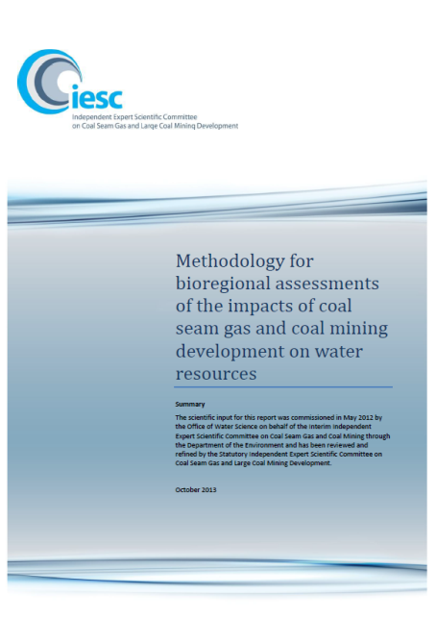

Bioregional assessments are being undertaken across New South Wales, Queensland, South Australia and Victoria, in the following areas:

* the Galilee, Cooper, Pedirka and Arckaringa subregions, within the Lake Eyre Basin bioregion
* the Maranoa-Balonne-Condamine, Gwydir, Namoi and Central West subregions, within the Northern Inland Catchments bioregion
* the Clarence-Moreton bioregion, NSW
* the Hunter and Gloucester subregions, within the Northern Sydney Basin bioregion, NSW
* the Sydney Basin bioregion, NSW
* the Gippsland Basin bioregion, VIC

A scientific methodology to guide how bioregional assessments are being undertaken was released by the Australian Government Minister for the Environment in October 2013, following endorsement by the IESC. The methodology articulates the scientific and intellectual basis for a consistent approach to all bioregional assessments.

The IESC has provided advice on the development of 11 submethodologies which describe in more detail the processes to be followed to undertake specific aspects of the overarching methodology. Two submethodologies were released through the year and are available on the bioregional assessments website.

* 1. **Governance, quality assurance and products**

The IESC provides advice on governance and quality assurance processes for bioregional assessments. This includes providing input into and reviewing bioregional assessment technical products.

The following technical products were considered by the IESC and have since been released by the Minister for the Environment.

* Context statements for Central West, Gwydir, Maranoa-Balonne-Condamine and Hunter subregions that summarise the current extent of knowledge about relevant characteristics of a subregion.
* Coal and coal seam gas resource assessments for the Namoi, Central West, Gwydir, Maranoa-Balonne-Condamine, Galilee and Gloucester subregions and the Clarence-Moreton bioregion that summarise the current status of coal and coal seam gas resource developments and how this may evolve in the future.
* Water-dependent asset register for the Gloucester subregion that broadly describes and lists the water-dependent assets identified in the subregion.
* Data registers for the Galilee, Maranoa-Balonne-Condamine, Gwydir, Namoi, Central West, and Hunter and Gloucester subregions and the Clarence-Moreton bioregion that list and broadly describe datasets used in the bioregional assessment for each subregion or bioregion.

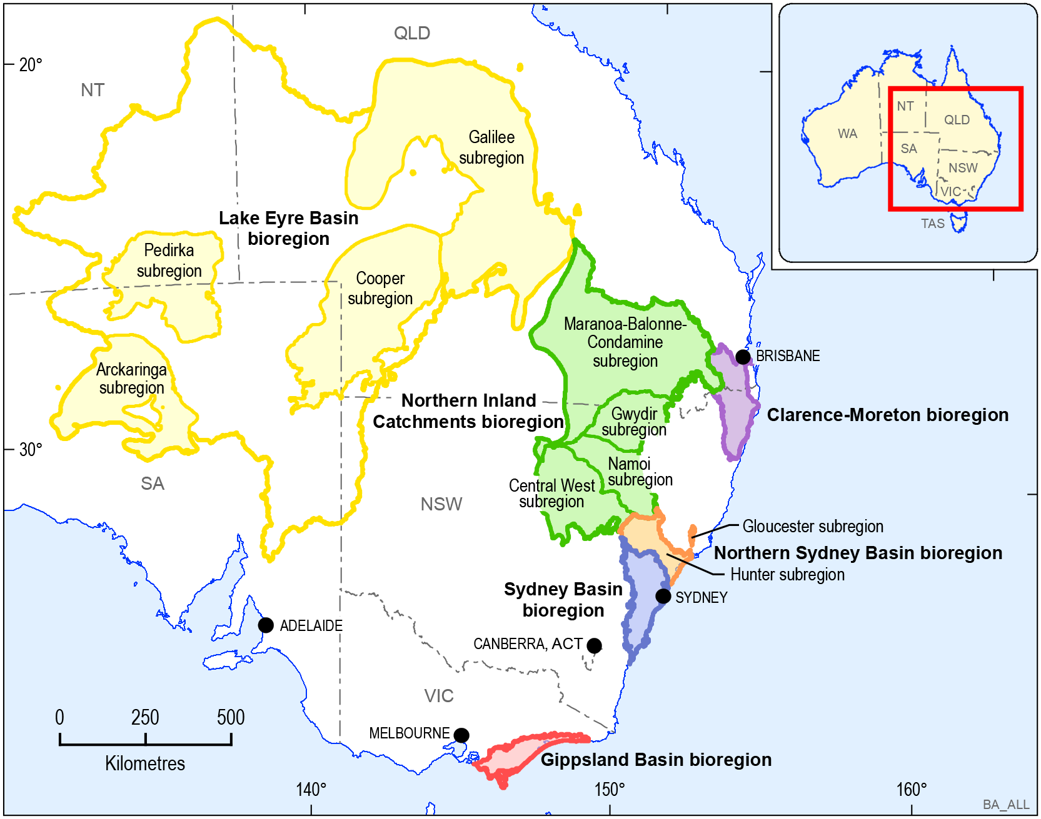

*Map: Bioregions and subregions*

1. **Research** 
   1. **Scientific advice on research priorities**

The IESC provides scientific advice to the Minister for the Environment on priorities and projects for the Australian Government’s research into the water-related impacts of coal seam gas and large coal mining development. The research aims to strengthen the science underpinning regulatory decisions, including by informing the advice the IESC provides to regulators.

The IESC has previously provided advice on priorities for new research to address knowledge gaps. This advice concentrated on areas of high risk, significant knowledge gaps and where there was potential to produce outputs of national significance within three years. The IESC also took into account current and emerging research being undertaken in Australia and overseas.

This process identified research needs across three priority themes:

* Hydrology—improved scientific understanding and modelling of alterations to groundwater and surface water characteristics and processes.
* Ecosystems and water—strengthening knowledge of potential impacts on key species and ecosystems, as well as methods for monitoring and mitigating these impacts.
* Chemicals—chemical and ecotoxicological investigations including the potential cross-contamination of drinking water and other water resources.

*Photo: IESC member Andrew Boulton (centre) advising the ecology research team at their study site in Maules Creek, NSW*

Cumulative impacts are also of interest and form a cross-cutting issue that is informed by bioregional assessments and ongoing research in the priority themes.

The Australian Government Department of the Environment is progressing priority research projects within these themes.

To date, the Australian Government has funded a series of research projects to address critical gaps in the current scientific understanding of water-related impacts of coal seam gas and large coal mining. This work is managed by the Department of the Environment.

Projects include a national assessment of the chemicals associated with coal seam gas extraction (including hydraulic fracturing), and background reviews on important issues such as bore integrity, connectivity between aquifers and co-produced water.

**Further information:** [www.iesc.environment.gov.au/research](http://www.iesc.environment.gov.au/research)

The IESC continued to provide advice on previously commissioned background reviews and research projects being managed by the Australian Government Department of the Environment. The IESC has made recommendations for improving quality assurance and peer review processes, and:

* endorsed or provided advice on a range of products, including:
  + final report for the project ‘*Modelling water-related ecological responses to coal seam gas and coal mining*’,
  + final report on ‘*Monitoring and management of subsidence induced by longwall coal mining activity*’, and the ‘*Reference list for water related Coal Seam Gas and Coal Mining Research Report (Part 4)*’.
  + ‘*Modelling water-related ecological responses to coal seam gas extraction and coal mining*’  - particularly on the content of a project workshop and assistance with scoping of a subsequent ecological research project.
  1. **Case study: Subsidence from coal mining activities**

Underground coal mining creates a void into which the roof and overlying rock collapse. This typically results in horizontal and vertical movement at the land surface, which can extend beyond the mine footprint and can affect natural and built environments. Although the general behaviour of the rock mass in the area of underground coal mining is well understood, the extent and nature of ground movements at the surface, and impacts to overlying groundwater systems and surface flow, vary on a site-by-site basis depending on local geology and mine layouts.

The report ‘*Subsidence from coal mining activities, Background review*’ (Commonwealth of Australia, 2014) outlines issues associated with subsidence from current coal mining practices in Australia. It discusses the available methods and models for subsidence prediction, the technologies that may be used for measuring and monitoring the scale and extent of mining-induced ground movements, and the prevention, management and mitigation of subsidence.

In its advice to the Australian and New South Wales government regulators on the Airly Mine Extension Project, the IESC recommended additional monitoring of ground movements, and cited the review report to support its advice on monitoring options.

* 1. **Case study: Research on water-related ecological responses to coal seam gas extraction and coal mining development**

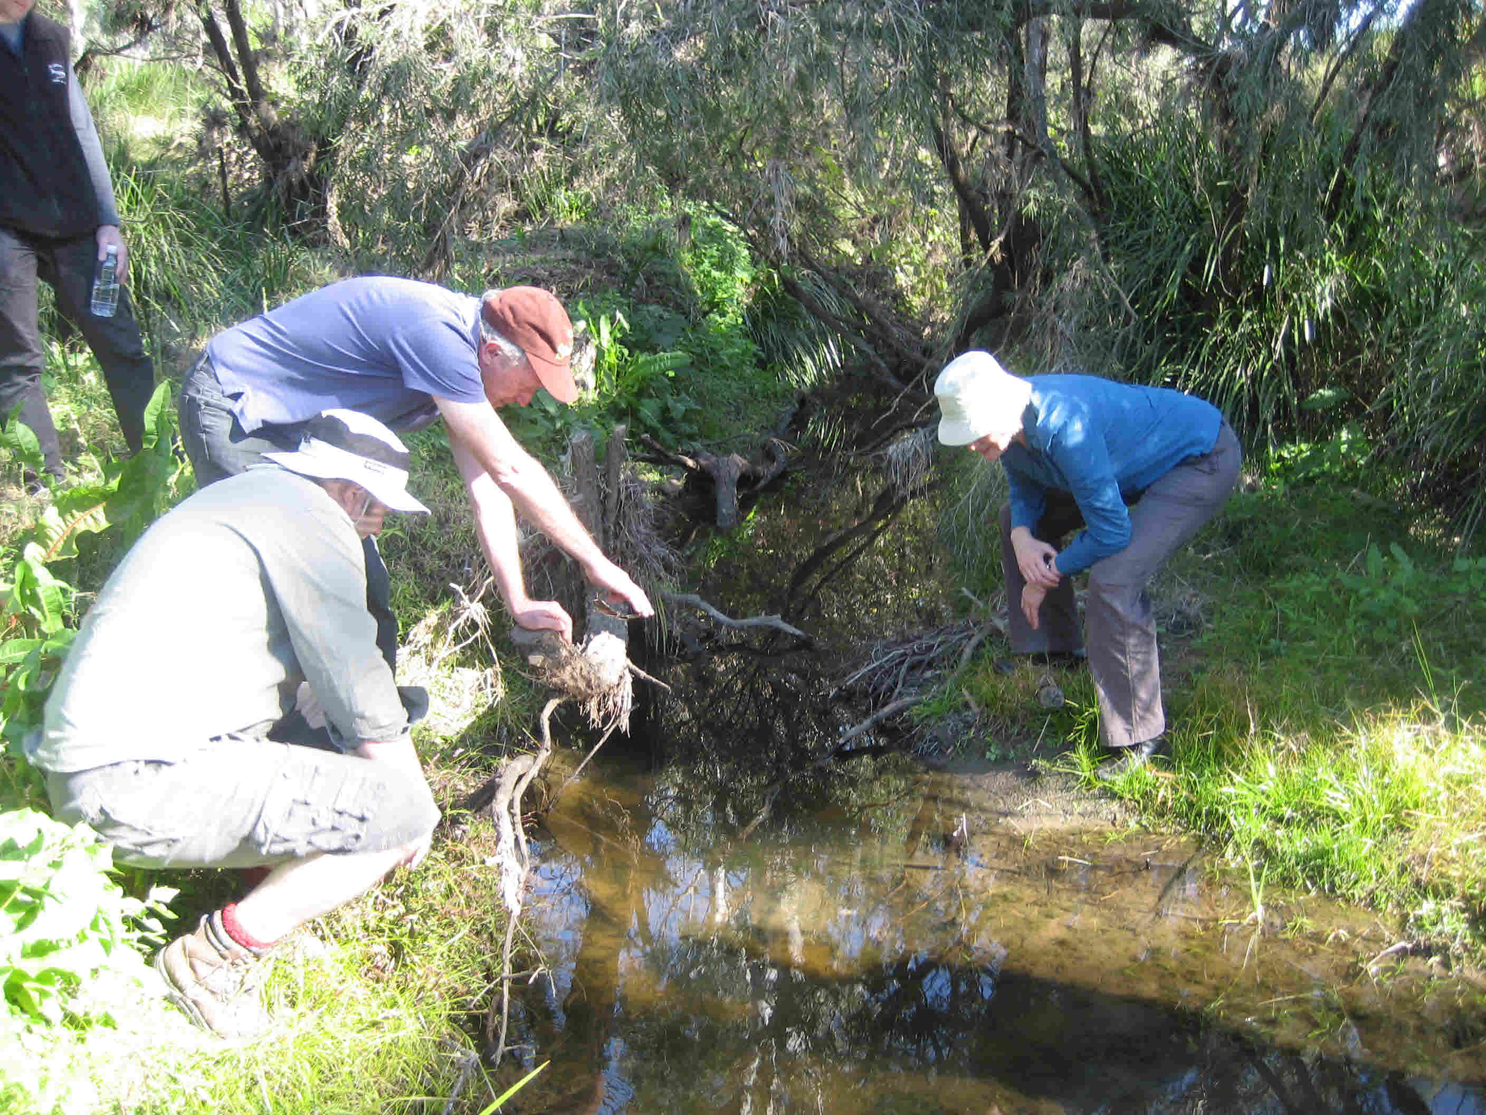The project, ‘*Modelling water-related ecological responses to coal seam gas extraction and coal mining’*, was endorsed by the IESC in 2014 and commissioned by the Australian Government Department of the Environment. The project will provide a common understanding of key aquatic ecological environments, inform subsequent projects in the ecosystems and water theme, explore the development of tools, including monitoring and analytical techniques, required to identify changes that are not part of natural variability.

A project workshop was held in July 2014 with participants including the then IESC member Emeritus Professor Angela Arthington and researchers with expertise in a number of fields including hydrogeology, ecology, wetlands and invertebrates. Two case study sites, Bremer River and Purga Nature Reserve, were visited as they are potentially impacted by existing or proposed mining activities.

*Photo: Bremer River upper reaches*

* 1. **Case study: Research on peat swamps and potential impacts from longwall coal mines**

Two categories of peat swamps are listed as threatened ecological communities under the EPBC Act. The peat swamps largely occupy Sydney Basin sandstone plateaux, and commonly rely on shallow groundwater levels or discharge.

On the advice of the IESC, the Australian Government Department of the Environment commissioned and published three reports on peat swamps. The IESC has subsequently provided advice to regulators, drawing on the findings of this research, which aims to protect peat swamps from mine subsidence impacts.

The reports highlight risks to swamps from subsidence, fracturing, and groundwater drawdown and drainage, and indicate that:

• to date, no strategies, other than changes in mine plan layout, have been proven to effectively mitigate longwall mining impacts to peat swamps.

• ecological baseline data must be established before mining, and subsidence and hydrological monitoring must be undertaken to warn of ecological risks.

• remediation of peat swamps following damage by subsidence cannot be relied upon as a management option.

Some parties have highlighted the resilience of peat swamps to historical mining activities and proposed adaptive management measures to mitigate impacts. However, IESC advice has identified the potential for irreversible impacts to peat swamps from subsidence fracturing and groundwater draw downs which cannot be adaptively managed. A recent approval from the Australian Government regulator for mining in the Illawarra region included conditions to limit subsidence, and constrain the extent of mining to minimise impacts to overlying swamps.

Improved understanding of peat swamps has enabled development of specific advice to regulators on assessment, monitoring, management and mine layout. There are however, ongoing uncertainties relating to fracturing, hydrological responses and ecological tolerances which may require further research.

1. **Understanding and disseminating scientific information**
   1. **Communication and publication of information**

The IESC plays a role in building public confidence in the scientific evidence which informs regulatory decisions on coal seam gas and large coal mining development. The IESC aims to increase awareness of its scientific advice, inform scientific dialogue on research and inform public dialogue on the potential impacts of coal seam gas and large coal mining developments on water resources.

To enable communities to be better informed and have greater confidence in the regulation of coal seam gas and large coal mining developments, the IESC makes all of its advice on these developments publicly available within 10 business days of providing it to the regulator. As the advice is made publicly available before decisions on development proposals are made, a high level of transparency and early access to the advice by all interested parties is ensured.

The IESC’s website is an important tool for communicating and publishing information and is available at: [www.iesc.environment.gov.au](http://www.iesc.environment.gov.au)

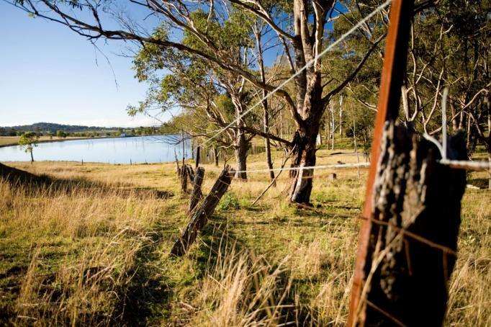The website contains:

* agendas and minutes for all meetings;
* the IESC’s advice on coal seam gas and large coal mining development proposals;
* the Information Guidelines which outline the information considered necessary to enable the IESC to provide robust scientific advice to government regulators;

*Photo: Aquatic ecosystem in the Hunter Valley*

* information on the bioregional assessments and other priority research, including web links to further information on the Australian Government Department of the Environment’s and the Bioregional Assessment’s websites; and
* other publications, including research reports and fact sheets on key scientific issues associated with the water-related impacts of coal seam gas and large coal mining development.

**Appendix A**

**Development proposals considered by the IESC during the period July 2014 to June 2015**

| **IESC #** | **Project title** | **Location** | **Requesting regulator** |
| --- | --- | --- | --- |
| 2014-051 | Bowen Gas Project | QLD | Australian Government |
| 2014-052 | Baralaba North Continued Operation | QLD | Australian and QLD governments |
| 2014-053 | Angus Place Mine Extension Project | NSW | Australian and NSW governments |
| 2014-054 | Springvale Mine Extension Project | NSW | Australian and NSW governments |
| 2014-055 | South Galilee Coal Project | QLD | Australian and QLD governments |
| 2014-056 | Muja South Extension | WA | Australian Government |
| 2014-057 | Russell Vale Colliery Underground Expansion Project | NSW | Australian and NSW governments |
| 2014-058 | Russell Vale Colliery Longwall 6 Project | NSW | Australian Government |
| 2014-059 | Airly Mine Extension Project | NSW | Australian and NSW governments |
| 2014-060 | Strike Energy Final Appraisal Production Testing in PEL 96 Project | SA | SA Government |
| 2014-061 | Santos GLNG Gas Fields Development Expansion Project | QLD | Australian and QLD governments |
| 2015-062 | Mount Owen Continued Operations Project | NSW | Australian and NSW governments |
| 2015-063 | West Muswellbrook Project | NSW | NSW Government |
| 2015-064 | Drayton South Coal Expansion Project | NSW | NSW Government |
| 2015-065 | Russell Vale Colliery Underground Expansion Project | NSW | NSW Government |
| 2015-066 | Watermark Coal Project | NSW | Australian Government |
| 2015-067 | Watermark Coal Project | NSW | Australian Government |

A full list of development proposals for which the IESC has provided advice to regulators is available from the IESC website: [www.iesc.environment.gov.au/advice/proposals.html](http://www.iesc.environment.gov.au/advice/proposals.html).

Information on the projects considered by the Australian Government Regulator under the EPBC Act is available from the Australian Government Department of the Environment’s website: [www.environment.gov.au/water/coal-and-coal-seam-gas](http://www.environment.gov.au/water/coal-and-coal-seam-gas)

