

Independent Expert Scientific Committee on Coal Seam Gas and Large Coal Mining Development:

Review of activities - December 2012-June 2014

*An overview of the activities of the Independent Expert Scientific Committee on Coal Seam Gas and Large Coal Mining Development from December 2012 to June 2014*

© Copyright Commonwealth of Australia, 2014



*Review of activities - December 2012–June 2014* is licensed by the Commonwealth of Australia for use under a Creative Commons By Attribution 3.0 Australia licence with the exception of the Coat of Arms of the Commonwealth of Australia, the logo of the agency responsible for publishing the report, content supplied by third parties, and any images depicting people. For licence conditions see: <http://creativecommons.org/licenses/by/3.0/au/>.

This report should be attributed as ‘*Independent Expert Scientific Committee on Coal Seam Gas and Large Coal Mining Development: Review of activities - December 2012-June 2014, Commonwealth of Australia, 2014’.*

This publication is funded by the Australian Government Department of the Environment. The views and opinions expressed in this publication are those of the authors and do not necessarily reflect those of the Australian Government or the Minister for the Environment.

**Contact details**

For information about this report or about the work of the IESC, please contact:

IESC Secretariat

Office of Water Science

Department of the Environment

GPO Box 787

Canberra ACT 2601

The report can be accessed at [www.iesc.environment.gov.au/index.html](http://www.iesc.environment.gov.au/index.html).

This report outlines the activities of the Independent Expert Scientific Committee on Coal Seam Gas and Large Coal Mining Development (the IESC) for the period December 2012 to June 2014.

A previous review covering the period of December 2012 to December 2013 has been revised to align reporting with standard financial year reporting.

Contents

**1.** **Introduction** 4

**1.1.** **Legislative functions of the IESC** 4

**1.2.** **Key achievements** 4

**2.** **Scientific advice on coal seam gas and large coal mining development proposals** 5

**2.1.** **Scientific advice on development proposals** 5

**2.2.** **Publication of advice** 6

**2.3.** **IESC advice on the EPBC Act amendment** 6

**3.** **Advice on the Bioregional Assessment Programme** 7

**3.1.** **Advice on the Bioregional Assessment Programme** 7

**3.2.** **Advice on the Bioregional Assessment Methodology** 7

**3.3.** **Advice on governance, quality assurance and products** 7

**4.** **Advice on research** 8

**4.1.** **Advice on research projects** 8

**4.2.** **Advice on research priorities** 8

**5.** **Understanding and disseminating scientific information** 9

**5.1.** **Communication and publication of information** 9

**5.2.** **Improving understanding** 9

**Appendix A - Development proposals considered by the IESC** 10

1. **Introduction**

**The Independent Expert Scientific Committee on Coal Seam Gas and Large Coal Mining Development (the IESC) is a statutory body under the *Environment Protection and Biodiversity Conservation Act 1999* (EPBC Act) which provides scientific advice to Australian governments on the water-related impacts of coal seam gas and large coal mining development proposals.**

The IESC consists of eight members with extensive scientific qualifications and expertise in the fields of geology, hydrogeology, hydrology, ecology, ecotoxicology, natural resource management and environment protection. Members are appointed by the Minister for the Environment on a part-time basis.

**Further information:** [www.iesc.environment.gov.au/committee/index.html](http://www.iesc.environment.gov.au/committee/index.html)

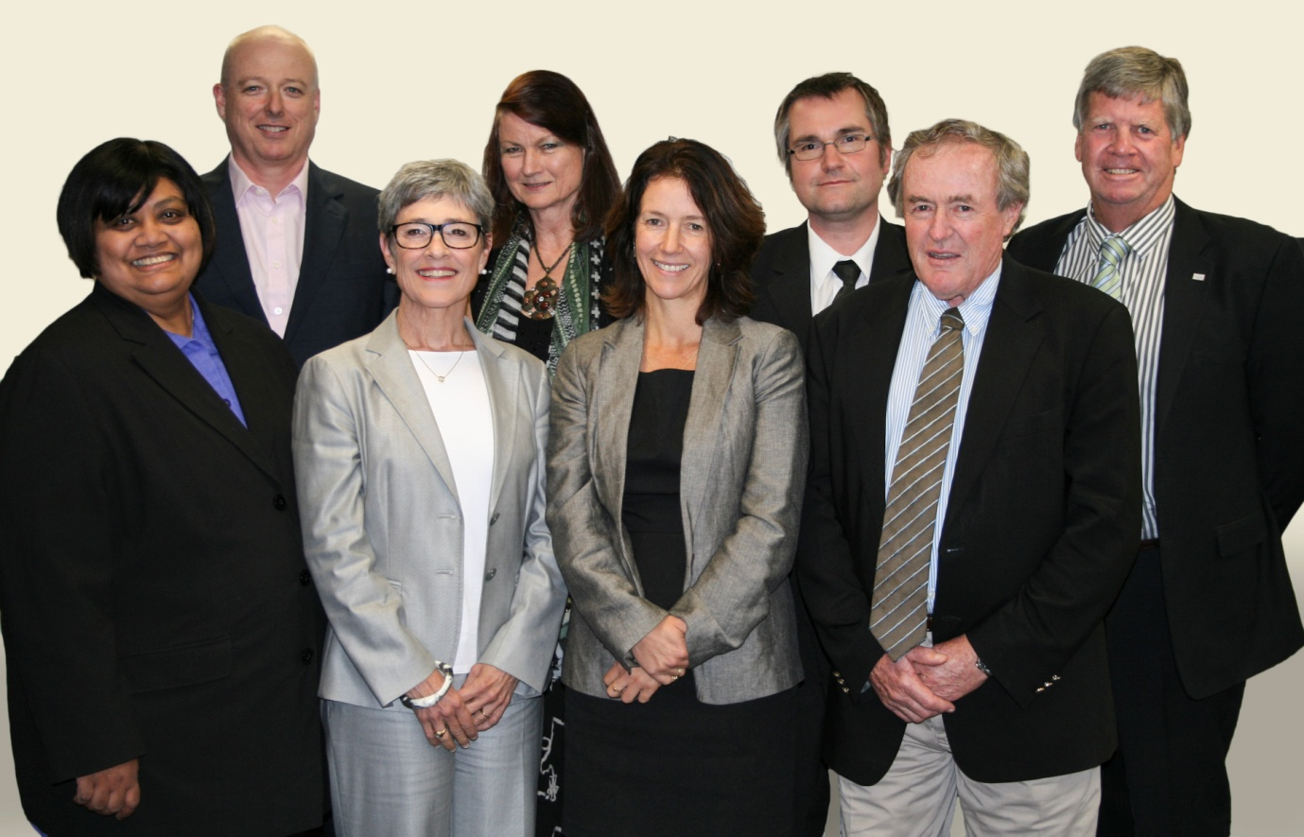

**IESC members (left-right)**

Professor Dayanthi Nugegoda

Dr Andrew Johnson

Ms Lisa Corbyn (Chair)

Emeritus Professor Angela Arthington

Ms Jane Coram

Professor Craig Simmons

Emeritus Professor Peter Flood

Mr Jim McDonald

*Photo: Independent Expert Scientific Committee.*

* 1. **Legislative functions of the IESC**

Under the EPBC Act, the IESC has several legislative functions to:

* Provide scientific advice to the Commonwealth Environment Minister and relevant state ministers on the water-related impacts of proposed coal seam gas or large coal mining developments.
* Provide scientific advice to the Commonwealth Environment Minister on:
* bioregional assessments being undertaken by the Australian Government
* research priorities and projects commissioned by the Commonwealth Environment Minister.
* Publish and disseminate scientific information about the impacts of coal seam gas and large coal mining activities on water resources.
  1. **Key achievements**

The IESC has contributed to strengthening the science underpinning regulatory decisions on coal seam gas and large coal mining development proposals by:

* publishing *Information Guidelines* for use by regulators and proponents to ensure adequate water-related data and tools are used in assessing proposed developments;
* providing expert scientific advice on 44 requests from the Commonwealth, New South Wales and Queensland regulators on large coal mining and coal seam gas development proposals;
* providing advice to the Australian Government on bioregional assessments and research, including endorsing the methodology for the bioregional assessments, providing advice on research projects and priorities, endorsing six background reviews for publication and publishing three fact sheets on current scientific issues.

1. **Scientific advice on coal seam gas and large coal mining development proposals**
   1. **Scientific advice on development proposals**

**Summary of development proposals considered by the IESC from Dec 2012 to June 2014**

* 44 requests from the Commonwealth, New South Wales and Queensland regulators.
* 27 requests from the Commonwealth regulator, 12 joint requests from Commonwealth and Queensland regulators, 2 requests from the Queensland regulator, and 3 requests from the New South Wales regulator.
* 38 requests related to large coal mining development proposals and 6 related to coal seam gas proposals.
* 24 requests on development proposals in Queensland, 19 in New South Wales, and 1 in Western Australia.
* 25 requests were for new developments and 19 were extensions to existing developments.
* The expected production of the proposed coal mining developments ranged from 1 million to 30 million tonnes per year.
* The proposed coal seam gas developments have ranged from 60 to 6,500 wells and have covered development areas of up to 8,000 km2.

A primary role of the IESC is to provide expert scientific advice on the water-related impacts of coal seam gas and large coal mining development proposals to Commonwealth and state Government regulators to enable better informed regulatory decision-making. The IESC’s advice is intended to help increase transparency and strengthen the scientific basis of regulatory decisions.

In March 2013, the IESC published *Information Guidelines*. The Information Guidelines assist regulators and proponents provide the information considered necessary by the IESC to enable the delivery of robust scientific advice. The IESC undertook a review of the Information Guidelines in consultation with regulators and government scientific agencies, and released an updated version in April 2014. The Information Guidelines are available online: [www.iesc.environment.gov.au/publications.html](http://www.iesc.environment.gov.au/publications.html).

To date, the IESC’s advice has highlighted the need to provide adequate baseline information and to consider:

* the scale of developments in a regional context
* development and application of hydrological models
* site water and salt balances
* potentially significant impacts to water resources and water related assets, including upstream and downstream, direct and indirect impacts
* cumulative impacts from activities in the same catchment or region
* the effectiveness of ongoing monitoring, mitigation and management measures.

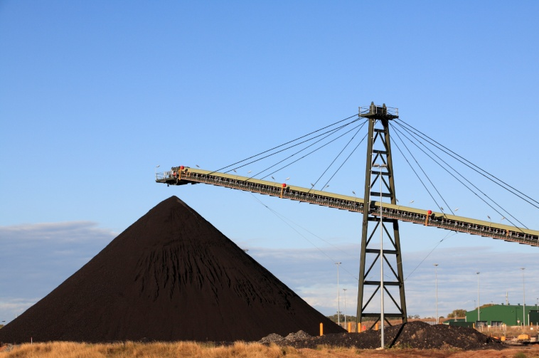A list of development proposals considered by the IESC is provided at Appendix A.

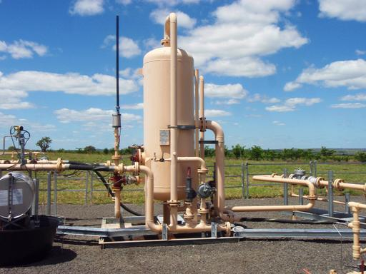

*Photo: Coal seam gas operations.*

*Photo: Coal mining operations.*

* 1. **Publication of advice**

To achieve well informed communities that have greater confidence in the regulation of coal seam gas and large coal mining developments, all IESC advice is to be made publicly available. As at end of June 2014, 22 of the 44 pieces of advice provided to regulators on proposed developments have been published. Aiming to balance the principles of transparency, equity of access and commitment to informing the regulatory decision making process, the IESC has adopted a protocol for publishing that involves the advice being published within 10 business days of being provided to regulators.

Once published, the IESC’s advice on development proposals is available on its website: [www.iesc.environment.gov.au/advice/proposals.html](http://www.iesc.environment.gov.au/advice/proposals.html).

* 1. **IESC advice on the EPBC Act amendment**

In June 2013, the EPBC Act was amended to include significant impacts on water resources as a new matter of national environmental significance in relation to coal seam gas and large coal mining development (‘water trigger’). Any project that has or is likely to have a significant impact on water resources must be referred to the Commonwealth regulator for assessment and approval.

The IESC also provided scientific advice to the Commonwealth Environment Minister on the implementation of the then proposed legislative amendment to the EPBC Act. In its advice, the IESC outlined scientific elements for inclusion in the definition of a significant impact on water resources and in the terms of reference for the assessment of coal seam gas and large coal mining developments, and identified mitigation actions that could be considered by regulators. The IESC also provided scientific advice to the Commonwealth regulator, as requested, on the draft Significant Impact Guidelines for the ‘water trigger’.

The IESC’s advice on these matters is available on its website: [www.iesc.environment.gov.au/advice/othermatters.html](http://www.iesc.environment.gov.au/advice/othermatters.html).

1. **Advice on the Bioregional Assessment Programme**
   1. **Advice on the Bioregional Assessment Programme**

The IESC provides advice on the Australian Government’s Bioregional Assessment Programme and the science underpinning the methodology used to prepare them. The bioregional assessments are being delivered through a collaboration between the Department of the Environment, the Bureau of Meteorology, CSIRO and Geoscience Australia.

Bioregional assessments are innovative science-based studies developing detailed baseline information and analysis of the environment in particular geographic areas underlain by coal and coal seam gas resources. Bioregional assessments are analysing the ecology, hydrology, geology and hydrogeology of bioregions, with explicit assessment of the potential direct, indirect and cumulative impacts of coal seam gas and large coal mining development on water resources both above and below ground.

**Further information:** [www.bioregionalassessments.gov.au](http://www.bioregionalassessments.gov.au).

The initial bioregional assessments products were first released in June 2014 and are being progressively made available to June 2016. As products are released, the bioregional assessments are intended to provide a single authoritative source for all interested parties, including government regulators, natural resource managers, coal seam gas and coal mining companies, interested community members and the IESC, to refer to when considering the water-related impacts of potential coal seam gas and large coal mining developments.

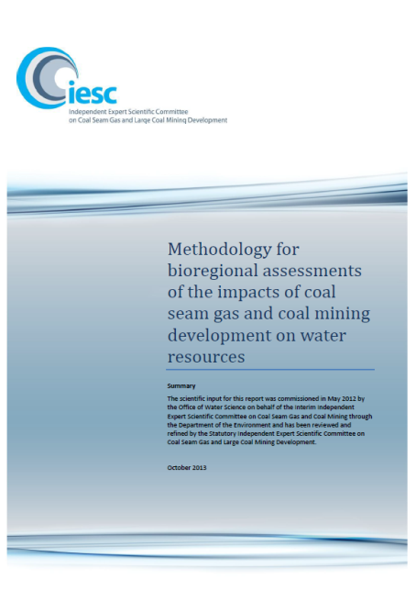

Bioregional assessments are being undertaken across New South Wales, Queensland, South Australia and Victoria, in the following areas:

* the Galilee, Cooper, Pedirka and Arckaringa subregions, within the Lake Eyre Basin bioregion
* the Maranoa-Balonne-Condamine, Gwydir, Namoi and Central West subregions, within the Northern Inland Catchments bioregion
* the Clarence-Moreton bioregion
* the Hunter and Gloucester subregions, within the Northern Sydney Basin bioregion
* the Hawkesbury-Nepean, Georges River and Wollongong Coast subregions, within the Southern Sydney Basin bioregion
* the Gippsland Basin bioregion.
  1. **Advice on the Bioregional Assessment Methodology**

A scientific methodology to guide how bioregional assessments are being undertaken has been developed. The methodology articulates the scientific and intellectual basis for a consistent approach to all bioregional assessments. The IESC was involved in the development of, and endorsed the bioregional assessment methodology, which was released in October 2013.

* 1. **Advice on governance, quality assurance and products**

The IESC also provides advice on governance and quality assurance processes for bioregional assessments, and has highlighted the importance of conducting effective stakeholder engagement.

The IESC is providing input to and reviewing bioregional assessments technical products. The first technical products—context statements for the Galilee, Gloucester and Namoi subregions, and the Clarence-Moreton bioregion—were released in June 2014. The context statements bring together existing information about the ecology, hydrology, geology and hydrogeology of each region and will provide a reference that will inform modelling and analysis of the impacts of coal seam gas and large coal mining activities in later technical products.

1. **Advice on research** 
   1. **Advice on research projects**

The IESC provides scientific advice to the Australian Government on previously commissioned background reviews and research projects being managed by the Department of the Environment. The IESC has made recommendations for improving quality assurance and peer review processes.

To date, the Australian Government has funded a series of research projects to address critical gaps in the current scientific understanding of water-related impacts of coal seam gas and large coal mining.

Projects include a national assessment of the chemicals associated with coal seam gas extraction (including hydraulic fracturing), and background reviews on important issues such as bore integrity, connectivity between aquifers and co-produced water.

In June 2014, six background reviews were published:

* Aquifer connectivity within the Great Artesian Basin, and the Surat, Bowen and Galilee Basins
* Hydraulic fracturing (‘fraccing’) techniques
* Co-produced water – risks to aquatic ecosystems
* Subsidence from coal seam gas extraction in Australia
* Subsidence from coal mining activities
* Bore Integrity.

**Further information:** [www.iesc.environment.gov.au/research/index.html](http://www.iesc.environment.gov.au/research/index.html).

* 1. **Advice on research priorities**

Following consultation with key stakeholders, the IESC provided advice to the Commonwealth Environment Minister on priorities for new research projects in September and October 2013. The advice concentrated on areas of high risk, significant knowledge gaps and where there was potential to produce outputs of national significance within three years. The IESC’s advice was informed by a workshop with stakeholders in March 2013. The IESC also took into account current and emerging 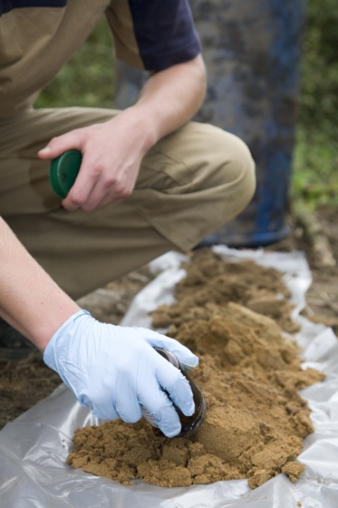research being undertaken in Australia and overseas.

The IESC identified knowledge gaps and has provided scientific input to identify research needs in four priority areas or themes relating to the potential impacts on water resources from coal seam gas and large coal mining developments:

* Hydrology—better understanding and modelling of alterations to groundwater and surface water characteristics and processes.
* Ecosystems and water—strengthening knowledge of potential impacts on key species and ecosystems, as well as methods for monitoring and mitigating these impacts.
* Chemicals—chemical and ecotoxicological investigations including the potential cross-contamination of drinking water and other water resources.
* Cumulative impacts—assessing the potential impacts from individual coal seam gas or coal mining developments in conjunction with the impacts from other existing and likely developments in the region.

*Photo: Soil sampling.*

The Department of the Environment is progressing priority research projects within these themes.

**Further information:** [www.iesc.environment.gov.au/research/index.html](http://www.iesc.environment.gov.au/research/index.html).

1. **Understanding and disseminating scientific information**
   1. **Communication and publication of information**

The IESC has a role to build public confidence in the scientific evidence which informs regulatory decisions on coal seam gas and large coal mining development. The IESC aims to increase awareness of its scientific advice, inform scientific dialogue on research, and inform public dialogue on the potential impacts of coal seam gas and large coal mining developments on water resources.

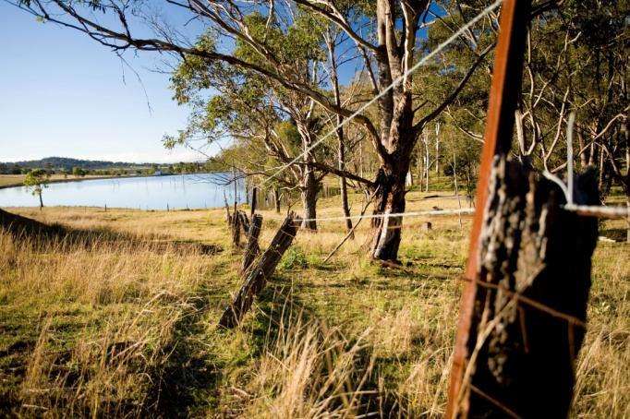The IESC’s website is an important tool for communicating and publishing information and is available at: [www.iesc.environment.gov.au/index.html](http://www.iesc.environment.gov.au/index.html).

The website contains:

* agendas and minutes for all meetings
* outcomes from workshops
* the IESC’s advice on coal seam gas and large coal mining development proposals
* information on bioregional assessments and research
* other publications such as *Information Guidelines* and fact sheets.

*Photo: Aquatic ecosystem in the Hunter Valley*

The IESC has developed a number of fact sheets on key scientific issues associated with the water related impacts of coal seam gas and large coal mining development, including subsidence from longwall coal mining, subsidence from coal seam gas extraction, and connectivity between water systems. The fact sheets are available on the website: [www.iesc.environment.gov.au/publications.html](http://www.iesc.environment.gov.au/publications.html).

* 1. **Improving understanding**

In order to remain current on coal seam gas and coal mining activities, the IESC undertakes regional visits in conjunction with one of its meetings each year.

In July 2013, the IESC toured two well-established coal seam gas operations in the Bowen Basin, Queensland, and, in June 2014, toured an operating open cut and underground coal mine, and a coal mine undergoing rehabilitation in the Hunter Valley Region, New South Wales. These visits are a useful opportunity for the IESC to see firsthand the scale and complexity of operations and discuss on-ground processes, water management issues and rehabilitation with operators and local stakeholders.

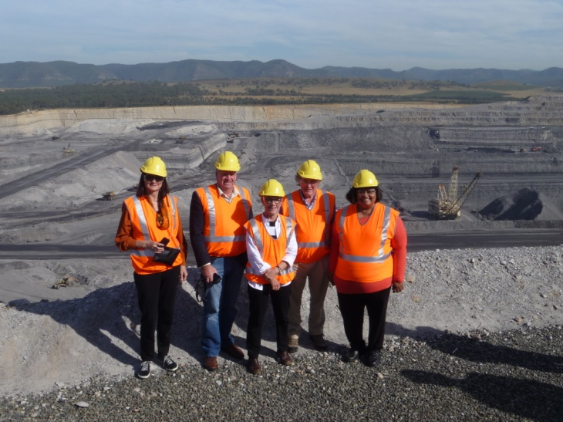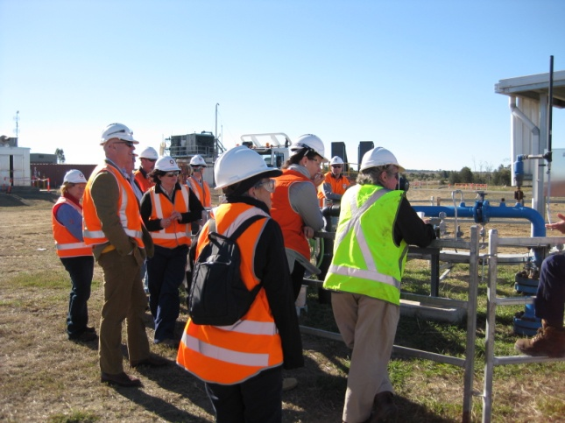

*Photo: IESC members at a coal mine in New South Wales, June 2014.*

*Photo: IESC members and staff from the Department of the Environment at a coal seam gas operation in Queensland, July 2013.*

**Appendix A**

**Development proposals considered by the IESC**

| **#** | **IESC #** | | **Project title** | **Location** | **Requesting regulator** |
| --- | --- | --- | --- | --- | --- |
| 1 | 2012-001 | | Drake Open Cut Coal Mine | QLD | Commonwealth |
| 2 | 2012-002 | | Maules Creek Coal Project | NSW | Commonwealth |
| 3 | 2012-003 | | Boggabri Coal Mine Extension | NSW | Commonwealth |
| 4 | 2012-004 | | Tarrawonga Coal Project | NSW | Commonwealth |
| 5 | 2012-006 | | Gloucester Coal Seam Methane Gas Project | NSW | Commonwealth |
| 6 | 2012-007 | | Sonoma Coal Mine Extension | QLD | Commonwealth |
| 7 | 2012-008 | | Moolarben Coal Mine - Stage 2 | NSW | Commonwealth |
| 8 | 2012-009 | | Newlands Coal Mine Extension Project | QLD | Commonwealth |
| 9 | 2012-010 | | Drayton South Coal Project | NSW | Commonwealth |
| 10 | 2012-011 | | Northern Expansion of the Camden Gas | NSW | Commonwealth |
| 11 | 2012-012 | | Kevin's Corner Coal Mine and Infrastructure | QLD | QLD and Commonwealth |
| 12 | 2012-013 | | Mt Penny Coal Project | NSW | Commonwealth |
| 13 | 2013-014 | | Arrow Surat Gas Project* | QLD | Commonwealth |
| 14 | 2013-016 | | Stratford Coal Mine Extension Project | NSW | Commonwealth |
| 15 | 2013-019 | | Cobbora Coal Project | NSW | Commonwealth |
| 16 | 2013-020 | | Foxleigh Coal Mine Project | QLD | Commonwealth |
| 17 | 2013-021 | | The Range Project | QLD | Commonwealth |
| 18 | 2013-022 | | Bowen Gas Project | QLD | QLD |
| 19 | 2013-023 | | Watermark Coal Project | NSW | Commonwealth |
| 20 | 2013-025 | | Bengalla Mine Extension | NSW | Commonwealth |
| 21 | 2013-026 | | Wallarah 2 Underground Coal Mine | NSW | Commonwealth |
| 22 | 2013-027 | | Galilee Coal (Northern Export Facility)* | QLD | QLD |
| 23 | 2013-028 | | Coalpac Consolidation Project | NSW | Commonwealth |
| 24 | 2013-030 | | Arrow Surat Gas Project* | QLD | QLD and Commonwealth |
| 25 | 2013-031 | | Byerwen Coal Mine | QLD | QLD and Commonwealth |
| 26 | 2013-032 | | Galilee Coal (Northern Export Facility)* | QLD | Commonwealth |
| 27 | 2013-033 | | Duchess Paradise Project | WA | Commonwealth |
| 28 | 2013-034 | | Carmichael Coal Mine and Rail Project | QLD | QLD and Commonwealth |
| 29 | 2013-035 | | Springsure Creek Coal Project | QLD | Commonwealth |
| 30 | 2013-036 | | Meteor Downs South Coal Project | QLD | Commonwealth |
| 31 | | 2013-037 | Moranbah South Project | QLD | QLD and Commonwealth |
| 32 | | 2013-038 | Bulga Coal Optimisation Project | NSW | Commonwealth |
| 33 | | 2013-039 | Spur Hill Underground Coal Project | NSW | New South Wales |
| 34 | | 2014-040 | Bylong Coal Project | NSW | New South Wales |
| 35 | | 2014-041 | Teresa Coal Project | QLD | QLD and Commonwealth |
| 36 | | 2014-042 | Surat North Development | QLD | Commonwealth |
| 37 | | 2014-043 | Liddell Coal Operations Extension | NSW | Commonwealth |
| 38 | | 2014-044 | Red Hill Mining Lease | QLD | QLD and Commonwealth |
| 39 | | 2014-045 | New Acland Coal Mine Stage 3 | QLD | QLD and Commonwealth |
| 40 | | 2014-046 | Boundary Hill South | QLD | QLD and Commonwealth |
| 41 | | 2014-047 | Caroona Coal Mine | NSW | New South Wales |
| 42 | | 2014-048 | Washpool Coal Mine | QLD | QLD and Commonwealth |
| 43 | | 2014-049 | Taroborah Coal Project | QLD | QLD and Commonwealth |
| 44 | | 2014-050 | Rolleston Coal Expansion | QLD | QLD and Commonwealth |
| * Considered by the IESC multiple times at different stages of the assessment process. | | | | | |

