

Independent Expert Scientific Committee on Coal Seam Gas and Large Coal Mining Development:

The year in review, December 2012-2013

*An overview of the activities of the Independent Expert Scientific Committee on Coal Seam Gas and Large Coal Mining Development from December 2012 to December 2013*

FEBRUARY 2014

© Copyright Commonwealth of Australia, 2014



*The year in review: December 2012-2013* is licensed by the Commonwealth of Australia for use under a Creative Commons By Attribution 3.0 Australia licence with the exception of the Coat of Arms of the Commonwealth of Australia, the logo of the agency responsible for publishing the report, content supplied by third parties, and any images depicting people. For licence conditions see: <http://creativecommons.org/licenses/by/3.0/au/>.

This report should be attributed as ‘*Independent Expert Scientific Committee on Coal Seam Gas and Large Coal Mining Development: The year in review, December 2012-2013*, Commonwealth of Australia, 2014’.

This publication is funded by the Australian Government Department of the Environment. The views and opinions expressed in this publication are those of the authors and do not necessarily reflect those of the Australian Government or the Minister for the Environment.

**Contact details**

For information about this report or about the work of the Committee, please contact:

IESC Secretariat

Office of Water Science

Department of the Environment

GPO Box 787

Canberra ACT 2601

The report can be accessed at: [www.environment.gov.au/coal-seam-gas-mining/index.html](http://www.environment.gov.au/coal-seam-gas-mining/index.html).

Contents

1. Introduction 4

1.1 Legislative functions of the Committee 4

1.2 Key achievements in 2013 4

2. Scientific advice on coal seam gas and large coal mining development proposals 5

2.1 Scientific advice on development proposals 5

2.2 Publication of advice 5

2.3 Committee advice on the EPBC Act amendment 6

3. Advice on the Bioregional Assessment Programme 7

3.1 Advice on the Bioregional Assessment Programme 7

3.2 Advice on the Bioregional Assessment Methodology 7

3.3 Advice on governance, quality assurance and products 7

4. Advice on research 8

4.1 Advice on research projects 8

4.2 Advice on research priorities 8

5. Publication and dissemination of scientific information and stakeholder engagement 9

5.1 Communication and publication of information 9

1. **Introduction**

**The Independent Expert Scientific Committee on Coal Seam Gas and Large Coal Mining Development (the Committee) was established as a statutory body under the *Environment Protection and Biodiversity Conservation Act 1999* (EPBC Act) in late 2012.**

The Committee consists of eight members with extensive scientific qualifications and expertise in the fields of geology, hydrogeology, hydrology, ecology, ecotoxicology, natural resource management and environment protection. The Committee is responsible for providing independent scientific advice for use in decision-making on coal seam gas and large coal mining developments.

**Further information:** [www.environment.gov.au/coal-seam-gas-mining/committee/index.html](http://www.environment.gov.au/coal-seam-gas-mining/committee/index.html).

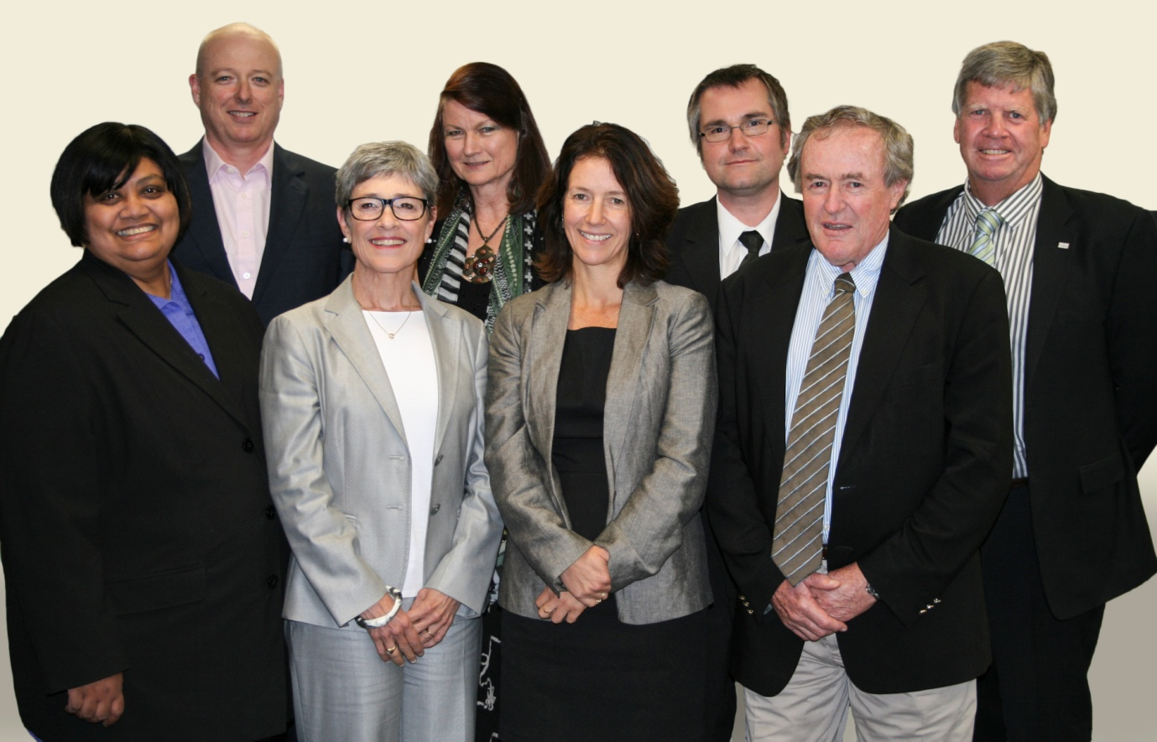

**Committee members (left-right)**

Professor Dayanthi Nugegoda

Dr Andrew Johnson

Ms Lisa Corbyn (Chair)

Emeritus Professor Angela Arthington

Ms Jane Coram

Professor Craig Simmons

Emeritus Professor Peter Flood

Mr Jim McDonald

**1.1 Legislative functions of the Committee**

Under the EPBC Act, the Committee has several legislative functions to:

* Provide scientific advice to the Commonwealth Environment Minister and relevant state ministers on the water-related impacts of proposed coal seam gas or large coal mining developments.
* Provide scientific advice to the Commonwealth Environment Minister on:
* bioregional assessments, including the methodology
* research priorities and projects.
* Publish and disseminate scientific information about the impacts of coal seam gas and large coal mining activities on water resources.

*Photo: Independent Expert Scientific Committee.*

**1.2 Key achievements in 2013**

The Committee contributed to strengthening regulatory decision-making on coal seam gas and large coal mining developments by:

* publishing *Information Guidelines* for use by regulators and proponents to ensure adequate water-related data and tools are used in assessing proposed developments
* providing expert scientific advice on 30 requests from the Commonwealth and Queensland regulators on large coal mining and coal seam gas proposals in Queensland and New South Wales
* providing advice to the Australian Government on bioregional assessments and research, including endorsing the methodology for the Bioregional Assessment Programme and providing advice on research projects and priorities.

**2.** **Scientific advice on coal seam gas and large coal mining development proposals**

**2.1 Scientific advice on development proposals**

**Summary of proposals considered by the Committee**

* 30 requests from the Commonwealth and Queensland regulators.
* 24 requests from the Commonwealth regulator; 2 requests from the Queensland regulator; 4 joint Commonwealth and state requests.
* 25 requests related to large coal mining development proposals and 5 related to coal seam gas proposals.
* 14 requests on proposals in New South Wales; 15 in Queensland; and 1 in Western Australia.
* 17 requests were for new developments and 13 were extensions to existing developments, with expected production ranging from 1 million to

30 million tonnes per year.

* The proposed coal seam gas developments have ranged from

60 to 6,500 wells and have covered development areas of up to 8,000 km2.

One of the primary roles of the Committee is to provide expert scientific advice to inform regulatory decision-making on coal seam gas and large coal mining developments. Its advice helps to increase transparency and strengthen the scientific basis of regulatory decisions.

In March 2013, the Committee published *Information Guidelines*, outlining the information expected from proponents and regulators to make an informed scientific assessment of potential impacts of proposals. These guidelines are available online: [www.environment.gov.au/coal-seam-gas-mining/publications.html](http://www.environment.gov.au/coal-seam-gas-mining/publications.html).

To date, the Committee’s advice has highlighted the need to provide adequate baseline information and to consider:

* the scale of developments
* water balances at the site and regional level
* hydrological and numerical models and the application of models
* potential direct and indirect impacts, including upstream and downstream impacts
* ecological impacts
* cumulative impacts from activities in the same catchment or region.

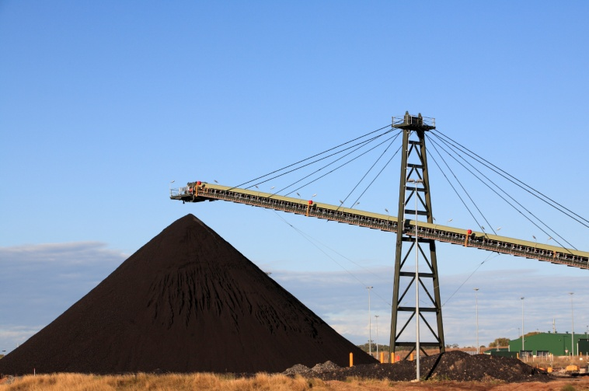A summary of proposals considered by the Committee is on the following page.

**2.2** **Publication of advice**

All advice is to be made publicly available. The Committee’s advice is published in the context of the regulator’s decision, aiming to balance the principles of transparency, equity of access and commitment to acknowledge the timing of the regulatory decision-making process. As at December 2013, 11 of the 30 pieces of advice have been published. Advice is available on the Committee’s website: <http://www.environment.gov.au/coal-seam-gas-mining/proposal-advice.html>.

*Photo: Coal mining.*

**Proposals considered by the Committee**

| **#** | **IESC #** | **Project title** | **Location** | **Requesting regulator** |
| --- | --- | --- | --- | --- |
| 1 | 2012-001 | Drake Open Cut Coal Mine | QLD | Commonwealth |
| 2 | 2012-002 | Maules Creek Coal Project | NSW | Commonwealth |
| 3 | 2012-003 | Boggabri Coal Mine Extension | NSW | Commonwealth |
| 4 | 2012-004 | Tarrawonga Coal Project | NSW | Commonwealth |
| 5 | 2012-006 | Gloucester Coal Seam Methane Gas Project | NSW | Commonwealth |
| 6 | 2012-007 | Sonoma Coal Mine Extension | QLD | Commonwealth |
| 7 | 2012-008 | Moolarben Coal Mine - Stage 2 | NSW | Commonwealth |
| 8 | 2012-009 | Newlands Coal Mine Extension Project | QLD | Commonwealth |
| 9 | 2012-010 | Drayton South Coal Project | NSW | Commonwealth |
| 10 | 2012-011 | Northern Expansion of the Camden Gas | NSW | Commonwealth |
| 11 | 2012-012 | Kevin's Corner Coal Mine and Infrastructure | QLD | QLD and Commonwealth |
| 12 | 2012-013 | Mt Penny Coal Project | NSW | Commonwealth |
| 13 | 2013-014 | Arrow Surat Gas Project* | QLD | Commonwealth |
| 14 | 2013-016 | Stratford Coal Mine Extension Project | NSW | Commonwealth |
| 15 | 2013-019 | Cobbora Coal Project | NSW | Commonwealth |
| 16 | 2013-020 | Foxleigh Coal Mine Project | QLD | Commonwealth |
| 17 | 2013-021 | The Range Project | QLD | Commonwealth |
| 18 | 2013-022 | Bowen Gas Project | QLD | QLD |
| 19 | 2013-023 | Watermark Coal Project | NSW | Commonwealth |
| 20 | 2013-025 | Bengalla Mine Extension | NSW | Commonwealth |
| 21 | 2013-026 | Wallarah 2 Underground Coal Mine | NSW | Commonwealth |
| 22 | 2013-027 | Galilee Coal (Northern Export Facility)* | QLD | QLD |
| 23 | 2013-028 | Coalpac Consolidation Project | NSW | Commonwealth |
| 24 | 2013-030 | Arrow Surat Gas Project* | QLD | QLD and Commonwealth |
| 25 | 2013-031 | Byerwen Coal Mine | QLD | QLD and Commonwealth |
| 26 | 2013-032 | Galilee Coal (Northern Export Facility)* | QLD | Commonwealth |
| 27 | 2013-033 | Duchess Paradise Project | WA | Commonwealth |
| 28 | 2013-034 | Carmichael Coal Mine and Rail Project | QLD | QLD and Commonwealth |
| 29 | 2013-035 | Springsure Creek Coal Project | QLD | Commonwealth |
| 30 | 2013-036 | Meteor Downs South Coal Project | QLD | Commonwealth |
| * Considered by the Committee multiple times at different stages of the assessment process. | | | | |

**2.3 Committee advice on the EPBC Act amendment**

In June 2013, the EPBC Act was amended to include significant impacts on water resources as a new matter of national environmental significance in relation to coal seam gas and large coal mining development (‘water trigger’). Any project that has or is likely to have a significant impact on water resources must be referred to the Commonwealth regulator for assessment and approval.

The Committee was requested to provide scientific advice to the Commonwealth Environment Minister on the implementation of the then proposed legislative amendment to the EPBC Act. In its advice, the Committee outlined scientific elements for inclusion in the definition of a significant impact on water resources and in terms of reference for the assessment of coal seam gas and large coal mining developments, and identified mitigation actions that could be considered by regulators. The Committee also provided scientific advice to the Commonwealth regulator, as requested, on the draft Significant Impact Guidelines for the ‘water trigger’.

**Further information:** [www.environment.gov.au/coal-seam-gas-mining/index.html](http://www.environment.gov.au/coal-seam-gas-mining/index.html).

**3. Advice on the Bioregional Assessment Programme**

**3.1 Advice on the Bioregional Assessment Programme**

The Committee plays a key role in providing advice on the Bioregional Assessment Programme and the science underpinning the methodology. The programme is being delivered in collaboration between the Department of the Environment, the Bureau of Meteorology, the Commonwealth Scientific and Industrial Research Organisation (CSIRO), and Geoscience Australia.

Bioregional assessments will analyse the hydrology, geology, hydrogeology and ecology of bioregions, with explicit assessment of the potential direct, indirect and cumulative impacts of coal seam gas and large coal mining development on water resources both above and below ground. The assessments will strengthen the science underpinning future decisions about proposed coal seam gas and large coal mining activities. Assessments will initially be undertaken in up to 15 subregions within six bioregions across New South Wales, Queensland, South Australia and Victoria.

Bioregional assessments will progressively collate annual baseline information and provide analyses of subregions, targeting regions with significant coal deposits and focusing on areas where there is significant existing or anticipated pressure from large coal mining and coal seam gas development.

**Further information:** [www.environment.gov.au/coal-seam-gas-mining/bioregional-assessments.html](http://www.environment.gov.au/coal-seam-gas-mining/bioregional-assessments.html).

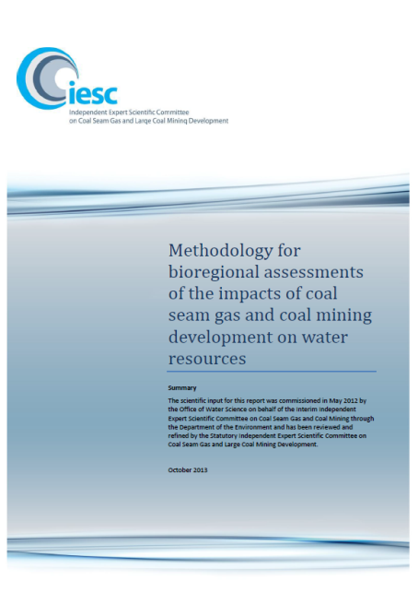

**3.2 Advice on the Bioregional Assessment Methodology**

A scientific Methodology has been developed to guide the process to deliver the scientific products which will represent the bioregional assessments. The Committee reviewed, provided advice and endorsed the Methodology, which was released in October 2013.

**3.3 Advice on governance, quality assurance and products**

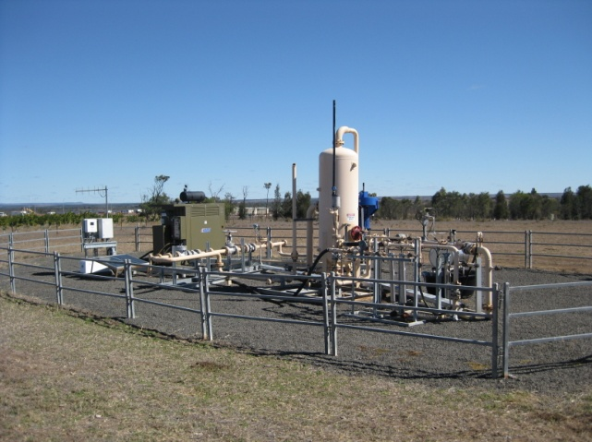The Committee also provided advice on governance and quality assurance processes for bioregional assessments, and highlighted the importance of conducting effective stakeholder engagement.

The Committee provided input to and reviewed the first bioregional assessments technical products, including context statements for the Namoi subregion within the Northern Inland Catchments bioregion, and the Clarence-Moreton subregion within the Clarence-Moreton bioregion.

**Further information:** [www.environment.gov.au/coal-seam-gas-mining/bioregional-assessments.html](http://www.environment.gov.au/coal-seam-gas-mining/bioregional-assessments.html).

*Photo: Coal seam gas operation in Queensland.*

**4. Advice on research**

**4.1 Advice on research projects**

To date, the Australian Government has funded more than 20 research projects to address critical gaps in the current scientific understanding of water-related impacts of coal seam gas and large coal mining.

Key projects include a national assessment of the chemicals associated with coal seam gas extraction (including hydraulic fracturing), and knowledge reviews on key issues such as bore integrity, connectivity between aquifers and co-produced water.

In accordance with its legislated mandate, the Committee provided scientific advice on previously commissioned critical science reviews and research projects being managed by the Department of the Environment. The Committee also made recommendations for improving quality assurance and peer review processes.

**4.2 Advice on research priorities**

Following consultation with key stakeholders, the Committee provided advice to the Commonwealth Environment Minister on priorities for new research projects in September and October 2013. The advice concentrated on areas of high risk, significant knowledge gaps and where there was potential to produce outputs of national significance within three years. The Committee’s advice was informed by a workshop with key stakeholders in March 2013. The Committee also took into account current and emerging research being undertaken in Australia and overseas.

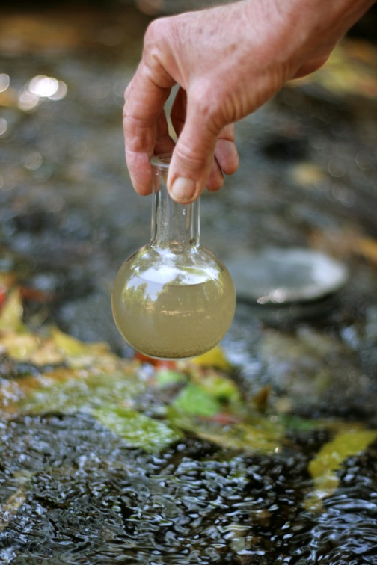The Committee identified knowledge gaps in four priority areas or themes relating to the potential impacts on water resources from coal seam gas and large coal mining developments:

* Hydrology – better understanding and modelling alterations to groundwater and surface water characteristics and processes.
* Ecosystems and water – strengthening knowledge of potential impacts on key species and ecosystems, as well as methods for monitoring and mitigating these impacts.
* Chemicals – chemical and ecotoxicological investigations including the potential cross-contamination of drinking water and other water resources.
* Cumulative impacts – assessing the potential impacts from individual coal seam gas or coal mining developments in conjunction with the impacts from other existing and likely developments in the region.

Within these themes, the Committee assisted the Department of the Environment to focus on priority projects which are being progressed.

**Further information:** [www.environment.gov.au/coal-seam-gas-mining/research/index.html](http://www.environment.gov.au/coal-seam-gas-mining/research/index.html).

*Photo: water sampling.*

**5. Publication and dissemination of scientific information and stakeholder engagement**

**5.1 Communication and publication of information**

The Committee has an important role in building public confidence in the scientific evidence which informs regulatory decisions. The Committee aims to increase awareness of its functions and its scientific advice, inform scientific dialogue on research, and inform public dialogue on the potential impacts of coal seam gas and large coal mining developments on water resources.

The Committee’s website is an important tool for communicating and publishing information and is available at: [www.environment.gov.au/coal-seam-gas-mining](http://www.environment.gov.au/coal-seam-gas-mining). The website contains:

* 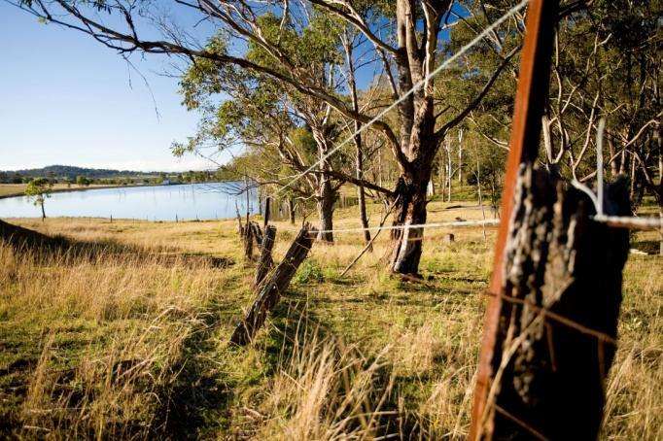agendas and minutes for all meetings
* outcomes from workshops
* the Committee’s advice on coal seam gas and large coal mining development proposals
* information on bioregional assessments and research
* other publications such as *Information Guidelines* and fact sheets.

To enhance mutual understanding, the Committee also engaged with industry and government agencies on research priorities and bioregional assessments, inviting key representatives to workshops and Committee meetings where relevant.

*Photo: aquatic ecosystem in the Hunter Valley.*

In July 2013, the Committee visited two well-established coal seam gas operations in the Bowen Basin, Queensland. Engaging with industry was a useful opportunity for the Committee to discuss on-ground processes and water management issues with operators.

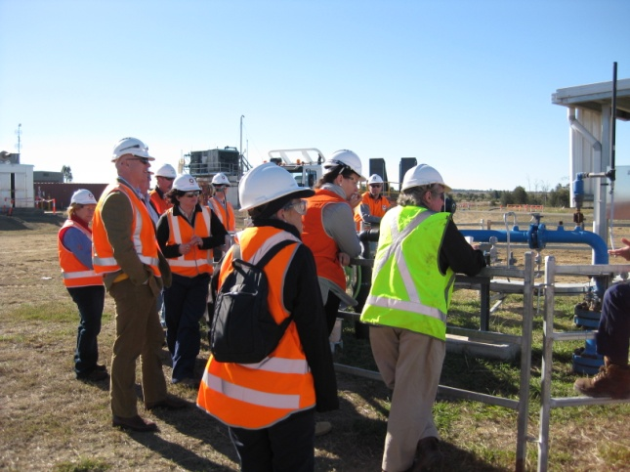

*Photo: Committee members and staff from the Department of the Environment at a coal seam gas operation in Queensland, July 2013.*

