Environmental water tracers in environmental impact assessments for coal seam gas and large coal mining developments

Confidently identifying and evaluating causal pathways from water resources to a specified asset(s) with a high degree of confidence is key to an effective environmental impact assessment. Environmental water tracers (EWTs) can often complement other techniques and contribute to the multiple lines of evidence needed to inform ecohydrological conceptual models and identify potential risks to assets. Importantly, in some situations, EWTs may be the only feasible way of gaining information about surface-groundwater and/or inter-aquifer interactions at appropriate spatial and temporal scales.

This fact sheet supplements the IESC information guidelines for proponents preparing coal seam gas and large coal mining development proposals (IESC 2018) and associated explanatory notes, by explaining how EWTs can be used in environmental impact assessments. References to further reading materials are provided to ensure that more detailed technical explanations are available, where needed.

## Scope

Only naturally occurring and anthropogenic tracers within waterbodies and aquifers are considered here. Deliberate addition of tracers into aquatic systems is outside the scope of this document. However, we recognise that there may be instances when the addition of tracers may be warranted.

In addition, it should be noted that our guidance is for proponents preparing environmental impact statements, rather than for the detection and evaluation of possible contamination from existing developments. Our focus is on tracers of water movement not contaminant tracers.

We also note the growing use of EWTs for detecting locations of water movement through major faults. A separate explanatory note on the characterisation of geological faults is currently being developed. Published explanatory notes are available on the [IESC’s website](http://iesc.environment.gov.au/publications).

|  |
| --- |
| A large and growing number of approaches, methods and tools are now available for investigating EWTs, and these techniques are developing at a rapid rate. However, we note that the extent to which EWTs decrease groundwater modelling uncertainty may be small, and so EWTs may not be required in all situations. |

|  |
| --- |
| Definition Environmental water tracers (EWTs) are substances or properties that can be measured in surface and groundwater to better understand recharge and discharge processes and water movements. The applications for EWTs could include: surface-groundwater interactions; groundwater recharge and discharge; groundwater flow rates; groundwater flow direction; and mixing between water sources.  Environmental tracers for water studies can include physico-chemical properties such as heat and electrical conductivity; gases from the atmosphere (e.g. chlorofluorocarbons (CFCs)) which have dissolved in groundwater during recharge; radioisotopes derived from radioactive decay processes; and stable isotopes. EWTs may be naturally occurring or the result of human activity. |

## Risk-based framework

Coal seam gas (CSG) and large coal mining developments can disrupt the hydrological cycle, particularly through groundwater depressurisation and drawdown of the water table. Where sensitive environmental receptors are present, a key part of an environmental impact assessment is to determine whether a causal pathway exists for a project to impact these receptors (e.g. see Henderson et al. 2016). In some instances, EWTs in combination with other data can be used to provide specific information about different aspects of a hydrogeological system. In particular, EWTs can provide evidence that risks to receptors are not present, or, where the potential for impact cannot be excluded, provide a tool to help understand the likelihood and magnitude of possible impacts over various timeframes.

|  |
| --- |
| In undertaking environmental impact assessments, data collection and decision-making should be guided by the magnitude of risk – greater effort should be applied where high risks are identified (Middlemis and Peeters 2018). |

Tracer studies should be carefully designed to answer questions relevant to key risks. For example, the use of EWTs in environmental impact assessments may be considered to fall within three categories (after Lamontagne and Mallants 2018):

1. to quantify system processes and parameters (e.g. recharge or groundwater discharge);

2. as a line of evidence to support or refute proposed conceptual groundwater models; and/or

3. as a quantitative or qualitative constraint in numerical groundwater modelling. This is considered leading practice although is not yet routinely adopted (see the following section on improving modelling with tracer evidence).

The results of studies using EWTs complement other types of information and investigations, typically using hydraulic head information, that are commonly undertaken for an environmental impact assessment. A conceptual diagram outlining the use of EWTs as a means of investigating risk is provided in Figure 1.

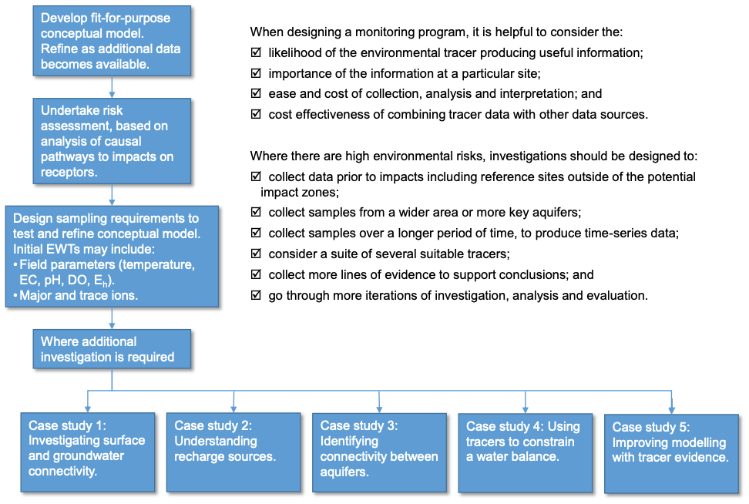

**Figure 1: Using environmental tracers to investigate risk. Multiple lines of evidence may be required to obtain sufficient certainty in a conceptual model of a project area, refer to the case studies below.**

The scope of investigation will vary depending on the question or questions raised in the environmental impact assessment and associated risks. Where qualitative information is needed, such as to answer the question ‘is any river flow derived from groundwater?’, a definitive answer may be obtained with relatively little data.

Where quantitative information is needed, such as for the question ‘what fraction of river flow is derived from groundwater?’ more data from multiple lines of evidence is likely to be required. A suite of suitable tracers in combination with other data sources may be required in high risk situations where improved confidence is needed to quantify water systems and potential impacts.

## Introducing tracers

Diagram 
Water 1 plus Water 2 plus or minus Reactions equals Water 3

Where mixing occurs between two different water sources, then at the most basic level, the use of tracers can be summed up by the following equation:

EWTs are useful because rainfall at different times or locations, or rainfall that infiltrated and followed different subsurface pathways, could have different tracer ‘fingerprints’. The elements and compounds most commonly used as EWTs are relatively non-reactive and their concentrations change mainly through mixing or predictable decay (Kendall and Caldwell 1998). They can therefore be used to gain information about the source of water or mixing of water from different sources, such as inter-aquifer mixing or groundwater-surface water interaction.

Examples of commonly used EWTs are presented here. The different water sources involved are referred to as end-members. These can be different aquifers, surface water from one or more water bodies, precipitation and/or seawater. For a thorough discussion of environmental tracer isotope geochemistry, refer to Clark and Fritz 1997, Cook and Herczeg 2000, Mazor 2003, Plumer 2003, Kendall 2004, Kendall and McDonnell 2009, IAEA 2013 or Elliot 2014.

|  |
| --- |
| A brief review of EWTs is provided in Walker et al. 2018 as part of a multi-method recharge estimation comparison case study. |

### Physico-chemical properties of water

Easily measured physico-chemical properties of water may be used as EWTs. For example, electrical conductivity (EC) and temperature can be measured on site with relatively in-expensive hand-held sensors. EC is a measure of the concentration of ions in water and is the most commonly used method of recording the salinity of freshwaters. Where there is a detectable difference in EC, it may be used in the study of recharge, groundwater-aquifer interactions, inter-aquifer mixing, or for detecting the inflows of groundwater into surface water bodies. Temperature vs depth profiles may be used for estimating the locations and fluxes of groundwater recharge and/or discharge. Examples of studies using temperature-based EWTs are provided by Rau et al. (2010) and Rau et al. (2014).

### Major and trace ions

Analysis of major ions (e.g. Na, Mg, Cl) are useful to investigate mixing of groundwater from different aquifers, or the interactions between groundwater and surface water. Evapotranspiration of rainfall and mineral dissolution controls the major ion geochemistry in groundwater and surface water, where ions can be dissolved in water and are present in rain. Where the concentrations or ratios of the major ions vary between end-members, the extent of interaction can be identified and quantified.

A Piper plot is often used to examine ratios between major ions. Trace ion proportions (e.g. Mn, Br, I) can be used to refine interpretation of results of major ion analysis. Relevant trace ions for analysis should be identified based on local geochemistry.

### Environmental isotopes

Environmental isotopes are important tracers in water studies. The stable isotope ratios of hydrogen (2H/1H) and oxygen (18O/16O) in water trace the water molecule itself (results expressed as 2H and 18O). The isotopic signatures of waters are controlled by the local climate (including temperature, humidity, and the degree of evaporation). These tracers are particularly valuable in groundwater studies because the isotopic signature is generally not altered, or changes in predictable ways.

The isotopic signature of water from an aquifer can sometimes be used to detect and quantify the mixing of two or more different waters if the isotopic signature of those end-members is distinctive. A unique quantitative understanding of complex water mixes with multiple end-members may, however, require a suite of suitable EWTs and complementary information. This can provide information on recharge sources, inter-aquifer mixing or changes in baseflow to a stream from regional groundwater sources (see Appelo and Postma 2005, pp. 32–41).

|  |
| --- |
| Environmental isotopes can be easily collected by a broad range of stakeholders. The [Outback Water Project](https://outbackwaterproject.com.au/), a recent citizen science project in central Australia, has enlisted members of the local communities, ranger groups, tourists and hikers to collect water samples from remote waterholes that research scientists were not able to visit.  Scientists are analysing the stable isotopic composition (2H and 18O) of water samples to infer the role of groundwater in the persistence of waterholes (and much of the biodiversity) in the region. The results will help identify groundwater-dominated sites which are likely to act as future biodiversity refugia under global warming. This information will inform a biodiversity conservation strategy and/or a climate change adaptation program for the area (e.g. as part of prioritising management actions). |

### Radioisotopes

Together with the stable isotopes, major and trace ions, groundwater contains numerous radioisotopes with a variety of half-lives (as these ions will reduce over time). Radionuclides allow the mean residence times of groundwater to be determined, which in turn permits recharge rates and flow rates to be calculated.

Dating groundwater can be valuable in validating a model, for example, in demonstrating that water in a particular aquifer was recharged in the distant past, without input from recent rainfall. Some radioisotopes (such as 14C, 36Cl and 3H) are produced naturally by interaction of cosmic rays with atmospheric gases (see Cecil and Green (2000) for a discussion of 222Rn). Other radioisotopes have been produced through human nuclear activities (such as 85Kr). Many naturally-occurring isotopes (such as 14C, 3H) also have concentrations that have been elevated by human activities.

### Anthropogenic tracers

Other globally-dispersed anthropogenic chemicals that dissolve in infiltrating water are also used as EWTs to date groundwater. For example, atmospheric concentrations of CFCs and sulfur hexafluoride (SF6) have changed over time – and these historical concentrations are known. Concentrations of these tracers dissolved in groundwater reflect the atmospheric concentration at the time of infiltration. SF6 and, under some conditions, CFCs, degrade sufficiently slowly that their concentrations in confined aquifers can be considered to alter over time only through mixing (see Darling et al. 2010 for a discussion of CFCs and SF6 in groundwater dating).

## Case studies

Case studies demonstrating how EWTs can be used to investigate surface-groundwater and/or inter-aquifer interactions follows. It is noted that many of these case studies are not from areas where there are CSG or coal mining developments. They are included because they inform the broad application of EWTs as a risk assessment tool, especially when they are used in combination with other investigative techniques.

### Case study 1: Investigating surface and groundwater connectivity.

|  |
| --- |
| Measurement of EWTs in rivers are often used as a means to locate areas where rivers are gaining. They can also be used to quantify rates of river surface–groundwater exchange, if the concentration of the tracer in groundwater is also measured (Figure 2). |
| This figure shows EWTs in rivers associated with gaining reaches of a river.  Tracer 1 shows the possible concentrations of an ion tracer whose concentration in groundwater exceeds that within the river. Tracer 2 shows the possible concentrations of an ion tracer whose concentration in groundwater is less than that within the river.  Tracer 3 shows a tracer such as dissolved helium or radon whose concentration in groundwater exceeds that in the river. |
| Figure 2: Indicative example of EWTs in rivers associated with gaining reaches of a river. Tracer 1 (blue solid line) shows the possible concentrations of an ion tracer whose concentration in groundwater exceeds that within the river. The tracer increases in concentration in areas where the river is gaining, and shows no change where the river is losing, or neither gaining nor losing. Tracer 2 (brown dotted line) shows the possible concentrations of an ion tracer whose concentration in groundwater is less than that within the river. The third example (green solid line) shows a tracer such as dissolved helium or radon whose concentration in groundwater exceeds that in the river. As these tracers are dissolved gases, with low concentrations in the atmosphere, their concentration in the river will decrease in areas where the river is not gaining due to gas exchange between the river and the atmosphere. |
| Further examples are provided by Gardner et al. (2011), Heilweil et al. (2015) and Atkins et al. (2016). |

Atkinson et al. (2015) undertook a multi-tracer approach to estimate groundwater discharge into a section of the Gellibrand River, Victoria. The authors concluded that groundwater is estimated to contribute between 10 – 50% of river flow (approximately >40% during summer low flows).

The authors compared tracer concentrations (EC, pH, cations, anions, d18O, d2H, 222Rn, 3H) along a longitudinal section of the river to those in groundwater in the near-river aquifers. Sampling was undertaken over a period of approximately 15 months to quantify discharge rates under different seasonal conditions. Importantly, the authors sampled for 222Rn, which has a half-life of 3.8 days. If found in surface water, it can indicate an active area of groundwater contribution (assuming there has been no recent rainfall at the site).

Sampling indicated increases in all major ions and 222Rn concentrations (and an associated decrease in 3H concentrations) largely between sampling points 0 – 7.5 km and 16.8 – 22 km (Na concentrations are provided at Figure 3). Groundwater percentages of the total river flow estimated using 222Rn, Cl and 3H concentrations agreed to within ± 12%.

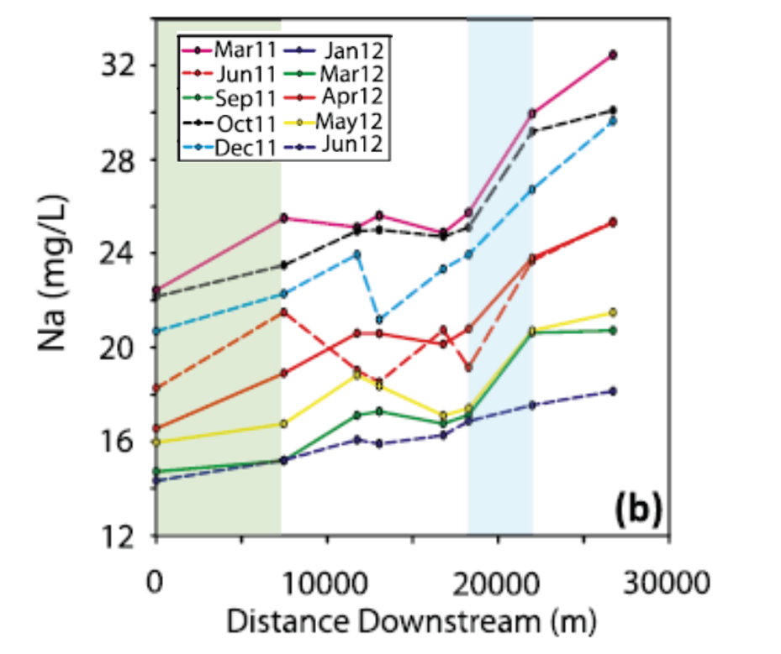

Figure 3: Distribution of sodium concentrations over ten sampling campaigns (modified from Atkinson et al. 2015). Major increases in Na are seen between two reaches at 0–7.5 km (green) and 16.8–22 km (blue).

Atkinson et al. (2015) conclude that the two gaining reaches (indicated by increases of major ions and 222Rn concentrations) provide most of the groundwater discharge, separated by a variably losing and gaining section. Groundwater inflows were estimated to account for between 10 – 50% of river flow (approximately >40% during summer low flows).

### Case study 2: Understanding recharge sources of receptors.

|  |
| --- |
| Piper plots show the percentage composition of major ions in most natural waters, i.e. Na, K, Ca, Mg, Cl, CO3, HCO3, and SO4 (Figure 4). Where there is a clear grouping of samples, the diagram can be used to indicate separation between different water sources. |
| This figure shows a piper plot showing water types based on the percentage composition of major ions (modified from Fetter 2001). |
| Figure 4: Piper plot showing water types based on the percentage composition of major ions (modified from Fetter 2001). Percentage composition of anions and cations are plotted separately within the lower triangles, where the overall anion and cation composition is plotted within the middle diamond.  Further examples are provided by Melchiorre et al. (2005) and Keppel et al. (2016). |

Dogramaci et al. (2012) used EWTs to assist in conceptualisation of a groundwater system in the Hamersley Basin in the Pilbara, Western Australia. The authors demonstrated that groundwater is primarily derived from high-rainfall events, with little contribution from surface water bodies to the deeper groundwater system.

Water abstraction associated with iron ore mining and other regional developments affect groundwater in the Hamersley Basin. Two EWTs were used to better understand the relationship between surface water in a marsh, alluvial groundwater and the deep groundwater.

First, the authors analysed major ion chemistry data to distinguish between water from different water sources. The major ions in saline groundwater (yellow) are dominated by Na and Cl. This contrasts with groundwater in the deep fractured (green) and alluvial aquifers (red), where Ca, Mg, HCO3 and SO4 dominate. This indicated that water in the Fortescue Marsh was generally distinct from groundwater (Figure 5).

This distinction is not definitive, as there is the potential for the alluvial water to be sourced from mixing of the deep fractured water source (see the overlapping area of green and red samples in Figure 5).

**This diagram shows the chemical signatures of groundwater samples from the Hamersley Basin in the Pilbara, Western Australia. The major ions in saline groundwater are dominated by Na and Cl. This contrasts with groundwater in the deep fractured and alluvial aquifers, where calcium, magnesium, hydrogen carbonate and sulfate dominate. This figure is from Dogramaci et al. 2012.
**

Figure 5: Piper plot of groundwater chemistry in the Hamersley Basin, Pilbara (from Dogramaci et al. 2012).

|  |
| --- |
| The meteoric water line (Figure 6) plots the global distribution of 2H and 18O values of rainfall and fresh surface waters and has the relationship 2H = 8.13 18O + 10.8‰. Local differences in climate may result in local meteoric water lines having a slightly different slope and intercept to the global average, and samples from warmer climates lie at higher 2H and 18O values. Water samples which fall on a meteoric water line are little affected by processes that cause isotopic fractionations. Evaporation or high-temperature water-rock interaction causes predictable changes to the stable isotope ratios (Domenico and Schwartz 1990; Clark and Fritz 1997; Fetter 2001; Clark 2015). |
| This figure shows a meteoric water line for the global distribution of δ2H and δ18O values of rainfall and fresh surface waters. This figure was modified from Allison 1982. |
| Figure 6: Meteoric water line process schematic (modified from Allison 1982). |

Secondly, stable isotope data was analysed. The results of the stable isotope analysis indicated that:

• groundwater samples from the fractured aquifer and shallow alluvium (green and red dots, Figure 7) fall close to the local meteoric water line (LMWL, in blue). This supports the conceptualisation that high-rainfall events recharge these aquifers, with little evaporation occurring prior to recharge; and

• saline water samples from Fortescue Marsh plot on another line (yellow dots and line, Figure 7). This is consistent with the effect of evaporation and enrichment of the isotopic signature of water samples.

This graph shows the percentage of deuterium plotted against the percentage of oxygen-18. The composition of saline water samples from the Fortescue Marsh is distinctly different to the local meteoric water line. This figure is from Dogramaci et al. 2012. 


Figure 7: Stable isotope plot of groundwater in the Hamersley Basin, Pilbara (modified from Dogramaci et al. 2012). The figure shows the LMWL for large rainfall events (i.e. the isotopic signature of local rainfall, excluding small events <20 mm) in blue. Saline water samples, from the Fortescue Marsh, are shown in yellow.

These findings supported a conceptualisation that most groundwater was derived from high-rainfall events, with little contribution from surface water bodies to the deeper groundwater system.

The authors concluded that any contribution from the marsh to groundwater was very limited.

### Case study 3: Identifying connectivity between aquifers.

|  |
| --- |
| In addition to the below case study, Cartwright et al. (2010), Fulton et al. (2015) Batlle-Agilar et al. (2017) and Qian et al. (2018) also demonstrate how EWTs can be used as lines of evidence to determine connectivity between different aquifers. |

### *Iverach et al. (2015) used tracers to investigate the possibility of small-scale interaction between aquifers in the Condamine River Catchment in Queensland. The authors concluded that there is limited evidence of groundwater movement between the Walloon Coal Measures (WCM) and the alluvial aquifers.*

In the Condamine River Catchment in Queensland, identifying whether or not there is a possibility of groundwater movement between the coal seams and the alluvial aquifers is important for effective operational and regulatory management. Verification of conceptual models is essential to help exclude the possibility that CSG activity could substantially change the quantity or quality of water resources available for other users. However, the IESC notes that tracers cannot identify the “possibility” of groundwater movement under future development scenarios. They can only provide information on “historic” groundwater movement.

A simple cross-section of the area is shown in Figure 8.

This figure shows a geological cross section of the Condamine alluvium. 
The Condamine River Alluvial Aquifer overlies the Walloon Coal Measures. The Marburg/Hutton Sandstone separates the alluvium and coal measures from the Great Artesian Basin. This figure is from Iverach et al. 2015. 

Figure 8: Conceptual geological cross-section in the study area (from Iverach et al. 2015).

Previous studies indicate that there is no relationship between concentrations or ratios of major ions in the groundwater of the target WCM and the alluvial groundwater. This suggested that any movement of water between the aquifers was limited (Iverach et al. 2015).

However, to provide further confidence in the results of previous studies, Iverach et al. (2015) used other tracers to investigate the possibility of smaller-scale interaction between the aquifers. These interactions could be from either limited areas or small volumes of water. They identified a number of irrigation bores where both:

• 3H was below detection, indicating that the groundwater recharged >70 years ago before nuclear testing in the 1960s caused higher than natural concentrations of 3H in rainfall; and

• dissolved organic carbon (DOC) was present at detectable levels.

The DOC was unlikely to be derived from the surface at the time of recharge as biological processes would have consumed all DOC in the >70 years since recharge. This provided further support for the hypothesis that there is little interaction between the WCM and the overlying alluvium aquifers.

In addition, the authors plotted the abundance of 13C in methane samples (y-axis) against inverse methane concentration (x-axis), to examine potential groundwater mixing (Figure 9). This showed that those bores that met the above criteria (for 3H and DOC) plotted on a line, with 13C intercept that indicated methane from the WCM.

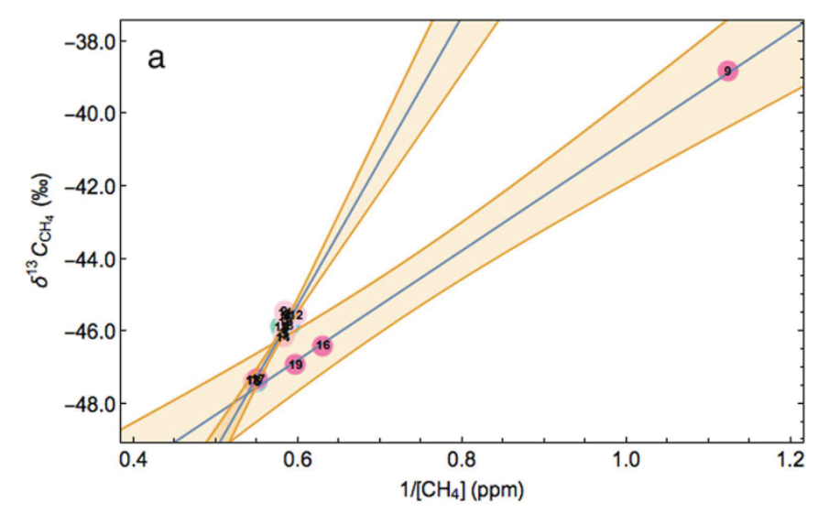

Figure 9: A mixing plot for irrigation bores (from Iverach et al. 2015). Samples 17, 19, 16 and 9 sit on a regression line that indicates mixing with methane from the WCM. These are the bores in which detectable methane is present and 3H is absent. All other irrigation bores sit on a different mixing line that indicates mixing with methane sourced from the vadose zone. Mixing lines shown in blue. 90% confidence bands shown in orange. When the isotopic composition of a compound (here, 13C on CH4) is plotted versus the reciprocal of the concentration of that compound (i.e., 1/CH4), then mixing between two water sources is represented by a straight line. Mixing between two water sources can also sometimes be identified by straight line relationships when concentrations of one compound (or ion) are plotted against concentrations of another separate compound (or ion).

The use of a suite of standard and advanced tracer techniques allowed Iverach et al. (2015) to detect methane migration, but not water migration, to a subset of irrigation bores. This provided further evidence to support the conceptualisation of limited groundwater movement in the WCM and the alluvial aquifers.

### Case study 4: Using tracers to constrain a water balance.

|  |
| --- |
| A water balance can be used to validate a project’s conceptual model, and at its simplest can be defined as water inflows = water outflows (in a system that’s at equilibrium). |

Temperate highland peat swamp ecosystems are common in areas within the Sydney Basin where longwall mining occurs. Stable water isotopes were used as a tool by David et al. (2018a) to determine evaporation from EPBC-listed temperate highland peat swamps on sandstone, and build on basic hydrogeochemical and isotope characterisation of the system. Combining this with information from other sources the authors constrained the water balance sufficiently to determine that groundwater is likely to be a major source of water to the peat swamps.

David et al. (2018b) studied the isotopic composition of pore water vapour within the swamps using vertical profiles. The study compared the results to the isotopic composition of regional groundwater, rainwater and surface water. Additionally, as the process of evaporation results in preferential loss of light isotopes, evaporation could be quantified (Figure 10).

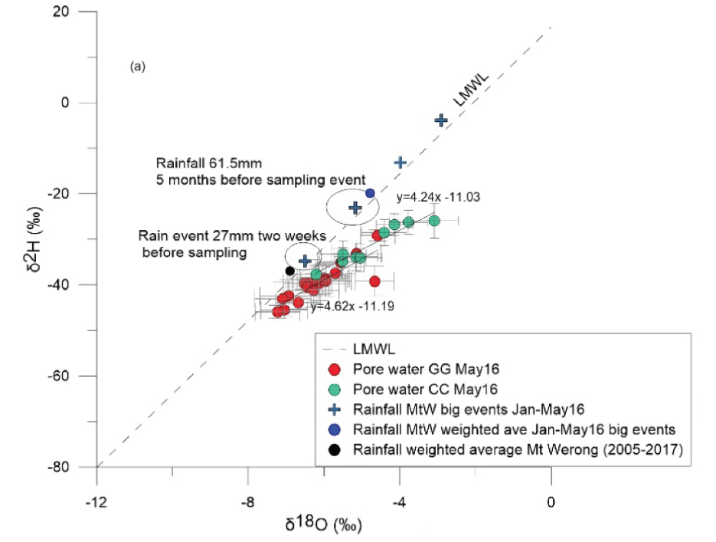

Figure 10: Stable 18O and 2H values of surface water, swamp groundwater, regional groundwater, swamp pore water, and weighted rainfall average for Mt Werong, NSW (from David et al. 2018). Evaporation can be seen in the samples that plot to the right of the LMWL (green and red dots).

Analytical modelling was then used to produce a water balance with components of rainfall, runoff and evaporation. The resulting deficit is assigned to groundwater contribution. The results (from a dry period) are shown in Figure 11.

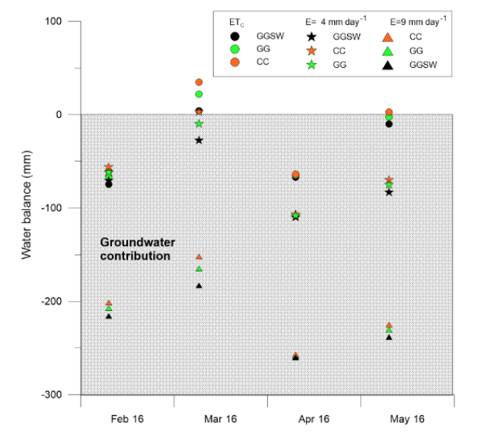

Figure 11: Results of an isotope water balance for three swamps in the Blue Mountains, NSW. The authors applied a simple mass balance (based on different rainfall, runoff and evaporation scenarios) to determine the swamp water balance. The water balance deficit (shown above: grey area indicates negative values, representing the deficit) is assumed to represent regional groundwater inflow. However, these may be minimum values, since discharge from the swamps is not included in the water balance. GG, CC and GGSW represent the three different swamps, and the different symbols represent three different methods for estimating evapotranspiration. The study therefore determined that groundwater is a substantial contributor to the water balance, especially during dry periods (from David et al. 2018a).

Based on the results, the authors concluded that there is a substantial groundwater contribution to the water balances of the swamps studied. The isotope tracer results indicated, that if combined with surface water outflow data, a quantitative estimate of both evaporative losses and groundwater contributions would be possible that is otherwise difficult to obtain.

Knowledge of the water balance derived from EWTs has the potential to improve adaptive management of these swamps. This is important because they are subject to multiple stresses including mining, forestry plantations and bushfires.

### Case study 5: Improving modelling with tracer evidence.

Despite the preceding examples of the use of environmental tracers, direct incorporation of tracer information into numerical models to support environmental impact assessments is not commonly undertaken (Lamontagne and Mallants 2018). Direct use of tracers, however, offers the potential to substantially improve model predictions, by making better use of available data to constrain models (e.g. see Bauer et al. 2001, Engelhardt et al. 2013, Turnadge and Smerdon 2014, Wallis et al. 2014 and McCallum et al. 2017). This is an emerging area in environmental impact assessment, and the use of EWTs to directly improve models is especially encouraged in high-risk areas.

|  |
| --- |
| EWTs, in conjunction with flow and transport models, can provide quantitative estimates of groundwater flow rates and pathways (see Reilly et al. 1994 for one of the first applications of this work). For example, tracers, and age, can provide a proxy for flow. This can be used to constrain recharge rates in steady state systems where (after Reilly et al. 1994):  time = depth = depth x porosity  vertical velocity recharge rate |

Schilling et al. (2019) undertook a literature review to investigate how EWTs can be used to improve the calibration of modelling results. They were able to identify that tracer concentrations and exchange fluxes are particularly useful for reducing modelling uncertainty when used in combination with other classical modelling data sources (noting that suitability will vary depending on the investigation site).

Schilling et al. (2019) undertook a literature review to analyse the current use of EWTs in, and identify the best EWTs for, successful flow model calibration. The review analysed approximately 55 papers, which focussed on the use of the following modelling parameters:

• classical data sources that typically include hydraulic head, surface water discharge, and hydraulic conductivity/transmissivity; and

• unconventional data sources, including temperature, exchange fluxes, soil moisture, tracer concentrations and/or residence/travel times.

The review indicates that the inclusion of at least one unconventional data source in combination with classical data sources strongly improves the certainty of modelling results. However, whilst tracer concentrations and exchange fluxes were identified as the data sources with the greatest versatility, optimal EWTs will vary depending on the system under investigation; temporal and spatial scales of interest; modelling objectives; and modelling and calibration strategies (Schilling et al. 2019). The authors also noted that many models were calibrated manually, rather than using widely available, mathematically robust and automated models. This may add uncertainty, where manual trial-and-error calibration is recommended only as a preliminary investigation strategy (Schilling et al. 2019).

|  |  |  |  |  |  |  |  |  |  |  |  |  |  |  |  |
| --- | --- | --- | --- | --- | --- | --- | --- | --- | --- | --- | --- | --- | --- | --- | --- |
| The integration of EWTs into numerical models is not widespread and has a number of challenges including, but not limited to, the potential for tracers to require greater model complexity (due to new parameter requirements) which will result in longer model run times. This is to ensure that the history matching (calibration) process does not induce a systematic parameter and predictive bias and therefore undermine the uncertainty quantification underpinning risk assessment (e.g. see Knowling et al. 2019). Noting this, the use of EWTs should be considered using approaches listed in Table 1, including particle tracking, direct age simulation and/or solute transport simulation to calibrate numerical groundwater flow models.  Table 1: Summary of the advantages and disadvantages of incorporating tracers into groundwater models.   | **Groundwater model type or approach** | **Advantages** | **Disadvantages** | | --- | --- | --- | | Abstract or indirect representation of the information provided by the EWTs, including zone budgets (zones defined as model layers or areas within the model) (e.g. see Mackie 2014) | Simpler implementation in model | Requires a detailed consideration of the aquifer system physics | | Particle tracking (e.g. Knowling et al. 2019) | Fast Most accurate in highly heterogeneous aquifers, or where aquifers are relatively thin | Does not include reactive, diffusive and dispersive transport so can be least accurate form of modelling overall | | Direct age simulation | More reliable than particle tracking | Does not consider the different input functions or diffusion coefficients of the various tracers | | Explicit tracer simulation using solute transport  (e.g. Knowling et al. 2019) | Most accurate models, if sufficient tracer input data is available | Requires longest model run times potentially compromising risk quantification | |

## Conclusion and recommendations

EWTs are useful tools to investigate hydrological system processes, and when used in conjunction with other types of investigations, can be used to quantify risks to assets (see Table 2). Where there is a high risk to a sensitive asset, multiple lines of evidence should be considered to obtain sufficient certainty in a conceptual model of a project area and the associated impacts of a proposed action. There are several ‘levels’ of EWT that could provide multiple lines of evidence to investigate risks:

• EWTs that are commonly employed (e.g. field data properties and major ions), as these are relatively straight forward and inexpensive to apply and would commonly be applied in baseline studies;

• EWT techniques that are established (e.g. environmental isotopes and radioisotopes), but more expensive or more challenging to apply; and/or

• EWT techniques (e.g. 3H, 4He and 36Cl) that require more advanced research services.

Whilst EWTs are separated above, differentiation is somewhat arbitrary as some techniques may be easier or more difficult to apply at particular sites. Analytical advances are also improving the feasibility of multi-tracer approaches because EWTs are becoming easier to collect and analyse over time, and more protocols are established for interpretation of EWT results.

Table 2: Summary of EWTs that are commonly employed to investigate risks. Whilst all tracer types (rows) could be applied to answer any of the question categories (columns), numbering indicates most likely applications in the first instance (1 highest likelihood to 3 least likelihood).

| EWTs | Surface and groundwater connectivity | Recharge sources of receptors | Connectivity between aquifers | Constraining a water balance | Groundwater flow models |
| --- | --- | --- | --- | --- | --- |
| Physico-chemical properties of water  (e.g. EC, temperature) | 1 | 3 | 2 |  | 3 |
| Major and trace ions (e.g. Na, Mg, Cl) |  | 1 | 2 | 3 |  |
| Environmental isotopes (e.g. d18O, d2H) |  | 1 | 2 | 3 | 3 |
| Radioisotopes  (e.g. 222Rn, 3H) | 1 | 2 | 3 |  | 3 |
| Anthropogenic tracers (e.g. CFCs, SF6) |  | 1 | 3 |  | 2 |

Citation

Office of Water Science 2020. *Environmental water tracers in environmental impact assessments for coal seam gas and large coal mining developments – factsheet*.  Prepared by the Office of Water Science for the Independent Expert Scientific Committee on Coal Seam Gas and Large Coal Mining Development, Canberra.  Available [online]:   
[www.iesc.environment.gov.au/publications/environmental-water-tracers](http://www.iesc.environment.gov.au/publications/environmental-water-tracers).

References and further reading

Allison GB 1982. The relationship between 18O and deuterium in water in sand columns undergoing evaporation. Hydrology, 55: 163-169.

Appelo CAJ and Postma D 2005. Geochemistry, groundwater and pollution. 2nd edition. CRC Press, Boca Raton.

Atkins ML, Santos IR and Maher DT 2016. Assessing groundwater-surface water connectivity using radon and major ions prior to coal seam gas development (Richmond River Catchment, Australia). Applied Geochemistry, 73: 35-48.

Atkinson AP, Cartwright I, Gilfedder BS, Hofmann H, Unland NP, Cendón DI and Chisari R 2015. A multi-tracer approach to quantifying groundwater inflows to an upland river; assessing the influence of variable groundwater chemistry. Hydrological Processes, 29: 1-12.

Batlle-Aguilar J, Banks EW, Batelaan O, Kipfer R, Brennwald MS and Cook PG 2017. Groundwater residence time and aquifer recharge in multilayered, semi-confined and faulted aquifer systems using environmental tracers. Hydrology, 546: 150-165.

Bauer S, Fulda C and Schäfer W 2001. A multi-tracer study in a shallow aquifer using age dating tracers 3H, 85Kr, CFC-113 and SF6 – indication for retarded transport of CFC-113. Hydrology, 248: 14-34.

Cartwright I, Weaver T, Cendón DI and Swane I 2010. Environmental isotopes as indicators of inter-aquifer mixing, Wimmera region, Murray Basin, Southeast Australia. Geochemical Geology, 277: 214-26.

Cecil LD and Green JR 2000. Radon-222. In P.G. Cook and A.L. Herczeg (eds.) Environmental Tracers in Subsurface Hydrology. Kluwer Academic Press.

Clark, I 2015. Groundwater geochemistry and isotopes. CRC press.

Clark I and Fritz P 1997. Environmental isotopes in hydrogeology, CRC Press, Florida.

Cook PG and Herczeg AL (eds.) 2000. Environmental tracers in Subsurface Hydrology, Kluwer Academic Press, Boston.

Darling WG, Gooddy DC, Morris BL and MacDonald AM 2010. Using CFCs and SF6 for groundwater dating: a SWOT analysis. In Water-rock interaction XIII. CRC Press, 15-22. Available [online]: <http://nora.nerc.ac.uk/10940/> accessed May 2019.

David K, Timms W, Hughes CE, Crawford J and McGeeney D 2018a. Application of pore water stable isotope method and hydrogeological approaches to characterise a wetland system. Hydrol. Earth Syst. Sci., 22: 6023-6041. Available [online]: <https://www.hydrol-earth-syst-sci.net/22/6023/2018/> accessed May 2019.

David K, Timms W, Baker A and McGeeney D 2018b. Hydrogeochemical characterisation of swamps near underground mining development, International Mine Water Association, Pretoria, South Africa, September 2018. Available [online]: <https://www.imwa.info/imwaconferencesandcongresses/proceedings/303-proceedings-2018.html> accessed May 2019.

Dogramaci S, Skrzypek G, Dodson W and Grierson PF 2012. Stable isotope and hydrochemical evolution of groundwater in the semi-arid Hamersley Basin of subtropical northwest Australia. Hydrology, 475 (26): 281-293.

Domenico PA and Schwartz F 1990. Physical and Chemical Hydrogeology. John Wiley & Sons.

Elliot T 2014. Environmental Tracers. Water, 6: 3264-3269.

Engelhardt I, Prommer H, Moore C, Schulz M, Schüth C and Ternes TA 2013. Suitability of temperature, hydraulic heads, and acesulfame to quantify wastewater-related fluxes in the hyporheic and riparian zone. Water Resources Research, 49: 426-440, doi: 10.1029/2012WR012604.

Fetter CW 2001. Applied Hydrogeology. 4th edition. New Jersey.

Fulton S, Wohling D and Keppel M 2015. Pedirka Basin Aquifer Connectivity Investigation. DEWNR Technical report 2015/08, Government of South Australia, through Department of Environment, Water and Natural Resources, Adelaide. Available [online]: <https://www.waterconnect.sa.gov.au/Content/Publications/DEW/DEWNR-TR-2015-08-Pedirka-Basin-Aquifer-Connectivity.pdf> accessed May 2019.

Gardner WP, Harrington GA, Solomon DK and Cook PG 2011. Using terrigenic 4He to identify and quantify regional groundwater discharge to streams. Water Resources Research, 47(6): W06523, doi:10.1029/2010WR010276.

Henderson BL, Hayes KR, Mount R, Schmidt RK, O’Grady A, Lewis S, Holland K, Dambacher J, Barry S and Raiber M 2016. Developing the Conceptual Model of Causal Pathways. Submethodology M05 from the Bioregional Assessment Technical Programme. Department of the Environment and Energy, Bureau of Meteorology, CSIRO and Geoscience Australia. Available [online]: <http://www.bioregionalassessments.gov.au/sites/default/files/ba-m05-conceptualmodels-20170501.pdf> accessed May 2019.

Heilweil VM, Grieve PL, Hynek SA, Brantley SL, Solomon DK and Risser DW 2015. Stream measurements locate thermogenic methane fluxes in groundwater discharge in an area of shale-gas development. Environmental Science and Technology, 49: 4057-4065, doi: 10.1021/es503882b.

IESC 2018. Information Guidelines for proponents preparing coal seam gas and large coal mining development proposals. Available [online]: <http://www.iesc.environment.gov.au/system/files/resources/012fa918-ee79-4131-9c8d-02c9b2de65cf/files/iesc-information-guidelines-may-2018.pdf> accessed May 2019.

International Atomic Energy Agency (IAEA) 2013. Isotope methods for dating old groundwater. International Atomic Energy Agency, Vienna. Available [online]: <https://www-pub.iaea.org/MTCD/Publications/PDF/Pub1587_web.pdf> accessed May 2019.

Iverach CP, Cendón DI, Hankin SI, Lowry D, Fisher RE, France JL, Nisbet EG, Baker A and Kelly BFJ 2015. Assessing Connectivity Between an Overlying Aquifer and a Coal Seam Gas Resource Using Methane Isotopes, Dissolved Organic Carbon and Tritium. Scientific Reports, 5: 15996; doi: 10.1038/srep15996 (2015).

Kendall C 2004. Fundamentals of stable isotope geochemistry, United States Geological Survey. Available [online]: <https://wwwrcamnl.wr.usgs.gov/isoig/res/funda.html> accessed May 2019.

Kendall C and Caldwell EA 1998. Fundaments of Isotope Geochemistry. Elsevier, Amsterdam. Note: an excerpt is available on the USGS website [online]: https://wwwrcamnl.wr.usgs.gov/isoig/isopubs/itchch2.html accessed May 2019.

Kendall C and McDonnell JJ (eds.) 2009. Isotope tracers in catchment hydrology. Elsevier, New York. Note: an excerpt is available on the USGS website [online]: <https://wwwrcamnl.wr.usgs.gov/isoig/isopubs/itchch2.html> accessed May 2019.

Keppel M, Gotch T, Inverarity K, Niejalke D and Wohling D 2016. A hydrogeological and ecological characterisation of springs near Lake Blanche, Lake Eyre Basin, South Australia. DEWNR Technical report 2016/03, Government of South Australia, through the Department of Environment, Water and Natural Resources, Adelaide. Available [online]: <http://www.waterconnect.sa.gov.au/Content/Publications/DEWNR/LEBSA_Hydroecological_Characterisation_of_Lake_Blanche_springs.pdf> accessed May 2019.

Knowling MJ, White JT, Moore CR, Rakowski P and Hayley K 2019. On the assimilation of environmental tracer observations for model-based decision support. Hydrology and Earth System Sciences: 1-19, doi.org/10.5194/hess-2019-436.

Lamontagne S and Mallants D 2018. Workshop on Environmental Tracers in Coal and Unconventional Gas Proposals. CSIRO. Adelaide.

Mazor E 2003. Chemical and Isotopic Groundwater Hydrology. CRC Press.

McCallum JL, Cook PG, Dogramaci S, Purtschert R, Simmons CT and Burk L 2017. Identifying modern and historic recharge events from tracer-derived groundwater age distributions. Water Resources Research, 54(11): 9514-9532.

Melchiorre E, Dale D, Mills J and Chapman B 2005. Geochemical and stable isotope evidence for precipitation and groundwater sourcing of recharge at the Green Valley site, Vigo County, Indiana. Mine Water and the Environment, 24: 88-100.

Middlemis H and Peeters LJM 2018. Uncertainty analysis—Guidance for groundwater modelling within a risk management framework. A report prepared for the Independent Expert Scientific Committee on Coal Seam Gas and Large Coal Mining Development through the Department of the Environment and Energy, Commonwealth of Australia 2018.

Plumer LN 2003. Environmental tracers and how they are used to understand the aquifer. U.S. Geological Survey Circular 1222.

Qian J, Tong Y, Ma L, Zhao W, Zhang R and He X 2018. Hydrochemical characteristics and groundwater source identification of a multiple aquifer system in a coal mine. Mine Water and the Environment, 37: 528–40.

Rau GC, Andersen MS, McCallum AM and Acworth RI 2010. Analytical methods that use natural heat as a tracer to quantify surface water-groundwater exchanged, evaluated using field temperature records. Hydrogeology, 18: 1093-1110.

Rau GC, Andersen MS, McCallum AM and Acworth RI 2014. Heat as a tracer to quantify water flow in near-surface sediments. Earth-Science Reviews, 129: 40-58.

Reilly TE, Plummer LN, Phillips PJ and Busenberg E 1994. The use of simulation and multiple environmental tracers to quantify groundwater flow in a shallow aquifer. Water Resources Research, 30(2): 421–33.

Schilling OS, Cook PG and Brunner P 2019. Beyond classical observations in hydrogeology: The advantages of including exchange flux, temperature, tracer concentration, residence time, and soil moisture observations in groundwater model calibration. Reviews of Geophysics, 57: 146-182.

Turnadge C and Smerdon B 2014. A review of methods for modelling environmental tracers in groundwater: Advantages of tracer concentration simulation. Journal of Hydrology, 519: 3674–3689.

Walker D, Parkin G, Schmitter P, Gowing J, Tilahun SA, Haile AT and Yimam AY 2018. Insights from a Multi-Method Recharge Estimation Comparison Study. Groundwater, 57(2): 245–58.

Wallis I, Moore C, Post V, Wolf L, Martens E and Prommer H 2014. Using predictive uncertainty analysis to optimise tracer test design and data acquisition. Journal of Hydrology, 515: 191-204.