**The Independent Expert Scientific Committee on Coal Seam Gas and Large Coal Mining Development (IESC) is seeking comment on the draft Explanatory Note, Uncertainty Analysis in Groundwater Modelling.**

**The IESC note the draft nature of the Explanatory Note and welcome feedback on its content, usability and applicability. In particular, views are sought on:**

* **the technical content within the draft Explanatory Note. Are there any areas that are missing or not captured adequately?**
* **the relevance to your specific area of work and any views on its uptake and adoption.**
* **potential options to increase uptake and adoption.**

**A glossary is being developed and the Explanatory Note will be updated once this is finalised. Feedback received during the consultation process will be used to further target and refine sections to ensure a robust and relevant document.**

**This paper provides a background on the IESC’s role. Context for the draft Explanatory Note is also provided to consider when providing feedback.**

***The IESC and the Information Guidelines***

The IESC is a statutory body under the *Environment Protection and Biodiversity Conservation Act 1999* (EPBC Act). One of the IESC’s key legislative functions is to provide scientific advice to the Commonwealth Environment Minister and relevant state ministers in relation to coal seam gas (CSG) and large coal mining development proposals that are likely to have a significant impact on water resources.

The Independent Expert Scientific Committee’s *Information Guidelines for proponents preparing coal seam gas and large coal mining development proposals* (Information Guidelines) outline the information that project proponents should provide to enable the IESC to provide robust scientific advice to government regulators on the potential water-related impacts of CSG and large coal mining development proposals. The Explanatory Note supports the Information Guidelines by providing information and guidance on undertaking uncertainty analysis of groundwater modelling.

***The Explanatory Note, Uncertainty Analysis in Groundwater Modelling***

The complexities and inherent uncertainties associated with conceptualising and estimating hydraulic characteristics (i.e. parameterisation) of groundwater systems indicates that predictive uncertainty analysis should be an important part of the groundwater modelling process. The general approach that is currently observed in environmental impact assessments is the development of a single numerical groundwater model without any uncertainty analysis. When considered in a risk management context, this approach is not sufficient to predict the range of potential impacts and their likelihood. A quantitative uncertainty analysis delivers the range of model prediction scenarios, each plausible in that they are consistent with all available information and data. Uncertainty analysis also provides insight into what are the main sources of uncertainty and how much the uncertainty in model outcomes is reduced by data.

The draft Explanatory Note is intended to complement the Australian Groundwater Modelling Guidelines (AGMG). It is acknowledged that there are a range of externalities (e.g. limited formal training/guidance, timing, cost, project staging etc.) that need to be considered to increase adoption and uptake of uncertainty analysis for project scale environment impact assessments. A robust uncertainty analysis is important for regulatory decision-making, as it will inform and ensure management options and approaches are commensurate with the level of risk and its likelihood for any particular impact. Feedback on the draft Explanatory Note will help develop a robust, relevant and usable document.

Explanatory Note, Uncertainty Analysis in Groundwater Modelling

**Copyright and disclaimer**

© Commonwealth of Australia, 2018

*Explanatory Note, Uncertainty Analysis in Groundwater Modelling* is licensed by the Commonwealth of Australia for use under a Creative Commons By Attribution 3.0 Australia licence with the exception of the Coat of Arms of the Commonwealth of Australia, the logo of the agency responsible for publishing the report, content supplied by third parties, and any images depicting people. For licence conditions see: <http://creativecommons.org/licenses/by/3.0/au/>.

This report should be attributed as ‘*Independent Expert Scientific Committee on Coal Seam Gas and Large Coal Mining Development: Explanatory Note, Uncertainty Analysis in Groundwater Modelling, Commonwealth of Australia, 2018’.*

This publication is funded by the Australian Government Department of the Environment and Energy. The views and opinions expressed in this publication are those of the authors and do not necessarily reflect those of the Australian Government or the Minister for the Environment and Energy.

**Citation**

Middlemis H and Peeters LJM (2018) Explanatory Note, Uncertainty Analysis in Groundwater Modelling. A report prepared for the Independent Expert Scientific Committee on Coal Seam Gas and Large Coal Mining Development through the Department of the Environment and Energy.

**Acknowledgements**

This report was finalised by the Independent Expert Scientific Committee on Coal Seam Gas and Large Coal Mining Development (IESC) based on consideration of work commissioned by the Office of Water Science on behalf of the Independent Expert Scientific Committee on Coal Seam Gas and Large Coal Mining Development (IESC) in January 2018 through the Department of the Environment and Energy.

Main contributors of scientific input to this work were Glen Walker (IESC), Peter Baker (OWS), XXXX and XXXX

**Contact details**

For information about this report or about the work of the IESC please contact:

IESC Secretariat

Office of Water Science

Department of the Environment and Energy

GPO Box 787

CANBERRA ACT 2601

This report can be accessed at<http://www.iesc.environment.gov.au/>

**EXECUTIVE SUMMARY**

**Context**

The complexities and inherent uncertainties associated with conceptualising and estimating hydraulic characteristics (i.e. parameterisation) of groundwater systems indicates that predictive uncertainty analysis should be an important part of the groundwater modelling process. Currently observed in environmental impact assessments is the development of a single numerical groundwater model without any uncertainty analysis. When considered in a risk management context, this approach is not sufficient to predict the range of potential impacts and their likelihood. A quantitative uncertainty analysis delivers the range of model prediction scenarios, each plausible in that they are consistent with all available information and data. Uncertainty analysis also provides insight into what are the main sources of uncertainty and how much the uncertainty in model outcomes is reduced by data.

The Explanatory Note is intended to support the IESC Information Guidelines and complement the Australian Groundwater Modelling Guidelines (AGMG). A robust uncertainty analysis is important for regulatory decision-making, as it will inform and ensure management options and approaches are commensurate with the level of risk and its likelihood for any particular impact.

Uncertainty is often lumped into two main types: deficiency in our knowledge of the natural world (including effects of error in measurements); and failure to capture the complexity of the natural world (or what we know about it) in a modelling tool.

The IESC Information Guidelines set the context for this Explanatory Note on groundwater model uncertainty analysis. The Information Guidelines require that:

* modelling results should be presented to show a range of possible outcomes based on uncertainty analysis;
* assessment of potential impacts should outline the quality of, and risks and uncertainty inherent in, the background data and the modelling, particularly with respect to predicted potential scenarios;
* the assessment should acknowledge uncertainties in the modelling, identify the sources of errors (e.g. conceptual model and parameter uncertainty) and quantify the level of uncertainty.

This Explanatory Note provides detailed information on undertaking uncertainty analyses, and establishes some key guiding principles:

* the model must be designed to be specifically fit for the purpose to provide information about uncertainty in a way that allows decision makers to understand the effects of uncertainty on project objectives, and the effects of potential bias;
* uncertainty must be considered/addressed at problem definition and at each subsequent stage of the workflow;
* collaborative engagement with regulatory agencies is required at all stages, to discuss and agree the methodologies and understand the implications of the results.

**Risk Management Framework**

A well-executed groundwater model uncertainty analysis provides estimates of the probabilities of the predicted water-related impacts of proposed developments for input to environmental assessments and management planning, embedded within a risk management framework (i.e. probability and consequence are quantified). It also provides information on the effect of uncertainties in the data, knowledge or modelling on the predicted outcomes, such that decision-making can have a robust foundation.

A quantitative uncertainty analysis delivers the range of model prediction scenarios or outcomes that are each equally plausible in that they are consistent with all available information and observations/data. Uncertainty analysis also reveals the main sources of uncertainty and how much the uncertainty in model outcomes is reduced by the observations/data. It is important to emphasise that uncertainty analysis pertains to the model outcomes (scenarios), not the model itself. It is entirely possible that a model (with its particular set of parameters) that has a small uncertainty in reproducing historical groundwater level observations can produce drawdown predictions with a much greater uncertainty (than the history match).

An uncertainty analysis must therefore be carried out within a risk management context that identifies which model outcomes are relevant for decision making for that project. In the ISO 31000:2009 risk management standard, **risk is defined as the effect of uncertainty on project objectives**, and it is characterised as a function of the probability and consequence of an outcome. Hence predictions of the consequences (impacts) of development or management options should quantify or characterise the related uncertainties. This means that groundwater models should be designed to systematically investigate the causal pathways for potential impacts on water resources and water-dependent assets arising from a proposed development.

**Early and Ongoing Engagement and Consultation to select the best methods**

As there are many complex issues involved in uncertainty analysis, early (and ongoing) dialogue between the proponent and regulator (and their technical experts) is needed about what model outcomes are needed (given the risk context), what approaches to groundwater modelling and uncertainty analysis are appropriate and to what extent the analysis needs to be conservative.

Within the resources available for the impact assessment, there is a trade-off between the complexity of the uncertainty analysis and the complexity of the groundwater model. More complex groundwater models tend to take longer to run, while more comprehensive uncertainty analysis approaches require more model runs. This requires a balance between model simplicity and complexity for an uncertainty evaluation such that it is commensurate with the risk/consequence profile of the project. In selecting the appropriate level of complexity, the Explanatory Note emphasises the need to fully and transparently document the choices made and the consultations and risk assessments involved.

As well as constraints on the available data and resources (time and budget), and the technical challenges, a major factor in justifying choices in groundwater modelling and uncertainty analysis is the effect on the model outcomes. From a precautionary viewpoint, it is often justified to make conservative choices, i.e. choices that will overestimate hydrological changes rather than underestimate (e.g. an uncertainty analysis with conservative assumptions may require less complex modelling approaches and yet may provide acceptable outcomes). Whether model choices are conservative and to what extent again needs to be discussed between the proponent and regulator.

**Uncertainty Methods**

This Explanatory Note outlines three general approaches to uncertainty analysis (listed here in increasing order of complexity and thus resources required); (1) scenario analysis with subjective probability, (2) deterministic modelling with linear probability quantification and (3) stochastic modelling with Bayesian probability. The Explanatory Note outlines how the technical and practical challenges are surmountable, even when considering the resource limitations of practical impact assessment studies.

The first method can be described as a sensitivity style of uncertainty analysis. It consists of running the model a limited number of times for different scenarios of parameter or input values (usually previously identified from sensitivity testing). The main advantage of this kind of ‘what-if’ analysis is that it is straight forward to implement and communicate and that it is not computationally demanding. The main drawback is that the selection of scenarios is subjective and the likelihood of a scenario therefore is also subjective.

The second approach, deterministic modelling with linear probability quantification, assumes the model behaves linearly for parameter values in the vicinity of the adopted history-match (conditional) calibration, and that the uncertainty in parameters and observations can be approximated by normal or lognormal distributions. The main advantage is that this method provides an objective and repeatable estimate of the likelihood for the model outcomes through confidence intervals. The drawbacks are that it is computationally more demanding, the interpretation and communication is more complex than a scenario analysis and, most importantly, the assumptions on normality and linearity need to be justified.

In the third approach, stochastic modelling with Bayesian probability, the model is evaluated repeatedly to create an ensemble of model outcomes, with each individual model performance fitting the history-match observations within specified criteria. Based on such an ensemble of model outcomes, the likelihood of any particular model outcome can be computed. The main advantage is that it does not require assumptions on linear model behaviour or normally distributed parameters. The drawbacks are that it is even more computationally demanding than the second approach and, while the assumptions on normality and linearity are relaxed, there are other assumptions involved in the analysis, such as the method for generating the ensemble of model runs or the way the fit with observations is calculated.

While the technical approaches are very different, the common principles are that uncertainty analysis needs to be an integral part of the modelling workflow from the start, focussed on well-defined model outcomes, and that early and ongoing engagement, consultation and dialogue is required between the proponent and regulator (and their technical experts).

Each method requires all information to be presented by the proponent in their assessment, with a formal discussion on which parameters are included in the analysis and why. A formal examination of the uncertainty in these parameters and of the uncertainty in the observations/data, and a formal description of what is an acceptable level of model-to-observation-misfit (to objectively evaluate model performance) should also be undertaken. In the context of groundwater modelling, a crucial practical requirement is a stable groundwater model that converges over a wide range of parameter values, which requires careful design, testing and review of the groundwater model(s).

The Explanatory Note provides a fatal-flaws checklist for reviewers to assess an uncertainty analysis (most questions need specialist skills). The main foci are: the clear definition of the model outcomes required; the justification of the methods and assumptions applied; the open, transparent and logical documentation of methods and results that is amenable to scrutiny; and the level of consultation and communication between proponent and regulator.

**Table of Contents**

1 EXPLANATORY NOTE CONTEXT 1

2 SOURCES OF UNCERTAINTY 2

3 RISK CONTEXT, CAUSAL PATHWAYS AND ADAPTIVE MANAGEMENT 3

3.1 Uncertainty is integral to Risk Management 3

3.2 Causal Pathways 4

3.3 Adaptive Management 5

4 GUIDING PRINCIPLES FOR UNCERTAINTY ANALYSIS 5

5 IMPORTANCE OF AVOIDING BIAS 6

6 MODELLING WORKFLOW FOR UNCERTAINTY ANALYSIS 7

7 MODELLING WORKFLOW, CONFIDENCE LEVEL, CONDITIONAL CALIBRATION 10

7.1 Modelling Workflow (conceptual viewpoints) 10

7.2 AGMG Model Confidence Level Classification 11

7.3 Conditional Calibration 11

8 MODEL COMPLEXITY / SIMPLICITY 13

8.1 Geological Complexity 13

8.2 Model Complexity Overheads 13

9 UNCERTAINTY QUANTIFICATION TECHNIQUES 14

10 MODEL PREREQUISITES FOR UNCERTAINTY QUANTIFICATION 15

10.1 Clearly defined model outcomes in space and time 15

10.2 A list of parameters or model features that are included in the uncertainty analysis 15

10.3 Probability distributions for each of the parameters included in the uncertainty analysis and a description of the covariance between parameters 15

10.4 A converging groundwater model over the entire plausible range of model parameters 16

10.5 The measurement uncertainty of each observation and/or a project-specific assessment of acceptable model to measurement misfit 16

11 UNCERTAINTY QUANTIFICATION APPROACHES 16

11.1 Deterministic Scenario Analysis with Subjective Probability 16

11.2 Deterministic Modelling with Linear Probability Quantification 17

11.3 Stochastic Modelling with Bayesian Probability 18

11.4 Qualitative Uncertainty Analysis (Assumption Hunting) 20

11.5 Sensitivity Analysis 21

12 ENGAGEMENT AND COMMUNICATION 21

12.1 Engagement 22

12.2 Calibrated Language 22

13 CASE STUDY – MINING AREA C SOUTHERN FLANK VALLEY 23

14 FATAL FLAWS CHECKLIST 24

15 SUPPORTING DOCUMENTS 28

# EXPLANATORY NOTE CONTEXT

The Independent Expert Scientific Committee on Coal Seam Gas and Large Coal Mining Development (IESC) is a statutory body under the *Environment Protection and Biodiversity Conservation Act 1999* (Cth) (EPBC Act). Further information is available on the [IESC website](http://iesc.environment.gov.au/).

The IESC Information Guidelines (Cth, 2018) set the context for this Explanatory Note. They outline the information needed from proponents of coal seam gas (CSG) and large coal mining proposals to enable the IESC to provide advice to decision makers. This includes the fundamental requirements for groundwater modelling approaches for water-related cumulative impact and risk assessments.

The key guiding principles of the Information Guidelines include:

* the importance of identifying water-dependent environmental assets and potential impact causal pathways;
* impact assessments based on conceptual, analytical and numerical modelling and related water and salt balances and other data needs; and,
* adaptive management based on monitoring and evaluation of mitigation measure performance.

The Information Guidelines require that:

* modelling results should be presented to show a range of possible outcomes based on uncertainty analysis;
* assessment of potential impacts should outline the quality of, and risks and uncertainty inherent in, the background data and the modelling, particularly with respect to predicted potential scenarios;
* the assessment should acknowledge uncertainties in the modelling, identify the sources of errors (e.g. conceptual model and parameter uncertainty) and quantify the level of uncertainty.

This Explanatory Note supports the Information Guidelines by providing specific and detailed guidance on uncertainty analysis for groundwater modelling methods of impact and risk assessments for CSG and large coal mine developments. Guidance is also provided on the engagement process with agencies, and communication on uncertainty issues.

This Explanatory Note is brief, with a focus on practical uncertainty methods. It is designed to provide specific guidance for application to CSG and large coal mine proposals, with reference to other documents on methodologies for groundwater modelling and uncertainty assessments. This Explanatory Note is not designed or presented as a comprehensive treatise on uncertainty methods.

This Explanatory Note draws from and must be read in conjunction with:

* IESC Information Guidelines (Cth, 2018);
* Australian Groundwater Modelling Guidelines (“AGMG”; Barnett et al. 2012);
* Modelling water-related ecological responses to coal seam gas extraction and coal mining (Cth, 2015);
* Coal seam gas extraction modelling groundwater impacts (Cth, 2014a);
* Subsidence from coal seam gas extraction in Australia (Cth, 2014b);
* Subsidence from coal mining activities, background review (Cth, 2014c);
* Significant Impact Guidelines 1.3 (water trigger): Coal seam gas and large coal mining developments - impacts on water resources (Cth, 2013);
* NCGRT National Groundwater Modelling Uncertainty Workshop 2017 (Middlemis et al. 2018); and
* Methodology for bioregional assessments of the impacts of coal seam gas and coal mining development on water resources (Barrett et al. 2013).

# SOURCES OF UNCERTAINTY

The subsurface environment is complex and heterogenous, and difficult to directly observe, characterise or measure. Contrary to engineering systems which are generally closed, relatively simple and well defined or measured, hydrogeologic systems are open, complex and partially defined (Neuman and Wierenga, 2003). As groundwater systems are open to influence by geology, topography, vegetation, climate, hydrology and human activities, uncertainty affects our ability to accurately measure or describe the existing or predicted future states of these systems.

Simulation modelling is used to investigate current and future system states and thus support decisions for groundwater resource assessment, management and policy. The Australian Groundwater Modelling Guidelines (AGMG) provide information on simulation modelling (Barnett et al. 2012). Groundwater models are simplified scientific constructs that are continuously refined to investigate new evidence, conceptualisations and uncertainties, and the effects of management options on future eventualities. While models cannot predict the future with total (100%) confidence, decision makers and stakeholders use model results to inform decisions on what level of risk is acceptable for a specific context. Model results must therefore be accompanied by uncertainty analyses that quantify or qualify the confidence we have in the modelled outcomes for specified courses of action.

There are different ways to categorise uncertainty, but it is often lumped into two main types (Barnett et al. 2012):

* deficiency in our knowledge of the natural world (including the effects of error in measurements), and
* failure to capture the complexity of the natural world (or what we know about it).

Beven and Young (2013) provide a rigorous categorisation of uncertainty as either epistemic or aleatory:

* deficiencies in data/measurements or knowledge/understanding that are each a type of epistemic uncertainty (i.e. uncertainty that could be reduced with improved data and/or scientific understanding);
* by comparison, aleatory uncertainty arises from apparent random probability, which is often considered to be irreducible (part of the inherent randomness of natural systems), but which can be treated in probabilistic/statistical terms.

For the purpose of this Explanatory Note, it is helpful to consider four sources of scientific uncertainty affecting groundwater model simulations:

* Structural/Conceptual - geological structure and hydrogeological conceptualisation assumptions applied to derive a simplified view of a complex hydrogeological reality (any system aspect that cannot be changed in an automated way in a model);
* Parameterisation - hydrogeological property values and assumptions applied to represent complex reality in space and time (any system aspect that can be changed in an automated way in a model via parameterisation);
* Measurement error – combination of uncertainties associated with the measurement of complex system states (heads, discharges), parameters and variability (3D spatial and temporal) with those induced by upscaling or downscaling (site-specific data, climate data);
* Scenario Uncertainties - guessing future stresses, dynamics and boundary condition changes (e.g. mining, climate variability, land and water use change).

These four sources of scientific uncertainty result in predictive uncertainty – the bias and error associated with model simulations (see Figure 1, after Richardson et al. 2017, and Doherty and Moore, 2017). Bias refers to systematic error, which displaces the model outputs away from the accepted “true” value, and error refers to the difference (spread) between the average value of model simulations and the accepted true value. Bias and error affect the precision of model results, even when that model is consistent with the conceptual understanding of the system and the related observations and measurements.

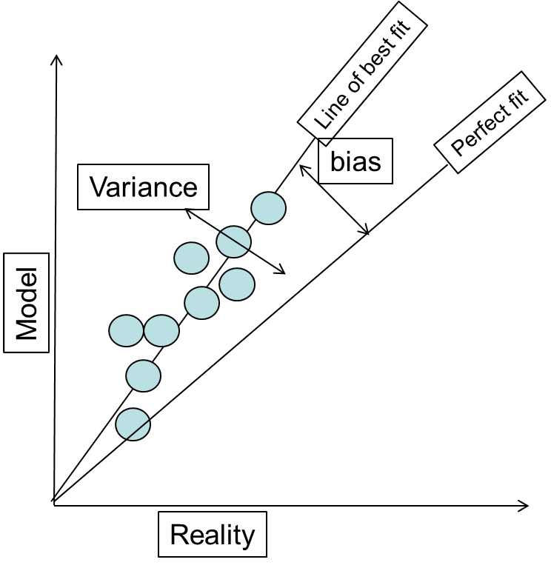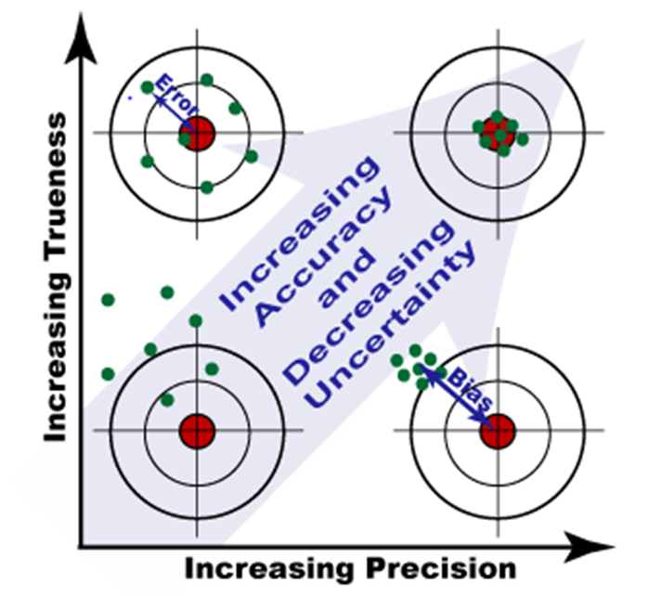Figure 1 - errors, biases and influences on uncertainty (after Richardson et al. 2017; Doherty and Moore, 2017)

Being overcommitted to one conceptualisation over others (bias), perhaps the wrong one, could lead to simulations that overestimate or underestimate impacts. If uncertainty analysis focusses only on errors and neglects to account for or discuss biases, incomplete and distorted evidence of the modelling accuracy will be provided.

For detailed background and discussion of uncertainty issues and methodologies, consult the NCGRT report on the groundwater modelling uncertainty workshop (Middlemis et al. 2018).

# RISK CONTEXT, CAUSAL PATHWAYS AND ADAPTIVE MANAGEMENT

## Uncertainty is integral to Risk Management

Risk is defined as the effect of uncertainty on project objectives (AS/NZS 31000:2009).

Risk is characterised/quantified as a function of the probability and consequences of an outcome.

Freeze et al. (1990) characterizes the role of models in decision-support as quantifying the level of risk associated with management options. It follows that if a model is applied to support environmental decision-making, its simulations of the consequences (impacts) of management options must quantify the related uncertainties (Doherty and Moore, 2017).

Uncertainty analysis is therefore an integral part of a robust risk management framework, as it informs and complements other aspects such as risk assessment and mitigations/treatments, communicating outcomes and prioritising effort to reduce uncertainty (e.g. by acquiring data on key processes) (Walker, 2017). A key example of high priority (but relatively low cost) data that reduces uncertainty in groundwater models is accurate LiDAR topographical data. Accurate definition of the interface between the surface and the sub-surface is critical for implementing boundary conditions in a model to represent surface water features (creeks/rivers), evapotranspiration and spring features (Doble and Crosbie, 2017).

In environmental management, risk has negative connotations generally associated with the hazards or impacts of a development. In this sense, risk is one possible (negative) consequence of uncertainty. Other (positive) consequences of uncertainty can also be identified (Begg, 2013) by way of opportunities to achieve desired benefits (e.g. to justify expenditure on a mining project where sound environmental management can manage other project risks). This highlights the point that value judgements are involved in all risk assessments and the value judgements depend entirely on the economic, social and/or environmental values established in public policies, business cultures and community viewpoints. While scientific studies provide objective information on environmental risks, impacts, mitigations, benefits and management, subjective value judgements are also involved via business, political and/or community viewpoints.

The precautionary principle is incorporated in the principles of ecologically sustainable development (ESD), which are promoted by the objectives of the EPBC Act 1999 (Cth). ESD principles establish that social considerations are a key factor in decision‑making processes, along with economic and environmental factors. Further information on the precautionary principle and ESD is provided in the report on the 2009 independent review of the EPBC Act (Australian Government; 2009). These principles are very important, and have been tested in Australian law, notably in the Queensland Land Court case in 2015 in relation to the proposed Adani Carmichael coal mine (QLC 48).

In this Explanatory Note context, the precautionary principle may be summarised as follows: if a development raises the risk of harm to the environment (i.e. in non-trivial likelihood and consequence terms), then proportionate precautionary measures should be taken even if some cause and effect relationships are not fully established scientifically. Importantly, if both key pre-conditions for the application of the precautionary principle are established (the threat of serious or irreversible environmental damage, and scientific uncertainty as to the nature and scope of the threat of environmental damage; noting that these conditions or thresholds are cumulative), the burden of proof shifts to the proponents of the development (Australian Government, 2009; item 13.21). Hence the critical need to investigate causal pathways when designing groundwater modelling approaches for unbiased investigation and quantification of uncertainty.

This Explanatory Note focuses on environmental management, and thus it mainly discusses the negative aspects of risk. However, the techniques described herein to analyse hydrogeological uncertainty can be used to guide decisions on opportunities that can generate cost-effective benefits for proponents of developments (e.g. by investigating and minimising dewatering uncertainties) as well as for all stakeholders via adaptive environmental management (e.g. establishing threshold impacts/triggers), based on the consideration of causal pathways for potential impacts and the effects of uncertainty.

## Causal Pathways

The Information Guidelines highlight the need to investigate causal pathways for potential impacts on the water resources and water-dependent assets arising from mining or CSG operations via the stressors of dewatering or depressurisation of hydrogeological units. Identifying relevant causal pathways is a crucial part of uncertainty quantification. It will determine the modelling approach, the sources of uncertainty to consider and most importantly, the model outcomes required.

Causal pathways should be identified by conservatively considering potential connectivities between groundwater units and/or surface water features and related ecological assets such as groundwater dependent ecosystems (GDEs). More detail on causal pathways and conceptual model development is provided in Holland et al. (2016) and the IESC report on modelling water-related ecological responses (Cth, 2015). OGIA (2016a, 2016b) has published good examples of hydrogeological and connectivity investigations. Practical guidance on GDEs is provided in Eamus et al. (2006), Eamus (2009), Richardson et al. (2011), and BoM (2015).

The Information Guidelines therefore require detailed descriptions of the modelling approaches used to assess the likelihood, consequence or significance of impacts and the overall level of risk to water-dependent assets, and of the data quality and inherent uncertainties in the baseline conditions and the model simulations of predicted impacts.

A conservative approach to modelling and impact assessment may be warranted in terms of aiming to over-predict the impacts of development, as that provides confidence in assessments in the face of uncertainty (this is discussed further in the next few sections). On the other hand, an overly conservative approach is not necessarily warranted in terms of the potential cost of missed economic opportunity. These issues are discussed further in section 4.

Bioregional Assessments (BAs) provide useful case studies for environmental impact assessments for large coal mines and CSG proposals. The guiding principles from the Information Guidelines were used to develop the BA methodologies (Cth, 2013) for the investigation of key issues, including:

* potential direct, indirect and cumulative impacts on water resources;
* causal pathways linking depressurisation and dewatering of coal seams at depth with impacts on anthropogenic and ecological values of water-dependent receptors and assets;
* conceptual models and quantitative, semi-quantitative or qualitative analyses for estimating the likelihood of risks and/or impacts to receptors and related values, along with the level of confidence of scientific advice on these impacts; and
* monitoring, evaluation and review programs, and related risk assessment and treatment studies, to minimise or mitigate impacts on water resources.

However, a BA approach should not be considered a template for an Environmental Impact Statement (EIS), as it has a somewhat different objective, scope and scale. While BAs provide advice on the development stressors, causal pathways, receptors and assets, they are not development-specific EIS studies. However, BAs do provide useful information to EIS studies via the regional context information and especially the independent cumulative impacts assessment.

The Cooper sub-region Bioregional Assessment (Cth, 2017) considered causal pathways and the coal development horizon, concluding that detailed modelling for impact assessment was not warranted, and that conceptual modelling would be adequate at that time. This example demonstrates how establishing a low risk context via a causal pathway and risk assessment at an early stage can justify a qualitative approach to impact and uncertainty assessments, especially under adaptive management framework conditions (e.g. subject to future changes to the Cooper Basin coal development pathway).

## Adaptive Management

Adaptive management is often justifiably used to address environmental issues in the face of uncertainty. However, the large time lags affecting groundwater processes can mean that once an action is taken, it may be difficult to reverse the impacts where risk treatments are limited for groundwater actions (Walker, 2017). For example, by the time monitoring shows that a significant ecological asset will be affected, it may be too late to effectively act in some cases, in that turning off the pumps will not solve the problem (even if that were an immediate action) due to the hydrogeological time lag effects. This drives the need for a conservative approach to impact assessment, including careful analysis of uncertainties and investigation of options for risk treatments and mitigation to understand and communicate the residual risk and the ability to adaptively manage.

# GUIDING PRINCIPLES FOR UNCERTAINTY ANALYSIS

From a management perspective, modelling is considered to have failed if there is sufficient bias for a poor decision to be made (e.g. by lack of transparency or uncertainty analysis), especially if the consequence is large (Walker, 2017).

A modelling study should be designed to quantify its own reliability by accompanying its simulations with an objective assessment of uncertainty so that model users have transparent assurance that uncertainty is not underestimated (Doherty, 2010). Objective uncertainty analysis gives end-users confidence that a future potential impact (e.g. threshold impact exceeded) has been considered carefully in an unbiased way[1]. In statistical hypothesis testing terms, this means that there is a low risk of a type 2 error (i.e. false rejection of a hypothesis that has unwanted outcomes). However, statistical error discussions such as that can complicate groundwater management matters unnecessarily, so in simple terms, we mean this: if modelling is used to predict that an unwanted outcome won’t happen (e.g. via a biased model that overlooks important causal pathways), but it can indeed eventuate (with non-trivial probability), then we should consider that the model study has failed.

In an ideal world where every professional is expert in every scientific discipline applied to groundwater investigations, the following points would define an ideal uncertainty workflow:

1. define decision-critical potential impact(s);
2. define modelling study failure in terms consistent with a type 2 error, but in groundwater-related threshold impact terms that are specific and measurable in space and time (e.g. drawdown at a GDE of more than 2m in X years; spring discharge not less than Q50 in Y years; river baseflow more than Q95 in Z years);
3. design an efficient and effective modelling methodology of processing expert knowledge and data (via a modelling tool consistent with historical measurements of system responses to stress), with due consideration of potential bias, to quantify the probability of the unwanted outcome (threshold impact);
4. strike a balance between model simplicity and complexity in developing the model(s) for the purpose of uncertainty evaluation, commensurate with the risk/consequence profile of the project (may require more than one model);
5. demonstrate best endeavours to avoid under-estimating uncertainties relating to threshold impacts by invoking methods that consider potential causal pathways for impacts and including simplification-induced potential for error and bias in the hypothesis testing process;
6. justify increments in model complexity if uncertainty bounds need to be narrowed through extra information (may allow rejection of a hypothesis that cannot otherwise be rejected).

Further information is provided herein on the key elements of how model uncertainty can be analysed in the context of supporting a practical EIS project for large coal mining and CSG proposals. This should not be interpreted as a step-by-step guide to comprehensively analysing uncertainty.

# IMPORTANCE OF AVOIDING BIAS

In the sense of support for environmental decision-making, the potential impact (unwanted outcome) could take many forms. For example, it may be catastrophic, such as very low groundwater levels that cause a spring to cease flowing. It could be some other less critical criterion that indicates failure of an environmental management plan, such as lower-than-threshold stream flows for durations that compromise stream health (Doherty and Moore, 2017).

Tolerance of failure is related to the cost of failure (however that may be manifest). If the cost is relatively low, then a decision-maker can tolerate a moderate probability of failure, provided this reduces implementation costs for any attractive and effective risk treatment (i.e. economically and socially acceptable options that are able to reduce risk and be implemented in a timely fashion). On the other hand, if the cost of failure is high (e.g. unwanted impacts on high value ecosystems), the probability of its occurrence must be low for a management option to be deemed attractive and effective.

This means that conceptual models for large coal mines and CSG developments must adopt unbiased1(see previous footnote) ways of analysing how causal pathways can propagate impacts from depressurisation and dewatering of coal seams to manifest as direct, indirect and cumulative impacts on water-related and other receptors, and to investigate the key sources of uncertainty. More than one model conceptualisation or realisation may need to be tested in terms of the effect of conceptual or other sources of uncertainty on model outputs, which may lead to more than one mathematical model, as outlined in the AGMG (Barnett et al. 2012). The multiple models may be of different types (e.g. conceptual or analytical or numerical), depending on the objective to be investigated (it is not possible to be prescriptive).

The unbiased investigation of causal pathways is a key element of the ecological values analysis at the problem definition stage, along with data analysis, conceptualisation, and the initial risk analysis and treatment options assessment.

# MODELLING WORKFLOW FOR UNCERTAINTY ANALYSIS

Uncertainty analysis must be considered at the problem definition and at each subsequent stage of the workflow. It must be integrated within a risk management framework (i.e. initial risk assessment and subsequent review/revision) and involve meaningful (‘without prejudice’) engagement/consultation between proponents and agencies on methodologies and assumptions.

A conceptual example is illustrated in Figure 2 (after Walker, 2017, based on discussions in Gillaume et al. 2016, and Peeters, 2017b). Initially, a preliminary risk assessment is done, possible risk mitigations are considered, and the model is conceptualised to meet the objectives. As the modelling and assessment workflow proceeds through its iterations, there is a winnowing of the objectives according to risk, and complexity may be added or refined as necessary. In the preliminary stages, there may not be any need for numerical modelling, and if risks are not high at any stage, nothing more may be required and resourcing the investigation may be curtailed.

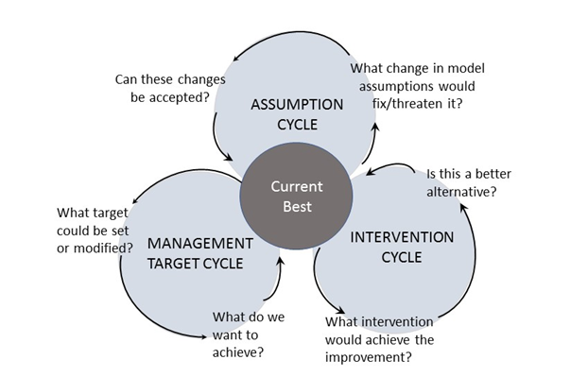Figure 2 - schematic iterative approach for groundwater modelling involving setting objectives, risk mitigation options and modelling conceptualisation (Guillaume et al. 2016)

The AGMG state that objective consideration of uncertainty is warranted for every groundwater project (Barnett et al. 2012). For high value or risk projects, the lack of an objective uncertainty assessment is a metric for model failure. For low risk projects, it may be acceptable to describe the effect of uncertainty on the project objectives in more qualitative terms. Most large coal mines and CSG projects would be classified as high environmental risk, although some projects may be able to be justified as low risk.

The following key principles drive the modelling workflow to objectively assess uncertainty, all of which are consistent with the AGMG (Barnett et al. 2012), including engagement with regulators at key stages (Table 1, Figure 3; see next page):

* While all projects require a qualitative uncertainty analysis as a minimum, discussing how model assumptions can potentially affect simulations, high risk projects also require a quantitative uncertainty assessment to a level of detail commensurate with the potential risks and/or consequences of the project (i.e. this means that a preliminary hydrogeological risk assessment is needed at an early stage in the project);
* Modelling methods must consider the coal mining or CSG development stressors (dewatering and depressurisation) and causal pathways for potential impacts on water resources and water-related assets;
* Explicitly define project objectives and what the model needs to predict in specific and measurable terms (e.g. threshold or trigger impact terms provide information on which decisions may be based objectively);
* Design the methodology to provide information about the uncertainty in conceptualisations and model simulation outputs in a way that allows decision makers to understand the effects of uncertainty on project objectives and the effects of potential bias (the model must be specifically fit for this purpose);
* Strike a balance between model simplicity and complexity in developing the model(s) for the purpose of uncertainty evaluation, commensurate with the risk/consequence profile of the project (may require more than one model);
* Constrain the model simulations with available observations and information;
* Present the range of model outcomes that are consistent with all observations and information (calibration-constrained model outcomes);
* Prepare reports to transparently and logically discuss modelling and methodology assumptions and choices and how they affect simulations, uncertainties and potential bias, and present the results clearly such they are not prone to misinterpretation;
* Iterate through the workflow during the project, revisiting objectives, assumptions, conceptualisations and simulations, as well as the risk assessment (with consideration of any risk treatments applied to mitigate impacts), in a process of engagement with agencies.

Engagement with regulatory agencies is required at the outset and at subsequent key stages, to discuss and agree the methodologies and ongoing refinements and to understand the implications of the results. Such engagement can be conducted on a ‘without prejudice basis’. Effective communication requires engagement throughout the investigation, not simply at the end to present the results (Richardson et al. 2017; Barnett et al. 2012); see also section 12.1.

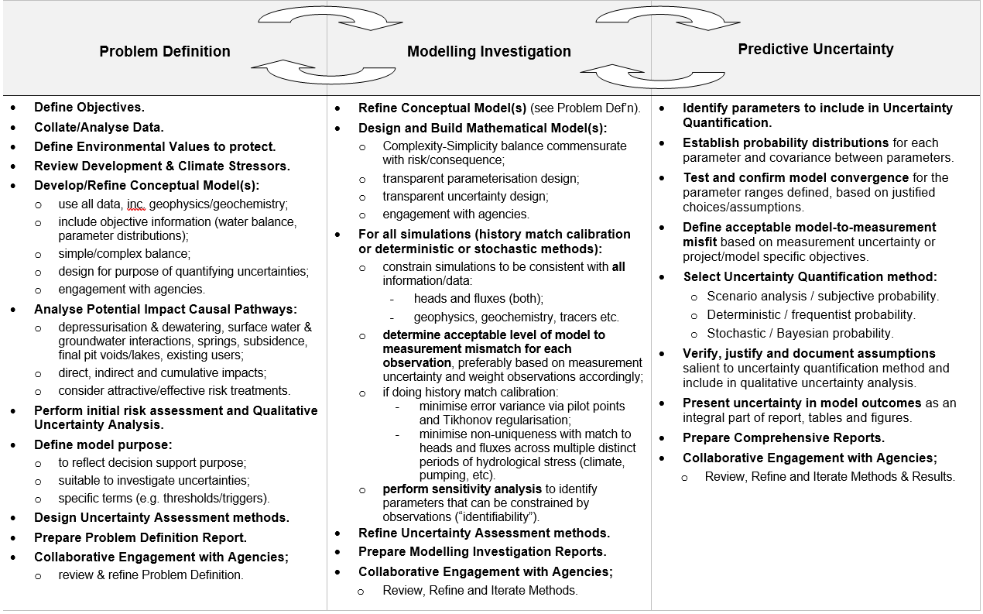Table 1 - modelling uncertainty analysis iterative workflow summary

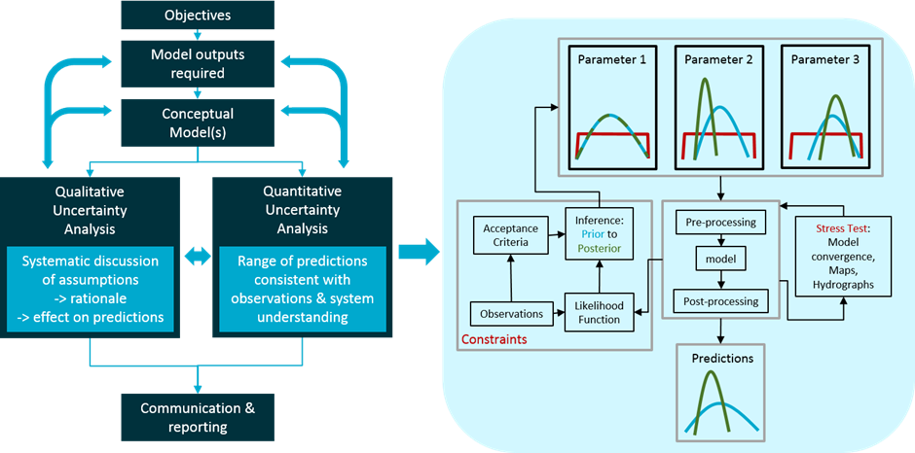Figure 3 - modelling uncertainty analysis iterative workflow (after Peeters, 2017b)

The high profile of global issues such as climate variability, energy security and controversial developments has raised awareness of uncertainty and risk amongst environmentalists, industry, regulators and the community. This has raised expectations that scientific results be presented in an honest, precise and transparent fashion. There are drivers for and occurrences of both under- and over-statement of uncertainties (e.g. reflecting unwarranted distortion of the assessments), in some cases deliberately aimed at undermining the science (Walker, 2017). Transparent documentation provides objective evidence of the uncertainty methods and assumptions applied, and formal engagement provides confidence to the regulator and community that all potential impacts have been considered, with appropriate proposed monitoring and adaptive management mitigations/treatments.

Decision-makers need to know the ‘most likely’ outcome and to understand whether there are circumstances that may result in unacceptable outcomes and what risk or mitigation treatments or adaptive management initiatives may be applied. Careful choice of language that is aligned with decision-making (e.g. positive or negative framing, and the use of thresholds) can reduce cognitive strain, making it easier for all stakeholders to understand the ideas presented without further analysis (Richardson et al. 2017). For example, a 5% chance that drawdown will be greater than 1m is the same as a 95% chance that it will be less than 1m; the latter may be a more positive framing with less cognitive strain.

# MODELLING WORKFLOW, CONFIDENCE LEVEL, CONDITIONAL CALIBRATION

## Modelling Workflow (conceptual viewpoints)

The model uncertainty workflow outlined herein differs from the traditional model workflow outlined in the AGMG of design, calibrate, predict and assess sensitivities (Figure 4, after Ferré, 2016).

Figure 4 - conceptual modelling workflow viewpoints (after Ferré, 2016)

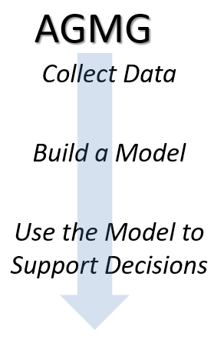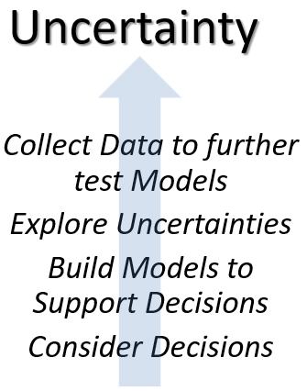

Although the uncertainty workflow differs conceptually from the traditional workflow, the innovation and adaption of modelling methods is encouraged by the AGMG itself (Barnett et al. 2012), and this Explanatory Note is consistent with and builds on the AGMG. A different view of the workflow is warranted because, while the uncertainty analysis workflow includes traditional elements of model building (design, calibration and sensitivity), an uncertainty-driven approach is designed and applied specifically to support decisions by exploring uncertainties within a risk and adaptive management framework.

The traditional workflow tends to result in complex models, even though the AGMG encourages finding the right balance between complexity and simplicity for the project objectives.

The uncertainty-driven approach usually requires carefully designed models with short run times for the large numbers of runs involved. However, careful design can take many forms, such as ensuring stable model simulations and that complexity is included where it is relevant to the project objective (“effective simplicity”), while not using long run times as an excuse to avoid necessary complexity.

## AGMG Model Confidence Level Classification

While this Explanatory Note is philosophically integrated and consistent with the AGMG (Barnett et al. 2012), there are two other areas where a slightly different focus is recommended (in addition to the conceptual workflow diagram above). Firstly, while the model confidence level classification table (AGMG, Section 2 and Table 2-1) is reasonable, the related commentary and guidance is poor and self-contradictory on some elements. Alternative methods of confidence level assessments have been tested including applying a method of indicating which attributes in the table are satisfied for a given model, and assessing the confidence level via consideration of the score counts in each class (an example is presented in Figure 5, based on an original suggestion by Dr Noel Merrick, pers. comm.). This avoids the current tendency where one guideline comment may be “cherry-picked” to undermine the model confidence classification, rather than considering the balance of model performance against the entire table of attributes (e.g. with reference to Figure 5, the AGMG commentary indicates that a single Class 1 attribute is sufficient to classify the model as Class 1 overall, even though the weight of evidence indicates otherwise).

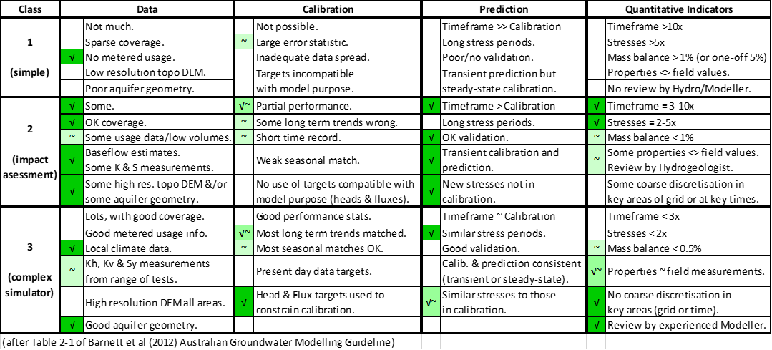Figure 5 - AGMG model confidence level case study example (after N. Merrick, pers. comm.)

However, this approach may also be prone to manipulation, and it is recommended that an improved method would require the modeller or reviewer to indicate in the table which conditions are satisfied, explain why others are not satisfied and why this is relevant to the model objectives, outcomes and uncertainties. This approach is consistent with other recommendations in this Explanatory Note for modellers to justify assumptions and choices in technical reports in a manner that is open, transparent and amenable for scrutiny.

The other divergence from the AGMG is that, while it recommends linear uncertainty methods due to their computational efficiency, this Explanatory Note lists linear uncertainty methods as one of several approaches for uncertainty analysis. Linear methods may be appropriate for a groundwater modelling project, provided that the underlying assumptions can be shown to be justified.

## Conditional Calibration

The traditional workflow has been characterised as a means of reducing parameter bias and uncertainty through calibrating the model against measured observations of historical hydrologic system behaviour. The process is also known as parameter identification or estimation, inverse solution or history matching (Barnett et al. 2012; Neuman and Wierenga, 2003). A model that is demonstrably consistent with monitoring data (especially if head and flux calibration targets are matched) is traditionally deemed to be a reliable deterministic simulator of future behaviour.

However, neither the structure nor the parameter values of a deterministic model are unique. This "equifinality" problem has long been recognised as generic and not simply one of identifying a system's "true" model structure or parameter values (Beven, 1993). In fact, a "true" model for a hydrologic system does not exist, due to the sources of uncertainty outlined previously. Even the most complex model can (by definition) only be approximate in its attempted simulation of environmental processes.

Doherty and Moore (2017) show that the calibration process does not reduce the uncertainty of a simulation where it is sensitive to parameters/combinations that lie within the “calibration null space”. The calibration null space here refers to those model parameters and combinations that are not informed by the available historical measurements.

However, Doherty and Moore (2017) also show that calibration is a valid first step in a two-step uncertainty analysis process using linear methods (see section 11.2):

1. finding a history match (inverse) solution of minimum error variance[2] by fitting model outputs to the calibration dataset of heads and fluxes (preferably during a period of wide-ranging hydrological stress); this reduces non-uniqueness and can be achieved using the uncertainty analysis techniques of pilot point parameter estimation with Tikhonov regularisation (a means of ensuring that parameter estimates do not move far from initial estimates that are considered to be reasonable; Barnett et al. 2012); and then;
2. quantifying the error in simulations made by the history-matched model.

A model that is carefully calibrated (and/or subsequently validated) in this way should be qualified as a **conditionally calibrated (validated) model in that it has not yet been falsified by tests against observational data** (Beven and Young, 2013).

Conditionally calibrated models are useful for running simulations within the range of the calibration and evaluation data (Barnett et al. 2012), while allowing for their updating in the light of future research and development or changes in catchment characteristics.

A conditionally calibrated model can be considered a ‘receptacle for expert knowledge’ (Doherty and Moore, 2017), or a ‘good representation of the system of interest’ (Barnett et al. 2012), in terms of:

* the conceptualisation and parameterisation used to represent real world hydraulic properties with effective simplicity (or appropriate complexity), and
* the historical behaviour of the system (as the history match (conditional calibration) constrains parameters to a narrow stochastic range).

Deterministic scenario analysis using a conditionally calibrated model and subjective probability assessment is discouraged as an uncertainty quantification approach due to its questionable subjectivity. However, if it can be established that the conceptualisation and parameterisation is conservative (i.e. over-estimates impact), then a deterministic scenario analysis can be used as a screening tool for further investigation and detailed modelling, or it may be used in qualitative uncertainty analysis for a low risk context (e.g. see section 11.1).

A conditional calibration approach can be used to provide the prior probability foundation for a (tractable but not strictly) Bayesian investigation of stochastic uncertainty (see section 11.3). However, it does not necessarily reduce sources of predictive bias that may be introduced via simplification assumptions or via a conditional calibration process that compensate for model defects via biased parameter values of the history-match model (Doherty and Moore, 2017).

# MODEL COMPLEXITY / SIMPLICITY

## Geological Complexity

The level of hydrogeologic complexity incorporated in any model should be commensurate with its purpose (Neuman and Wierenga, 2003). It is worth reiterating for the purpose of this Explanatory Note, the purpose of a modelling study is to provide information about the uncertainty in conceptualisations and model simulation outputs in a way that allows decision makers to understand the effects of uncertainty on project objectives and the effects of potential bias.

Refsgaard et al. (2012) concluded that the importance of geological models is lessened for flow modelling simulations, provided that (history match) conditional calibration against head and discharge data is performed, and that model simulations are confined; (i) to the same types of variables used for conditional calibration (e.g. head and flux data), and (ii) to similar hydrological stress regimes (pumping, climate and timeframes). These principles are consistent with the AGMG guiding principles (Barnett et al. 2012). It is argued that, in these cases, the inevitable (unknown) errors in the geological interpretations can (to some extent) be compensated by the biased parameter values of the history-match model. However, they warn that geological model uncertainties become crucial in situations where groundwater models that are history-matched to head and discharge data for the historical pumping or climate record are then used for extrapolation beyond that conditional calibration base. In such ‘out of range’ simulations, the geological structure uncertainty may often be the dominant source, and thus alternative hydrogeological conceptualisations should form part of the uncertainty assessment.

## Model Complexity Overheads

Highly complex models are expensive to develop, and usually run slowly or are not numerically stable. This hinders the methods used for uncertainty analysis to quantify the extent to which the model complexity and parameterisation allows for the available observations to be matched within specified criteria in order to reduce predictive uncertainty. It is also difficult to scrutinise (or indeed to communicate) all aspects of highly complex models, which renders them less transparent, which in turn can lead to a loss in confidence in the model results (Saltelli and Funtowicz, 2014).

There are also concerns that the AGMG (Barnett et al. 2012) are being used inappropriately in some cases to justify “indiscriminate complexification” of models, rather than “effective simplification” (Voss, 2011b) where that would be more appropriate for the investigation context, objectives and resources (Doherty, 2010). There are also cases where opponents of coal or CSG developments have suggested that impact assessments may be fatally flawed because it is claimed that models do not capture adequate complexity.

Whereas increased complexity does not necessarily translate directly into a stronger technical basis for regulatory decisions, the use of overly simplified models may result in erroneous decisions. An approach is advocated in this Explanatory Note that goes beyond platitudes of subjectively making a model “as simple or complex as required, but not too simple or complex” as many guidelines recommend. Rather;

* the model must be designed to be specifically fit for the purpose of providing information about uncertainty in a way that allows decision makers to understand the effects of uncertainty on project objectives, and the effects of potential bias;
* engagement with regulatory agencies is required from the outset and at all stages throughout the modelling study, to discuss and agree the uncertainty analysis methodologies and understand the implications of the results.

# UNCERTAINTY QUANTIFICATION TECHNIQUES

The practical implementation of the concepts described above can be a daunting task, especially when one seeks an approach that respects the theoretical nuances of uncertainty quantification in a transparent way, while being pragmatic in the face of modelling resources that are never unlimited.

There has been a wide variety of uncertainty quantification techniques developed for water resources in the last four decades (Maier et al. 2014). In very general terms, these can be classified in three groups, and for practical projects, these three different approaches may be considered to arrive at a probabilistic assessment of the model outcomes to inform a risk assessment:

1. Deterministic Scenario Analysis with subjective probability quantification

The model is run with a limited number of different plausible parameter combinations. In hydrogeological model reports, this is often referred to as sensitivity analysis (see section 0 for comprehensive discussion of sensitivity analysis). For these results to be used in a risk analysis, a subjective, often informal probability needs to be specified (e.g. a description such as ‘worst case’).

1. Deterministic modelling with linear probability quantification

The model is calibrated (either automated or by trial and error) to obtain a single parameter combination that is considered to be realistic and minimises the mismatch between observed and simulated values. The model is assumed to behave linearly in the vicinity of this optimal parameter combination and it is further assumed that the uncertainty in parameters and observations can be described through multivariate normal distributions. This may require transforming parameters and observations through for instance a log-transform. Using linear error propagation equations, the predictive uncertainty can be expressed as a confidence interval based on the standard deviation.

1. Stochastic modelling with Bayesian probability quantification

An ensemble of model predictions is generated, based on a large number of model evaluations with different parameter values that are all consistent with the observations.

Each of these practical methods does not have to be applied to any case. There is not a single preferred method, and there may be alternative methods (not outlined herein) that may be justified as more suitable. It is, however, crucial to acknowledge that each uncertainty analysis method has different underpinning assumptions. It is the role of the modeller to discuss and justify each assumption in the technical report(s) contained in EISs in a manner that is open, transparent and amenable for scrutiny, as well as presenting the results clearly such they are not prone to misinterpretation. Section 11 discusses in greater detail the main assumptions, advantages and drawbacks of each group of uncertainty quantification techniques.

The assumption hunting approach discussed by Peeters (2017a) provides a framework to systematically discuss assumptions in terms of the rationale behind the assumption chosen and its potential effects on the simulations required of the model to address the project objectives. This is discussed in greater detail in section 11.4.

Sensitivity analysis can play an important role in providing insights to the modelled system, by identifying which parameters can be constrained by data and which parameters have the greatest influence on the model outcomes. This is a first step in analysis of data worth or the value of information to guide further data collection, model development and monitoring design. Section 0 describes the role of sensitivity analysis in an uncertainty quantification workflow.

There is, however, a set of prerequisites that a groundwater model must satisfy before any of the approaches listed above can be applied, which is the topic of next section.

# MODEL PREREQUISITES FOR UNCERTAINTY QUANTIFICATION

The prerequisites for uncertainty quantification of groundwater model outcomes are listed below. If any of these prerequisites is not satisfied, adequate quantification of uncertainty is not possible (qualitative or semi-quantitative uncertainty analysis may be possible).

## Clearly defined model outcomes in space and time

It is not possible to quantify the uncertainty of a groundwater model as a whole. It is only possible to quantify the uncertainty of model simulations. It is therefore essential that the model outcomes that will be used to inform the decision-making process are explicitly defined in space and time. Examples are the maximum drawdown at a key bore or spring, the change in surface water groundwater exchange flux along a river reach for a specific period or the drawdown contours during or after cessation of coal or CSG development activities.

Some policy documents explicitly list trigger levels or impact thresholds (such as the NSW Aquifer Interference Policy). For assets where these are applicable, model outcomes can be specified directly as a function of these thresholds and trigger levels. If these are not available, the relevant model outcomes and threshold levels need to be discussed and agreed upon with the various stakeholders before modelling commences.

## A list of parameters or model features that are included in the uncertainty analysis

There is a practical upper limit to the number of model features that can be included in the uncertainty quantification. Before starting the analysis, a decision is needed on which parameters to include and which parameters to fix (exclude from the analysis). This selection needs to be done during the conceptualisation phase of the groundwater model as it affects the design and construction of the numerical model.

A more far-reaching consequence of this selection is that the uncertainty analysis will not result in a full probabilistic simulation, but a probabilistic simulation that is conditional upon the source of uncertainty included in the analysis. It is paramount that these assumptions and their justifications are communicated clearly so that reviewers, regulators and other stakeholders can easily identify which sources of uncertainty are included and which are not.

The parameterisation of models traditionally has a focus on (conditional) calibration, in which parameters are included to achieve the smallest residuals to historical measurements in a least-squares error term sense. These are not necessary the same parameters that have the greatest influence on simulations. A trivial example is that effective porosity in a confined aquifer will have very limited influence on groundwater head simulations but will dominate any transport simulations.

Due to the many non-linearities inherent to groundwater modelling, identifying which parameters can be constrained by data and which are important is often non-trivial. This requires a comprehensive sensitivity analysis, which is discussed in detail in section 0.

## Probability distributions for each of the parameters included in the uncertainty analysis and a description of the covariance between parameters

For each of the three types of practical uncertainty quantification methods listed above in section 0, it is important to define the plausible range over which a parameter can vary. At its simplest, a uniform distribution describes a range between a minimal and maximal value. Normal or lognormal distributions are fully characterised by a mean and standard deviation, while empirical distributions can take an arbitrary, multimodal shape. Some parameters may be correlated for lithological reasons, such as hydraulic conductivity (K) and storativity (S) for instance, or may be spatially correlated. This correlation needs to be expressed as a covariance between parameters. In some models, the parameterisation can be quite complex, such as a depth-dependent hydraulic conductivity or a multiplier on a spatially variable recharge field. For such complex parameterisation it is advisable to verify that the specified range of parameter values result in plausible model input values.

## A converging groundwater model over the entire plausible range of model parameters

It is essential that the groundwater model can be evaluated over the entire range of parameter combinations defined above. It is recommended to submit the model to a stress test in which a number of extreme parameter combinations are tested for convergence before committing to a computationally intensive automated conditional calibration or stochastic model evaluation.

By strategically choosing parameter combinations, this stress test can yield very useful insights on parameter sensitivity and model behaviour (for further information, refer to Crosbie et al. 2016).

## The measurement uncertainty of each observation and/or a project-specific assessment of acceptable model to measurement misfit

The reference model used in the uncertainty scenario analysis needs to have an acceptable misfit between simulated and observed data before it can be used in simulations. In uncertainty quantification, this misfit is used to obtain the probability of any parameter value. The goal is to find parameter combinations that result in model residuals that are equal to or smaller than the measurement uncertainty.

Observations can be affected by local processes not captured in the model and it is therefore recommended to include these upscaling issues in the measurement uncertainty. Alternatively, one can think of the measurement uncertainty as the maximum acceptable misfit of model to measured values. Defining this acceptable misfit is very much project- and model-specific and it is the task of the modeller, in discussion with the client, regulator and other stakeholders, to define and justify the acceptable misfit and how to integrate this in the uncertainty quantification workflow.

# UNCERTAINTY QUANTIFICATION APPROACHES

This section discusses in greater detail the three types of uncertainty quantification approaches listed in section 0, highlighting the advantages, drawbacks and potential pitfalls of each method. This document does not recommend any particular software, nor is it intended to give a step-by-step description of how to carry out an uncertainty analysis. This is covered in other publications such as Peeters (2017b) and Doherty (2015). Each section does however list the main assumptions for each approach that need to be transparently justified in the modelling report.

## Deterministic Scenario Analysis with Subjective Probability

In scenario analysis, a single realisation of a numerical model (e.g. the model that best fits the historical observations) is used to make simulations. For such results to be useful in a risk framework, it is necessary to express the probability of this single realisation. This is a subjective assessment, based on the available knowledge of the system, the design of the model and the modeller’s experience.

The model with parameter values that best match the observations is often described at the ‘most likely’. Many modellers aim to be conservative in parameter selection, especially parameters that are not easily constrained by observations. In such situations, where some aspects of the model will be ‘most likely’, while others are ‘conservative’, it becomes difficult to assess if the simulations are ‘most likely’ or ‘conservative’ overall.

To further complicate this issue, parameters are not necessarily conservative for all model outcomes. By way of a simple example, for a given pumping rate, high hydraulic conductivity values can be conservative when calculating the time lags that affect streamflow depletion. The higher the hydraulic conductivity is, however, the smaller the drawdown. High conductivity values are in this case not conservative for drawdown simulation effects.

Perturbing parameter values in an ad-hoc sensitivity analysis (e.g. one parameter at a time) by an arbitrary amount does provide some insight to model behaviour, but is not sufficient for uncertainty quantification if the following questions cannot be answered:

* What is the probability of the perturbed value and corresponding simulations?
* How is the amount of perturbation determined and how does this relate to the probability distribution of the parameters (see section 10.3)?
* Are parameter interaction effects accounted for?

Scenario analysis with subjective probability assessment is strongly discouraged as an uncertainty quantification approach, especially since the subjectivity of the assessment can readily be questioned.

A comprehensive, formal sensitivity analysis is encouraged, such as through analysis of the Jacobian matrix of a model or an ensemble of model runs, as it can be used to objectively assess the importance of particular parameter values and it will also allow a more robust uncertainty quantification (see section 0).

This does not mean that the scenario analysis approach is without merit, whether or not a formal comprehensive sensitivity analysis is conducted. If it can be established that the conceptualisation and parameterisation is conservative, a scenario analysis can be used as a screening tool to delineate areas for further research and detailed modelling, or it may be used as part of a qualitative uncertainty analysis (more details are provided in Peeters 2017b), especially if a formal sensitivity analysis is undertaken.

## Deterministic Modelling with Linear Probability Quantification

Linear error propagation techniques can be used to compute simulation confidence intervals for any given model with a single set of parameter values (the conditionally calibrated model). In the following, this is referred to as the reference model (e.g. the model that best fits the historical observations).

These linear error propagation techniques form the basis of the PREDVAR and PREDUNC tools provided in the PEST package (Doherty, 2016). The main assumptions are that:

1. The model behaves linearly in the immediate vicinity of the selected parameter values.
2. The parameter values, or their transformed values, are normally distributed. Interactions between parameters are described through multivariate normal distributions.
3. The parameter values used in the reference model represent the mean of the normal distribution.
4. The measurement uncertainty is normally distributed. Correlation in measurement uncertainty is captured through a multivariate normal distribution.
5. The model outcomes are normally distributed.

The model is evaluated at least twice for each parameter. The change in model outcome corresponding to perturbing each parameter in isolation is captured in what is referred to as the Jacobian matrix. As shown in Moore and Doherty (2005), this matrix can be combined with the covariance matrix describing the uncertainty in parameters and the covariance matrix describing the measurement uncertainty to calculate the prediction uncertainty. The model outcomes of the reference model are considered to be the mean of a normal distribution and the result of the error propagation provides the standard deviation.

An automated conditional calibration seeks a parameter combination that provides a best fit in a least-squares sense, for instance by using the Levenberg-Marquardt algorithm as implemented in PEST. In subsequent linear error propagation, this parameter combination is then considered as the mean of the multivariate normal distribution. An automated conditional calibration, even when using regularisation, can result in parameter combinations that are only a local rather than global minimum of the response surface.

Another pitfall is that, due to parameter correlation, parameters compensate for conceptual issues or for other parameters (e.g. the response of an aquifer often depends on ratios of model parameters, such as aquifer diffusivity (T/S), or recharge and transmissivity (R/T); Barnett et al. 2012). The classic example is provided in Doherty (2010), where incorrectly specified head boundary conditions lead to a small residual in head values, but biased hydraulic conductivity estimates. Using such biased values in a simulation obviously compromises the simulation and its confidence intervals. Relatively low-cost data-gathering techniques, such as a LiDAR survey of river bed and spring elevations, can greatly reduce the uncertainty in boundary conditions and by consequence, the uncertainty in inferred hydraulic property values.

Doherty (2015) and White et al. (2014) provide some strategies to minimise bias in parameter values by pre-processing observations and using multi-component objective functions.

As indicated in section 10.5, it is essential that the measurement uncertainty for each observation is assessed, independent from the model. Moore and Doherty (2005) show that the predictive uncertainty depends greatly on the measurement uncertainty and what is considered an acceptable model to measurement misfit. In formal linear error propagation, the weights of observations in the objective function are inversely proportional to the measurement uncertainty, i.e. measurements with small uncertainty will have greater weight. Adjusting weights of observations is a straightforward way to combine different types of observations, to emphasize observations that align with the model outcomes of interest, reflect the reliability of observations and compensate for scale and structural issues. To avoid criticism that the weighting of observations is a deliberate attempt to pervert the model outcome, the weighting must be justified in a transparent way.

One way of expressing this is by presenting the confidence interval that a weight corresponds to, assuming measurement error is normally distributed. A groundwater level measurement that is assigned a weight of 1 corresponds to a normal distribution with a mean equal to the observed value and a standard deviation of 1 m. If you consider model outcomes within two standard deviations as acceptable (approximately containing 90% of the probability mass), any model outcome within 2 m of the observed value is deemed acceptable.

Note that giving all observations an equal weight is not recommended, as that implicitly assumes that the measurement and structural uncertainty is equal throughout the model domain, which is seldom an appropriate assumption.

Many outcomes from groundwater models are non-linear functions of the model parameters. A naïve application of linear error propagation methods can thus lead to nonsensical results. Consider for instance that an analysis results in a drawdown prediction of 0.5 m with a standard deviation of 0.3 m. The 90th percentile prediction interval for a normal distribution, defined as [-1.96, +1.96], then becomes [-0.088, 1.088]. This would imply that in this model the development can cause a rise in groundwater levels.

The modelling team needs to verify and show that the model outcomes are sufficiently close to a linear function of the parameters for the linear error propagation to produce sensible results.

A final comment on the deterministic approach with linear error propagation, is that it is not straight-forward to consider multiple conceptualisations as the method is based on a single, deterministic reference model.

## Stochastic Modelling with Bayesian Probability

Stochastic modelling relaxes many of the assumptions on linearity and normality of parameters by evaluating a large number of parameter combinations and presenting the results, the model outcomes, as an ensemble.

In Bayesian inference, a prior distribution is specified for each parameter (and eventual joint distribution between parameters), encapsulating the current state of information and knowledge. A sampling algorithm evaluates a large number of parameter combinations and preferably retains parameter combinations with a high likelihood, i.e. a close fit to observations. The updated range of parameter values is called the posterior parameter distribution. This posterior parameter distribution is randomly sampled, and the corresponding model outcomes form the posterior predictive distribution.

This stochastic approach of uncertainty quantification is the most generic and has the least stringent assumptions. There are nevertheless many challenges and pitfalls in implementing this approach.

The largest drawback is the large number of model evaluations required. The advent of easily accessible supercomputer and cloud computing services means that evaluating a model several hundreds or thousands of times becomes feasible within the resources of a typical groundwater model project, even if a single model run requires more than an hour to converge. The largest bottleneck is not so much the run-time but ensuring the model is sufficiently stable that a large range of parameter combinations can be evaluated. Model emulation or surrogate models can partly alleviate the computational burden by replacing the original model with a low-resolution model or a statistical model (Asher et al. 2015). Adequately training such a model does, however, add another layer of uncertainty to the analysis, and it still requires hundreds to thousands of original model evaluations.

The number of model evaluations required is problem-specific. The number of samples from a posterior parameter or predictive distribution is considered sufficient if the moments of interest converge. If one is interested in the 95th percentile of a distribution, one has to verify that this summary statistic does not change with increasing number of model runs. Measures of central tendency, such as the mean and median, tend to converge quicker than the extremes of a distribution, such as the 95th or 99th percentile. The number of model runs required therefore depends on the shape of the posterior distribution as well as on the summary statistics of interest.

The stochastic approach allows specification of prior parameter distributions other than Gaussian, with, as an extreme, a fully empirical parameter distribution. The specification of these prior parameter distributions is the most appropriate way to incorporate existing knowledge into the uncertainty quantification. If the observation data is very informative (i.e. can constrain many of the parameters), specifying a too-narrow prior parameter distribution may result in not fully sampling parameter space and not including parameter combinations that provide equal or better fits to the data. Conversely, specifying too wide a prior distribution will make the sampling algorithm very inefficient and will greatly increase the number of model evaluations required to find parameter combinations that fit the data.

Should the data not be very informative (i.e. the data cannot constrain the parameters relevant to the model outcomes of interest), the posterior parameter distributions will be nearly identical to the prior distributions. As with deterministic modelling with linear error propagation, it is essential to identify which parameters can be constrained by the available observations.

Observations are introduced in the stochastic approach through the likelihood function. It can be shown that if measurement errors are assumed to be normally distributed, this is identical to linear error propagation. The discussion of weighting observations in previous sections is also, if not more, applicable to the stochastic approach. The modeller needs to specify the error model of the observations, independently of the model and to define what is an acceptable level of model to measurement misfit.

Null-space Monte Carlo is a special case of a stochastic approach in which the posterior parameter distribution is not generated through sampling from prior parameter distributions, but in which the posterior parameter space is defined by the null-space. The null-space is formed by linear combinations of parameters that have no impact on the model objective function. Random sampling of the null-space ensures that all the model runs in the ensemble of model runs have a similar model-to-measurement misfit. This is a very efficient sampling algorithm, but still relies on parameter values that can be described through multivariate normal distributions and the definition of the null-space hinges on a linearization of a single model run through singular value decomposition.

Approximate Bayesian Computation relaxes the need to have a closed-form, analytic expression of the likelihood function. This method, like the Generalized Likelihood Uncertainty Estimation (GLUE) technique, allows the modeller to specify how the likelihood is calculated. This can, for instance, be a set of constraints that need to be satisfied simultaneously (e.g. head residuals less than 2 m, flux residuals less than 1 ML/d and aquitard Kh less than aquifer Kh). This method allows much more flexibility in specifying the likelihood and is transparent and straightforward to communicate. It does again put the onus on the modeller to select and justify the likelihood functions.

The stochastic approach is more amenable to accommodating multiple conceptualisations. In Bayesian Model Averaging, each conceptualisation is assigned a prior probability and included in the sampling.

## Qualitative Uncertainty Analysis (Assumption Hunting)

As indicated in section 6, each model, regardless of complexity or severity of potential impacts, needs to be subjected to a qualitative uncertainty analysis in terms of a systematic and rigorous assessment of the model assumptions and choices. The justification of model choices is standard practice in groundwater model reporting and the AGMG (Barnett et al. 2012) recommends a ‘limitations and opportunities’ section to highlight the main limitations that can influence results. From the previous section it is clear that each uncertainty quantification approach is based on a number of assumptions that need to be justified and checked.

In the Bioregional Assessments, this qualitative uncertainty analysis is presented together with the results of the uncertainty quantification (Peeters et al. 2016). Each assumption is scored on whether the assumption or model choice is driven by data availability, time and budget available for the project or technical challenges. The most important score, however, is the perceived effect of the assumption on the model outcomes. Summarising this discussion with the scoring system through a table allows reviewers and stakeholders to quickly assess the importance of the various model assumptions.

The qualitative uncertainty analysis has great potential as a communication tool to engage stakeholders. It provides modellers and proponents an opportunity to transparently record that the effects of various assumptions have been logically considered in the modelling process. It also establishes a common ground between modellers and independent reviewers, in which reviewers need to precisely articulate why they disagree with the scoring and reasoning presented.

There are various ways to justify assumptions. For many issues in simulating coal development, there is academic and technical literature available that explores effects on simulation. Relevant examples are Brunner et al. (2010) on representing surface water groundwater connectivity in MODFLOW, Herckenrath et al. (2015) and Cth (2014a) on simulating dual phase flow for coal seam gas production, Cook et al. (2016) on propagation of depressurisation through aquitards and Doble et al. (2017) on the effect of leaky bores. The latter two also explore the effects of assumptions from first principles, starting from the fundamental groundwater flow equations.

Another approach to test assumptions, especially to those very specific to the model study, is to carry out numerical experiments with a small-scale model. Crosbie et al. (2016) analyse the effect of aquifer heterogeneity on regional drawdown simulations. Hayes and Nicol (2017) report building a simplified large-scale model to justify selection of boundary conditions, while Mackie (2013) explores the effect of aquitard heterogeneity through detailed small-scale stochastic analysis.

The most objective approach to assess the effect of an assumption is to incorporate the assumption in the parameterisation so that it can be tested through a formal, comprehensive sensitivity analysis, which is discussed in the next section.

## Sensitivity Analysis

Saltelli (2002) defines sensitivity analysis as: “The study of how uncertainty in the output of a model (numerical or otherwise) can be apportioned to different sources of uncertainty in the model input.”

In this definition, sensitivity analysis augments uncertainty quantification as it identifies which sources of uncertainty contribute most to predictive uncertainty. This is the first step in designing strategies to reduce predictive uncertainty by gathering new data or additional modelling.

There is, however, an important role for sensitivity analysis as a first step in an uncertainty quantification. The computational load of uncertainty quantification increases dramatically with increasing number of parameters. Factor screening or prioritisation aims to identify which parameters have the largest effect on model outcomes so that parameters with no or negligible effect can be excluded from the uncertainty quantification.

Closely related to this goal is parameter identifiability; only parameters to which the objective function is sensitive can be constrained by the observations. Hill and Tiedeman (2007) and Doherty and Hunt (2009) provide metrics for parameter identifiability from analysis of a Jacobian matrix, created through systematic, one-at-a-time perturbation of a single parameter set.

For example, a high value for the relative composite sensitivity (RCS) factor calculated via PEST from the Jacobian matrix for a parameter indicates that the model calibration is sensitive to that parameter, but that the measurements have provided enough information to adequately constrain the uncertainty. A low RCS value, however, indicates that the model calibration is not sensitive to the parameter because the measurements do not inform/constrain the calibration, and thus the effect on predictive uncertainty should be evaluated. Note that a numerical criterion is not applicable to this guidance, as the RCS is a relative factor, and thus the assessment of high and low is relative to the RCS factors calculated for a model.

While this is a good starting point for a comprehensive sensitivity analysis, Saltelli and Annoni (2010) show that this can lead to misleading results, especially when the model is non-linear and highly parameterised. Pianosi et al. (2016) provide a comprehensive overview of global sensitivity analysis methods and their application in environmental modelling. In the Bioregional Assessments (Peeters et al. 2016), the density-based approach by Plischke et al. (2013) is applied to all groundwater and surface water models. The advantages of this approach are that it makes no assumption on the shape of the correlation between parameters and simulations and it can be applied to any given ensemble of model runs, i.e. there is no specified sampling algorithm required.

These complex issues should be considered in any sensitivity analysis that supports uncertainty analysis, and the implications of the various assumptions and methods applied should be logically and transparently reported.

# ENGAGEMENT AND COMMUNICATION

Effective communication requires engagement throughout the investigation, not simply at the end to present the results (Richardson et al. 2017; Barnett et al. 2012).

The key to successful engagement and communication is to design and undertake the investigation methodology and present the results and related information about uncertainty in a way that will allow decision makers to understand the effects of uncertainty on project objectives (Richardson et al. 2017, cited in NCGRT, 2017); that is:

1. based on agreed and transparent model objectives;
2. tailored to decision-makers’ needs;
3. focused on the messages that are relevant to their decisions;
4. presented in plain and clear (precise, jargon-free) language, made fully transparent for independent scrutiny, and not prone to misinterpretation.

## Engagement

Engagement with regulatory agencies is required at the workflow outset and at subsequent key stages, to discuss and agree the methodologies and understand the implications of the results. Key points for engagement are indicated in the workflow (Table 1; see section 6).

This requires meaningful two-way dialogue between modellers and decision-makers (representing key stakeholder organisations; the proponent and the regulatory agencies). Such discussions can occur on a ‘without prejudice basis’. Communicating end-products to decision-makers is the last step in what should be multiple communication steps beforehand.

Transparency about the modelling objectives is critical, and needs to be discussed early in the project workflow. This may require agreement to develop more than one model in order to address what are quite different objectives, such as mine dewatering options (where data is often adequate) and/or impact assessment at sensitive receptors where data may be sparse. Using one model to address all issues has often delivered sub-optimal results in the past. However, recent advances in software (unstructured grids) and hardware (networked processors) mean that a well-designed one-model approach may be deemed adequate provided it considers causal pathways and evaluates the effects of uncertainties.

Effective communication of uncertainty requires an understanding of the role of decision makers and their needs, and of how they interact with other parties informing and responding to the decision-making process. Richardson et al. (2017) identify five main actors in the water resource management process: the water manager (regulator), the modeller (technician), the reviewer (independent), the stakeholders/public and the project proponent. The water manager as the primary decision maker in licensing mining projects should interact with all parties, including the public (e.g. landholders), and so will require the modeller to generate outputs that can be understood by all stakeholder groups.

Together, the model impact assessment results and uncertainty analysis should be used by decision makers as a guide to the likelihood of consequences eventuating (be they beneficial or adverse) and to the assessment (by all parties) of attractive and effective management actions/options. Positive or negative framing can be used in the decision support context, meaning that expressions should take advantage of this priming (i.e. the direction and expression are consistent) to reduce cognitive stress for all parties.

2D and 3D visualisation of conceptual models and other data can be helpful in explaining complex scientific processes and communicating concepts and simulation results. The AGMG (Barnett et al. 2012) present comprehensive guidance on reporting and visualisation issues.

## Calibrated Language

Consistency and precision in language is required to help avoid subjective decision-making biases by the water manager or the project proponent. It is critical for all parties to not distort the implications of the findings presented in the assessment, and for the modeller to present the methods and results in a way that is not prone to misinterpretation.

For any decision-maker it is important to have a clear description of the confidence in the model’s ability to provide accurate simulations along with a quantified level of uncertainty.

Confidence in this sense is an estimate of the quality of evidence and agreement among information sources about a given simulation or assessment (Cth, 2015b). This should be discussed at the problem definition stage and throughout the workflow to avoid the potential for the final results to be questioned due to non-alignment of views, and to help prioritise data acquisition to reduce measurement and conceptual uncertainties.

The IPCC (2013) devised a set of narrative descriptors on the likelihood of future climate outcomes that relate directly to probability classes that reflect uncertainty. Those principles have been combined with risk-based visualisation methods to develop an approach (Table 2) that enhances communication effectiveness for all parties (Richardson et al. 2017), comprising:

* the narrative descriptors of likelihood of a given outcome, coupled with
* quantitative ranges in probabilities from an uncertainty analysis, coupled with
* qualitative visual methods (risk-assessment style colour-coding).

Richardson et al. (2017) provide other examples of the use of calibrated language to rank confidence in uncertainty analysis. For example, combinations of agreement and evidence are given, with ‘agreement’ being a qualitative term that should be developed by a technical reference group for a project.

Table 2 - combined numeric, narrative and visual approach to describing likelihood

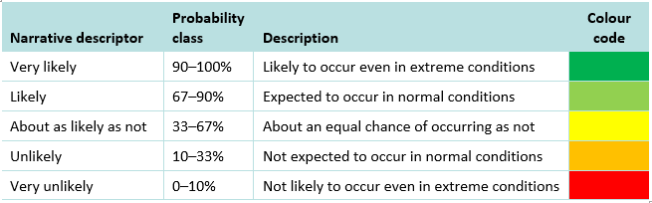

# CASE STUDY – MINING AREA C SOUTHERN FLANK VALLEY

The Mining Area C (MAC) set of iron ore deposits (North and South Flank) is being developed by BHP Billiton in the Pilbara region of Western Australia. The methodology applied to the 2017 MAC assessment involved developing multiple conceptual and numerical groundwater models representing different hydrogeological and eco-hydrological conceptualisations. A comprehensive uncertainty analysis was applied to predict the range of impacts and to mitigate and manage potential impacts on water-related receptors (BHPB, 2017a, b).

The BHP Billiton Water Resource Management Strategy (WRMS) is designed to mitigate and/or minimise operational impacts on surface water and groundwater as part of ‘business as usual’ activities. The strategy is consistent with the Western Australian Water in Mining Guideline (DoW, 2013), which encourages a consultative and cooperative relationship between regulator and proponents, and facilitation of early identification of water management issues to clearly outline information requirements for assessment (as does this Explanatory Note).

The BHPB WRMS applies a risk-based approach that considers scientific uncertainty, along with early warning triggers and thresholds of hydrological change processes and ecosystem responses. In the early stages of the process, these triggers and thresholds are typically conservative and precautionary reflecting incomplete scientific knowledge. As scientific understanding improves, the level of uncertainty reduces, and management triggers and thresholds are iteratively refined.

Two alternate groundwater models were developed, each based on materially different hydrogeological conceptualisations: one conservative with respect to the ease of drawdown propagation towards key ecological assets and the other less so. The models utilised different parameter combinations but were calibrated to the same key observations of groundwater levels, flows at Weeli Wolli Spring and the catchment water balance.

To address uncertainty, multiple model scenarios were devised with the two alternate groundwater models, representing parameter variability and the (uncertain) potential hydraulic connections within and between the regional and orebody aquifers. The initial model set comprised 2000 variants, of these 192 calibrated with justified confidence to be used in the assessment. The resulting outputs were presented as a range of drawdown responses due to a range of dewatering volumes from proposed operations at South Flank, as well as cumulative response from other operations.

The assessment recognised the temporal and spatial variance in water balances (Figure 6) and cumulative effects from other mining activities in the area, with consideration of a mid and high case mine production schedule and options for mine closure strategies. The backfilling of pit voids to above the recovered standing water level (nominally 5 m above the groundwater level) was proposed as part of the mine closure strategy and thus was not considered to be a water-affecting activity in terms of quantity or quality.

The predicted drawdown due to dewatering activities in the catchment was presented in terms of a range between the 20th and 80th percentile (P20 to P80) results. In this case, low percentiles represent a smaller drawdown footprint and dewatering requirement while the high percentiles represent a larger drawdown footprint and dewatering requirement. The range was not intended to represent confidence intervals but rather that the most likely prediction lies somewhere within the P20 to P80 range at most locations within the catchment.

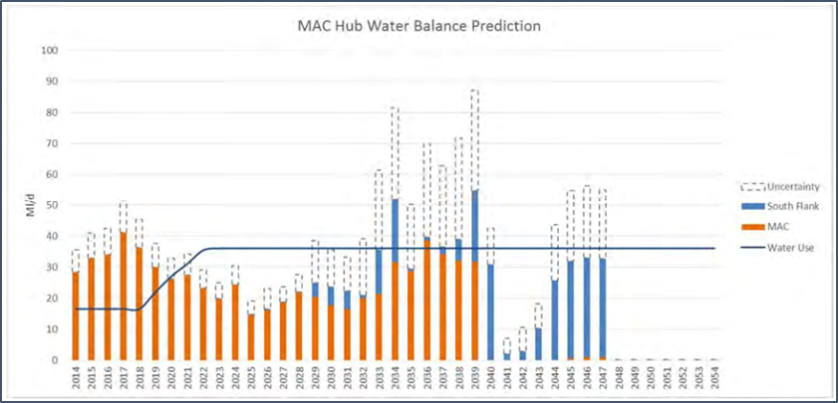Figure 6 - combined Mining Area C water balance showing annual dewatering estimates compared with water demand, and the uncertainty range (BHP Billiton, 2017a)

# FATAL FLAWS CHECKLIST

The fatal flaws checklist (**Error! Reference source not found.**) comprises nine sets of questions on essential aspects that any groundwater model uncertainty analysis needs to satisfy. The first two items can be viewed as a generic compliance checklist on whether uncertainty has been considered adequately (for the given risk context), and so they do not require a specific technical skill set to consider. The last seven items comprise more technical issues that require a degree of specialist hydrogeology and modelling skill to consider.

The checklist should be considered in addition to the general guidance provided in the main body of the Explanatory Note and the IESC Information Guidelines (including the checklist in the Information Guidelines), as well as best practice requirements (notably Table 9-1 of Barnett et al. 2012), and the IESC recommendations on modelling methods (Commonwealth of Australia, 2014, 2015).

While the criteria are presented in a checklist format, the answers must be provided with cross-references to where the objective evidence is provided to address the issue (i.e. to identify specific parts or sub-sections of the EIS, not simply to a chapter/section).

| Table 3 - Fatal Flaws Review Checklist for Uncertainty Assessment |
| --- |
| ■ Is there evidence of engagement (‘without prejudice’) between the project proponent and regulatory agencies, invoked from the project outset and at subsequent key stages:   * to discuss and agree the project objectives and the modelling objectives? * to discuss and agree the uncertainty analysis methodologies, including the nature and scope of the (minimum requirement) qualitative uncertainty analysis, and the quantitative uncertainty analysis for high risk projects (i.e. most large coal mines and CSG projects)? * to review the reporting on the modelling and uncertainty analyses, which must be presented in a manner that is open, transparent and amenable for scrutiny (and not prone to misinterpretation), and must include agreed justifications for invoking assumptions/criteria applied to implement the methodology? * to understand the implications of the results in terms of environmental decision-making? * to identify whether an independent technical review of the modelling and/or the uncertainty analysis is warranted? |
| ■ Is the modelling and uncertainty analysis methodology designed to provide information for decision makers on the effects of uncertainty on the project objectives (echoing the definition of risk in ISO31000:2009), and on the effects of potential bias?  Is the adopted complexity-simplicity balance commensurate with the overall risk context and the model purpose of investigating the uncertainty/risk issues (i.e. based on the evidence available of engagement identified in item 1)? |
| ■ Has the uncertainty assessment and modelling methodology been designed and implemented using all the available data, with detailed consideration of the hydrological stressors arising from the development and from natural stressors including climate variability, and with unbiased consideration of water-related asset values and causal pathways for potential impacts (direct, indirect and cumulative)? |
| ■ Where history-match conditional calibration is undertaken, has it minimised non-uniqueness and error variance and if not, is a reasoned justification provided? (AGMG recommends fitting model outputs to measured data on heads and discharges for a wide range of climate and hydrological stressor conditions, using Pilot Points and regularisation)?  Is an acceptable level of model-to-measurement mismatch defined for the conditional calibration? |
| ■ Are all simulations consistent with all relevant information/data and if not, is a reasoned justification provided? (AGMG recommends restricting predictions to the same types and magnitudes of variables used for conditional calibration (e.g. heads and fluxes) and to similar hydrological stressor regimes and timeframes) |
| ■ Has the model been submitted to stress testing in which a number of extreme parameter combinations (representative of a computationally-intensive automated conditional calibration or stochastic model evaluation) are tested for model convergence? |
| ■ Has a parameter sensitivity analysis and/or a parameter identifiability analysis been completed to identify which parameters can be constrained by the available observations and which parameters affect the simulations the most, and are the implications discussed? |
| ■ Have all reports been prepared in an open, honest and transparent way that is:   * amenable for independent scrutiny and not prone to misinterpretation; * based on agreed and transparent model objectives; * tailored to decision-makers’ needs (focus on messages relevant to their decisions); * presented in plain and clear language (precise, jargon-free, calibrated) and in conjunction with graphics in a manner that reduces cognitive strain. |
| ■ Do the hydrogeology and modelling reports present a transparent and logical discussion of the following?   * project objectives and the model objectives and uncertainty analysis methodologies * how the modelling objectives are defined in specific and measurable terms in space and time (e.g. threshold impacts of drawdown at a GDE of more than 2m in X years); * hydrogeological conceptualisations and parameterisations; * parameters to include in uncertainty quantification and related probability distributions; * measurement uncertainty of each observation or model to measurement misfit criteria; * agreed justifications for invoking model/method assumptions/criteria and how those choices affect simulations and uncertainties; * methods, simulations and results discussed using calibrated language and presented in a way that reduces cognitive strain and is not prone to misinterpretation. |

# SUPPORTING DOCUMENTS

Asher MJ, Croke BFW, Jakeman AJ and Peeters LJM (2015). A review of surrogate models and their application to groundwater modelling. *Water Resources Research*, **51**, 5957-5973.

Barnett B, Townley LR, Post V, Evans RE, Hunt RJ, Peeters L, Richardson S, Werner AD, Knapton A and Boronkay A (2012). Australian groundwater modelling guidelines. Waterlines report, National Water Commission, Canberra. <http://webarchive.nla.gov.au/gov/20160615064846/http://archive.nwc.gov.au/library/waterlines/82>

Barrett DJ, Couch CA, Metcalfe DJ, Lytton L, Adhikary DP and Schmidt RK (2013). Methodology for bioregional assessments of the impacts of coal seam gas and coal mining development on water resources. Prepared for the Independent Expert Scientific Committee on Coal Seam Gas and Large Coal Mining Development through the Department of the Environment.

Begg S (2013). Uncertainty, decisions, models and people. 2nd AusIMM International Geometallurgy Conference (GeoMet 2013).

Beven K (1993). Prophecy, reality and uncertainty in distributed hydrological modelling. *Advances in Water Resources*, **16**, 41–51.

Beven K and Young P (2013). A guide to good practice in modeling semantics for authors and referees. *Water Resources Research*, **49**, 5092-5098.

BHP Billiton (2017a). Mining Area C Southern Flank Proposal: Hydrological Impact Assessment and Water Management Principles Summary (Appendix 7). [www.epa.wa.gov.au/sites/default/files/PER_documentation/Appendix%207%20-%20Hydrological%20Impact%20Assessment.pdf](http://www.epa.wa.gov.au/sites/default/files/PER_documentation/Appendix%207%20-%20Hydrological%20Impact%20Assessment.pdf)

BHP Billiton (2017b). Mining Area C: Hydrological Impact Assessment and Water Management Plan Options Summary (Appendix 7; EMP rev6). [www.epa.wa.gov.au/sites/default/files/PER_documentation/Appendix%207%20-%20Rev%206%20EMP%20Hydrological%20Impact%20and%20Management%20Summary.pdf](http://www.epa.wa.gov.au/sites/default/files/PER_documentation/Appendix%207%20-%20Rev%206%20EMP%20Hydrological%20Impact%20and%20Management%20Summary.pdf)

Brunner P, Simmons C, Cook P and Therrien R. (2010). Modeling Surface Water-Groundwater Interaction with MODFLOW: Some Considerations. *Ground Water*, **48**, 174-180.

Bureau of Meteorology (2015). Atlas of Groundwater Dependent Ecosystems. [www.bom.gov.au/water/groundwater/gde/index.shtml](http://www.bom.gov.au/water/groundwater/gde/index.shtml)

Commonwealth of Australia (2009). The Australian Environment Act – Report of the Independent Review of the Environment Protection and Biodiversity Conservation Act 1999. October 2009. [www.environment.gov.au/system/files/resources/5f3fdad6-30ba-48f7-ab17-c99e8bcc8d78/files/final-report.pdf](http://www.environment.gov.au/system/files/resources/5f3fdad6-30ba-48f7-ab17-c99e8bcc8d78/files/final-report.pdf)

Commonwealth of Australia (2013). Significant Impact Guidelines 1.3: Coal seam gas and large coal mining developments - impacts on water resources. [http://www.environment.gov.au/system/files/resources/d078caf3-3923-4416-a743- 0988ac3f1ee1/files/sig-water-resources.pdf](http://www.environment.gov.au/system/files/resources/d078caf3-3923-4416-a743-%200988ac3f1ee1/files/sig-water-resources.pdf)

Commonwealth of Australia (2014a). Coal seam gas extraction: modelling groundwater impacts, prepared by Coffey Geotechnics for the Department of the Environment.

Commonwealth of Australia (2014b). Subsidence from coal seam gas extraction in Australia. Prepared by SKM for the Department of the Environment.

Commonwealth of Australia (2014c). Subsidence from coal mining activities, Background review. Prepared by SKM for the Department of the Environment.

Commonwealth of Australia (2015a). Independent Expert Scientific Committee on Coal Seam Gas and Large Coal Mining Development. <http://iesc.environment.gov.au/>

Commonwealth of Australia (2015b). Information Guidelines for the Independent Expert Scientific Committee advice on coal seam gas and large coal mining development proposals, October 2015. <http://iesc.environment.gov.au/>

Commonwealth of Australia (2015c). Modelling water-related ecological responses to coal seam gas extraction and coal mining, prepared by Auricht Projects and the Commonwealth Scientific and Industrial Research Organisation (CSIRO) for the Department of the Environment, Commonwealth of Australia. [http://www.environment.gov.au/system/files/resources/83770681-a40b-4fa2-bf6e- 8d41022873bd/files/modelling-water-related-ecological-responses-csg-extraction.pdf](http://www.environment.gov.au/system/files/resources/83770681-a40b-4fa2-bf6e-%208d41022873bd/files/modelling-water-related-ecological-responses-csg-extraction.pdf)

Commonwealth of Australia (2017). Bioregional Assessments. [www.bioregionalassessments.gov.au/](http://www.bioregionalassessments.gov.au/)

Cook P, Miller A, Shanafield M and Simmons C. (2016). Predicting Water Resource Impacts of Unconventional Gas Using Simple Analytical Equations. *Ground Water*, December 2016.

Crosbie R, Peeters L and Carey H. (2016). Groundwater modelling. Submethodology M07 from the Bioregional Assessment Technical Programme.

Doble R and Crosbie R (2017). Review: Current and emerging methods for catchment-scale modelling of recharge and evapotranspiration from shallow groundwater. *Journal of Hydrogeology*, **25**, 3-23.

Doble R, McCallum J, Turnadge C, Peeters, L., Wu B and Mallants D. (2017). Modelling inter‐aquifer leakage associated with well integrity failure. Prepared by the Commonwealth Scientific and Industrial Research Organisation (CSIRO), Canberra.

Doherty J (2010). Model-based environmental decision-making. Watermark Numerical Computing. November 2010. Downloadable from [www.pesthomepage.org](http://www.pesthomepage.org).

Doherty J (2015). Calibration and uncertainty analysis for complex environmental models. Published by Watermark Numerical Computing, Brisbane, Australia. 227pp. ISBN: 978-0-9943786-0-6. Downloadable from [www.pesthomepage.org](http://www.pesthomepage.org).

Doherty J (2016). PEST Model-Independent Parameter Estimation User Manual Part I: PEST Software. 6th ed. Brisbane: Watermark Numerical Computing. [www.pesthomepage.org](http://www.pesthomepage.org)

Doherty J and Hunt RJ. (2009). Two statistics for evaluating parameter identifiability and error reduction. *Journal of Hydrology*, **366**, 119-127.

Doherty J and Moore C (2017). Simple is beautiful. Background paper no.3 in Middlemis et al. (2018), NCGRT National Groundwater Modelling Uncertainty Workshop, Sydney, 10 July 2017.

DoW (2013). Western Australian Water in Mining Guideline. Water Licensing Delivery Series Report No. 12, Department of Water, Perth. <https://www.water.wa.gov.au/__data/assets/pdf_file/0019/1819/105195.pdf>

Eamus D, Froend R, Loomes R, Hose G and Murray B. (2006). A functional methodology for determining the groundwater regime needed to maintain the health of groundwater-dependent vegetation. *Australian Journal of Botany*, **54**, 97–114.

Eamus D (2009). Identifying groundwater dependent ecosystems. A guide for land and water managers. Prepared by University of Technology Sydney for Land & Water Australia. 16pp.

Ferré T (2016). Seeing Things Differently: Rethinking the Relationship Between Data, Models, and Decision-Making. 2016 Darcy Lecture Series in Groundwater Science. <https://www.youtube.com/watch?v=6YnYGwYSmQk>

Freeze RA, Massmann J, Smith L. Sperling T and James B. (1990). Hydrogeological Decision Analysis: 1. A Framework. *Ground Water*, **28(5)**, 738-766.

Guillaume JHA, Hunt RJ, Comunian A, Blakers RS and Fu B. (2016). Methods for exploring uncertainty in groundwater management predictions. A.J. Jakeman et al. (eds.), Integrated Groundwater Management. Chapter 28: pp.711-737

Hayes P and Nicol C (2017). Uncertainty by Design: Sufficient model simplification to make predictive uncertainty analysis tractable. Background paper no.4 in Middlemis et al. (2018), NCGRT National Groundwater Modelling Uncertainty Workshop, Sydney, 10 July 2017.

Herckenrath D, Doherty J and Panday S. (2015). Incorporating the effect of gas in modelling the impact of CBM extraction on regional groundwater systems. *Journal of Hydrology*, **523**, 587-601.

Hill MC and Tiedeman CR. (2007). Effective groundwater model calibration. Wiley. 480pp. ISBN: 978-0-471-77636-9.

Holland KL, Aryal SK, Bruce J, Carey H, Davies P, Ford J, Henderson B, Herr A, Janardhanan S, Merrin LE, Mitchell PJ, Mount RE, O’Grady AP, Ransley T, Sander R and Schmidt RK (2016). Conceptual modelling for the Maranoa-Balonne-Condamine subregion. Product 2.3 for the Maranoa-Balonne-Condamine subregion from the Northern Inland Catchments Bioregional Assessment. Department of the Environment and Energy, Bureau of Meteorology, CSIRO and Geoscience Australia, Australia. <http://data.bioregionalassessments.gov.au/product/NIC/MBC/2.3>.

IPCC (2013). Climate Change: The Physical Science Basis. Contribution of Working Group I to the Fifth Assessment Report of the Intergovernmental Panel on Climate Change, Cambridge, United Kingdom and New York, NY, USA, Cambridge University Press.

Mackie C (2013). Wallarah 2 Coal Project, Environmental Impact Statement, Appendix I Groundwater Impact Assessment. Mackie Environmental. April 2013.

Maier H, Kapelan Z, Kasprzyk J, Kollat J, Matott L, Cunha M, Dandy G, Gibbs M, Keedwell E, Marchi A, Ostfeld A, Savic D, Solomatine D, Vrugt J, Zecchin A, Minsker B, Barbour E, Kuczera G, Pasha F, Castelletti A, Giuliani M and Reed P. (2014). Evolutionary algorithms and other metaheuristics in water resources: Current status, research challenges and future directions Environmental Modelling & Software, 62, 271-299.

Middlemis H, Walker G, Peeters L, Moore C, Hayes P and Richardson S (2018). National Groundwater Modelling Uncertainty Workshop, Sydney, 10 July 2017. National Centre for Groundwater Research and Training.

Moore C and Doherty J (2005). The role of the calibration process in reducing model predictive error. *Water Resources Research*. **41(5)**.

Neuman SP and Wierenga PJ (2003). A comprehensive strategy of hydrogeologic modeling and uncertainty analysis for nuclear facilities and sites. Prepared by University of Arizona for the US Nuclear Regulatory Commission, Report NUREG/CR-6805.

OGIA (2016a). Groundwater connectivity between the Condamine Alluvium and the Walloon Coal Measures. A hydrogeological investigation report. Compiled by The Office of Groundwater Impact Assessment, Department of Natural Resources and Mines. August 2016.

OGIA (2016b). Groundwater modelling report for the Surat Cumulative Management Area. Compiled by The Office of Groundwater Impact Assessment, Department of Natural Resources and Mines. September 2016.

Peeters L (2017a) Assumption Hunting in Groundwater Modeling: Find Assumptions Before They Find You. *Ground Water*, **55**, 665-669.

Peeters L (2017b). Uncertainty analysis in groundwater modelling: where to start? Background paper no.2 in Middlemis et al. (2018), NCGRT National Groundwater Modelling Uncertainty Workshop, Sydney, 10 July 2017.

Peeters L, Pagendam D, Gao L, Hosack G, Jiang W and Henderson B. (2016). Propagating uncertainty through models. Submethodology M09 from the Bioregional Assessment Technical Programme.

Pianosi F, Beven K, Freer J, Hall JW, Rougier J, Stephenson DB and Wagener T. (2016). Sensitivity analysis of environmental models: A systematic review with practical workflow. *Environmental Modelling and Software*, **79**, 214–232.

Plischke E, Borgonovo E and Smith CL. (2013). Global sensitivity measures from given data. *European Journal of Operational Research*, **226**, 536-550.

QLC 48 (2015). Adani Mining Pty Ltd v Land Services of Coast and Country inc. & Ors [2015]. Land Court of Queensland.

Refsgaard JC, Christensen S, Sonnenborg TO, Seifert D, Højberg AL and Troldborg L. (2012). Review of strategies for handling geological uncertainty in groundwater flow and transport modeling. *Advances in Water Resources,* **36**, 36-50.

Richardson S, Irvine E, Froend R, Boon P, Barber S and Bonneville B. (2011). Australian groundwater-dependent ecosystem toolbox part 1: assessment framework. Waterlines report, National Water Commission, Canberra.   
<http://webarchive.nla.gov.au/gov/20160615084626/http://archive.nwc.gov.au/library/waterlines/69-70>

Richardson S, McMillan M and Currie D (2017) Communicating uncertainty to decision-makers and stakeholders. Background paper no.5 in Middlemis et al. (2018), NCGRT National Groundwater Modelling Uncertainty Workshop, Sydney, 10 July 2017.

Saltelli A (2002). Sensitivity analysis for importance assessment. in *Risk Analysis* **22**, pp.579-590.

Saltelli A and Annoni P. (2010). How to avoid a perfunctory sensitivity analysis. *Environmental Modelling and Software*, **25**, 1508-1517.

Saltelli A and Funtowicz S (2014). When All Models Are Wrong. *Issues in Science and Technology*, **30**, 79-85.

Voss C (2011a). Editor’s message: Groundwater modeling fantasies — part 1, adrift in the details. *Hydrogeology Journal*, **19**, 1281-1284.

Voss C (2011b). Editor’s message: Groundwater modeling fantasies — part 2, down to earth. *Hydrogeology Journal*, **19**, 1455-1458.

Walker G (2017). Predictive uncertainty in groundwater modelling: how is it best used? Background paper no.1 in Middlemis et al. (2018), NCGRT National Groundwater Modelling Uncertainty Workshop, Sydney, 10 July 2017.

White JT, Doherty JE and Hughes JD. (2014). Quantifying the predictive consequences of model error with linear subspace analysis. *Water Resources Research*, **50(2)**, 1152–1173.

1. Biased analysis may be acceptable, provided an extremely conservative methodology is applied logically, justified transparently and documented comprehensively (e.g. Ferré, 2017).
2. Minimum error variance means minimum spread of the error; it does not mean that the bias of a simulation is minimised – see the bias and error graphic shown in Figure 1 (section 2).