**The Independent Expert Scientific Committee on Coal Seam Gas and Large Coal Mining Development (IESC) is seeking comment on the draft Explanatory Note, ‘How to derive Site-specific Guideline Values for Physical and Chemical Parameters: IESC Information Guidelines Explanatory Note.’**

**The IESC notes the draft nature of the Explanatory Note and welcomes feedback on the content, usability and applicability. In particular, views are sought on:**

* **the technical content within the draft Explanatory Note. Are there any areas that are missing or not captured adequately?**
* **the relevance to your specific area of work and any views on its uptake and adoption.**
* **potential options to increase uptake and adoption.**

***The IESC and the Information Guidelines***

The IESC is a statutory body under the *Environment Protection and Biodiversity Conservation Act 1999* (Cth) (EPBC Act). One of the IESC’s key legislative functions is to provide scientific advice to the Commonwealth Environment Minister and relevant state ministers in relation to coal seam gas (CSG) and large coal mining development proposals that are likely to have a significant impact on water resources.

The Information Guidelines outline the information project proponents should provide to enable the IESC to provide robust scientific advice on potential water-related impacts of CSG and large coal mining development proposals. The Explanatory Note supports the Information Guidelines by providing further information and guidance on how to derive and apply site-specific guideline values for physical and chemical parameters.

***The Explanatory Note, ‘How to derive Site-specific Guideline Values for Physical and Chemical Parameters: IESC Information Guidelines Explanatory Note*.*’***

The EPBC Act lists “a water resource, in relation to coal seam gas development and large coal mining development” as a matter of national environmental significance. A water resource is defined under the Water Act 2007 (Cth). It covers surface water or groundwater or a watercourse, lake, wetland or aquifer (whether or not it currently has water in it) and includes all aspects of the water resource (including water, organisms and other components and ecosystems that contribute to the physical state and environmental value of the water resource).

As such, environmental assessments for proposed coal seam gas and large coal mining developments are required to consider the effects that a proposed development may have on water and sediment quality.

The draft Explanatory Note is intended to assist proponents in preparing environmental assessments for coal seam gas and large coal mining projects potentially impacting water and sediment quality. The Explanatory Note compiles information, and provides guidance, on designing an effective monitoring program for water and sediment quality indicators that can be applied for adaptive management and impact mitigation. The draft Explanatory Note also guides industry on how to use monitoring data from appropriate reference and control condition sites to develop site‑specific guideline values for water and sediment quality.



**How to Derive Site-specific Guideline Values for Physical and Chemical Parameters: IESC Information Guidelines Explanatory Note**

**Copyright and disclaimer**

© Commonwealth of Australia, 2018

*How to Derive Site-specific Guideline Values for Physical and Chemical Parameters: IESC Information Guidelines Explanatory Note* is licensed by the Commonwealth of Australia for use under a Creative Commons Attribution 4.0 International licence with the exception of the Coat of Arms of the Commonwealth of Australia, the logo of the agency responsible for publishing the report, content supplied by third parties, and any images depicting people. For licence conditions see: <https://creativecommons.org/licenses/by/4.0/>

This report should be attributed as Huynh T and Hobbs D 2018. *Site-specific Guideline Values for Physical and Chemical Parameters: IESC Information Guidelines Explanatory Note*. A report prepared for the Independent Expert Scientific Committee on Coal Seam Gas and Large Coal Mining Development through the Department of the Environment and Energy.

The Commonwealth of Australia has made all reasonable efforts to identify content supplied by third parties using the following format ‘© Copyright, [*name of third party*]’.

This publication is funded by the Australian Government Department of the Environment and Energy. The views and opinions expressed in this publication are those of the authors and do not necessarily reflect those of the Australian Government or the Minister for the Environment and Energy.

While reasonable efforts have been made to ensure that the contents of this publication are factually correct, the Commonwealth does not accept responsibility for the accuracy or completeness of the contents, and shall not be liable for any loss or damage that may be occasioned directly or indirectly through the use of, or reliance on, the contents of this publication.

**Citation**

Huynh T and Hobbs D 2018. *Site-specific Guideline Values for Physical and Chemical Parameters: IESC Information Guidelines Explanatory Note*. A report prepared for the Independent Expert Scientific Committee on Coal Seam Gas and Large Coal Mining Development through the Department of the Environment and Energy.

**Acknowledgements**

This report was finalised by the Independent Expert Scientific Committee on Coal Seam Gas and Large Coal Mining Development (IESC) based on consideration of work commissioned by the Office of Water Science on behalf of the Independent Expert Scientific Committee on Coal Seam Gas and Coal Mining (IESC) in March 2018 through the Department of the Environment and Energy.

Main additional contributors of scientific input to this work were Jenny Stauber (IESC), Carl Zimmermann (OWS) and Taysha Le Compte (OWS)

The Department acknowledges the traditional owners of country throughout Australia and their continuing connection to land, sea and community. We pay our respects to them and their cultures and to their elders both past and present.

**Contact details**

For information about this report or about the work of the IESC please contact:

IESC Secretariat

Office of Water Science

Department of the Environment and Energy

GPO Box 787

CANBERRA ACT 2601

This report can be accessed at <http://www.iesc.environment.gov.au/>

Table of Contents

Executive Summary 7

1. Introduction 8

1.1 Purpose of this Explanatory Note 8

1.2 CSG and LCM industry 8

2. Understanding the Australian Water Quality Guidelines 12

2.1. Water quality guideline values (GVs) and water quality objectives (WQOs) 12

2.2. Stressors 12

2.3. Levels of Protection 13

2.4. Water types 14

2.5. Management framework for applying the Guidelines for CSG and LCM industry 15

2.5.1. The management framework 15

2.5.2. Set primary management aims 15

2.6. Default water GVs for physico-chemical stressors 15

2.7. Default water GVs for toxicants 16

2.8. Default GVs for sediments 16

3. Deriving site-specific GVs for water and sediment quality 19

3.1 Why derive site-specific guideline values? 19

3.2 How do we apply site-specific GVs? 19

3.3 Approaches for deriving site-specific GVs 22

3.3.1 Deriving site-specific water GVs using local reference data 22

3.3.1.1 Identifying reference sites 22

3.3.1.2 Deriving numerical GVs for water from local reference data 23

3.3.2 Deriving site-specific sediment GVs using local reference data 25

3.3.3 Deriving site-specific GVs for a toxicant without default GVs using the species sensitivity distribution (SSD) approach 28

4. Designing water and sediment monitoring programs for CSG and LCM industry 32

4.1 Sampling program design 32

4.2 Effective water monitoring program 34

4.3 Effective sediment monitoring program 34

4.4 Site-specific water and sediment sampling program 34

4.4.1 Quality assurance and quality control in sampling and chemical analysis 35

4.4.2 Dealing with outliers and censored data 36

5. Integrating and optimising monitoring and assessment programs 37

5.1 Using multiple lines of evidence and associated indicators 37

5.2 Integrating chemical and biological approaches in the water quality management framework 38

5.3 Applying biological assessments as part of an integrated assessment 38

6. Temporary water bodies 40

6.1 Temporary water bodies 40

6.2 Effective monitoring programs for water and sediment quality indicators of temporary water bodies 41

6.2.1 Temporary water body conceptual modelling 41

6.2.2 Monitoring approach 41

6.2.3 Monitoring temporary water bodies 42

6.3 Time-period measurements and passive sampling devices (PSD) 44

6.4 Special problems associated with monitoring sediment and water quality in highly temporary waterbodies 45

7. Conclusions 46

References 47

Appendix 1: Recommended reading 49

Appendix 2: Glossary of terms and abbreviations 50

Appendix 3: Recommended sediment quality guideline values 53

# Executive Summary

Coal seam gas and large coal mine development (CSG and LCM industry) encompasses operations such as drilling, mining, extraction and transportation of products, often involving chemicals that could be harmful if released into the environment. Physical and chemical parameters can affect water and sediment quality. These effects are currently considered in the context of the ANZECC & ARMCANZ (2000a) guidelines (AWQ Guidelines). These provide detail on how guideline values (GVs) for water and sediment quality parameters were derived and can be applied in the environmental assessment process. In the AWQ Guidelines, default aquatic ecosystem water quality GVs were developed for a broad range of water types and indicators. However, it strongly emphasises that developing more locally relevant water GVs is preferred, particularly for areas associated with anthropogenic activities. The use of default GVs is discussed as part of understanding when and how site-specific GVs should be derived and used.

This Explanatory Note (EN) supplements the IESC Information Guidelines (<http://www.iesc.environment.gov.au/publications/information-guidelines-independent-expert-scientific-committee-advice-coal-seam-gas>). It provides guidance tailored specifically to the CSG and LCM industry. CSG and LCM operations are often located in arid, semi-arid or wet-dry tropical regions with temporary water bodies such as ephemeral streams and salt lakes. The EN introduces the use of a water and sediment quality management framework (WSQMF) to assist with the design of spatially and temporally appropriate monitoring programs for measuring physico-chemical parameters from which site-specific guideline values for water and sediment quality can be developed. The steps used to design a monitoring program and then derive site-specific GVs for water and sediment are explained explicitly for their derivation with CSG and LCM industries as the context, with reference to further bodies of work for more specific information on concepts used throughout the EN.

Case studies are used to further illustrate the process to derive site-specific GVs for physico-chemical stressors and toxicants in water and sediments. Further advice is also given on how to design effective monitoring programs for the collection of water and sediment samples for selected indicators that will be used to derive site-specific GVs. This considers both spatial and temporal aspects, and other various factors such as seasonality, water body types, flow regimes, and reference sites, which can have a major effect on how appropriate the site-specific GVs are for the CSG and LCM activity being proposed.

The EN provides guidance on the desired information for the IESC to undertake an assessment of development applications from CSG and LCM proponents. It aims to achieve this by assisting in designing an effective monitoring program for water and sediment quality indicators that can be applied for adaptive management and impact mitigation. Importantly, the EN guides the CSG and LCM industry on how to use monitoring data from appropriate reference and control condition sites to develop site-specific guideline values for water and sediment quality.

# Introduction

## Purpose of this Explanatory Note

In Coal Seam Gas and Large Coal Mine developments (CSG and LCM industry), existing water and sediment quality in the receiving environments are varied, and site-specific guideline values (GVs) are often prepared by project proponents in consultation with local environmental authorities and stakeholders. This Explanatory Note (EN) aims to better articulate how the Australian and New Zealand Guidelines for Fresh and Marine Water Quality (ANZECC & ARMCANZ, 2000a) can be implemented through the design of spatially and temporally appropriate monitoring programs for physical and chemical parameters from which site-specific GVs for water and sediment quality can be developed. These site-specific GVs can then be applied by the CSG and LCM industry to both permanent and temporary water bodies.

The EN provides information on:

* when and how to derive site-specific GVs for different indicators and how to use them for adaptive management/impact mitigation;
* requirements for deriving site-specific GVs at different stages of assessment;
* designing an effective monitoring program for water and sediment quality stressors;
* dealing with the effects of temporary water when designing a monitoring program; and
* integrating and optimising a monitoring and assessment program.

These concepts are illustrated with worked examples as case studies. Supporting information and recommended reading is provided in Appendix 1. This EN supplements the existing IESC Information Guidelines that have been prepared to assist proponents with the preparation of environmental assessment documentation in the CSG and LCM industry. It is hoped that the EN will not only be of use to environmental scientists working within the CSG and LCM industry, but also to consultants, regulators and managers with an interest in water management issues related to the CSG and LCM industry.

Groundwater and Groundwater Dependent Ecosystems are not covered in this document and are presented in a separate EN: Assessing Groundwater-Dependent Ecosystems. This EN does not cover the topic of biological monitoring, although it is recognised that this is an integral part of ecosystem monitoring and assessment in a weight of evidence approach to environmental management.

In view of this broad readership, only basic descriptions are provided in the main body of the EN; however, a list of publications is provided for those seeking greater technical detail. A comprehensive glossary is provided in Appendix 2 to assist the non-specialist reader with the terms used in this EN.

## CSG and LCM industry

The CSG and LCM industry is a highly diverse industrial sector which encompasses activities such as drilling, mining, extraction and transportation of products, all of which have the potential to impact on aquatic systems. Water is an important issue in CSG production and LCM. In addition to direct discharge, there is also potential for overland transport in runoff waters of solid materials associated with the operations. Water management issues need to be considered in development application documentation at the exploration stage (Greenfield) as well as in the design of extensions to an existing development (Brownfield). Activities from CSG operations might require site vegetation removal including ground-based geophysics and the construction of pipeline networks, storage ponds, site processing plants, water treatment plants and access roads. These activities might potentially result in changes to surface water quality, e.g. from soil erosion following heavy rainfall. Water management is critical during mine construction, operation and associated rehabilitation/restoration phases. An appropriate closure strategy also needs to be in place to minimise post-mining impacts on water quality. The water and sediment quality management framework in this document attempts to take these factors such as phases of operation and closure into consideration.

Each CSG and LCM development, whether on a Greenfield or Brownfield site, will have its own specific risks and requirements. However, a general conceptual model of the stressors, exposure pathways and receptors can help identify what indicators will be useful to monitor. Such conceptual models of causal pathways for the CSG and LCM industry for surface water have recently been described and are shown in Figure 1 and Figure 2. These summarise and synthesise the potential linkages between coal resource development and the impacts on water and water-dependent assets. Four causal pathway groups for surface water identified as part of the Bioregional Assessment (BA) Programme include:

• groundwater depressurisation and dewatering;

• groundwater physical flow paths;

• surface water drainage; and

• operational water management.

More detail about these causal pathways is presented in Appendix 3 of the BAs (Henderson et al., 2016).

Stressors from the CSG and LCM industry include physical stressors (e.g. salinity, pH), chemical stressors (e.g. nutrients) and toxicants (e.g. metals). A general list of analytes from CSG is provided in Appendix A of the Chemical Risk Assessment Guidance Manual: for chemicals associated with coal seam gas extraction (Department of the Environment and Energy, 2017). The analytes listed are designed to provide an example suite of analytical parameters that could be used to inform water quality monitoring programmes.

Further information on potential chemicals released from coal that are also representative of those used for CSG activities, is available in Apte et al. (2017). The report describes a laboratory-based study that investigated the potential for release of geogenic (naturally occurring) contaminants from coal samples taken from eight locations across Eastern Australia. The tests were designed to provide upper bound estimates of contaminant release.

The chemicals that could potentially be released through coal mining activities are similar to those listed for CSG as stated above. For more information on wastewater quality associated with coal mine sites in Australia, Thiruvenkatachari et al. (2011) lists a number of parameters of interest. Parameters will vary depending on the geology of the region. Further reading on potential chemicals of interest from coal mining can be found in Jankowski and Spies (2007), which investigates how subsidence from coal mining can affect the chemistry of surface water.

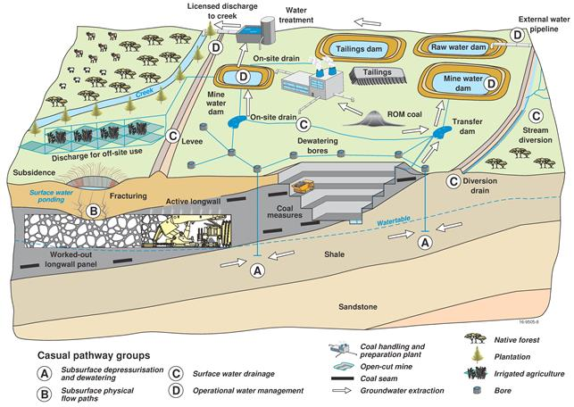

Figure 1: Conceptual diagram of casual pathway groups associated with coal mines (Henderson et al., 2016).

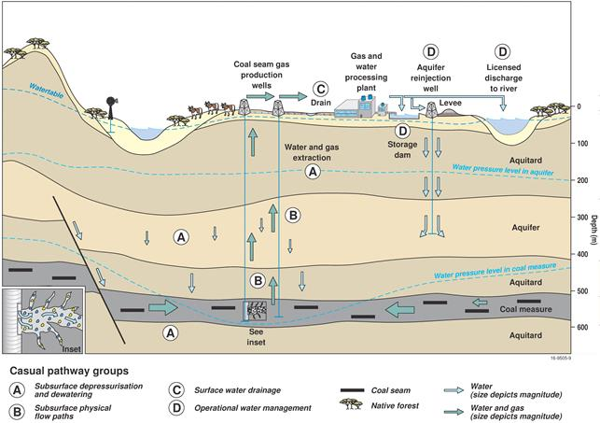

Figure 2: Conceptual diagram of casual pathway groups associated with coal seam gas operations (Henderson et al., 2016).

# Understanding the Australian Water Quality Guidelines

As part of the National Water Quality Management Strategy, the release of The Australian and New Zealand Guidelines for Fresh and Marine Water Quality (ANZECC & ARMCANZ, 2000a; Document 4 of the NWQMS) and the supporting document, the Australian Guidelines for Water Quality Monitoring and Reporting (ANZECC & ARMCANZ, 2000b; Document 7 of the NWQMS) represented a major step forward in water quality assessment and monitoring. The Guideline package (**AWQ Guidelines**) consists of several large volumes of information and provides a complete outline of how the AWQ Guidelines should be applied, together with a lengthy discussion on the underpinning science. For members of specific industries, accessing the relevant information from this comprehensive package is a daunting, yet necessary task. A complete update to the AWQ Guidelines is expected to be released in August, 2018. As part of the update the term “trigger value” will be replaced by “guideline value”. In this EN, guideline values (GVs) will be used throughout. The following sections will focus on understanding the AWQ Guidelines.

## Water quality guideline values (GVs) and water quality objectives (WQOs)

A water quality guideline value (GV) is a concentration of the key performance indicator measured for the ecosystem, below which there exists a low risk that adverse biological (ecological) effects will occur. It indicates a risk of impact if exceeded (Modified from the *trigger value* definition in ANZECC & ARMCANZ 2000a). The GVs are used as a general tool for assessing water quality and are the key to determining water quality objectives (WQOs) that protect and support the designated community values of our water resources, and against which performance can be measured. WQOs are the specific water quality targets (numerical concentration limit or native statement) agreed between stakeholders or set by local jurisdictions.

## Stressors

Many aquatic ecosystems experience a range of stressors, both natural and anthropogenic, that affect biodiversity or ecological health and are discussed at length in the AWQG (ANZECC & ARMCANZ 2000a, p3.3-3). Ecosystem conceptual models (ECMs) are a useful tool in identifying and understanding the importance of a range of potential stressors. Information on the development and use of ECMs can be found at <http://www.environment.gov.au/node/38339> Examples of ECMs of various types of wetland environments drawn up by the QLD Government are presented at the Queensland Wetland Info website at <https://wetlandinfo.ehp.qld.gov.au/wetlands/ecology/aquatic-ecosystems-natural/>).

Stressors can be classified broadly into two types depending on whether they have direct or indirect effects on the ecosystem.

**Direct effects:** Two types of physical and chemical stressors that directly affect aquatic ecosystems can be distinguished: those that are directly toxic to biota, and those that, while not directly toxic, can result in adverse changes to the ecosystem (e.g. to its biological diversity or its usefulness to humans). Excessive amounts of direct-effect stressors cause problems, but some elements and compounds (e.g. nutrients such as phosphorus (P) and nitrogen (N), and some metals such as copper and zinc) are essential at low concentrations for the effective functioning of biota. Contaminants that are potentially directly toxic to biota include metals, organic toxicants, ammonia, salinity, and pH. Stressors that are non-toxic include nutrients, temperature and turbidity.

**Indirect effects:** Stressors that do not directly affect biota can affect other stressors, making them more or less toxic. For example, the effects of reduced dissolved oxygen can influence redox conditions which can in turn influence the uptake or release of nutrients in sediments. Equally, pH, dissolved organic carbon (DOC) and suspended particulate matter (SPM) at lower levels than would cause direct effects themselves, can have a major effect on the bioavailable concentrations of some metals.

Other indirect stressors could be invasive species, irrigation extraction, disruption of riparian connectivity, altered flow periods, altered patterns of inundation, and increased variability of climate & rainfall/runoff. For example, the intentional dewatering of aquifers from mining may result in groundwater drawdown and reduce groundwater availability for a natural spring. CSG and LCM industry proposals are often for development in areas that already experience a variety of stressors; therefore, it is important to identify the multiple stressors co-occurring in the vicinity and their cumulative impacts.

The AWQ Guidelines specifically deal with key water quality management stressors for which guideline packages are provided. These include:

* nuisance growth of aquatic plants due to the change in a nutrient (N or P) composition (usually in the water (eutrophication);
* lack of dissolved oxygen (DO; asphyxiation of respiring organisms);
* increased suspended particulate matter because of increased erosion (smothering of benthic organisms, inhibition of primary production, inhibition of visual predation, reproductive impairment);
* unnatural changes in salinity, pH and/or temperature due to the interactions of water and exposed rock (clays and carbonate minerals). For example, Acid Mine Drainage (decreased pH) has resulted from the weathering of sulfide minerals (e.g. pyrite) contained in tailing, waste rock, exposed open cut walls or overburden; and
* unnatural flow, e.g. due to stream diversion, mining infrastructure or water discharge (inhibition of migration; associated changes to water temperature, which may particularly affect spawning; changes in estuarine productivity).

## Levels of Protection

For aquatic ecosystem protection, three levels of protection are recognised in ANZECC & ARMCANZ 2000a (pp 3.3-1)

**High conservation/ecological value systems**: These are unmodified or other highly-valued ecosystems, typically occurring in national parks, conservation reserves or in remote and/or inaccessible locations. Although not entirely without some human influence, the ecological integrity of such systems is regarded as intact, and there should be no detectable changes in biological diversity beyond natural variability.

**Slightly to moderately disturbed systems**: These are ecosystems in which aquatic biological diversity may have been adversely affected to a relatively small but measurable degree by human activity. The biological communities remain in a healthy condition and ecosystem integrity is largely retained. Some relaxation of the stringent management approach used for high conservation systems may be appropriate however maintenance of biological diversity relative to a suitable reference condition should be a key management goal.

**Highly disturbed systems:** These are measurably degraded ecosystems of lower ecological value. Although degraded, they retain, or after rehabilitation may have, ecological or conservation value, but for practical reasons it may not be feasible to return them to a slightly to moderately disturbed condition in the short term.

The level of protection should be discussed and agreed with the relevant regulators. Note that even though a system is assigned a certain level of protection, it does not have to remain ‘locked’ at that level. The AWQ Guidelines emphasise working to reduce the level of disturbance.

## Water types

Water quality varies naturally across different water types, so different GVs may need to be developed for each water type. Water types are classified by ecosystem type, with up to six types of water recognised for the GVs for physical and chemical stressors. Examples of major water types are freshwaters (lakes & reservoirs, wetlands, upland river & streams; and lowland rivers & streams) and marine water (estuarine and coastal waters) (ANZECC & ARMCANZ 2000a, pp 3.1-9). The Interim Australian National Aquatic Ecosystem Classification Framework (ANAE 2012) provides a nationally consistent process to classify aquatic ecosystem and habitat types within an integrated regional and landscape setting. The Interim ANAE classification framework relates ‘water type’ to chemistry and is influenced by the surrounding landscape (geological setting, water balance, quality, type of soils, vegetation and land use) which in turn dictates habitat of the aquatic environment. Water type information can be used to determine the ‘normal’ water chemistry of a waterbody which can then be used when deriving GVs. See ANAE 2012 for further information on how the interim ANAE Classification Framework can be used for classifying the ecosystem for which a site-specific GV is to be derived and the importance of the type of data required to have considered all possible water quality variables.

Consideration should also be given to temporary water bodies which are discussed later in this document (Section 6). Water regime conditions have a major influence in determining the nature and persistence of aquatic ecosystems. For example, permanent systems are often highly important in providing refugia for plants and animals during dry/drought conditions, while the unique nature of ephemeral systems, especially those in arid areas, leads to interesting endemic and highly adapted flora and fauna.

## Management framework for applying the Guidelines for CSG and LCM industry

## The management framework

The water and sediment quality management framework (WSQMF) provides managers with information to decide on strategies that will ensure ecologically sustainable development in the long-term for the CSG and LCM industry. Stakeholders and the community should also have a collective vision of how a water resource will be used, and there should be a good scientific understanding of the impact of CSG and LCM industry activities on that resource. The WSQMF can be used across a range of water/sediment quality management issues for both Greenfield and Brownfield mine development. In general, a Greenfield development will have less monitoring data available compared to that of a Brownfield site for deriving local GVs.

The management framework provides a step-by-step guide to the application of the water quality guideline management framework (ANZECC & ARMCANZ 2000a, p 2-2). This EN focuses on explaining when and how to derive site-specific GVs. In the WSQMF, an assessment is made as to whether current water/sediment quality is sufficiently protective of the established community values and management goals, through a comparison of ambient water and sediment quality against the WQOs. If the WQOs are met, the management focus will be on maintaining existing water quality. If the WQOs are not met, the management focus will be on improving water quality to meet the WQO. These decisions will typically be informed by a weight-of-evidence assessment, which may in turn trigger a reassessment of the indicator set or the WQGVs/WQOs step. This step will assess whether the selected GVs for the monitoring objectives are appropriate and if not, consideration of the need for deriving site-specific GVs is required (see more details on Section 3 and Figure 4).

## Set primary management aims

At this step, the levels of protection are selected for the relevant environmental values. Some temporary waters may be assigned, *a priori*, high conservation value (e.g. particular mound springs, wild rivers protection, and waters that provide habitat for listed threatened species). The combination of spatial and temporal variability in inundation may impose spatial and temporal requirements on the setting of both management goals and levels of protection.

Stakeholders set the primary management goals for water quality management of the water bodies of interest. Large parts of arid and semi-arid Australia are under native title or Indigenous tenure; therefore, consideration of the range of cultural and spiritual values have been included under AWQ Guidelines. For temporary waters, managers need to allow for the effects of temporal variability within and between wetting-drying cycles when determining management goals for the protection of environmental values.

## Default water GVs for physico-chemical stressors

Default GVs for physico-chemical stressors are provided in the AWQ Guidelines for five geographical regions across Australia (and New Zealand). The five regions comprise south-east Australia, tropical Australia, south-west Australia, south central Australia (and New Zealand). Where sufficient data are available, values are sub-divided within each region into upland rivers, lowland rivers, freshwater lakes and reservoirs, wetlands, estuaries and marine waters. Default GVs have been developed for the following physico-chemical stressors: Chlorophyll a, Total Phosphorus, Filterable Reactive Phosphate, Total Nitrogen, Ammonia, NOx (oxides of nitrogen), Dissolved Oxygen and pH.

These GVs have been derived using the 80th and/or 20th percentiles of the distributions of reference data provided by local agencies for these regions. For stressors such as nutrients, the GV is the upper 80th percentile (i.e. a higher value than the median), while for dissolved oxygen, the lower 20th percentile is used since detrimental effects usually occur due to a lack of oxygen. Stressors such as pH, temperature and salinity have both upper and lower bounds, as impacts are seen at either extreme. These values apply to slightly to moderately disturbed ecosystems. For highly disturbed ecosystems, a less conservative target such as the 90th (or 10th) percentile might apply (ANZECC & ARMCANZ, 2000a, pp. 3.3-8, 3.3-9). The application of default GVs is presented in section 3.2 (Step 4).

## Default water GVs for toxicants

The default GVs for toxicants, such as metals, pesticides, and other organic and inorganic chemicals, have been derived using advanced statistical analyses of database information on chronic (i.e. long-term) toxic effects on aquatic biota. They aim to protect designated percentages of aquatic life. For slightly to moderately disturbed systems, GVs are chosen that protect 95% of species. For high conservation/ecological value systems, the 99% species protection value is chosen until locally-derived toxicity data are available. For highly disturbed systems, values are provided for 90% and 80% species protection. For those chemicals that have the potential to bioaccumulate, a higher level of protection is recommended (e.g. 99% protection for slightly to moderately disturbed systems instead of 95%).

In some cases, sufficient chronic toxicity data were unavailable to apply the preferred statistical approach to guideline derivation, and this is especially so for most of the organic toxicants. In these cases, the GVs are derived using an assessment factor approach, where the lowest effect concentration from any one of the toxicity tests relevant to the toxicant in question is divided by a safety factor to give a conservative value that is protective of the ecosystem. Such GVs have lower levels of reliability (see Warne et al., 2015).

## Default GVs for sediments

It has been recognised that sediments are the ultimate repository for many contaminants that enter aquatic systems, and that many of these contaminants can have impacts on biota that live on or in the sediments (Simpson et al., 2013). Benthic biota can include surface-dwelling filter feeders (mussels, oysters) and grazers (amphipods, harpacticoid copepods, snails, and shrimps), burrowing organisms that may filter feed and/or deposit feed (amphipods, bivalves, crabs, polychaete worms, and shrimps) and those that live in intimate contact with the sediment, such as benthic algae or rooted plants. Similar to waters, the availability of contaminants to sediment organisms will depend on their chemical forms and the exposure route. The exposure route to sediment organisms can be via porewaters (the water surrounding sediment particles below the sediment-water interface), via ingestion of actual sediment particles, via food or via dermal exposure. From a CSG and LCM project’s perspective, it will be necessary to show that contaminants in sediments are not accumulating to unacceptable concentrations, nor releasing soluble contaminants at unacceptable dissolved concentrations to surface water or groundwater.

The Australian Sediment Quality Guidelines (ASGs) are based on ranked North American data on the effects of contaminants on several benthic organisms. Two GVs are provided. The lower number is based on the lower 10th percentile of effects data and is termed the sediment quality guideline value (SQGV). Sediment contaminant concentrations below this number are unlikely to result in biological impacts. The upper number is the SQGV-high and is the median of the effects data. Toxicity to benthic organisms is more likely if this number is exceeded. Because the guideline values were derived from a ranking of field samples having a mixture of contaminants, there is no explicit link between the upper guideline values and the cause of toxicity. The values are therefore likely to be conservative. The SQGVs are summarised in Appendix 3.

For organic contaminants, GVs are normalised to 1% organic carbon content to take into account the effect of organic carbon-contaminant interactions in reducing toxicity. This normalisation to 1% organic carbon can be applied over the range 0.2–10% organic carbon (i.e. for 10% organic carbon in the sediments, the GVs value is multiplied by 10). It is therefore desirable to measure the organic carbon content of sediments when evaluating the impacts of organic contaminants.

For metals, because most sediments are lacking in dissolved oxygen (anoxic or sub-oxic) except in the very surface (<2 cm) layer, metals that have the potential to be released to the porewaters will react in anoxic sediments with iron sulfide (FeS), forming insoluble metal sulfides. If there is an excess of iron sulfide (called acid-volatile sulfides, AVS) over acid-soluble metals, then there is little likelihood of toxicity via porewater exposure.

The key component of the sediment assessment is the comparison of measured contaminant concentrations to SQGVs. Some sediment contaminants are present only in porewaters (e.g. ammonia), and in these instances water quality GVs are applied. The hierarchical decision tree that applies to metals in sediments is shown in Figure 3 (Simpson and Batley, 2016). For all contaminants, a consideration of background concentrations will be important. This applies to metals which have natural sources, whereas organic contaminants are mainly man-made, and the background concentrations should be negligible.

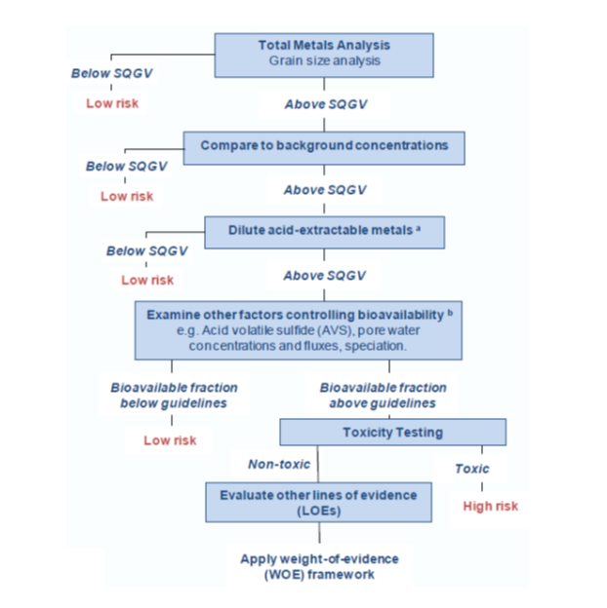

Figure 3: The decision tree for assessment of contaminated sediments for metals (Simpson and Batley, 2016; © CSIRO, 2016)

A more detailed consideration of metal bioavailability, as required in the lower part of the decision tree, would investigate the presence of AVS in relation to acid-extractable metals. Concentrations of metals in porewaters can be compared with the appropriate water quality GVs to assess the impact of sediments via the porewater exposure route.

The evaluation of sediment toxicity through laboratory or field bioassays is an important additional Line of Evidence (LoE) for assessments of sediment quality. The toxicity tests are designed to determine whether the whole sediment, or sediment-associated water in the case of porewater tests, may cause toxic effects to individual species of biota (Simpson et al., 2013). The assessment of toxicity should include organisms with a range of behaviours, feeding strategies and exposure routes. More details on sediment toxicity testing species and methods are presented in Simpson et al. (2013).

# Deriving **site-specific GVs for water and sediment quality**

## 3.1 Why derive site-specific guideline values?

While the AWQ Guidelines provide default aquatic ecosystem water and sediment quality GVs for a range of broad water types (see Sections 2.6-2.8), they also emphasise the need to develop more locally relevant GVs. Core to this is the concept of ‘continual improvement’, where management of waters should aim towards better water quality and ecological health. Some states (e.g. Qld, Vic) also have their own water quality guidelines based on the framework of the AWQ Guidelines, but with consideration of the specific local conditions. Adaptive management procedures should be considered in conjunction with a decision-tree approach when developing site-specific water and sediment quality GVs for physico-chemical and toxicant indicators. Site-specific GVs should also be derived for chemicals where no default water or sediment quality GVs currently exist, as well as when waters and sediments contain naturally high background levels which exceed default GVs.

## 3.2 How do we apply site-specific GVs?

At different stages of the development of a coal mine or CSG field, data availability is often different. For example, at a Brownfield site that may be undergoing expansion, more monitoring data are often available compared to that of a new development project at a Greenfield site. Therefore, the assessment process for a development application is also different from site to site.

A generic decision framework for deciding when it is appropriate to derive site-specific GVs is presented in Figure 4.

**Step 1**: An initial assessment is undertaken to select the appropriate physico-chemical and toxicant indicators relevant to the activity and that are needed to support the management goals. The selections are based on the activity (CSG, open cut or underground coal mine development), the environmental values of the site and its spatial bounds, water type, relevant stressors and levels of protection. These may have already been formally established by the responsible agency.

**Step 2**: Design an appropriate monitoring program for the selected indicators from step 1 (see Section 4)

**Step 3**: Indicators

Physico-chemical indicators: For indicators with suitable local reference data, derive site-specific GVs. For indicators with unsuitable local reference data, apply regional or national default GVs until local data become available to derive site-specific GVs.

Toxicant indicators: Apply default GVs if they are available. There is no need to derive site-specific GVs, except for sediments where background data from local reference sites exceed a default GV. In this case, derive a site-specific GV using local reference data.

If there are no default GVs available for the selected toxicants, use ecotoxicity data from the literature to derive interim GVs until default GVs are developed. Interim GVs can be derived using the Species Sensitivity Distribution (SSD) method (see detail of the method in Warne et al., 2015). If there are insufficient ecotoxicity data available, then determine if there are sufficient local data from reference sites (see Section 3.3) and use these to derive a site-specific GV.

**Step 4**: Test data can now be compared to the appropriate GVs. For physico‑chemical indicators, the median of the test data for a number, *n*, of independent samples from the test site should be compared. Exceedance of a GV is the prompt for further investigation.

In the case of toxicants, a more conservative approach is required. It is recommended that further investigation is triggered if the 95th percentile of the distribution of test data exceeds the GV (i.e. no action is triggered if 95% of the test values are below the GV). If only one sample was collected, and the result was greater than the GV, this would in most cases be a trigger for further action.

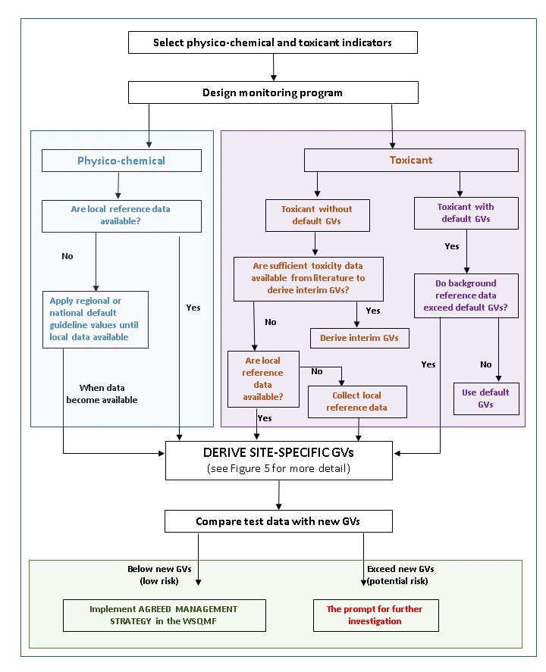

Figure 4: A decision tree of steps to derive site-specific GVs for physico-chemical stressors and toxicants in CSG and LCM industry water and sediment

## 3.3 Approaches for deriving site-specific GVs

There are two approaches for deriving local water and sediment quality GVs for aquatic ecosystems:

• Acceptable departure from reference condition—GVs are based on the premise that some departure from the reference condition is acceptable. (See section 3.3.1.2. on how to derive numerical GVs from reference data for water and sediment, and associated case studies).

• Direct measurement of biological impacts—GVs are based on the results of direct testing of the impacts of an indicator (e.g. a toxicant) on a target organism (usually by scientific studies). This approach using species sensitivity distributions (SSD) is used to derive site-specific GVs for toxicants (see more detail of this method in Warne et al., 2015) (See also Case study 2).

### 3.3.1 Deriving site-specific water GVs using local reference data

Using reference site monitoring data to derive site-specific water quality GVs is especially suited to water quality parameters that indirectly affect the aquatic ecosystem health rather than parameters that are directly or acutely toxic. This approach involves the steps outlined in the following sections.

### 3.3.1.1 Identifying reference sites

A reference site is a site whose condition is considered to be unimpacted or minimally impacted so it can serve as a suitable baseline or benchmark for the assessment and management of impacted sites in similar water bodies. The condition of the reference site is the ‘reference condition’ and values of individual indicators at that site are the ‘reference values’—values that can encompass physico-chemical, biological and habitat characteristics of an unimpacted or minimally impacted ecosystem (ANZECC & ARMCANZ 2000a, pp 3.1-14, 3.1-16)

Reference sites should meet the following criteria:

• Minimal disturbance to local environment and upstream (for example, from dense urban and industrial activity, extractive industry, or intensive livestock or cropping areas)

• No significant point source and diffuse source discharges nearby or upstream (e.g. mine discharge, sewage treatment plant discharges, industrial discharges, major agricultural or storm water drains, and agricultural discharges such as those from dairies)

• Flow or water regime not significantly altered (if the site is classified as temporary, waterbody types and wet- and dry-phase GVs should be defined)

• Sufficient water quality monitoring data available, and data from these sites collected, stored and analysed using approved protocols.

The best available sites will be used to derive local water quality guidelines. Where no sites are deemed suitable, alternative approaches may be required, such as the use of default GVs or state/regional GVs, establishment of new reference sites for monitoring, or use of different percentiles of available site data. Guideline values derived from data at a particular reference site should only be applied to similar water types.

### 3.3.1.2 Deriving numerical GVs for water from local reference data

The AWQ Guidelines recommend derivation of GVs based on monitoring at reference sites. The preferred approach for the derivation of site-specific GVs for physico-chemical indicators is based on at least two years of monthly monitoring data from appropriate reference site(s) at a frequency sufficient to capture likely changes in the system. The sampling frequency and duration need to be tailored to the degree of variability in the relevant analytes in order to capture two complete annual cycles particularly for temporary water (more detail in Section 6). In some regions, water quality can be influenced by strong seasonal or event-scale effects, so it will be important to use monitoring data that cover these seasons or events and derive GVs appropriate to the particular season (e.g. separate wet and dry season GVs for tropical waters). Using more than one reference site will better characterise the local region than will a single site.

Figure 5 presents an example of the procedure for deriving numerical GVs from local reference data for each water type within each region for a slightly to moderately disturbed system. The first step is to undertake a review of the local reference data to determine if the data meet the requirements: (i) adequate temporal and spatial sampling program; (ii) meet the quality assurance and quality control (QA/QC) protocol and (iii) appropriate reference sites. If the dataset does not meet these requirements (particularly for Greenfield sites), several appropriate reference sites should be established and monitoring data collected. Default national and regional GVs should be used until local reference data become available.

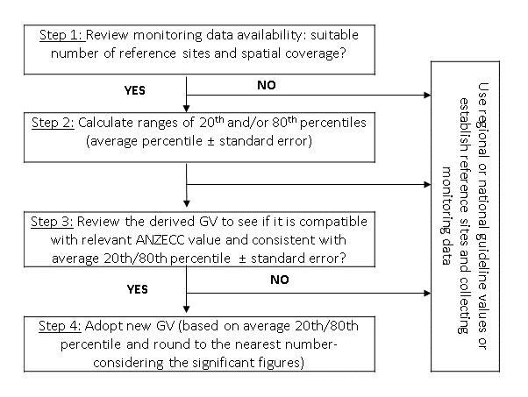

Figure 5: Procedure for deriving numerical GVs from local reference data for each water type within each region (slightly to moderately disturbed systems) (adapted from Queensland Water Quality Guidelines 2009, Environmental Policy and Planning, Department of Environment and Heritage Protection)

If the data requirements are met, ranges of 20th and/or 80th percentiles using the local reference data are calculated to derive the site-specific GVs for selected indicators. The AWQ Guidelines note that the choice of percentiles is arbitrary and advocates the use of 'an appropriate percentile of the reference data distribution to derive the guideline value' (ANZECC & ARMCANZ 2000a, pp 3.3-7,3.3-8).

#### Case study 1: Deriving a site-specific GV for salinity of water at a coal mine in the Hunter Valley (NSW) using baseline monitoring data

An open-cut thermal coal mine in the Upper Hunter Valley region of NSW commenced production in 1995. Even though the mine operates as a zero off-site discharge mine, the requirements for discharged water were defined if the proponent was required to undertake controlled discharges. Site-specific GVs for physico-chemical indicators of the site needed to be derived. Monitored parameters for controlled discharges could then be compared to the site-specific GVs to determine whether an impact was likely. This case study describes how to derive site-specific GVs for water salinity as an example.

An initial assessment identified that salinity was the main stressor of environmental concern if mine water was discharged off site. The national default GV for upland rivers in South East Australia for water salinity (as electrical conductivity – EC) of 30–350 µS/cm was used as the WQO for aquatic ecosystem protection of the Hunter River. As the salinity of the water at reference sites exceeded this GV, a site-specific GV for salinity was derived using monitoring data from the reference sites.

Three locations (A, B & C) were selected as reference sites that reflected the water quality of the local waterways before mine operations commenced. The water quality of these reference sites was collected monthly over the mine operation period. Subsequent review of the data identified that only one reference site (B) met all the reference site criteria, namely sufficient water quality monitoring data that met the QA/QC protocol. There was a point source of wastewater discharge of a new mine within 20 km upstream of reference site A & evidence of water runoff from agriculture activities above reference site C. Therefore, only data from the reference site B was used to derive the site-specific GV for salinity.

Salinity (EC) data collected monthly over 10 years (1994 to 2005) at the selected reference site was used to derive the site-specific GV for salinity (Table 1). As the site was identified as a slightly to moderately disturbed system, the 80th percentile of the reference site data was calculated.

Table 1: Recommended GV for salinity derived from local reference monitoring data

|  |  |  |  |  |  |  |
| --- | --- | --- | --- | --- | --- | --- |
| Indicator | Aquatic ecosystem for upland rivera | Variation of local reference data | | | | Recommended site-specific GV for slightly to moderately disturbed system |
| Min | Max | Median | 80th percentile |
| EC (µS/cm) | 30 - 350 | 867 | 4850 | 2800 | 3,470 | 3,470 |

a Regional GVs (Hunter River Water Quality Objectives for upland rivers)

The derived site-specific GV (3,470 µS/cm) was 10-fold higher than the regional default of 350 µS/cm. However, a study in 1979 reported that soils within the catchment are typically sodic or saline-sodic and confirmed that the pre-mining creek water quality was saline, with water samples having an average EC of 7,500 µS/cm. Therefore, the new GV of 3,470 µS/cm was considered to be acceptable and was adopted.

The above approach required local reference data collected monthly for at least two years from an appropriate reference site, so that the data would accommodate natural variability. In wet-dry tropical systems where seasonal flow is dominant, it may be desirable to group data into seasonal periods and derive more than one GV (e.g. separate wet and dry season GVs).

### 3.3.2 Deriving site-specific sediment GVs using local reference data

The AWQ Guidelines apply the default GVs for some contaminants based on the contaminants' biological effect on biota. This was achieved by statistical data evaluation of concentrations and toxicity. However, there are many other contaminants that enter the environment that have no ecotoxicological effects data that can be used to develop SQGVs. In some situations, site‐specific GVs for sediment quality (SS-SQGVs) can be developed for some contaminants that do not have default GVs or where natural background concentrations of the contaminant exceed the default GVs. The approach suggested is to derive a value on the basis of median natural background (reference) concentrations multiplied by an appropriate factor. As suggested in the current AWQ Guidelines (ANZECC & ARMCANZ 2000a, pp 3.5-5), a factor of two is recommended. In some highly disturbed ecosystems a slightly larger factor may be more appropriate, but no larger than three. It is noted, however, that this approach has low reliability. This approach requires baseline data to be collected for at least two years, so that the data encompass natural variability.

Numerical GVs are derived from local reference data for a sediment indicator by calculating the minimum and maximum values as well as the 20th, 50th (median) and 80th percentiles. Then, relevant stakeholders make a decision on an appropriate factor to be used to multiply the median values to derive the new GVs. In some cases, the 80th percentile is used as the GV rather than application of a factor of 2 or 3 to the reference site median.

#### Case study 2: Deriving a site-specific GV for a toxicant (Zinc) in sediment

This hypothetical case study aims to provide an example of how to derive a site-specific sediment quality guideline value (SS-SQGV) for a toxicant with a national default GV, but where its natural background concentration exceeds the default GV. A river basin in NSW has been historically receiving wastewater discharge from coal mine activities and a new CSG development in this same river catchment is being proposed. The new CSG operation was required to develop sediment quality objectives and design a sediment monitoring program. The initial assessment identified that a new GV for zinc would be needed as the median concentration of zinc in the sediment of local reference sites exceeded the default GV for Zn of 200 mg/kg.

Six upstream reference sites, all located above all the discharge points were selected. Sediment samples were collected in triplicate from an area within 1 m2 in clean screw capped glass jars that contained no preservatives. A composite sample for each site was used for analysis of Zn. The standard sampling and laboratory analysis methods from the practical guide of sediment quality assessment (Simpson and Batley, 2016) were used. To cover the natural variability of the sites including the waterbody, habitat and grain size of sediment, the sampling program was conducted over 2 years with 3 samples collected per year. The laboratory analysis data was used to develop the SS-SQGV.

Table 2: Recommended SS-SQGV for Zn derived from local reference monitoring data

|  |  |  |  |  |  |  |  |  |
| --- | --- | --- | --- | --- | --- | --- | --- | --- |
| Indicator | Default GVs | | Variation of local reference data | | | | | Recommended site-specific GV for highly disturbed system |
| GV | SQG-High | Min | 20th % ile | Median | 80th % ile | Max |
| Zn (mg/kg) | 200 | 410 | 105 | 150 | 178 | 350 | 480 | 360* |

* Median x 2

Key regional stakeholders reviewed the background information and monitoring data with consideration of local conditions, natural variation of Zn concentrations in sediment at reference sites, management goals and economic benefits of the project. The condition of the river was identified as a highly disturbed system. In this case the 80th percentile (350 mg/kg) was lower than the default SQG-high (410 mg/kg) and significantly lower than the maximum value of the reference site (480 mg/kg) (Table 2). Therefore, the median of 178 was multiplied by a factor of 2 to give a GV of 356 mg/kg: this is lower than the maximum Zn concentration of the reference sites, close to the 80th %ile and lower than the SQG-high value for Zn. This value of 356 (rounded to 2 significant figures, 360) was selected as the new SS‑SQGV for Zn for this site.

Case study 3: Deriving site-specific guideline values for sulfate using an ecotoxicity assessment and SSD approach

### 3.3.3 Deriving site-specific GVs for a toxicant without default GVs using the species sensitivity distribution (SSD) approach

The SSD method is the preferred method for deriving site-specific GVs for toxicants without default GVs. The method should be used whenever the toxicity data for a toxicant meet the minimum data requirements for this method. Toxicity data for at least five species that belong to at least four taxonomic groups are required: details on minimum data requirements for using an SSD can be found in the AWQ Guidelines with updates to these requirements published by Warne et al. (2015).

Background information and detail of the SSD method can be found in Warne (2001) and Warne et al. (2015). An overview of the revised method for calculating GVs using the SSD method is provided in Figure . While default GVs are derived to protect against harmful effects from long-term (i.e. chronic) exposures, the method set out in this EN can also be used to derive GVs for short-term (i.e. acute) exposures, which may be useful at regional and/or site-specific scales or for other uses such as setting licences or in prosecutions. Short-term GVs typically aim to protect most species against lethality during intermittent and transient exposures (see Batley et al., 2014 for further guidance on the derivation of short-term GVs). Case study 3 provides an example of how to derive a new GV for a toxicant that does not have a default GV 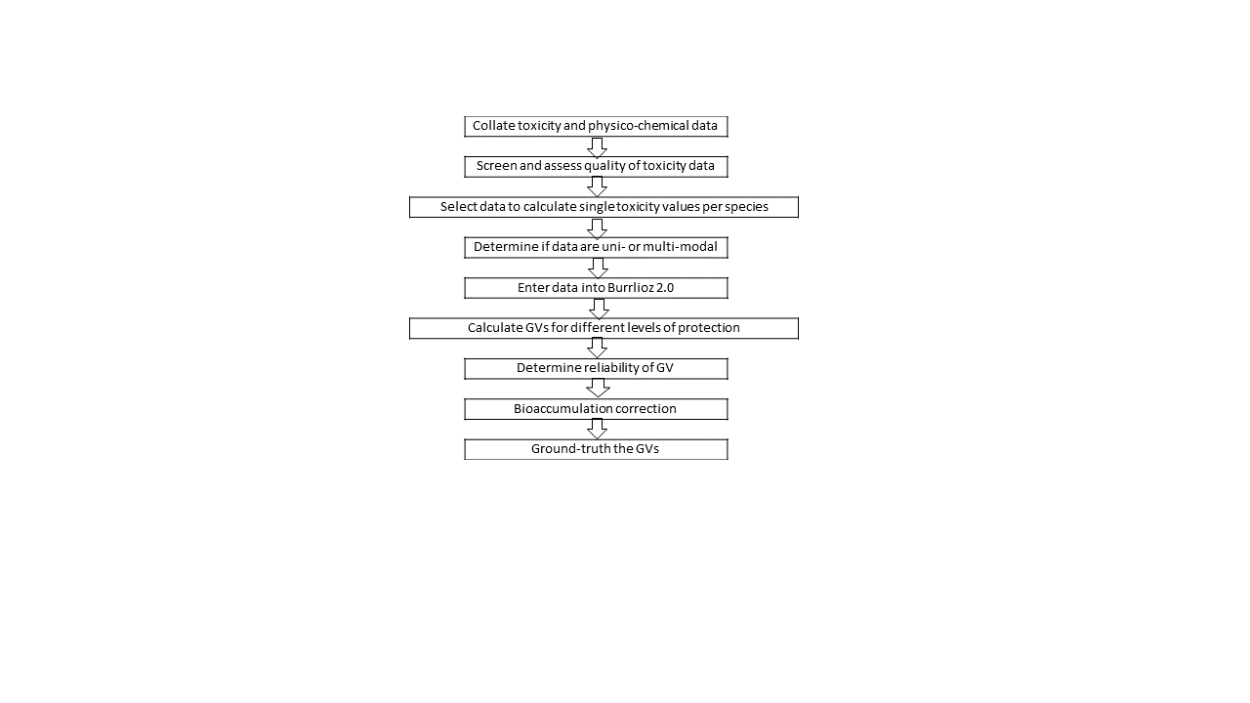using the SSD method.

Figure 6: Schematic of the method for deriving guideline values (GVs) using the species sensitivity distribution approach (Warne et al., 2015)

Both Warne et al. (2015) and ANZECC & ARMCANZ (2000a) give advice on considering the potential bioaccumulation of a toxicant when deriving a guideline value. Section 8.3.3.4 and Section 8.3.5.7 of ANZECC & ARMCANZ (2000a) discuss the background to incorporating bioaccumulation into guidelines and how bioaccumulation was incorporated into the derivation of the current guidelines respectively.

When deriving a site-specific GV for a toxicant that has the potential to bioaccumulate, ANZECC & ARMCANZ (2000a) recommend, as a first step, using the next more stringent protective concentrations as the GV. For example, where the receiving ecosystem is designated as slightly to moderately disturbed and the 95% protective GV would normally be recommended; in the case of a toxicant that has the potential to bioaccumulate, the 99% protection GV would be used. This GV would then be reality checked as per the last step of Figure 6. Further steps are described in ANZECC & ARMCANZ (2000a) (Section 8.3.5.7) and should be considered if specific data are available.

#### Case study 3: Deriving site-specific guideline values for sulfate using an ecotoxicity assessment and SSD approach

Elevated concentrations of sulfate (SO42-) can occur in river water associated with coal mine activities. In most cases, water produced through coal mine activities is stored or re-used. Although not a preferred option, in some circumstances disposal of excess water to the receiving environment is necessary, such as water releases to prevent the failure of storage dams during extreme rainfall events. Where such scenarios could occur, there is a need to establish concentration limits for discharge water that protect aquatic ecosystems at both local and catchment scales. Sulfate was the key parameter of potential concern, but there was no default AWQ GV for sulfate to protect freshwater ecosystems.

A new GV for sulfate using an ecotoxicity assessment approach was derived. Ambient water GVs for sulfate were derived using the species sensitivity distribution (SSD) method described in the AWQ Guidelines, using the concentration that would affect 10% of the test population (EC10) (Warne and van Dam 2008). In this example, new site-specific GVs were derived for sulfate at four levels of protection (80%, 90%, 95% and 99% for local freshwater species) as per ANZECC & ARMCANZ (2000). This range of protection levels cover a wide spectrum of ecosystems found in the catchment and can be applied in different locations of the river basin. The following data (Table 3) were obtained from chronic toxicity tests of sulfate to five locally relevant species, using upstream water as a control and upstream water spiked with sulfate in a serial dilution as the test waters. The five test species used for the direct toxicity assessments commonly occur over large parts of central Queensland (tropical Australia).

Table 3: Estimates of toxicity used to derive a sulfate GV, presented as concentrations (mg/L) of sulfate

|  |  |  |
| --- | --- | --- |
| Species | Test endpoint and duration | EC10  SO42- (mg/L) |
| *Paratya australiensis* (glass shrimp juvenile) | Juvenile growth – 7 days | 3,590 |
| *Melanotaenia splendida splendida* (tropical fish juvenile) | Biomass – 7 days | 6,030 |
| *Lemna disperma (*duckweed) | Population growth – 7 days | 1,750 |
| *Pseudokirchneriella subcapitata* (green alga) | Population growth – 72 h | 2,350 |
| *Ceriodaphnia cf. dubia* (water flea) | Reproduction - 7-d partial life-cycle test | 926 |

The five estimates of toxicity were generated from five chronic toxicity tests by a commercial testing service. The data were then used in an SSD to calculate the GVs using the software package BurrliOZ (Campbell et al. 2000), which was developed specifically for the AWQ Guidelines (Figure ). The SSD was used to derive GVs for ecosystem protection at different levels of species protection (Table 4). These are generated automatically in the software package. These different levels of protection may be used for parts of the same catchment that have similar attributes but be designated different levels of protection, e.g. a high ecological value zone would use the 99% protection value.

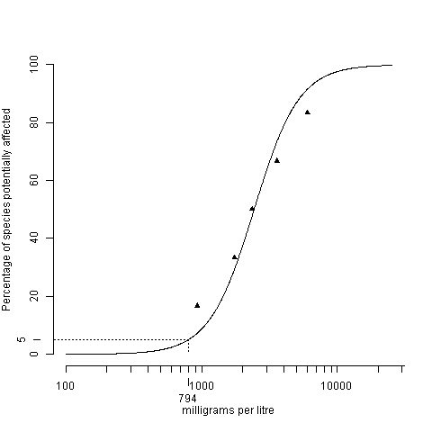

Figure 7: Species sensitivity distribution showing the concentration of sulfate (mg/L) that will protect 95% of species

The above approach required one ‘range finder’ (to determine a range of concentrations to define the target concentration for each toxicity test) and two ‘definitive’ tests to each of the (minimum of five) test species, with each test conducted over a set time period. ANZECC/ ARMCANZ (2000) states that while the SSD was derived from five species from four phyla, the resultant GVs should be regarded with caution since only the minimum data requirements are met. For a more robust GV, ideally more species i.e. at least 8 species, should be used (see Warne et al., 2015 for further information).

Table 4: Guideline values at various levels of species protection (80-99%) for sulfate.

|  |  |
| --- | --- |
| Level of species protection | Moderate reliability GVs based on chronic EC10 for 5 species for SO42- (mg/L) |
| 80% | 1,435 |
| 90% | 1,055 |
| 95% | 794 |
| 99% | 424 |

# Designing water and sediment monitoring programs for CSG and LCM industry

## 4.1 Sampling program design

Monitoring programs need to be based on some conceptual model of the behaviour of the contaminants of concern in the aquatic system into which they are to be discharged. An example of a basic conceptual model was given in Figure 1 and Figure 2, which show the causal pathways to the receiving environment for contaminants from different components of a typical CSG and LCM operation. More detailed models might consider the fate and impacts of specific contaminants (e.g. see ANZECC & ARMCANZ, 2000a).

This section summarises the key information required for designing an appropriate monitoring program, following the management framework. The monitoring program design is determined by the monitoring objectives of the CSG and LCM development. First, the study type is considered because this will define the field sampling program and subsequent data analyses. Three distinct study types can be identified: (1) descriptive studies; (2) studies that measure change; and (3) studies that improve system understanding (cause and effect). The scope of the study should then be defined. This comprises the spatial and temporal boundaries of the study. The reference sites should be identified. From this point, it is then possible to consider specific aspects of the sampling design.

The sampling program should ultimately be defined by program objectives that can include the statistical power required for discriminating between hypotheses or be based on the levels of acceptable sampling variability. For example, important considerations would include the likely spatial uniformity of the parameter/s of interest at a location (e.g. at depth, cross-sections of a river) and the extent of the potential impacts downstream. For example, where a water body is well mixed, and a parameter of interest is evenly distributed in the water column, a grab sample may be appropriate. However, if water quality changes with depth, a number of samples at different depths may be required.

Essential features of a sampling strategy include ensuring that:

* samples collected are representative of the source material (i.e. waters, sediments and biota in a creek, river or lake) at the locations of interest;
* variation is taken into account – both in space (spatially) and over time (temporally) – owing to the need to recognise that different physico-chemical variables often vary at different spatial and temporal scales so one size may not fit all variables;
* *in situ* measurements are reliable (see Section 6 for more detail on passive sampling devices);
* the integrity of materials sent for laboratory analysis has not been compromised by contamination, degradation or transformation;
* sufficient sample volume to meet required detection limits for a particular analytical method, appropriate collection methods are used, and reference or control sample data are collected; and
* consideration of flow conditions (whether event or ambient or knowing the time since last flood and/or when rewetting occurred) (see Section 6 for more details on temporary water bodies).

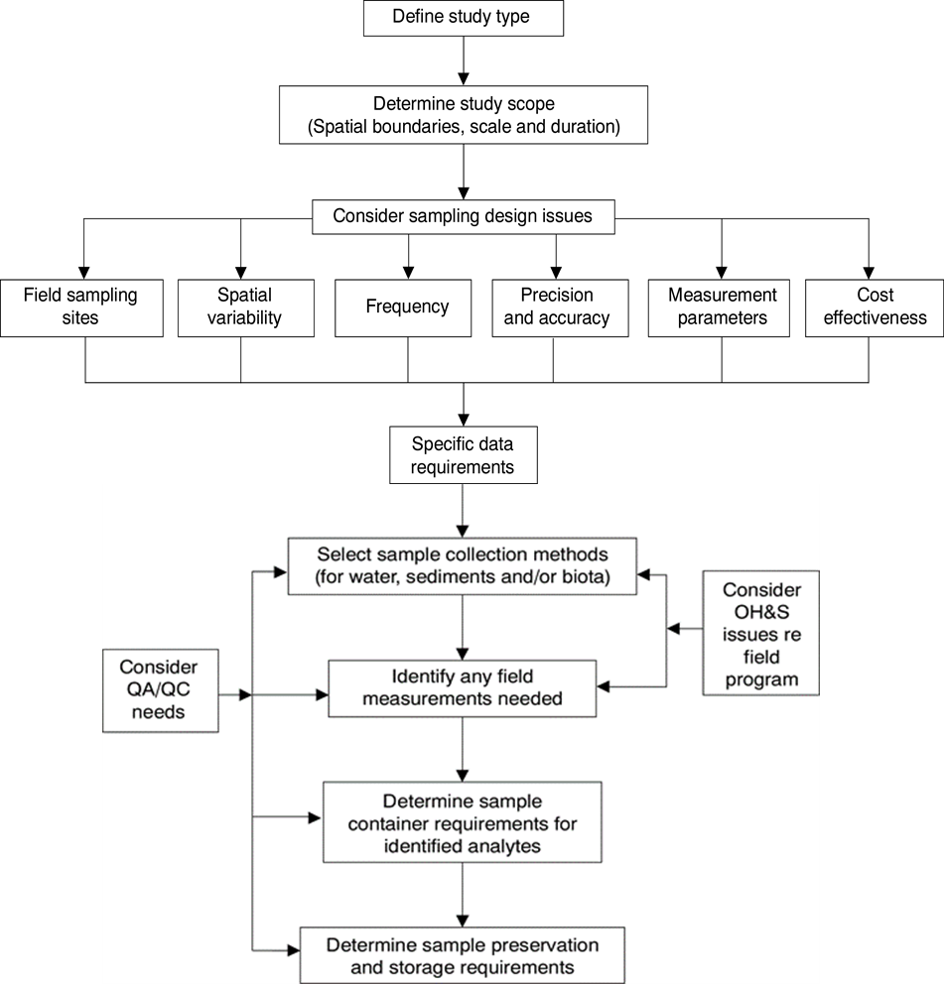

Figure 8: Framework for a water/sediment quality monitoring program with specific data requirements for a sampling program (draft updated AWQ Guidelines, Australian and New Zealand Governments and Australian State and Territory Governments 2018)

## 4.2 Effective water monitoring program

Deciding what to measure will follow from the conceptual understanding. All possible CSG and LCM associated water entering a water body needs to be analysed and, where it is seen that concentrations of any contaminant may not be adequately diluted, then these should form part of the monitoring program. Contaminant constituents that have the potential to be mobilised in mine discharges will also be of concern. In relation to process water discharges, measurements might include the range of metals, ammonium and nitrate (open cut blasting activities) and sulfate (and possibly sulfide), as well as chemicals used in fracturing fluids.

## 4.3 Effective sediment monitoring program

The design of a sampling program for sediments should consider the fact that sediments are often heterogeneous. Contaminant distribution depends heavily on grain size. In general, metals that accumulate via adsorption to particles will be associated with the finest particles with high surface area to volume ratios. Sandy and other coarse-grain sediment particles generally have a low metal content. Generally, the metals on these particles have low bioavailability, and so potentially pose a low threat to benthic organisms. However, bioavailability of metals is also dependant on the redox conditions and that if these were altered, adsorbed contaminants may become bioavailable.

Sampling of sediments will generally use a stratified random sampling design, where sampling of sediment is undertaken from locations at increasing distances from the point source in the case of a discharge. The spatial heterogeneity (both horizontal and vertical) should also be taken into consideration. Sampling should involve replicate samples to determine localised heterogeneity. Vertical heterogeneity can be assessed from core samples and, in general, these are preferable to surface grab samples. Sediment deposition in a water body will not necessarily occur uniformly but will be dictated by flow. Scouring of bottom sediments is common in the channels of fast-flowing rivers, while deposition will occur in low flow regions, floodplains and terminal lakes and swamps. Depositional areas are therefore more relevant for the assessment of mining impacts on sediment quality.

Sedimentation rates in water bodies typically vary from mm to 1–2 cm/year, although in tropical areas with large seasonal variability in river flows, sediment accumulation in off-river areas can be much larger. Except in the latter cases, recent sedimentation is therefore unlikely to be seen at depths below 5 cm. The bulk of biological activity also occurs in the upper 5 cm, although some organisms can burrow to greater depths (Simpson and Batley, 2016). The depths to which sediments are sampled should therefore be relevant to the monitoring objective. At some stage, it may be appropriate in any monitoring survey to establish the nature of the depth profile of contaminants at the sites under consideration. (Further details can be found in Chapter 2 of the Sediment Quality Assessment – A Practical Guide by Simpson and Batley, 2016).

## 4.4 Site-specific water and sediment sampling program

From the specific data requirements identified in the design process, sample collection methods for water and sediment should be considered, including sample container requirements for the identified analytes, together with any sample preservation and storage requirements. Any necessary field measurements should also be identified. Laboratory and field QA/QC needs should also be considered, together with specific occupational health and safety requirements.

The sampling design should comprise:

* selection of field sampling sites: systematic, random, stratified or clustered sampling;
* spatial variability within a sample site: e.g. surface vs depth;
* frequency: daily, weekly, monthly; wet or dry season;
* precision and accuracy: number of samples; replication; power to detect differences;
* preservation, storage, treatment requirements for each indicator; and
* cost-effectiveness: as small as possible while still meeting the stated objectives of the monitoring study.

### 4.4.1 Quality assurance and quality control in sampling and chemical analysis

As part of the quality assurance procedure, data collection, storage and analysis should be consistent. The detail of sampling protocols is clearly presented in the Queensland Monitoring and Sampling Manual 2018 (<https://www.ehp.qld.gov.au/water/monitoring/sampling-manual/pdf/monitoring-sampling-manual-2018.pdf>).

Appropriate QA/QC will be required to be demonstrated by any laboratory undertaking chemical analyses. Quality assurance include such aspects as would be covered in laboratory accreditation, such as fully documented methods, traceability of results, appropriately trained personnel and implementation of good laboratory practice.

As part of any analysis, QA/QC should include:

* recovery of known additions (spike recovery tests);
* analysis of appropriate certified reference materials (where available): this should be undertaken with each batch of samples;
* adequate calibration of the analytical method;
* replicate analyses: at least 5-10% of samples should be analysed in duplicate;
* field sampling and method blanks; and
* charge balance error calculation (CBE): when all the major cations (such as Ca2+, Mg2+, Na+, K+) and anions (such as Cl-, SO42-, and HCO3-) have been analysed, the sum of cations in equivalents should equal the sum of anions in equivalents. The difference between the two sums should typically not exceed 1 or 2 percent. However, for diluted water from a high rainfall event of low-ionic strength, a CBE can be expected, typically ± 10 percent but it can be as high as ± 30 percent for samples with dissolved-solids concentrations less than 100 mg/L. The acceptable CBE is ± 10% for a wide range of waters.

In addition, the laboratory should participate regularly and perform well in inter-laboratory collaborative testing programs. Accreditation of the laboratory is desirable, as it is a means of ensuring that appropriate standards of QA/QC are in place, although it will not necessarily guarantee accurate results.

### 4.4.2 Dealing with outliers and censored data

Below detection limit (BDL) data are typically reported as <x, where x is the detection limit. The data analysis section of the Monitoring and Reporting Guidelines (ANZECC & ARMCANZ, 2000a) recommends that when analysing results containing BDL data, BDL values be replaced by either the detection limit or half the detection limit. It also notes that the impact of this action should be clearly understood. This practice is clearly inappropriate in assessing a single value for compliance with a trigger value. If a significant portion (e.g. >25%) of data falls into this category, then care should be taken with drawing inferences. In this case, a more sensitive analytical method would be required.

Unusual or extreme observations are termed ‘outliers’, implying that they are aberrant and should be discarded. For typical-sized datasets, generally any data point falling outside three standard deviations of the mean will be aberrant. They should first be the subject of follow-up investigations to determine whether they are related to recording or analytical errors or associated with sampling and sample handling. Examining co-dependence with data for other components of the aberrant sample will assist here. It is recommended that only with the most extreme measurements (i.e. more than four standard deviations from the mean), should the data be automatically discarded. However, in highly variable systems (e.g. temporary waters) where pulses in contaminant concentrations can occur, applying such a recommendation may not be appropriate.

# Integrating and optimising monitoring and assessment programs

## 5.1 Using multiple lines of evidence and associated indicators

While this EN has focused on physical and chemical stressors, additional biological parameters are also an important component of environmental management. The concept of a weight-of-evidence (WoE) assessment using multiple lines-of-evidence (LoE) implies that the integration of the different LoE gives greater weight (or certainty) to the inference, and thereby to the decision, regarding the water/sediment quality objective being met, than the consideration of a single LoE. WoE using multiple LoEs is now in international usage and is an accepted methodology for the assessment of water and sediment quality. The updated AWQ Guidelines have included the WoE approach in water and sediment quality assessments (Figure ). The pressures, stressors and community value attributes of the system are selected. This is a particularly important approach for temporary waters where all indicators are variable (with results difficult to interpret without as complete a dataset as possible), and data collection opportunities for water quality are inherently limited and opportunistic. It is also a common step at the commencement of monitoring to acquire data to derive water quality guideline values and assemble suitable chemical and biological baselines.

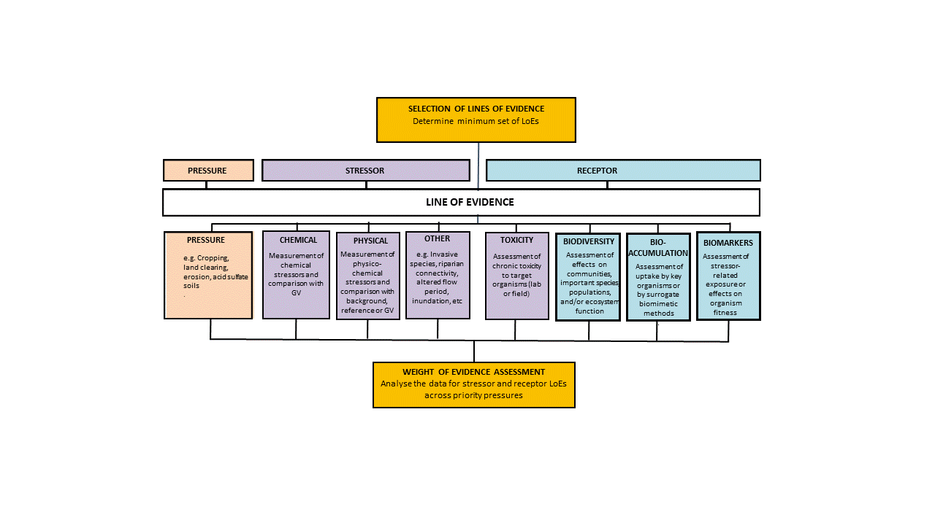

Figure 9: Weight of evidence assessment (draft updated AWQ Guideline, Australian and New Zealand Governments and Australian State and Territory Governments 2018)

## 5.2 Integrating chemical and biological approaches in the water quality management framework

It is important to consider integrated monitoring and assessment at all phases of the water and sediment quality management framework. Key features to consider concerning the early management steps include ensuring that:

* Technical expertise for both chemical and biological aspects is available at all relevant steps, including negotiations on the primary management aims.
* Chemical and biological indicators are selected and balanced to meet the primary management aims, especially the level of protection, and the availability of controls.
* Sampling of common sites is conducted jointly, as far as possible, recognising that biological assessment places greater demands upon the availability of spatial controls.
* The level of acceptable change and statistical sensitivity to detect the change is consistent with the level of protection that is designated, for both indicator types. Optimisation of the program is applied equally and fairly across both types of assessment in a manner that does not compromise environmental protection.

## 5.3 Applying biological assessments as part of an integrated assessment

A combination of physical, chemical and biological assessments enhances the confidence in correctly attributing causes to any observed change in water quality. Biological variables integrate effects of past and present exposure and directly assess progress in achieving the management goals, while physical and chemical variables provide information about causality. Such an integrated approach is also promoted for sediment assessment, where a combination of toxicity tests, chemical contaminant measurements and benthic macroinvertebrate analyses provide a weight-of-evidence of adverse impacts.

Biological (and chemical) assessment would be substantially reduced wherever wastewaters at a mine site are fully contained and where the risk of reaching surface or groundwaters is negligible. Biological assessment might also be reduced where, after extensive investigations, a very good understanding of wastewater/ecological effects relationships has been developed, so that chemical measures could be used to predict effects in receiving waters. However, wastewaters are inevitably complex and typically change in composition over time, and so it would be unusual to find examples where water chemistry alone would suffice for environmental assessment.

As a rule, while some biological assessment will be expected wherever a corresponding chemical assessment program is in place, the extent and intensity of this assessment will increase, the higher the level of protection assigned to an ecosystem. The level of protection, assessment objectives, and a balance of indicators to apply in a monitoring program are intimately linked, and the process of determining these should be carried out simultaneously. Where a mine effluent is discharged to a receiving water, prediction and early detection may be important considerations. Ecotoxicological studies, apart from determining a safe dilution for wastewater discharge, also provide a definitive assessment of possible ‘high risk’ to ecosystems where the GV is exceeded in the event of subsequent discharge.

Ecological studies, particularly by way of biodiversity assessment, provide the ultimate evaluation of whether or not ecosystems have been protected. Some level of biodiversity monitoring will be expected to provide such assurance to key stakeholders and the community generally. However, it is important to remember that biodiversity responses integrate past and present contaminant exposures and, as a rule, the frequency with which biological sampling occurs is substantially less than that which may be required for chemical water sampling. For example, annual monitoring might be appropriate (especially when complemented by early detection methods). In tropical areas, this could be at the end of a wet season, to integrate the effects of any wastewater discharges over that season.

Biodiversity assessment in the broader sense provides information on all types of threats to aquatic ecosystems, not just chemical. Thus, ecological studies are also particularly useful with respect to issues such as those that do not necessarily involve toxic effects, but which have whole-of-ecosystem effects that can be demonstrated by comparison with reference sites. In combination with the chemical measurements, these will aid in the development of site-specific GVs.

Where few ecological data currently exist, it is recommended that seasonal sampling is conducted for two or three years to develop a suitable monitoring program. At this point, the program would be revised and rationalised where necessary. In general, applying biodiversity assessments as one-off surveys at mining operations is not a sufficient approach to water quality evaluations.

# Temporary water bodies

CSG and LCM industry operations in Australia frequently deal with temporary water bodies. The GVs for toxicants in the AWQ Guidelines were based on chronic responses to steady-state conditions, which by definition do not occur in temporary waters. Nonetheless, the flexibility of the ANZECC & ARMCANZ (2000a) approach does provide for consideration of these issues from a risk-based perspective. Also, recent updates in the methods for GV derivation (Warne et al 2015) offer useful advice in setting appropriate protective concentrations for temporary water bodies.

## 6.1 Temporary water bodies

Temporary systems comprise a diversity of water bodies, including ephemeral or intermittent streams, lakes, wetlands, internal deltas, braided channel systems, playas, mound springs, saline lakes and ephemeral pools.

Streams dry up and surface waters disappear during the dry periods only to reappear with associated biological communities following the onset of the next substantial rains. These systems may be ephemeral i.e. flowing briefly (< 1 month) with irregular timing and usually only after unpredictable rain has fallen (Batley et al., 2003) or intermittent, flowing for longer periods in a predictable wet season. Many temporary waters have considerable year-to-year variability in the duration of their inundated phase which, in turn, has major consequences for their sediment and water quality.

Variability in water quantity and quality means that factors such as long-term fate, persistence, load and concentration, and contextual issues such as sensitivity and connectivity need to be taken into account by management agencies. The lack of explicit guidance in the AWQ Guidelines and the dominance of temporary waters in many areas where CSG and LCM operations are undertaken led to concerns as to how to deal with following:

* Temporary systems tend to be highly variable in nature with flows or inundation periods that are unpredictable and often short but intense. Toxicant concentrations may subsequently be highly variable over the wetting-drying cycle and fixed frequency sampling may miss events.
* The toxicant guideline values from the AWQ Guidelines are derived from chronic exposure responses to single toxicants. How to deal with pulsed exposures is not well defined but Warne et al. (2015) offers advice on deriving short-term GVs using acute toxicity data that may be applied to temporary waters.
* There are logistical difficulties associated with sampling in systems that can flood unpredictably and over enormous scales. Remoteness of arid and semi-arid zone systems from major centres has hampered an understanding of these systems, including life cycles, biodiversity, and life histories of resident biota and general ecological processes.

These features potentially impede successful implementation of the AWQ Guidelines, and some advice is offered below to tackle most of the uncertainties and problems associated with temporary systems.

## 6.2 Effective monitoring programs for water and sediment quality indicators of temporary water bodies

To design an effective monitoring program for temporary water bodies, the following sections outline steps that should be considered.

### 6.2.1 Temporary water body conceptual modelling

As mentioned previously, the use of ecological conceptual models (Section 2.2) allows the development and understanding of the interactions between natural ecosystem variability and responses to pressures unrelated to water quality on ecosystem health. Some specific considerations required for sampling and ongoing monitoring of temporary waters include:

* understanding the variation in turbidity, salinity and colour (dissolved organic carbon concentrations) all of which are biologically important stressors that have high levels of natural variability in temporary waters;
* developing a link between the duration and nature of connectivity between temporary waters. This will assist in predictive modelling of the extent and duration of water quality stressors; and
* improving the understanding of the relationship between antecedent hydrologic conditions, the length of time since last inundation, the volume of inundation at the start of the wetting phase and initial water quality conditions.

### 6.2.2 Monitoring approach

Water quality monitoring should be undertaken in much the same way as it is for permanent water bodies, with monitoring of key parameters over the wetting-drying cycle. The effect of the wetting–drying cycle on key physical and chemical parameters (e.g., temperature, dissolved oxygen, salinity, turbidity, pH) in intermittent rivers and ephemeral streams (IRES) will depend on a number of key local (IRES-specific), and often interacting variables (Figure 60) including:

* channel substrate type (bedrock, sand or silt, organic-rich or organic-poor material);
* groundwater interactions, including hyporheic flows; and
* whether pools form after flow cessation; if so, pool morphology (e.g., length, width, depth, and orientation to the prevailing winds).

Event-driven sampling is desirable to capture waters during key events, including the first flush where the higher concentrations of contaminants enter the river system. Water quality will usually change from having higher pH and clarity and low conductivity and dissolved organic carbon after rainfall and significant flow, to having lower pH, being turbid and rich in organic matter, and sometimes salt during and after recessional flow, as evaporation concentrates the diminishing water. Exceedance of GVs should be assessed as prescribed in the AWQ Guidelines, partitioning and comparing the data for physical and chemical stressors into respective wet and dry seasons.

This variability should also be established for nearby reference systems, (possibly sites on the same water body upstream of the mine site). The wet and near-dry phases should be characterised separately, as per Section 2.6. In general, the default GVs are adopted for toxicants and sediments (see section 2.7 and 2.8 of EN). While the relevance of these GVs to particular temporary systems may not have been assessed, other broad-ranging comparisons, including between temperate and tropical species’ sensitivity, have not revealed significant differences. However, it may be necessary to adjust values for background variation, particularly in the case of the first flush.



Figure 60: Physical and chemical parameters of water in IRES are influenced by a number of regional- and local-scale variables (Figure from Gómez et al., 2017)

### 6.2.3 Monitoring temporary water bodies

Accessibility problems (especially during the wet phase) and very significant spatial and temporal variation in water quality over the wetting-drying cycle require tailored approaches to reliable collection and measurement of indicators. Some established and newer approaches to addressing these issues include:

* automatic samplers (refrigerated if necessary) triggered by events (or via telemetry);
* continuous or integrated monitoring of stressors (loggers and telemetry) with potential in the near future to extend to direct measurement of some toxicants; and passive samplers that integrate chemical concentrations over time (e.g. DGT, ‘peepers’, chelex-resin columns, polar and non-polar organic molecule samplers etc.) See more detail below;
* remote sensing and hyperspectral and other imagery (e.g. salts, turbidity, chlorophyll); and
* sediment chemistry as an archive of past water quality.

Where access during the wet phase is particularly challenging, and also for the less predictably inundated water bodies, the use of surrogate/proxy datasets that can be obtained during the dry phase is also likely to be beneficial. Examples include:

* direct toxicity assessment of potential discharges coupled with hydrological and/or geochemical modelling to provide a prediction of acceptable whole effluent dilutions and probability of exceedance of them in the receiving environment;
* assessment of sediment chemistry as a direct measure of sediment quality, as an archive of past water quality, a proxy of potential water quality during the wet phase and potential water quality detriment footprint;
* use of terrestrial phase assessments as surrogates for aquatic phase water/sediment such as terrestrial invertebrate health indices (see relevant recent paper by Alisha Steward et al. 2018), riparian vegetation condition indices, and in pastoral areas, measures of stock access/trampling and defecation rates;
* assessment of propagule (eggs, spores, resting stages) bank status as a proxy for *in situ* recruitment potential;
* assessment of permanent refuge water, sediment and ecological status as an indicator of probable wet-phase ecosystem health; and
* remote sensing and hyperspectral and other imagery to detect deposited salts.

Given the generally high variability of physical and chemical stressors in temporary waters, and the effects of first flushes and evapo-concentration on them, ecological lines of evidence which integrate this variability in abiotic conditions through time will be particularly useful inclusions for water quality assessment. However, the following factors can strongly influence the variability in organism assemblage development between wetting-drying cycles and, geographically, within temporary water networks:

* stochastic recruitment effects on assemblage development;
* in-built genetic variability in timing and triggers for ending aestivation within populations (‘spreading the risk’) and amongst different species;
* physical and chemical constraints on assemblage succession trajectories and variability amongst years will require different benchmarking between inundation events. For example, the initial conditions (and hence process of ecosystem successional development) in temporary salt lakes are dependent on the amount of inflow in the initial re-wetting of the ecosystem, with different taxa favoured by different salinities; and
* changes in the relative input of surface, hyporheic and groundwater flows (particularly to pools/refugia) over the wetting-drying cycles, with differing implications for water and sediment quality.

All of these factors will affect the selection of ecological lines of evidence and the achievable sensitivity to water quality changes.

Other considerations when selecting ecological lines of evidence include:

* developing “omic” technologies shows promise for collecting extensive datasets quickly (updated AWQ Guidelines, 2018) which are valuable where sampling opportunities are limited, and/or to provide additional lines of evidence within limited timeframes and budgets,
* Anthropogenic changes in water quality will commonly be associated with some change in water quantity, such as via a discharge or spill.

Temporary waters may be very sensitive to alterations in the wetting-drying cycle, and so assessment of water quality impacts will usually need to be done in light of ecosystem responses to the associated changes to water availability. An understanding of the extent of the sensitivity of the ecosystem to the change in water availability would need to be developed along with an appropriate measurement for use as a line of evidence for monitoring purposes.

## 6.3 Time-period measurements and passive sampling devices (PSD)

The monitoring and sampling manual in the Environmental Protection Water Policy (2009) and the practical guide for Sediment Quality Assessment (Simpson and Batley, 2016) describe passive sampling devices (PSDs) for monitoring trace concentrations of contaminants. PSDs are used to:

* Detect contaminants that may be present in concentrations below the limit of detection that a laboratory can reach when testing a water sample. Trace levels of contaminants are often concentrated to detectable levels by PSDs placed in water for a controlled exposure period.
* Obtain a time-weighted average concentration over a deployment period, which can vary between several days and several weeks for different PSD types and for different analytes.

For organic chemicals in water, PSDs have evolved over many years, and various devices and methods have been employed. Most of these methods fall into two categories: those that use an organic solvent as the sorbent phase, and those that use a solid sorbent phase, including semi-permeable membrane devices (SPMDs) and Chemcatcher.

The diffusive gradients in thin film (DGT) device uses a binding layer to accumulate elements in the solutes in a controlled way using a diffusive hydrogel. The establishment of a constant concentration gradient in the diffusion layer forms the basis for measuring metal concentrations quantitatively without the need for separate calibration. Numerous binding gels have been developed to measure a range of metals and metalloids, dissolved inorganic nutrients (phosphate, nitrate and ammonium), sulfide, radioisotopes and organic pollutants. Advantages of using DGTs are:

* time-integrated and *in-situ* measurements;
* independent of pH and ionic strength;
* simple field deployment with the ability to measure multiple elements;
* increased efficiency and decreased sampling frequency of compliance water quality monitoring programs; and
* one DGT unit could potentially replace numerous grab samples and provide a far more representative view of in-stream concentrations over a deployment period and reduce monitoring costs by at least 34% (Huynh and Vink, 2016)

Diffusive equilibrium in thin films (DET) technique, which does not contain a binding layer, can be deployed in sediment for solutes for which there is no suitable binding layer. The DET comprises a single relatively thick sheet of gel (typically 0.8 mm) supported in a holder with a membrane. Solutes in the surrounding water diffuse into the gel until concentrations equilibrate.

## 6.4 Special problems associated with monitoring sediment and water quality in highly temporary waterbodies

Although biological monitoring is not part of this EN, given all the unique problems with temporary waters, biological monitoring is needed as an additional LOE. The (mostly invertebrate) biota of temporary systems demonstrate a succession associated with the wetting and drying cycle. Water quality during the first flush, and later, when pools have nearly dried out, may be extreme and the biota may be particularly stressed at these times. In temporary systems, biological monitoring offers the same virtues as elsewhere. Particularly where water chemistry is highly variable, biological responses may better integrate and ‘smooth’ past and present exposures to varying concentrations of contaminants. In the likely absence of relevant ecological information, efforts should be made to characterise the dynamics of biological communities in these systems at ‘impact’ and adjacent reference sites for each phase of the wetting-drying cycle. For example, sampling twice during stream flow and well after a ‘first-flush’, during recessional flow and the pool phase. First-flush studies are relevant where there is potential for dissolution of deposited mine contaminants and especially where there is potential for fish kills.

If seepage of mine waters is likely to reach the sediments of stream beds during the dry phase, sampling of the hyporheic fauna might also be required if such a fauna is naturally present. This general sampling program should proceed regardless of how advanced a mine is into its operational life. Wherever possible, such baseline data should be gathered in a site configuration that meets a quality-control design of multiple before-after, control-impact sites that preferably are paired (BACIP) (Smith, 2002 and Downes et al., 2002). Modifications can then be made as information accrues. After such information has been gathered intensively for two years (or two wetting-drying cycles), the program can be optimised for future monitoring.

Key sampling times for routine monitoring are likely to focus on the recessional flow period and in the case of temporary water bodies, during the dry phase. Large inland rivers may be particularly difficult to sample during floods as waters spread over vast areas and when, in any case, dilution rates of any dispersed mine wastes would be expected to be very high. In anticipation of high variability in temporary systems, it would be prudent for managers to also include in their monitoring programs early detection indicators such as pH, EC, or dissolved oxygen (DO) whose responses provide reasonable evidence of contaminant exposure and, therefore, early warning of possible adverse effects. These indicators, however, should not be employed as a substitute for biodiversity measurement.

# Conclusions

This EN provides guidance on the desired information for the IESC to undertake an assessment of development applications from CSG and LCM proponents. It aims to achieve this by assisting in designing an effective monitoring program for water and sediment quality indicators that can be applied for adaptive management and impact mitigation. Importantly, the EN guides CSG and LCM industry on how to use monitoring data from appropriate reference and control condition sites to develop site-specific guideline values for water and sediment quality and discusses when it may be appropriate to derive toxicant GVs for water and sediment where the default guidelines are either missing or are not appropriate.

Case studies are used to further illustrate the process to derive site-specific GVs for physico-chemical stressors and toxicants in water and sediments. Further advice is also given on how to design effective monitoring programs for the collection of water and sediment samples for selected indicators that will be used to derive site-specific GVs. This considers both spatial and temporal aspects, and other various factors such as seasonality, water body types, flow regimes, reference sites, etc., which can have a major effect on how appropriate the site-specific GVs are for the CSG and LCM activity being proposed.

# References

ANZECC & ARMCANZ 2000a. Australian and New Zealand Guidelines for Fresh and Marine Water Quality. National Water Quality Management Strategy. Paper No 4. Volume 1, The Guidelines. Australian and New Zealand Environment and Conservation Council, Agriculture and Resource Management Council of Australia and New Zealand. Canberra.

ANZECC & ARMCANZ 2000b. Australian guidelines for water quality monitoring and reporting. National Water Quality Management Strategy. Paper No. 7. Australian and New Zealand Environment and Conservation Council, Agriculture and Resource Management Council of Australia and New Zealand, Canberra.

Apte, SC, Williams, M Kookana, RS, Batley, GE, King JJ, Jarolimek CV & Jung RF 2017. Release of geogenic contaminants from Australian coal seams: experimental studies, Project report, report prepared by the Land & Water, Commonwealth Scientific and Industrial Research Organisation (CSIRO) as part of the National Assessment of Chemicals Associated with Coal Seam Gas Extraction in Australia, Commonwealth of Australia, Canberra.

Aquatic Ecosystems Task Group 2012. Aquatic Ecosystems Toolkit. Module 2. Interim Australian National Aquatic Ecosystem Classification Framework. Department of Sustainability, Environment, Water, Population and Communities, Commonwealth of Australia, Canberra

Australian and New Zealand Governments and Australian State and Territory Governments 2018. Australian and New Zealand Guidelines for Fresh and Marine Water Quality, draft document.

Batley G, van Dam R, Warne M, Chapman J, Fox D, Hickey C, and Stauber J 2014. Technical rationale for changes to the method for deriving Australian and New Zealand Water Quality Guideline Values for Toxicants. A water for a healthy country flagship report. Prepared for the Department of Sustainability, Environment, Water, Population and Communities, 48 pp.

Department of Environment and Heritage Protection 2009. Queensland Water Quality Guidelines, Version 3, ISBN 978-0- 9806986-0-2.

Department of the Environment and Energy 2017. Chemical Risk Assessment Guidance Manual: for chemicals associated with coal seam gas extraction, Guidance manual prepared by Hydrobiology and ToxConsult Pty Ltd for the Department of the Environment and Energy, Commonwealth of Australia, Canberra.

Downes J, Barmuta L, Fairweather P, Faith D, Keough M, Lake P, Mapstone P, and Quinn G 2002. Monitoring Ecological Impacts: Concepts and Practice in Flowing Water. Cambridge University Press, New York, New York, USA.

Gómez R, Arce M, Baldwin D and Dahm C 2017. Water physicochemistry in intermittent rivers and ephemeral streams In Intermittent Rivers and Ephemeral Streams Ecology and Management. Datry T, Bonada N and Andrew Boulton (Eds). UK, Academic press, Elsevier 109-127.

Henderson BL, Hayes KR, Mount R, Schmidt RK, O’Grady A, Lewis S, Holland K, Dambacher J, Barry S and Raiber M 2016. Developing the conceptual model of causal pathways. Submethodology M05 from the Bioregional Assessment Technical Programme. Department of the Environment and Energy, Bureau of Meteorology, CSIRO and Geoscience Australia, Australia. Available (online): <http://www.bioregionalassessments.gov.au/sites/default/files/ba-m05-conceptualmodels-20170501.pdf>.

Huynh T & Vink S 2016. Reducing Analytical and Water Quality Monitoring Costs using Diffusive Gradients in Thin Films (DGT) Technique. Technical report. ACARP project C23027. Australian Coal Association Research Program, Brisbane, Queensland.

Jankowski J, and Spies B 2007. Impact of longwall mining on surface water-groundwater interaction and changes in chemical composition of creek water. Proceedings of the XXXV IAH Congress: Groundwater and Ecosystems, Lisbon, Protugal, 17-21 September 2007, Ribiero, Chambel, Condesso de Melo (eds), Published by International Association of Hydrogeologists, ISBN 978-989-95297-3-1.

Simpson S and Batley G 2016. Sediment quality assessment: A practical guide (2nd Edition), CSIRO Publishing, Clayton, Vic.

Smith E 2002. BACI design In Encyclopedia of Environmetrics, El-Shaarawi A and Piegorsch W (eds), 141-148. Chichester, John Wiley & Sons, Ltd.

Steward A, Negus P, Marshall J, Clifford S, Dent C, 2018. Assessing the ecological health of rivers when they are dry. Ecological Indicators 85:537-547.

Thiruvenkatachari R, Younes M, Su S. 2011. Coal mine site investigation of wastewater quality in Australia. Desalination and Water Treatment, 32, 357-364.

Warne M St J (2001). Derivation of the ANZECC and ARMCANZ Water Quality Guidelines for Toxicants. Australasian Journal of Ecotoxicology, 7, 123–136.

Warne M St J and van Dam R 2008. NOEC and LOEC data should no longer be generated or used. Australasian Journal of Ecotoxicology, 14, 1-5.

Warne M, Batley G, van Dam R, Chapman J, Fox D, CW Hickey C and Stauber J 2015. Revised method for deriving Australian and New Zealand Water Quality Guideline Values for Toxicants. Revised 12 October 2016. Prepared to support the Australian and New Zealand Guidelines for Fresh and Marine Water Quality. Department of Science, Information Technology and Innovation, Brisbane, Queensland. Available (online): <https://publications.csiro.au/rpr/download?pid=csiro:EP159161&dsid=DS3>.

# Appendix 1: Recommended reading

Queensland has presented a draft environmental values (EVs) and water quality guidelines (WQGs) to protect environmental values for Queensland Murray-Darling Basin surface waters

<https://www.ehp.qld.gov.au/water/policy/pdf/mdb-main-report1-surface-water.pdf>

Dawson River Sub-Basin Environmental Values and Water Quality Objectives Basin No. 130 (part), including all waters of the Dawson River Sub-Basin except the Callide Creek Catchment (EHP, 2011). Available (online)

<https://www.ehp.qld.gov.au/water/policy/pdf/plans/fitzroy_dawson_river_wqo_290911.pdf>

The factsheet explains the framework under which water quality guidelines and objectives are derived under the Environmental Protection (Water) Policy 2009. Water types for which guidelines can be derived include fresh (surface and ground water), estuarine and coastal/marine waters

National partnership agreement on coal seam gas and large coal mining development. Available (online) <http://www.federalfinancialrelations.gov.au/content/npa/environment/national-partnership/past/coal_mining_development_NP.pdf>.

Victoria EPA 2018. Development of environmental quality indicators and objectives for the draft SEPP (WATERS). Available (online) <http://www.epa.vic.gov.au/~/media/Publications/1688.pdf>.

NSW Planning and Environment 2014. State Environmental Planning Policy (SEPP) for mining, petroleum production and extractive industries amendment planning rules for coal mining and coal seam gas activity. Available (online) <http://www.planning.nsw.gov.au/Policy-and-Legislation/Mining-and-Resources/Coal-Seam-Gas>.

South Australia Environment Protection- Water Quality Policy (WQ EPP) 2015. Available (online) <https://www.waterconnect.sa.gov.au/Industry-and-Mining/CSG-Coal-Mining/SitePages/Home.aspx>.

BSI 2011, Water Quality – Sampling. Part 23: Guidance on passive sampling in surface waters (ISO 5667- 23:2011), BSI Standards Publication

# Appendix 2: Glossary of terms and abbreviations

ANZECC: Australian and New Zealand Environment and Conservation Council.

Aquatic ecosystem: Any water environment from small to large, from pond to ocean, in which plants and animals interact with the chemical and physical features of the environment.

ARMCANZ: Agriculture and Resource Management Council of Australia and New Zealand.

AVS: Acid volatile sulfides, the reactive sulfide concentration in an aquatic sediment.

BACIP: Before-after, control-impact, paired.

Bioavailable: Able to be taken up by organisms.

Burrlioz:  A species sensitivity distribution software package developed and used in the ANZECC & ARMCANZ (2000a) guidelines to derive guideline values (previously termed trigger values) to protect aquatic ecosystems. A new version of this (BurrliOZ V2.0) is being developed as part of the current revision of the AWQ Guidelines.

CBE: Charge balance error

Chronic toxicity: A lethal or sub-lethal adverse effect that occurs after exposure to a chemical for a period of time that is a substantial portion of the organism’s life span or an adverse effect on a sensitive early life stage.

Condition indices: Measures of the system state or health

Detection limit: Method detection limit is the concentration of a substance that, when processed through the complete analytical method, produces a signal that has a 99% probability of being different from the blank.

DGT: The diffusive gradients in thin film – A passive sampler technique

DO: Dissolved oxygen.

DOC: Dissolved organic carbon.

Environmental values: Particular values or uses of the environment that are important for a healthy ecosystem or for public benefit, welfare, safety or health and that require protection from the effects of contaminants, waste discharges and deposits. Several environmental values may be designated for a specific waterbody.

Hyporheic fauna: organisms that inhabit a region beneath and alongside a [stream bed](https://en.wikipedia.org/wiki/Stream_bed), where there is mixing of shallow [groundwater](https://en.wikipedia.org/wiki/Groundwater) and [surface wate](https://en.wikipedia.org/wiki/Surface_water)r.

Indicator: Measurement parameter or combination of parameters that can be used to assess the quality of water and sediment.

Invertebrates: Animals lacking a dorsal column of vertebrae or a notochord.

Level of protection: The acceptable level of change from a defined reference condition.

‘Omic’ technologies are primarily aimed at the universal detection of genes (genomics), mRNA (transcriptomics), proteins (proteomics) and metabolites (metabolomics) in a specific biological sample

Parameter: A measurable or quantifiable characteristic or feature.

PSD: Passive sampling devices

Percentile: Interval in a graphical distribution that represents a given percentage of the data points.

Porewater: The water that occupies the space between and surrounds individual sediment particles in an aquatic sediment (often called interstitial water).

Pressure: Activities that could result some pressure to natural condition including cropping, soil erosion, land clearing

Quality assurance (QA): The implementation of checks on the success of quality control (e.g. replicate samples, analysis of samples of known concentration).

Quality control (QC): The implementation of procedures to maximise the integrity of monitoring data (e.g. cleaning procedures, contamination avoidance, sample preservation methods).

Redox: Simultaneous (chemical) reduction and oxidation; reduction is the transfer of electrons to an atom or molecule, whereas oxidation is the removal of electrons from an atom or molecule.

Reference condition: An environmental quality or condition that is defined from as many similar systems as possible (including historical data) and used as a benchmark for determining the environmental quality or condition to be achieved and/or maintained in a particular system of equivalent type.

SSD: Species sensitivity distribution

Spike recovery tests: A known amount of analyte is added (spiked) into the natural test sample matrix and its response is measured (recovered) in the assay by comparison to an identical spike in the standard diluent. Spike recovery test is used to determine whether analyte detection is affected by a difference between the diluent used to prepare the standard curve and the biological sample matrix

SPMD: Semi‐permeable membrane device

Stakeholder: A person or group (e.g. an industry, a government jurisdiction, a community group, the public, etc.) that has an interest or concern in something.

Standard, e.g. water quality standard: An objective that is recognised in environmental control laws enforceable by a level of government

Standard error: measures the accuracy with which a sample represents a population.

Stressor: The physical, chemical or biological factors that can cause an adverse effect on an aquatic

ecosystem as measured by the condition indicators.

Taxa (singular = taxon): Any group of organisms considered to be sufficiently distinct from other such groups to be treated as a separate unit (e.g. species, genera, families).

Water quality guideline value: A numerical concentration limit for a water quality parameter.

# Appendix 3: Recommended sediment quality guideline values

|  |  |  |
| --- | --- | --- |
| **CONTAMINANT** | **GUIDELINE VALUE** | **SQG-HIGH** |
| METALS (mg/kg dry weight) a |  |  |
| Antimony | 2.0 | 25 |
| Cadmium | 1.5 | 10 |
| Chromium | 80 | 370 |
| Copper | 65 | 270 |
| Lead | 50 | 220 |
| Mercury | 0.15 | 1.0 |
| Nickel | 21 | 52 |
| Silver | 1.0 | 4.0 |
| Zinc | 200 | 410 |
| METALLOIDS (mg/kg dry weight) a |  |  |
| Arsenic | 20 | 70 |
| ORGANOMETALLICS |  |  |
| Tributyltin (µg Sn/kg dry weight, 1% TOC ) c, d | 9.0 | 70 |
| ORGANICS (µg/kg dry weight, 1% TOC ) b, c |  |  |
| Total PAHs e | 10,000 | 50,000 |
| Total DDT | 1.2 | 5.0 |
| p.p’-DDE | 1.4 | 7.0 |
| o,p’- + p,p’-DDD | 3.5 | 9.0 |
| Chlordane | 4.5 | 9.0 |
| Dieldrin  f | 2.8 | 7.0 |
| Endrin f | 2.7 | 60 |
| Lindane | 0.9 | 1.4 |
| Total PCBs | 34 | 280 |
| Total petroleum hydrocarbons (TPHs) (mg/kg dry weight) g | 280 | 550 |

a Primarily adapted from the ERL/ERM values of Long et al. (1995).  
b Primarily adapted from TEL and PEL values of MacDonald et al. (2000) and CCME (2002)  
c Normalised to 1% organic carbon within the limits of 0.2 to 10%. Thus if a sediment has (i) 2% OC, the ‘1% normalised’ concentration would be the measured concentration divided by 2, (ii) 0.5% OC, then the 1% normalised value is the measured value divided by 0.5, (iii) 0.15% OC, then the 1% normalised value is the measured value divided by the lower limit of 0.2.  d Basis of revision is described in Appendix A2, Simpson et al. (2013).   
e The SQGV and SQG-High values for total PAHs (sum of PAHs) include the 18 parent PAHs: naphthalene, acenaphthylene, acenaphthene, fluorene, anthracene, phenanthrene, fluoranthene, pyrene, benzo[a]anthracene, chrysene, benzo(a)pyrene, perylene, benzo(b)fluoranthene, benzo(k)fluoranthene, benzo(e)pyrene, benzo(ghi)perylene, dibenz(a,h)anthracene, and indeno(1,2,3-cd)pyrene. Where non-ionic organic contaminants like PAHs are the dominant chemicals of potential concern (COPCs), the use of ESB approach is desirable, that includes a further 16 alkylated PAHs (generally listed as C1-/C2-/C3-/C4-alkylated).  
f Where dieldrin or endrin are the major COPCs, it is recommended that ESB approaches are applied as described in the Appendix A4, Simpson et al. (2013).  
g Origin described in the Appendix A5, Simpson et al. (2013).