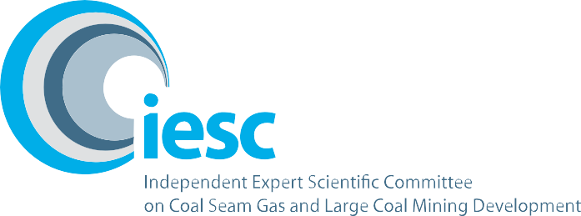

2019–2020

Annual Review of Activities
  - An overview of the activities of the Independent Expert Scientific Committee on Coal Seam Gas and Large Coal Mining Development from July 2019 to June 2020

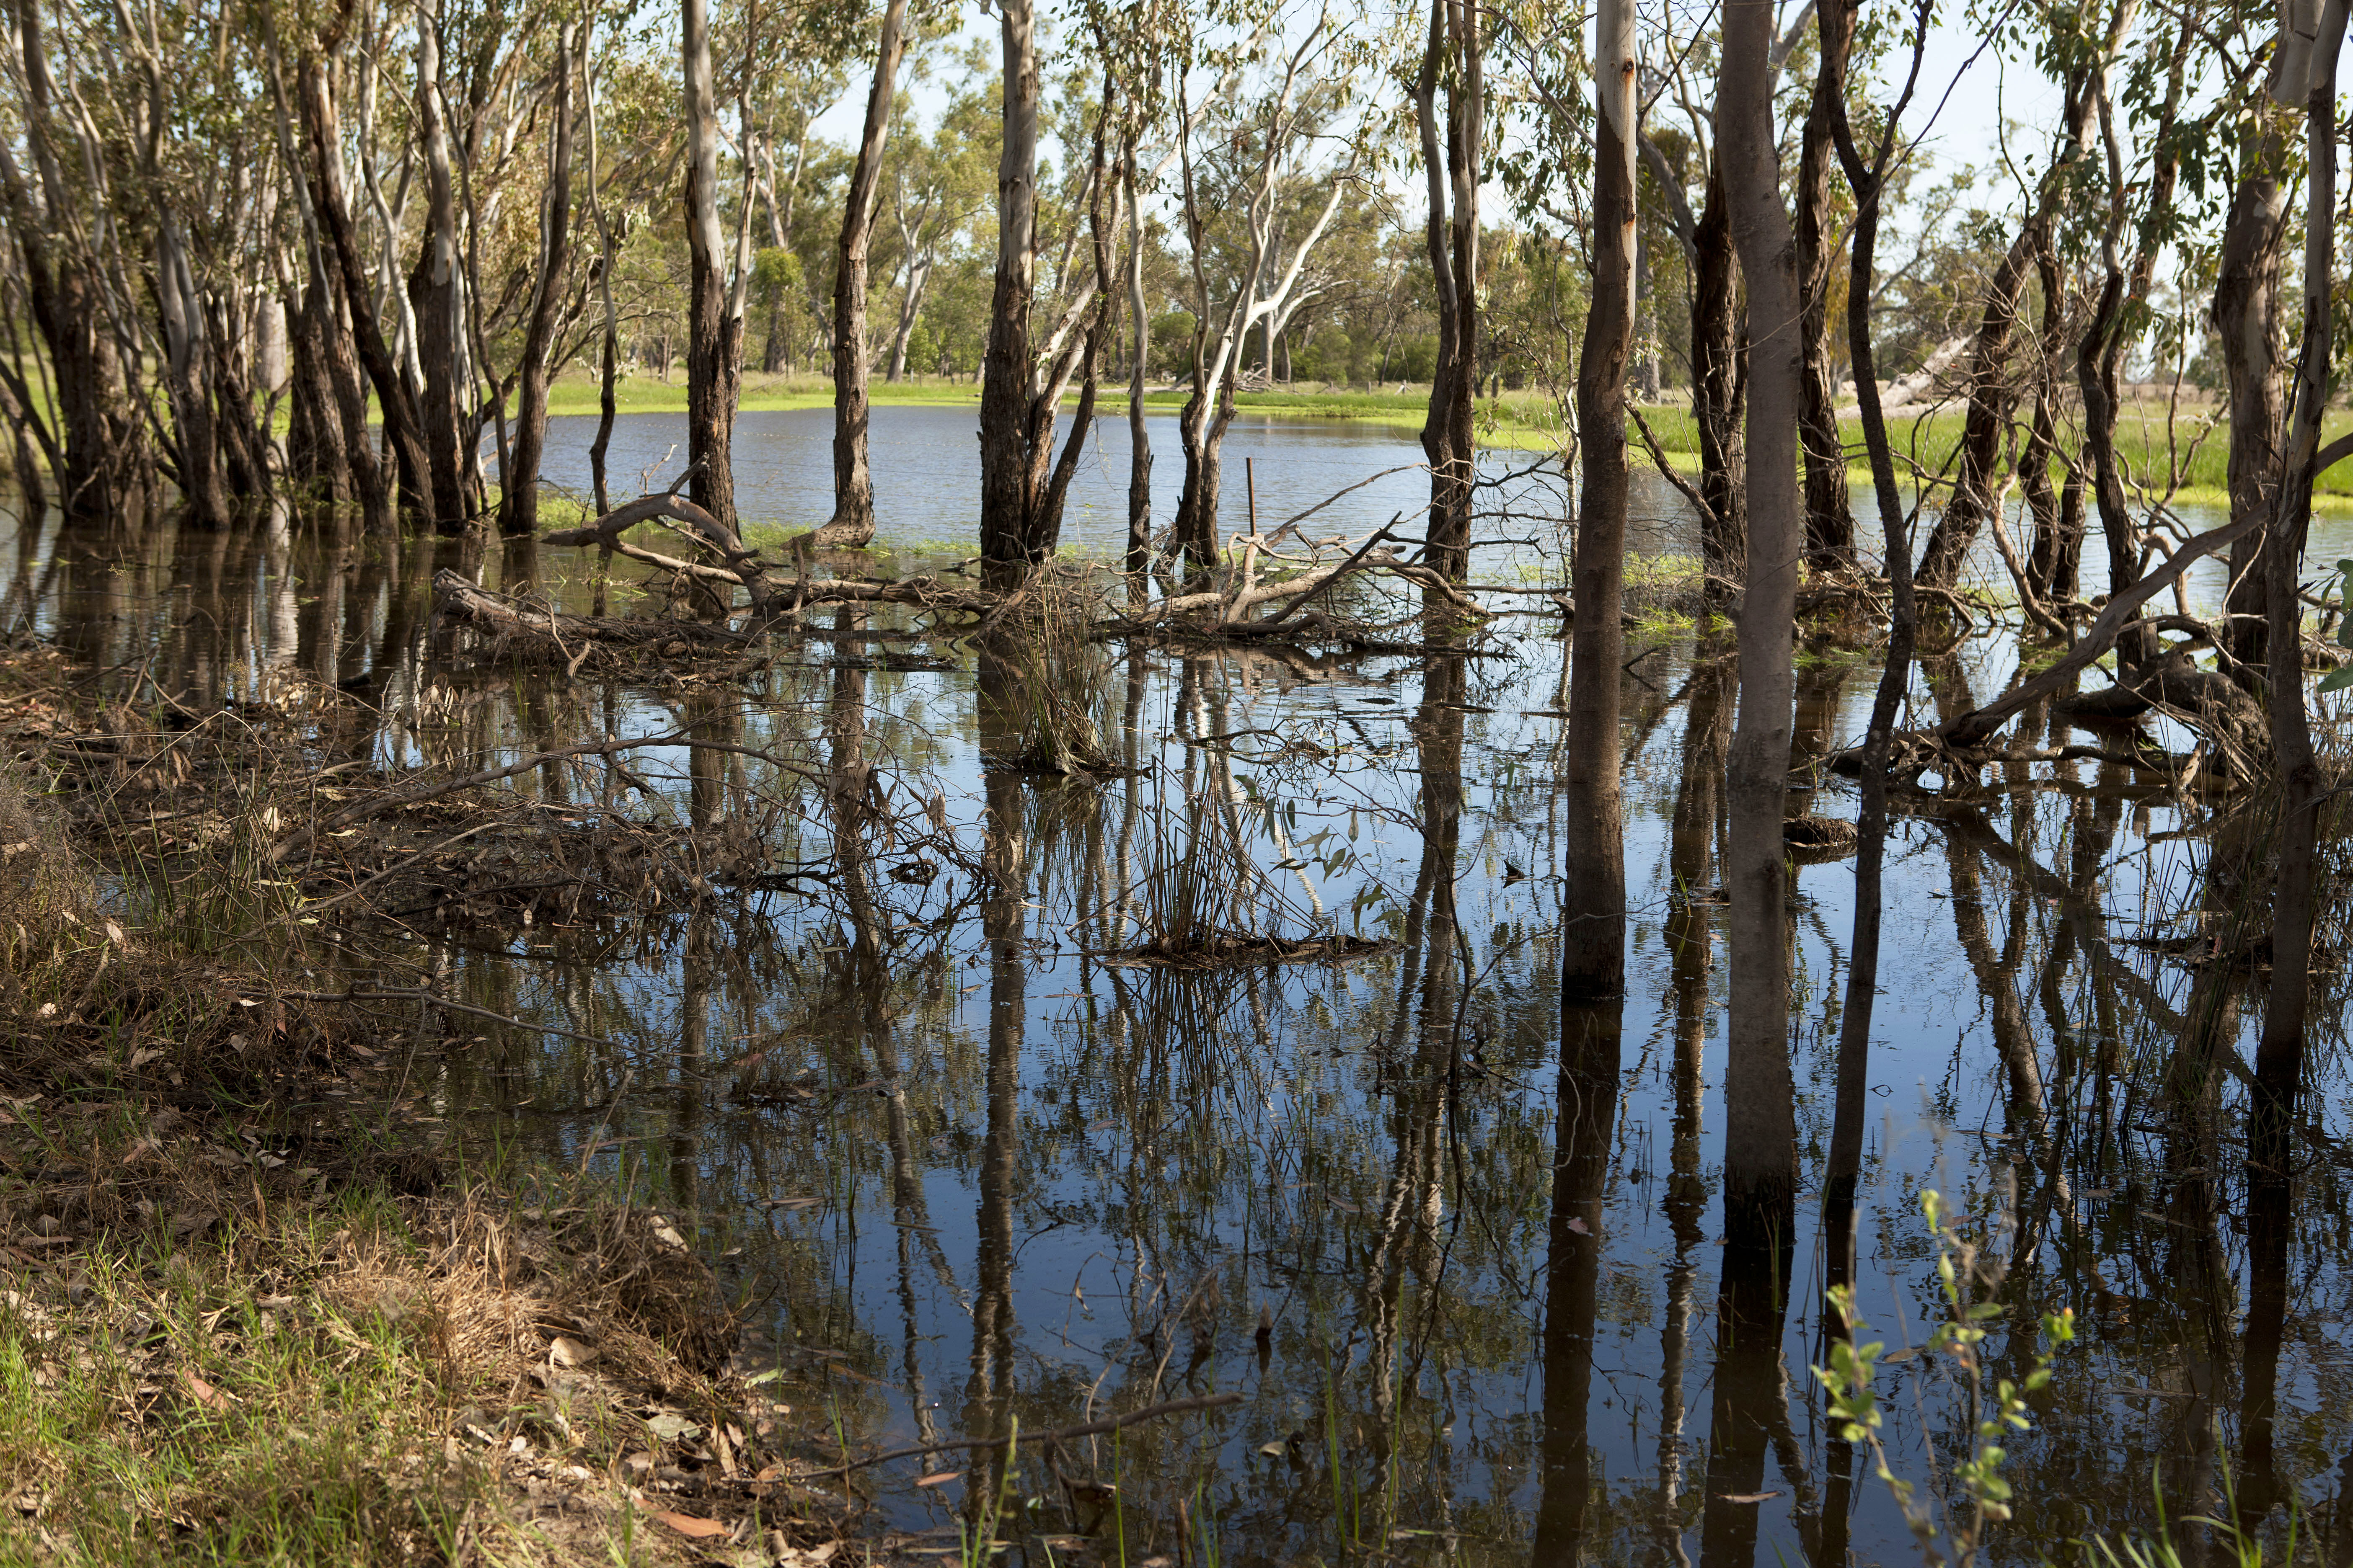

© Commonwealth of Australia, 2020.

Annual Review of Activities—July 2019 – June 2020 is licensed by the Commonwealth of Australia for use under a Creative Commons Attribution 4.0 International licence with the exception of the Coat of Arms of the Commonwealth of Australia, the logo of the agency responsible for publishing the report, content supplied by third parties, and any images depicting people. For licence conditions see: https://creativecommons.org/licenses/by/4.0/
This report should be attributed as ‘Independent Expert Scientific Committee on Coal Seam Gas and Large Coal Mining Development: Annual Review of Activities—July 2019 – June 2020, Commonwealth of Australia’.
This publication is funded by the Australian Government Department of Agriculture, Water and the Environment. The views and opinions expressed in this publication are those of the authors and do not necessarily reflect those of the Australian Government or the Minister for the Environment.
Contact details
For information about this report or about the work of the IESC, please contact:
IESC Secretariat
Office of Water Science
Department of Agriculture, Water and the Environment
GPO Box 787
CANBERRA ACT 2601
Email: IESCSecretariat@environment.gov.au

The report can be accessed at http://www.iesc.environment.gov.au/
Images
Front cover: Creek flowing through the Brigalow Nature Reserve in Goondiwindi | © Copyright Department of Agriculture, Water and the Environment (taken by staff)
All other images © Department of Agriculture, Water and the Environment unless specified otherwise


Contents
1. Message from the Chair 1
2. Highlights at a glance 2
3. The IESC 3
4. IESC meetings 5
5. Advice on coal seam gas and large coal mining development proposals 7
6. Information Guidelines 9
7. Engagement 10
8. Research 12
9. Site visits 12

1. Message from the Chair

I am happy to present the Independent Expert Scientific Committee on Coal Seam Gas and Large Coal Mining Development (IESC) Annual Review of Activities 2019–2020.

Although the COVID-19 pandemic has forced the IESC to adapt the way we meet and formulate advice, we have continued to provide independent expert scientific advice to the Australian Government Minister for the Environment and relevant state ministers on the water-related impacts of proposed coal seam gas and large coal mining developments.

During 2019–20 the IESC met six times, including once virtually, and provided advice on 10 coal development project proposals. Since the establishment of the interim IESC in 2012, we have provided over 130 pieces of advice to regulators.

In September 2019 we farewelled former IESC member Professor Joan Esterle. On behalf of the IESC, I thank Professor Esterle for her time and commitment. Following Professor Esterle’s departure, in October 2019 the Minister for the Environment, the Hon Sussan Ley MP, appointed Dr Catherine Moore to the IESC. Dr Moore brings to the IESC more than 25 years of experience as a groundwater scientist and modeller. Her appointment coincided with the reappointment of Professor Wendy Timms and Professor Craig Simmons.

The IESC has continued its commitment to improving the understanding of the impacts of coal seam gas and large coal mining developments on water resources through its research priorities. In 2020 we funded a research project to gather knowledge about coal mine voids in Queensland through a scoping study to identify the location and potential impacts of these voids in the landscape.

On behalf of the IESC, I thank the Office of Water Science (OWS) in the Australian Government Department of Agriculture, Water and the Environment for its continued support, scientific expertise and dedication in assisting our work.

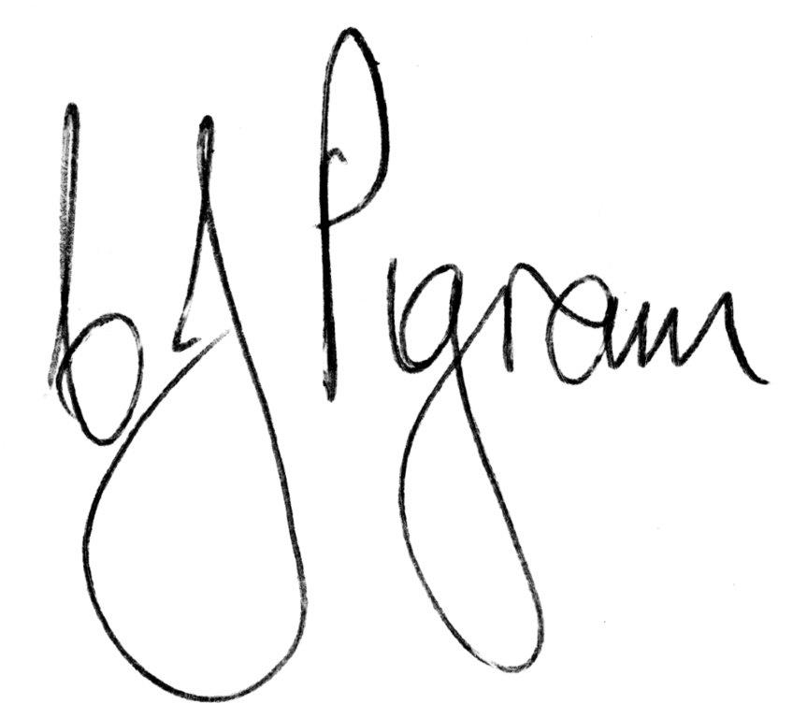

Dr Chris Pigram AM, FTSE
IESC Chair

2. Highlights at a glance
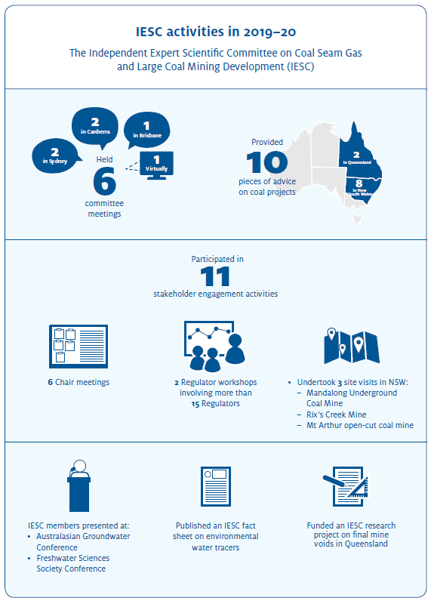

3. The IESC
The IESC consists of eight members, appointed on a part-time basis by the Australian Government Minister with responsibility for the environment. Each of them has extensive scientific qualifications and expertise in geology, hydrogeology, hydrology, ecology or ecotoxicology.


Dr Chris Pigram – Chair
Dr Pigram is a geologist with over 40 years’ experience and is a leader in research and management of minerals, marine and petroleum geoscience programs, and geospatial and earth monitoring. Dr Pigram was formerly the CEO of Geoscience Australia, where he held the role for seven years. Consequently, he has extensive experience in managing the interface between science and government and in stakeholder engagement. He is a Fellow of the Australian Academy of Technology and Engineering.


Professor Craig Simmons – Hydrogeology
Professor Simmons is a leading international authority on hydrogeology and groundwater modelling. Considered one of Australia’s foremost groundwater academics, he is the Matthew Flinders Distinguished Professor of Hydrogeology and Schultz Chair in the Environment at Flinders University, and Director of the National Centre for Groundwater Research and Training. Professor Simmons was the 2015 South Australian Scientist of the Year and the 2017 Australian Water Professional of the Year.


Dr Catherine Moore – Hydrogeology
Dr Moore is a groundwater scientist and modeller with a hydrogeology background and more than 25 years’ experience. Her work on theory and methodologies contributes to pragmatic tools for developing robust groundwater models, including quantification of model predictive uncertainty, optimising the most cost-effective data acquisition and monitoring model-data assimilation strategies. She recently led the groundwater modelling team at GNS Science in New Zealand and is currently based at CSIRO in Brisbane.


Professor Wendy Timms – Geology and Hydrogeology
Professor Timms has extensive geology, hydrogeology and engineering expertise with over 25 years of professional experience, including mine water experience at coal, gas, uranium and potash sites in Australia, Asia and Canada. She is Professor of Environmental Engineering at Deakin University, leading research in groundwater hydrology and water tracer technology, and has published over 200 technical reports and journal publications.


Professor Jenny Davis – Ecology
Professor Davis has expertise in freshwater biodiversity and wetland conservation with more than 200 published papers and reports. She was awarded the Limnology Medal for excellence in freshwater research in 2006. Professor Davis co-chairs the Wetlands Working Group of the International Association for Ecology, Evolution and Conservation. She is a Director of the Research Institute for Environment and Livelihoods at Charles Darwin University.


Associate Professor Rory Nathan – Hydrology
Associate Professor Nathan has over 35 years’ experience in engineering and environmental hydrology and is currently Associate Professor of Hydrology and Water Resources at the University of Melbourne. He has made a substantial contribution to industry best-practice in a range of engineering and environmental fields, particularly in the characterisation of hydrologic risk, the assessment of hydrologic impacts, and hydrologic model development and application.


Dr Jenny Stauber – Ecotoxicology
Dr Stauber has 40 years of research experience in the fields of ecotoxicology, water quality, contaminant environmental risk assessment and human toxicology. She serves as an expert ecotoxicologist on a wide range of advisory panels for national and international agencies. Dr Stauber is currently a Chief Research Scientist in CSIRO Land and Water. She is a Fellow of the Australian Academy of Technology and Engineering and a 2020 Fellow of the Australian Academy of Science.


Dr Andrew Boulton – Ecology
Dr Boulton’s research spans river and groundwater ecology, especially in semi-arid areas, with 4 books and 130 peer-reviewed articles. He has been on international and national panels to assess riparian zone policies, environmental flows, groundwater-dependent ecosystems and biodiversity of intermittent rivers. Dr Boulton is Adjunct Professor in Ecosystem Management at the University of New England and has held academic positions at other national and international universities.

4. IESC meetings
The IESC meets regularly to prepare its scientific advice in response to requests from government regulators and to increase its collective scientific understanding of the potential water-related impacts of coal seam gas and large coal mining developments.
The IESC met six times during 2019–20. Meetings were held in Brisbane, Sydney, Canberra and virtually.
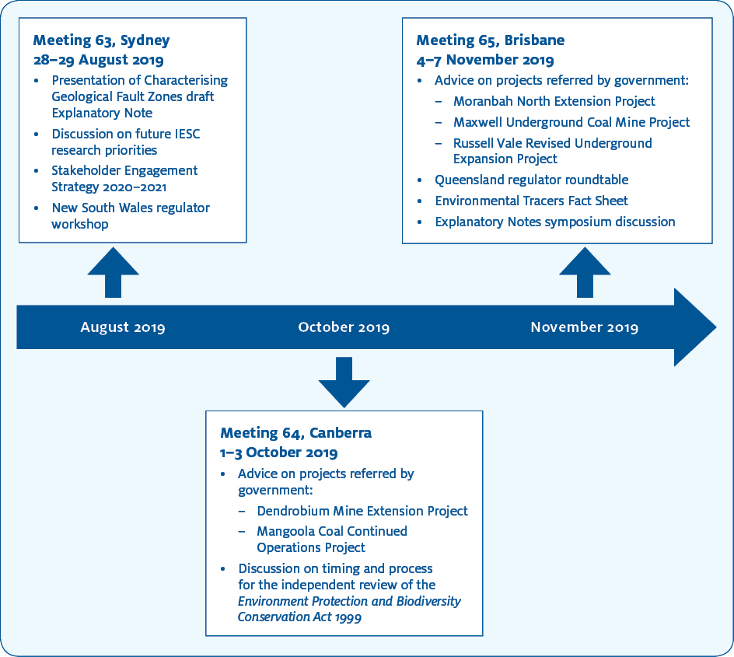

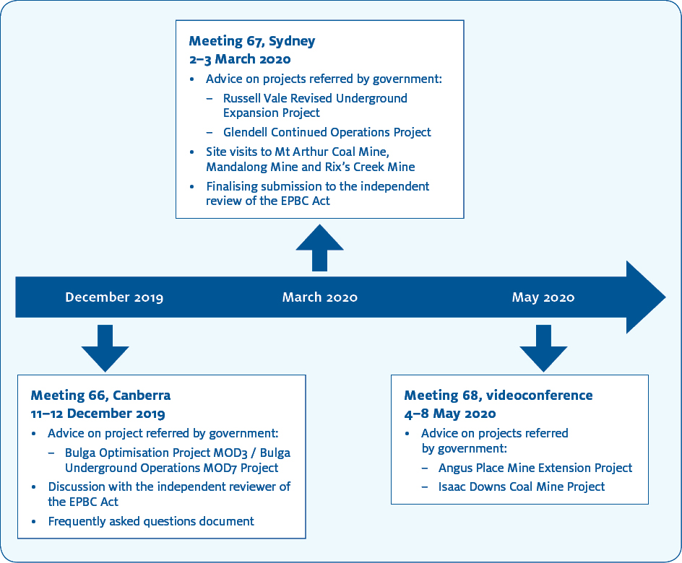

5. Advice on coal seam gas and large coal mining development proposals
The IESC provides independent expert scientific advice to the Australian and state government regulators on the potential impacts of coal seam gas and large coal mining proposals on water resources. The advice is designed to ensure that decisions by regulators on coal seam gas and large coal mining developments are informed by the best available science.
In its advice the IESC considers all potential impacts on water resources. This includes the proposed project’s effects on groundwater, surface water, water quality and quantity, ecosystems and ecological processes.
The IESC does not make decisions about whether to approve a development proposal. The Australian Government and relevant state government regulators have this responsibility.
The IESC’s scientific advice is published on the IESC website within 10 business days after sending it to the government regulator.
In 2019–20 the IESC provided 10 pieces of advice on coal development proposals.

IESC reference | Referring government | Project location | Project name | Date of IESC advice
2020-114 | Australian and QLD | QLD | Isaac Downs Coal Mine Project (EPBC 2019/8413)—New Development | 12 May 2020
2020-113 | Australian and NSW | NSW | Angus Place Mine Extension Project (EPBC 2013/6889 and SSD 5602)—Expansion | 12 May 2020
2020-112 | NSW | NSW | Russell Vale Revised Underground Expansion Project (MP 09_0013)—Expansion | 5 Mar 2020
2020-111 | Australian and NSW | NSW | Glendell Continued Operations Project (EPBC 2019/8409 and SSD 9349)—Expansion | 11 Mar 2020
2019-110 | Australian and NSW | NSW | Bulga Optimisation Project MOD3 / Bulga Underground Operations MOD7 (EPBC 2018/8300 and SSD 4960 / DA 376-8-2003)—Expansion | 16 Dec 2019
2019-109 | Australian and NSW | NSW | Maxwell Underground Coal Mine Project (SSD 9526 and EPBC 2018/8287)—Expansion | 19 Nov 2019
2019-108 | NSW | NSW | Russell Vale Colliery Underground Expansion Project (MP 09_0013)—Expansion | 19 Nov 2019
2019-107 | Australian | QLD | Moranbah North Extension Project (EPBC 2018/8338)—Expansion | 15 Nov 2019
2019-106 | Australian and NSW | NSW | Mangoola Coal Continued Operations Project (EPBC 2018/8280 and SSD 8642)—Expansion | 4 Oct 2019
2019-105 | Australian and NSW | NSW | Dendrobium Mine Extension Project (EPBC 2017/7855 and SSD 8194)—Expansion | 14 Oct 2019

Development proposals considered by the IESC in 2019–2020
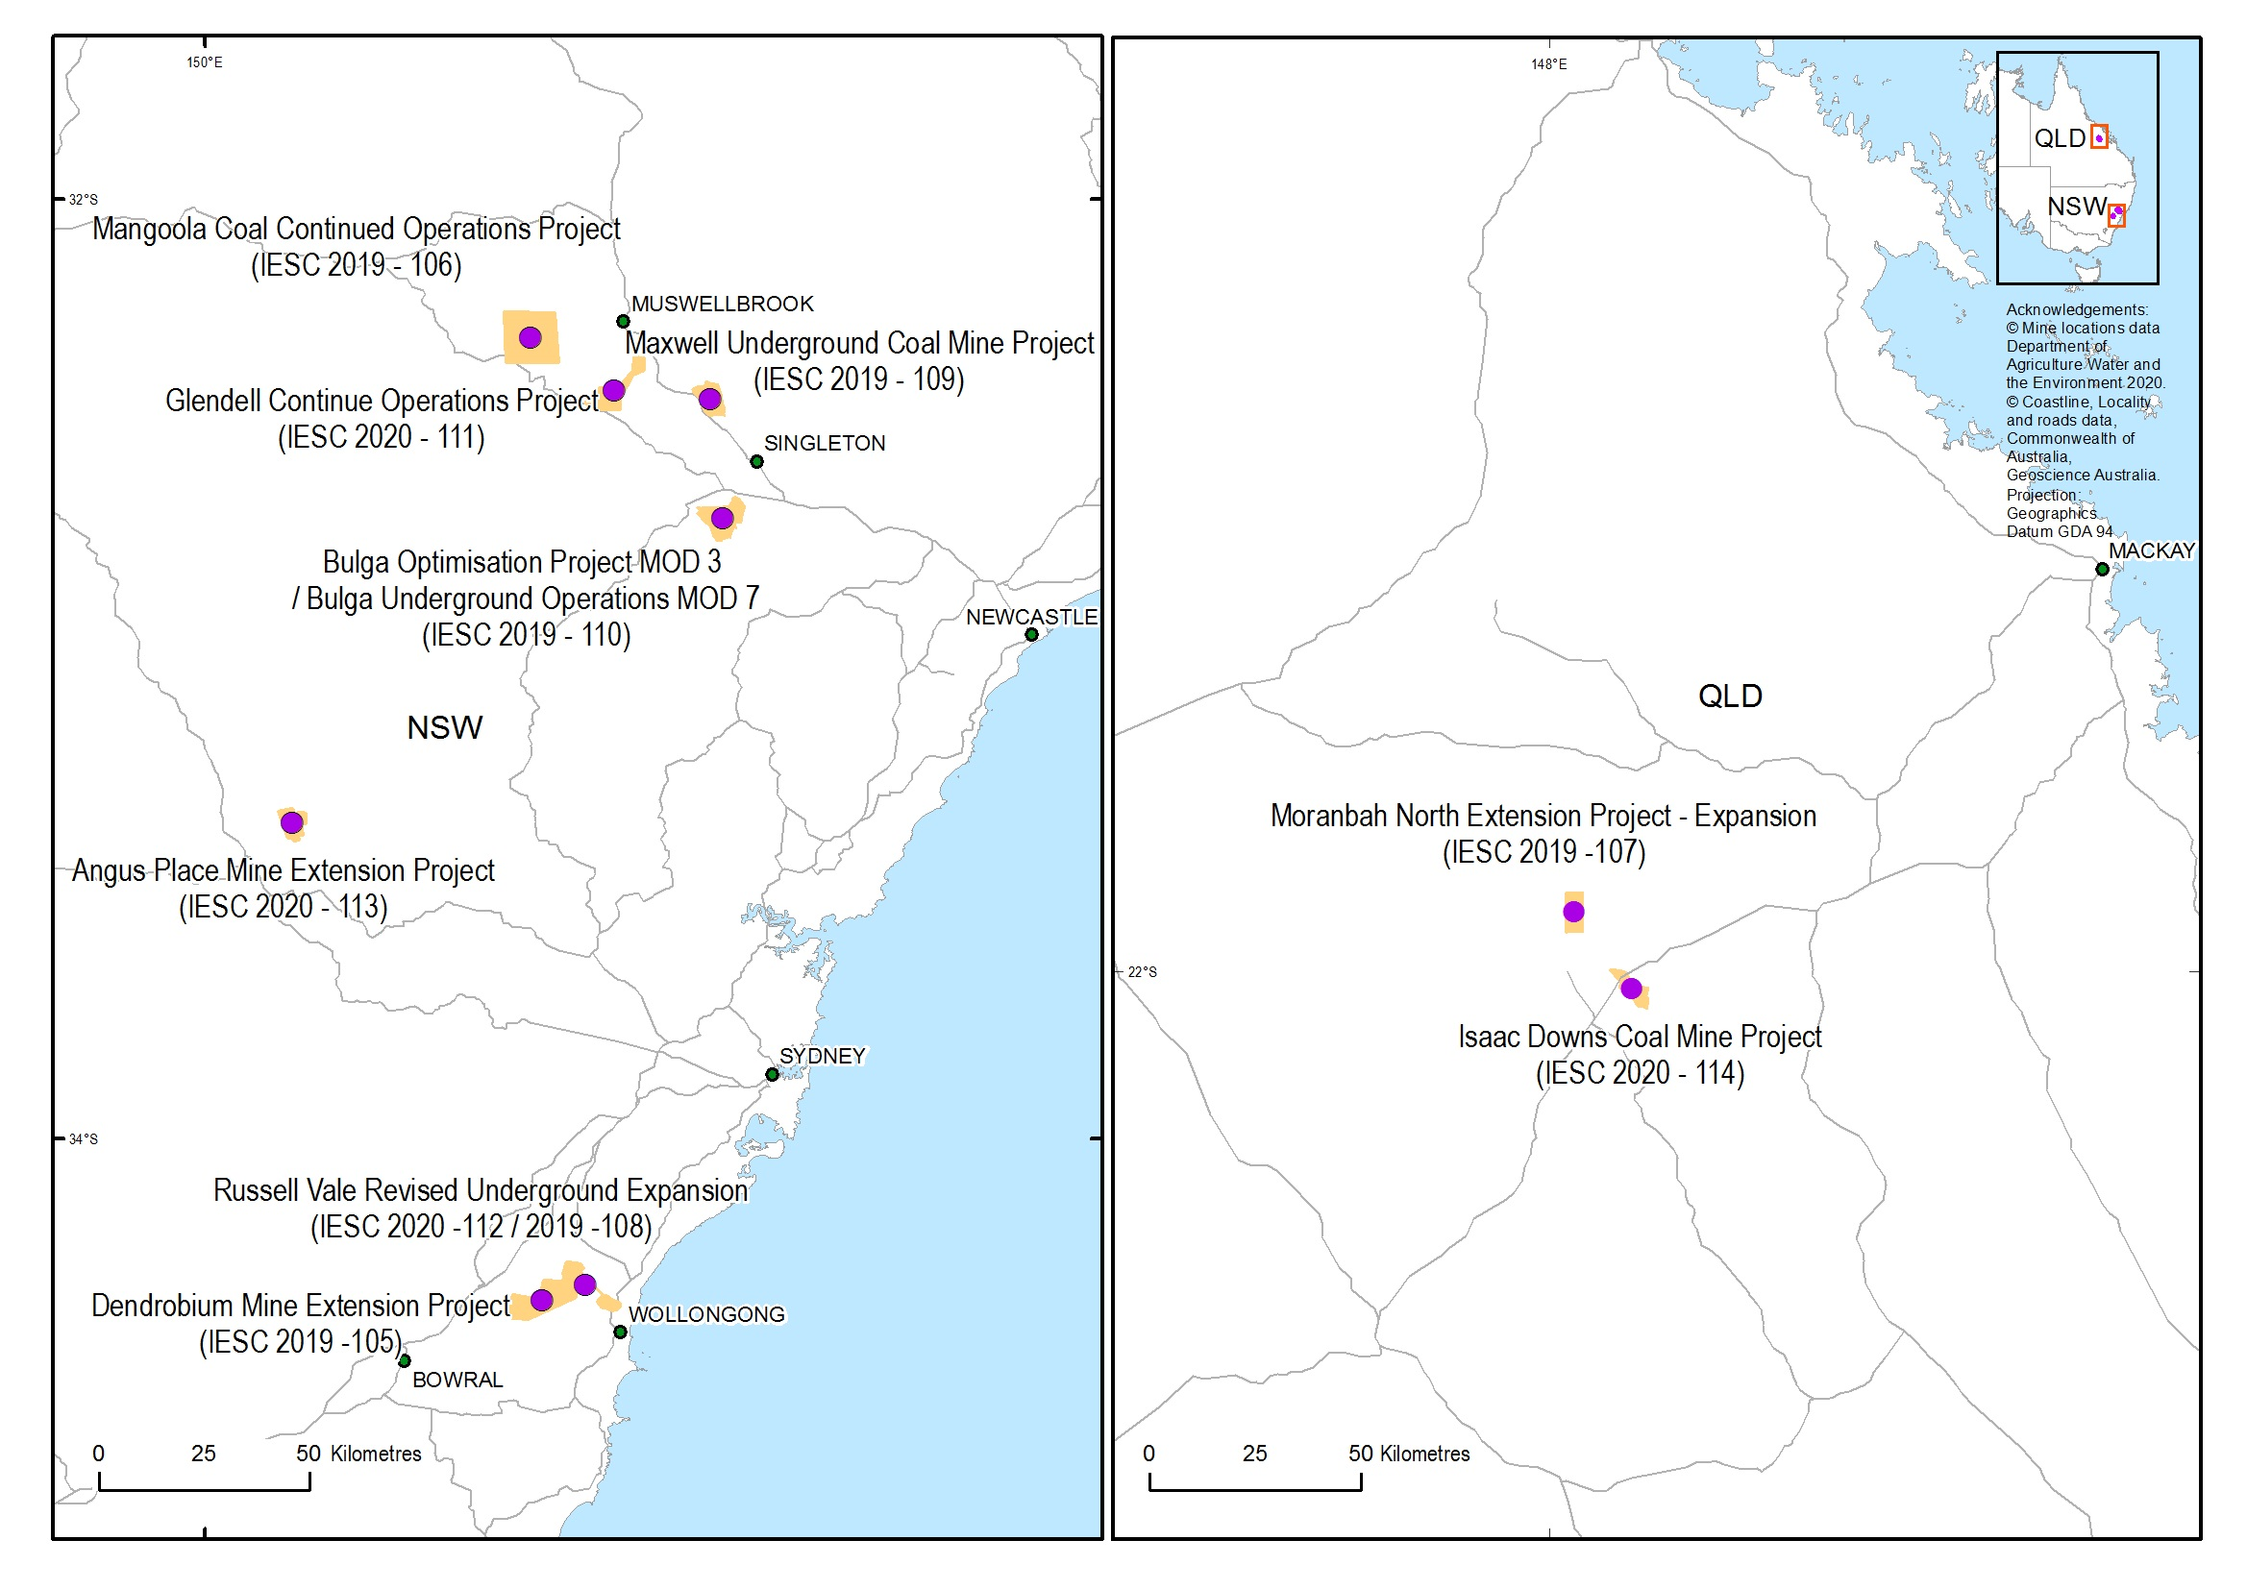
Locations of proposed developments considered by the IESC in 2019–20
Note: The IESC provided advice on the Russell Vale Underground Expansion project twice in 2019-–20.

6. Information Guidelines
The IESC Information Guidelines outline the information considered necessary to enable the IESC to provide robust scientific advice to government regulators on the water-related impacts of coal seam gas and large coal mining development proposals.
To date, the IESC has released three Explanatory Notes to supplement the Information Guidelines, providing tailored guidance and up-to-date robust scientific methodologies and tools for specific components of Environmental Impact Assessments on coal seam gas and large coal mining developments. The IESC also publishes fact sheets on key scientific issues to help industry and regulators with environmental assessments.
Explanatory Note in preparation
During 2019–20, the IESC continued to work on a fourth Explanatory Note: Characterisation of Geological Fault Zones. This Explanatory Note will discuss important features of faults, including key definitions for characterising geological faults and for the risk assessment process.
Understanding the faults within and near coal development project areas is important because these faults may enable groundwater flow connection between mining excavations or coal seams and valuable environmental assets such as aquifers, springs and groundwater-dependent ecosystems. For example, increasing groundwater drawdown during mining or extraction can potentially activate or create flows along pathways in a particular direction that were not active before development.
Published Explanatory Notes
Three Explanatory Notes are available on the IESC website.
Uncertainty analysis—Guidance for groundwater modelling within a risk management framework identifies tools and methods to help proponents understand the range of available approaches to uncertainty analysis in groundwater modelling. It is designed to be used across a range of regulatory regimes.
Assessing groundwater-dependent ecosystems reviews tools and methods for groundwater-dependent ecosystem assessment to help proponents choose the most effective approach.
Deriving site-specific guideline values for physico-chemical parameters and toxicants introduces the use of a water and sediment quality management framework to assist with the design of appropriate monitoring programs for measuring physico-chemical parameters and toxicants from which site-specific guideline values can be developed.
New fact sheet
In February 2020 the IESC published a new fact sheet, Environmental water tracers in environmental impact assessments for coal seam gas and large coal mining developments. This fact sheet supplements the Information Guidelines and associated Explanatory Notes by explaining how environmental water tracers can be used in Environmental Impact Assessments. It provides references to further reading materials to ensure that more detailed technical explanations are available where needed.

7. Engagement
In 2019–20 the IESC continued to engage with key stakeholders to increase the understanding of how their work contributes to a stronger scientific framework for regulating coal seam gas and large coal mining developments, and to invite feedback on our publications.
As part of this engagement, the IESC Chair had six meetings with government officials and a peak industry body to learn more about how they use the IESC’s advice and to seek their views on the IESC Information Guidelines and Explanatory Notes.

Regulator meetings
The IESC hosted two large-scale meetings with a range of government regulators:
- the New South Wales Regulator Workshop—Sydney, August 2019
- the Queensland Regulator Roundtable—Brisbane, November 2019.
The purpose of these meetings was to discuss and seek feedback on the IESC’s scientific advice, Information Guidelines and Explanatory Notes, and to discuss items of mutual interest.

Conferences
Australasian Groundwater Conference
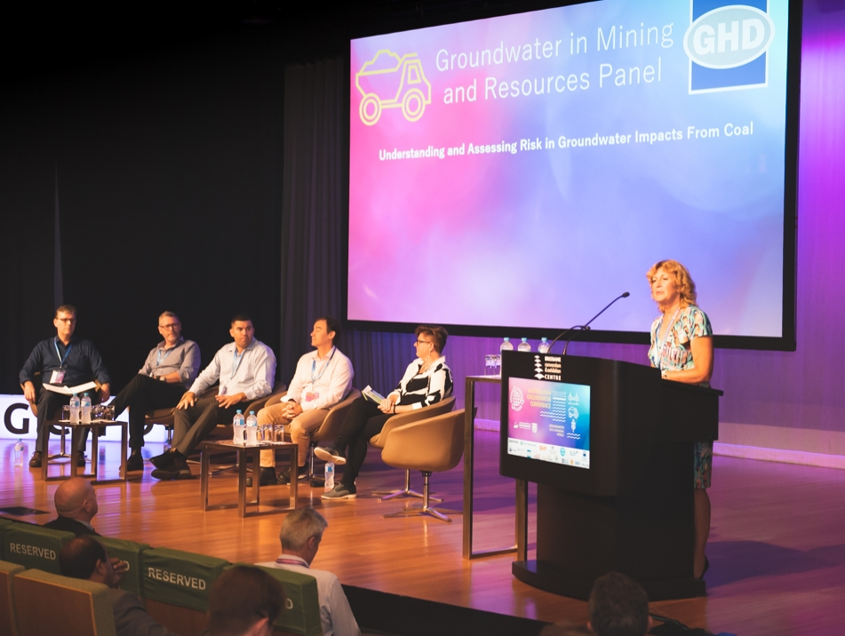
IESC member Dr Jenny Stauber chaired the Resources Panel at the Australasian Groundwater Conference held in Brisbane from 24 to 27 November 2019. The panel’s discussion topic was ‘Groundwater in Mining and Resources: Understanding and Assessing Risk in Groundwater Impacts from Coal Resource Development’.
The Resources Panel was made up of Wendy Timms (Deakin University), John Williams (NSW Government), Chris Loveday (QLD Government),
James Tomlin (AGE Consultants) and
Blair Douglas (BHP Engineering Centre of Excellence).
Dr Stauber also co-chaired (with Grant Hose) a session on stygofauna and microbes in groundwater.

Australian Freshwater Sciences Society and New Zealand Freshwater Sciences Society Joint Conference 2019
Dr Andrew Boulton represented the IESC at the Australian Freshwater Sciences Society and New Zealand Freshwater Sciences Society Joint Conference held in Waurn Ponds, southern Victoria, from 1 to 4 December 2019. In his presentation, Dr Boulton provided an overview of the IESC’s role and functions, highlighting the Information Guidelines and Explanatory Notes. He also described some of the outcomes of ecological research overseen by the Office of Water Science and explained how these outcomes have informed the IESC’s project advice. This was the first time the IESC’s activities were described to the aquatic ecologists and water managers in these two societies, and the presentation attracted considerable interest and enthusiasm.

‘Given how heavily the IESC relies on access to the most recent and best available environmental science, it is important for members to attend professional conferences across a range of scientific disciplines and to present talks on the IESC’s role, contributions and information needs. I found that after my talk, there were many Australian and New Zealand researchers who caught up with me to discuss the potential relevance of their recent work and to hear more about what the Committee does.’
Dr Andrew Boulton, IESC member

IESC submission to the EPBC Act review
A statutory review of the Environment Protection and Biodiversity Conservation Act 1999 (EPBC Act) began on 29 October 2019. The EPBC Act is Australia’s central piece of national environmental law. It is independently reviewed every 10 years to examine how well it is operating and the extent to which its objects have been achieved.
In March 2020 the IESC made a formal submission to the EPBC Act review. The IESC look forward to the release of the review’s final report, expected at the end of 2020.

8. Research
The IESC sets research priorities and funds research in these areas to improve understanding of the potential water-related impacts of coal seam gas and large coal mining developments.
In June 2020 the IESC funded a research pilot project to increase the understanding of coal mine voids in Queensland through a scoping study to identify the location and potential impacts of these voids in the landscape. The study aims to:
- identify and map where coal mine voids are located or proposed in the landscape.
- analyse void dimensions and historical and current water qualities
- analyse what ecological work has been undertaken on voids, their waters, and their banks and edges
- analyse what mitigation measures and management strategies are currently employed.
The IESC look forward to sharing the results of this study following its completion in 2021.

9. Site visits
In March 2020 the IESC visited three coal mine operations in the Hunter Valley region of New South Wales. These site visits focused on water resources and rehabilitation activities, enabling members to gain a firsthand understanding of these issues.
The IESC would like to thank the staff at these sites for taking time out of their busy days to show members around the various facilities and to answer their questions.

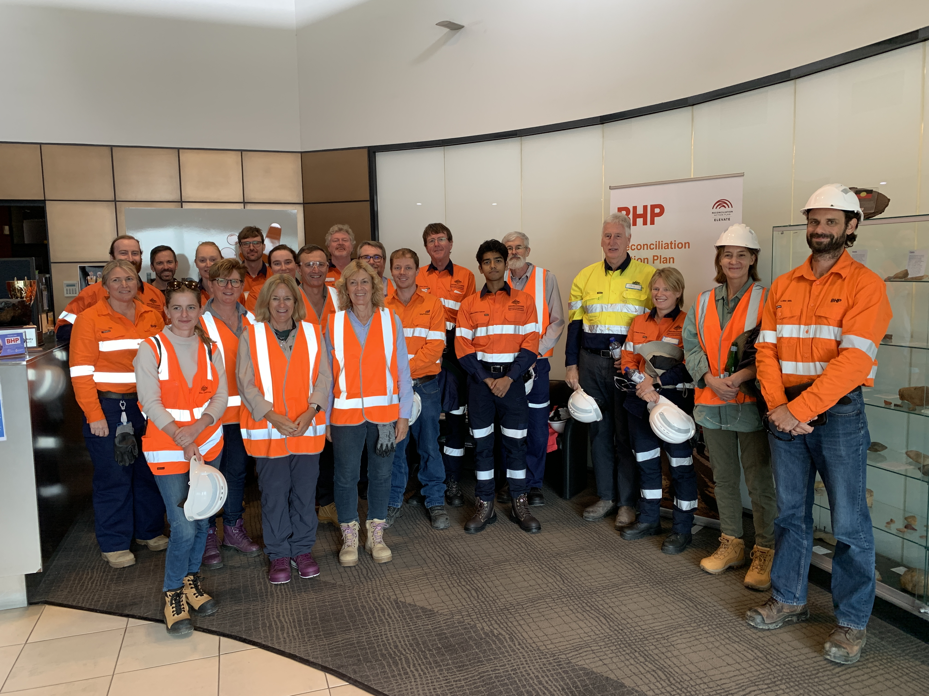
Mandalong Mine
A visit to Centennial Coal’s Mandalong Mine in the Newcastle coal fields near Morisset was an opportunity for IESC members to view underground longwall mining operations. The IESC toured sections of the longwall and spoke to site staff about operations and safety.

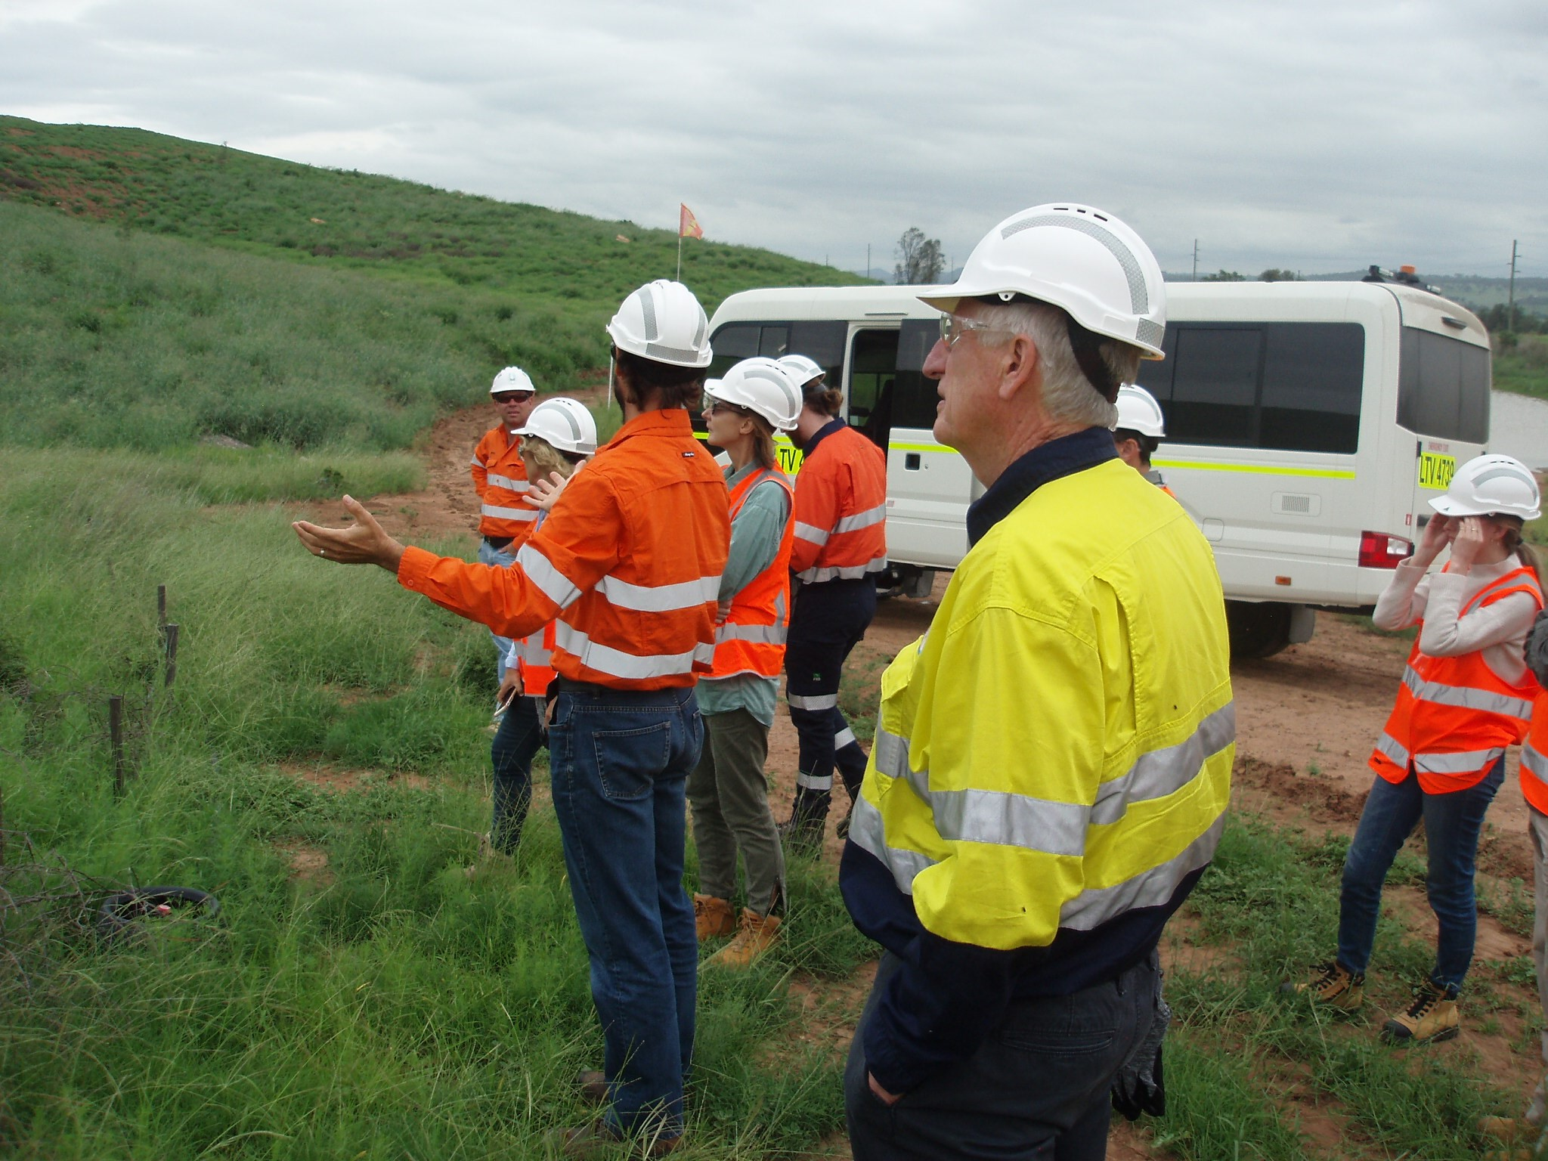
Mt Arthur Coal Mine
IESC members enjoyed a pit tour of BHP’s Mt Arthur open-cut coal mine, the biggest coal mine in the Hunter Valley. The IESC learned about rehabilitation work being undertaken on site and about the planned final landform.

Rix’s Creek Mine
IESC members found it valuable to inspect and discuss the rehabilitation work at Rix’s Creek Mine, located 90 km from the Port of Newcastle. The IESC learned about the soil rehabilitation being undertaken on site to make the area suitable for agriculture.
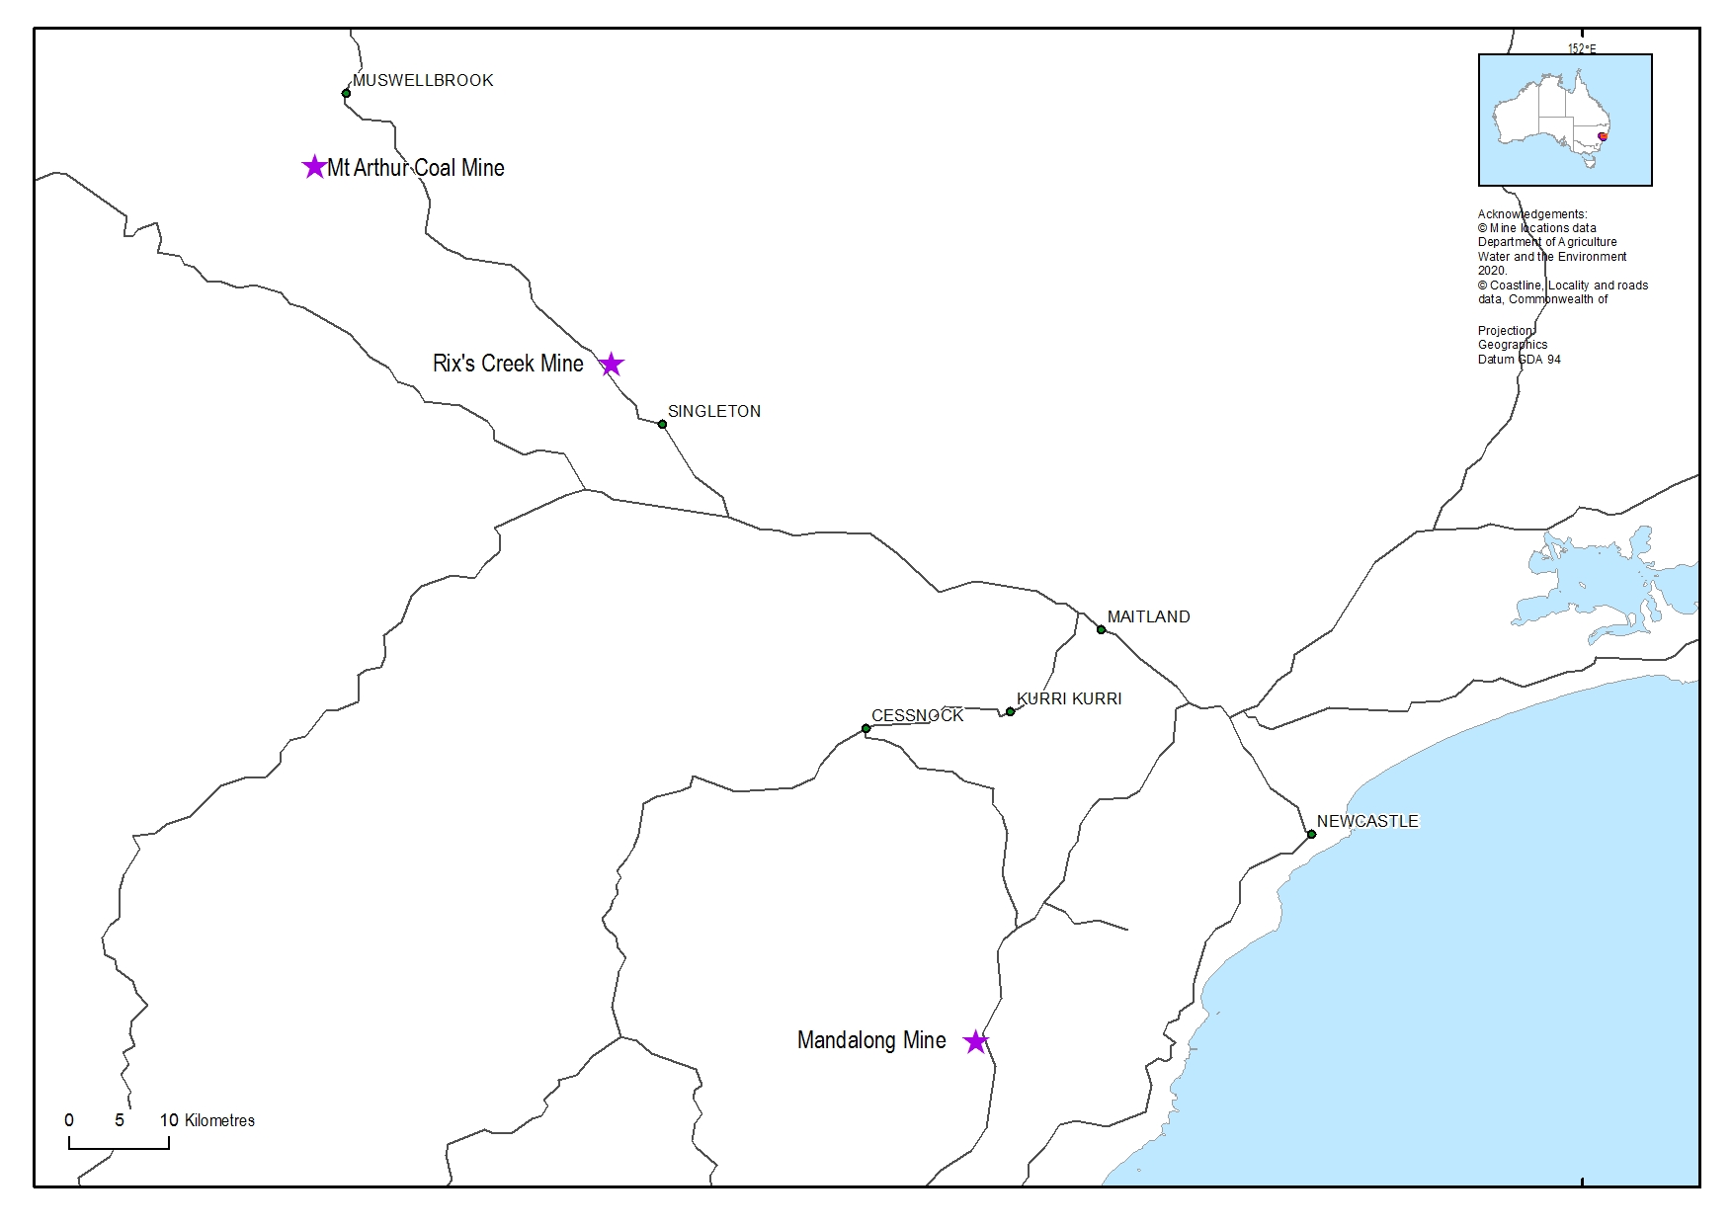
Locations of IESC site visits in 2019–20

Back cover
Paperbark forest behind the Hunter Wetlands Centre
Location: Shortland Wetland
Copyright: © Department of Agriculture, Water and the Environment (taken by staff)

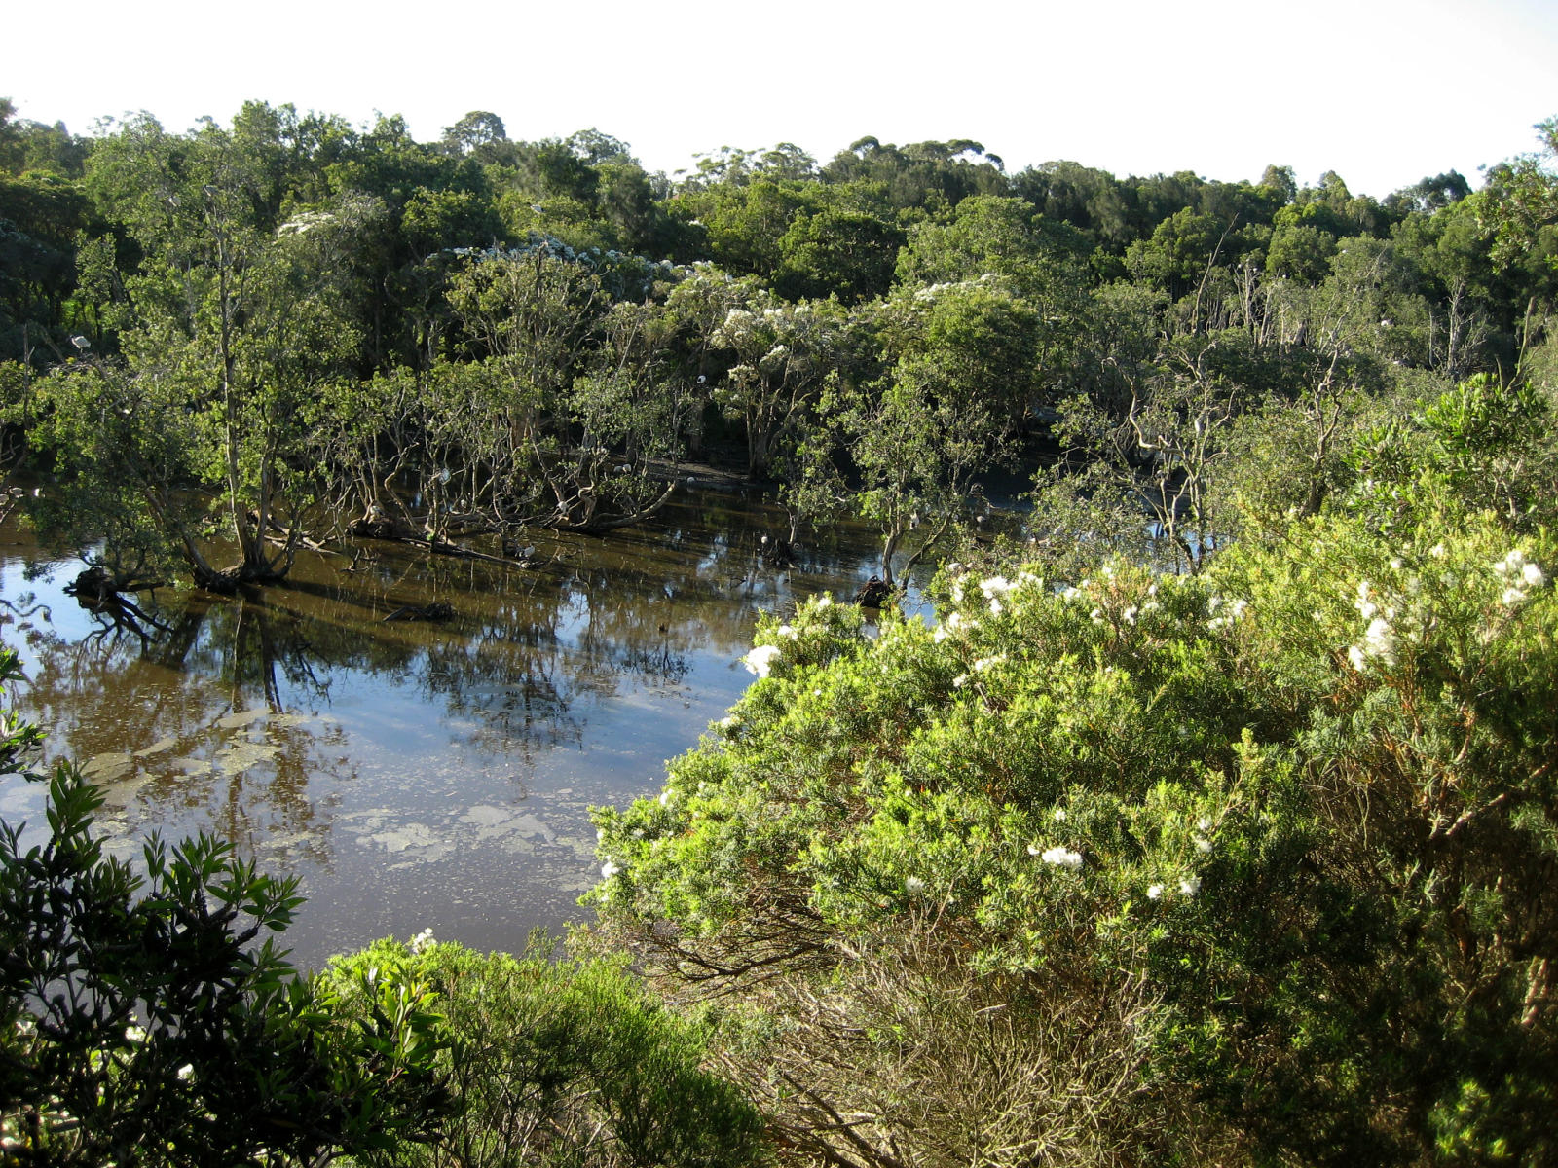



www.iesc.environment.gov.au

